Supplementary Information

Stress-Compensated, Deformation-free Indium Tin Oxide Bilayer Electrodes for Ultrathin Flexible Perovskite Solar Cells
Noboru Ohashi^{1*}, Ryuji Kaneko¹, Chikako Sakai¹, Yoko Wasai², Seiji Higuchi³, Kenji Yazawa¹, Hirokazu Tahara¹, Taketo Handa¹, Tomoya Nakamura¹, Richard Murdey¹, Yoshihiko Kanemitsu¹, and Atsushi Wakamiya^{1*}
¹Institute for Chemical Research, Kyoto University, Uji, Kyoto 611-0011, Japan
² Analytical Technology Department, HORIBA Techno Service Co., Ltd., Chiyoda-ku, Tokyo, 101-0063, Japan
³ Scientific / Semiconductor Product R&D Center, HORIBA Ltd., Minami-ku, Kyoto, 601-8510, Japan

E-mail: ohashi.noboru.6n@kyoto-u.ac.jp, wakamiya@scl.kyoto-u.ac.jp

Supplementary Methods

Materials
Lead(II) iodide (PbI₂, 99.99%), cesium iodide (CsI, >99%), methylamine hydrobromide (MABr, >98%), lead(II)bromide (PbBr₂, >98%), formamidinium iodide (FAI, recrystallized), and bathocuproine (BCP) were purchased from Tokyo Chemical Industry (TCI). Co(III) (tris(2-(1H-pyrazol-1-yl)-4-tert-butylpyridine)cobalt(III) tri[bis(trifluoromethane)sulfonimide] (FK 209 Co(III) TFSI salt, 98%) was purchased from Sigma-Aldrich. 2,2′,7,7′-Tetrakis(N,N-di-p-methoxyphenylamino)-9,9′-spirobifluorene (spiro-OMeTAD) was purchased from Nippon Fine Chemical. Lithium(I) bis(trifluoromethanesulfonyl)imide (LiTFSI, 90%), KI (>99.5%), KF (>99%) were purchased from Wako Pure Chemical Industries. NH₄Cl (>98.5%) was purchased from Nacalai Tesque Inc. These materials were used as received. Tin(IV) oxide (SnO₂) nanoparticles, 15 wt% in H₂O colloidal dispersion, were purchased from Alfa Aesar. The SnO₂ dispersion was centrifuged at 10000 rpm for 10 min, and the supernatant was filtered through a 0.45 µm PTFE filter (Agilent Technologies Japan) to remove the aggregates. Acetone (99%), dimethyl sulfoxide (DMSO, super dehydrated), and N,N-dimethylformamide (DMF, super dehydrated) were purchased from Wako Pure Chemical Industries. 4-tert-butylpyridine (TBP, 96%) and chlorobenzene (anhydrous 99.8%) were purchased from Sigma-Aldrich. The solvents were degassed by argon gas bubbling for 1 h and further dried over molecular sieves in nitrogen-filled glove box (O₂ <1 ppm) before use. Optical clear adhesives were purchased from PANAC Co., Ltd. Ultrathin PEN films were provided by TOYOBO CO., LTD.

Apparatus
The sample surface was cleaned with nitrogen plasma (JP-100HA, Aqa Co., Ltd.). ITO layers were deposited by RF sputtering (CV-19D-RDSP, CryoVac corp.). The module pattern processing was performed by laser scribing (LPM-300, Mitsuboshi Diamond Industrial Co., Ltd.) Device performance at AM 1.5G was measured using an OTENTO-SUN III solar simulator (Bunkoukeiki Co., Ltd.). Device performance at 200 lx was measured using a white LED with a color temperature of 5000 K (BLD-100, Bunkoukeiki Co., Ltd.). The IPCE measurement was performed with an SMO-250III spectrometer (Bunkoukeiki Co., Ltd.). The sample thickness was measured by a stylus profilometer (alpha-step IQ, KLA-Tencor corp.). Electrical conductivity was measured by a four-point probe instrument (Loresta-GX MCP-T700, Nittoseiko Analytech Co., Ltd.). X-ray diffraction (XRD) of the sample was measured by an X-ray diffractometer (RINT 2500, Rigaku Corp.). The complex refractive index was measured by a spectroscopic ellipsometer (UVISEL Plus, HORIBA, Ltd.). Light transmittance was measured by UV-vis-NIR spectrophotometer (UV-3600 PLUS, Shimadzu Corp.). A high magnification image was taken with a scanning electron microscope (SU 8010, Hitachi High-tech corp.).

Fabrications
Ultrathin PEN films (4 μm thick) were bonded to 0.9 mm thick glass substrates. First, the carrier glass was coated with optical clear adhesive. Next, the PEN film was placed on top of the adhesive while the glass was heated to 50 °C. The laminated substrates were degassed at 100 °C for 10 minutes and stored under vacuum. The surface was cleaned by nitrogen plasma treatment (JP-100HA, Aqa Co., Ltd.) before and after ITO deposition.
ITO layers were deposited by RF sputtering (CV-19D-RDSP, CryoVac corp.). The chamber base pressure was below 5.0 × 10⁻⁴ Pa. The substrate/target distance was 9 cm and the RF power was 50 W. To remove air bubbles between glass/OCA/PEN interfaces, the chamber was flushed repeatedly with nitrogen gas. Sputtering was performed under a mixed gas of argon (99.7%) and oxygen (0.3%). Pre-sputtering time was >5 min.
When the ITO films were used in solar cells fabrication, they were first cleaned by 5 min sonication in ultrapure water. SnO₂ dispersion diluted to 1:1 with ultrapure water was then spin-coated on the substrate at 4000 rpm for 30 s. After annealing at 140 °C for 30 min, the SnO₂ surface was cleaned with UV-ozone 15 min. Two methods were used to dope the SnO₂ layers: In the first method, an aqueous solution of 200 mM NH₄Cl was applied to the SnO₂ surface by spin coating, followed by annealing at 125 °C for 30 min, while in the second method, KF was mixed with the SnO₂ dispersion to a concentration of 50 mM. The substrates were then sonicated with ultrapure water for 5 minutes and returned to the N₂-filled glovebox.
The perovskite layer was fabricated with a 1-step antisolvent method.¹ The precursor solution contained FAI (450.5 mg), CsI (44.3 mg), MABr (54.3 mg), PbBr₂ (121.4 mg), PbI₂ (1357.4 mg) and KI (10.3 mg) in DMF:DMSO solvent (1:0.3 vol%, total volume of 3.12 mL). The concentration was 1.05 m in terms of PbI₂. The composition of mixed-cation perovskite was Cs_{0.05}FA_{0.80}MA_{0.15}PbI_{2.65}Br_{0.35}. For the bending and stabilized power output test, perovskite precursor without KI was used. After stirring at 40 °C for 30 min, the solution was filtered through a 0.45 µm PTFE filter. The precursor solution was spin-coated on ITO/SnO₂ substrates (190 µL, 1000 rpm 10 s, ramp up the revolution speed for 5 s, 3000 rpm 20 s). Chlorobenzene (0.3 mL) was dripped on the substrate starting 4 s before the end of the 3000 rpm spinning. The resulting transparent film was annealed at 150 °C on a hot plate for 10 min to form the characteristic 500 nm thick metallic black perovskite layer. (Note that the annealing temperature was confirmed by measuring the substrate temperature with a thermocouple. The hot plate was set to 160 °C.)
To prepare the hole transport layer, spiro-OMeTAD (72.3 mg, 0.059 m), Co(III)TFSI complex (FK 209, 13.5 mg, 0.0090 m), TBP (28.8 µL, 0.21 m), and Li TSFI (9.1 mg, 0.031 m) were dissolved in chlorobenzene (1.0 mL). After stirring at 70 °C for 30 min, the resulting suspension was filtered with a 0.45 µm PTFE filter. The solution (90 µL) was spin-coated on the perovskite layer (4000 rpm, 30 s) and annealed at 70 °C for 30 min.
The devices were transferred under an N₂ atmosphere to a vacuum chamber, where 80 nm gold electrodes were thermally evaporated through a shadow mask. Full details of the standard device fabrication procedures are similar to our previous reports.^{1,2}
For the ITO layers prepared directly on glass substrates, the substrate was cleaned by ultra-sonication with acetone and ultrapure water (10 min each). ITO sputtering conditions were as described above.
For the ultrathin module, the module pattern processing (P1, P2, and P3, shown in Fig. 6a) was performed by laser scribing (LPM-300, Mitsuboshi Diamond Industrial Co., Ltd.). The pulse width, wavelength, and power of the laser were <15 ps, 532 nm, and 0.1–0.3 W, respectively. Pattering was performed in a nitrogen atmosphere. The pattern width of P1, P2, and P3 were 80 μm, 300 μm, and 80 μm, respectively. The geometric fill factor was 91.1%.

Characterizations
Device performance at AM 1.5G was measured under an inert atmosphere using an OTENTO-SUN III solar simulator (Bunkoukeiki Co., Ltd.) and a Keithley 2400 sourcemeter (Tektronix, Inc.). The scan speed was 0.04 V/s. The light intensity of the illumination source was calibrated using a standard BS520BK silicon photodiode. Other measurements were performed in air (30% relative humidity). A white LED with a color temperature of 5000 K (BLD-100, Bunkoukeiki Co., Ltd.) was used for low-light solar cell measurement. IPCE spectra were obtained with an SMO-250III spectrometer system (Bunkoukeiki Co., Ltd.). Metal masks were used for the electrical measurements to define a cell aperture area of 0.1 cm².
For the bending test, a PET frame was laminated on the border of the ultrathin film solar cell to prevent unintentional deformation.³ The setup for the in-situ J–V measurements during the bending test is shown in Supplementary Fig. 15. The bending radius was 1 mm.
The curvature of the glass substrates and ITO layer thickness was estimated with a stylus profilometer (alpha-step IQ, KLA-Tencor corp.). A four-point probe (Loresta-GX MCP-T700, Nittoseiko Analytech Co., Ltd.) was used to measure the layer conductivity.
X-ray diffraction (XRD) measurement (RINT 2500, Rigaku Corp.) was carried out with Cu Kα radiation (1.5406 Å). The complex refractive index was measured by a spectroscopic ellipsometer (UVISEL Plus, HORIBA, Ltd.). Light transmittance was measured by UV-vis-NIR spectrophotometer (UV-3600 PLUS, Shimadzu Corp.). High-magnification images were taken with a scanning electron microscope (SU 8010, Hitachi High-tech corp.).

Supplementary note 1:
Morphology and optical transmittance of ITO-A and ITO-C
Cross-sectional SEM images of the ITO-C and ITO-A/ITO-C films are shown in Supplementary Fig. 16a. In both cases, a distinct pattern of crystal grains can be observed within the ITO-C layer. The density of grain boundaries appears to decrease going towards the substrate interface and a uniform, the featureless region is observed adjacent to the glass substrate. Considering a two-dimensional growth model with surface diffusion,⁴ we can denote two components within the ITO-C layers; an initial nuclei layer ITO-C1, and a bulk layer ITO-C2 (ITO-Cs).
A schematic illustration showing the ITO-C growth model is shown in Supplementary Fig. 16b. Given the sputtering pressure of 0.1 Pa, the mean free path is comparable to the target distance (9 cm).⁵ In this situation, the mass flux can be considered one-dimensional. When the fastest crystal growth direction is normal to the substrate and surface diffusion of the atoms dominates the crystal growth, causing platelet and needle structures to appear on the surface of the crystal film.⁴
We compared the transmittance spectra of the ITO-A/ITO-Cs layers and the ITO-Cs bilayer in Supplementary Fig. 16c. The total thickness of both films was the same to prevent an interference peak shift. The transmittance of the ITO-A/ITO-Cs layers is higher than that of the ITO-Cs bilayer.
To learn more about the optical characteristics of the ITO-Cs structures, the complex refractive index was examined by spectral ellipsometry. Supplementary Fig. 16d shows the complex refractive index of each layer. The difference between the refractive index of ITO-C1 and ITO-C2 was greatest in the wavelength range of 500 to 600 nm. The improved transmittance in this region can be attributed to the optical interference between the ITO-C1 and ITO-C2 layers. In addition, the extinction coefficient of ITO-Cs in the near IR region was increased compared to ITO-A due to the interaction of free electrons.⁶ Near IR transmittance of ITO-A/ITO-Cs was improved by replacing part of ITO-Cs with ITO-A. We concluded that optical interference between ITO-A, ITO-C1, and ITO-C2 plays a key role in determining the overall transmittance.

Supplementary Figures and Tables
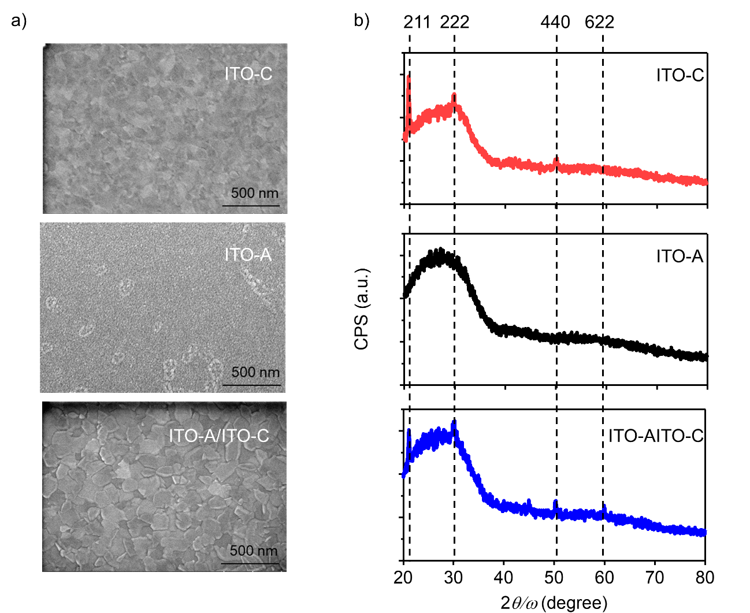

Supplementary Fig. 1 Characterization of ITO layers on glass substrates. a SEM images. b XRD profiles. The ITO-A and ITO-C layers were 50 nm and 150 nm thick, respectively.

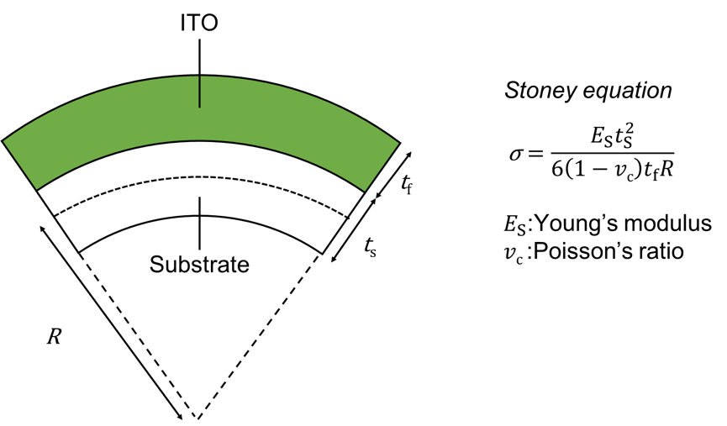

Supplementary Fig. 2 Schematic illustration of the ITO film indicating the parameters used to determine internal stress.

Supplementary Fig. 3 Optical transmittance spectra of three ITO-A/ITO-C bilayers each having a total thickness of 200 nm.

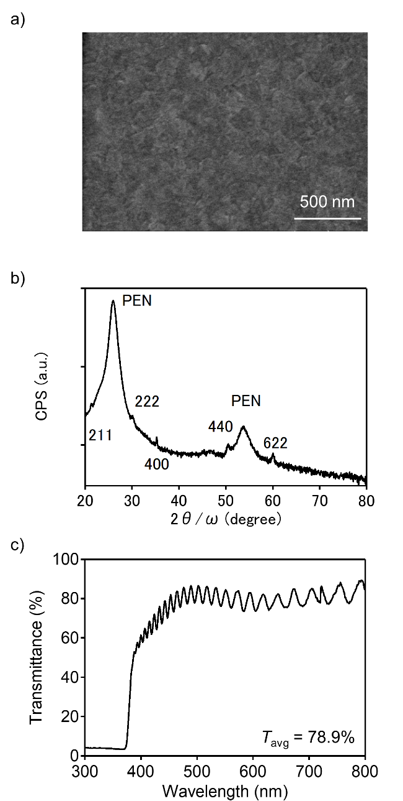

Supplementary Fig. 4 The properties of ITO-A/ITO-C on ultrathin PEN. a SEM image, b XRD spectrum and c transmittance spectrum The thicknesses of the ITO-A and ITO-C layers were 50 nm and 150 nm, respectively. Note that the additional broad peaks in the XRD pattern originate from the PEN substrates.⁷ The poor transparency of the PEN film in the UV region resulted in strong attenuation observed below about 380 nm.

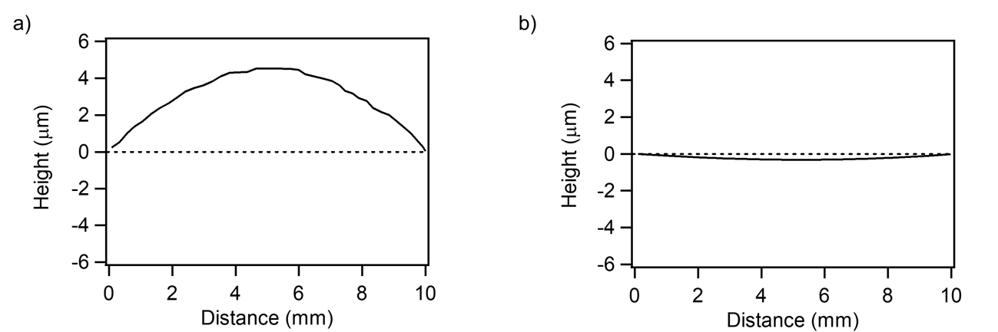

Supplementary Fig. 5 Surface height profiles of glass/ITO substrates. a Glass/ITO-C b glass/ITO-A.

Supplementary Table 1 Growth parameters and representative properties of ITO-C and ITO-A layers on glass substrates.
Material | Substrate temperature  (°C) | Argon pressure  (Pa) | σ_{f}ª  (GPa) | σª  (S cm⁻¹)
ITO-C | 150 | 0.1 | −0.17 | 2100
ITO-A | 25 | 5 | +0.033 | 67
ªInternal stress and conductivity of representative 150 nm thick ITO layers.

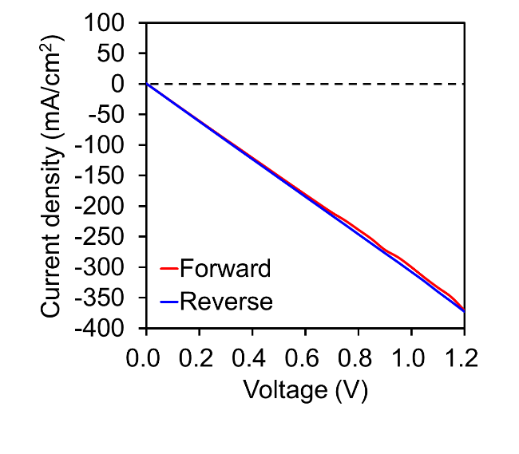

Supplementary Fig. 6 Current–voltage curves for an ultrathin device fabricated on single layer ITO-C. The electrodes have shorted together, making the solar cell nonfunctional.

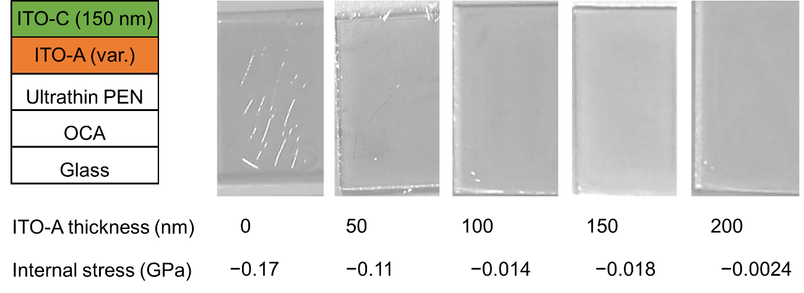

Supplementary Fig. 7 Photos of ultrathin films with different ITO-A layer thicknesses. The thickness of the ITO-C overlayer was fixed at 150 nm, while the thickness of the ITO-A layer varied between 0–200 nm.

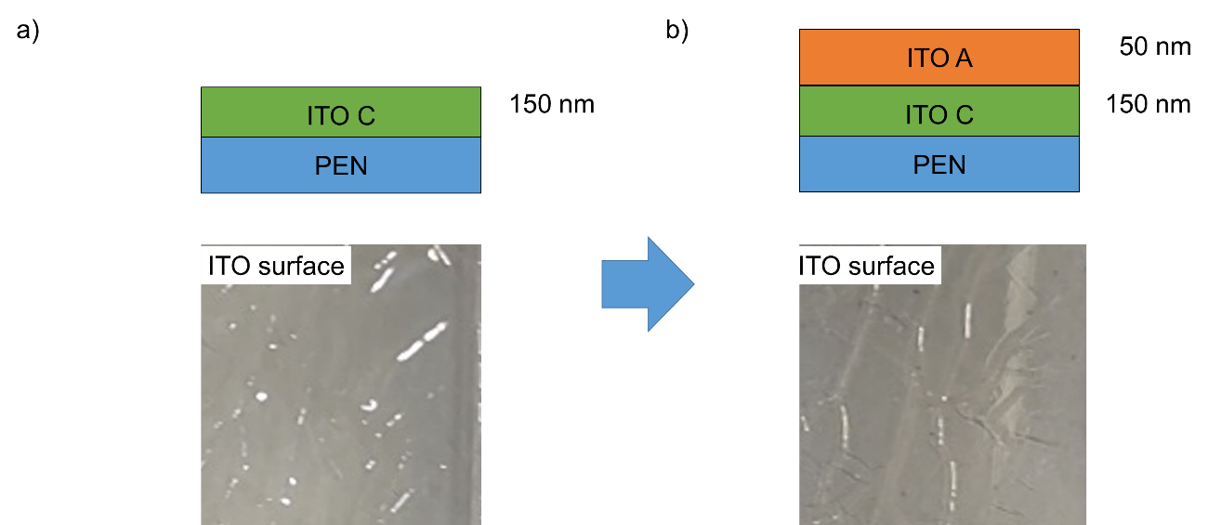

Supplementary Fig. 8 Cross section and surface morphology of ultrathin PEN/ITO substrates. a PEN/ITO-C b PEN/ITO-C/ITO-A. If ITO-C is the bottom layer the wrinkles do not disappear after the top ITO-A layer is applied even if the internal stress is compensated.

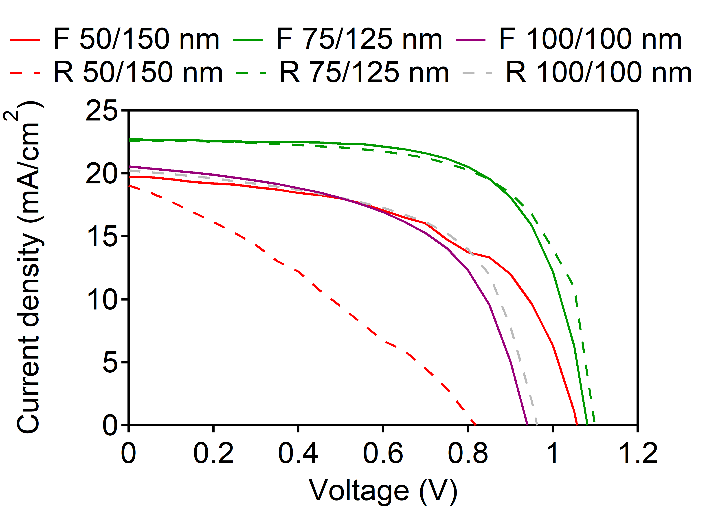

Supplementary Fig. 9 Current–voltage curves recorded under AM 1.5G for the champion cells obtained with each of the three different 200 nm bilayers. Forward and reverse scans are denoted by F and R, respectively. 50/150 nm means 50 nm ITO-A and 150 nm ITO-C.

Supplementary Fig. 10 Current–voltage curves of an ultrathin perovskite solar cell with and without glass/optically clear adhesive (OCA) in a nitrogen atmosphere under AM 1.5G illumination.

Supplementary Fig. 11 Stabilized power output (SPO) for an optimized ultrathin solar cell.

Supplementary Fig. 12 PCE histogram for the optimized ultrathin devices. 16 data were used to create the histogram.

Supplementary Fig. 13 Optical transmittance spectrum of the ultrathin PEN film.

Supplementary Fig. 14 Current–voltage curves for the 3-cell ultrathin perovskite module recorded in ambient air under AM 1.5G illumination.

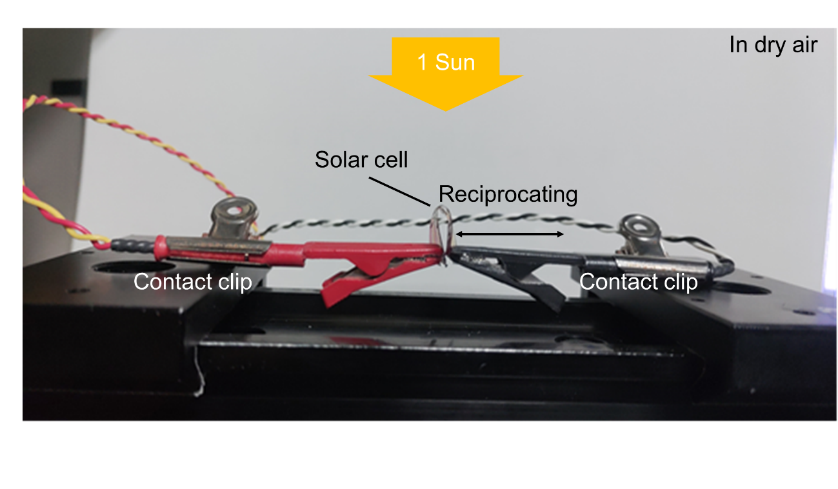

Supplementary Fig. 15 Photo of apparatus used to record the PCE retention as a function of bend cycle number. Measurements were performed in air (30% relative humidity).

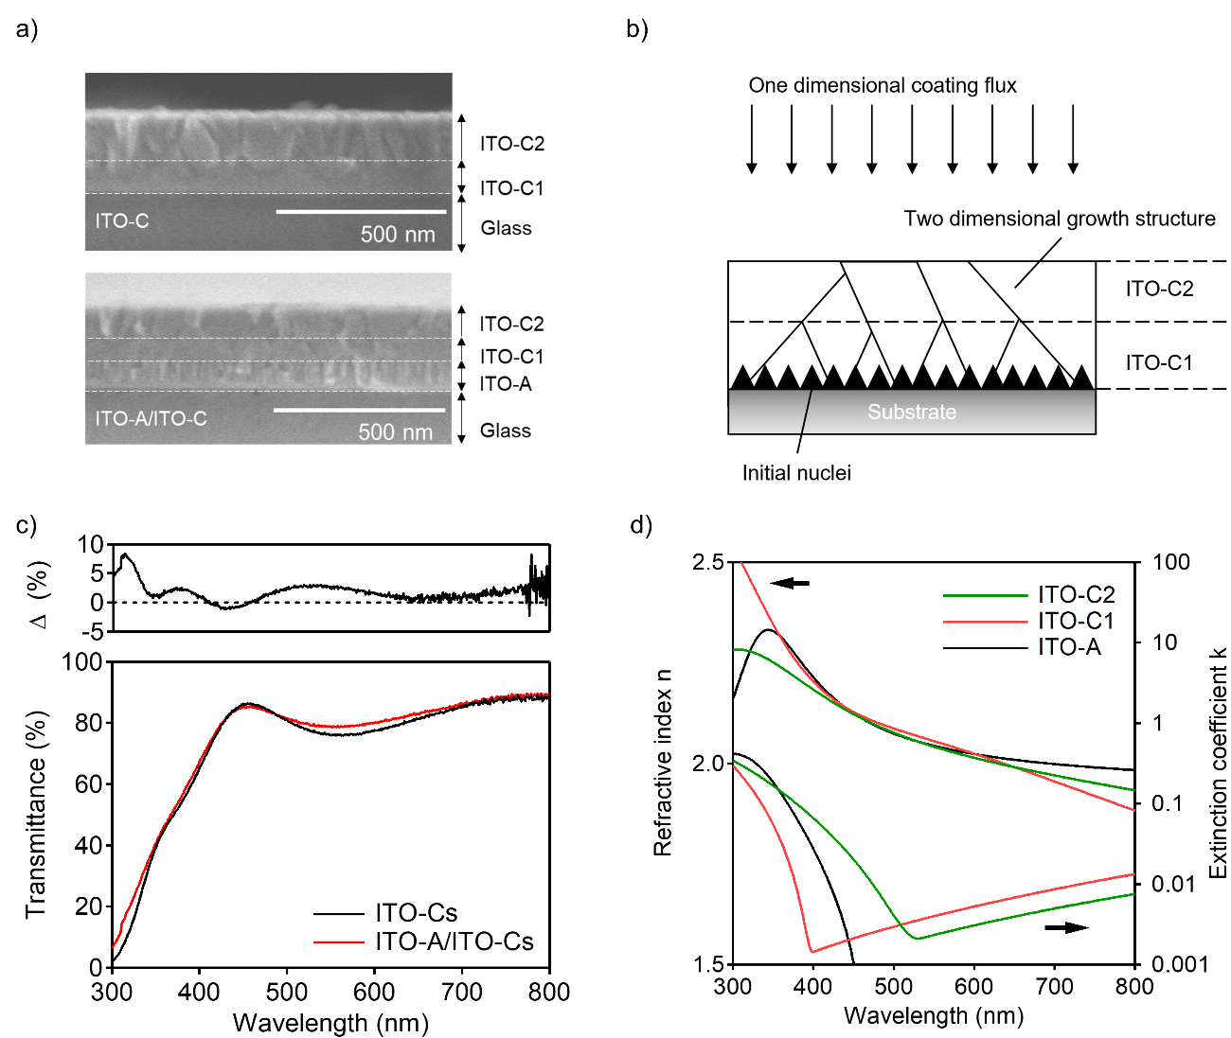

Supplementary Fig. 16 Morphology and optical transmittance of ITO-A and ITO-C. a Cross-sectional SEM images of ITO-C and ITO-A/ITO-C deposited on glass substrates. b Schematic illustration of ITO-C growth showing the two different crystalline regions ITO-C1 and ITO-C2. c Optical transmittance spectra of a 50/150 nm ITO-A/ITO-Cs and 200 nm ITO-Cs layer. The difference spectrum is shown in the top panel. d Spectral dependence of the refractive index and extinction coefficient of ITO-A, ITO-C1, and ITO-C2.

Supplementary references
1 Ozaki, M. et al. Iodine-rich mixed composition perovskites optimised for tin(iv) oxide transport layers: the influence of halide ion ratio, annealing time, and ambient air aging on solar cell performance. J. Mater. Chem. A 7, 16947–16953 (2019).
2 Ozaki, M. et al. A purified, solvent-intercalated precursor complex for wide-process-window fabrication of efficient perovskite solar cells and modules. Angew. Chem. Int. Ed. 58, 9389–9393 (2019).
3 Huang, W. et al. Efficient and mechanically robust ultraflexible organic solar cells based on mixed acceptors. Joule 4, 128–141 (2020).
4 Thornton, J. A. High rate thick film growth. Annu. Rev. Mater. Sci. 7, 239–260 (1977).
5 Jennings, S. G. The mean free path in air. J. Aerosol Sci. 19, 159–166 (1988).
6 Kim, H. et al. Electrical, optical, and structural properties of indium-tin-oxide thin films for organic light-emitting devices. J. Appl. Phys. 86, 6451–6461 (1999).
7 Foroutani, K. et al. Preparation of conductive flexible films by in situ deposition of polythiophene nanoparticles on polyethylene naphthalate. Mater. Sci. Semicond. Process. 18, 6–14 (2014).

