Supporting Information for

Local Electron Density Regulation of Iron Single Atoms by Adjacent Nitrogen Vacancies for Ultra-stable Photo-Fenton-Like Reactions

Fei Chen^{a, 1,} *, Yi-Jiao Sun^{a, 1}, Chao-Wei Yuanª, Chang-Wei Baiª, Ke-An Zhuª, Xin-Jia Chenª, Bin-Bin Zhangª, Qi Yang^{b, c}
ªKey Laboratory of the Three Gorges Reservoir Region's Eco-Environment, Ministry of Education, College of Environment and Ecology, Chongqing University, Chongqing 400045, China
^{b}College of Environmental Science and Engineering, Hunan University, Changsha 410082, China
^{c}Key Laboratory of Environmental Biology and Pollution Control (Hunan University), Ministry of Education, Changsha 410082, China

Corresponding Authors：
*Prof. Fei Chen, E-mail: fchen0505@cqu.edu.cn

This supporting information contains an 85-page document, including 16-page experimental descriptions, 21 tables, 45 figures, references, and this cover page.

Supplementary Materials and Methods

Text S1. Chemicals and reagents
Dicyandiamide (C₂H₄N₄), ferric chloride hexahydrate (FeCl₃•6H₂O), bisphenol A (BPA), rhodamine B (RhB), tetracycline hydrochloride (TC), ciprofloxacin (CIP), p-chlorophenol (DCP), methylene blue (MB), methyl phenyl sulfoxide (PMSO), methyl phenyl sulfone (PMSO₂), 2,2,6,6-tetramethyl-4-piperidinyl (TEMP), nitro-blue tetrazolium (NBT, C₄₀H₃₀N₁₀O₆C₁₂), 5,5-dimethyl-1-pyrroline N-oxide (DMPO), 4-Hydroxy-TEMPO (TEMPOL), tetramethylpiperidine-nitrogen oxide (TEMPO), ascorbic acid (C₆H₈O₆), tert-butyl alcohol (TBA), hydrogen peroxide (H₂O₂, 30 wt%), L-histidine (C₆H₉N₃O₂), ethylenediaminetetraacetic acid disodium salt (EDTA-2Na), 2, 4-Hexadiene (2, 4-HD), ethanol, peracetic acid (PAA), hydrogen peroxide (H₂O₂), peroxymonosulfate (PMS), peroxydisulfate (PDS), sodium carbonate anhydrous (Na₂CO₃), sodium chloride (NaCl), sodium sulfate anhydrous (Na₂SO₄), sodium dihydrogen phosphate anhydrous (NaH₂PO₄), sodium nitrate (NaNO₃), acetonitrile, acetic acid, and formic acid were all purchased from Macklin Chemical Reagent Co., China, Sinopharm Chemical Reagent Co., China, Sigma-Aldrich Chemical Reagent Co., China or Shanghai Chemical Reagent Co., China. All solutions were prepared with Milli-Q water with an 18.25 MΩ/cm resistivity. The NaOH or HClO₄ adjusted the pH of the solution.
Text S2. Characterizations
X-ray powder diffraction patterns of the as-prepared catalysts were recorded with a Bruker D8 advanced X-ray diffractometer (XRD) with Cu Kα X-ray irradiation at 40 kV and 40 mA. A field emission scanning electron microscope (FESEM, Apreo 2C, Thermo Fisher Scientific Co., USA) and transmission electron microscopy (TEM) with an FEI Tecnai G20 (Hitachi Co., Japan) were both used to analyze the surface morphology of different catalysts. The UV-vis diffuse reflectance spectra (UV-vis DRS) of different catalysts were measured by a UV3600-plus spectrometer (Shimadzu Co., Japan) at 200-800 nm. The valence states of the constituent elements were measured by X-ray photoelectron spectroscopy (XPS) using an ESCALAB 250Xi spectrometer (Thermo Fisher Inc., USA). The specified surface areas were obtained using a Brunauer-Emmett-Teller (BET) method with a Builder 4200 instrument (Tristar II 3020M, Micromeritics Co., USA). The surface properties were analyzed on a Fourier transform infrared spectroscopy (FTIR, Nicolet Is10, Thermo Fisher Scientific Co., USA). The measured thickness of the prepared catalysts was achieved by a Smart SPM1000 atomic force microscope (AFM). The ultraviolet-visible diffuse reflectance spectroscopy (UV-vis DRS) was conducted on a UV3600-plus spectrometer in the range of 250-800 nm. An FLS-1000 fluorometer obtained the photoluminescence (PL) and time-resolved PL spectra. The electron spin resonance (ESR) signal spin-trapped by the reagent 5, 5-dimethyl-l-pyrroline N-oxide (DMPO), tetramethylpiperidine-nitrogen oxide (TEMPO), and 2,2,6,6-Tetramethyl-4-piperidone (TEMP) with an ESR spectrometer (ER200-SRC, Bruker Co., USA) was used to reconfirm the generated reactive species during the catalytic reaction. A CHI660E electrochemical workstation equipped with a standard three-electrode system (a saturated Ag/AgCl electrode as the reference electrode, a platinum wire as the counter electrode, and the catalysts-coated FTO glass as the working electrode) was adopted to analyze the photoelectric properties of the prepared catalysts. The total organic carbon (TOC) results were obtained on a TOC-VCPH analyzer (Multi N/C 2100, Analytic Jena AG, Germany). The acute and chronic toxicity predictions of the BPA molecule and its intermediates were examined using the Ecological Structure-Activity Relationships (ECOSAR) system.
Text S3. Analytical methods of BPA
The concentrations of contaminants were detected on an Agilent 1260 Infinity HPLC with a UV detector and a ZORBAX SB C-18 (5 μm, 4.6 × 250 mm) column at 35 ± 1 °C. The mobile phase was a mixture of acetonitrile and 0.2% acetic acid water (60: 40, v/v). The samples were analyzed at a flow rate of 1.0 mL•min⁻¹, and the injection volume was set as 20 μL. The detection wavelength was 273 nm and the analysis time was 3.5 min. The formed products of BPA degradation were analyzed by a liquid chromatography-mass spectrometry (LC-MS) system equipped with a 6460 HPLC (Agilent Inc., USA, with a Kromasil C18 column (4.6×250 mm)) and an API 3000 mass analyzer. Other conditions coincided with BPA concentration measurement.
Text S4. Measurements of other pollutant concentrations
The quantification of the concentrations of other organic contaminants taken from batch experiments was performed by HPLC (Agilent 1260 Infinity, USA). The samples were separated on a ZORBAX SB-C18 (5 μm, 4.6 × 150 mm) column at 35 ± 2 °C and monitored with a UV-visible detector. The formic acid, acetonitrile, and 0.1% aqueous acetic acid were the mobile phases used in this work. The detailed parameters are listed in Table S2.
Text S5. X-ray Absorption fine structure spectra (XAFS) measurement
The extended X-ray absorption fine structure (EXAFS) measurements were carried out on the sample at 21A X-ray nano diffraction beamline of Taiwan Photon Source (TPS), National Synchrotron Radiation Research Center (NSRRC). This beamline adopted a 4-bounce channel-cut Si (111) monochromator for mono-beam X-ray nano diffraction and absorption spectroscopy. The end station is equipped with three ionization chambers and a Lytle/SDD detector after the focusing position of the KB mirror for transmission and fluorescence mode X-ray absorption spectroscopy. The photon flux on the sample ranges from 1×10¹¹~3×10⁹ photon/sec for X-ray energy from 6-27 keV.
Text S6. Density Functional Theory (DFT) calculations
The relative DFT calculations used in this work were performed by applying a generalized gradient approximation with the Perdew-Burke-Ernzerhof (PBE) exchange and correlation functional using the "Vienna ab initio simulation package" (VASP 5.4) ¹⁻³. The solvation program VASPsol treated the solvent as a continuous dielectric and was used to deal with solvent effects. Within the framework of the projector-augmented wave method, a plane wave basis set up with a cutoff energy of 450 eV was performed, while a 3×3×1 Monkhorst-Pack grid was used for the Brillouin zone. The Gaussian smearing width was set to 0.1 eV. All atoms were allowed to relax and converge to 0.01 eV Å⁻¹. The adsorption energy (ΔE_{ads}) can be defined as follows:
E_{ads} = E_{tot} – (E_{s} + E_{m}) (S1)
where E_{tot}, E_{s,} and E_{m} depict the total energies of the adsorption complex, the isolated molecule, and the material, respectively.
The Gibbs free energy (ΔG) for all PAA activation reactions can be defined as follows:
ΔG =ΔE + ΔZPE – TΔS (S2)
where ΔE, ΔZPE, T, and ΔS are the DFT energy of the adsorption complex, zero-point energy difference, reaction temperature, and entropy difference, respectively.
The formation energy of N vacancy (Nv) can be calculated by the following formula:
E_{f} = E_{(Nv)} + E_{(N atom)} – E_{(original-FeCN-bulk-2)} (S3)
where E_{f} is the Nv formation energy; E_{(Nv)} is the energy of one Nv in the FeCN-bulk-2 structure; E_{(original-FeCN-bulk)} is the total energy of the original FeCN-bulk-2; E_{(N atom)} is the energy of one N atom.
Text S7. Computational details for BPA molecules
The theoretical calculations were performed with the Gaussian 16 program suite. The structures of the studied compounds were fully optimized at the B3LYP-D3/6-311+G(d) level of theory. The vibrational frequencies of the optimized structures were also performed at the same level. By verifying that all the vibrational frequencies were real, these structures were characterized as a local energy minimum on the potential energy surface. The Fukui index of the studied molecules was calculated using the Multiwfn software. The Visual Molecular Dynamics (VMD) program was used to plot the color-filled isosurface maps to show the molecular orbitals, the molecular electrostatic potential (ESP), and the Fukui index of the targeted pollutant.
Text S8. Ecological Structure-Activity Relationships (ECOSAR) analysis
The possible products in the treated BPA solutions and the predicted acute and chronic toxicity of BPA and its intermediates of catalytic degradation were evaluated using the Ecological Structure-Activity Relationships (ECOSAR) system.
Text S9. The photoluminescence (PL) spectra of different photocatalysts
The room temperature PL spectroscopy tests of differently prepared samples were also investigated. As shown in Fig. S8, the CN-bulk exhibited the highest PL signal intensity due to the inherent severe charge recombination. In the presence of Nv or Fe sites, the PL intensity decreased significantly, confirming the introduction of nitrogen defect and iron metal sites facilitated the separation of photo-generated charges. Most importantly, FeCN-Nv-2 exhibited the lowest PL intensity (almost invisible), indicating that the synergistic effect of the two sites worked effectively.
Text S10. CV, LSV, and MS measurements
In addition, the density of charge carriers of different materials was determined by CV and LSV measurements. As shown in Fig. S9a. b, the FeCN-Nv-2 exhibited the highest current, indicating the highest yield of photo-generated charge carriers.
The Mott-Schottky curves (Fig. S9c) all show a positive slope, indicating that the prepared samples all belong to an n-type semiconductor. The flat bands of the four different materials are -0.310, -0.236, -0.222, and -0.182 V (concerning Ag/AgCl), respectively. Based on the equations (Eqs. S4-5), the E_{VB} values of +2.27, +2.17, +2.308, and 2.398 eV could be calculated for CN-bulk, CN-Nv, FeCN-bulk-2, and FeCN-Nv-2, respectively, while the corresponding E_{CB} values were -0.510, -0.436, -0.422 and -0.382 eV. Notably, the conduction potential of both Nv and Fe sites was lowest and significantly lower than O₂/•O₂⁻ (-0.33 eV), demonstrating the strong electron reduction ability of FeCN-Nv-2 and enhancing the molecular oxygen activation.
(S4)
(S5)
where E_{CB} and E_{CB} represent the conduction and valence band potential, respectively, E_{FB} is the flat band potential, and E_{g} is the semiconductor's bandgap.
Text S11. Transient photocurrent responses and EIS analyses
As well known, the transient photocurrent responses indicate the charge carrier separation characteristic, and electrochemical impedance spectroscopy (EIS) analysis reflects the charge migration capacity. As shown in Fig. S10a, b, the highest current, and lowest electric resistance were achieved by FeCN-Nv-2, suggesting that more photo-generated charge carriers were generated and efficiently transferred to participate in the subsequent activation of molecular oxygen and oxidant PAA.
Text S12. LC/MS and toxicity assessment
Moreover, LC/MS and toxicity assessment were coupled to determine the intermediates, pathways, and potential hazards of BPA. The findings reveal that BPA was rapidly decomposed into small ones and then mineralized into CO₂ and H₂O (Fig. S23, Table S14). Moreover, the acute and chronic toxicity by Ecological Structure-Activity Relationships (ECOSAR) (Table S15) shows a progressive decrease in product toxicity. Similarly, a comprehensive comparison of this system with those already reported in the literature further highlights the significant advantages of the constructed system (Table S16).
Text S13. Evaluation of the main active species in comparative systems
We also used quenching experiments to compare the reactive species of the other three comparative systems (Figs. 5a, S35a, b, and S36, Table S11). In the CN-bulk+PAA/vis system alone, •OH and h⁺ were the primary active species. While they changed to •O₂⁻, h^{+,} and R-O• in the CN-Nv+PAA/vis and to •O₂⁻, ¹O₂, h^{+,} and R-O• in the FeCN-bulk-2+PAA/vis system. The initial results suggest that the coexistence of Nv and Fe single-atom sites could substantially boost the reductive ability of electrons on CB toward forming related active species with high oxidizability. To clarify the reinforcing effect of Nv, the relevant ESR signals of various reactive species in the FeCN-bulk-2+PAA/vis system were also collected (Fig. S37).
Text S14. Contribution of different active species
Besides, the kinetic evaluation of capture agents further specifies the contribution of different active species. The reaction rate constants after the addition of L-histidine, TEMPOL, and 2, 4-HD are expressed as k₁, k₂, and k₆, respectively. The initial rate constant in the absence of a quencher is k₀. The detailed calculations follow Eqs. S6-8.
(S6)
(S7)

(S8)
where λ(¹O₂), λ(•O₂⁻), and λ(R-O•) were the contributions of ¹O₂, •O₂⁻, and R-O• to the removal of BPA, respectively.
Dosing L-histidine, TEMPOL, and 2, 4-HD alone in the FeCN-Nv-2+PAA/vis system resulted in a distinct decline in the reaction rate constants of k₁ (1.16E⁻² min⁻¹), k₂ (2.89E⁻³ min⁻¹) and k₃ (2.85E⁻² min⁻¹), respectively. Based on the Eqs. S6-8, the values of λ(¹O₂), λ(•O₂⁻), and λ(R-O•) could be calculated as 84.0%, 96.0%, and 58.4%, respectively. The three values were then summed and normalized to yield the corrected contributions of 35.2%, 40.3%, and 24.5%, consistent with the order in the experimental design. The above results also further affirm that Nv and Fe dual sites substantially enhanced the molecular oxygen activation and oxidant utilization.
Text S15. Evaluation of the stability of FeCN-Nv-2 after catalytic reaction
Moreover, the relevant analyses after the reaction were also described thoroughly in the Supporting Information (Fig. S42-44). All the above shows that Fe SAC regulated by the vicinity of Nv can be effectively and stably applied for PAA photo-activation. An electron-induced pathway can be maximally opened to promote decontamination.
To verify the stable performance of the FeCN-Nv-2, the constructed Fenton-like system was first subjected to four cycles of experiments. Delightfully, the BPA removal did not significantly diminish. Moreover, the precipitated Fe content was also tested at a concentration of only 0.458 mg/L, occupying a tiny percentage of Fe source in the raw material. These findings indicate that the FeCN-Nv-2 can be recycled.
We also characterized the material after the reaction, and the SEM pattern results (Fig. S42) show no visible changes in the material structure, proving that FeCN-Nv-2 was morphologically preserved.
To further confirm the above point, FeCN-Nv-2 was collected and qualitatively characterized by XRD, XPS, and FTIR after the reaction (Fig. S43). No visible changes were observed compared to the material before the reaction, demonstrating the structural stability of the synthesized single-atom catalysts for long-term use.
Then, the XPS patterns were resolved separately before and after the different reactions (Fig. S44). After the comparisons, no significant changes were observed in the different profiles, supporting that the materials were stable. It is worth mentioning that the ratio of different types of nitrogen differed but did not affect the activity. Such a variation will be analyzed in-depth in the subsequent related studies.
Text S16. The Fe³⁺ leakage during the recycling experiment
After the cycling experiment, the amount of iron precipitated was detected by ICP-MS at a concentration of 0.458 mg/L, occupying only less than 0.6% of the original catalyst, proving that FeCN-Nv-2 single-atom catalyst could be utilized reproducibly. To further verify the advantages of the FeCN-Nv-2+PAA/vis system, an equivalent amount of precipitated Fe was used to activate PAA (Fig. S45). The results show that the BPA removal in the homogeneous Fe³⁺-activated PAA system was only 2.2%, which could be negligible. The above further confirms the significant merits of single-atom photo-activators (FeCN-Nv-2) design.
Supplementary Table 1 | The relative energy at different positions of Fe and Nv sites
Location of Nv | Nv formation energy (eV) | Relative energy (eV)
Ⅰ | 9.83 | 3.22
Ⅱ | 6.61 | 0
Ⅲ | 8.51 | 1.90
Ⅳ | 7.20 | 0.59
Ⅴ | 6.88 | 0.27
Ⅵ | 7.99 | 1.38

Supplementary Table 2 | Detection conditions for different targets
Compounds | Acetonitrile | Acetic acid | Formic  acid | Flow rate  (mL/min) | Wavelength (nm)
BPA | 60.0% | 40.0% | / | 1.00 | 273
PMSO | 20.0% | / | 80.0% | 1.00 | 215
PMSO₂ | 20.0% | / | 80.0% | 1.00 | 215
CIP | 75.0% | 25.0% | / | 1.00 | 274
TC | 20.0% | 80.0% | / | 1.00 | 355
DCP | 70.0% | 30.0% | / | 1.00 | 280
RhB | / | / | / | / | 554
MB | / | / | / | / | 665

Supplementary Table 3 | The BET surface area, average pore diameter, and pore volume of the as-prepared catalysts
Catalysts | BET surface area (m²/g) | Average Pore diameter (nm) | Pore Volume (cm³/g)
CN-bulk | 9.94 | 19.98 | 0.07
CN-Nv | 25.91 | 18.15 | 0.15
FeCN-bulk-2 | 12.92 | 19.89 | 0.08
FeCN-Nv-2 | 46.33 | 20.69 | 0.27

Supplementary Table 4 | The position attribution of different characteristic peaks in the C 1s and O 1s spectra
Sample | C-O/C-N | C-C | C-O
FeCN-bulk-2 | 288.3 | 285.0 | 532.3
FeCN-Nv-2 | 288.2 | 284.9 | 532.5
CN-bulk | 288.3 | 285.0 | 532.3
CN-Nv | 288.3 | 285.0 | 532.2

Supplementary Table 5 | The position attribution of different characteristic peaks in the N 1s spectra
Sample | Oxidized N | Graphite N | Pyrrole N | Pyridine N
FeCN-bulk-2 | 404.8 | 401.3 | 399.7 | 398.7
FeCN-Nv-2 | 404.8 | 401.3 | 399.8 | 398.6
CN-bulk | 404.9 | 401.3 | 399.8 | 398.7
CN-Nv | 404.7 | 401.3 | 399.8 | 398.8

Supplementary Table 6 | Comparison of the relative content of various types of N in different catalysts
N% | CN-Nv | CN-bulk | Fe-CN-Nv-2 | Fe-CN-bulk-2
Oxidized N | 7.0 | 9.2 | 9.0 | 8.8
Graphite N | 10.5 | 8.1 | 4.8 | 6.7
Pyrrole N | 27.0 | 29.5 | 37.4 | 33.6
Pyridine N | 55.5 | 53.2 | 48.8 | 50.9

Supplementary Table 7 | Comparison of the relative content of various elements in different catalysts
Atomic % | CN-Nv | CN-bulk | Fe-CN-Nv-2 | Fe-CN-bulk-2
C 1s | 43.1 | 43.2 | 39.6 | 43.1
N 1s | 53.9 | 54.0 | 51.9 | 54.2
O 1s | 2.8 | 2.6 | 7.8 | 2.2
Fe 2p | 0.2 | 0.2 | 0.7 | 0.5

Supplementary Table 8 | Comparison of Fe 2p XPS spectra between FeCN-bulk-2 and FeCN-Nv-2
Fe 2p | Items | FeCN-Nv-2 | FeCN-bulk-2
Fe 2p_{3/2} | Position (eV) | 725.5 | 725.9
Fe 2p_{3/2} | Area (%) | 62.8 | 64.2
Fe 2p_{1/2} | Position | 711.0 | 711.2
Fe 2p_{1/2} | Area (%) | 37.2 | 35.8

Supplementary Table 9 | The possible iron coordination forms by taking different standard samples as a comparison
R(Å) | Fe-Fe | Fe-N | Fe-O
Fe-foil | 2.21/4.51 | / | /
FeO | 2.64 | / | 1.66
Fe₂O₃ | / | / | 1.44
FePc | / | 1.50 | /
FeCN-Nv-2 | / | 1.50 | /

Supplementary Table 10 | EXAFS fitting parameters at the Fe K-edge for various samples (Ѕ₀²=0.792)
Sample | Shell | CNª | R(Å)^{b} | σ²(Å²)^{c} | ΔE₀(eV)^{d} | R factor
Fe foil | Fe-Fe | 8.0 | 2.46 | 0.0045 | 5.0 | 0.0017
Fe foil | Fe-Fe | 6.0 | 2.85 | 0.0045 | 5.0 | 0.0017
FeCN-Nv | Fe-N | 4.2 | 2.04 | 0.0104 | 2.2 | 0.0005
ªCN: coordination numbers; ^{b}R: bond distance; ^{c}σ²: Debye-Waller factors; ^{d}ΔE₀: the inner potential correction. R factor: goodness of fit. Ѕ₀² was set to 0.792, according to the experimental EXAFS fit of Fe foil by fixing CN as the known crystallographic value.
Supplementary Table 11 | The BPA removal in various catalytic systems
Catalytic systems | Removal efficiency |  |  | k_{app} (min⁻¹)
CN-bulk | 7.1% |  |  | 2.64E-3
CN-Nv | 16.8% |  |  | 7.33E-3
FeCN-bulk-1 | 9.7% |  |  | 4.43E-3
FeCN-Nv-1 | 58.0% |  |  | 3.2E-2
FeCN-bulk-2 | 62.9% |  |  | 3.64E-2
FeCN-Nv-2 | 100.0% |  |  | 7.24E-2
FeCN-bulk-3 | 64.5% |  |  | 3.74E-2
FeCN-Nv-3 | 75.8% |  |  | 5.08E-2
Different quenchers | CN-bulk | CN-Nv | Fe-CN-bulk-2 |  | Fe-CN-Nv-2
Control | 7.1% | 16.8% | 62.9% |  | 100.0%
TBA | 4.1% | 15.6% | 52.2% |  | 80.1% (×)
TEMPOL | 8.7% | 8.5% | 4.1% |  | 11.7% (√)
EDTA-2Na | 4.2% | 7.8% | 34.6% |  | 65.2% (×)
L-histidine | 8.1% | 12.6% | 27.6% |  | 29.3% (√)
2, 4 HD | 9.6% | 2.5% | 29.9% |  | 56.5% (√)
PMSO | - | - | 43.1% |  | 77.4% (×)

Supplementary Table 12 | Effect of PAA concentrations on BPA removal using FeCN-Nv-2 catalyst
PAA concentration (mM) |  | Removal efficiency (%) | k_{app} (min⁻¹)
2 | 100.0 |  | 7.91E-2
1 | 100.0 |  | 7.24E-2
0.1 | 46.3 |  | 2.19E-2
0.01 | 18.4 |  | 7.48E-3

Supplementary Table 13 | The removal efficiency of FeCN-Nv-2 at different initial pH
System | Removal efficiency (%) | k_{app} (min⁻¹)
9.05 | 77.2 | 5.3E-2
7.00 | 80.0 | 5.5E-2
6.35 | 100.0 | 7.24E-2
3.08 | 80.2 | 4.8E-2

Supplementary Table 14 | The degradation products of BPA in the Fe-CN-Nv-2 system
Products | m/z | Structural formula
BPA | 227
BP-1 | 245
BP-2 | 151
BP-3 | 135
BP-4 | 93

Supplementary Table 15 | Using the Ecological Structure-Activity Relationships system, the predicted acute and chronic toxicityª of BPA and its degradation products were obtained
 | Possible products | Acute toxicity (mg·L⁻¹) |  |  | Chronic toxicity (mg·L⁻¹): ChV
 | Possible products | fish (LC₅₀) | daphnid (LC₅₀) | green algae (EC₅₀) | fish | daphnid |  | green algae
BPA |  | 2.65 | 5.24 | 1.33 | 0.550 |  | 1.77 | 0.227
BP-1 |  | 19.3 | 169 | 6.40 | 11.1 |  | 64.2 | 0.822
BP-2 |  | 48.3 | 16.4 | 59.8 | 4.53 |  | 1.64 | 7.79
BP-3 |  | 66.5 | 20.0 | 81.6 | 6.07 |  | 1.90 | 9.95
BP-4 |  | 27.7 | 9.64 | 34.4 | 2.61 |  | 0.969 | 4.53
ª Toxicity was classified based on the Globally Harmonized System of Classifica1tion and Labeling of Chemicals. Very toxic (Red): LC₅₀/EC₅₀/ChV ≤ 1 mg·L⁻¹, Toxic (Pink): 1 mg·L⁻¹<LC₅₀/EC₅₀/ChV≤10 mg·L⁻¹, Harmful (Yellow): 10 mg·L⁻¹ < LC₅₀/EC₅₀/ChV ≤ 100 mg·L⁻¹, Not harmful (Green): LC₅₀/EC₅₀/ChV > 100 mg·L⁻¹.
Supplementary Table 16 | Comparison between FeCN-Nv-2 and the previously reported catalysts in BPA removal
Material |  |  |  | Experimental Conditions |  |  | Time(>95%) | Ref.
Material | BPA  (mg/L) |  | Oxidant  (mM) |  | Solution pH | Catalyst  (g/L)
rGO-P25 | 2.3 |  | / |  | 8.0 | 0.5 | 60 min (UV) | ^{[4]}
O-g-C₃N₄ | 11.4 |  | 10 (PMS) |  | 6.4 | 1.0 | 60 min (dark) | ^{[5]}
g-C₃N₄/BiOCl_{x}I_{1-x} |  | 10 | / |  | 7.5 | 0.6 | 30 min (dark) | ^{[6]}
Cr-g-C₃N_{4SAC} | 10 |  | 163 (H₂O₂) |  | 3.0 | 0.2 | 70 min (vis) | ^{[7]}
N-TiO₂ | 5 |  | / |  | 6.0 | 0.5 | 4 h (UV) | ^{[8]}
Cu_{SAC} | 2.3 |  | 10 (H₂O₂) |  | 6.2 | 0.5 | 3 h (dark) | ^{[9]}
GO@BiOI/BW | 10 |  | / |  | 9.0 | 0.5 | 5 h (vis) | ^{[10]}
GO-Fe | 4.6 |  | 0.5 (PMS) |  | 3.0 | 0.2 | 60 min (vis) | ^{[11]}
FeCN-Nv-2 | 5 |  | 1 (PAA) |  | 7.3 | 0.2 | 30 min (vis) | here

Supplementary Table 17 | Comparison of H₂O₂ and PAA activation using FeCN-Nv-2 catalyst
System | Removal efficiency (%) | k_{app} (min⁻¹)
H₂O₂ | 6.9 | 2.26E-3
PAA | 100.0 | 7.24E-2
PMS | 100.0 | 2.87E-1
PDS | 3.3 | 1.51E-3

Supplementary Table 18 | BPA removal in the FeCN-Nv-2+PAA/dark systems in the presence of different quenchers
Different quenchers | CN-bulk | CN-Nv | Fe-CN-bulk-2 | Fe-CN-Nv-2
Control | 2.2% | 2.2% | 31.7% |  | 66.7%
TBA | 3.4% | 3.4% | 31.1% |  | 61.3%
TEMPOL | 6.8% | 6.8% | 9.5% |  | 12.0%
EDTA-2Na | 3.3% | 1.5% | 11.0% |  | 21.1%
L-histidine | 4.0% | 7.1% | 13.2% |  | 17.3%
2, 4 HD | 5.7% | 3.2% | 25.5% |  | 35.6%
PMSO | - | - | 37.4% |  | 53.1%

Supplementary Table 19 | Comparison of the different bond lengths between CN-bulk, CN-Nv, and FeCN-Nv-2
 | Bond length (Å) | CN-bulk | CN-Nv | FeCN-Nv-2
PAA | O-O | 1.47 | 1.50 | 2.47
O₂ | O-O | 1.23 | 1.25 | 1.33
BPA | C-O | 3.07 | 3.24 | 4.09

Supplementary Table 20 | Comparison of adsorption energies between catalysts and molecules
E_{ads} (eV) | PAA | BPA | O₂
CN-bulk | 0.31 | -0.30 | -0.07
CN-Nv | 0.26 | -0.30 | -0.14
FeCN-Nv-2 | -2.88 | -0.57 | -1.35

Supplementary Table 21 | Charge distributions and Fukui index of BPA.
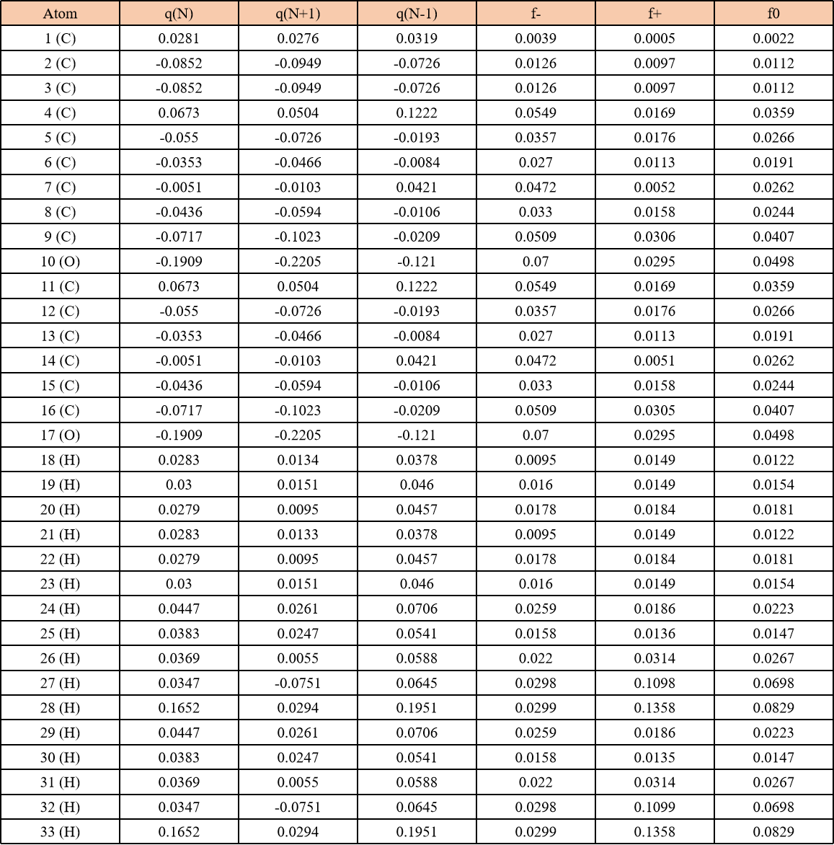

Supplementary Figure 1 | The relative energy at different positions of the Nv site to Fe site in FeCN-Nv-2.

Supplementary Figure 2 | AFM images of FeCN-Nv-2.

Supplementary Figure 3 | (a) The N₂ adsorption-desorption isotherms of different prepared catalysts; (b) the corresponding pore size distribution of CN-bulk, CN-Nv, FeCN-bulk-2, and FeCN-Nv-2, respectively.

Supplementary Figure 4 | Solid ESR spectra of CN-bulk and CN-Nv for determining the formation of nitrogen vacancies.

Supplementary Figure 5 | TEM-based elemental mapping of Fe: (a-b) FeCN-Nv-2 and (c-d) FeCN-bulk-2.

Supplementary Figure 6 | TEM-based elemental mappings of C, N, and O: (a-d) FeCN-Nv-2 and (e-h) FeCN-bulk-2.

Supplementary Figure 7 | Enhanced light-harvesting and photoelectric properties. a, b, c, d, e, f, UV-vis diffuse reflectance spectra (a), corresponding plots of transformed Kubelka-Munk function versus photon energy (an inset), energy band structure of different catalysts (b), and represent the fluorescence lifetime of CN-bulk (c), CN-Nv (d), FeCN-bulk-2 (e), and FeCN-Nv-2 (f), respectively. g, Enhanced electron density of Fe SAC by neighboring Nv and a possible photocatalytic mechanism for visible light-assisted PAA activation using FeCN-Nv-2.

Supplementary Figure 8 | The PL intensities of CN-bulk, CN-Nv, FeCN-bulk-2, and FeCN-Nv-2.

Supplementary Figure 9 | Free energy evolution of CN-bulk, CN-Nv, FeCN-bulk-2, and FeCN-Nv-2 in (a) CV (b) LSV, and (c) Mott-Schottky plots.

Supplementary Figure 10 | (a) Comparison of transient photocurrent responses under visible light irradiation, and (b) The electrochemical impedance spectroscopy (EIS) spectra of CN-bulk, CN-Nv, FeCN-bulk-2, and FeCN-Nv-2, respectively.
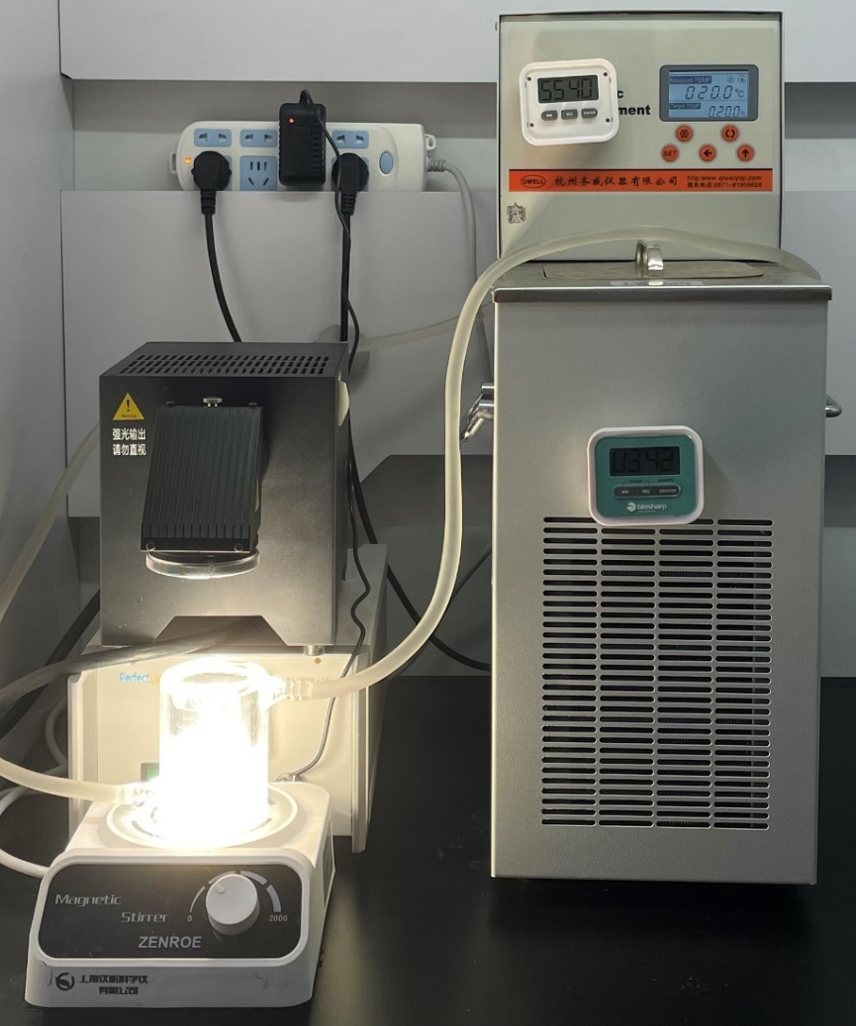

Supplementary Figure 11 | Diagram of the experimental device.
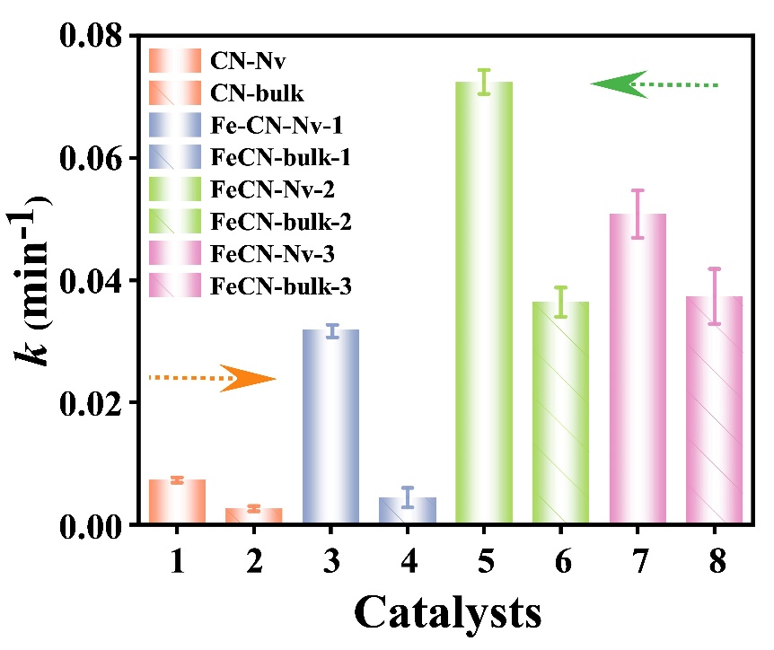

Supplementary Figure 12 | The reaction rate constants in different reaction systems.

Supplementary Figure 13 | Correlation of chemical reaction kinetic parameters of different reaction systems with their reaction time.

Supplementary Figure 14 | Degradation of BPA in different catalytic systems.

Supplementary Figure 15 | (a) Degradation of BPA under visible light irradiation in the presence of different oxidant concentrations using FeCN-Nv-2 as a PAA photo-activator and (b) the corresponding reaction rate constants.

Supplementary Figure 16 | Effect of different initial pH values on BPA removal in the constructed Fe-CN-Nv-2+PAA/vis system.
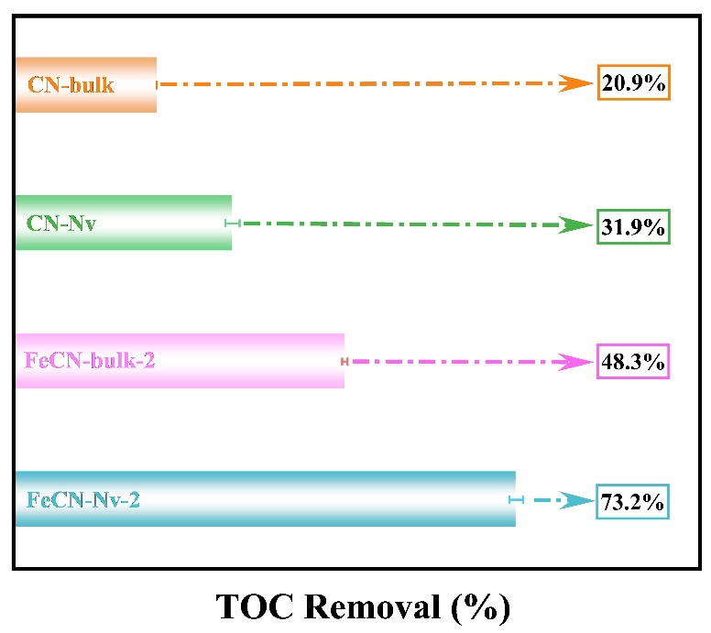

Supplementary Figure 17 | TOC removal in different reaction systems.

Supplementary Figure 18 | BPA removal efficiency of the FeCN-Nv-2+PAA/vis system in the presence of different coexisted ions. (Condition: [Ion]₀=5 mM, [Catal.]₀=0.2 g/L, [PAA]₀=1 mM, [pH]₀=6.35, [BPA]₀=0.022 mM, [Temp.]=20±2 °C).

Notably, inorganic salt ions are ubiquitous in natural water bodies. Therefore, in order to investigate the tolerance and application potential of the FeCN-Nv+PAA/vis system, different anions were selected for injection. As shown in Fig. S17, adding anions showed no significant effect except CO₃²⁻. The results indicate that such a photo-Fenton system had good resistance to ionic interference. As for the declined BPA removal with CO₃²⁻, it could be possibly due to its trapping effect of ROS, and this result also agreed with the previous report.

Supplementary Figure 19 | Differences in BPA removal efficiency between FeCN-Nv-2+PAA/vis system and FeCN-bulk-2+PAA/vis in the presence of (a) CO₃²⁻ and (b) PO₄³⁻.
In particular, the constructed FeCN-Nv-2+PAA/vis system was also resistant to PO₄³⁻. In contrast, the conventional Fe-based AOP systems are generally limited by the strong coordination of PO₄³⁻ with Fe sites, resulting in a significant decrease in catalytic activity. The above results indicate that the finely designed Fe SAC in this work exhibited better purification performance for organic wastewater containing PO₄³⁻, further confirming the potential of such a novel photo-Fenton-like technology.

Supplementary Figure 20 | BPA removal efficiency of the FeCN-Nv-2+PAA/vis system using different water sources.

In addition, the constructed FeCN-Nv-2+PAA/vis system exhibited satisfactory removals for different water sources, demonstrating the practicality of such an AOP technology.

Supplementary Figure 21 | Utilization efficiency of PAA in the FeCN-Nv-2+PAA system.

The utilization efficiency of PAA could reach 56.4%, significantly higher than the traditionally reported system, indicating that the FeCN-Nv-2 catalyst could efficiently utilize PAA.

Supplementary Figure 22 | The zeta potentials of CN-bulk, CN-Nv, FeCN-bulk-2, and FeCN-Nv-2 in an aqueous solution.

The catalysts had similar zeta potentials and therefore had similar uptake of BPA.
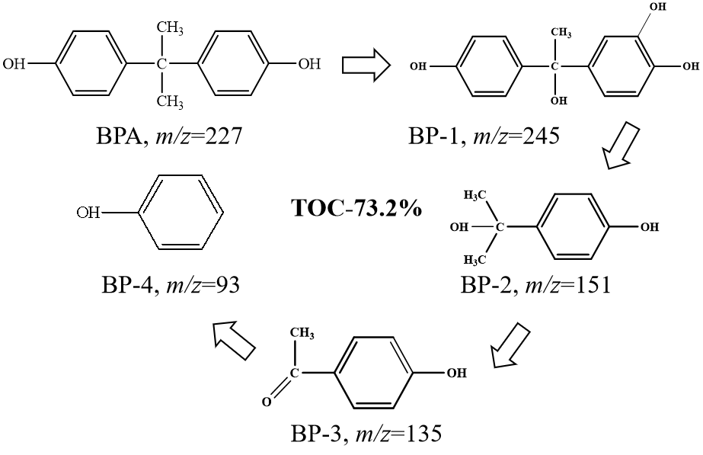

Supplementary Figure 23 | The proposed BPA removal pathways in the Fe-CN-Nv-2 system.

Supplementary Figure 24 | (a) Degradation of BPA in the presence of different oxidants under visible light irradiation using FeCN-Nv-2 as the activators and (b) the corresponding reaction rate constants.

Supplementary Figure 25 | (a) Degradation of BPA in the FeCN-Nv-2+PMS/vis system with different oxidant concentrations and (b) the corresponding reaction rate constants.

The activity of the reaction system increased significantly with the increase in PMS dosage, indicating that PMS concentration was the key constraint of this system.

Supplementary Figure 26 | The utilization efficiency of PMS in the constructed FeCN-Nv-2+PMS/vis system.

In the constructed FeCN-Nv-2+PMS/vis system, the oxidant utilization was only 31.6%, and the subsequent further improvement of oxidant utilization could be one of the critical points for the performance breakthrough in this field.

Supplementary Figure 27 | Removal of various organic pollutants in the FeCN-Nv-2+PAA/vis system.

Supplementary Figure 28 | The conversion of PMSO to PMSO₂ in the FeCN-Nv-2+PAA/vis system.

C₉H₁₈N⁺

Supplementary Figure 29 | Identification of TEMPO.
C₁₁H₂₂NO₃⁺

Supplementary Figure 30 | Identification of CH₃COO-TEMPO.

Supplementary Figure 31 | Identification of CH₃-TEMPO.

TEMPO | + | CH₃• |  | CH₃-TEMPO |  | (S9)

Supplementary Figure 32 | (a, b) represents the ESR signals of the photo-induced holes in different catalytic systems.

Supplementary Figure 33 | UV spectra of NBT transformation using FeCN-Nv-2 for determining •O₂⁻ and NBT removal efficiency using different catalytic systems.

Compared with other comparative systems, the FeCN-Nv-2+PAA system showed a maximum NBT conversion, confirming that the highest number of •O₂⁻ could be achieved in this system and further facilitated the decontamination of pollutants.

Supplementary Figure 34 | The solid ESR spectra of FeCN-Nv-2 and FeCN-bulk-2 for determining the formation of nitrogen vacancies.

Supplementary Figure 35 | Degradation of BPA in the presence of various scavengers in (a) FeCN-bulk-2+PAA/vis and (b) FeCN-Nv-2+PAA/vis systems, respectively.

Supplementary Figure 36 | Degradation of BPA in the presence of various scavengers in (a) CN-bulk+PAA/vis, and (b) CN-Nv+PAA/vis systems and the corresponding degradation efficiency in (c) CN-bulk+PAA/vis and (d) CN-Nv+PAA/vis, respectively.

Supplementary Figure 37 | DMPO spin-trapping ESR spectra for (a) DMPO-•OH and (b) DMPO-•O₂⁻; (c) TEMP-based ESR spectra for ¹O₂; (d) TEMPO-based ESR spectra of holes in the FeCN-bulk-2+PAA/vis system.
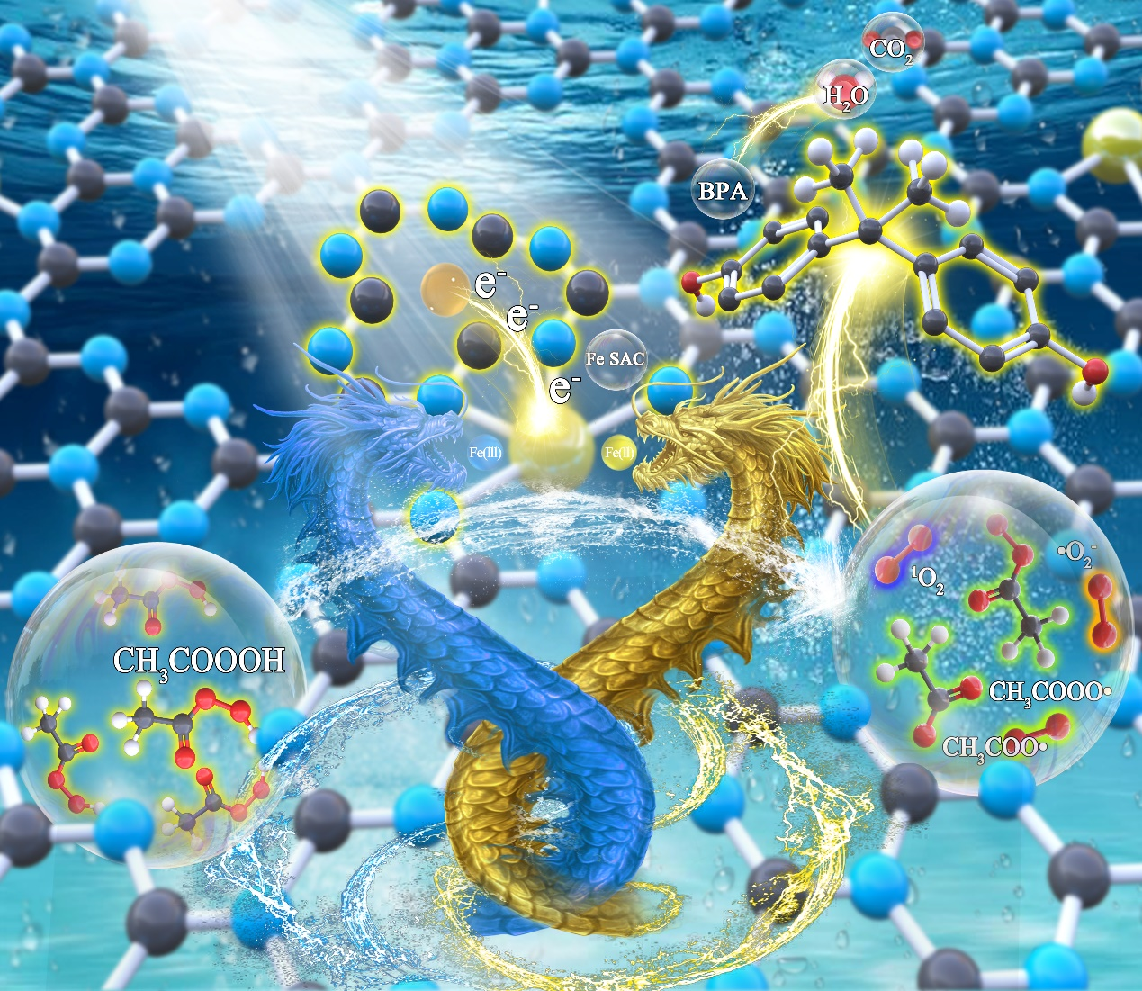

Supplementary Figure 38 | Enhanced electron density of Fe SAC by neighboring Nv and a possible photocatalytic mechanism for visible light-assisted PAA activation using FeCN-Nv-2.

Supplementary Figure 39 | Degradation of BPA in the presence of various scavengers in (a) CN-bulk+PAA/dark, (b) CN-Nv+PAA/dark systems, (c) FeCN-bulk-2+PAA/dark and (d) FeCN-Nv-2+PAA/dark systems, respectively.

In contrast to dark systems, the intervention of visible light could generate organic radicals, favoring organic pollutants' decontamination. Thus, in the future, if organic radicals production can be enhanced with high selectivity, it may possess great potential for rapid decontamination of contaminants.

Supplementary Figure 40 | The conversion of PMSO to PMSO₂ in the FeCN-Nv-2+PAA/dark system.

Supplementary Figure 41 | Charge density difference of BPA absorption by different catalysts in (a) CN-bulk, (b) CN-Nv, and (c) FeCN-Nv-2, respectively.

DFT results confirm that the presence of simultaneous Nv and Fe sites could significantly improve the intrinsic properties of g-C₃N₄, e.g., light absorption and charge transfer kinetics, and also substantially strengthen the adsorption of BPA, PAA, and O₂, further enhancing the activation of O₂ and PAA to speed up the degradation. Moreover, the neighboring Nv could serve as an electron storage and transport center and continuously transport electrons to Fe sites under visible light to promote their reduction ability and Fe³⁺/Fe²⁺ cycling, further hastening PAA activation to produce highly-oxidative species.
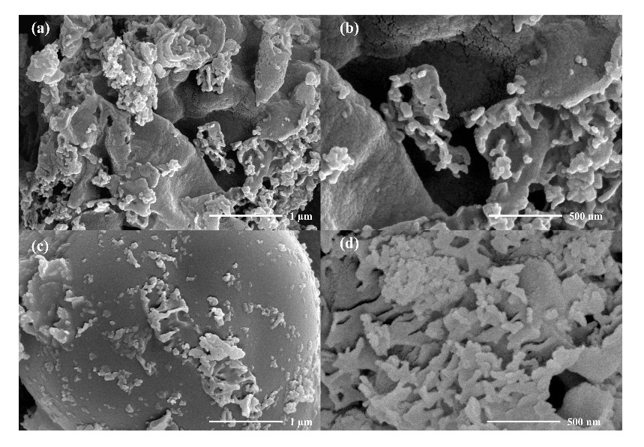

Supplementary Figure 42 | SEM images of FeCN-Nv-2 before (a-b) and after (c-d) the reaction.

Supplementary Figure 43 | Comparative characterization of FeCN-Nv-2 before and after the catalytic reaction: (a) XRD, (b) survey XPS, and (c) FTIR.

Supplementary Figure 44 | Comparison of XPS spectra: (a) C 1s, (b) N 1s, (c) O 1s, and (d) Fe 2p of FeCN-Nv 2 before and after the reaction.

Supplementary Figure 45 | Differences in BPA removal between homogeneous Fe³⁺-activated PAA and heterogeneous FeCN-Nv-2+PAA systems.
References:

[1] Kresse, G.; Furthmüller, J., Phys. Rev. B 54 (16) (1196) 11169-11186.
[2] Kresse, G.; Furthmüller, J., Comput. Mater. Sci. 6 (1) (1996) 15-50.
[3] Perdew, J. P.; Burke, K.; Ernzerhof, M., Phys. Rev. Lett. 77 (18) (1996) 3865.
[4] F. Yu, X. Bai, C. Yang, L. Xu, J. Ma, Catalysts, 9(7) (2019) 607.
[5] Y. Gao, Y. Zhu, L. Lyu, Q. Zeng, C. Hu, Environ. Sci. Technol. 52(24) (2018) 14371-14380.
[6] X. Hu, Y. Zhang, B. Wang, H. Li, W. Dong, Appl. Catal. B: Environ. 256 (2019) 117789.
[7] F. Chen, X. L. Wu, C. Shi, H. Lin, J. Chen, Y. Shi, X. Duan, Adv. Func. Mater. 31(13) (2021) 2007877.
[8] D. P. Subagio, M. Srinivasan, M. Lim, T. T. Lim, Appl. Catal. B: Environ. 3 (2010) 414-422.
[9] W. Ma, M. Sun, D. H. Huang, C. H. Chu, T. Hedeke, X. X. Wang, J. H. Kim, M. Elimelech, Environ. Sci. Technol. 56(12) (2022) 8733-8745.
[10] M. T. Zhu, A. K. Tonni, Y. P. You, A. Ram, H. D. O. Mohd, Mater. Sci. Eng. 108 (2020) 110420.
[11] F. Cheng, P. Zhou, X.W. Huo, Y. Liu, Y. X. Liu, Y. L. Zhang, J. Colloid. Interf. Sci. 15 (2020) 540-549.

