Supporting Information
ROS-Responsive Sequential Release Systems with Excellent Biofilm Permeability for Enhanced Antibacterial and Regeneration-promoting Therapy in Periodontitis

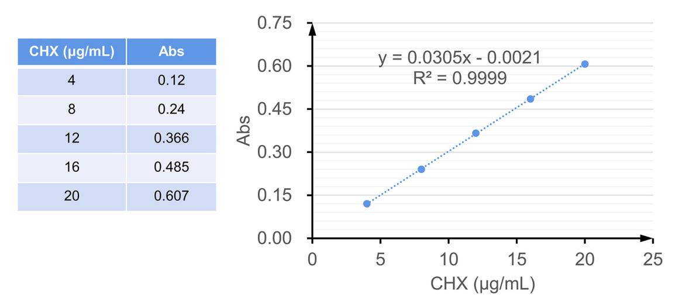
Fig.S1 Standard curve of CHX.

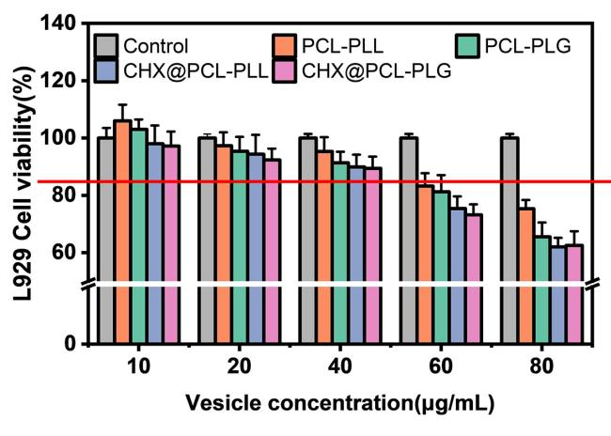
Fig.S2 Cytotoxicity assay.

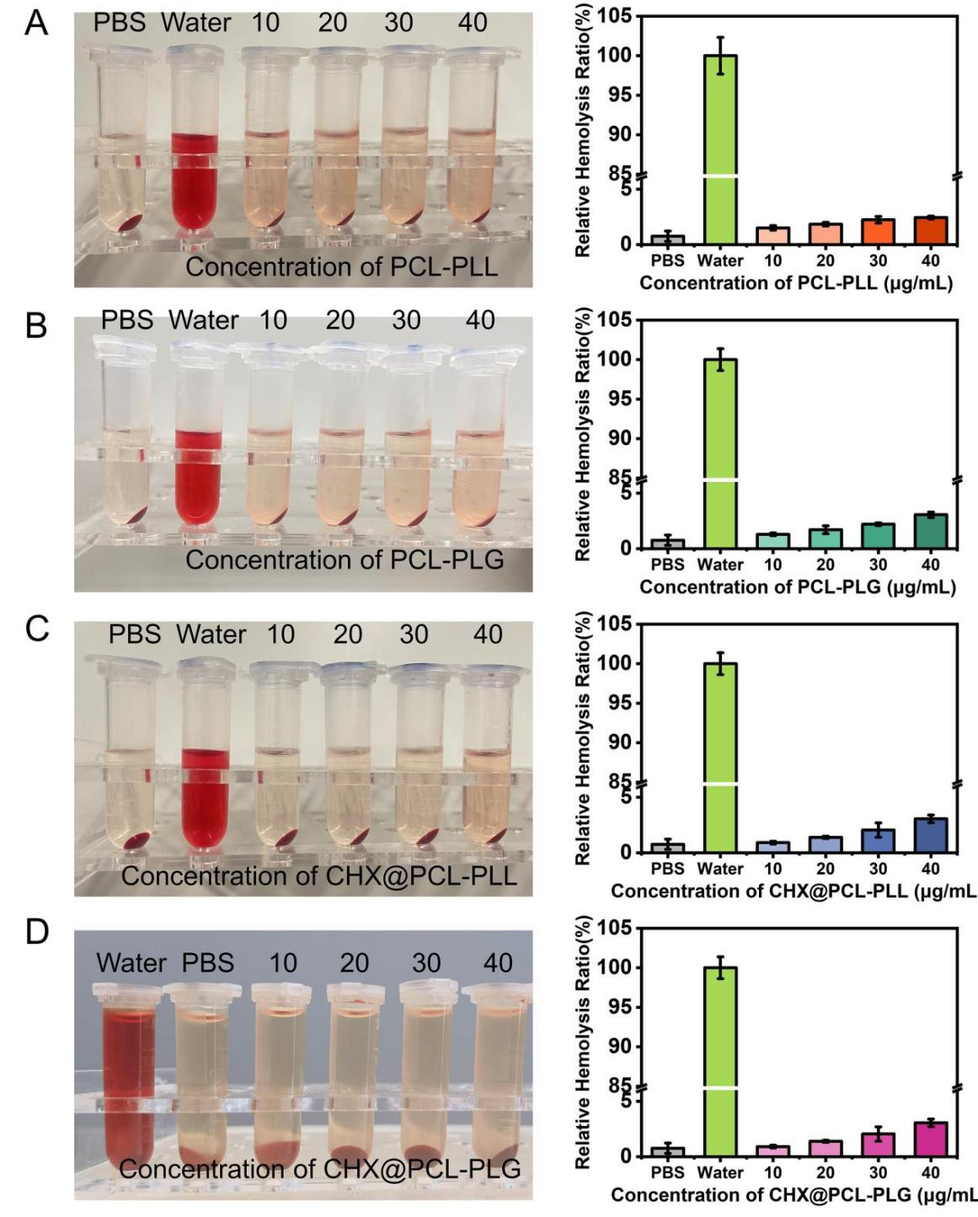
Fig.S3 A-D) Hemolysis assay of vesicles at different concentrations.

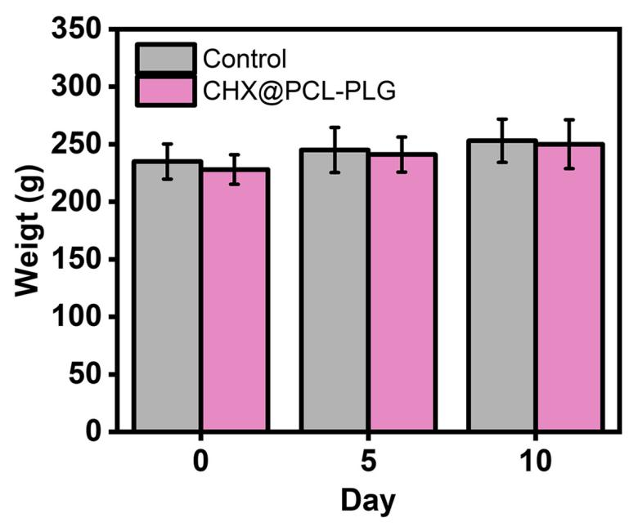
Fig.S4 Body weight of rats.

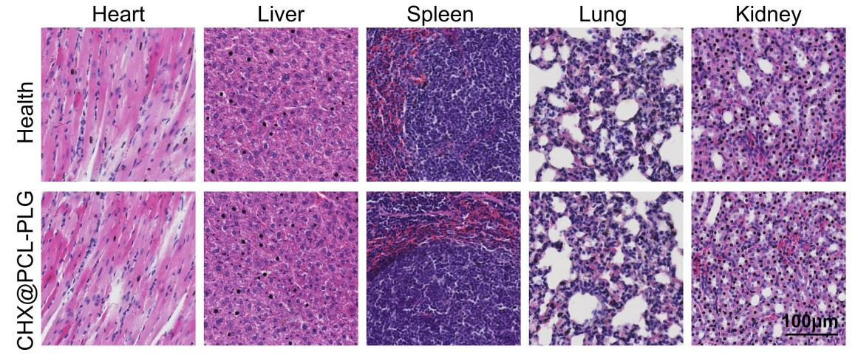
Fig.S5 H&E staining images of heart, liver, spleen, lung and kidney sections from rats.

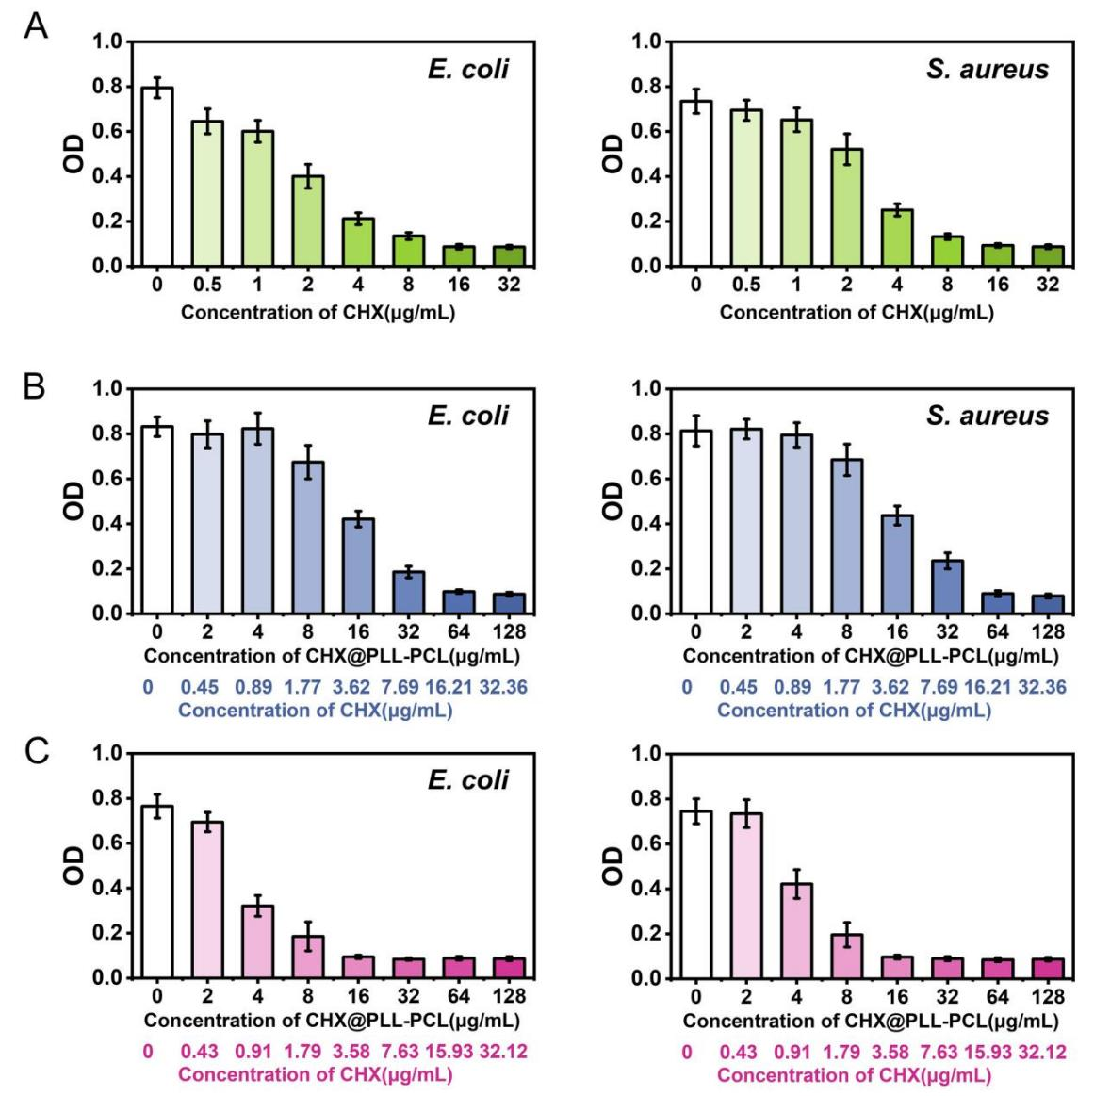
Fig.S6 A-C) Bacterial MIC experiments for CHX, CHX@PCL-PLL and CHX@PCL-PLG.

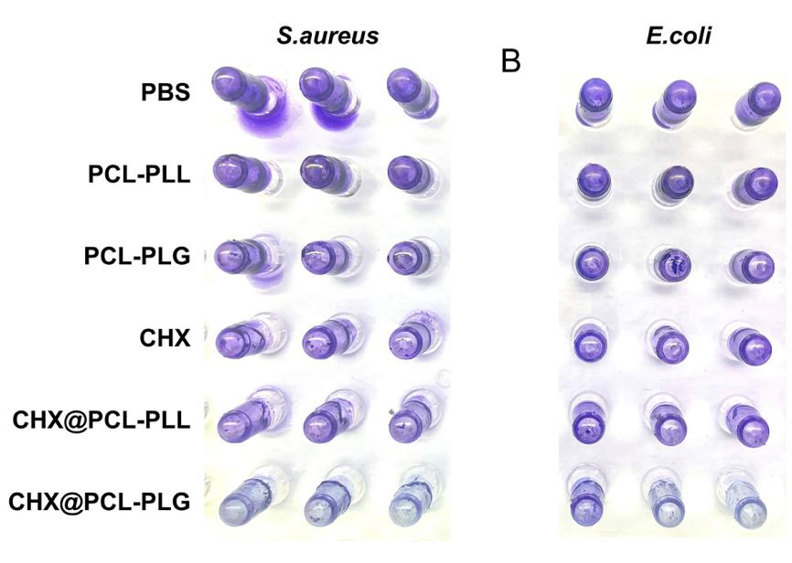
Fig.S7 Biofilm disruption experiments.

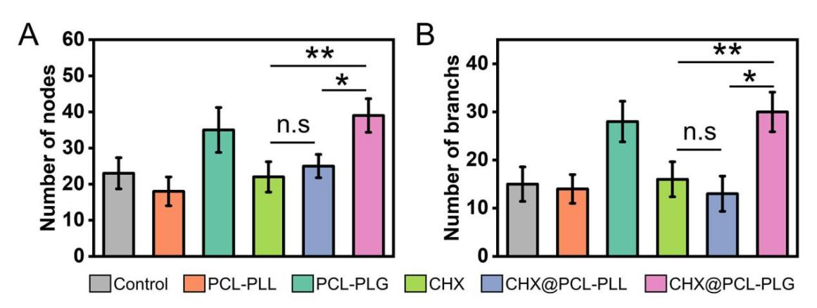
Fig.S8 Statistical analysis of the number of nodes and segments for tube formation experiments.

