Characterizations and environmental impacts of exhaust of non-road vehicles

Hsing-Wang Li¹, Chia-Hsiang Lai², Yi-Ching Lin³, Po-Yen Chien³, Wei-Hsiang Chen^{3,4}, Yen-Ping Peng^{3,4＊}

¹Green Energy & System Integration Research & Development Department, China Steel Corporation, Kaohsiung, Taiwan
²Department of Biotechnology, National Formosa University, Yunlin, Taiwan
³Institute of Environment Engineering, National Sun Yat-sen University, Kaohsiung, Taiwan
⁴Aerosol Science and Research Center, National Sun Yat-sen University, Kaohsiung, Taiwan

Supporting Information

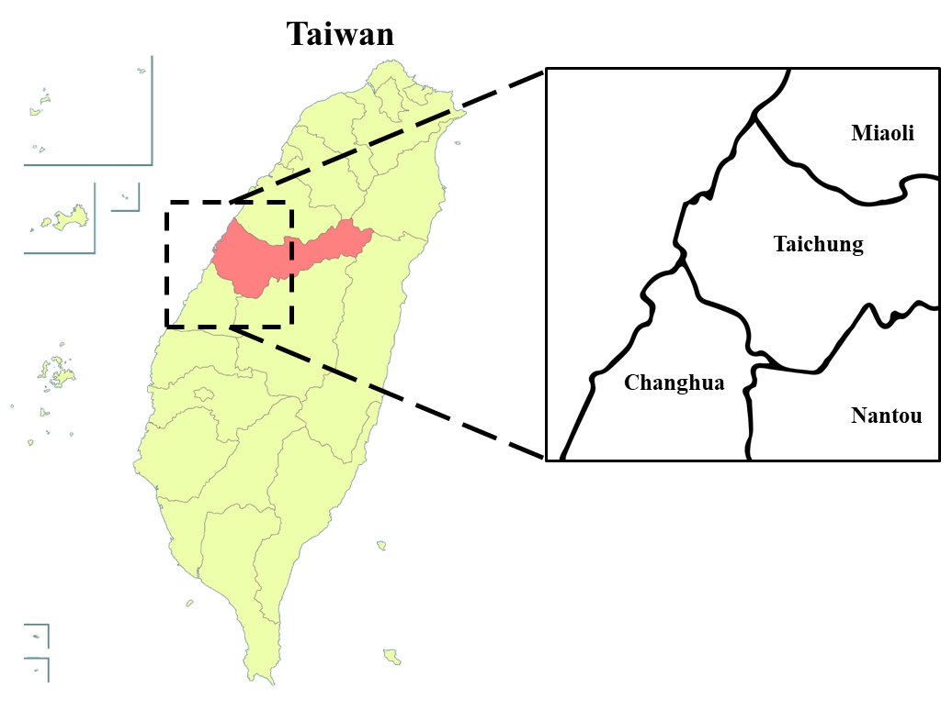
Figure S1. model domain

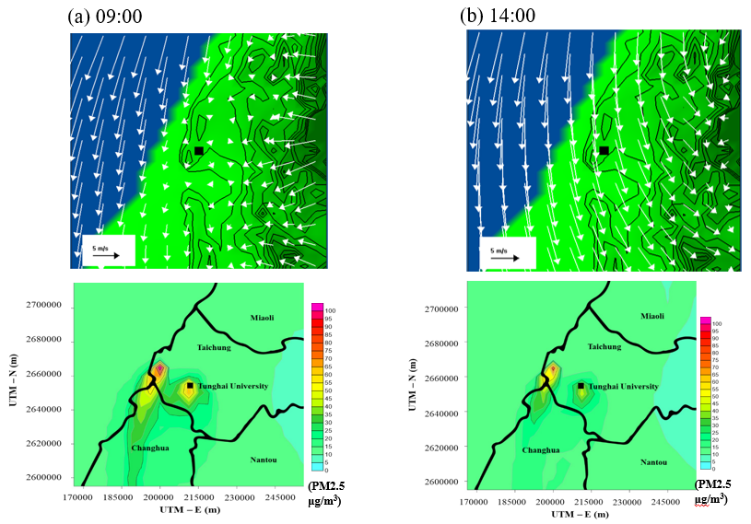

Figure S2. Simulated surface wind vectors and PM_{2.5} concentration contour (ug/m³) on November 29 in 2018 at (a) 09:00, and (b) 14:00
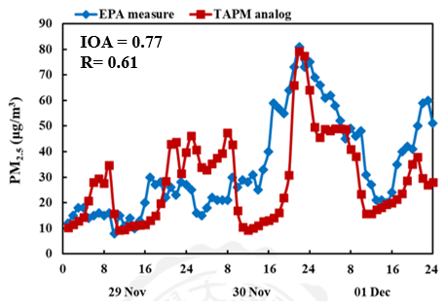
Figure S3. Comparisons of hourly surface PM_{2.5} concentration at sampling site from November 29 to Dec 1 in 2018.

