Supplemental digital content

Lung recruitment and hyperinflation with higher positive end-expiratory pressure in COVID-19: a computed tomography study

Figure E1. Flow chart of the study

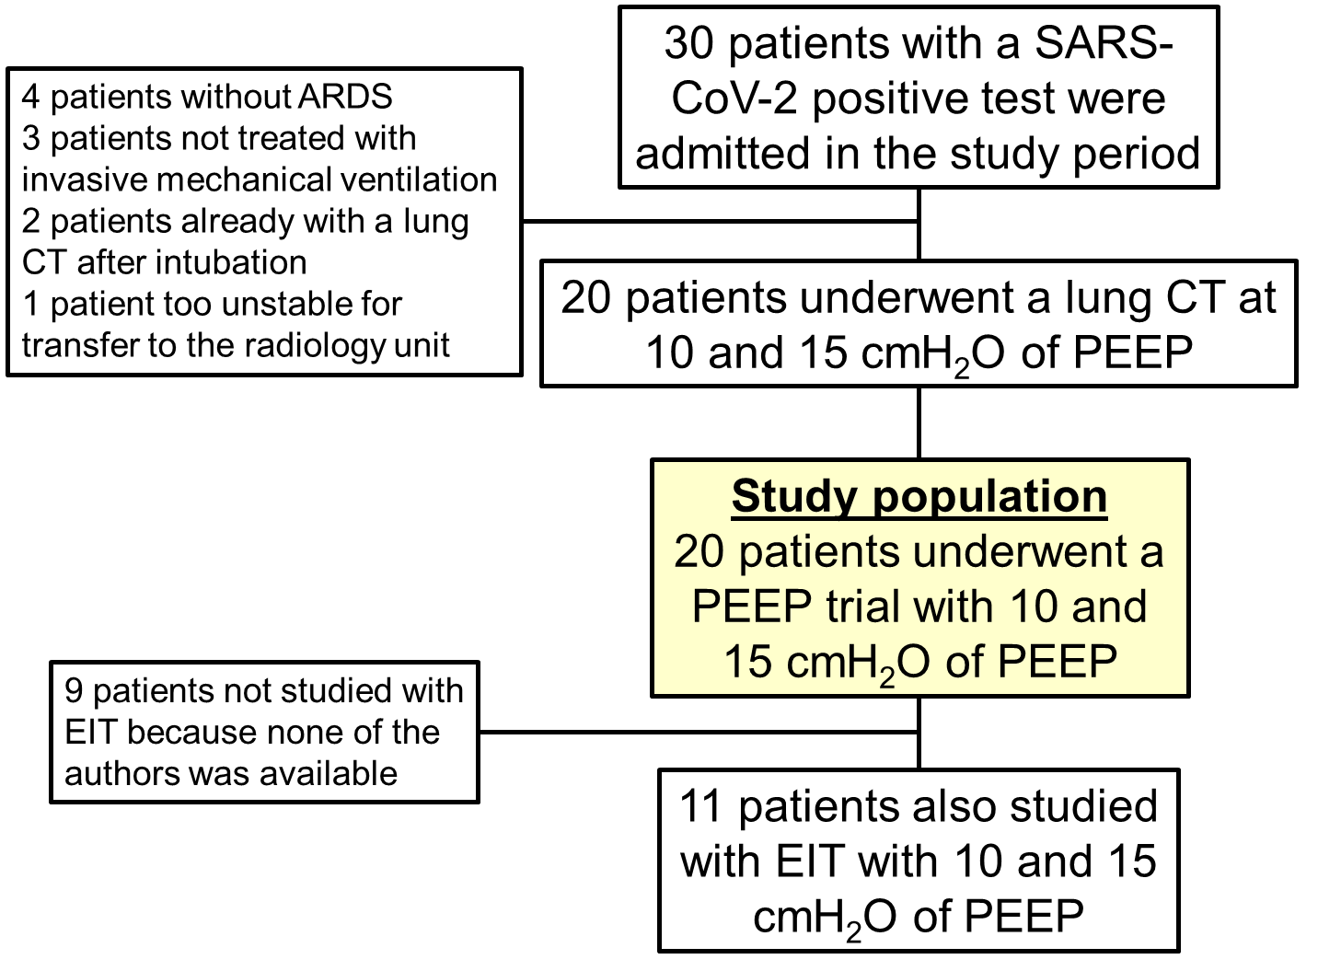

ARDS: acute respiratory distress syndrome. PEEP: positive end-expiratory pressure. CT: computed tomography. EIT: electrical impedance tomography.
Figure E2. Association of compliance with lung aeration with 10 cmH₂O of PEEP
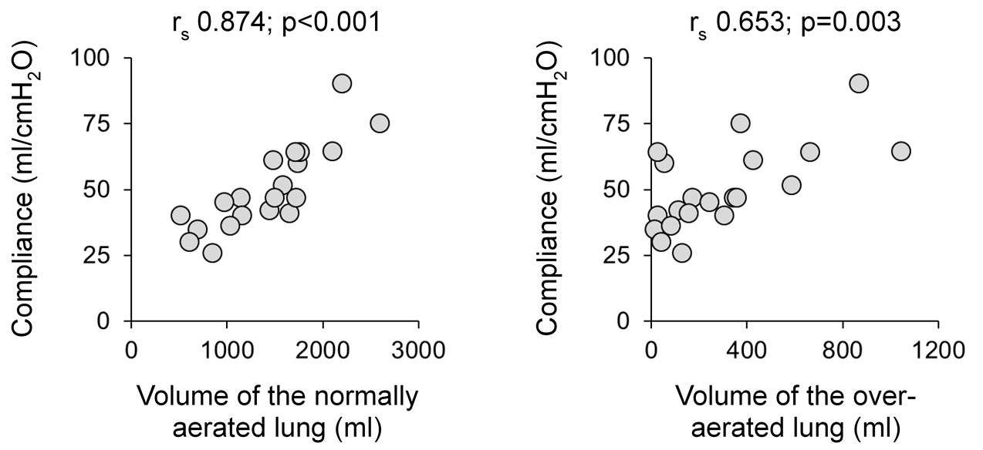

Y-axis: respiratory system compliance with 10 cmH₂O of PEEP. X-axis: lung aeration measured with CT with 10 cmH₂O of PEEP. r_{s} (coefficient) and p-value refer to Spearman’s rank-order correlation.

Figure E3. Representative images of two different CT responses to increasing PEEP

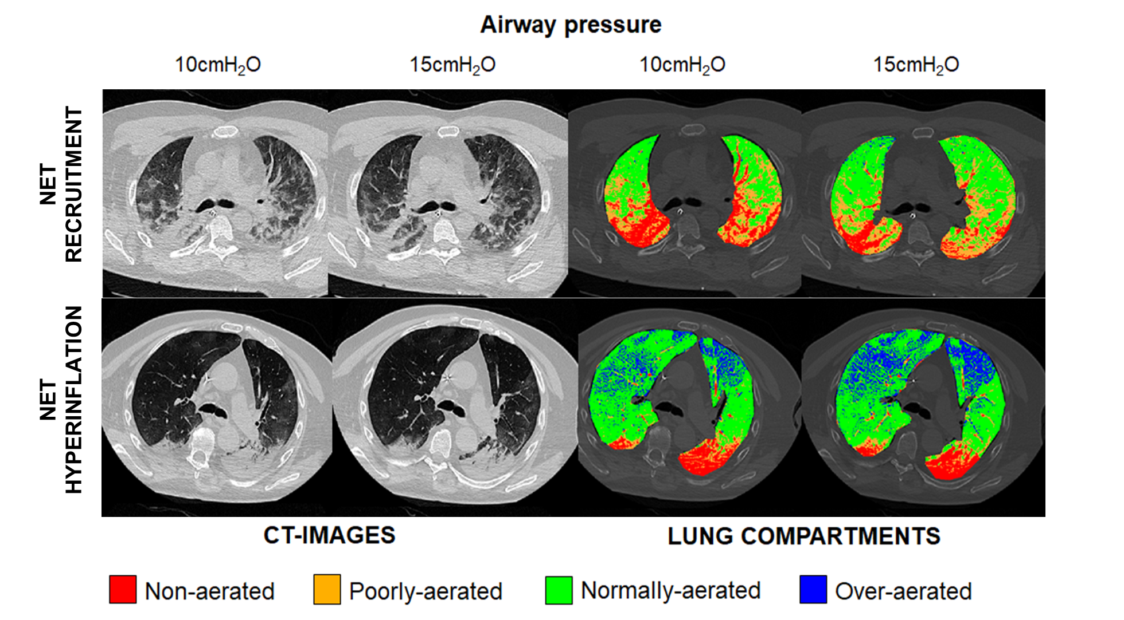

Representative CT images taken at the level of carina at 10 and 15 cmH₂O of airway pressure from two mechanically ventilated patients with COVID-19 and very different degrees of recruitment and hyperinflation. Left panels: original lung CT images, with aeration shown on a continuous gray scale. Right panels: using an automated encoding system, we attributed a specific color to the non-aerated, poorly-aerated, normally-aerated, and over-aerated compartments. Upper panels: whole-lung recruitment was 107 ml and hyperinflation 40 ml (net recruitment 67 ml). Lower panels: whole-lung recruitment was 73 ml and hyperinflation 370 ml (net hyperinflation 297 ml).
Figure E4. Vertical distribution of PEEP-induced recruitment and hyperinflation

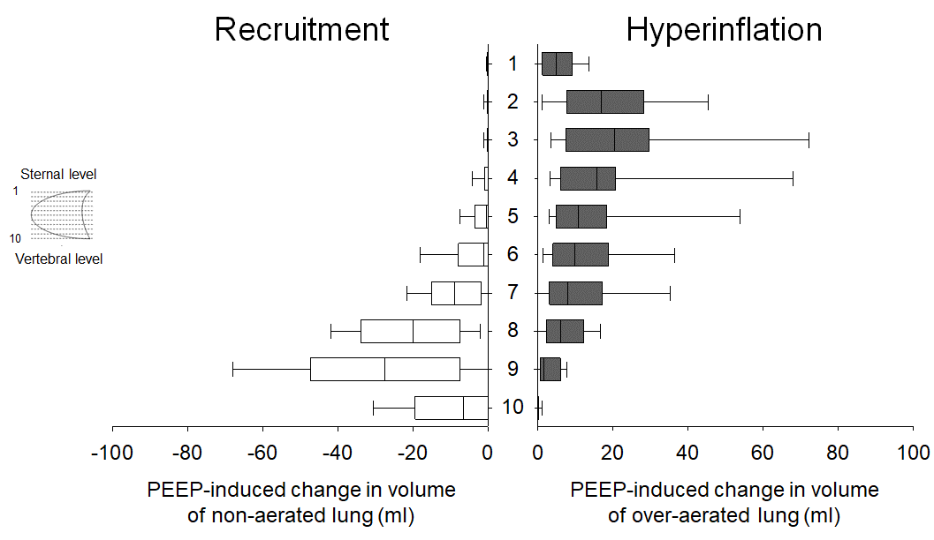

Lung CT images were divided in ten equally spaced vertical levels, from the sternum (level 1) to the vertebra (level 10). On average, increasing PEEP from 10 to 15 cmH₂O induced hyperinflation in the ventral lung, where the superimposed pressure was lower, and recruitment in the dorsal lung, where the superimposed pressure was higher. Please refer to Figure E4 for the vertical distribution of the superimposed pressure.

Figure E5. Vertical distribution of the superimposed pressure

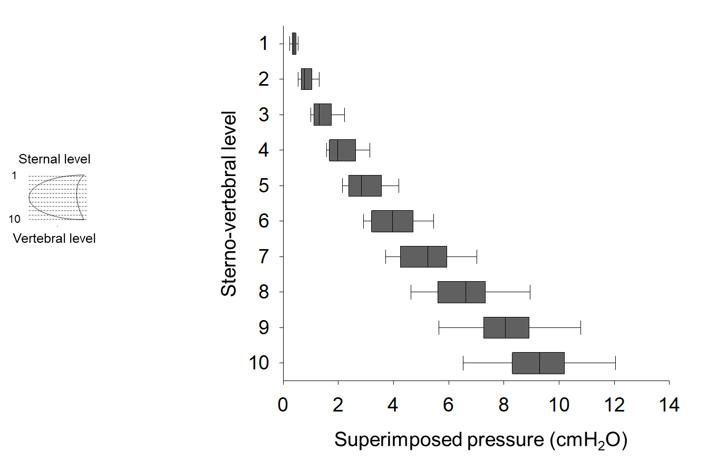

Lung CT images were divided in ten equally spaced vertical levels, from the sternum (level 1) to the vertebra (level 10). The pressure (super)imposed on each level was obtained from regional density (~ weight) and vertical distance from the sternum.

Figure E6. Association of the lung morphological response to a higher PEEP with the maximal superimposed pressure

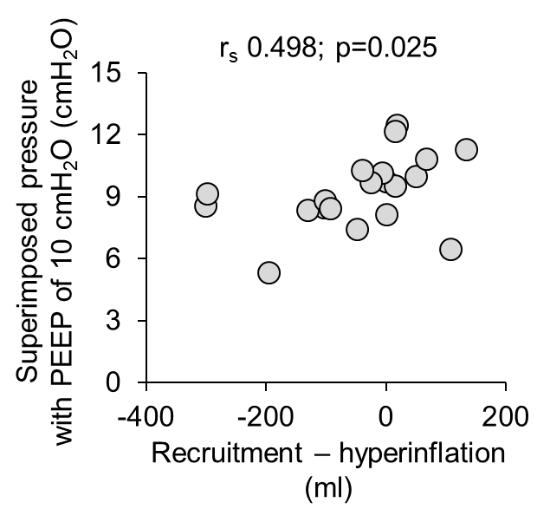

Y-axis: (maximal) superimposed pressure on the most dorsal lung level with 10 cmH₂O of PEEP. X-axis: difference between recruitment and hyperinflation induced by increasing PEEP from 10 to 15 cmH₂O, both expressed in ml. A positive value denotes net recruitment and a negative value net hyperinflation. r_{s} (coefficient) and p-value refer to Spearman’s rank-order correlation.

Figure E7. Individual response to the PEEP trial: gas exchange and mechanics

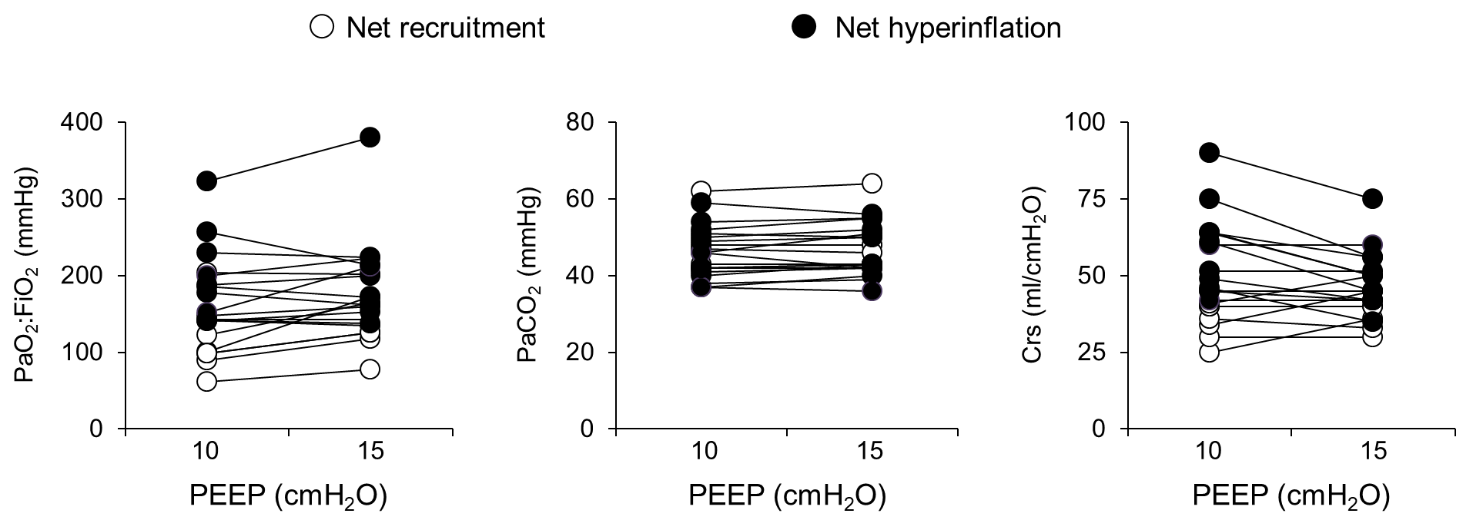

Gas exchange and respiratory system compliance were measured with 10 and 15 cmH₂O of PEEP while all other ventilatory settings were kept constant. Dots connected by a line refer to the same patient. Net recruitment and net hyperinflation refer to the predominant CT response to increasing PEEP: decrease in the volume of the non-aerated lung or increase in the volume of the over-aerated lung.
Table E1. Average response to the PEEP trial

 | PEEP of 10 cmH₂O | PEEP of 15 cmH₂O | p-value
Ventilatory settings
Tidal volume (ml) | 420 (360-450) | 420 (360-450)
Respiratory rate (bpm) | 18 (16-20) | 8 (16-20)
FiO₂ (%) | 60 (50-70) | 60 (50-70)
Respiratory system mechanics
Plateau airway pressure (cmH₂O) | 19 (17-21) | 26 (23-26) | <0.001
Driving airway pressure (cmH₂O) | 9 (7-10) | 10 (8-10) | 0.376
Compliance (ml/cmH₂O) | 47 (40-63) | 45 (40-51) | 0.057
Gas exchange
Arterial pH | 7.37 (7.33-7.40) | 7.38 (7.32-7.40) | 0.495
PaCO₂ (mmHg) | 46 (41-51) | 45 (42-52) | 0.132
PaO₂ (mmHg) | 83 (72-102) | 100 (80-111) | 0.032
PaO₂/FiO₂ (mmHg) | 146 (107-197) | 164 (136-210) | 0.036
Hemodynamics
Heart rate (bpm) ° | 66 (58-79) | 68 (60-76) | 0.551
Mean arterial pressure (mmHg) | 78 (70-81) | 79 (70-87) | 0.829
Lactate (mmol/L) | 1.4 (1.0-1.6) | 1.4 (1.1-1.6) | 0.203
ScvO₂ (%) ° | 75 (71-81) | 76 (73-82) | 0.243

Twenty mechanically ventilated patients underwent a PEEP trial, where PEEP was increased from 10 to 15 cmH₂O while other ventilatory settings were kept constant. Herein we describe the average response of the study population. ScvO₂: central venous oxygen saturation. ° One missing value.

Figure E8. Individual response to the PEEP trial: regional compliance

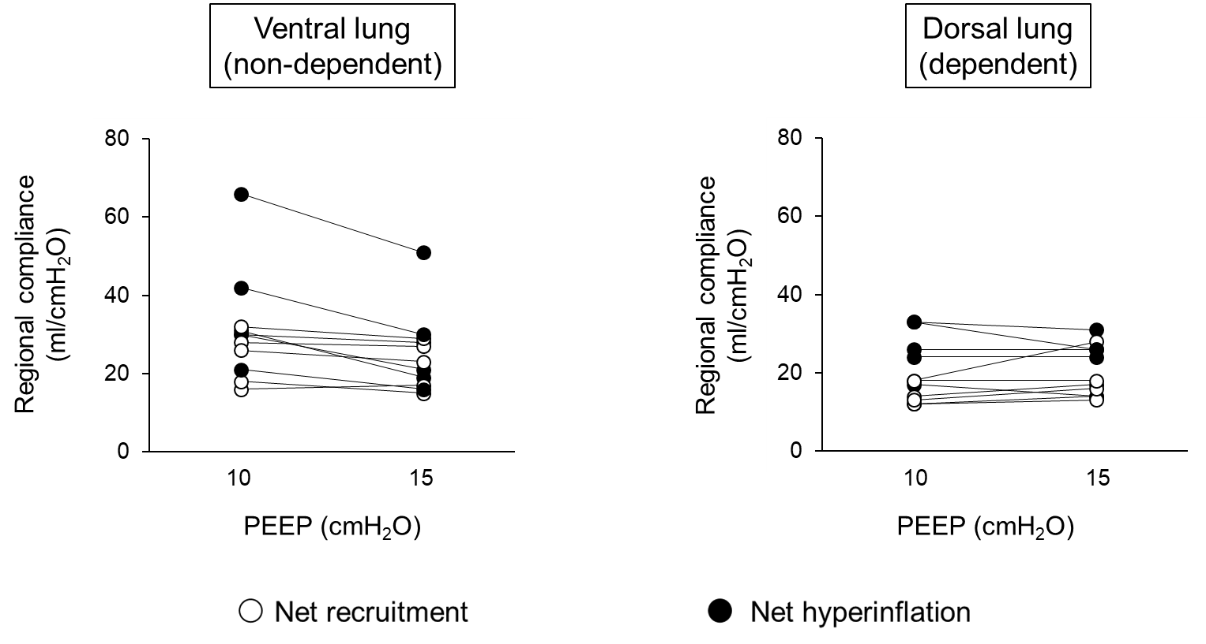

Eleven patients were studied with EIT during the PEEP trial. Regional compliance computed as the ratio of regional tidal volume to driving airway pressure. Dots connected by a line refer to the same patient. Net recruitment and net hyperinflation refer to the predominant CT response to increasing PEEP: decrease in the volume of the non-aerated lung or increase in the volume of the over-aerated lung.
Figure E9. Diagnostic accuracy of some physiological variables for net recruitment in response to increasing PEEP

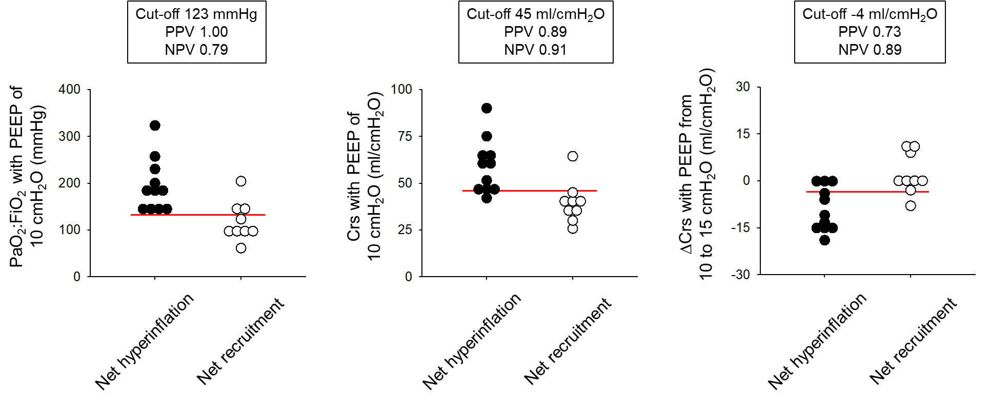

Herein we describe the diagnostic accuracy of the physiological variables significantly associated with the individual CT response to increasing PEEP (see Figure 3 in the main manuscript). Outcome was “net recruitment” that is increasing PEEP induced larger recruitment than hyperinflation. The diagnostic accuracy of compliance with 10 cmH₂O of PEEP was the highest. The probability of net recruitment was 89% when compliance was ≤45 cmH₂O and 9% when it was >45 cmH₂O.
Figure E10. Individual Ct response to increasing PEEP and baseline compliance
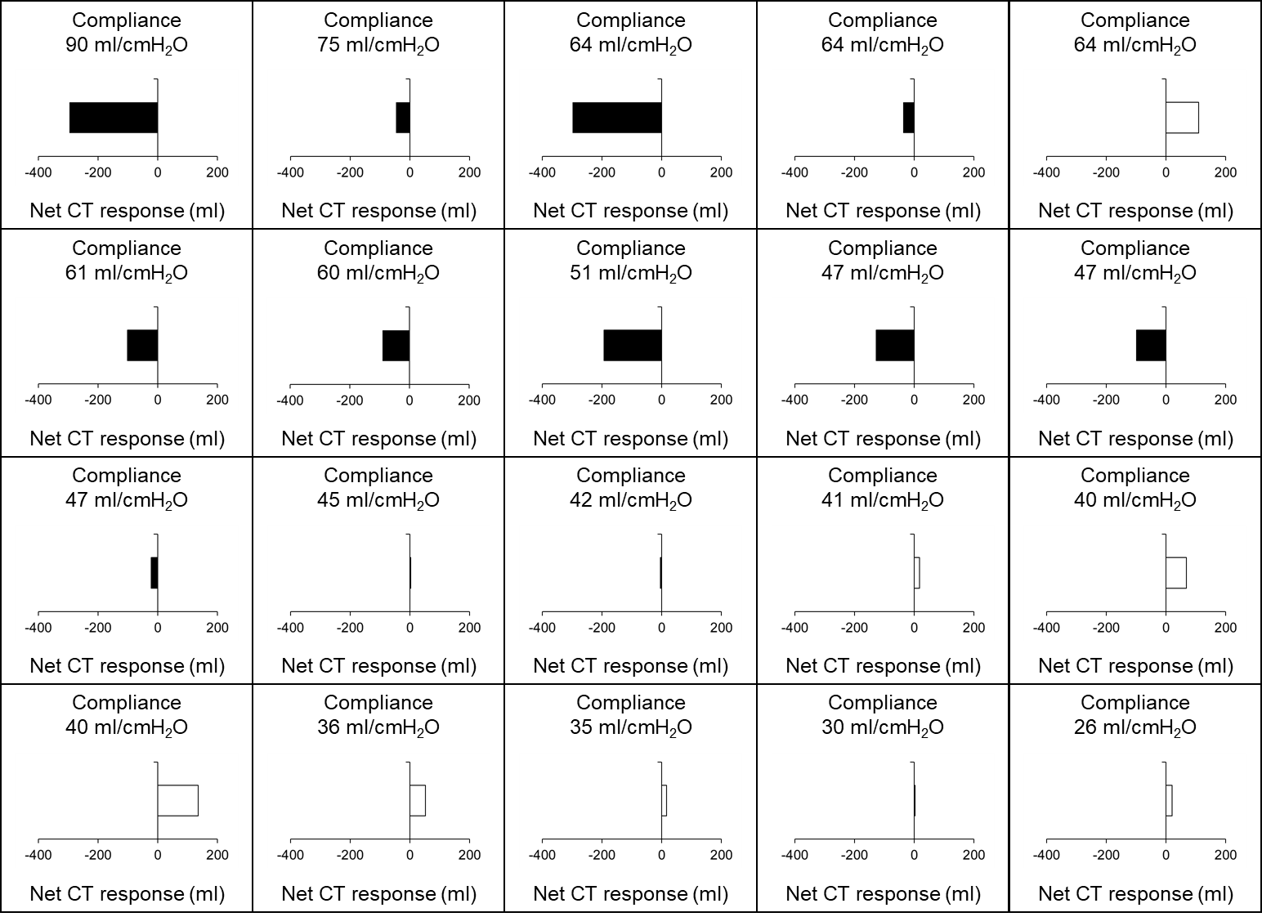
Each box refers to one patient. Patients are ordered according to their compliance with 10 cmH₂O of PEEP (descending order). Net CT response was the difference between recruitment and hyperinflation. Black bars: net hyperinflation. White bars: net recruitment.
Figure E11. Association of lung morphology with 10 cmH₂O of PEEP with the response to increasing PEEP

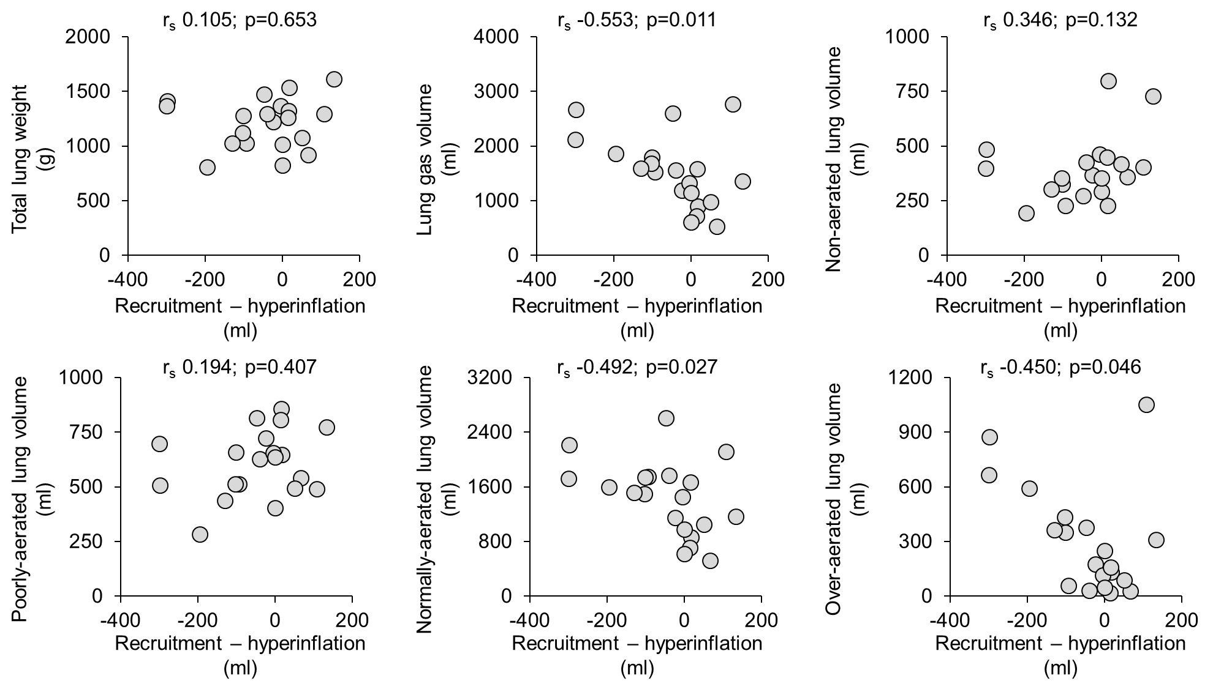

Y-axis: lung morphology with 10 cmH₂O of PEEP. X-axis: difference between recruitment and hyperinflation induced by increasing PEEP from 10 to 15 cmH₂O, both expressed in ml. A positive value denotes net recruitment and a negative value net hyperinflation. P-value refers to Spearman’s rank-order correlation.

Table E2. Comparison between patients with net recruitment or hyperinflation in response to increasing PEEP

Variable | PEEP (cmH₂O) | Net  recruitment | Net hyperinflation
N |  | 9 | 11
Overall lung inflation (CT)
Lung volume (ml) | 10 | 2147 (1701-2930) | 2781 (2602-3471)
Lung volume (ml) | 15 | 2518 (1992-3030) | 3197 (3042-4247)
Lung volume (ml) | From 10 to 15 | 95 (39-449) | 416 (249-575)
Non-aerated lung volume (ml) | 10 | 401 (320-586) | 351 (270-423)
Non-aerated lung volume (ml) | 15 | 308 (211-468) | 275 (230-351)
Non-aerated lung volume (ml) | From 10 to 15 | 107 (44-121) | 58 (31-91)
Poorly aerated lung volume (ml) | 10 | 635 (490-789) | 624 (504-696)
Poorly aerated lung volume (ml) | 15 | 670 (496-716) | 597 (519-670)
Poorly aerated lung volume (ml) | From 10 to 15 | 18 (-67-65) | -22 (-50-25)
Well aerated lung volume (ml) | 10 | 975 (657-1407) | 1714 (1489-1763)
Well aerated lung volume (ml) | 15 | 1092 (857-1809) | 2063 (1792-2219)
Well aerated lung volume (ml) | From 10 to 15 | 115 (76-413) | 334 (220-413)
Hyper-inflated lung volume (ml) | 10 | 129 (36-277) | 361 (113-589)
Hyper-inflated lung volume (ml) | 15 | 175 (67-375) | 507 (228-776)
Hyper-inflated lung volume (ml) | From 10 to 15 | 46 (18-72) | 159 (98-186)
Gas exchange and respiratory system mechanics (PEEP trial)
PaO₂:FiO₂ (mmHg) | 10 | 101 (95-145) | 186 (143-230)
PaO₂:FiO₂ (mmHg) | 15 | 135 (122-169) | 200 (153-223)
PaO₂:FiO₂ (mmHg) | From 10 to 15 | 27 (5-35) | 0 (-14-23)
PaCO₂ (mmHg) | 10 | 46 (42-50) | 46 (38-52)
PaCO₂ (mmHg) | 15 | 46 (43-51) | 43 (40-55)
PaCO₂ (mmHg) | From 10 to 15 | 1 (0-3) | 1 (-1-2)
Compliance (ml/cmH₂O) | 10 | 40 (32-43) | 60 (47-64)
Compliance (ml/cmH₂O) | 15 | 40 (34-48) | 50 (42-56)
Compliance (ml/cmH₂O) | From 10 to 15 | 0 (-2-10) | -11 (-15-0)
Regional lung inflation (EIT) °
N |  | 5 | 6
Tidal volume to ventral lung (%) | 10 | 65 (48-71) | 60 (47-72)
Tidal volume to ventral lung (%) | 15 | 57 (42-66) | 57 (37-67)
Tidal volume to ventral lung (%) | From 10 to 15 | -7 (-9--3) | -5 (-8--3)
Tidal volume to dorsal lung (%) | 10 | 35 (29-52) | 40 (28-53)
Tidal volume to dorsal lung (%) | 15 | 43 (34-58) | 43 (33-63)
Tidal volume to dorsal lung (%) | From 10 to 15 | 7 (3-9) | 5 (3-8)
Tidal volume to ventral lung (ml) | 10 | 259 (194-283) | 260 (210-308)
Tidal volume to ventral lung (ml) | 15 | 229 (167-263) | 248 (164-286)
Tidal volume to ventral lung (ml) | From 10 to 15 | -26 (-37--12) | -22 (-35--12)
Tidal volume to dorsal lung (ml) | 10 | 140 (117-211) | 175 (121-233)
Tidal volume to dorsal lung (ml) | 15 | 171 (137-238) | 189 (143-269)
Tidal volume to dorsal lung (ml) | From 10 to 15 | 26 (12-37) | 22 (12-35)
Ventral lung compliance (ml/cmH₂O) | 10 | 26 (17-30) | 31 (27-48)
Ventral lung compliance (ml/cmH₂O) | 15 | 23 (16-28) | 25 (18-35)
Ventral lung compliance (ml/cmH₂O) | From 10 to 15 | -3 (-3-0) | -10 (-13--4)
Dorsal lung compliance (ml/cmH₂O) | 10 | 14 (12-18) | 25 (16-33)
Dorsal lung compliance (ml/cmH₂O) | 15 | 17 (15-23) | 25 (14-28)
Dorsal lung compliance (ml/cmH₂O) | From 10 to 15 | 3 (0-7) | -1 (-4-1)

Twenty mechanically ventilated patients with COVID-19 underwent a lung CT and a PEEP trial with 10 and 15 cmH₂O of PEEP. Eleven were also studied with EIT during their PEEP trial. Herein we describe patients with net recruitment or hyperinflation in response to increasing PEEP.

