Figure S1: Predicted seed yield of 28 genotypes based on BLUP (Best Linear Unbiased Prediction). Blue circles represent the BLUPs above the BLUP means and red circles represent the BLUPs below the BLUP means
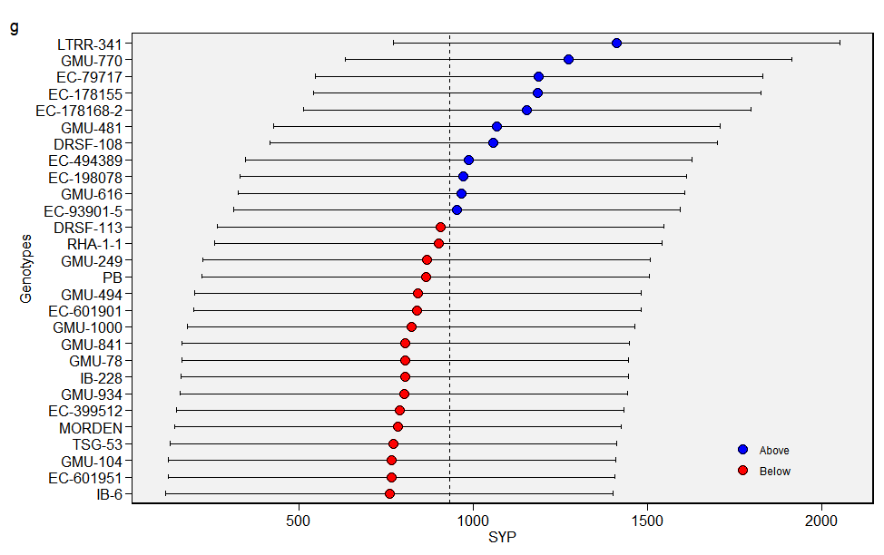
Figure S2: Predicted oil content of 28 genotypes based on BLUP (Best Linear Unbiased Prediction). Blue circles represent the BLUPs above the BLUP means and red circles represent the BLUPs below the BLUP means
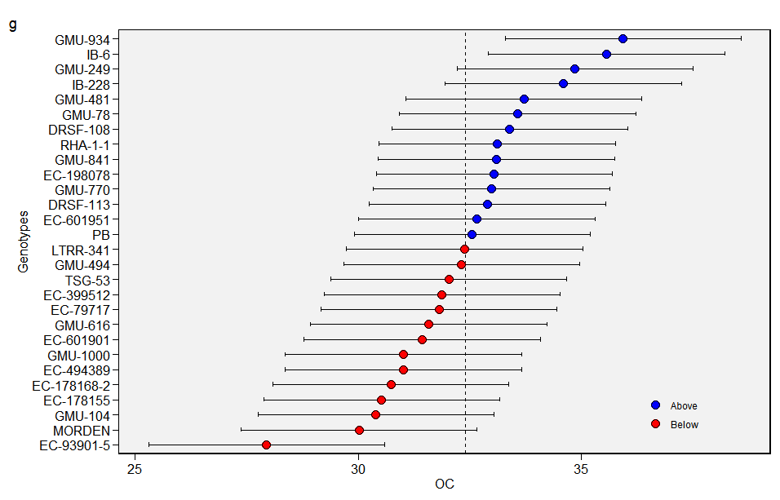
Table S1: Mean performances of the sunflower genotypes

Accession | Days to 50 % flowering | Days to maturity | Plant height  (cm) | Head diameter  (cm) | 100 seed weight  (g) | Seed yield per plant  (kg/ha) | Oil content (%)
GMU-481 | 62 | 96 | 107.5 | 12.0 | 4.0 | 1088 | 33.4
EC-399512 | 63 | 96 | 99.6 | 11.5 | 3.4 | 1144 | 32.0
EC-601951 | 59 | 92 | 80.2 | 7.3 | 4.3 | 1255 | 32.0
EC-178168-2 | 61 | 95 | 101.2 | 12.0 | 4.1 | 1411 | 30.2
LTRR-341 | 56 | 89 | 114.6 | 11.5 | 4.7 | 1355 | 32.3
MORDEN | 51 | 86 | 60.6 | 9.9 | 5.3 | 816 | 29.4
GMU-770 | 60 | 93 | 114.2 | 11.5 | 3.8 | 1111 | 33.0
EC-178155 | 60 | 95 | 116.2 | 9.5 | 3.7 | 944 | 30.0
EC-79717 | 57 | 92 | 95.1 | 11.2 | 4.2 | 777 | 31.6
EC-494389 | 59 | 92 | 90.65 | 9.6 | 3.1 | 1394 | 30.6
EC-93901-5 | 59 | 93 | 113.2 | 13.5 | 4.9 | 944 | 26.8
EC-601901 | 62 | 95 | 73.6 | 7.9 | 3.5 | 722 | 31.0
EC-198078 | 63 | 96 | 108.7 | 11.4 | 5.3 | 794 | 33.1
RHA-1-1 | 63 | 94 | 96.6 | 9.8 | 4.1 | 1033 | 33.2
GMU-494 | 60 | 94 | 106.9 | 9.9 | 3.5 | 1372 | 33.2
GMU-249 | 63 | 95 | 129.3 | 11.3 | 4.5 | 1216 | 32.2
GMU-616 | 63 | 94 | 117.1 | 11.9 | 4.2 | 1433 | 35.3
IB-6 | 61 | 93 | 124.4 | 11.4 | 3.9 | 905 | 36.2
GMU-934 | 63 | 96 | 106.3 | 10.3 | 4.9 | 911 | 36.7
GMU-1000 | 64 | 94 | 100.2 | 10.4 | 3.9 | 888 | 30.6
GMU-104 | 64 | 96 | 102.8 | 9.6 | 3.9 | 1249 | 29.8
IB-228 | 63 | 95 | 100.5 | 9.25 | 3.5 | 722 | 35.0
GMU-78 | 63 | 93 | 116.7 | 11.9 | 4.3 | 1188 | 33.8
GMU-841 | 63 | 95 | 125.9 | 11.7 | 3.7 | 638 | 33.2
TSG-53 | 61 | 94 | 92.4 | 11.8 | 4.3 | 1133 | 31.9
DRSF-108 | 63 | 95 | 136.4 | 13.7 | 3.4 | 655 | 32.5
DRSF-113 | 65 | 97 | 131.2 | 13.3 | 3.4 | 777 | 33.5
Phule Bhaskar | 63 | 94 | 126.6 | 13.4 | 3.7 | 1105 | 32.9
Range | 51 to 65 | 86 to 96 | 60.6 to136.4 | 7.3 to 13.7 | 3.1 to 4.9 | 638 to 1433 | 29.4 to 36.2

Table S2: Pooled analysis of variance
Source of variation | D.F | F value
Source of variation | D.F | Days to maturity | Seed yield | Oil content
GEN | 27 | 1.34 | 4.03 | 8.35
ENV | 3 | 149.48 | 4.17 | 3.87
ENV:GEN | 78 | 0.62 | 4.31 | 1.64
REP | 1 | 0.23 | 0.98 | 3.22
RESIDUALS | 115

Table S3: Identification of new sources of resistance to SDM along with per se performance
Sr.No. | Entry | Yield (kg/ha) | Downy mildew disease incidence/ reaction (%)
 |  |  | 2017-2020 | Kharif (Rainy) 2021
1 | RHA-1-1 | 1088 | Resistant | Resistant (0)
2 | EC-399512 | 1144 | Resistant | Resistant (0)
3 | EC-178168-2 | 1255 | Resistant | Resistant (0)
4 | EC-601901 | 1411 | Resistant | Resistant (0)
5 | EC-198078 | 1355 | Resistant | Resistant (0)
6 | GMU-770 | 816 | Resistant | Resistant (0)
7 | GMU-481 | 1111 | Resistant | Resistant (0)
8 | LTRR-341 | 944 | Resistant | Resistant (0)
9 | GMU-841 | 777 | Resistant | Resistant (0)
10 | IB-228 | 1394 | Resistant | Resistant (0)
11 | EC-79717 | 944 | NA | Susceptible (20)
12 | EC-178155 | 722 | NA | Susceptible (24)
13 | EC-494389 | 794 | NA | Susceptible (18)
14 | EC-93901-5 | 1033 | NA | Susceptible (3)
15 | TSG-53 | 1372 | NA | Susceptible (5)
16 | EC-601951 | 1216 | NA | Susceptible (32)
17 | GMU-78 | 1433 | NA | Resistant (0)
18 | GMU-1000 | 905 | NA | Susceptible (40)
19 | GMU-104 | 911 | NA | Susceptible (50)
20 | GMU-934 | 888 | NA | Susceptible (45)
21 | GMU-616 | 1249 | NA | Susceptible (36)
22 | GMU-249 | 722 | NA | Resistant (0)
23 | GMU-494 | 1188 | NA | Resistant (0)
24 | IB-6 | 638 | NA | Susceptible (80)
25 | DRSF-108 ( C ) | 1133 | Susceptible (C) | Susceptible (20)
26 | DRSF-113( C ) | 655 | Susceptible (C) | Susceptible (25)
27 | Phule Bhaskar (C) | 777 | Resistant (C) | Resistant (0)
28 | Morden (C) | 1105 | Highly Susceptible | Susceptible (100)

Table S4: RMSPD estimates for the models tested for yield
MODEL | mean | sd | se | Q2.5 | Q97.5
AMMI2 | 0.14 | 0.007 | 0.003 | 0.13 | 0.15
AMMI1 | 0.16 | 0.016 | 0.007 | 0.14 | 0.18
AMMIF | 0.18 | 0.018 | 0.008 | 0.16 | 0.20
AMMI0 | 0.20 | 0.013 | 0.006 | 0.19 | 0.22
S.D-Standard Deviation; S.E-Standard Error of the Mean; Q2.5-percentile 2.5; Q97.5-percentile 97.5.

Table S5: BLUP for yield of genotypes under study: BLUPg- Genotypic effect; Predicted- Predicted mean; LL-Lower limit; UL-Upper limit
Rank | GEN | BLUPg | Predicted | LL | UL
1 | LTRR-341 | 479.4 | 1411 | 769.6 | 2053.0
2 | GMU-770 | 341.1 | 1273 | 631.4 | 1914.7
3 | EC-79717 | 256.3 | 1188 | 546.5 | 1829.9
4 | EC-178155 | 251.4 | 1183 | 541.7 | 1825.0
5 | EC-178168-2 | 222.6 | 1154 | 512.8 | 1796.2
6 | GMU-481 | 135.2 | 1067 | 425.4 | 1708.8
7 | DRSF-108 | 125.8 | 1057 | 416.0 | 1699.4
8 | EC-494389 | 54.3 | 986 | 344.6 | 1628.0
9 | EC-198078 | 39.5 | 971 | 329.8 | 1613.1
10 | GMU-616 | 33.8 | 965 | 324.1 | 1607.4
11 | EC-93901-5 | 20.4 | 952 | 310.6 | 1594.0
12 | DRSF-113 | -25.5 | 906 | 264.6 | 1548.0
13 | RHA-1-1 | -32.4 | 899 | 257.8 | 1541.1
14 | GMU-249 | -66.1 | 865 | 224.1 | 1507.4
15 | Phule Bhaskar | -68.9 | 862 | 221.2 | 1504.6
16 | GMU-494 | -91.2 | 840 | 198.9 | 1482.3
17 | EC-601901 | -92.6 | 839 | 197.5 | 1480.9
18 | GMU-1000 | -110.4 | 821 | 179.8 | 1463.1
19 | GMU-841 | -126.9 | 804 | 163.2 | 1446.6
20 | GMU-78 | -127.5 | 804 | 162.7 | 1446.0
21 | IB-228 | -128.9 | 802 | 161.2 | 1444.6
22 | GMU-934 | -131.2 | 800 | 158.9 | 1442.3
23 | EC-399512 | -142.4 | 789 | 147.8 | 1431.2
24 | Morden | -148.1 | 783 | 142.1 | 1425.4
25 | TSG-53 | -161.2 | 770 | 129.0 | 1412.3
26 | GMU-104 | -165.8 | 766 | 124.4 | 1407.7
27 | EC-601951 | -167.4 | 764 | 122.8 | 1406.1
28 | IB-6 | -172.9 | 758 | 117.2 | 1400.6

Table S6: RMSPD estimates for the models tested for yield for oil content
MODEL | mean | sd | se | Q2.5 | Q97.5
AMMI1 | 0.15 | 0.012 | 0.005 | 0.14 | 0.17
AMMIF | 0.16 | 0.006 | 0.002 | 0.15 | 0.16
AMMI2 | 0.16 | 0.025 | 0.011 | 0.14 | 0.19
AMMI0 | 0.21 | 0.007 | 0.003 | 0.20 | 0.22

Table S7: BLUP for oil content of genotypes under study: BLUPg- Genotypic effect; Predicted- Predicted mean; LL-Lower limit; UL-Upper limit
Rank | GEN | BLUPg | Predicted | LL | UL
28 | EC-93901-5 | -4.44 | 27.94 | 25.29 | 30.59
27 | Morden | -2.37 | 30.01 | 27.36 | 32.66
26 | GMU-104 | -1.99 | 30.39 | 27.74 | 33.04
25 | EC-178155 | -1.86 | 30.52 | 27.87 | 33.17
24 | EC-178168-2 | -1.66 | 30.72 | 28.07 | 33.37
23 | EC-494389 | -1.38 | 31.00 | 28.35 | 33.65
22 | GMU-1000 | -1.38 | 31.00 | 28.36 | 33.65
21 | EC-601901 | -0.96 | 31.43 | 28.78 | 34.07
20 | GMU-616 | -0.81 | 31.57 | 28.92 | 34.22
19 | EC-79717 | -0.58 | 31.80 | 29.15 | 34.45
18 | EC-399512 | -0.51 | 31.87 | 29.23 | 34.52
17 | TSG-53 | -0.36 | 32.02 | 29.37 | 34.67
16 | GMU-494 | -0.07 | 32.31 | 29.66 | 34.96
15 | LTRR-341 | -0.01 | 32.38 | 29.73 | 35.03
14 | Phule Bhaskar | 0.16 | 32.55 | 29.90 | 35.20
13 | EC-601951 | 0.25 | 32.65 | 30.00 | 35.30
12 | DRSF-113 | 0.50 | 32.89 | 30.24 | 35.54
11 | GMU-770 | 0.59 | 32.98 | 30.34 | 35.63
10 | EC-198078 | 0.65 | 33.04 | 30.39 | 35.69
9 | GMU-841 | 0.69 | 33.09 | 30.44 | 35.73
8 | RHA-1-1 | 0.71 | 33.11 | 30.46 | 35.75
7 | DRSF-108 | 1.00 | 33.39 | 30.74 | 36.04
6 | GMU-78 | 1.18 | 33.57 | 30.92 | 36.22
5 | GMU-481 | 1.31 | 33.71 | 31.06 | 36.35
4 | IB-228 | 2.20 | 34.59 | 31.94 | 37.24
3 | GMU-249 | 2.46 | 34.85 | 32.20 | 37.50
2 | IB-6 | 3.17 | 35.56 | 32.91 | 38.21
1 | GMU-934 | 3.54 | 35.93 | 33.28 | 38.58

