Supplementary material

for

Synergistic effect and mechanism of enhanced degradation on aromatic compounds by bacterial flora

Xingshe Liu, Yongjun Liu*, Shuang Li, Zhe Liu, Aining Zhang, Zhihua Li.

*Corresponding author
School of Environmental and Municipal Engineering, Xi’an University of Architecture and Technology, Yan Ta Road. No.13, Xi’an 710055, China
Tel: +86-29-82202520
E-mail: liuyongjun@xauat.edu.cn
Supporting Information:
- Determination of the Catechol 2,3-dioxygenase (C23O) enzyme activity
The activity of catechol 2,3-dioxygenase (C23O) was assayed with the absorbance increase at 375nm. The reaction mixture contained 1 mL of enzyme solution, 2 mL of sodium phosphate buffer (0.05 mol/L, pH = 7.2), and 0.1 mmol/L catechol. The reaction was allowed to last for 20 min at 37 ℃ (Ding et al., 2018; Wei et al., 2010). The formula for calculating the enzyme mass-specific activity (EMSA) is as follows:
where V_{t} is the total volume of the reaction system (mL); ∆A is the increased absorbance of the reaction solution at OD375; Ɛ is the molar absorption coefficient per unit length, Ɛ375 = 36,000 L/mol/cm (Wojcieszyńska et al., 2012); t is the reaction time (20 min); L is the inner diameter of the colorimetric dish (1 cm); V_{e} is the volume of the enzyme (1 mL); and C_{pro} is the protein concentration (mg/mL).
- Determination of biotoxicity
T. Thermophila was selected as the toxicity indicator organism in the experiment, The T. Thermophila cells were seeded in 100 mL of dedicated medium and cultured at 32°C for 36 h. The water samples before and after metabolism containing aromatic compounds with different structures were assessed by six dilution ratios respectively (6.25, 8.3, 12.5, 16.7, 25, 50%). 0.2 mL of T. thermophila cells were added to the 96-well microplate and diluted to 1 mL with water. Three replicates were performed for each diluted water sample. After 24 h of incubation, the mircoplate luminometer was used to determine cell density of T. thermophila at 490 nm (Ma et al., 2018). The formula for calculating the growth inhibition rate of T. thermophile (μ) was as follows:
(2)
OD_{C1}—The absorbance values of control blank group;
OD_{C} —The absorbance values of control group;
OD_{t} —The absorbance value of test group;
OD_{t1}— The absorbance value of sample blank group.
The toxicity was expressed as the half-effect concentration (EC₅₀) of the maximum toxic effect. Logistic fitting was performed on the growth inhibition rate and the dilution concentration of the sample using Origin 8.5 software, and the EC₅₀ value of the sample was calculated according to the fitting result.
- DNA extraction and community structure analysis
The V5–V7 region of the bacterial 16S ribosomal RNA gene was amplified using primers 338F (5′-CTCCTACGGGAGGCAGCAG-3′) and 806R (5′-GGACTACHVGGGTWTCTAAT-3′). The PCR reaction was conducted as follows: initial denaturation (95 ℃ for 3 min), followed by 25 cycles of denaturation (95 ℃ for 30 s), annealing (72 ℃ for 45 s), extensions (72 ℃ for 30 s), and a final extension (72 ℃ for 10 min). The PCR reaction system included: 4 μL of 5×TransStart FastPfu buffer, 2 μL of 2.5 mM dNTPs, 0.8 μL of upstream primer (5 uM), 0.8 μL of downstream primer (5 uM), 0.4 μL of TransStart FastPfu DNA polymerase, 10 ng of template DNA, and 20 μL of ddH₂O. Each sample was replicated into three samples. After mixing the PCR products of the same sample, the PCR products were recovered using 2% agarose gel. Then, AxyPrep DNA Gel Extraction Kit (Axygen Biosciences, Union City, CA, USA) was used to purify the recovered products and perform detection by 2% agarose gel electrophoresis. Meanwhile, Quantus™ Fluorometer (Promega, USA) was used to quantify the recovered product. The sequence data in this study have been deposited in the GenBank database with the following accession numbers: PRJNA889696.

Figures:

Fig. S1. The diversity indices of bacterial flora during the process of biodegradation using different aromatic compounds as the only carbon source on the genus level. (a) indices of Shannon, (b) indices of Chao, (c) indices of Simpson.

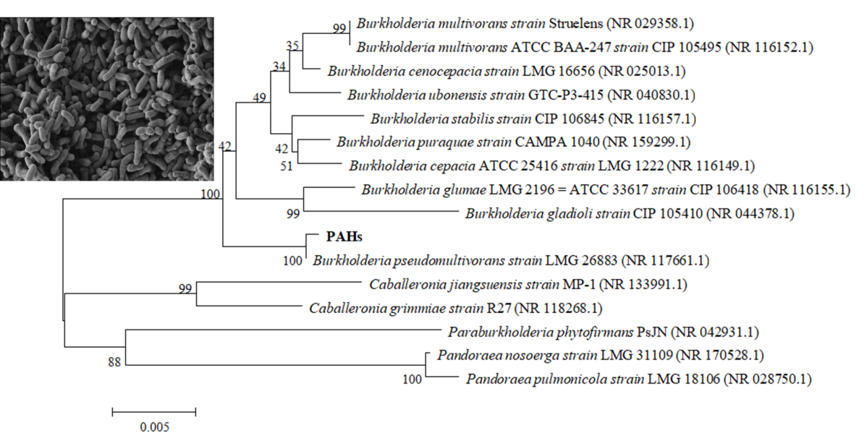
Fig. S2. Phylogenetic tree showed the affiliation of selected strains and published sequences in Genbank.
Fig. S3. The relationship between the structure of aromatic compounds and the enzyme activity expression sequence and activity of key enzyme during the biodegradation. (a) DHA enzyme for degrading phenol, (b) DHA enzyme for degrading naphthalene, phenanthrene and pyrene, (c) C23O enzyme for degrading phenol, (d) C23O enzyme for degrading naphthalene, phenanthrene and pyrene.

References
Ding, P., Song, W., Yang, Z., Jian, J. 2018. Influence of Zn(II) stress-induction on component variation and sorption performance of extracellular polymeric substances (EPS) from Bacillus vallismortis. Bioprocess Biosyst Eng, 41(6), 781-791. http://dx.doi.org/10.1007/s00449-018-1911-6.
Wei, J., Zhou, Y., Xu, T., Lu, B., 2010. Rational design of catechol-2, 3-dioxygenase for improving the enzyme characteristics. Appl Biochem Biotechnol. 162, 116-126. http://dx.doi.org/10.1007/s12010-009-8720-y.
Wojcieszyńska, D., Hupert-Kocurek, K., Greń, I., Guzik, U., 2011. High activity catechol 2,3-dioxygenase from the cresols – Degrading Stenotrophomonas maltophilia strain KB2. Int Biodeter Biodegr. 65, 853-858. http://dx.doi.org/10.1016/j.ibiod.2011.06.006.
Ma, W., Han, Y., Xu, C., Han, H., Zhu, H., Li, K., Zheng, M. 2018. Biotoxicity assessment and toxicity mechanism on coal gasification wastewater (CGW): A comparative analysis of effluent from different treatment processes. Science of The Total Environment, 637-638, 1-8. https://doi.org/10.1016/j.scitotenv.2018.04.404.

