Fig S1.
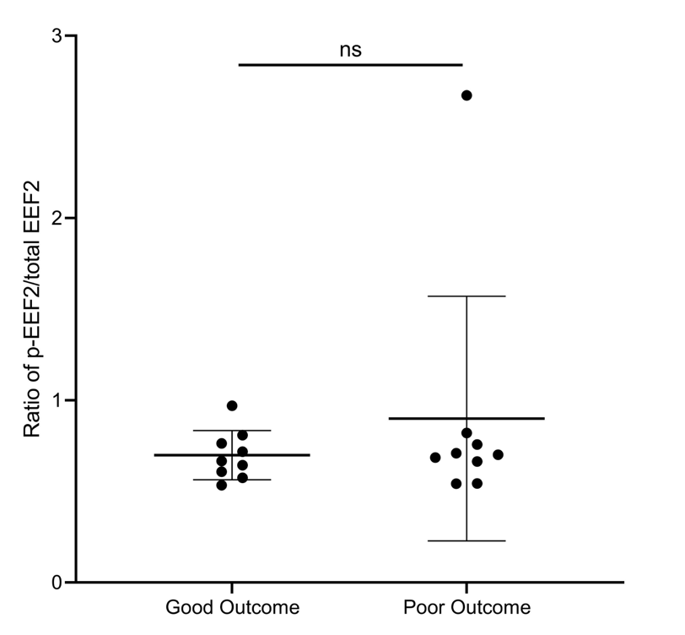
Fig S1. Semi-quantitative analysis based on western blotting result among 18 patients.
The ratio of phosphorylated-eEF2 (p-eEF2)/total eEF2 shows no statistical significance between good- and poor outcome patients.

Fig S2.
Fig S2. Bioinformatics of eEF2 in relation to inflammatory stage of healing.
a-d) A positive correlation between eEF2 and autophagy; e-l) There was a positive association between collagen & ECM binding and eEF2; m-p) eEF2 was positively associated with regulation of apoptosis
All the proteins which were enriched in autophagy, collagen & ECM binding and negative regulation of apoptotic process were collected and used a regression analysis with eEF2.

Fig S3.
Fig S3. eEF2 knock down among the inflammatory fibroblast model.
a) Representative images of western blotting from proteins lysates generated from fibroblasts treated with normal medium, TNF stimulation and si-eEF2 incubation after TNF stimulation. Cells treated with TNF showed a 22% decrease in eEF2 expression while si-eEF2 incubated cells demonstrated a 67% decrease in eEF2 expression.
b) Representative images of western blotting from proteins lysates generated from fibroblasts treated with normal medium, TNF stimulation and si-eEF2 incubation after TNF. Cells incubated with TNF showed a 37% decrease of Col1a1 production when compared with normal control. Cells showed a 50% (48 hours) decrease and 87% (72 hours) decrease in Col1a1 production when treated with si-eEF2 after incubating with TNF.

Fig S4.
Fig S4. Bioinformatics of eEF2 in relation to proliferative stage of healing based on GSEA analysis.
a-d) eEF2 was positively associated with cell migration. All the proteins which were enriched in cell migration were collected and used a regression analysis with eEF2.

