Supplementary Figure Legend
Fig. S1 Cupriavidus necator GX_5 colonies grown on LB agar

Supplementary Table Heading
Table S1 The effect of initial mental concentration on adsorption capacity of Cupriavidus necator GX_5 for Cd (II)
Table S2 The effect of initial mental concentration on removal efficiency of Cupriavidus necator GX_5 for Cd (II)
Table S3 The effect of biosorbent dosage on adsorption capacity of Cupriavidus necator GX_5 for Cd (II)
Table S4 The effect of biosorbent dosage on removal efficiency of Cupriavidus necator GX_5 for Cd (II)

Supplementary Figure
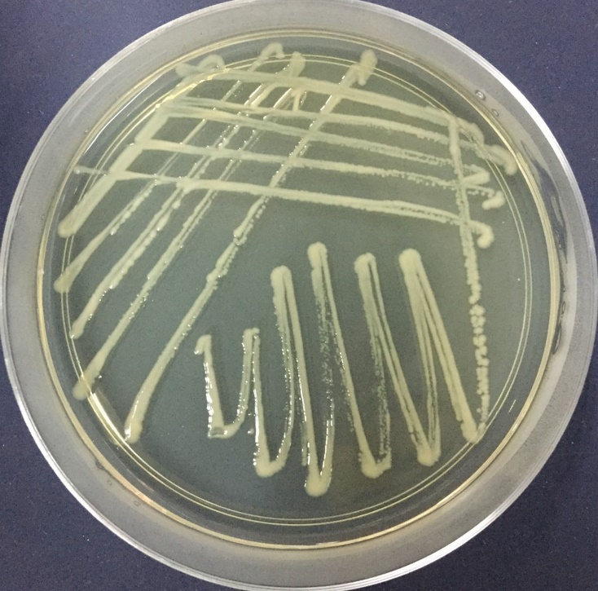

Fig. S1 Cupriavidus necator GX_5 colonies grown on LB agar

Supplementary Table

Table S1 The effect of initial mental concentration on adsorption capacity of Cupriavidus necator GX_5 for Cd (II)

D Initial Cd²⁺ concentration (mg/L)  Adsorption capacity (mg/g)  Biosorbents | 5 | 10 | 20 | 50 | 100 | 200
Live | 3.03^{h}±0.12 | 4.29^{fgh}±0.03 | 5.16^{efg}±0.26 | 7.52^{cd}±0.54 | 11.25^{b}±0.88 | 17.17ª±1.62
Dead | 3.93^{gh}±0.03 | 5.42^{ef}±0.14 | 6.46de±0.44 | 8.76^{c}±0.43 | 12.02^{b}±1.45 | 17.55ª±1.70

Table S2 The effect of initial mental concentration on removal efficiency of Cupriavidus necator GX_5 for Cd (II)

D Initial Cd²⁺ concentration (mg/L)  Removal efficiency (%)  Biosorbents | 5 | 10 | 20 | 50 | 100 | 200
Live | 60.51^{b}±2.36 | 42.91^{d}±0.31 | 25.78^{f}±1.32 | 15.05^{h}±1.08 | 11.25^{i}±0.88 | 8.58^{j}±0.81
Dead | 78.53ª±0.60 | 54.23^{c}±1.44 | 32.32e±2.19 | 17.52^{g}±0.86 | 12.02^{i}±1.45 | 8.77^{j}±0.85

Table S3 The effect of biosorbent dosage on adsorption capacity of Cupriavidus necator GX_5 for Cd (II)

Dosage (g/L)  Adsorption capacity (mg/g)  Biosorbents | 0.2 | 0.5 | 1.0 | 2.0 | 4.0
Live | 15.97^{b}±1.30 | 9.34de±0.91 | 7.33^{f}±0.64 | 6.44^{fg}±0.06 | 4.39^{h}±0.12
Dead | 21.47ª±2.16 | 13.15^{c}±1.01 | 9.57^{d}±0.48 | 7.87^{ef}±0.09 | 5.44^{gh}±0.19

Table S4 The effect of biosorbent dosage on removal efficiency of Cupriavidus necator GX_5 for Cd (II)
D Dosage (g/L)  Removal efficiency (%)  Biosorbents | 0.2 | 0.5 | 1.0 | 2.0 | 4.0
Live | 6.39^{h}±0.52 | 9.34^{g}±0.91 | 14.65^{f}±1.27 | 25.77^{d}±0.23 | 35.15^{b}±0.98
Dead | 8.59^{g}±0.87 | 13.15^{f}±1.01 | 19.13e±0.95 | 31.49^{c}±0.38 | 43.49ª±1.54

