Additional material 1 to: “Probabilistic multi – hazard assessment at an active but under-monitored volcano: Ceboruco, Mexico”
*Robert Constantinescu^{1, 5}, Karime González Zuccoloto², Dolors Ferrés³, Katrin Sieron⁴, Claus Siebe⁵, Charles Connor¹, Lucia Capra⁶, Roberto Tonini⁷

¹ School of Geosciences, University of South Florida, Tampa, U.S.A. email: robertc1@usf.edu
² Centro de Ciencias de Información Geoespacial, Mexico City, Mexico.
³ Escuela de Ciencias de la Tierra, Universidad Nacional Autónoma de México, Mexico City, Mexico.
⁴ Centro de Ciencias de la Tierra, Universidad Veracruzana, Xalapa, Mexico.
⁵ Instituto de Geofísica, Universidad Nacional Autónoma de México, Mexico City, Mexico.
⁶ Centro de Geociencias, Universidad Nacional Autónoma de México, Juriquilla Querétaro, Mexico.
⁷ Istituto de Geofisica e Vulcanologia, Sezione de Roma 1, Rome, Italy.

Corresponding author: Robert Constantinescu | robert.constantinescu00@gmail.com

Here we present the conditional probability maps for each phenomena considered in the hazard assessment at Ceboruco (i.e., occurrence of hazards is conditional to the occurrence of a specific eruption size from a specified vent).
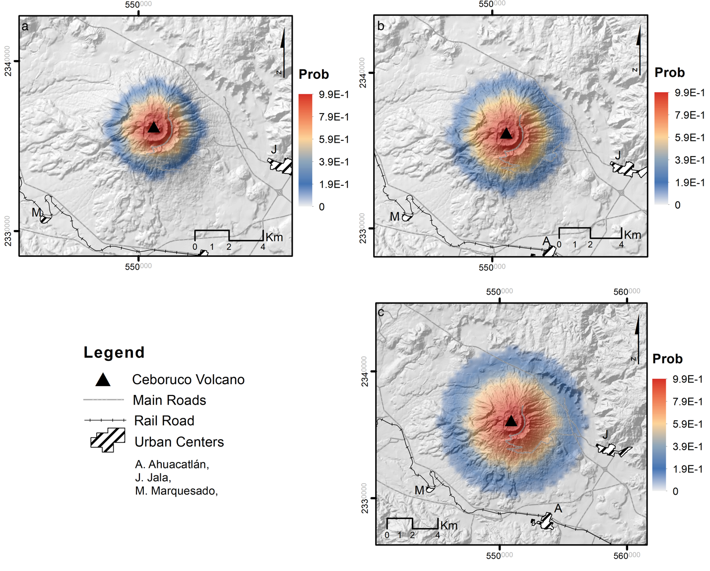
Supplementary Information Figure 1. The conditional probability maps showing the areas affected by volcanic ballistics given: a) a small eruption (S1), b) a moderate eruption (S2) and c) a large eruption (S3) from the central vent.

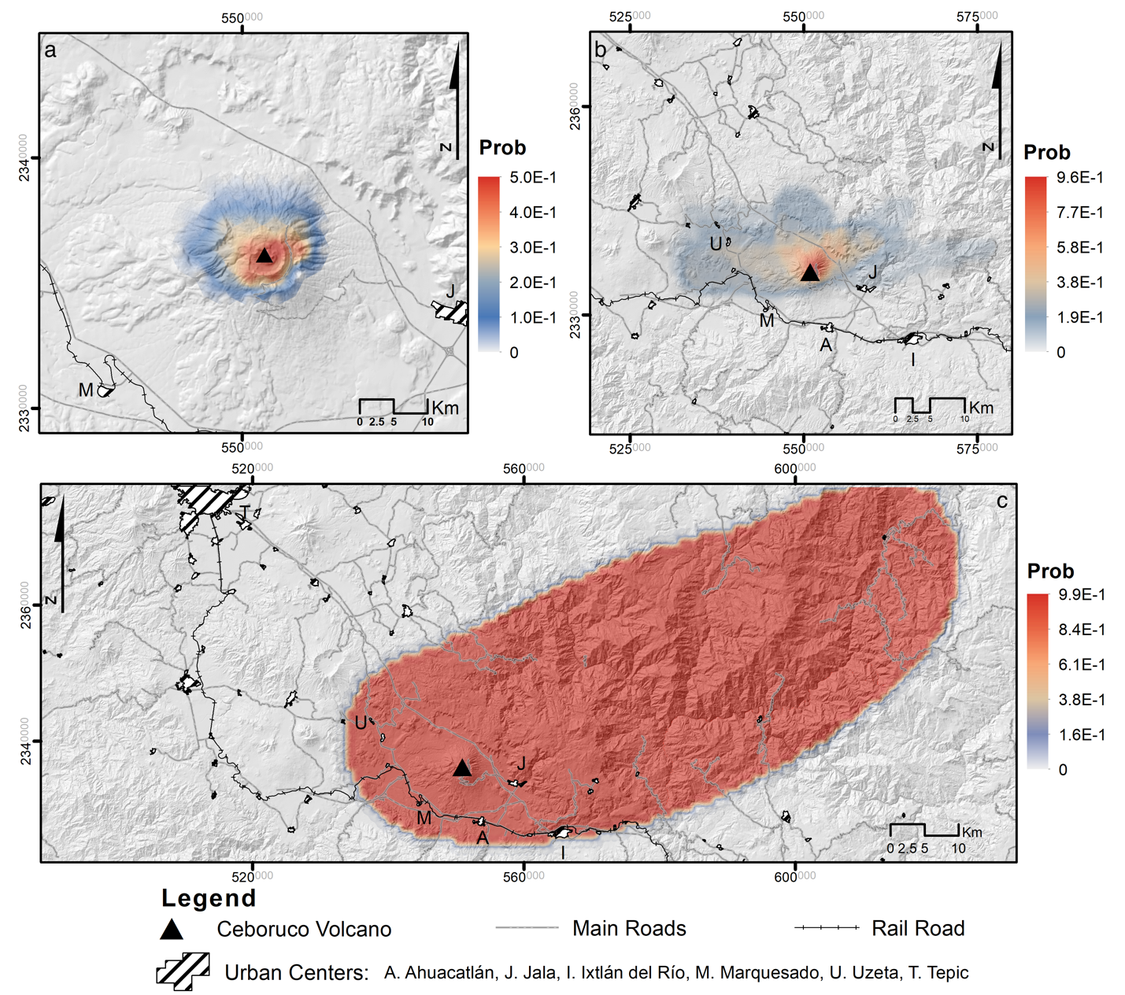
Supplementary Information Figure 2. The conditional probability maps showing the areas affected by tephra fallout given: a) a small eruption (S1), b) a moderate eruption (S2) and c) a large eruption (S3) from the central vent.

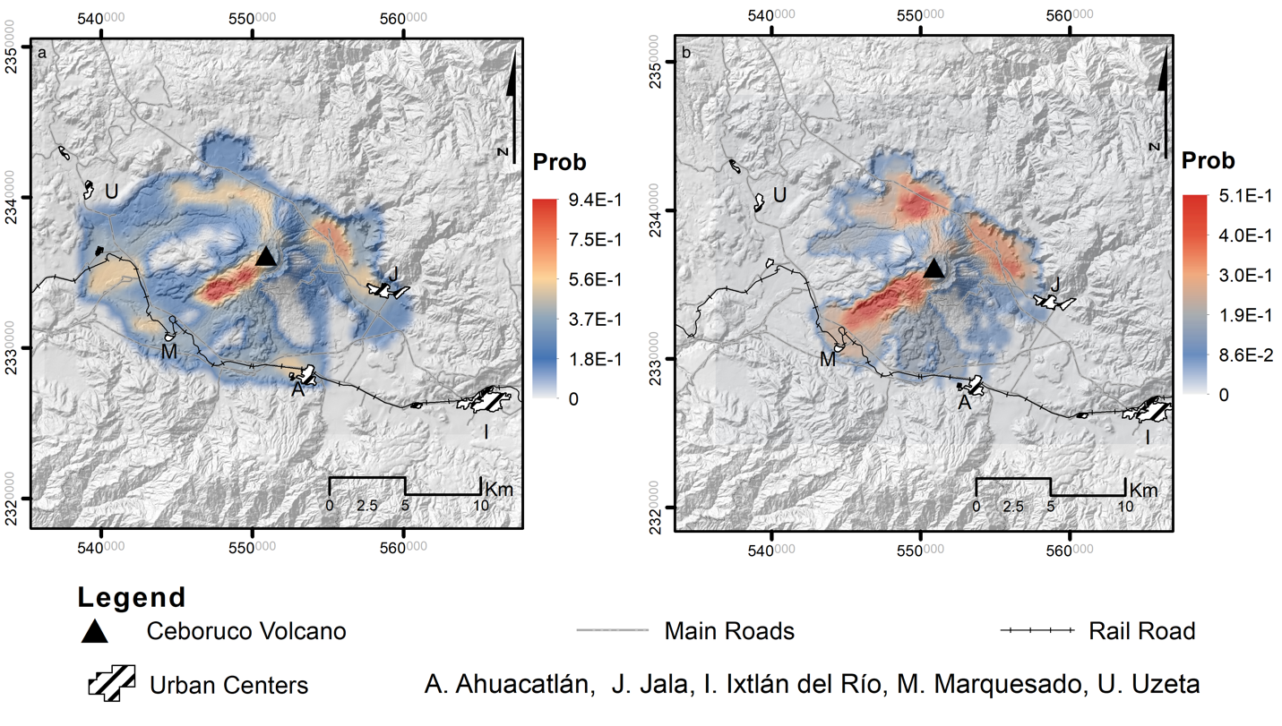
Supplementary Information Figure 3. The conditional probability maps showing the areas affected by lava flows given: a) a small eruption (S1) and b) a moderate eruption (S2) from the central vent.

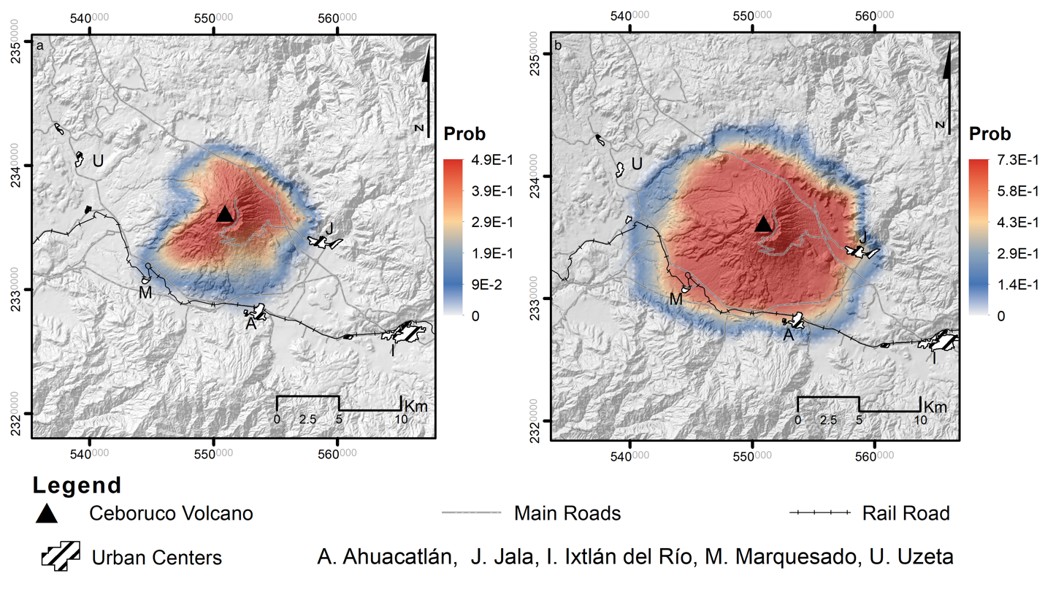
Supplementary Information Figure 4. The conditional probability maps showing the areas affected by pyroclastic density currents given: a) a moderate eruption (S2) and b) a large eruption (S3) from the central vent.

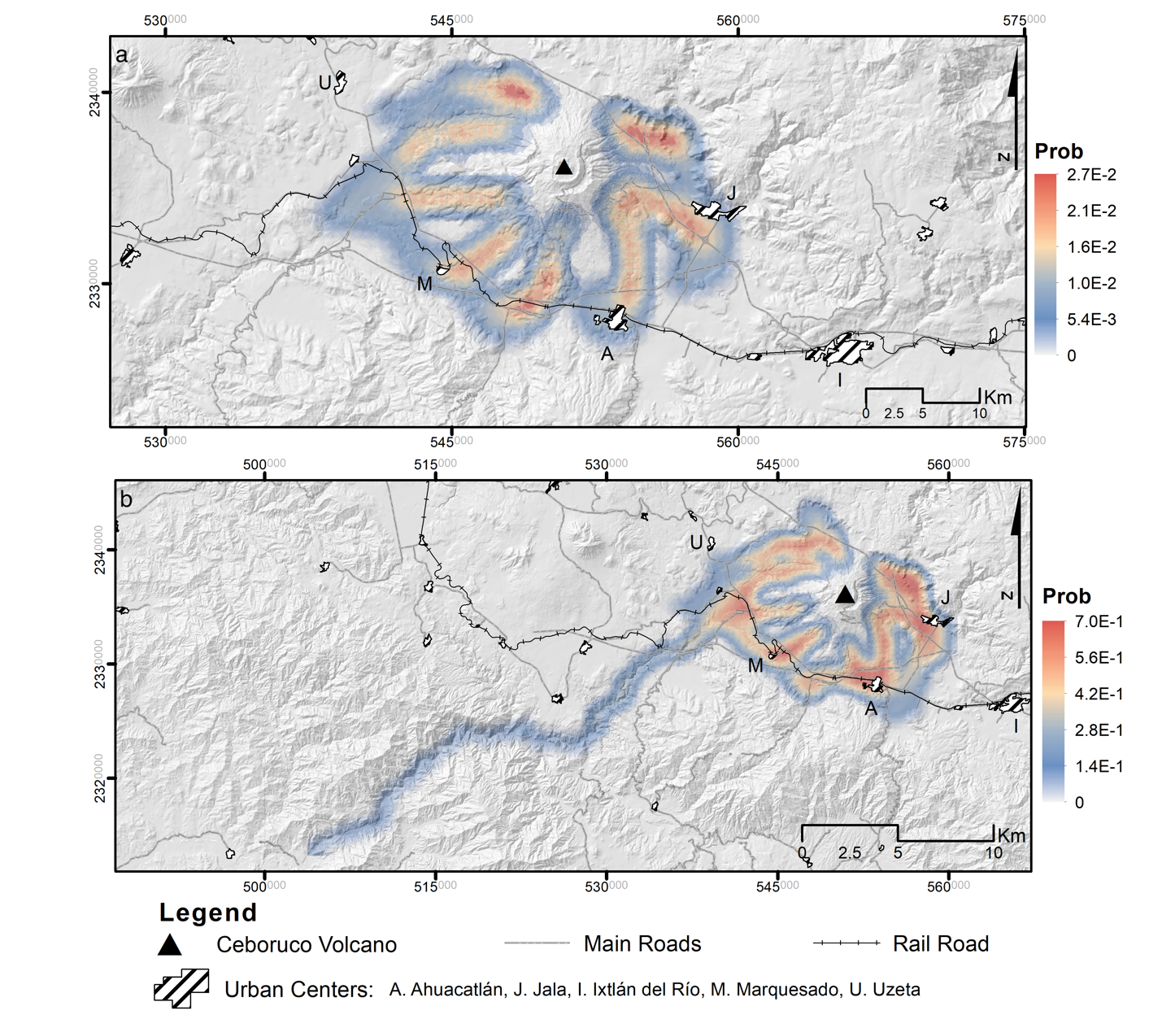
Supplementary Information Figure 5. The conditional probability maps showing the areas affected by lahars given: a) a moderate eruption (S2) and b) a large eruption (S3) from the central vent.

