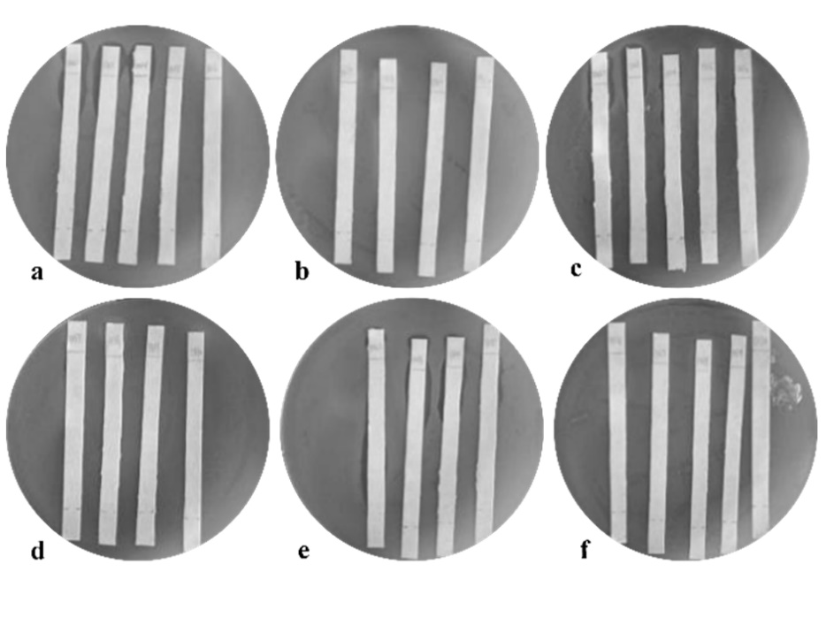
Fig. S1 Determination of ionic characteristics of antibacterial active substances by pH paper chromatography (a. 50% methanol: pH 2.2-6; b. 50% methanol: pH 7-10; c. 50% ethanol: pH 2.2-6; d. 50% ethanol: pH 7-10; e. 50% acetone: pH 2.2-6; f. 50% acetone: pH 7-10)

