Supplementary Material - Methods
Inclusion criteria for participants were 1) being outpatients in the age range of 18 to 65; 2) meeting criteria for a major depressive episode, with past or recurrent MDD, as determined through the Mini International Neuropsychiatric Interview (MINI); 3) response to treatment (monotherapy or combined therapy) for MDD during the current or most recent major depressive episode; 4) having a total score of 14 or less on the Montomery-Åsberg Depression Rating Scale (MADRS) at baseline and screening visits; 5) willingness and ability to complete self-reported assessments on a specialized smartphone used for the study (LogPad®), which required fluency in English; 6) willingness to wear an actigraph device throughout the duration of the study.

Exclusion criteria were as follows: 1) a primary Axis I diagnosis other than MDD; 2) lifetime diagnosis of either bipolar I or II disorder, MDD with psychotic features, schizophrenia, or schizoaffective disorder; 3) a significant Axis II diagnosis, such as borderline or antisocial personality disorder; 4) high risk of suicide, as determined through clinical judgment; 5) 6-month history of moderate or severe substance or alcohol use prior to the screening visit; 6) presence of significant neurological disorder, head trauma, or unstable medical conditions.

Participants continued their treatment regimen upon entry in the study as prescribed by the study psychiatrist throughout the study. Treatment adjustments were permitted as clinically indicated, and were documented through a case report form.

At the discretion of the study psychiatrist, medications for stable medical conditions, as well as vitamins, supplements, family planning methods, and over-the-counter medication for pain were permitted. These were disclosed by the patient and recorded in a note to file for the purpose of data analysis.

Criteria for relapse included participants’ having a MADRS score of >= 22 at one of the study visits, and confirmed during a relapse verification visit; antidepressant dose increase/addition; elevated QIDS scores; and judgment of clinicians who were blinded to the identity of the participants.

Actigraphy

Sleep onset latency was calculated by the algorithm, though it appeared as a value of 0 for the entire dataset. Therefore, this variable could not be used as part of the analyses.

In order to combine non-wear and sleep data from the different algorithms, we extracted the non-wear scores from the output files produced by the GGIR package, and mapped them to the epoch-aggregated minute-by-minute files. For each algorithm (i.e., Choi, Troiano and van Hees) we obtained a file which summarized the non-wear intervals and scoring mapped to the minute-by-minute epoch-aggregated files.

Development of a novel non-wear algorithm

We created a visualization of the data collected each day for these participants, where we included the following, based on 1-minute epochs: 1) vector magnitude (i.e., raw acceleration data), 2) sleep scoring (using the Cole-Kripke algorithm), 3) sleep interval (using the Cole-Kripke and Tudor-Locke algorithms), 4) wear according to the wear sensor, 5) wear according to the Choi algorithm; 6) wear according to the Troiano algorithm; 7) wear according to the van Hees algorithm; 8) wear according to the majority algorithm 9) a summary row indicating percentage of non-wear, as indicated by these 4 methods of detection.

Visual Quality Control

Independent scorers were trained through a series of training sessions, where scorers individually assessed the data visualization for one participants. The visualization file was reviewed day-by-day and each of the scorers identified where they believed there was false non-wear detection using a .csv file which indicated the non-wear periods. These files were reviewed in a group, and a consensus was reached regarding false non-wear detection. See figure S2 for a sample visualization of files used for visual quality control.

Combining Sleep and Non-wear
We combined sleep and non-wear at the epoch level, where each minute was scored for both sleep and non-wear, and at the interval level, where we calculated the number of minutes of missingness or non-wear according to the majority algorithm for each detected sleep interval, and percentage of minutes of missingness or non-wear according to the majority algorithm for each detected sleep interval.

Addressing Data Missingness
For instance, two R packages used to analyze actigraphy data-- the actigraph.sleepr package, which implements sleep scoring and detection algorithms, and the nparACT package, which computes non-parametric circadian activity rhythm analysis variables – require data to be complete at the time of analysis. In the context of actigraphy data, missingness can be thought of at two levels: at the epoch level, where individual epochs of data that are used to calculate aggregated variables (e.g., non-parametric circadian activity rhythm analysis variables) may be missing, and at the aggregated variable level, where aggregated variables for entire days/intervals may be missing.

If data were not available in the 3 days before and 3 days following the day with the missing data, we shifted the 7-day window accordingly (e.g., 2 days prior and 4 days following the day with missing data, if the 3 days prior day was not available for analysis).
This approach was applied to obtain interval and epoch-level sleep-wake scoring, and epoch-level non-wear scoring from the actigraph.sleepr package. Note that the imputed data were removed prior to running the non-wear statistics at the minute-by-minute level, and data were considered as missing.

Advantages of using raw data and epoch-aggregated data
The advantages of epoch-aggregated data include efficient storage and intuitive interpretability. In contrast, the raw accelerometer output is typically in units of gravity (g), and is more difficult to interpret due to its size (e.g., 30 samples per second in the case of our sampling method). Additionally, the processing of raw files is more computationally demanding. For example, the year’s worth of epoch-aggregated count data is 525 600 lines long with a file size of 67MB, but the raw gt3x file consists of nearly 956 million lines and takes up 15 GB of memory.

Relationship between sleep and depressive symptoms

Figure S3 illustrates the relationship between data missingness or non-wear with depressive symptoms

Figure S1: Participants in the Wellness Monitoring Study

Figure S2: Example of Visualization for Quality Control of Majority Non-Wear Algorithm
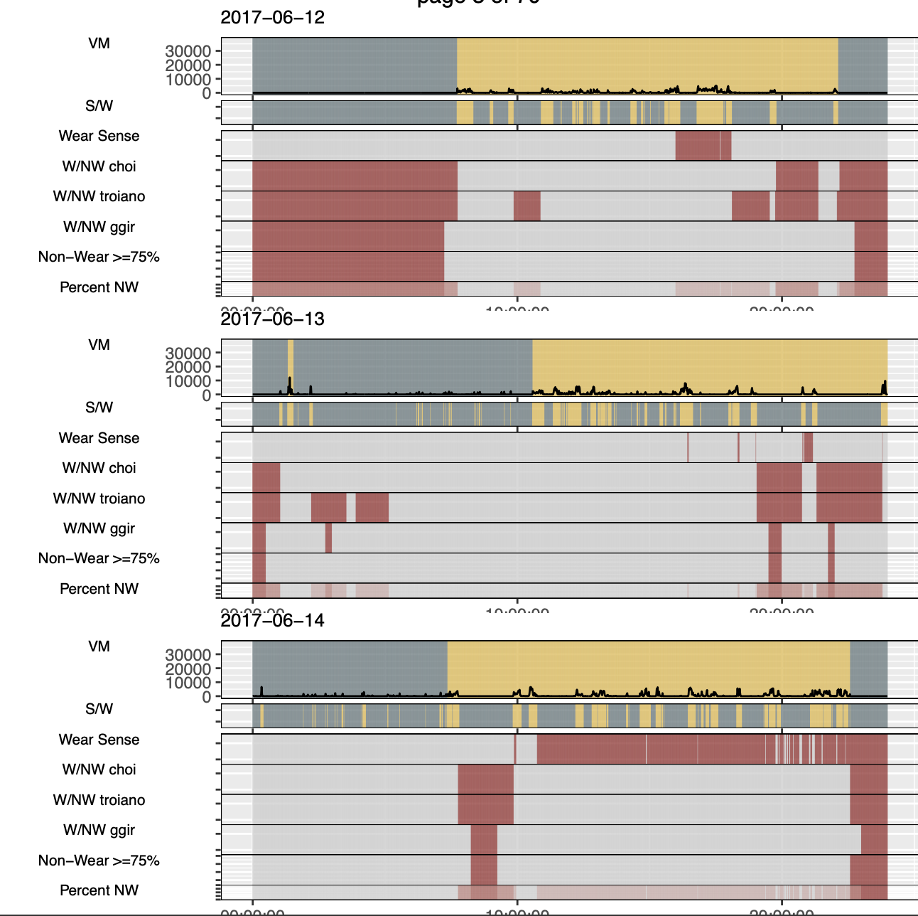
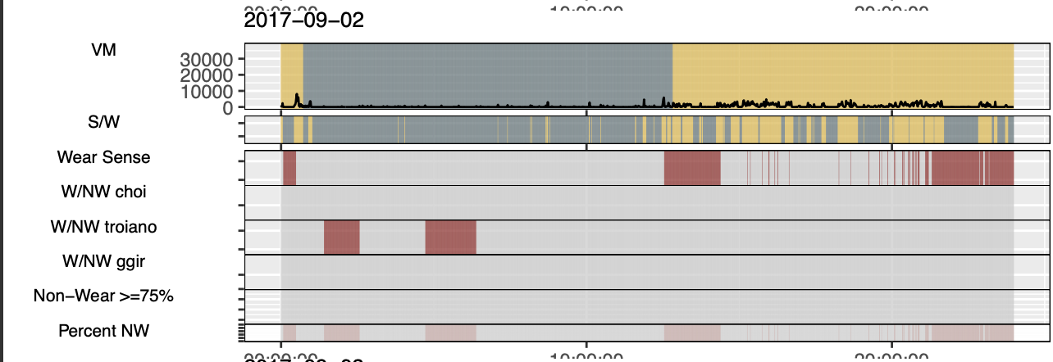

Figure S3: Relationship between Data Missingness or Non-wear and Depressive Symptoms
 | Average Per Day Per Period of Aggregation
- Missing | 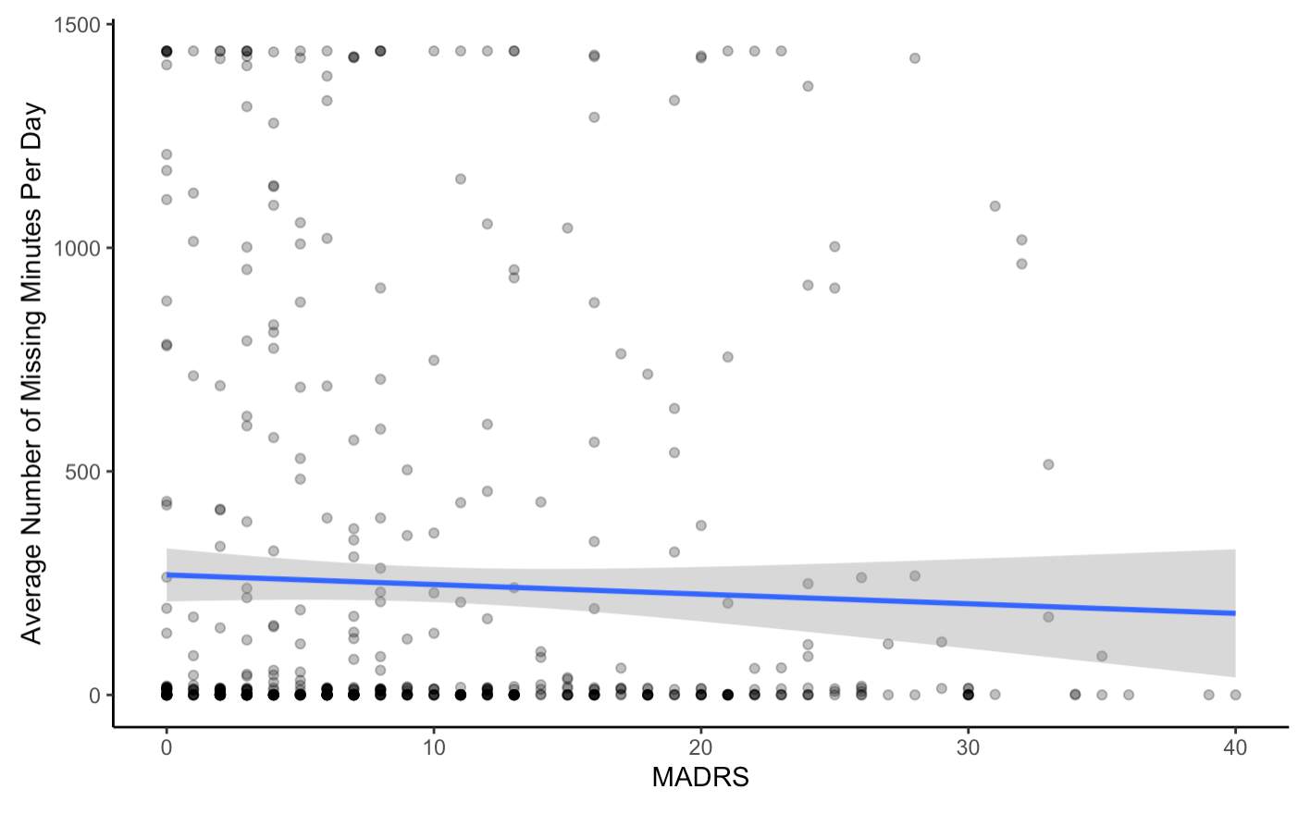  Rho=-0.04  P=0.36
- Majority Algorithm | 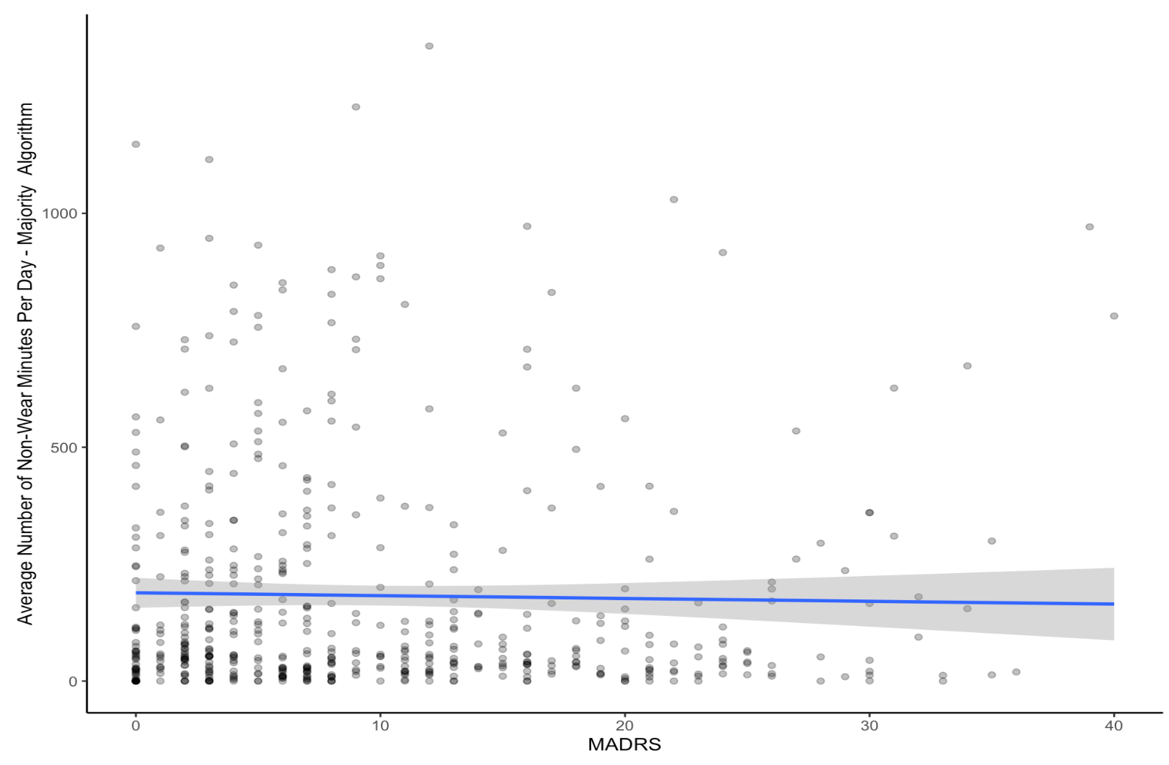  Rho=-0.02  P=0.63
- Choi | 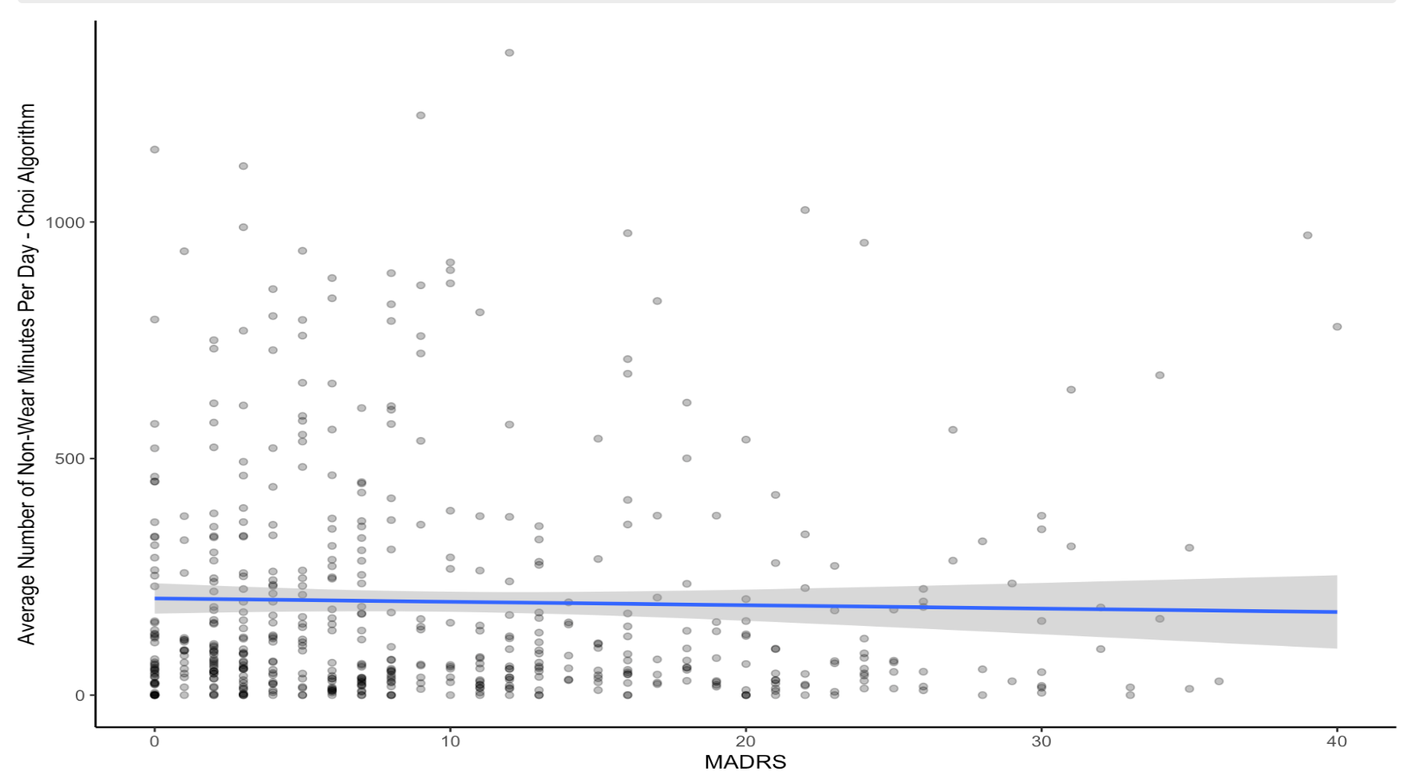  Rho=-0.03  P=0.57
- Van Hees algorithm | 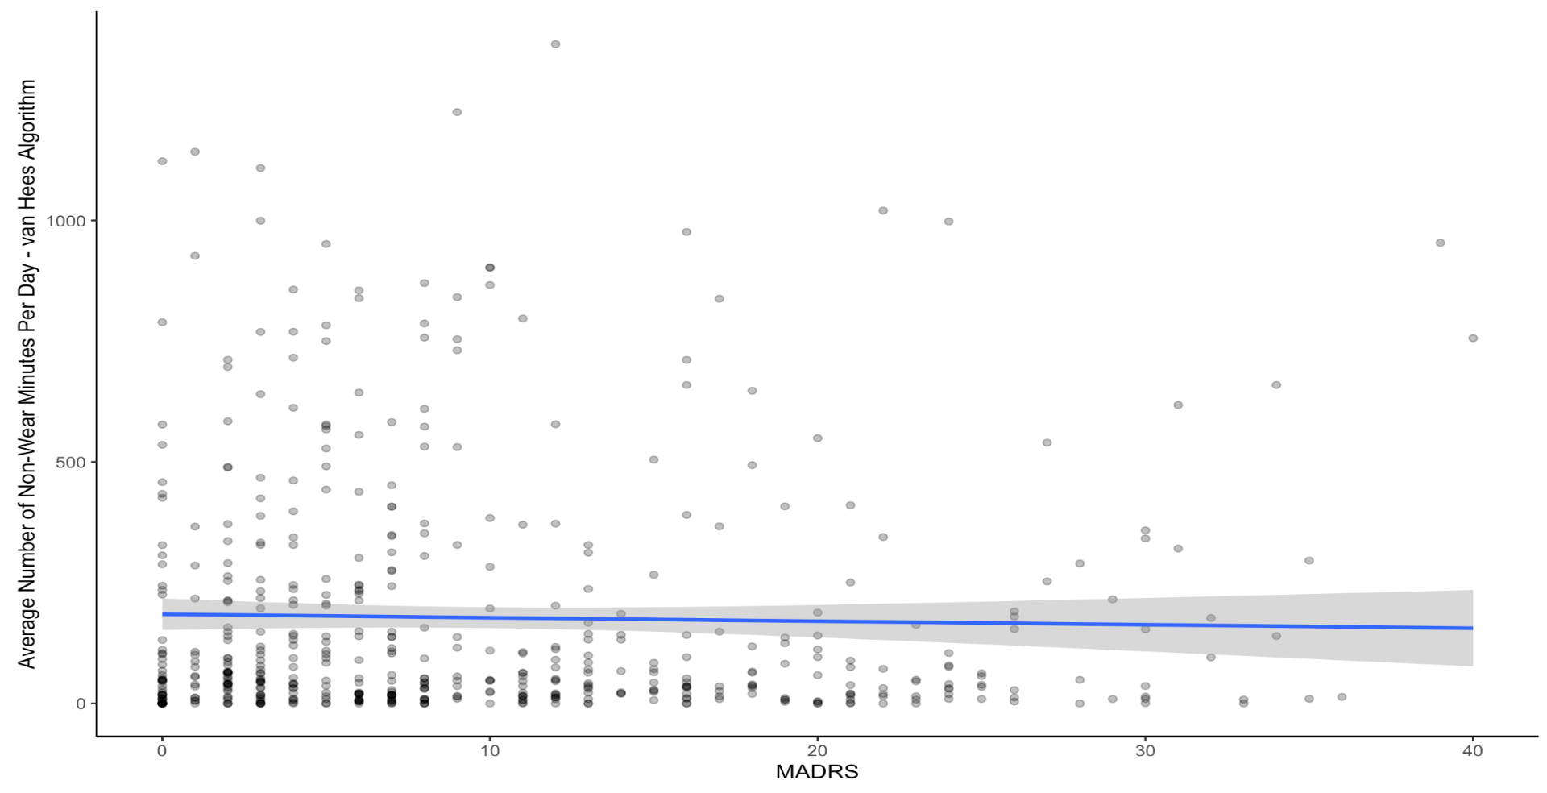  Rho= -0.02  P=0.57
- Wear Sensor | 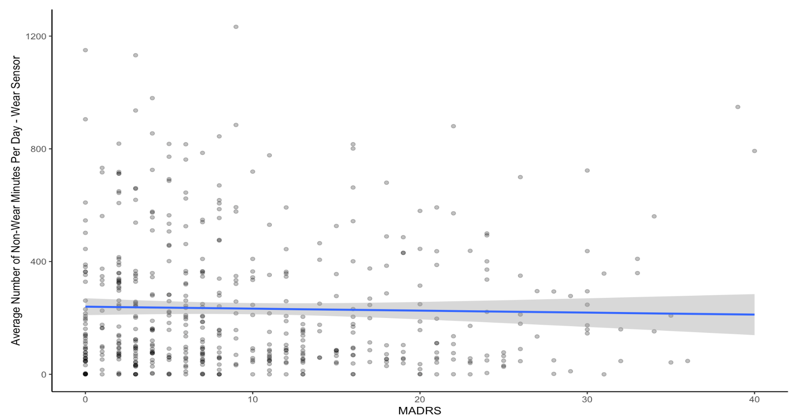  Rho=-0.03  P=0.55

Figure S4: An illustration describing thresholding approach for excluding sleep intervals for the sensitivity analysis. A total of 200 thresholds for excluding sleep intervals which overlapped with non-wear, and their combination with thresholds of number of hours of data per day for the day to be considered valid. We assessed whether these thresholds impacted the relationship of individual sleep metrics with depressive symptoms. Overlap thresholds were tested in 10% increments, ranging between <10% overlap and 100% overlap of sleep intervals with non-wear intervals. Valid day thresholds were tested in hourly increments ranging from >6 valid hours to 24 valid hours and all collected data, where a day had to have at least this number of hours of data available to be considered valid. Sleep intervals were detected by the Cole-Kripke and Tudor Locke algorithms. Wear/non-wear intervals were detected by 3-method majority algorithm.

