Supporting information for

Meshy-metal Evaporator with Enhanced Vapor Diffusion Making the Better of Environment Energy

Yifan Liª, Yuanying Niª, Chengcheng Liª, Huihui Wangª, Jieqiong Wangª, Zhuwei Gaoª, Dun Wangª, Wei Huangª*, Mingxin Zhangª*, and Zhongxin Liuª*

ª State Key Laboratory of Marine Resource Utilization in South China Sea, Hainan Provincial Key Lab of Fine Chemistry, School of Chemical Engineering and Technology, Hainan University, Haikou, Hainan 570228, P. R. China.

*Corresponding authors:
huangwei@hainanu.edu.cn (W. Huang)
zmx@hainanu.edu.cn (Mingxin Zhang)
liuzhongxin@hainanu.edu.cn (Zhongxin Liu)
Content
1. Supplementary Figures. 1
2. Assessment of sustainability 9
3. Analysis of the energy utilization efficiency 11
3.1 Calculation of the energy demand 11
3.2 The calculation of energy balance 11
3.3 Analysis of the energy utilization efficiency 12
3.3.1 Analysis of the solar energy utilization efficiency 12
3.3.2 Analysis of the wind energy utilization efficiency 12
4. The calculation of theoretical water yield 14
5. Experimental section 17
6. References 19

1. Supplementary Figures.
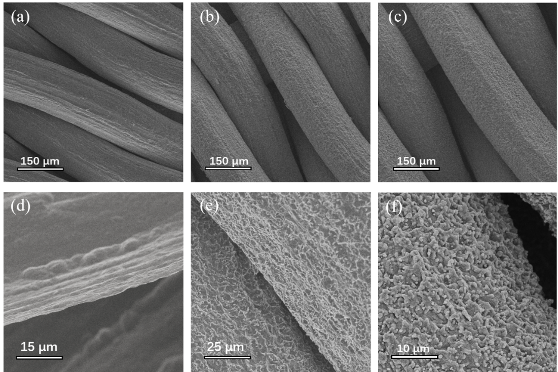
Fig. S1. Morphologies and structures of the Ti mesh and meshy MoS₂/Ti: (a,d) SEM image of the original Ti mesh. (b,e) The oxalic acid activated Ti mesh. (c,f) Synthetic meshy MoS₂/Ti.
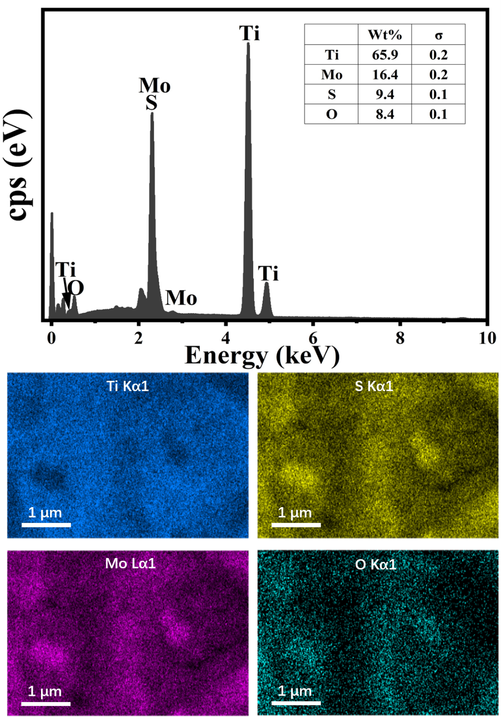
Fig. S2. EDS mapping shows the mass distributions of element Ti, Mo, S and O of meshy MoS₂/Ti.

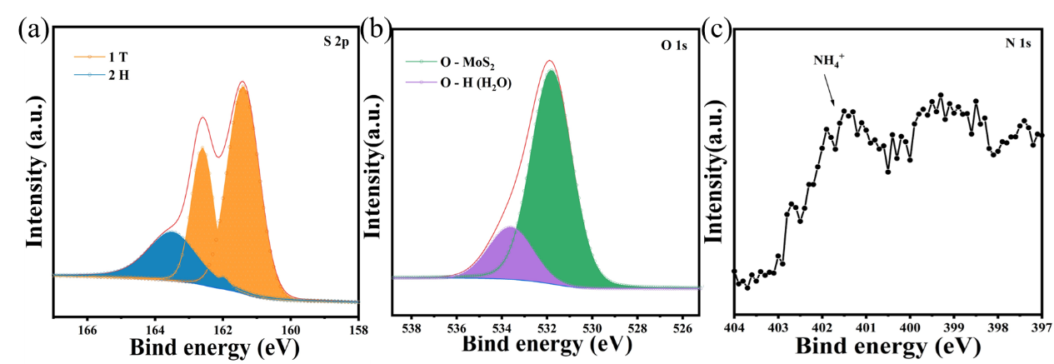
Fig. S3. XPS spectrum. (a) S 2p, (b) O 1s, and (c) N 1s of meshy MoS₂/Ti [1-3].

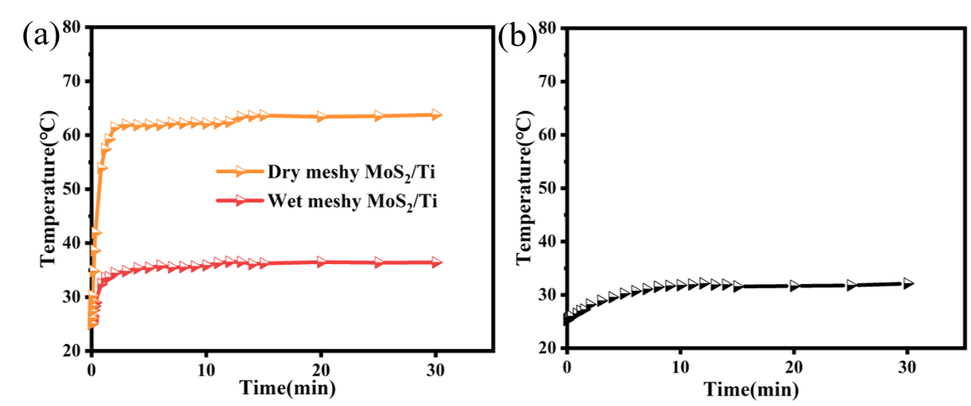
Fig. S4. The temperature response profiles of (a) meshy MoS₂/Ti and (b) PLA framework under one sun.

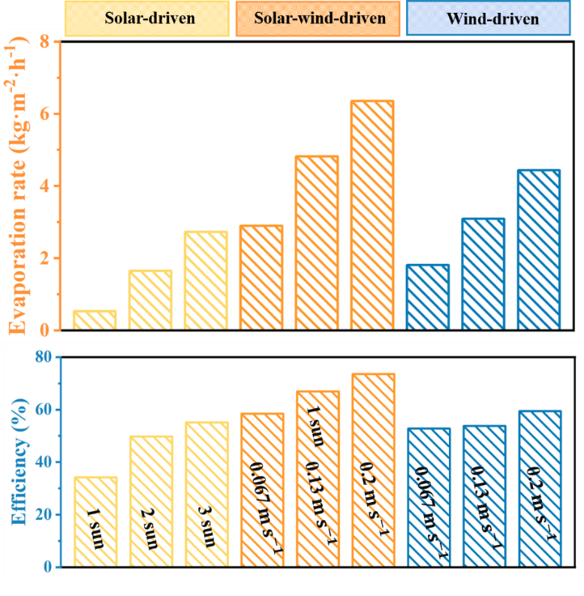
Fig. S5. The water evaporation rate and the energy conversion efficiency under different conditions. (The black numbers in the figure represents the test conditions.)
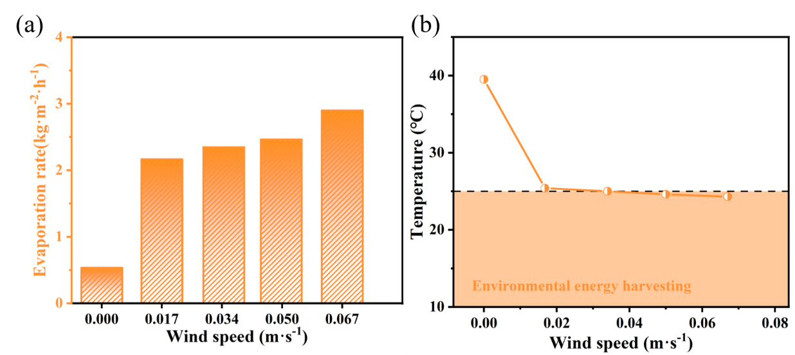
Fig. S6. The temperature at the top of meshy MoS₂/Ti with different airflow rates under one sun. It can be seen that airflow rate lower than 0.034 m s⁻¹, the temperature of meshy MoS₂/Ti is higher than the airflow temperature, which induces extra energy-loss. While airflow rate is higher than 0.034 m s⁻¹, the energy from air can be absorbed by the material for the temperature of meshy MoS₂/Ti is lower than air-flow temperature.

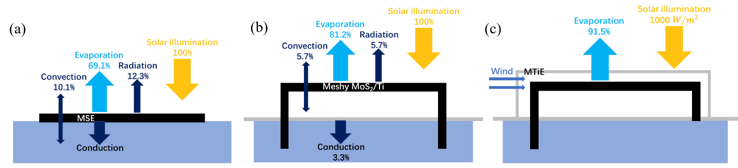
Fig. S7. Energy balance and heat-loss diagram of the (a) MSE (MoS₂-based solar evaporator) under one sun. MSE is MoS₂ evaporator made by Ye’ group[4], (b) meshy MoS2/Ti and (c) MTiE under one sun with 0.034 m s-1 airflow. Calculation details in section S2.3.

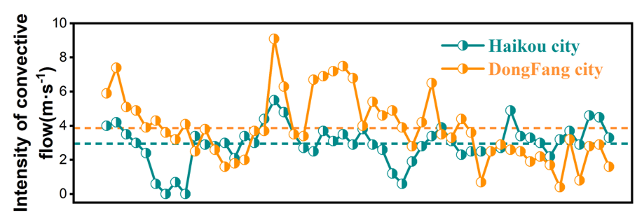
Fig. S8. The wind speed change at Haikou City and Dongfang City, Hainan Province. The data intercepted the actual wind speed test every 4 hours in one week, the average wind speed in these two regions is all more than 3 m s⁻¹. Data source: National Meteorological Center.

Modeling for vapor diffusion distribution of interconnected porosity
We used Fluent® software to simulate and establish a model of vapor distribution in interconnected porosity. The model is obtained by simplifying the cross-section of the metal mesh as shown in the figure below, and the diameter of the metal wire and the size of the pore were determined by electron microscopy as 200 μm and 150 μm, respectively. The evaporation wall and convection temperatures were set at 298.15K, and the airflow passed through the pores from left to right. The initial humidity of the airflow was set at 50%RH, and the humidity of the pore wall was set at 100%RH. The vapor distribution in the pores under convective flows of 0.2 m s⁻¹.

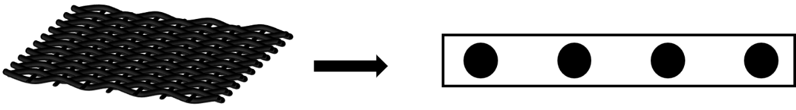
The model was simplified according to the structure and SEM of metal mesh.

For the closed system, without the introduction of airflow, and the humidity of the air in the whole space is 100%RH, which seriously affects the phase change process of water, which is the reason for the decrease of evaporation performance from 1.6 kg m⁻² h⁻¹ to 0.5 kg m⁻² h⁻¹ in this work. After the airflow is introduced, the high concentration of vapor is effectively diffused, and the thickness of boundary layer is also effectively reduced, thus promoting the phase transformation process, which is a double improvement for the evaporation performance.
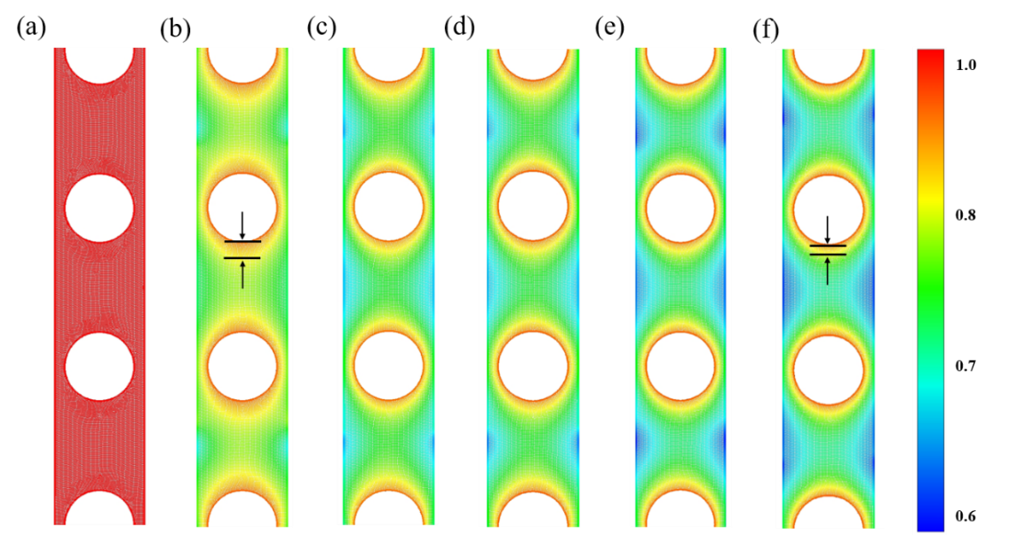
Fig. S9. Distributions of vapor concentration in pores with flow at different incident angles. (a) The absence of airflow. (b-f) At the incidence angles of 0°, 30°, 45°, 60° and 90°, respectively. The boundary layer thickness is defined as the distance between the evaporation wall and the point where the vapor concentration is 80% of the saturated vapor concentration. It can be clearly seen that no matter which direction the airflow flows, the boundary layer thickness can be effectively reduced.

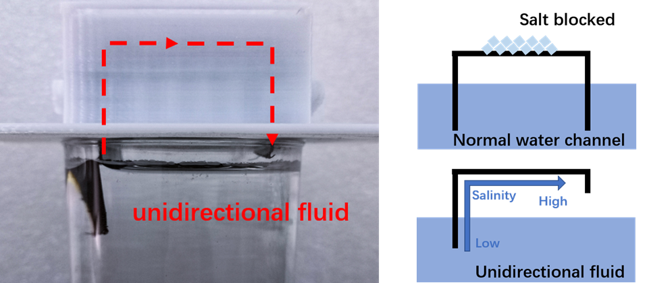
Fig. S10. Image of unidirectional fluid salt-resistant devices, indicating the fluid flow.

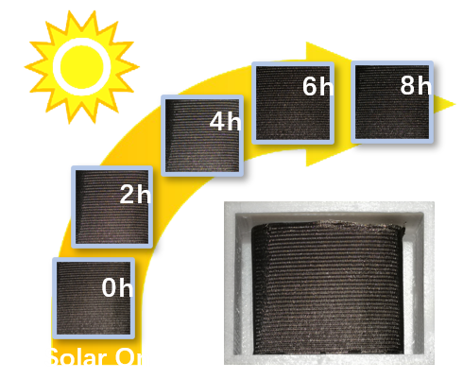
Fig. S11. Photo images of the meshy MoS₂/Ti during 8 hours of continues operation under the conditions of 1 sun + 0.2 m s⁻¹ airflow in 3.5 wt% simulated seawater. It can intuitively see that there is no salt crystallization on the surface of the meshy MoS₂/Ti.
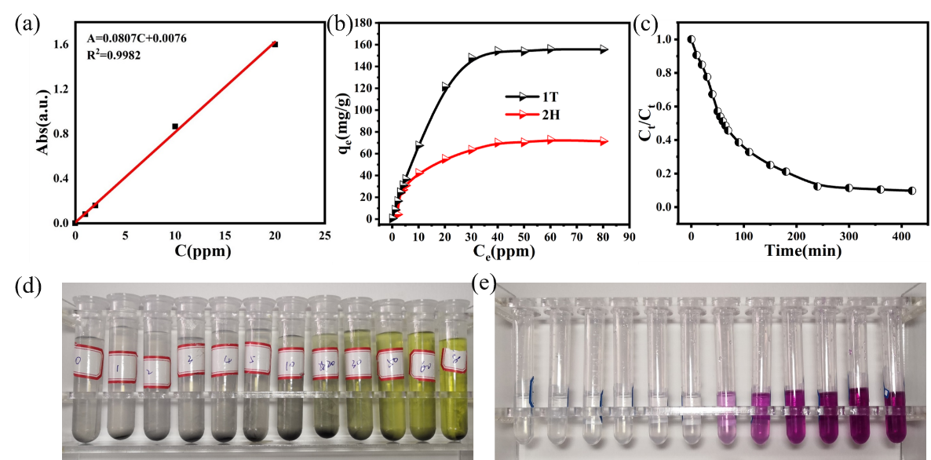
Fig. S12. Performance of adsorbents on removal of Cr (VI). (a) The standard curve of DPC method. (b) Adsorption isotherm of chromium on two MoS₂ samples. (c) Adsorption kinetic plot of chromium by 1T-MoS₂. (d) Photo of 0.25g·L⁻¹ 1T-MoS₂ powder adsorbed in 0-80 ppm Cr (VI) ions solution for 24 hours. (e) The complexation changes of different solutions with complexing agent can be seen that the Cr (VI) ion solutions below 5ppm are almost all removed by 1T-MoS₂ powder.

2. Assessment of sustainability
Global warming potential (GWP), which can be applied to assess the sustainability of industrial technologies is gaining increasing attention from industry in facing the severe global warming. However, few GWP studies have been carried out to assess the sustainability of solar evaporation systems and their superiority in comparison to the current mainstream desalination technologies, such as reverse osmosis (RO) and low temperature-multiple effect distillation technology (LT-MED). Therefore, to assess the environmental impacts of the MTiE, the preliminary life cycle assessment (LCA) is conducted based on ISO standards 14040[5] to make a comparison of present evaporator with three other seawater desalination systems: the Cu_{x}S/Cu foam evaporator (SCF), the RO system, and the LT-MLD system. Since the systems evaluated in this study are not included in the LCI database or ecoinvent v3.1 database, each system needs to be built and compared horizontally based on industry and literature data. It is found that the major Carbon Dioxide Equivalent (CO_{2e}) of the two evaporators comes from the metal substrate. The results of IPCC 2013 20a method for each system based on the number of times of uses of each evaporator before replacement is shown in Fig. S13a, the MTiE performs better than the SCF, emitting two orders of magnitude lower CO_{2e} than that of the SCF. The GWP of the system decreases as the lifetime increases and when the lifetime exceeds 1500 uses, the system is more sustainable than the lifetime of 25 years of RO and LT-MLD[6]. Moreover, the marine aquatic ecotoxicity is particularly high for RO and LT-MLD systems, which is unfriendly to the marine environment. This comparison shows that the MTiE is a more environmentally friendly choice alternative to current water treatment systems. Based on the preliminary analysis (Fig. S13b), the production of Ti accounts for 40% of the total CO_{2e}. Although primary environmental impacts of MTiE comes from the evaporator itself, this process has not been optimized. In the future, less emission and stable substrate will be selected and the optimized assemble process will be carried out for the device, committing to produce a more environmentally friendly seawater desalination system. Finally, we propose a conceptual solar-wind-driven evaporation system in Fig. S13c. Wind energy is converted into electricity, stored energy in flywheels, and mechanical energy to drive small downstream fans by wind turbine generator as upstream devices. The electric energy can be used to drive the downstream fans under no wind, and the flywheel can convert the stored energy back to wind turbine generator, so as to generate a continuous wind, and combined with the solar energy, to achieve the continuous efficient production capacity of the evaporator, which might provide an all-green and sustainable high-yield way for the extraction of freshwater in the near future.
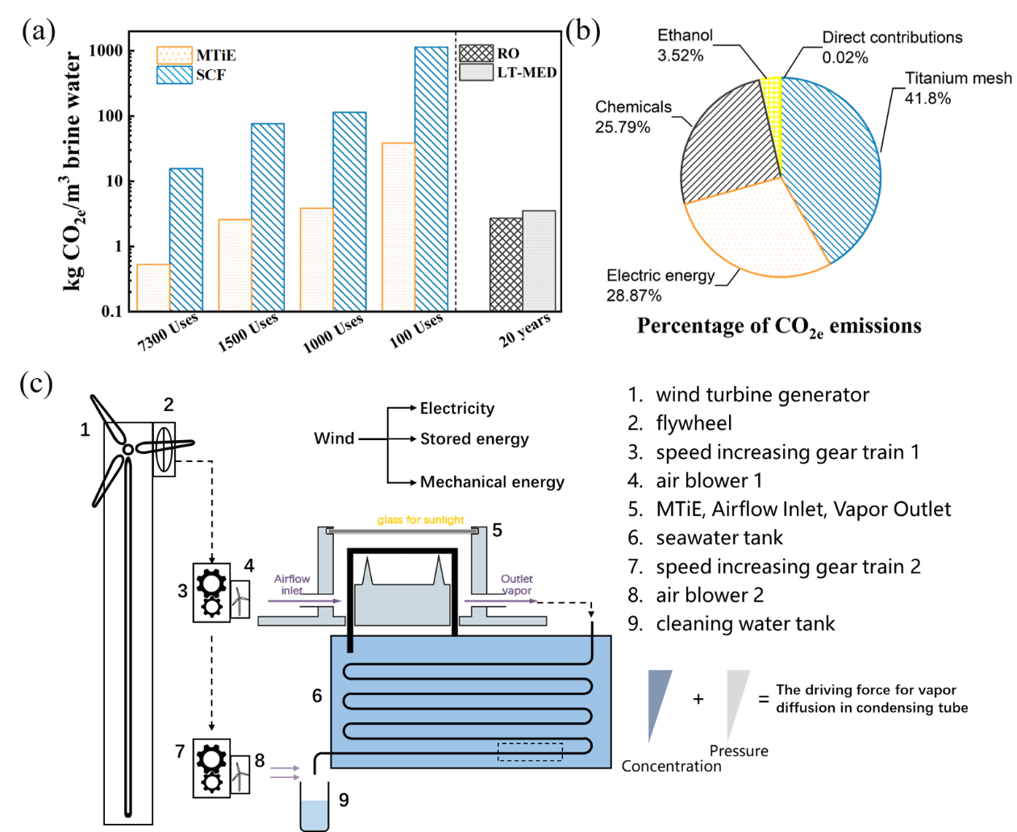
Fig. S13. (a) The global warming potential of the MTiE, the Cu_{x}S/Cu foam evaporator (SCF), as it relates to the lifetime of each evaporator, as well as the global warming potential of reverse osmosis (RO) system and low temperature-multiple effect (LT-MED) system. (b) The relative CO_{2e} emissions of each process or material involved in the production of MTiE. (c) Conceptual solar-wind conjugate water treatment system.

3. Analysis of the energy utilization efficiency

3.1 Calculation of the energy demand
Our indoor evaporative tests were performed under a temperature of 25±1 ℃ and humidity of 50±3% RH.
$h_{LV}=h_{w-v}+h_{∆T}$ (Equation S1)
Where $h_{LV}$ ($J·g^{-1}$)is the enthalpy of evaporation of water, $h_{w-v}$is the phase change of liquid to water (2260 J g⁻¹) under 25℃, $h_{∆T}$ is sensible heat from 25 to $T_{top}$ °C with specific heat of 4.2 J g⁻¹ K⁻¹, and $T_{top}$ is the temperature of the top of MTiE under different conditions.

3.2 The calculation of energy balance
(1) Solar to vapor efficiency
Based on a previously reported method, the solar-to-vapor efficiency was calculated using the equation:
$η_{solar energy}=\frac{\overline{m}h_{LV}}{P}$ (Equation S2)
In which $η_{solar energy}$ is evaporation efficiency of solar energy, $\overline{m}$is the evaporation rate, $h_{LV}$ is the total enthalpy of sensible heat (47.9 J g⁻¹, from $25$ to 36.4 ℃ with specific heat of 4.2 J g⁻¹ K⁻¹ ) and phase change of liquid to water ( 2260 J g⁻¹ ), and 𝑃 is the incident laser power density(1000 W m⁻² ). So the evaporation efficiency is 81.2% of solar flux.

(2) Radiation loss
The Radiation loss can be calculated via the equation:
$Radiation loss=\frac{∅}{AP}=\frac{εσ(T_{a}^{4}-T^{4})}{P}$ (Equation S3)
In which $∅$( W m⁻² ) donates the radiation heat flux, can be calculated by Stefan-Boltzmann equation: $∅=Aεσ(T_{a}^{4}-T_{}^{4})$, where A ( m² ) is the evaporation area, σ is the Stefan-Boltzmann constant$(5.67×{10}^{-8} W m^{-2} K^{-4}$), ε is the emissivity of material supposed as the maximum emissivity of $0.93$ about meshy MoS₂/Ti, 𝑃 is the incident laser power density (1 sun in this paper). Therefore, the radiation heat flux is 67 W m⁻² , which is $6.7\%$of the solar flux.

(3) Conductive loss
The conduction loss was calculated according to the flowing Equation:
$Conductive loss=\frac{Q}{AP∆t}=\frac{Cm∆T}{AP∆t}$ (Equation S4)
In which Q is heat loss, C is the specific heat capacity of water (4.2 J g⁻¹ K⁻¹), m (85 g ) is the weight of water used in the paper, and ΔT (0.3$K$) is the temperature difference of pure water after and before solar illumination under 1 sun after 1 h. According mentioned above, the conduction heat loss was calculated ~33 W m⁻², which is ~3.3$\%$ of solar flux.
(4) Convection loss
The convection loss is caused by the flowing fluid (i.e. air) around the evaporator, which can be calculated by the Newton’s Law of Cooling:
$ψ=ξAΔT$ (Equation S5)
$Convection loss=\frac{ψ}{AP}=\frac{ξΔT}{P}$ (Equation S6)
Where 𝜓 is the thermal energy, $ξ$= 5 W m⁻² K⁻¹represents the convection heat transfer coefficient, 𝛥𝑇 represents the temperature difference between the surface temperature of the evaporator and the ambient temperature, which is 11.4 K here. Therefore, the heat loss by convection is calculated to be $5.7\%$ in our experiment.

3.3 Analysis of the energy utilization efficiency

3.3.1 Analysis of the solar energy utilization efficiency
Just like the formula mentioned in the text:
$η=vh_{LV}/Q_{in}$ (Equation S7)
where $η$ ($\%$) is energy conversation efficiency, v (kg m⁻² h⁻¹) is the water evaporation rate, $h_{LV}$ (J g⁻¹) is the enthalpy of evaporation of water and $Q_{in}$ (J) is the solar energy.

3.3.2 Analysis of the wind energy utilization efficiency
The energy loss of solar energy was analyzed through the previous section energy balance analysis. When the wind introduced into the system, the energy loss was too intricate, so we won’t discuss it here and redefined the total energy conversion efficiency as (The airflow velocity used in this work is the friction velocity of the meshy MoS₂/Ti):
$η=\frac{v_{S}}{v_{solar}+v_{win}}$ (Equation S8)
where $v_{S}$ is the evaporation rate of MTiE, $v_{solar}$ and $v_{win}$ are the evaporation rates, assuming 100% utilization of sunlight and airflow, respectively.

The $v_{solar}$ can be calculated via the equation:
$v_{solar}=Q_{in}/h_{LV}$ (Equation S9)
The calculation of $v_{win}$ is as follows[7, 8]:
$v_{win}=\frac{D(C_{s}-C_{a})}{δ}$ (Equation S10)
In which D (m² s⁻¹) donates the vapor diffusion coefficient, ΔC=$C_{s}-C_{a}$ is the vapor concentration difference (kg m⁻³) and $δ$ is the thickness of boundary layer. There three parameters are estimated empirically by:
$δ=\frac{5v}{u_{*}}$ (Equation S11)
The air kinematic viscosity $v$ (m² s⁻¹), the vapor diffusion coefficient D (m² s⁻¹) can be parameterized based on mean air temperature, T (K), as follows:
$D=\left(1.49×{10}^{-7}\right)T-1.96×{10}^{-5}$ (Equation S12)
$v=\left(9×{10}^{-8}\right)T-1.13×{10}^{-5}$ (Equation S13)
The $u_{*}$ is the friction velocity (m s⁻¹):
$u_{con}m_{1}=u_{*}m_{2}$ (Equation S14)
Where $u_{con}$ is input flow velocity, $m_{1}$ and $m_{2}$ are the sectional area ($m^{2}$) of inlet pipe and device.
$C_{s}-C_{a}=\frac{M_{w}}{R}(\frac{P_{s}(T_{a})}{T_{a}}-RH\frac{P_{s}(T)}{T})$ (Equation S15)
Where $M_{w}$($kg/mol$) is the molar mass of water (≈0.018 kg mol⁻¹), R (J mol⁻¹ K⁻¹)is the universal gas constant (8.314 J mol⁻¹ K⁻¹), T_{a} (K) is the surface temperature, since the surface temperature of the material is not much different from room temperature during evaporation, we have approximated T_{a} and T. P_{s} (Pa)is the vapor pressure at the evaporating surface assumed to be the saturation vapor pressure at the surface temperature, and $RH$ is the air relative humidity.

The vapor pressure Ps (Pa) is computed using the Clausius-Clapeyron relation as:

$P_{S}(T)=611exp⁡(\frac{λM_{w}}{R}(\frac{1}{273}-\frac{1}{T}))$ (Equation S16)

where $λ$ (J g⁻¹) is the latent heat of vaporization (2450 J g⁻¹ under atmospheric pressure).

The $v_{solar}$ and $v_{win}$ are calculated to be 1.55 kg m⁻² h⁻¹ and 7.098 kg m⁻² h⁻¹ for 0.2 m s⁻¹ airflow (1.72 kg m⁻² h⁻¹ for 0.034 m s⁻¹, 3.02 kg m⁻² h⁻¹ for 0.067 m s⁻¹ and 5.337 kg m⁻² h⁻¹ for 0.13 m s⁻¹), respectively. The energy conversion efficiencies under different test conditions are summarized in the following table.

Table S1. Summary of the energy conversion efficiency
 | 0.067 m s⁻¹ | 0.13 m s⁻¹ | 0.2 m s⁻¹
Under dark | 52.8% | 53.8% | 59.4%
Under 1 kW m⁻² illumination | 58.4% | 66.9% | 73.5%

4. The calculation of theoretical water yield
Our indoor evaporative tests were performed under a temperature of 25±1 and humidity of 50±3%RH.
The volume of air V (m⁻³) crossing through the device:
$V=vtA_{l}$ (Equation S17)
Where t(s) is time of airflow injection, $A_{l}$(m²) is the the areas of longitudinal section of MTiE.
The amount of vapor m (g) produced by evaporation:
$m=EA_{p}t$ (Equation S18)
Where E is the evaporation rate, $A_{p}$(m²) is the areas of projection plane of MTiE.
Increased moisture content $∆\dot{m}$(g m³) of the airflow through the evaporation region:
$∆\dot{m}=\frac{m}{V}=\frac{EA_{p}}{vA_{l}}$ (Equation S19)
Total moisture content $\dot{m_{T}}$ (g m³) of the airflow at the outlet
$\dot{m_{T}}=∆\dot{m}+{\dot{m}}_{original}$ (Equation S20)
Where ${\dot{m}}_{original}$ is moisture content of air at the room temperature.
In a water bath temperature of 15℃, the moisture content that can be collected is
$\dot{m}=\dot{m_{T}}-\dot{m_{cool}}$ (Equation S21)
So the theoretical water yield is:
$E_{coll}=\frac{vA_{l}\dot{m}}{A_{p}}$ (Equation S22)

The $E_{coll}$are calculated to be 4.06 kg m⁻² h⁻¹ for 0.2 m s⁻¹ airflow (1.35 kg m⁻² h⁻¹ for 0.067 m s⁻¹ and 2.71 kg m⁻² h⁻¹ for 0.13 m s⁻¹ ), respectively. The collection radio under different test conditions is summarized in the following table.

Table S2. Summary of the water yield and collection ratio.
 | 0.067 m s⁻¹ | 0.13 m s⁻¹ | 0.2 m s⁻¹
Under 1 kW m⁻² illumination | 1.34 kg m⁻² h⁻¹ | 2.22 kg m⁻² h⁻¹ | 2.65 kg m⁻² h⁻¹
Collection radio | 99.3% | 81.9% | 65.3%

Table S3. Comparison of water yield and vapor-to-water efficiency of recent solar-thermal desalination system in literatures.
Water yield (kg·m⁻²·h⁻¹) | Vapor-to-water efficiency (%) | Ref.
2.1 | 0.525 | [9]
0.7* | 0.528 | [10]
0.87* | 0.37 | [11]
0.72 | 0.576 | [12]
1.72 | 0.65 | [13]
1.1 | 0.425 | [14]
0.4 | 0.746 | [15]
0.34* | 0.21* | [16]
1.1 | 0.26 | [17]
0.8 | 0.62* | [18]
0.25* | 0.24 | [19]
0.18* | 0.22 | [20]
2.4 | 0.65* | [21]
2.65 | 0.65 | This work
* Values estimated based data presented in corresponding reference.
Table S4. Comparison of the water evaporation rate and the energy conversion efficiency with representative reports.
Evaporation rate  $$(kg m^{-2} h^{-1})$$ | Friction velocity  ($m s^{-1}$) | Energy conversion efficiency | Ref.
10.9 | 6 | 3.4% | [22]
1.39 | 0.5 | 4% | [23]
14 | 3 | 7% | [24]
7.6 | 3 | 10.2% | [25]
5.67 | 3 | 12.8% | [26]
11.58 | 6 | 17.7% | [27]
14.5 | 2 | 25.4% | [28]
3.7 | 0.256 | 30.0% | [21]
6.4 | 0.2 | 73.5% | This work
Hence, we steadfastly deem wind injection has many virtues: in the first place, wind energy can be harnessed directly. Compared to electricity, wind energy can be directly used for evaporation, without the secondary conversion of energy. Secondly, there is the skillfully deflected. Even the maximum wind velocity (3.0 m s⁻¹) used in this paper corresponds to only 0.2 m s⁻¹ inside the device by equation $v_{1}*m_{1}=v_{2}*m_{2}$, in which, v, m are the convective velocity, sectional area, respectively.

5. Experimental section
Fabrication of the meshy MoS₂/Ti and assembly of the MTiE
Ti mesh with 0.6 mm of thick and 300 per liner inch (PPI) of average pores was first tailored into size of 3 cm×10 cm, and then washed with mixed diluent of nitric and hydrofluoric acid, ethanol, acetone and deionized water to remove the surface impurity. The meshy MoS₂/Ti was prepared by two steps, including the surface etching and the growth of defective MoS₂ solar absorber. Ti mesh was etched by 10 wt% oxalic acid solution in boiling state for 30 mins and then washed alternately with deionized water and ethanol. The defective MoS₂ solar absorber was in-situ grown on the etched Ti mesh by a hydrothermal method. Typically, 0.3863 g of H₃₂Mo₇N₆O₂₈ and 0.714 g of CH₄N₂S were added to a 100 mL beaker filled with 70 mL of deionized water and stirred for about 30 mins. Then, the mixed solution was transferred into a 100 mL Teflon-lined stainless-steel autoclave with etched Ti mesh immersed in, and maintained at 200 ℃ for 24 h. After the autoclave cooled to room temperature naturally, and the meshy MoS₂/Ti membrane was obtained by washing with deionized water several times to remove the excess solution.
The device was designed and modeled by Unigraphics NX software, and the model was printed by a 3D printer. The meshy MoS₂/Ti was folded into “Ո” shape and inserted into the device. Finally, a glass cover was sealed on the top, and the whole MTiE is finished
Characterizations
The morphologies and structures were characterized using a Hitachi S-4800 field emission scanning electron microscope (SEM). Transmission electron microscopy (TEM) and high-resolution transmission electron microscopy (HRTEM) micrographs were acquired using a JEOL 2100F microscope. The absorbance, the diffuse reflection and transmission across 250 to 2500 nm were measured by the ultraviolet–visible–near-infrared (UV-vis-NIR) spectrophotometer (PerkinElmer Lambda 750s) equipped with an integrated sphere for reflected light collection. Crystal diffraction analysis was performed by Rigaku Smart Lab X-ray diffractometer. The Raman spectrum was measured by Reflex in Via laser Raman spectrometer. Infrared spectra of the samples were measured by BRUKER T27 Fourier transform infrared spectrometer. Shimazu KRATOS X-ray photoelectron spectroscopy (XPS) was used to analyze the valence state and the electron chemical shift in the inner layer of the samples. The standard curves and concentrations of chromium ions were measured by Thermo Fisher Evolution 220 UV-vis spectrophotometer. A FLIR E6 IR camera was used to observe the temperature distribution of the samples under different conditions. The salinities of water before and after distillation were characterized by inductively coupled plasma spectroscopy (ICP-OES, Agilent 700). The contact angles were measured using a JC2000D1 contact-angle analyzer (Shanghai Zhongchen Digital Technic Apparatus Co. Ltd, China). The 3D printing device was made by Explore E2 3D printer. The actual wind speed was measured by Aicevoos AS-H8.
Test of water evaporation performance
The xenon lamp source was used to simulate the sunlight, and the intensity of the light source was calibrated with an optical power meter to keep it at one sun intensity (100±5 mW cm⁻²). The evaporation performance was measured under constant light intensity, and the quality change of water in the evaporation process was recorded in real time by electronic balance, and the change value was recorded in time by software connected to the computer. The evaporation performance of the system was evaluated by analyzing the quality change data. In addition, when evaluating the evaporation effect in seawater in the laboratory, 3.5 wt% of NaCl solution was used as simulated seawater for solar desalination tests.
Cr(VI) sorption experiment
0.1415 g of K₂Cr₂O₇ was dissolved in 500 ml of deionized water, and the concentration of a concentration of 100 mg L⁻¹ of Cr(VI) solution was configured and diluted in subsequent use; 5g L⁻¹ of DPC acetone solution Prevention in dark place; 0.2M H₂SO₄ solution is used to adjust the pH to enhance complex strength. A certain mass of adsorbent was dispersed in the Cr(VI) solution and shuffled 24 hours to ensure adsorption balance. The suspension was centrifuged, taking the upper layer, and analyzed by diphenylcarbazide (DPC) spectrophotometric method. The adsorption cycle test was collected by centrifugation and desorbed by Cr(VI). Related formulas will be displayed in support information. Powder test was used to better compare with other materials’ catalytic performance, and the amount of powder test is far lower than the content of MoS₂ on the evaporation membrane.

6. References
1. Liu J, Wang Z, Li J, Cao L, Lu Z, Zhu D. Structure Engineering of MoS2 via Simultaneous Oxygen and Phosphorus Incorporation for Improved Hydrogen Evolution. Small. 2020;16:1905738. https://doi.org/10.1002/smll.201905738.
2. Lei D, Shang W, Zhang X, Li Y, Qiao S, Zhong Y, et al. Facile Synthesis of Heterostructured MoS2–MoO3 Nanosheets with Active Electrocatalytic Sites for High-Performance Lithium–Sulfur Batteries. ACS Nano. 2021;15:20478-88. https://doi.rog/10.1021/acsnano.1c09007.
3. Shi S, Sun Z, Hu YH. Synthesis, stabilization and applications of 2-dimensional 1T metallic MoS2. J Mater Chem A. 2018;6:23932-77. https://doi.rog/10.1039/C8TA08152B.
4. Chen R, Wang X, Gan Q, Zhang T, Zhu K, Ye M. A bifunctional MoS2-based solar evaporator for both efficient water evaporation and clean freshwater collection. J Mater Chem A. 2019;7:11177-85. https://doi.rog/10.1039/c9ta02002k.
5. Arvanitoyannis IS. Waste Management in Food Packaging Industries. In: Arvanitoyannis IS, editor. Waste Management for the Food Industries. Amsterdam: Academic Press; 2008. p. 941-1045.
6. Zhang S, Zhang W, Xiong W, Hou X, Li Y. Life Cycle Assessment Of Typical Seawater Desalination Processes. Environmental Engineering. 2019;37:168-73. https://doi.rog/10.13205/j.hjgc.201903032.
7. Haghighi E, Or D. Evaporation from porous surfaces into turbulent airflows: Coupling eddy characteristics with pore scale vapor diffusion. Water Resour Res. 2013;49:8432-42. https://doi.org/10.1002/2012WR013324.
8. Ben Neriah A, Assouline S, Shavit U, Weisbrod N. Impact of ambient conditions on evaporation from porous media. Water Resour Res. 2014;50:6696-712. https://doi.org/10.1002/2014WR015523.
9. Guo Y, Zhao X, Zhao F, Jiao Z, Zhou X, Yu G. Tailoring surface wetting states for ultrafast solar-driven water evaporation. Energy Environ Sci. 2020;13:2087-95. http://doi.rog/10.1039/d0ee00399a.
10. Yang H, Sun Y, Peng M, Cai M, Zhao B, Li D, et al. Tailoring the Salt Transport Flux of Solar Evaporators for a Highly Effective Salt-Resistant Desalination with High Productivity. ACS Nano. 2022;16:2511-20. https://doi.rog/10.1021/acsnano.1c09124.
11. Zhang T, Zhao J, Liang L, Guo C. Constructing a Solar Evaporator with Salt-Collecting Paper by Stacking Hydrophilic Sponges for Freshwater Production and Salt Collection. ACS Appl Mater Interfaces. 2022;14:668-76. https://doi.rog/10.1021/acsami.1c17534.
12. Chen K, Li L, Zhang J. Design of a Separated Solar Interfacial Evaporation System for Simultaneous Water and Salt Collection. ACS Appl Mater Interfaces. 2021;13:59518-26. https://doi.rog/10.1021/acsami.1c18379.
13. Wu L, Dong Z, Cai Z, Ganapathy T, Fang NX, Li C, et al. Highly efficient three-dimensional solar evaporator for high salinity desalination by localized crystallization. Nat Commun. 2020;11:521. https://doi.rog/10.1038/s41467-020-14366-1.
14. Wu S, Xiong G, Yang H, Gong B, Tian Y, Xu C, et al. Multifunctional Solar Waterways: Plasma‐Enabled Self‐Cleaning Nanoarchitectures for Energy‐Efficient Desalination. Adv Energy Mater. 2019;9:1901286. https://doi.rog/10.1002/aenm.201901286.
15. Wang X, Liu Q, Wu S, Xu B, Xu H. Multilayer Polypyrrole Nanosheets with Self-Organized Surface Structures for Flexible and Efficient Solar–Thermal Energy Conversion. Adv Mater. 2019;31:1807716. https://doi.org/10.1002/adma.201807716.
16. Zhu L, Gao M, Peh CKN, Wang X, Ho GW. Self-Contained Monolithic Carbon Sponges for Solar-Driven Interfacial Water Evaporation Distillation and Electricity Generation. Adv Energy Mater. 2018;8:1702149. https://doi.rog/10.1002/aenm.201702149.
17. Alabastri A, Dongare PD, Neumann O, Metz J, Adebiyi I, Nordlander P, et al. Resonant energy transfer enhances solar thermal desalination. Energy Environ Sci. 2020;13:968-76. https://doi.rog/10.1039/c9ee03256h.
18. Xu N, Zhu P, Sheng Y, Zhou L, Li X, Tan H, et al. Synergistic Tandem Solar Electricity-Water Generators. Joule. 2020;4:347-58. https://doi.rog/10.1016/j.joule.2019.12.010.
19. Cooper TA, Zandavi SH, Ni GW, Tsurimaki Y, Huang Y, Boriskina SV, et al. Contactless steam generation and superheating under one sun illumination. Nat Commun. 2018;9:5086. https://doi.rog/10.1038/s41467-018-07494-2.
20. Ni G, Zandavi SH, Javid SM, Boriskina SV, Cooper TA, Chen G. A salt-rejecting floating solar still for low-cost desalination. Energy Environ Sci. 2018;11:1510-9. https://doi.rog/10.1039/c8ee00220g.
21. Lu H, Shi W, Zhao F, Zhang W, Zhang P, Zhao C, et al. High‐Yield and Low‐Cost Solar Water Purification via Hydrogel‐Based Membrane Distillation. Adv Funct Mater. 2021;31:2101036. https://doi.rog/10.1002/adfm.202101036.
22. Li J, Wang X, Lin Z, Xu N, Li X, Liang J, et al. Over 10 kg m−2 h−1 Evaporation Rate Enabled by a 3D Interconnected Porous Carbon Foam. Joule. 2020;4:928-37. https://doi.rog/10.1016/j.joule.2020.02.014.
23. Li H-N, Liu Y-W, Hu Y-Q, Zhu C-Y, Huang X-J, Wu J, et al. Magnetic-controllable Janus fibrous membranes with wind-resistant floatability for airflow-enhanced solar evaporation. J Polym Sci. 2022;60:2309-17. https://doi.rog/10.1002/pol.20210942.
24. Zheng S, Yang M, Chen X, White CE, Hu L, Ren ZJ. Upscaling 3D Engineered Trees for Off-Grid Desalination. Environ Sci Technol. 2022;56:1289-99. https://doi.rog/10.1021/acs.est.1c05777.
25. Yin K, Wu Z, Wu J, Zhu Z, Zhang F, Duan J-A. Solar-driven thermal-wind synergistic effect on laser-textured superhydrophilic copper foam architectures for ultrahigh efficient vapor generation. Appl Phys Lett. 2021;118:211905. https://doi.rog/10.1063/5.0050623.
26. Li S, Yang X, He Y, Wang Y, Liao D, Chen Y, et al. Hierarchical porous aero-cryogels for wind energy enhanced solar vapor generation. Cellulose. 2022;29:953-66. https://doi.rog/10.1007/s10570-021-04335-2.
27. Wang H, Zhang C, Ji X, Yang J, Zhang Z, Ma Y, et al. Over 11 kg m-2 h-1 Evaporation Rate Achieved by Cooling Metal-Organic Framework Foam with Pine Needle-Like Hierarchical Structures to Subambient Temperature. ACS Appl Mater Interfaces. 2022;14:10257-66. https://doi.rog/10.1021/acsami.1c20769.
28. Choi J, Lee H, Sohn B, Song M, Jeon S. Highly efficient evaporative cooling by all-day water evaporation using hierarchically porous biomass. Sci Rep. 2021;11:16811. https://doi.rog/10.1038/s41598-021-96303-w.

