Supplementary Materials
Supplementary Results
Clinical phenotype importance
Several phenotypes were revealed in Cohorts 1-4 (Figure 3). In Cohort 1, genetic carrier/susceptibility to disease, pneumococcal pneumonia, short stature, valvular heart disease and alveolar/parietoalveolar pneumonopathy were the five strongest phenotypes. Other respiratory (bronchiectasis, asthma), blood (decreased white blood-cell-count (BCC), gram-negative septicemia) and autoimmunity conditions (disorders of the immune mechanism) were emerged (Figure 3a).
In Cohort 2, autoimmune disease not-elsewhere-classified (NEC), valvular heart disease, chromosomal anomalies, myopathy and non-Hodgkin’s lymphoma were the five strongest phenotypes. Similar respiratory (plus bronchopneumonia/ lung abscess), blood (plus thrombocytopenia) and autoimmunity conditions to Cohort 1, were revealed (Figure 3b).
In Cohort 3, deficiencies of circulating enzymes, autoimmune disease NEC, bone marrow/stem cell transplant, genetic carrier/susceptibility to disease and disorders of purine/pyrimidine metabolism were the top five phenotypes. Besides similar respiratory, blood and autoimmunity conditions to Cohorts 1-2, chromosomal anomalies, celiac disease, and unspecified or cardiac congenital anomalies emerged.
In the largest Cohort 4, chromosomal anomalies, disorders of purine/pyrimidine metabolism, lymphoid leukemia chronic, deficiencies of circulating enzymes and bronchiectasis were the strongest phenotypes. Various other genetic (cleft palate, cardiac shunt heart septal defect, sarcoidosis), blood (thrombocytopenia, disease of white BCC), autoimmunity (thymus gland, hypoparathyroidism) and blood cancer (non-Hodgkin’s lymphoma, lymphoid histiocytic tissue cancer) diseases were revealed.
Temporal distribution of the earliest phenotypes
The earliest three phenotypes were (median month value reported from Figure 4); Cohort 1: asthma(34.1), hypoparathyroidism(32.7), bone marrow/stem cell transplant(24.6); Cohort 2: autoimmune disease NEC(36.5), asthma(33.4), hypoparathyroidism(32.7); Cohort 3: psoriatic arthropathy(32.4), autoimmune disease NEC(28.8), paraproteinemia(25.8); Cohort 4: lymphoid leukemia chronic(29.3), autoimmune disease NEC(23.7), non-Hodgkin’s lymphoma(21.7).

Supplementary Tables
Supplementary Table 1) The 10 Jeffrey Modell Foundation (JMF) warning signs of primary immunodeficiency (adapted from⁷).

Warning signs in children
1.≥4 new ear infections within 1 year
2.≥2 serious sinus infections within 1 year
3.≥2 months on antibiotics with little effect
4.≥2 pneumonias within 1 year
5. Failure of an infant to gain weight or grow normally
6. Recurrent, deep skin or organ abscesses
7. Persistent thrush in mouth or fungal infection on skin
8. Need for intravenous antibiotics to clear infections
9.≥2 deep-seated infections including septicemia
10. A family history of PID

Warning signs in adults
1.≥2 new ear infections within 1 year
2.≥2 new sinus infections within 1 year, in the absence of allergy
3. 1 pneumonia per year for>1 year
4. Chronic diarrhea with weight loss
5. Recurrent viral infections (colds, herpes, warts, condyloma)
6. Recurrent need for intravenous antibiotics to clear infections
7. Recurrent, deep abscesses of the skin or internal organs
8. Persistent thrush or fungal infection on skin or elsewhere
9. Infection with normally harmless tuberculosis-like bacteria
10. A family history of PID

Supplementary Table 2) ICD diagnosis codes relevant to combined immunodeficiencies (CID) and common variable immunodeficiencies (CVID) identified in the Optum® database¹³. See https://www.icd10data.com/ICD10CM/Codes/D50-D89/D80-D89/D81- for further information.

ICD | Description
Combined immunodeficiencies
D81.3 | Adenosine deaminase deficiency
D81.30 | Adenosine deaminase deficiency, unspecified
D81.32 | Adenosine deaminase 2 deficiency
D81.39 | Other adenosine deaminase deficiency
D81.4 | Nezelof's syndrome
D81.5 | Purine nucleoside phosphorylase deficiency
D81.6 | Major histocompatibility complex class I deficiency
D81.7 | Major histocompatibility complex class II deficiency
D81.810 | Biotinidase deficiency
D81.818 | Other biotin-dependent carboxylase deficiency
D81.819 | Biotin-dependent carboxylase deficiency, unspecified
D81.89 | Other combined immunodeficiencies
D81.9 | Combined immunodeficiency, unspecified
Common variable immunodeficiencies
D83.0 | Common variable immunodeficiency with predominant abnormalities of B-cell numbers and function
D83.1 | Common variable immunodeficiency with predominant immunoregulatory T-cell disorders
D83.2 | Common variable immunodeficiency with autoantibodies to B- or T-cells
D83.8 | Other common variable immunodeficiencies
D83.9 | Common variable immunodeficiency, unspecified

Supplementary Table 3) Diagnostic performance of all machine learning models, across all cohorts analyzed. The TabMLPNet model showed the highest diagnostic performance across all cohorts and is indicated with bold letters. The ROC AUC for TabMLPNet and TabResNet were significantly higher compared to LR and SVM in the largest Cohorts 3 and 4 (P<0.05). These statistically significant differences are indicated with *. No other significant differences were observed between ROC curves.
Patient Cohorts
Metric |  | Cohort 1 | Cohort 2 | Cohort 3 | Cohort 4
Sensitivity | TabMLPNet | 0.88 | 0.87 | 0.82 | 0.87
Sensitivity | TabResNet | 0.86 | 0.85 | 0.80 | 0.86
Sensitivity | LR | 0.86 | 0.84 | 0.79 | 0.85
Sensitivity | SVM | 0.86 | 0.85 | 0.79 | 0.80
Specificity | TabMLPNet | 0.85 | 0.84 | 0.82 | 0.82
Specificity | TabResNet | 0.84 | 0.83 | 0.81 | 0.81
Specificity | LR | 0.82 | 0.82 | 0.80 | 0.75
Specificity | SVM | 0.82 | 0.82 | 0.80 | 0.79
PPV | TabMLPNet | 0.87 | 0.87 | 0.80 | 0.87
PPV | TabResNet | 0.86 | 0.86 | 0.79 | 0.86
PPV | LR | 0.85 | 0.84 | 0.79 | 0.83
PPV | SVM | 0.85 | 0.82 | 0.79 | 0.80
NPV | TabMLPNet | 0.87 | 0.91 | 0.81 | 0.83
NPV | TabResNet | 0.85 | 0.86 | 0.79 | 0.81
NPV | LR | 0.84 | 0.85 | 0.76 | 0.78
NPV | SVM | 0.83 | 0.85 | 0.78 | 0.79
Accuracy | TabMLPNet | 0.87 | 0.87 | 0.80* | 0.85*
Accuracy | TabResNet | 0.86 | 0.86 | 0.79* | 0.84*
Accuracy | LR | 0.85 | 0.85 | 0.77 | 0.80
Accuracy | SVM | 0.85 | 0.84 | 0.74 | 0.80
ROC AUC | TabMLPNet | 0.94 | 0.93 | 0.88* | 0.91*
ROC AUC | TabResNet | 0.93 | 0.92 | 0.87* | 0.90*
ROC AUC | LR | 0.92 | 0.91 | 0.85 | 0.88
ROC AUC | SVM | 0.92 | 0.91 | 0.84 | 0.87

Supplementary Figures
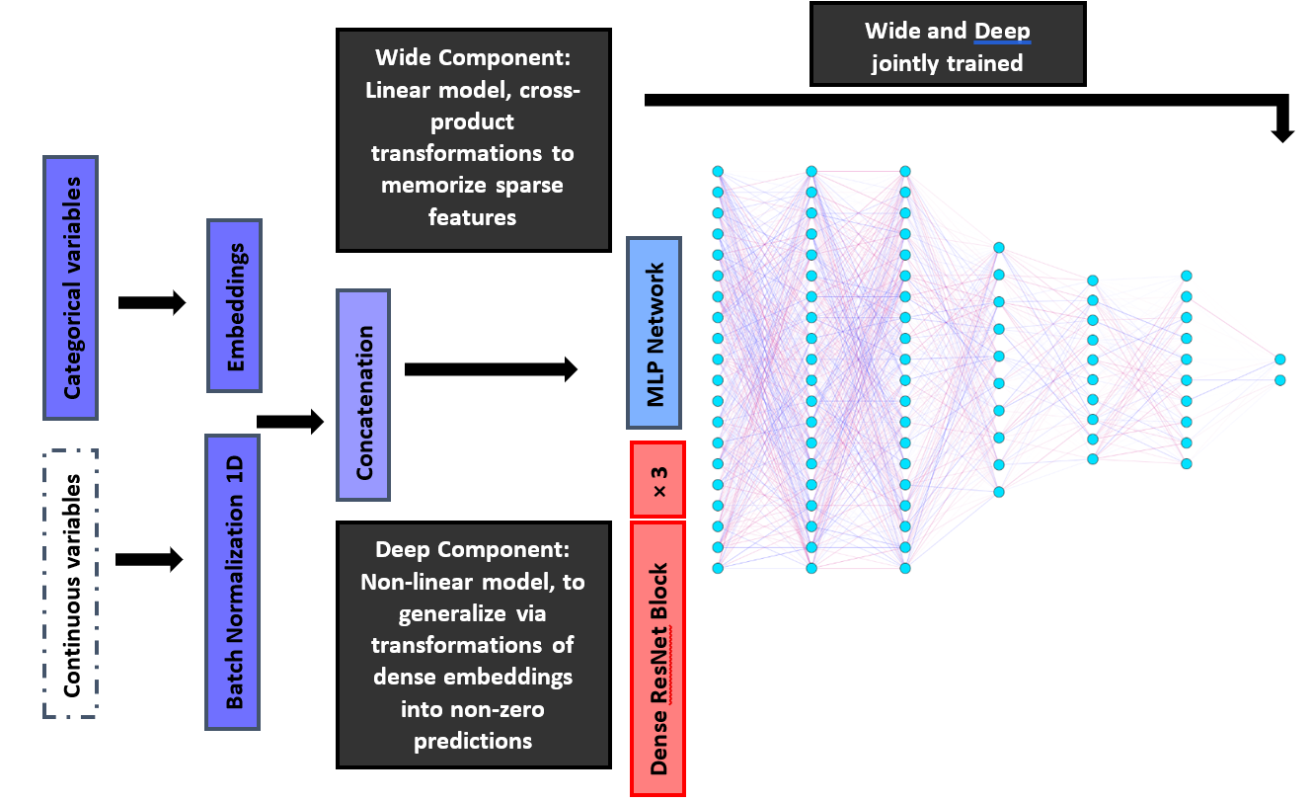
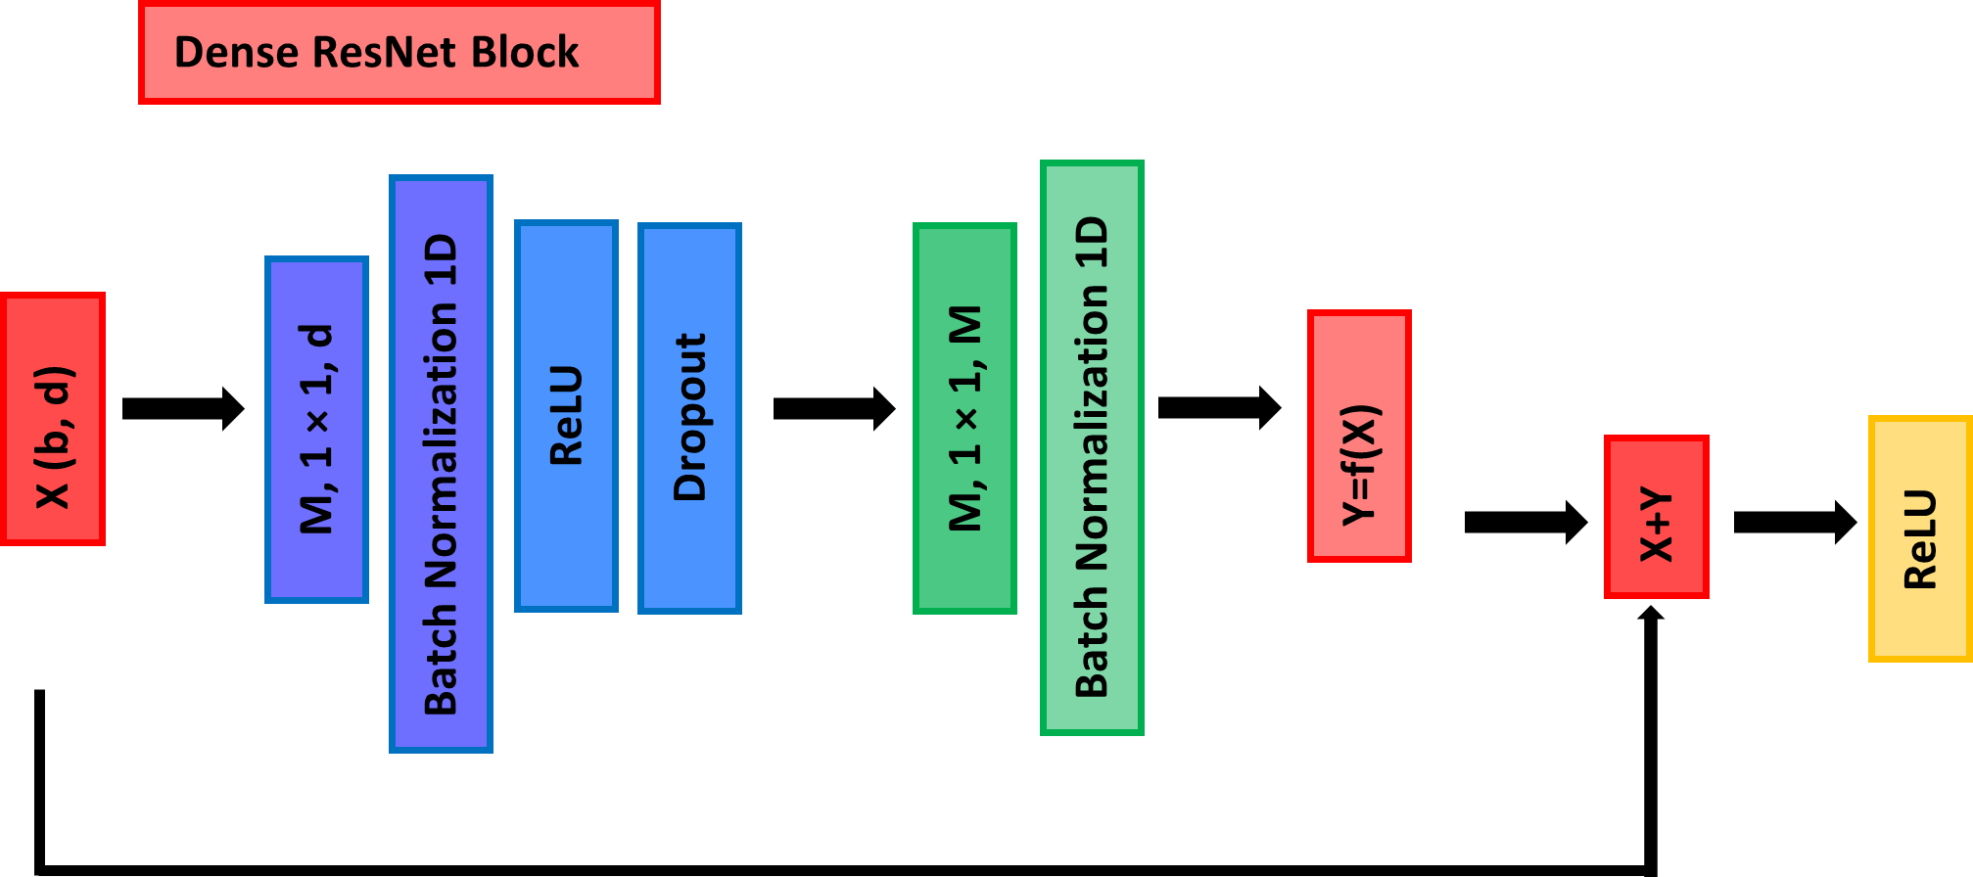
Supplementary Figure 1) TabMLPNet and TabResNet deep learning model architectures. Categorical variables were processed in our study by using binary values across diagnostic (ICD) features. Our models were designed to process both categorical and continuous variables for future applications in clinical settings, where medical claims data could be combined with results from blood sample, genetic and imaging biomarkers. The wide and deep components are jointly trained for both models^{19,20}. The TabMLPNet model is produced by eliminating the dense ResNet block from the TabResNet model. Both model structures are given here, for clinical scenarios in which leveraging information from either model into meta-models would be deemed as necessary. Further architectural details (such as dimension and number of layers per model) are described in the Methods.
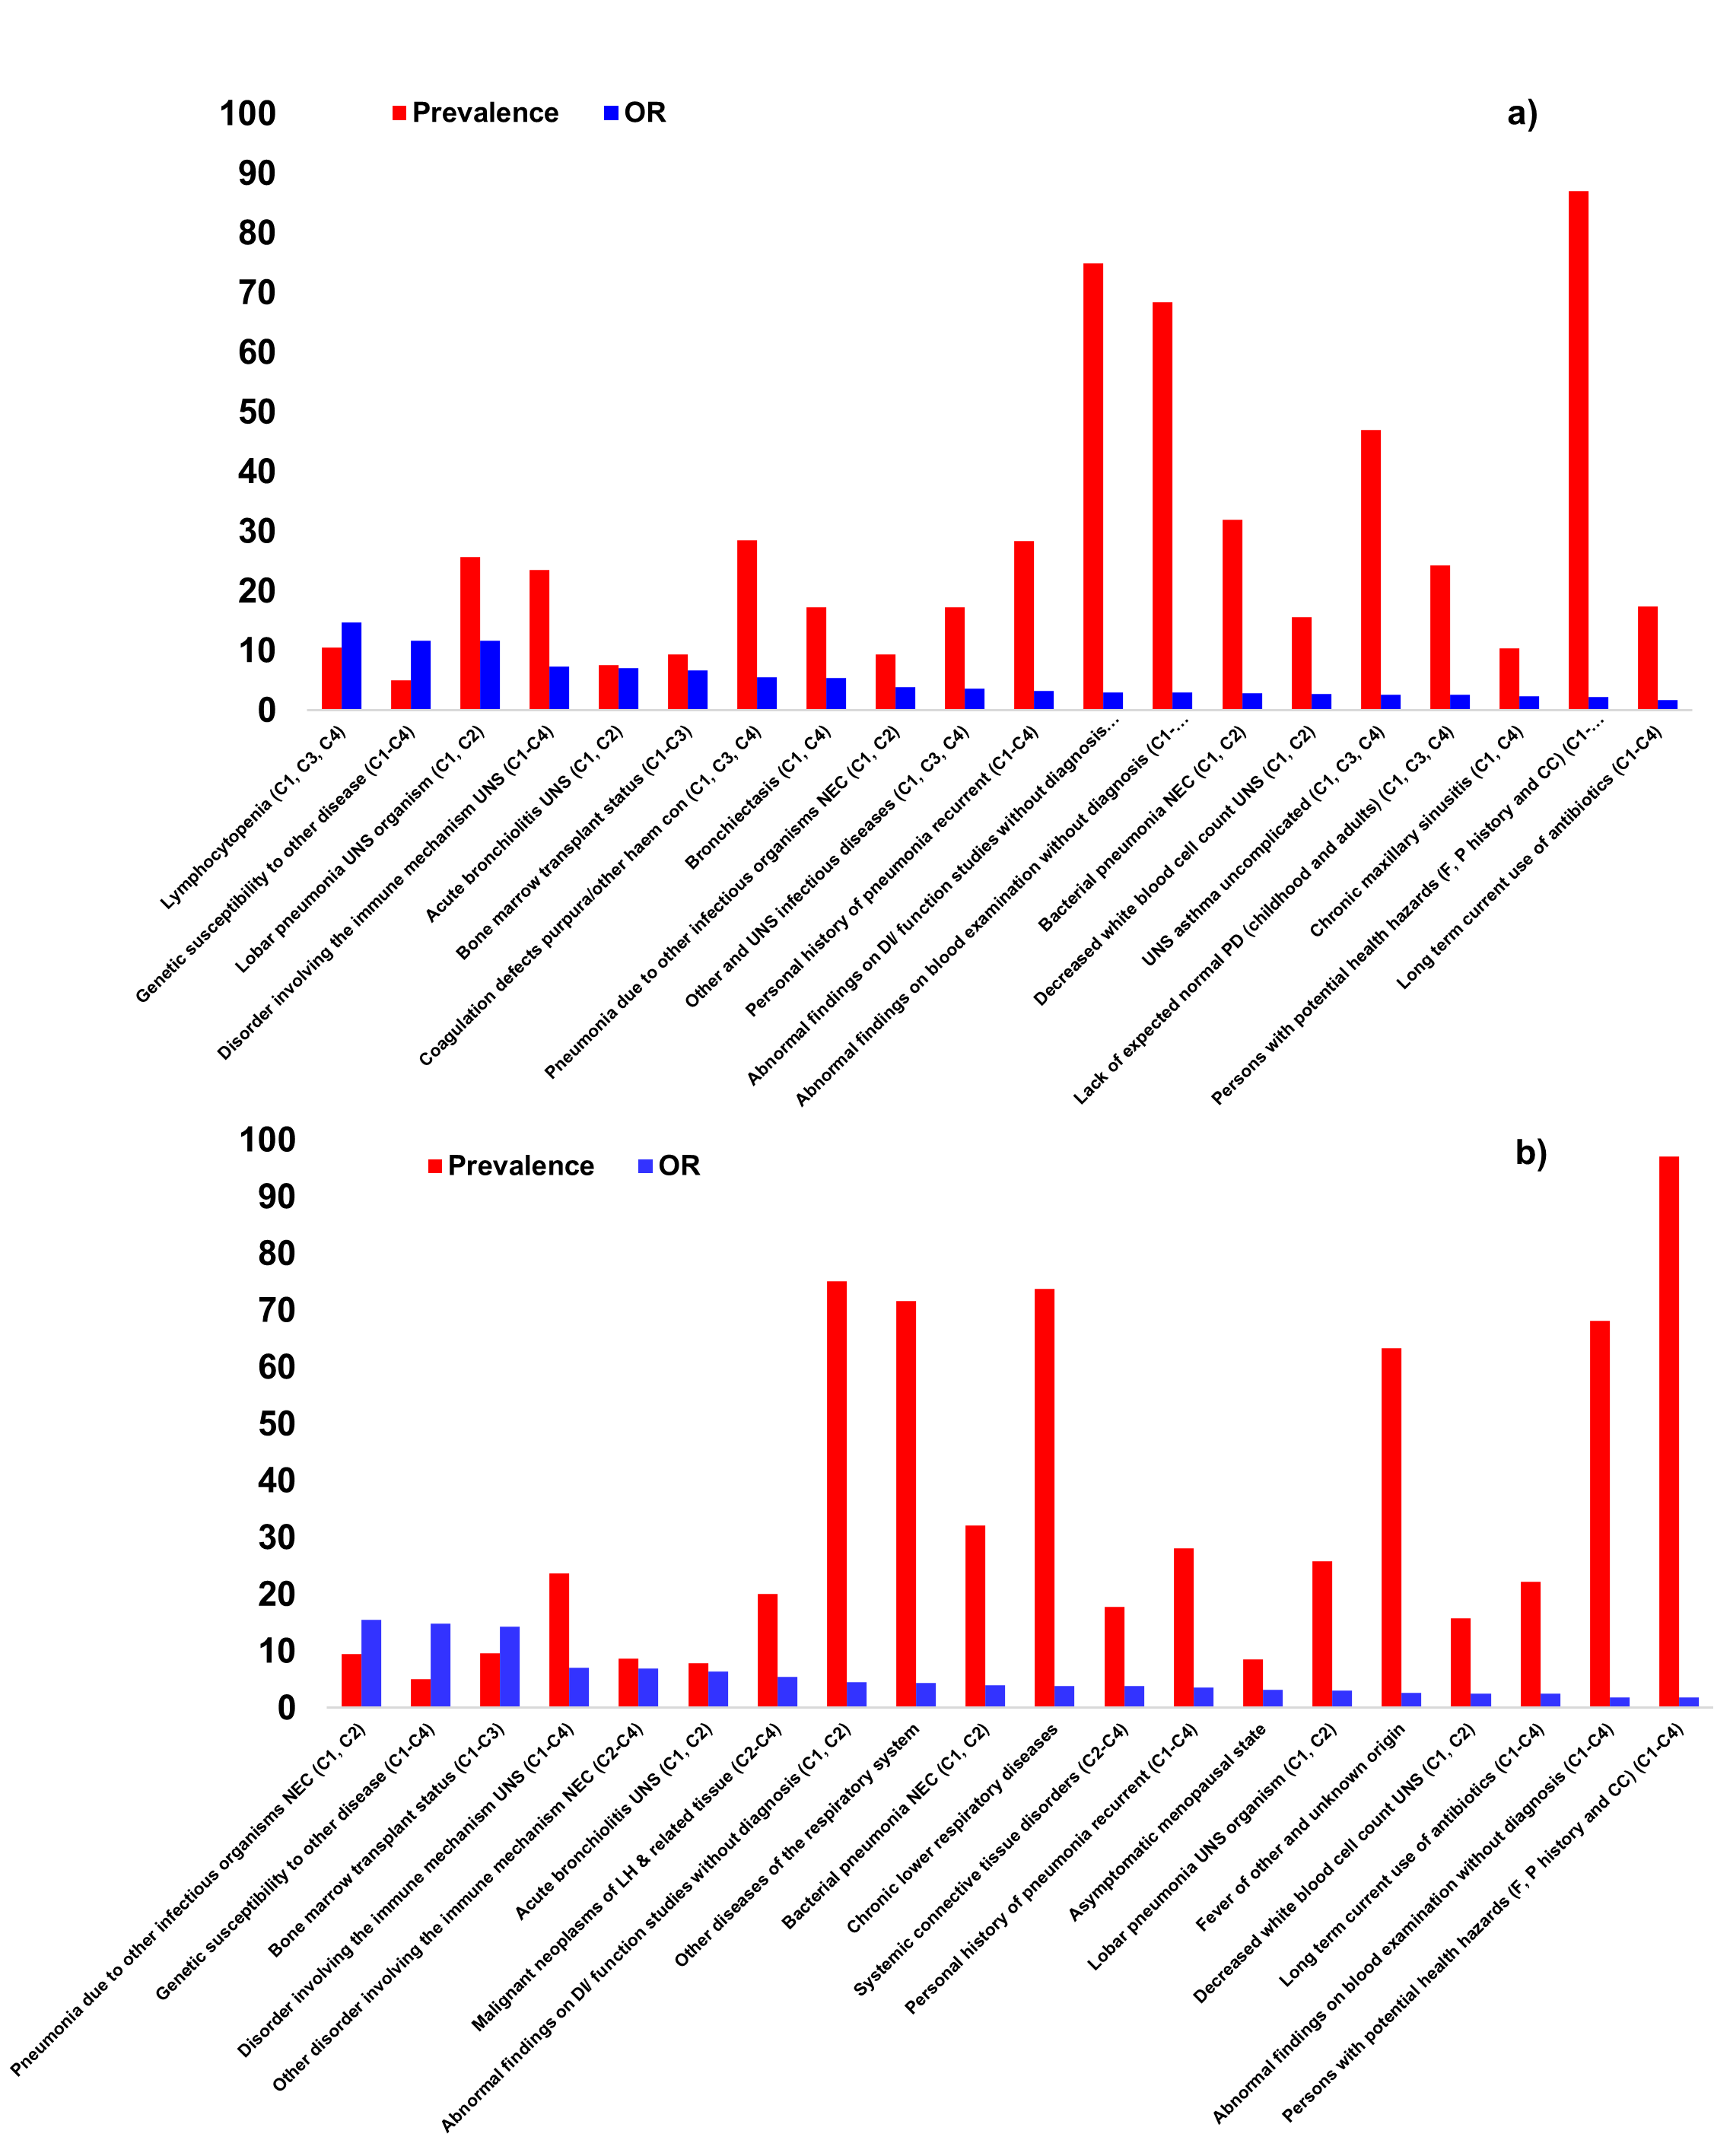

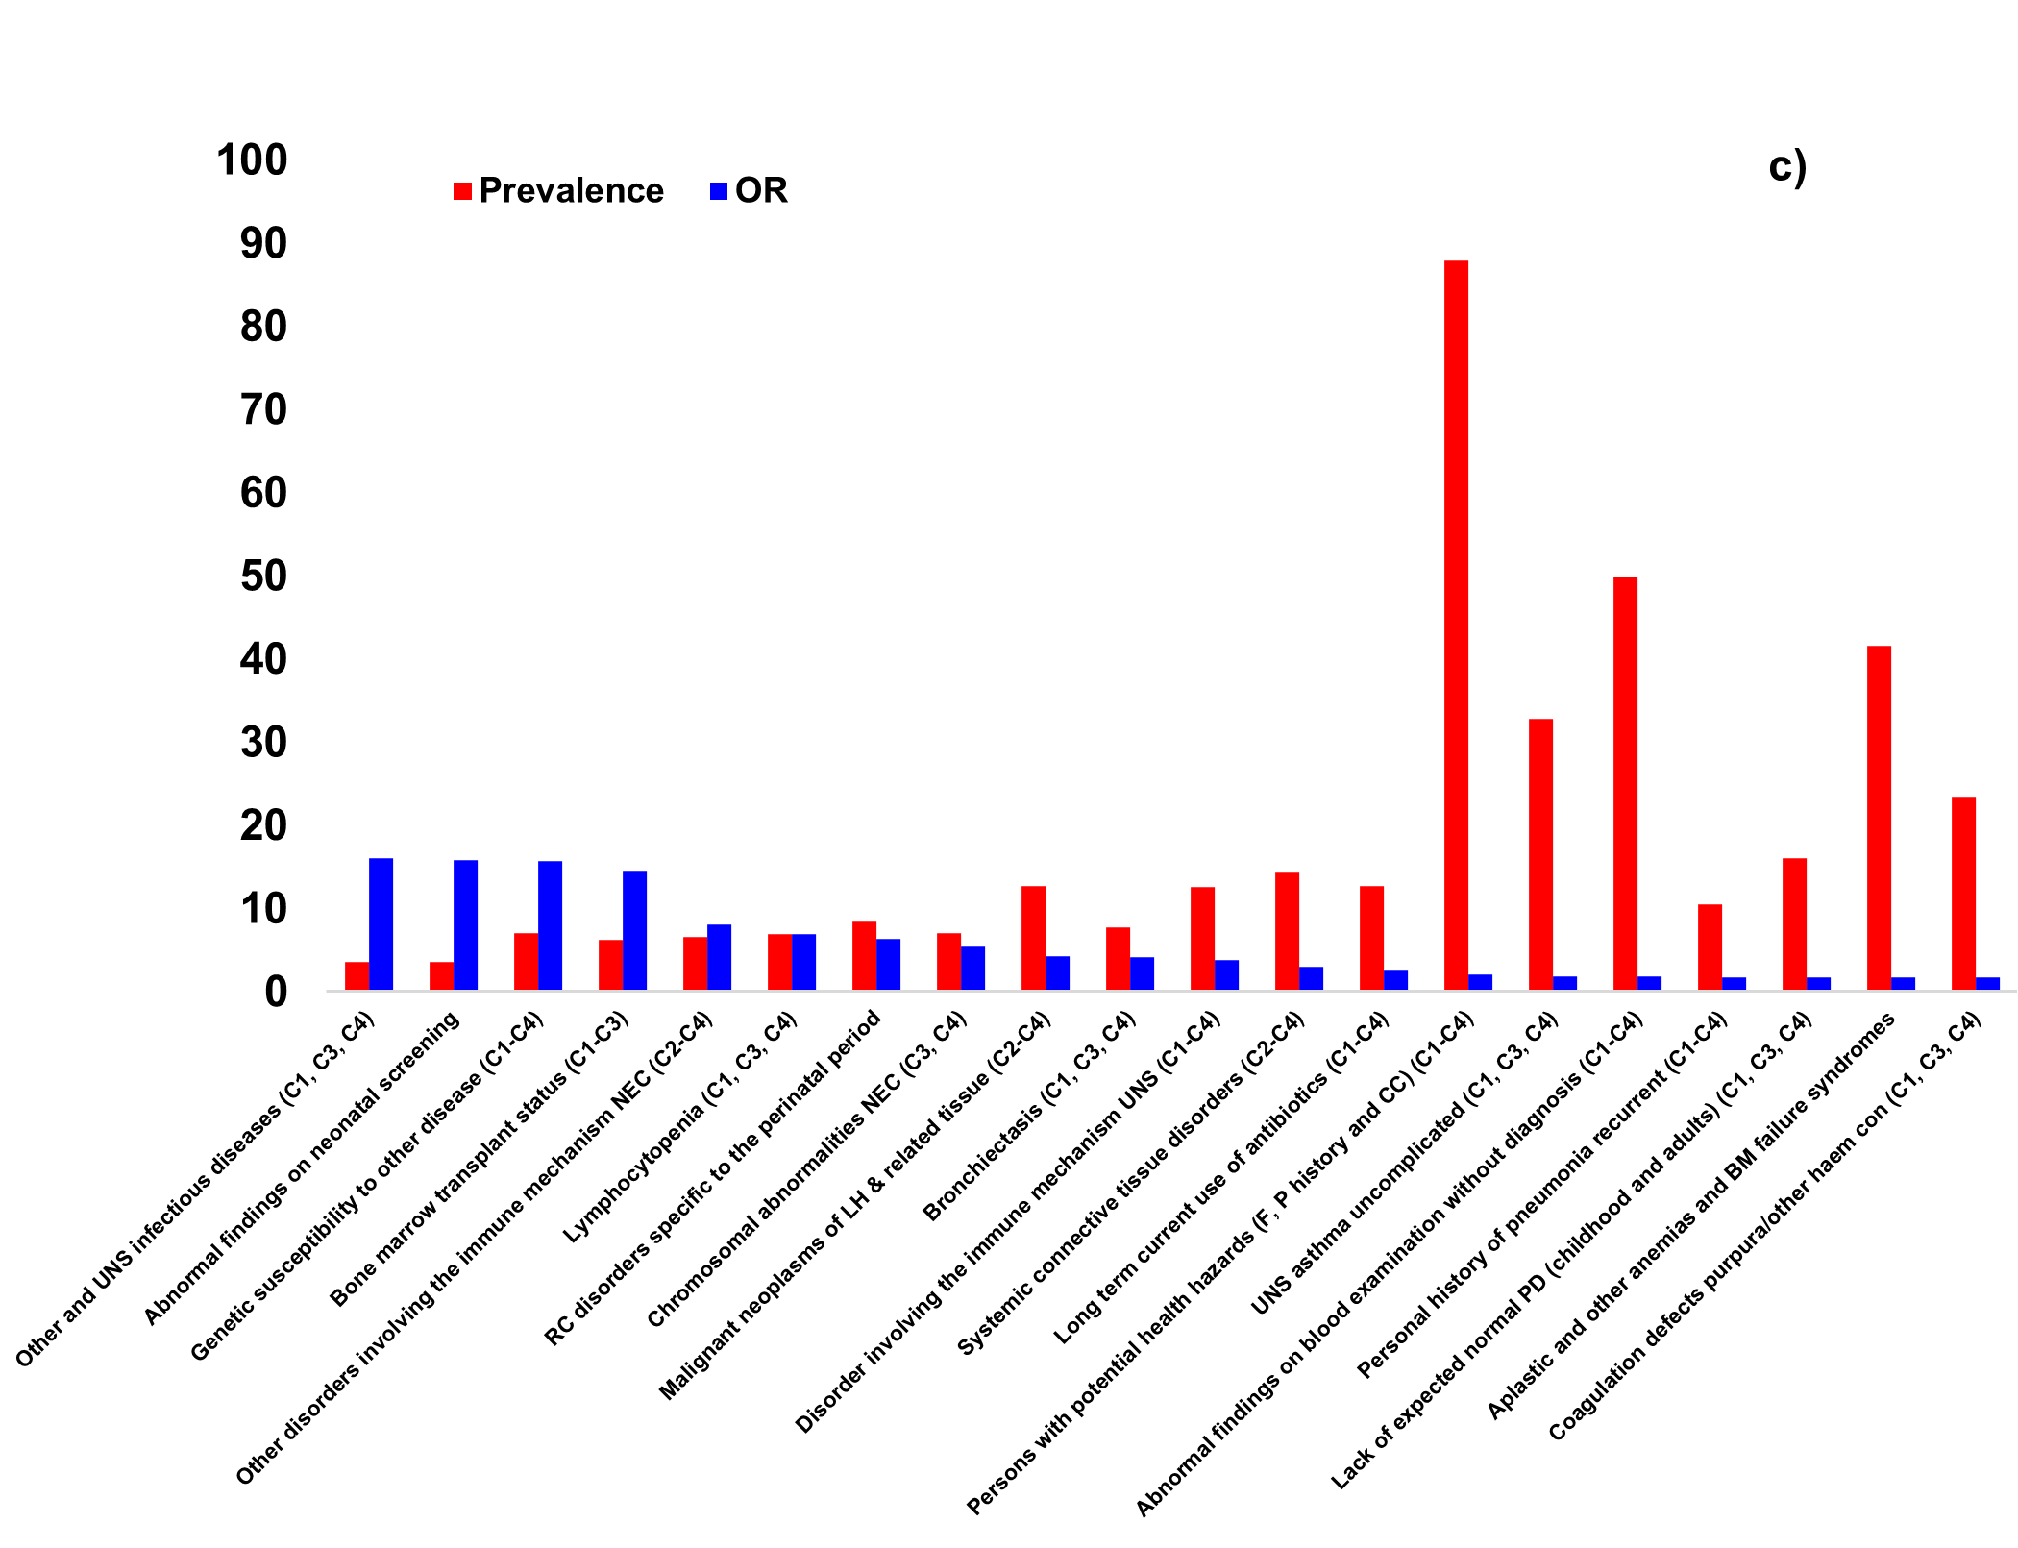
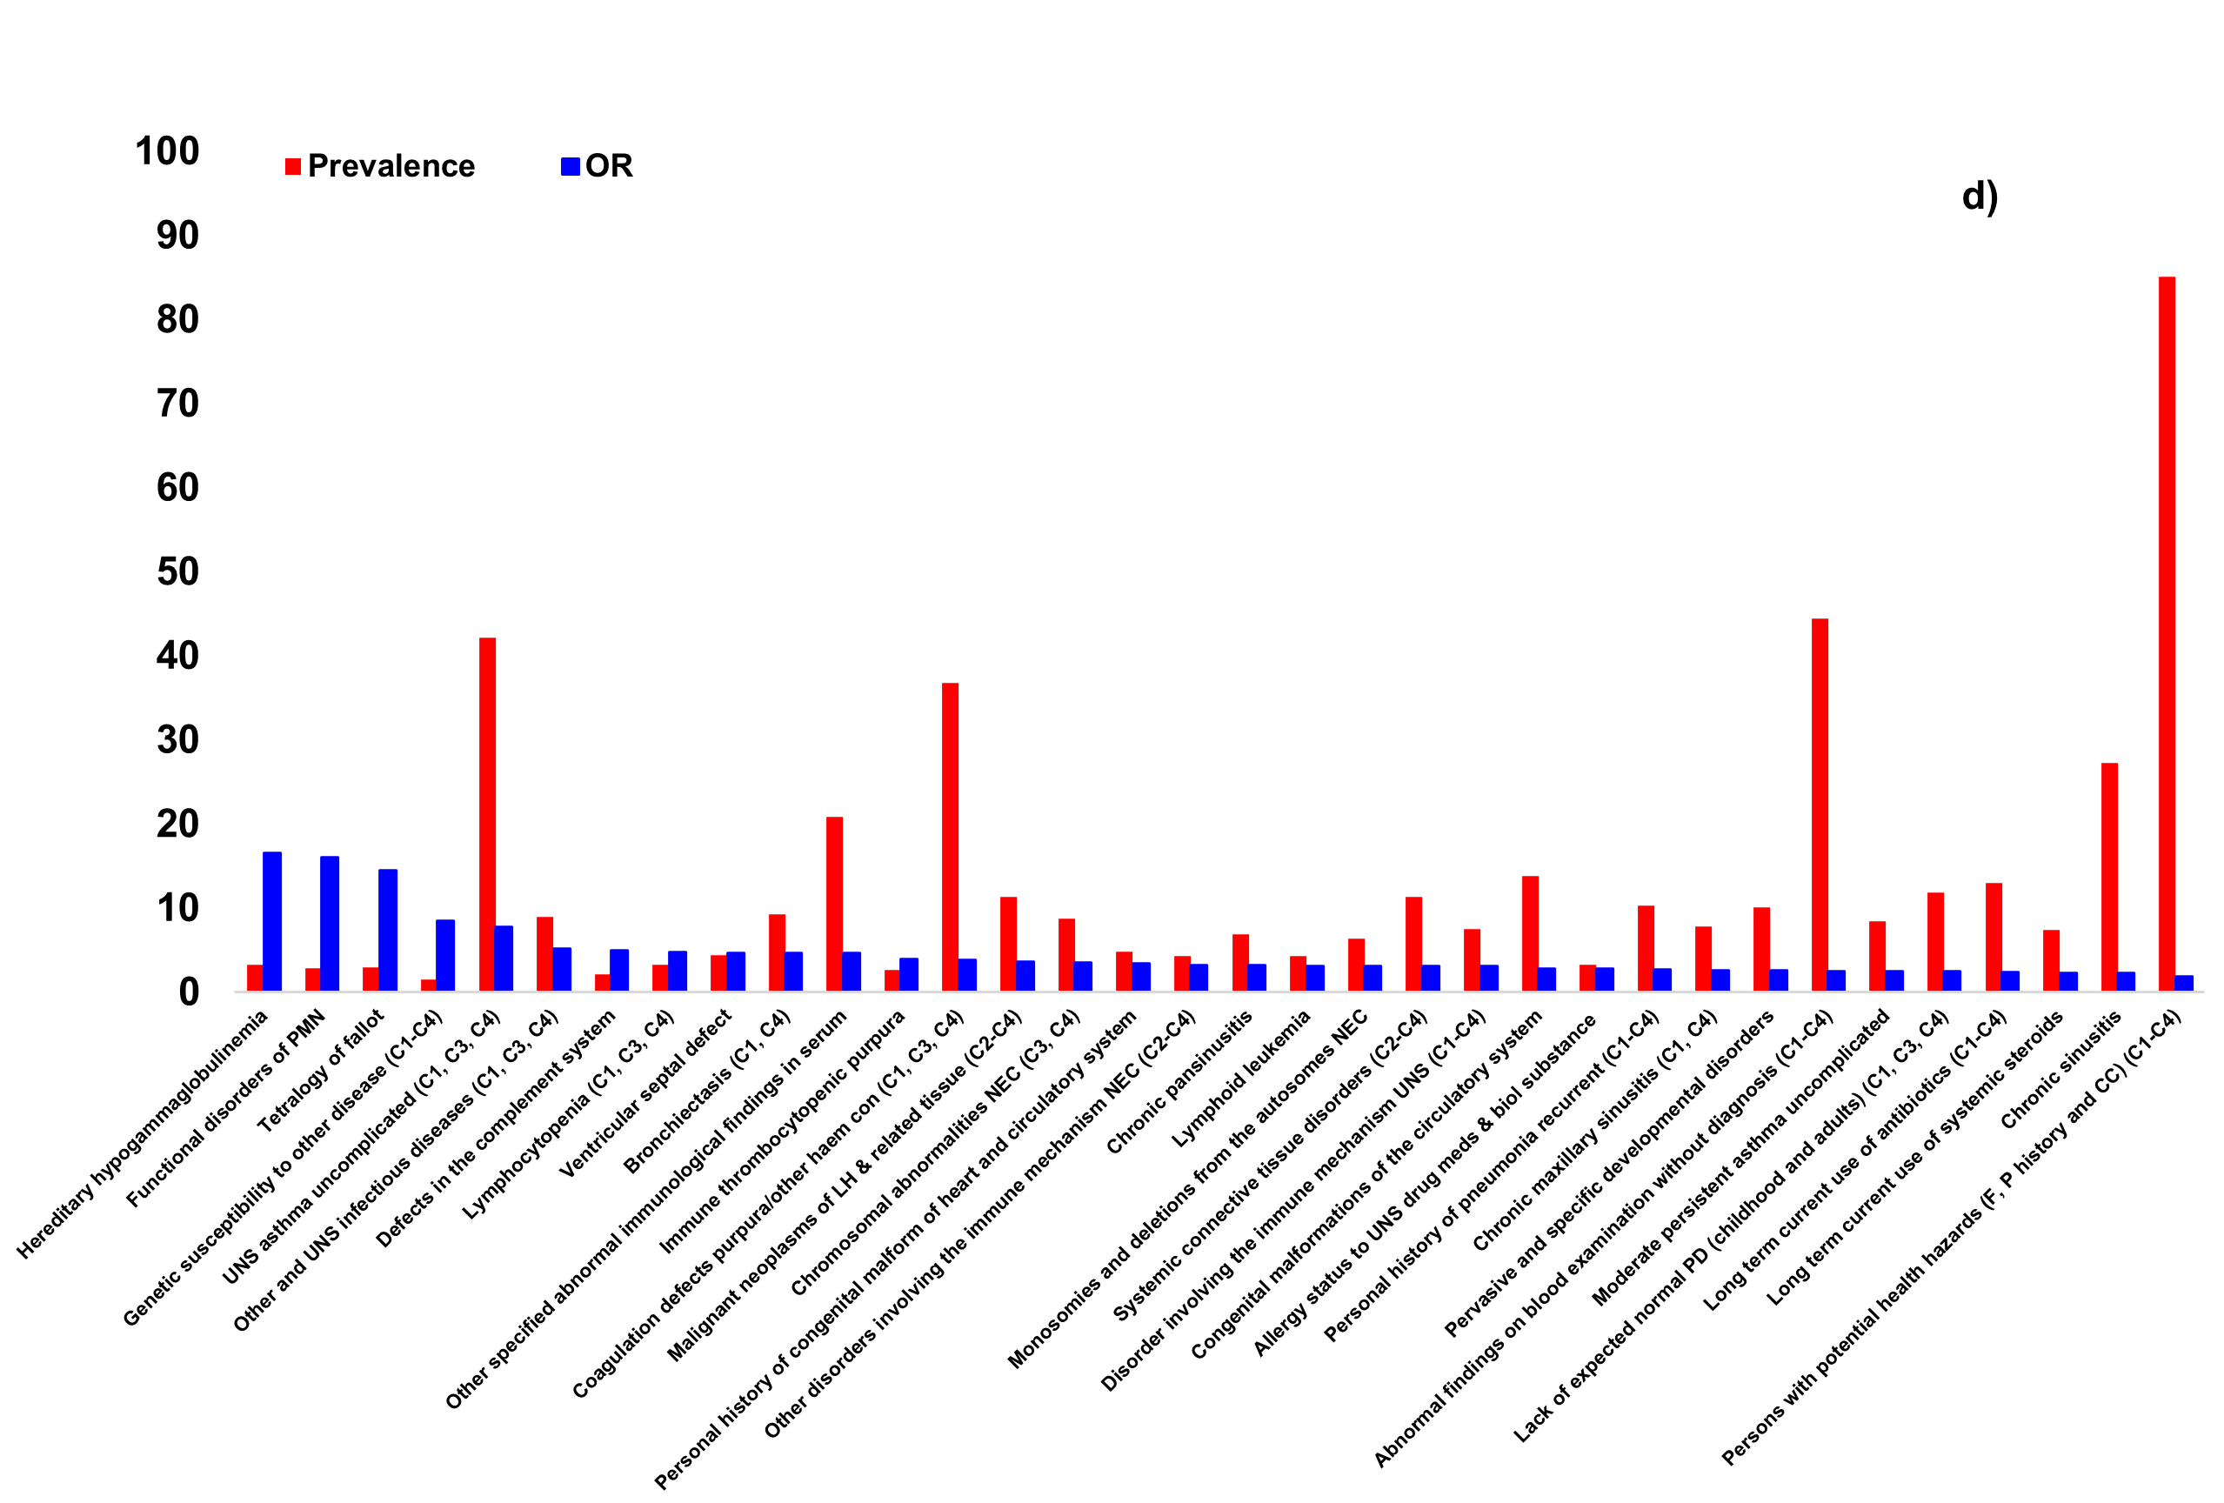
Supplementary Figure 2) Odds ratio (OR, blue) and prevalence (%, red) for the top ICD codes associated with CID (identified in Cohorts 1-3; a-c, respectively), and CID and CVID (identified in the largest cohort, Cohort 4; d) PIDs. All clinical phenotypes associated with the diagnosis of PID at a significance level of p < 10⁻³ which had an OR > 1.5 were included in the illustrations. Univariate logistic regression was used to calculate the ORs. PMN: Polymorphonuclear neutrophils, F: Family, P: Personal, CC: Certain conditions, PD: Physiological development, UNS: Unspecified, DI: Diagnostic imaging, NEC: Not elsewhere classified, LH: Lymphoid hematopoietic, RC: Respiratory and cardiovascular, CID: Combined immunodeficiencies, CVID: Common variable immunodeficiencies, C1-C4: Declare congruent ICD codes in Cohorts 1-4.

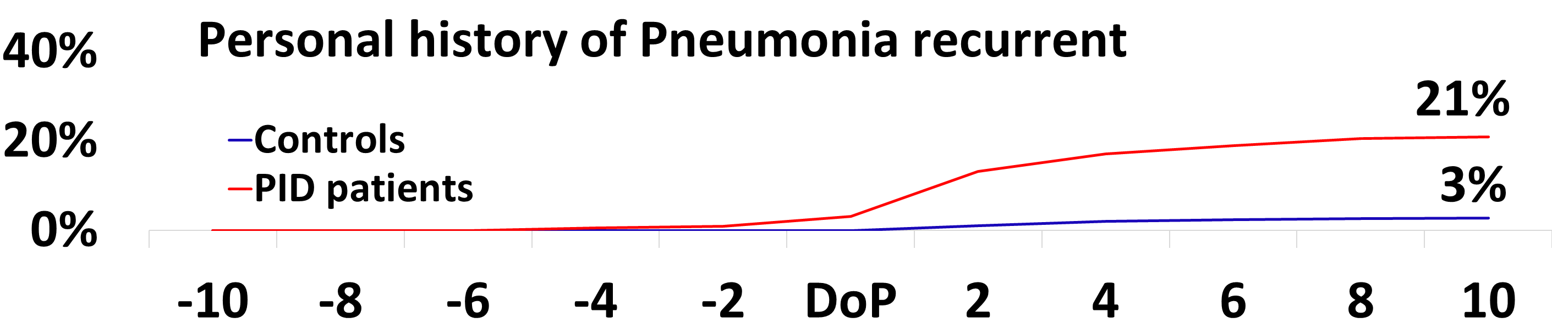
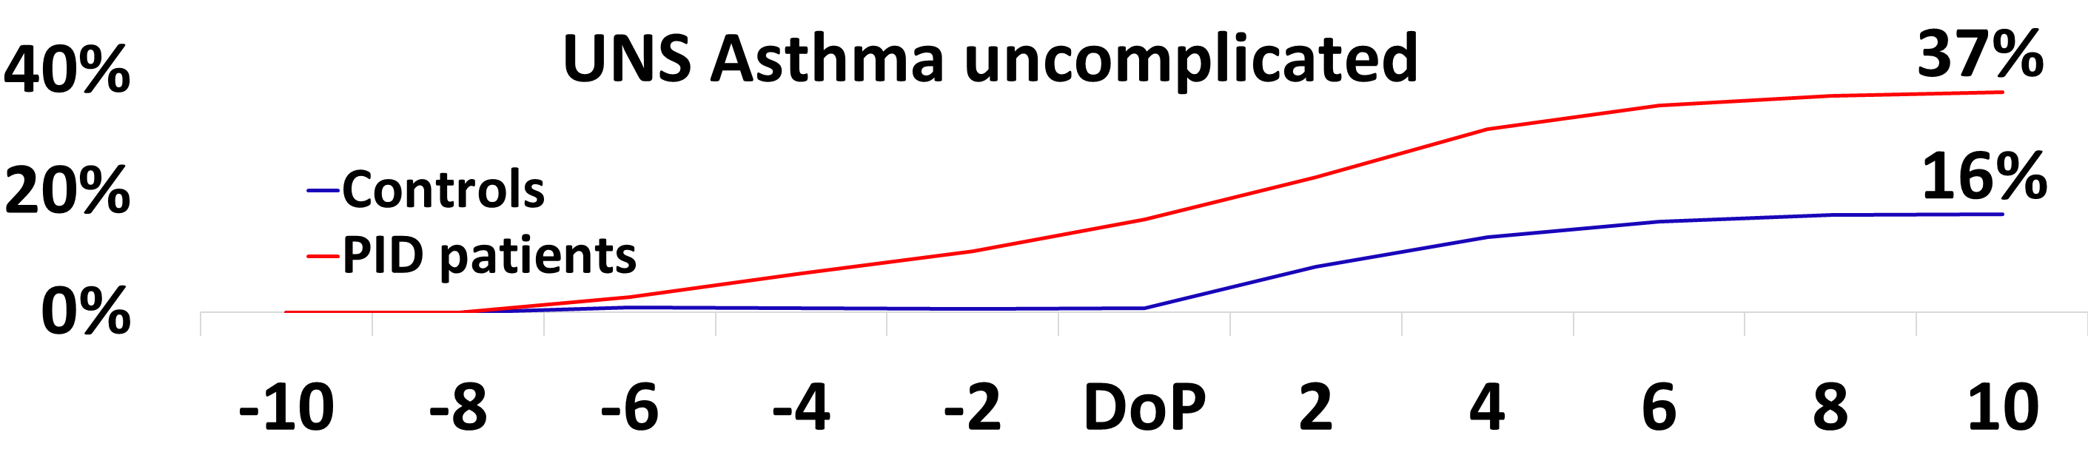
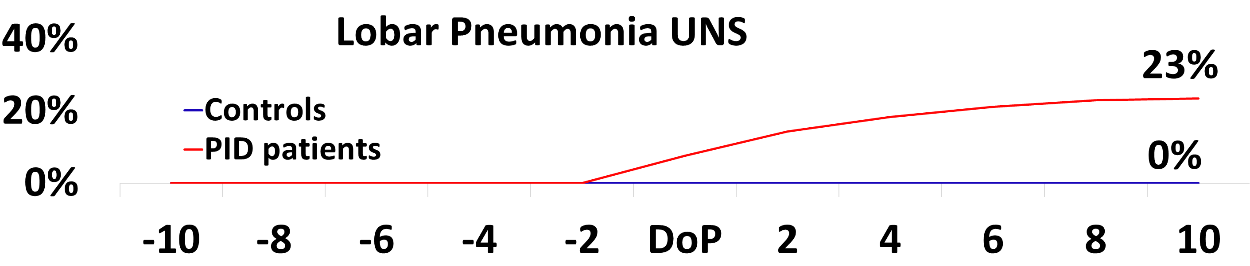
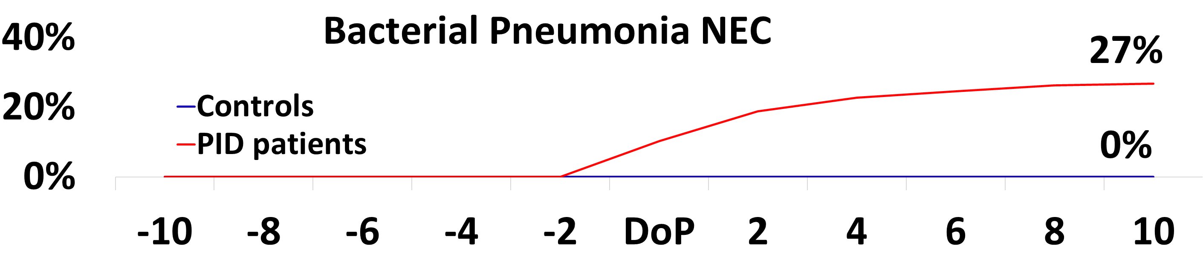
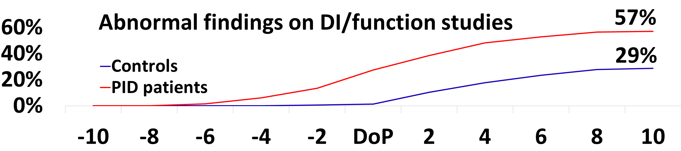
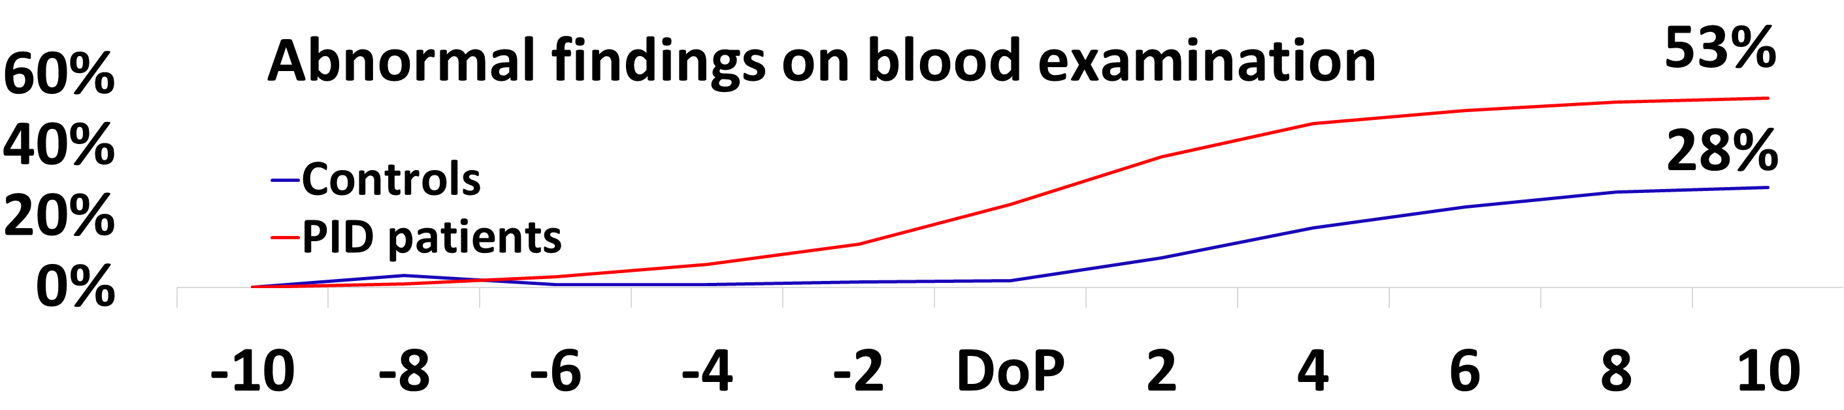
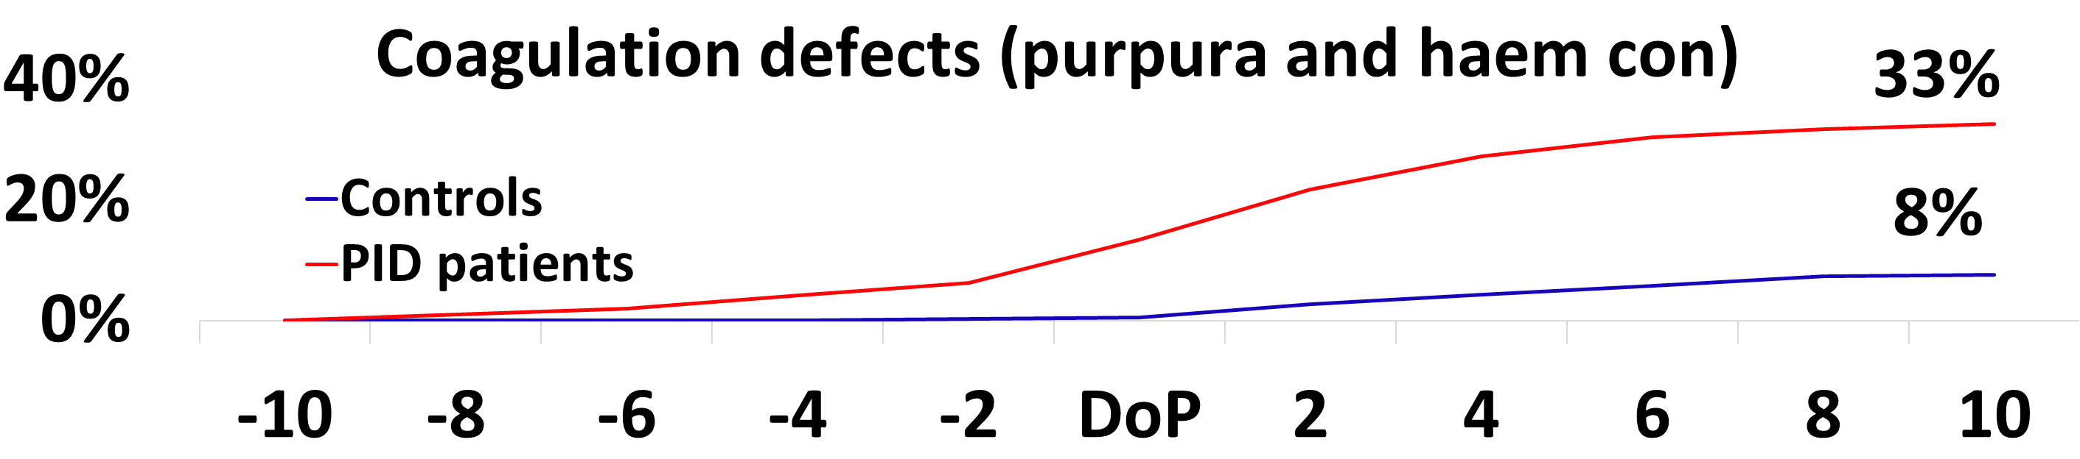
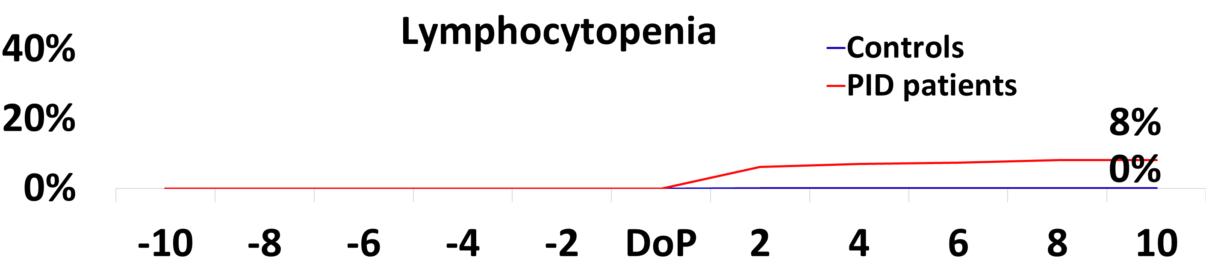
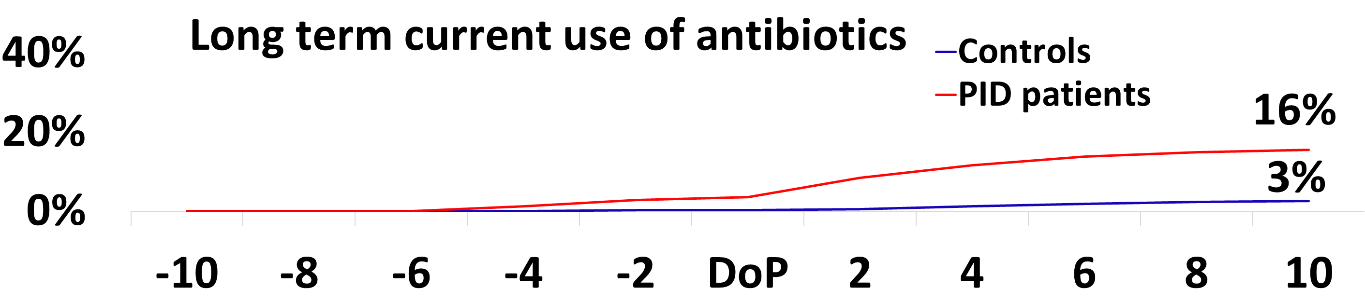
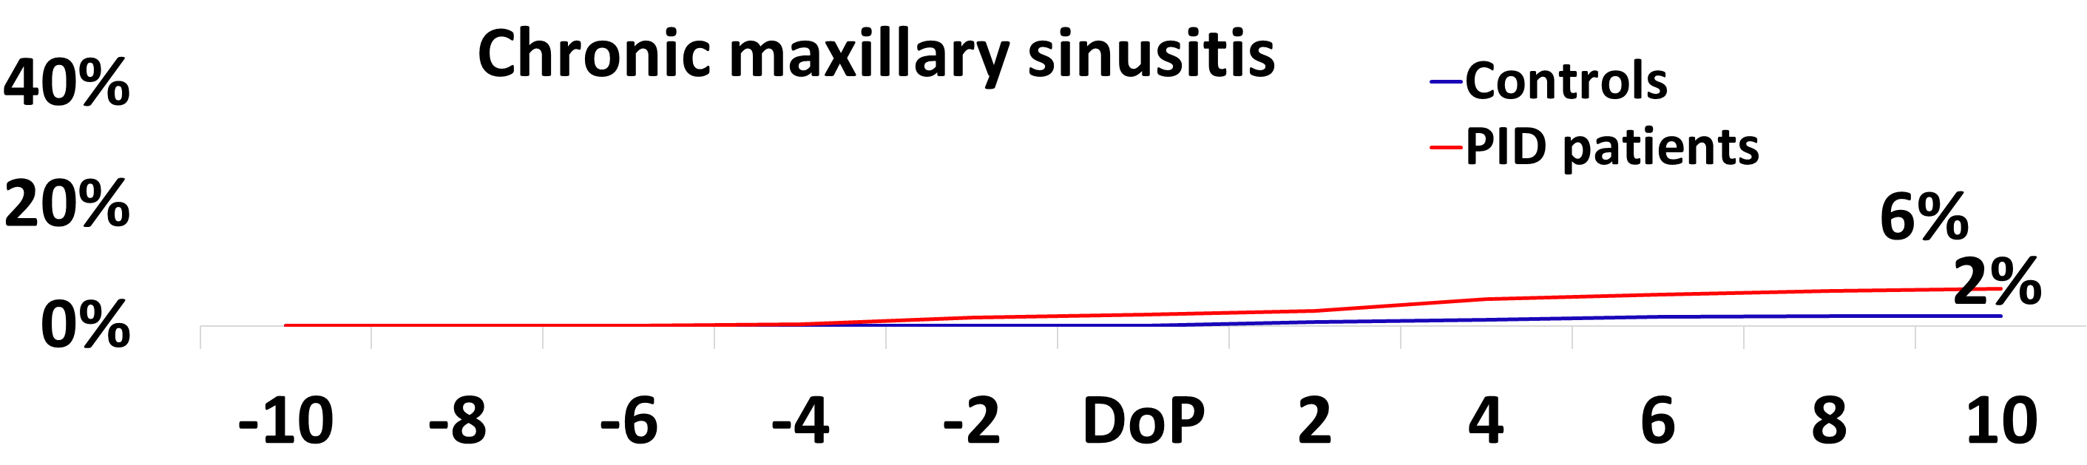
Years to Pneumonia diagnosis
Years to Pneumonia diagnosis
Proportion (%)
a)
b)
Years to Pneumonia diagnosis
Years to Pneumonia diagnosis
Proportion (%)
c)
d)
Years to Pneumonia diagnosis
Proportion (%)
Years to Pneumonia diagnosis
e)
f)
Years to Pneumonia diagnosis
Proportion (%)
Years to Pneumonia diagnosis
g)
h)
Proportion (%)
Years to Pneumonia diagnosis
Years to Pneumonia diagnosis
i)
j)

Supplementary Figure 3) 20-year time frames of pulmonary (a-d) and non-pulmonary (e-j) ICD codes associated with PID (CID) patients with pneumonia against non-PID patients with pneumonia, prior to and after the diagnosis of pneumonia (used as a common phenotype between PID cases and controls).
The illustrations depict the cumulative proportion of patients with each particular ICD code, which equals the sum of the proportions from each of the years preceding or following pneumonia diagnosis. CID: Combined immunodeficiency, DoP: Diagnosis of pneumonia, UNS: Unspecified, NEC: Not elsewhere classified, DI: Diagnostic imaging, haem con: Hemorrhagic conditions. Note that both e) and f) represent diagnostic procedures “without diagnosis”. The x axis shows years.

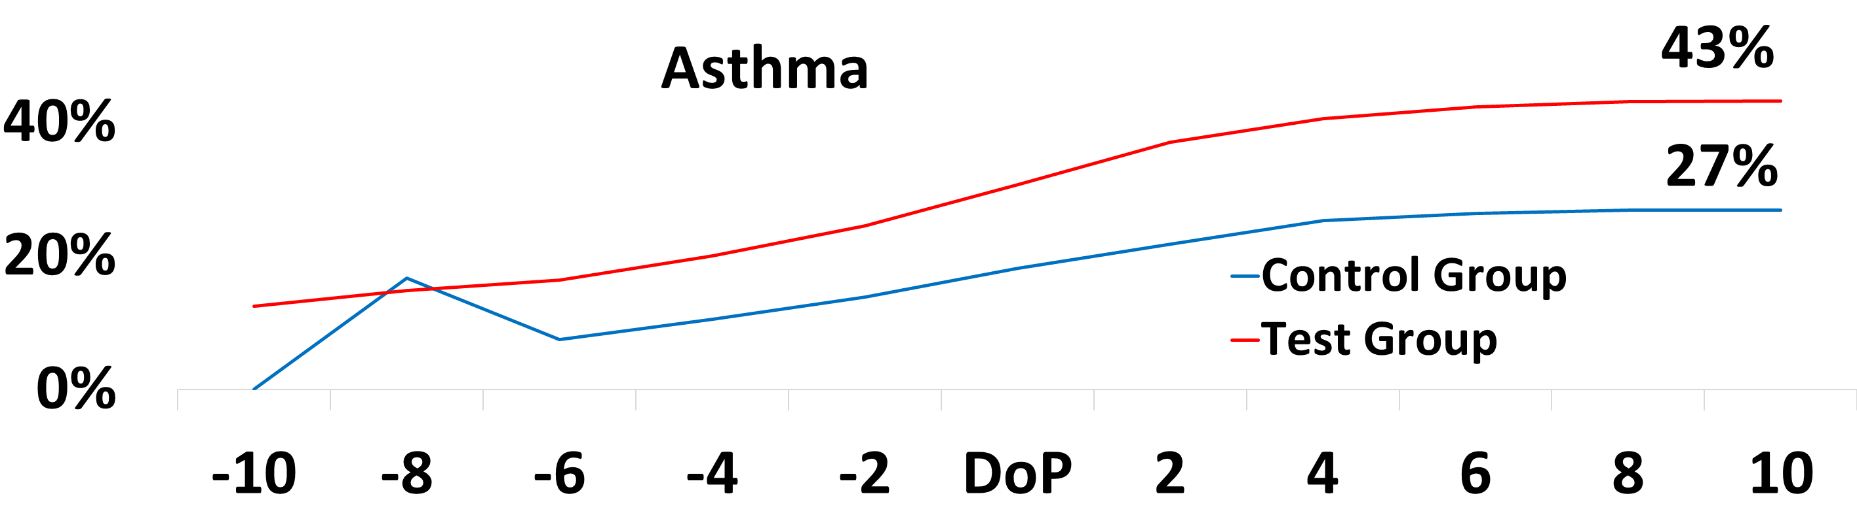
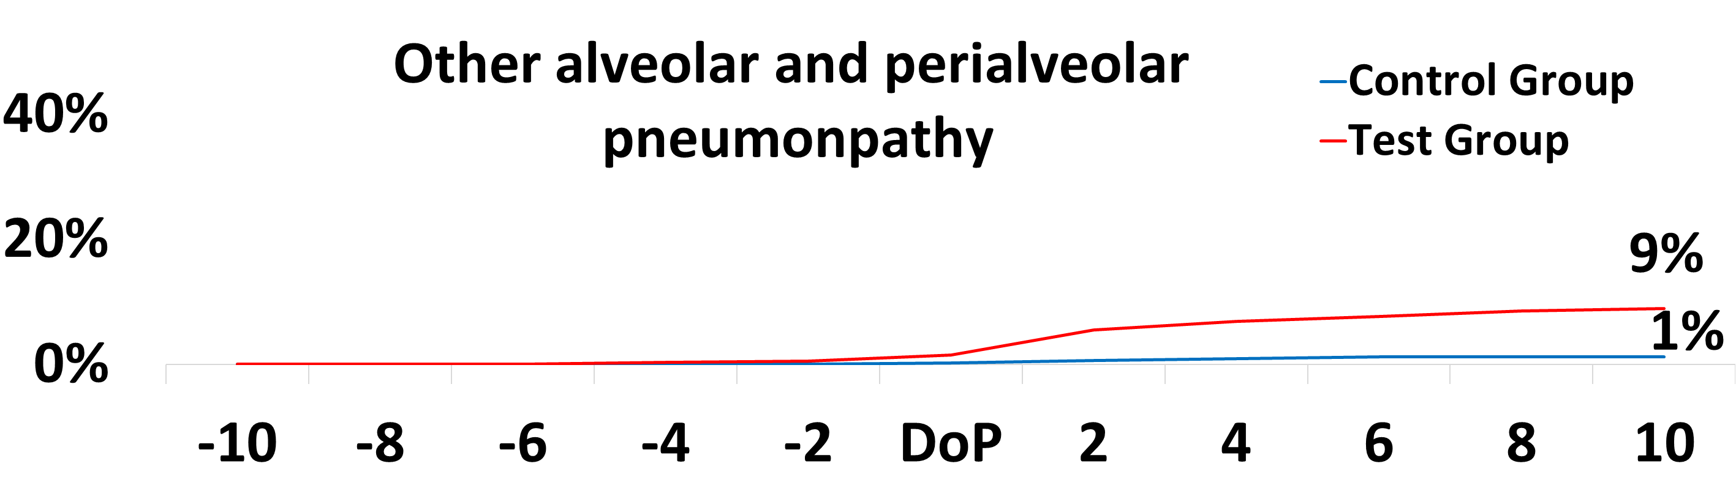
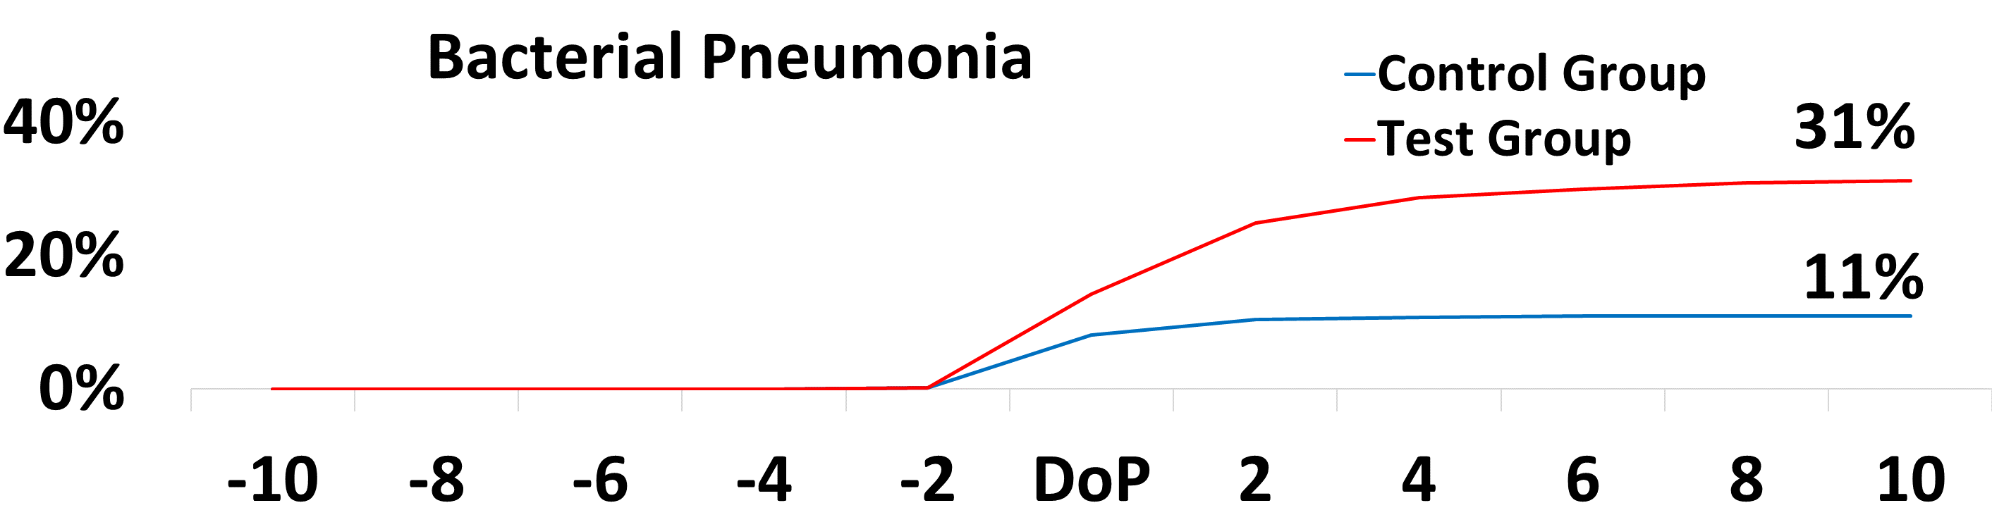
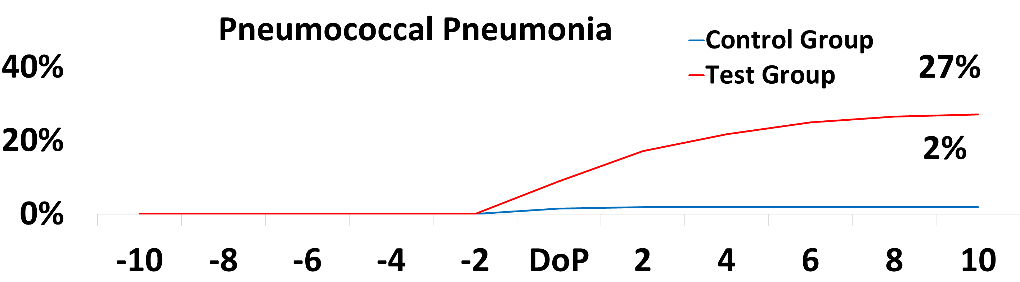
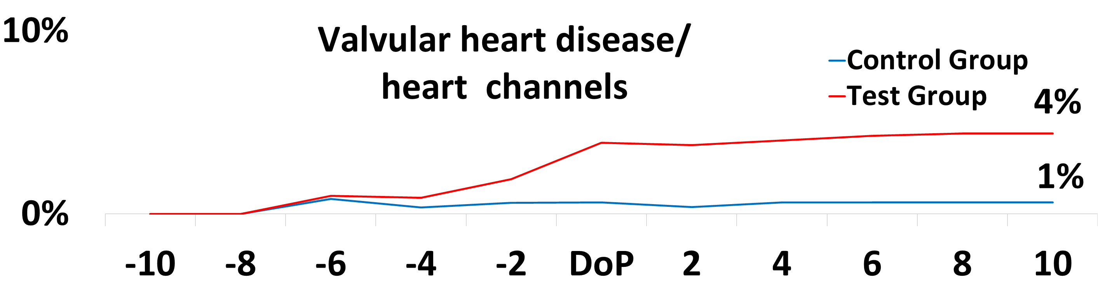
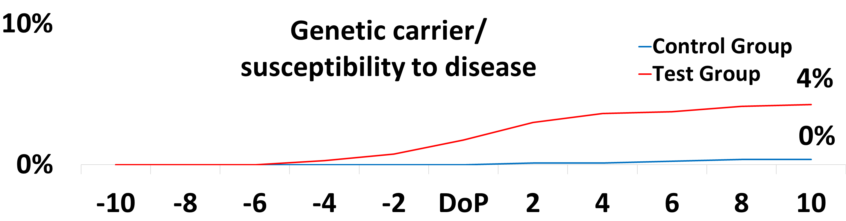
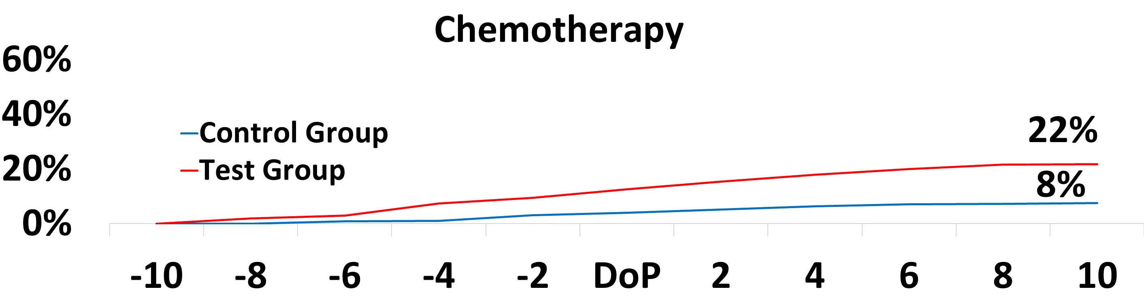
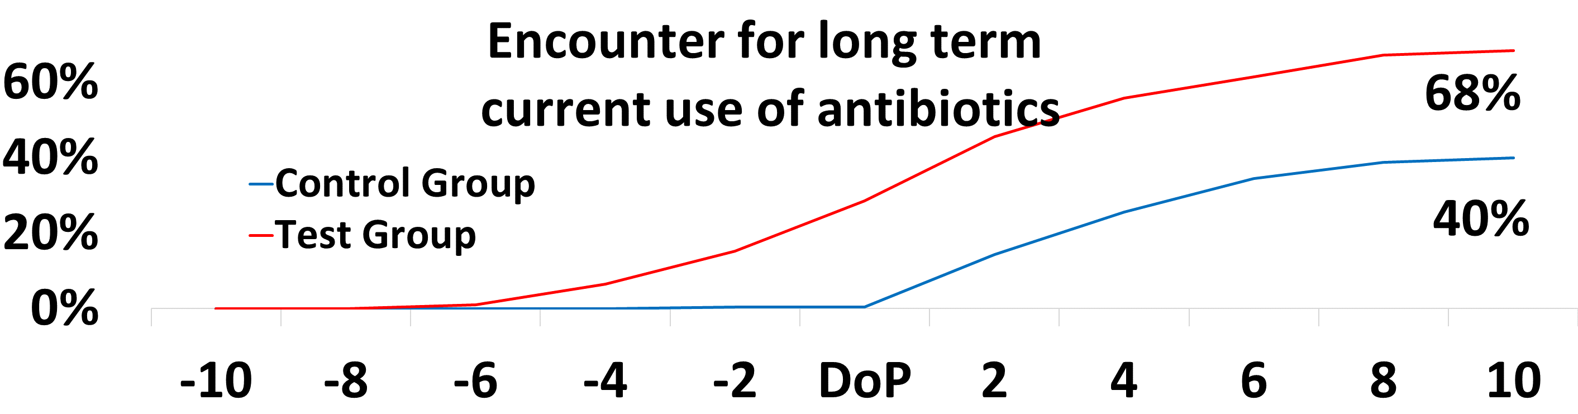
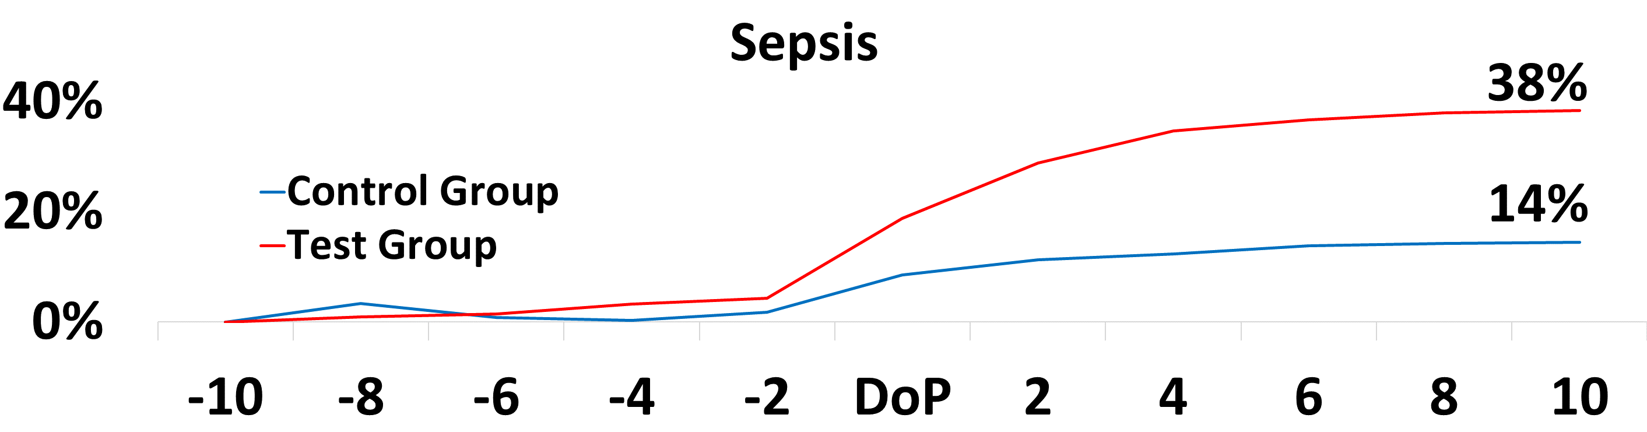
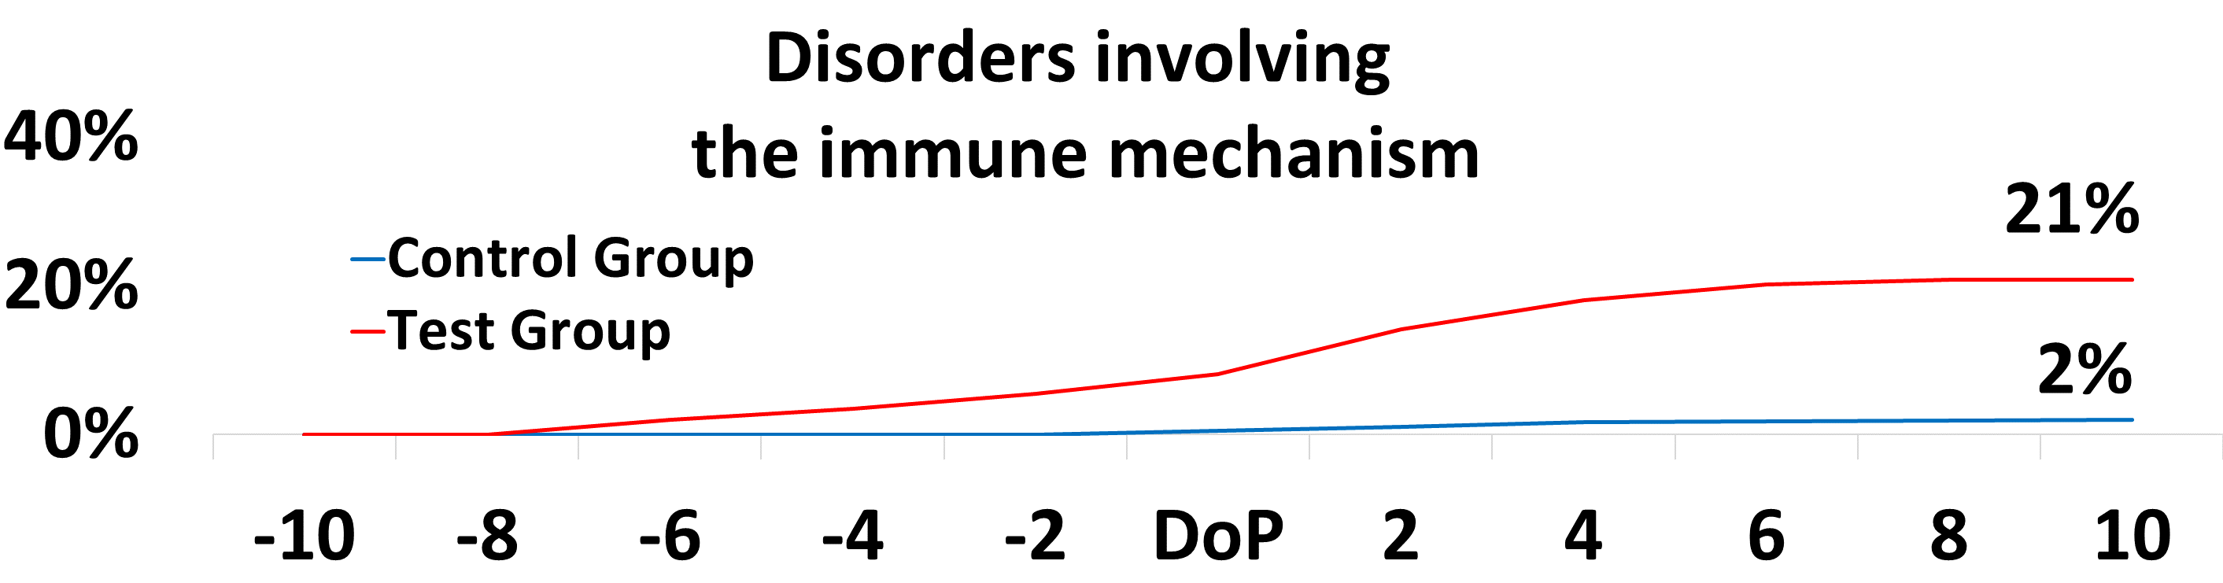
Years to Pneumonia diagnosis
Years to Pneumonia diagnosis
Proportion (%)
d)
c)
Years to Pneumonia diagnosis
Years to Pneumonia diagnosis
Proportion (%)
a)
b)
Years to Pneumonia diagnosis
Proportion (%)
Years to Pneumonia diagnosis
f)
i)
Proportion (%)
Years to Pneumonia diagnosis
Years to Pneumonia diagnosis
j)
Years to Pneumonia diagnosis
Proportion (%)
Years to Pneumonia diagnosis
h)
g)
Supplementary Figure 4) 20-year time frames of pulmonary (a-d) and non-pulmonary (e-j) clinical phenotypes associated with PID (CID) patients with pneumonia against non-PID patients with pneumonia, prior to and after the diagnosis of pneumonia (used as a common phenotype between PID cases and controls). To derive fair comparisons, time courses were derived from Cohort 1, in which there was an even number of patients with pneumonia in cases and controls (all 797 in either group).
The illustrations depict the cumulative proportion of patients with each particular phenotype, which equals the sum of the proportions from each of the years preceding or following pneumonia diagnosis. CID: Combined immunodeficiency. The x axis shows years.

