Authors’ Biography

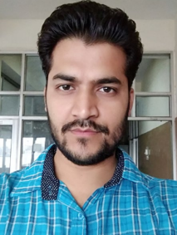
Sanjeev Kumar received B.Tech. degree and M.Tech. degree in Electronics and Communication Engineering from Panjab Technical University, Jalandhar in 2010 and 2016. He is currently a candidate of Ph.D. degree in Electronics and Communication Engineering at UIET, Panjab University, Chandigarh. His research interests include visible light communication. He has been awarded Senior Research Fellowship from CSIR, New Delhi in 2018.
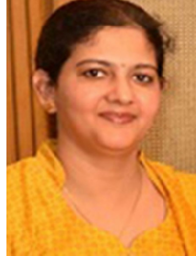
Preeti Singh is working as Assistant Professor in Electronics and Communication Engineering Department in U.I.E.T, Panjab University, Chandigarh. She has done her Bachelor’s and Master’s degree in Electronics and Communication Engineering. She got her Ph.D. degree in the year 2013. Her areas of interest are optical communication (wired and wireless), optical biosensors and signal processing.

