LEGENDS OF SUPPLEMENTARY FILES
Supplemental figure 1: Macro observations of the cartilage of the knee joint of male mice. Mice that were candidate for the DMM surgery were added to the macro observations when possible. The macro observations were conducted at 4, 8 and 16 months. (A) For the body size : n= 22 for the KO, n= 20 for the WT and n= 14 for the UP at 4 months; n= 8 for the KO and n= 10 for the WT and UP at 8 months; n= 14 for the KO, n= 12 for the WT and n= 11 for the UP at 16 months. (B) For the body weight : n= 22 for the KO, n= 26 for the WT and n= 22 for the UP at 4 months; n= 8 for the KO and n= 9 for the WT and n= 10 for the UP at 8 months; n= 13 for the KO, n= 12 for the WT and n= 11 for the UP at 16 months. (C) For the femoral length : n= 8 for each genotype at 4 months; n= 8 for the KO and n= 9 for the WT and n= 10 for the UP at 8 months; n= 11 for the KO, n= 12 for the WT and n= 11 for the UP at 16 months. (D) The femoral length was displayed to show the evolution of the femurs over time within the genotypes. (A-C) Ordinary one-way ANOVA was performed to compare the body size, the body weight, and the femoral length between the genotypes, at each time-point. Kruskal-Wallis was performed when the distribution was not Gaussian. (D) Two-way ANOVA was performed to examine the influence of time on the femoral length inside each genotype. The data were plotted as a box plot showing all points with error bars representing ±SD and differences being considered significant at p-values<0.05 (*p<0.05, **p≤0.01, ***p≤0.001, ****p≤0.0001).
Supplemental figure 2: Histomorphometry of the cartilage was performed with QuPath at 4, 8, and 16 months. Knee joints of male mice were stained with Toluidine Blue and the thickness of the total cartilage (including non-calcified and calcified cartilage) was measured. (A) For the medial tibial plateau : n= 7 for the KO, n= 8 for the WT and UP at 4 months; n= 8 for the KO and WT and n= 7 for the UP at 8 months; n= 8 for the KO, n= 7 for the WT and n= 9 for the UP at 16 months. (B) For the lateral tibial plateau : n= 7 for the KO, n= 8 for the WT and UP at 4 months; n= 8 for all the genotypes at 8 months; n= 8 for the KO, n= 7 for the WT and n= 9 for the UP at 16 months. Two-way ANOVA was performed to evaluate the genotype effect (in black) and the time effect inside a genotype (in the corresponding color). The data were plotted as a box plot showing all points with error bars representing ±SD and differences being considered significant at p-values<0.05 (*p<0.05).
Supplemental figure 3 : µCT analysis on the metaphysis of the tibia of the male mice at 4, 8 and 16,months (A) The trabecular bone parameters over time, with the trabecular separation, the trabecular thickness and the trabecular structure model index. Two-Way ANOVA was performed with error bars representing ± SEM and differences being considered significant at p-values<0.05, * represents significant differences between the KO and the UP and Δ represents significant differences between the WT and the UP (*/Δp<0.05, **/ΔΔp≤0.01, ***p≤0.001). (B) The length of the tibial crest of 16-month-old mice. One-Way ANOVA was performed, the data were plotted as a box plot showing all points with error bars representing ±SD and with differences being considered significant at p-values<0.05 (*p<0.05, **p≤0.01, ***p≤0.001, ****p≤0.0001).
Supplemental figure 4: Whole mount in situ hybridization for the omd mRNA on WT zebrafish larvae at 48 hpf, 5 dpf and 8 dpf and on omd^{-/-} larvae at 5 dpf. Ventral and lateral view are illustrated. Scale bar = 200 µm. Cartilage structures are annotated as followed Ep: Ethmoid plate; Pq: Palatoquadrate; Ch: Ceratohyal; Cb: Ceratobranchial arches; Mc: Meckel’s Cartilage; Tr: trabecula; Hs: Hyosymplectic cartilage. The meckels’s cartilage and the palatoquadrate articulate themselves into the jaw joint.
Supplemental figure 5: Analysis of the overexpression of omd in the zebrafish. (A) The overexpression model was generated by the injection of the zebrafish mRNA of omd in the 1-cell zygote followed by the observation of the ventralization at 24 hours post fertilization (hpf) and the developmental deformities at 4 days post fertilization (dpf). (B) The percentage of ventralized larvae was reported at 24 hpf after the injection of 0.4 ng (n = 314) or 0.8 ng (n = 103) of omd. The injection of 0.4 ng (n = 301) or 0.8 ng (n = 72) of the mRNA of the GFP served as a control. The data were plotted as percentage of the observed class in stacked columns. A Chi-square test was performed with differences being considered significant at p-values<0.05 (****p≤0.0001). A normal embryo and ventralized embryo with a red arrow pointing to the ventralization are illustrated. Scale bar = 200 µm. (C) The percentage of developmental deformities presented by the larvae was reported at 4 dpf after the injection of 0.4 ng (n = 367) or 0.8 ng (n = 96) of omd. The injection of 0.4 ng (n = 169) or 0.8 ng (n = 79) of the mRNA of the GFP served as a control. A different class of deformities was attributed: normal, cyclops, narrow eyes, one asymmetrical eye, asymmetrical eyes, small eyes and other defect which included non-specific defects. The larvae were stained with Alcian Blue and the representative illustration of each class was selected. Scale bar = 200 µm. The data were plotted as percentage of the observed class in stacked columns. A Chi-square test was performed with differences being considered significant at p-values < 0.05 (*p<0.05, ****p≤0.0001).
Supplemental figure 6 : RNA-seq analysis of primary human pre-osteoblast cultures treated with 10 ng/ml of rhOMD during 72-h with n=11 (6 men and 5 women). (A) Vulcano plot with Threshold padj < 0.01 and Log2FoldChange. (B) IBSP gene expression comparison.
Supplemental figure 7: Illustration of the ROI measured with QuPath for the histomorphometry analysis. (A, B) Toluidine Blue staining was used for uncalcified (1) and calcified (2) cartilage measurement. The yellow line was drawn to measure the plate length. Inside the yellow circle, the area of the growth plate was defined (3). The Safranin-O Fast Green was used to measure the subchondral bone volume. The subchondral bone volume was measured inside the yellow box and calculated using the formula TV – (Bone marrow volume (4) + cartilage volume) (C).
Supplemental Table 1 : Analysis of the gait development from the CatWalkXT of 4, 8 and 16 month-old male mice. Parameters of the front paws and the hinds paws are reported. The first column corresponds to the gait parameter with its specific unit; the second column corresponds to the genotype, the third column corresponds to the reported value, the fourth, fifth and sixth columns are the reported p-values between KO and WT, KO and UP, WT and UP respectively. At 4 months: n=8 for each genotype; at 8 months n=8 for each genotype; at 16 months: n=14 for the KO, n=12 for the WT and n=10 for the UP. One-Way Anova was performed when the distribution was gaussian and Kruskal-Wallis was performed when the distribution was not gaussian with differences being considered significant at p-values<0.05 (*p<0.05, **p≤0.01, ***p≤0.001).
Supplemental Table 2 : RNA-Seq analysis of primary human pre-osteoblasts treated with 10 ng/ml of rhOMD during 72-h. List of differential gene expression, upregulated and downregulated genes sorted according to their padj. Genes with significant differential gene expression are highlighted in yellow with differences being considered significant at padj<0.05.

Supplemental figure 1
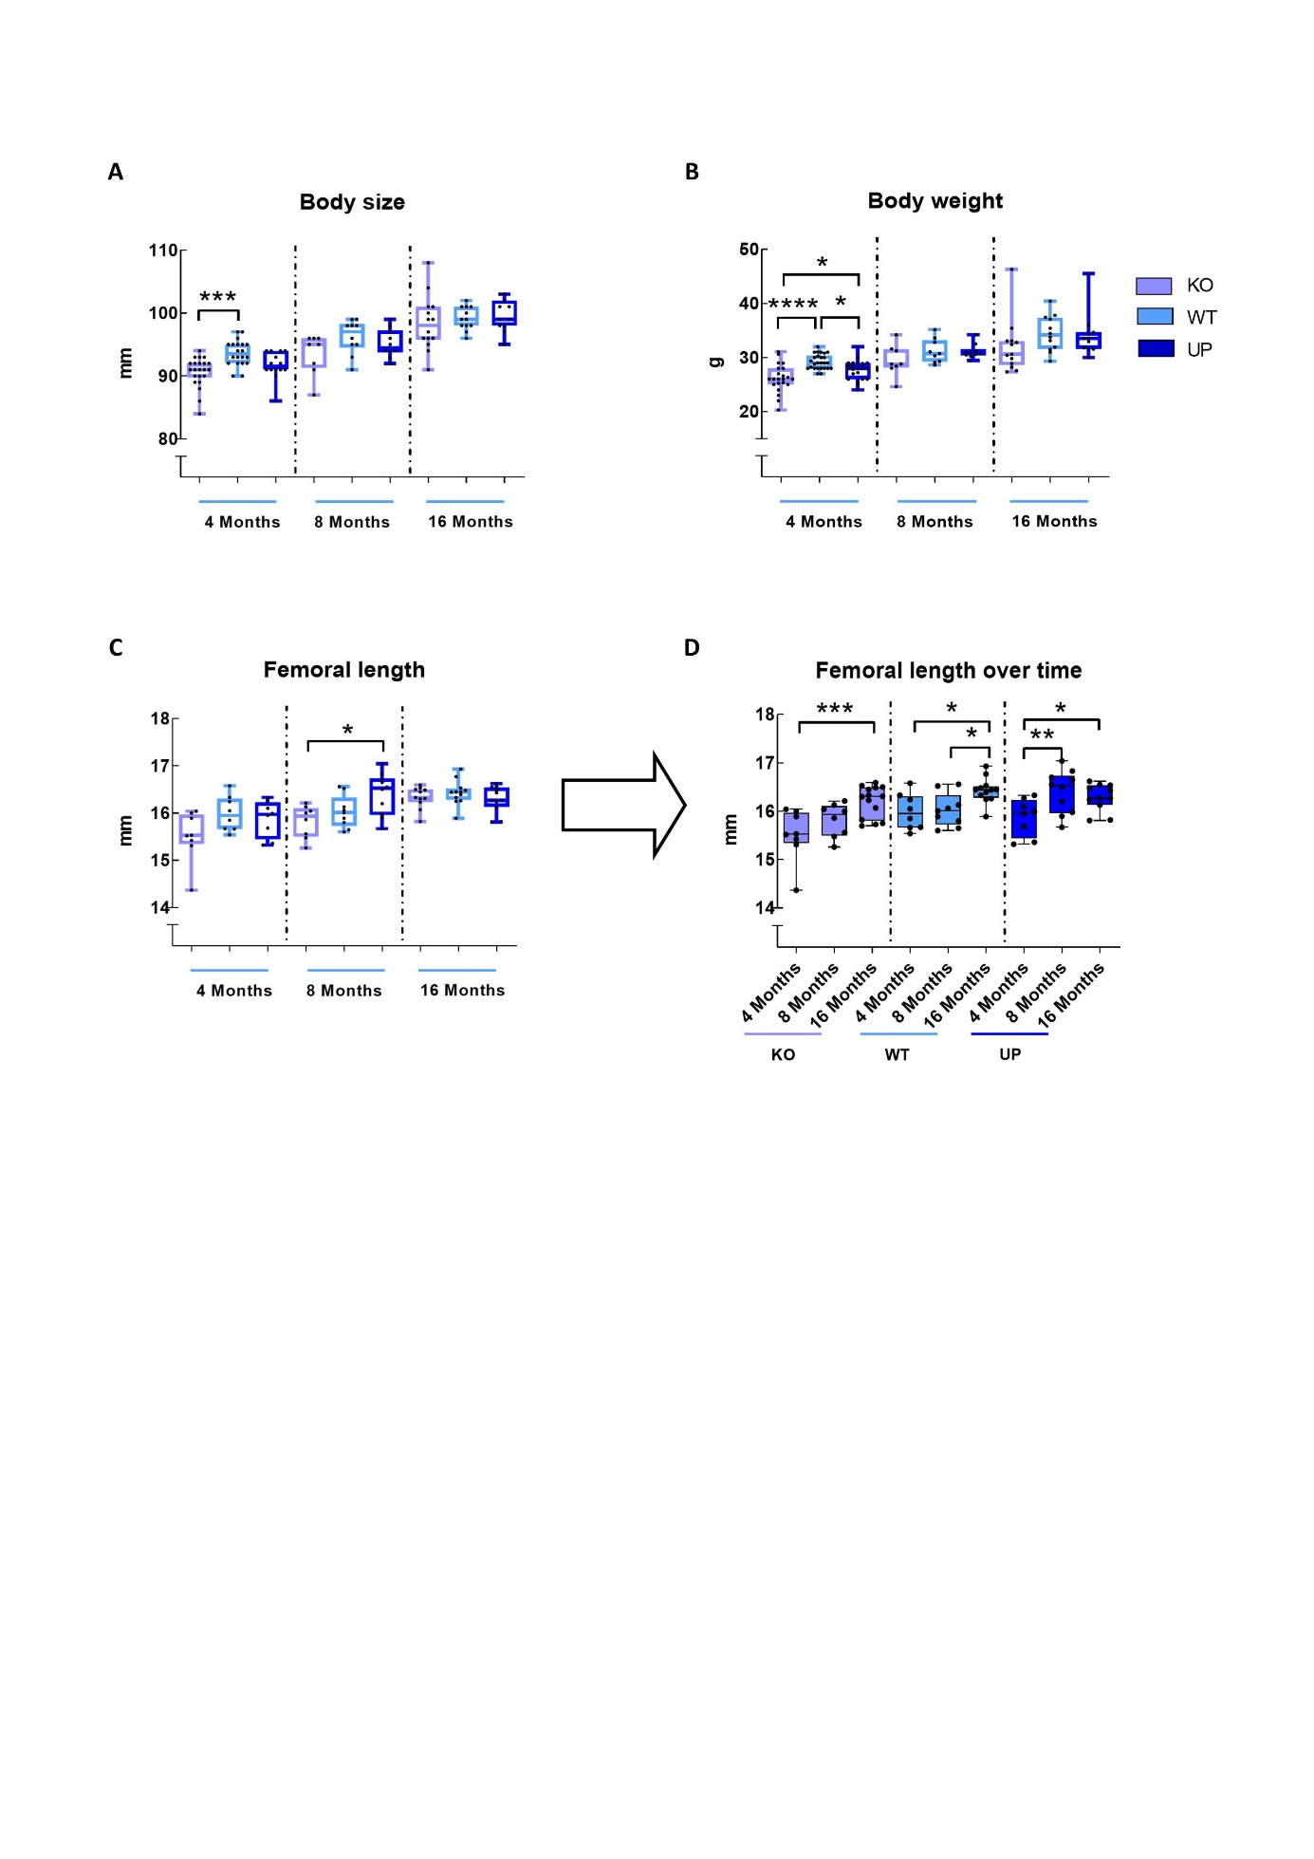
Supplemental figure 2
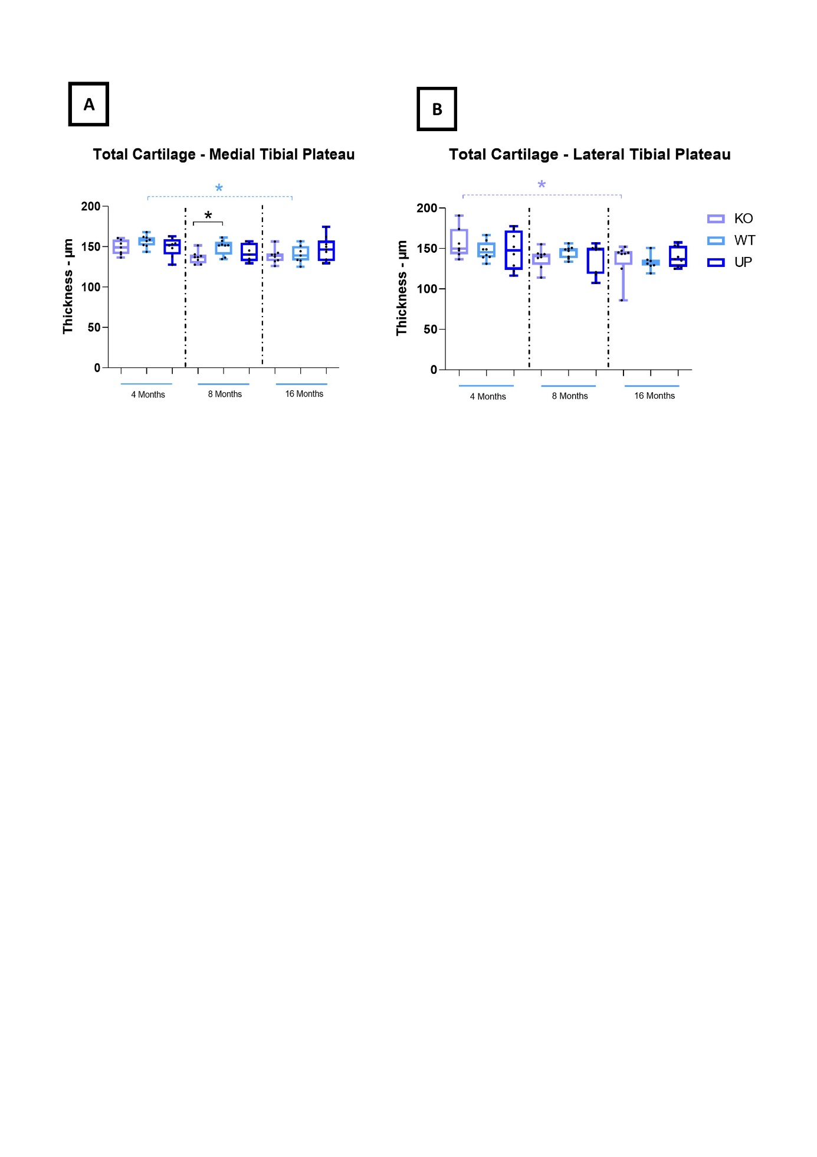
Supplemental figure 3
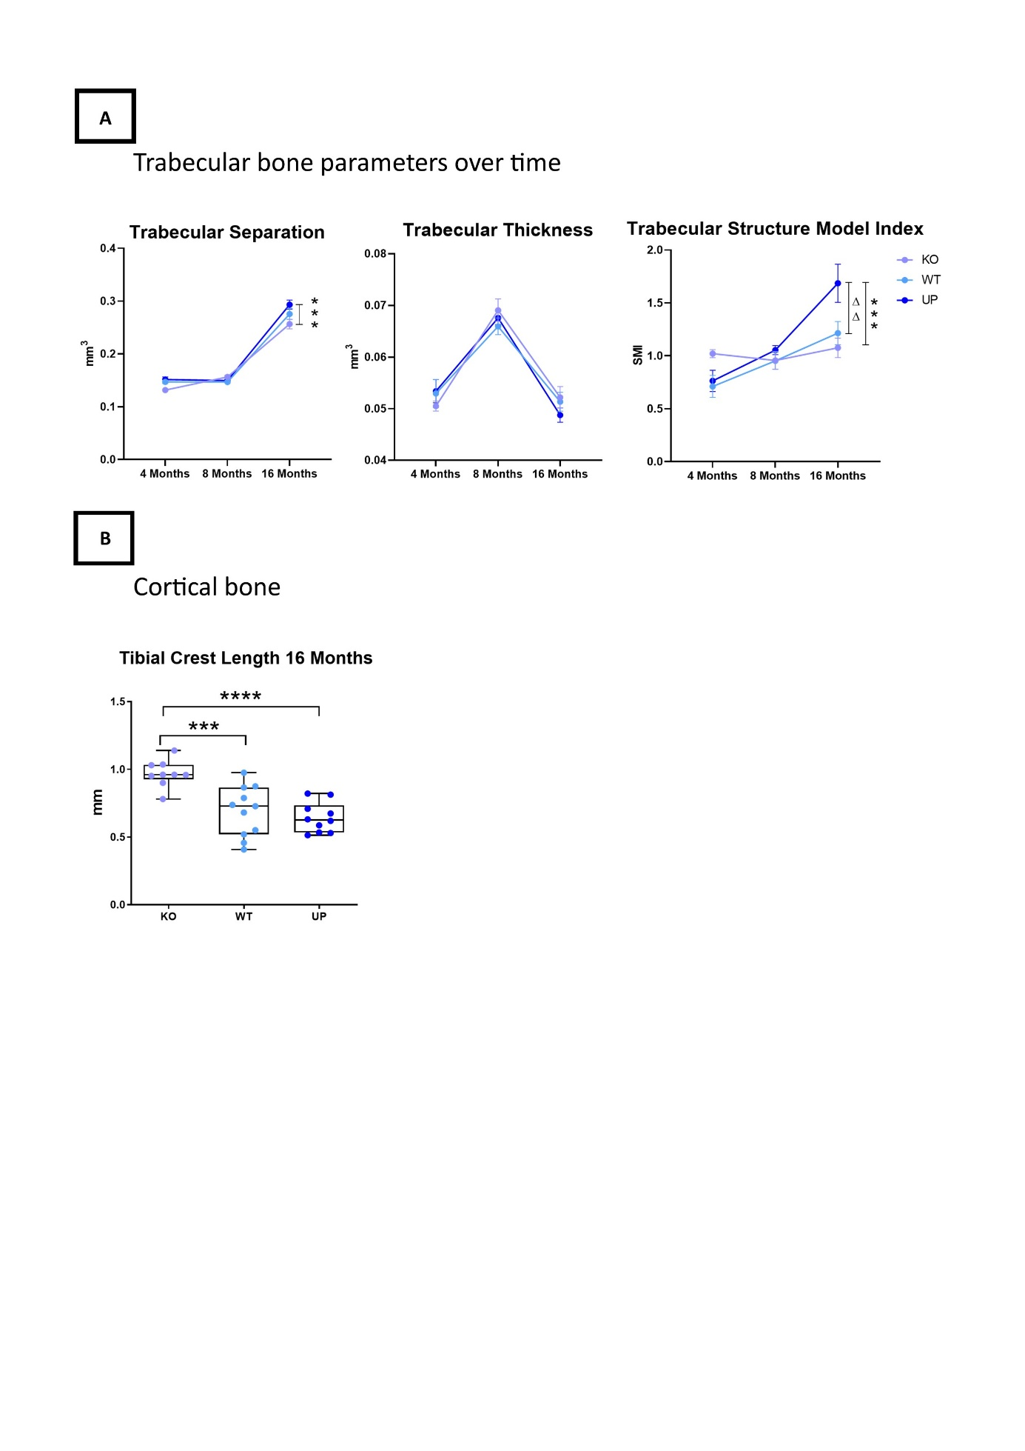
Supplemental figure 4
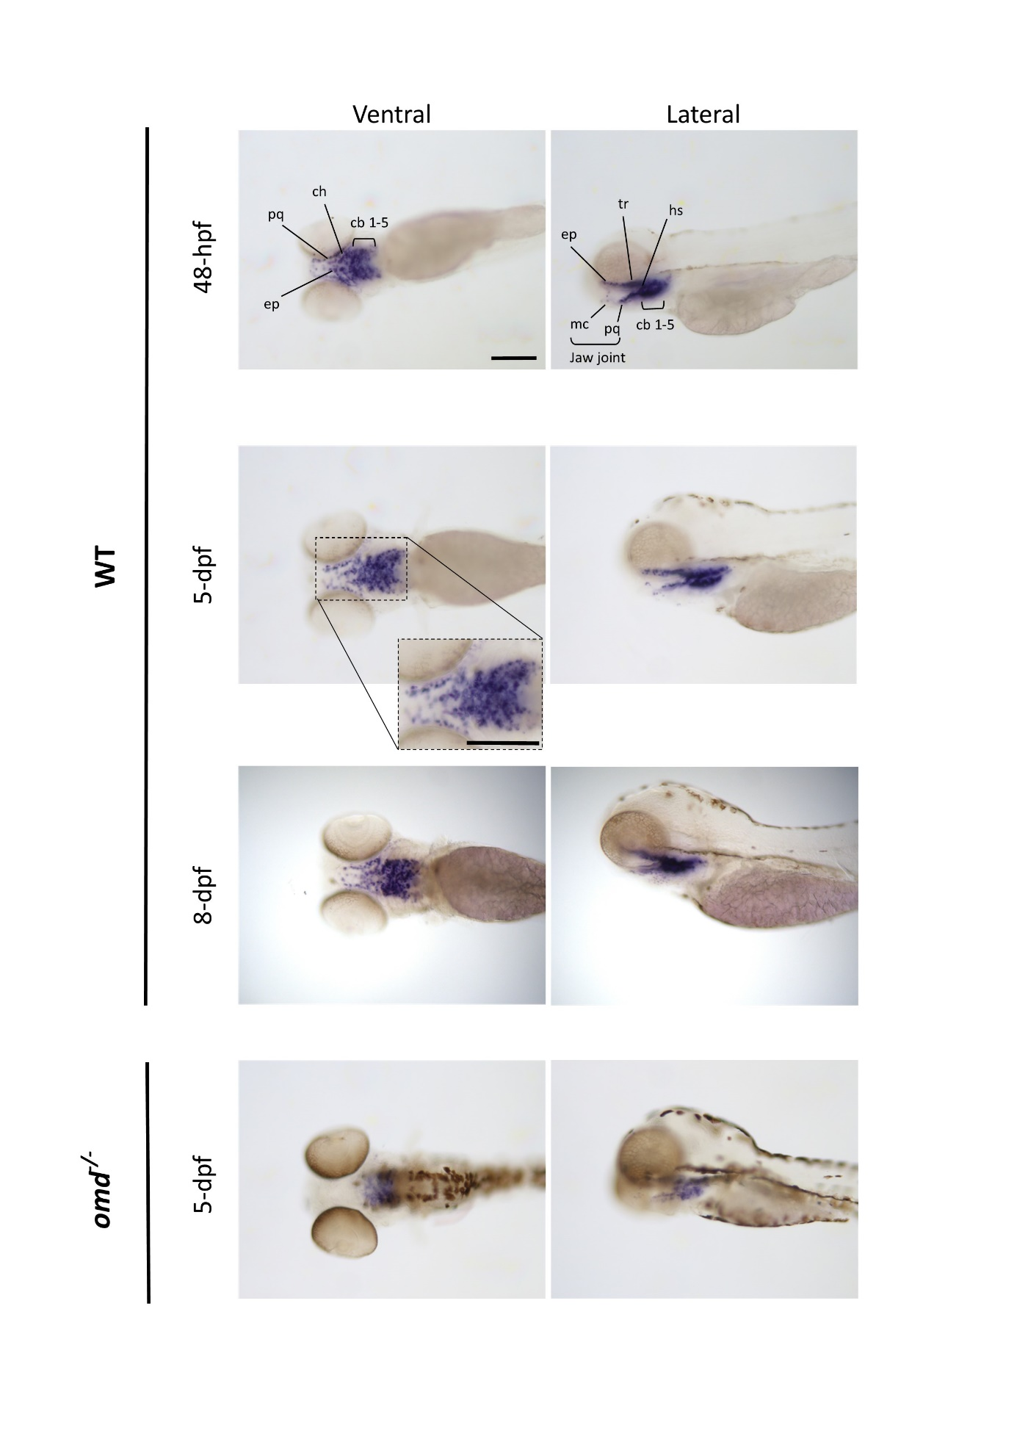
Supplemental figure 5

Supplemental figure 6
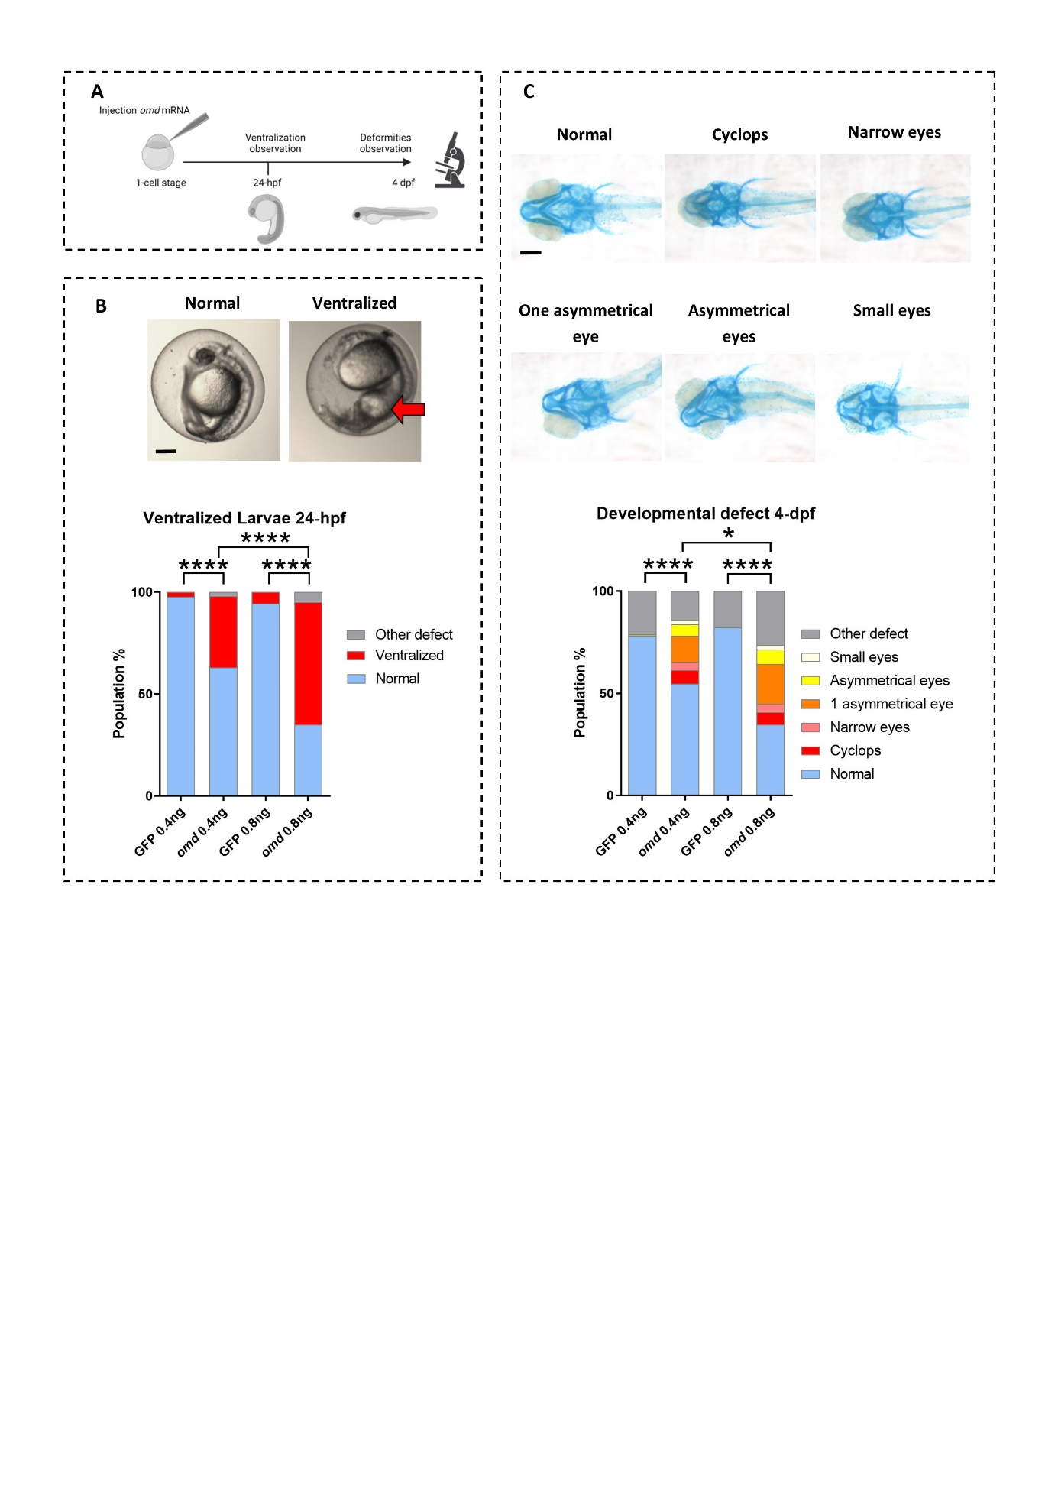
Supplemental figure 6
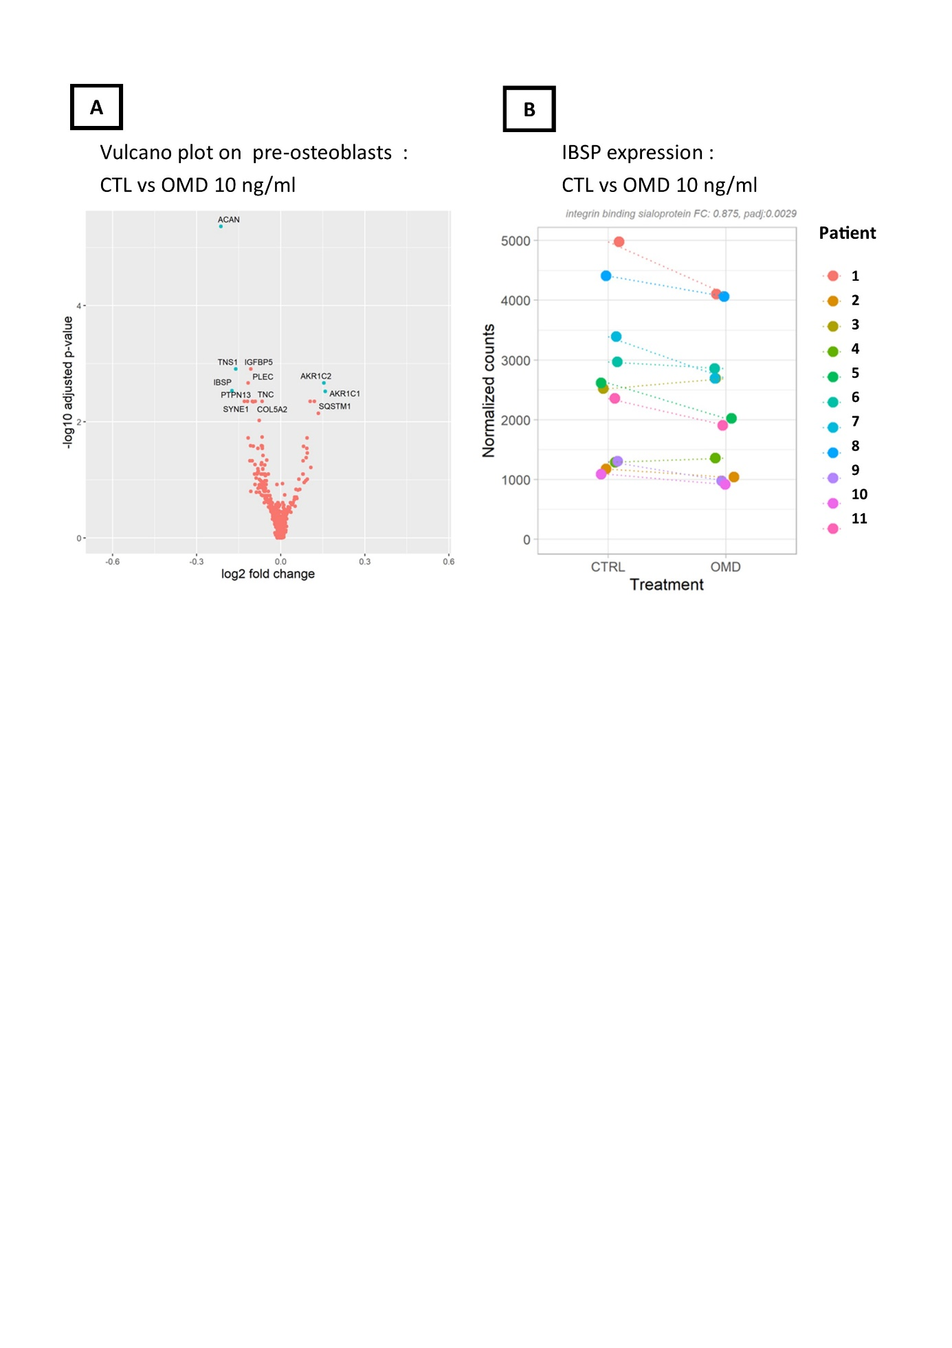
Supplemental figure 7

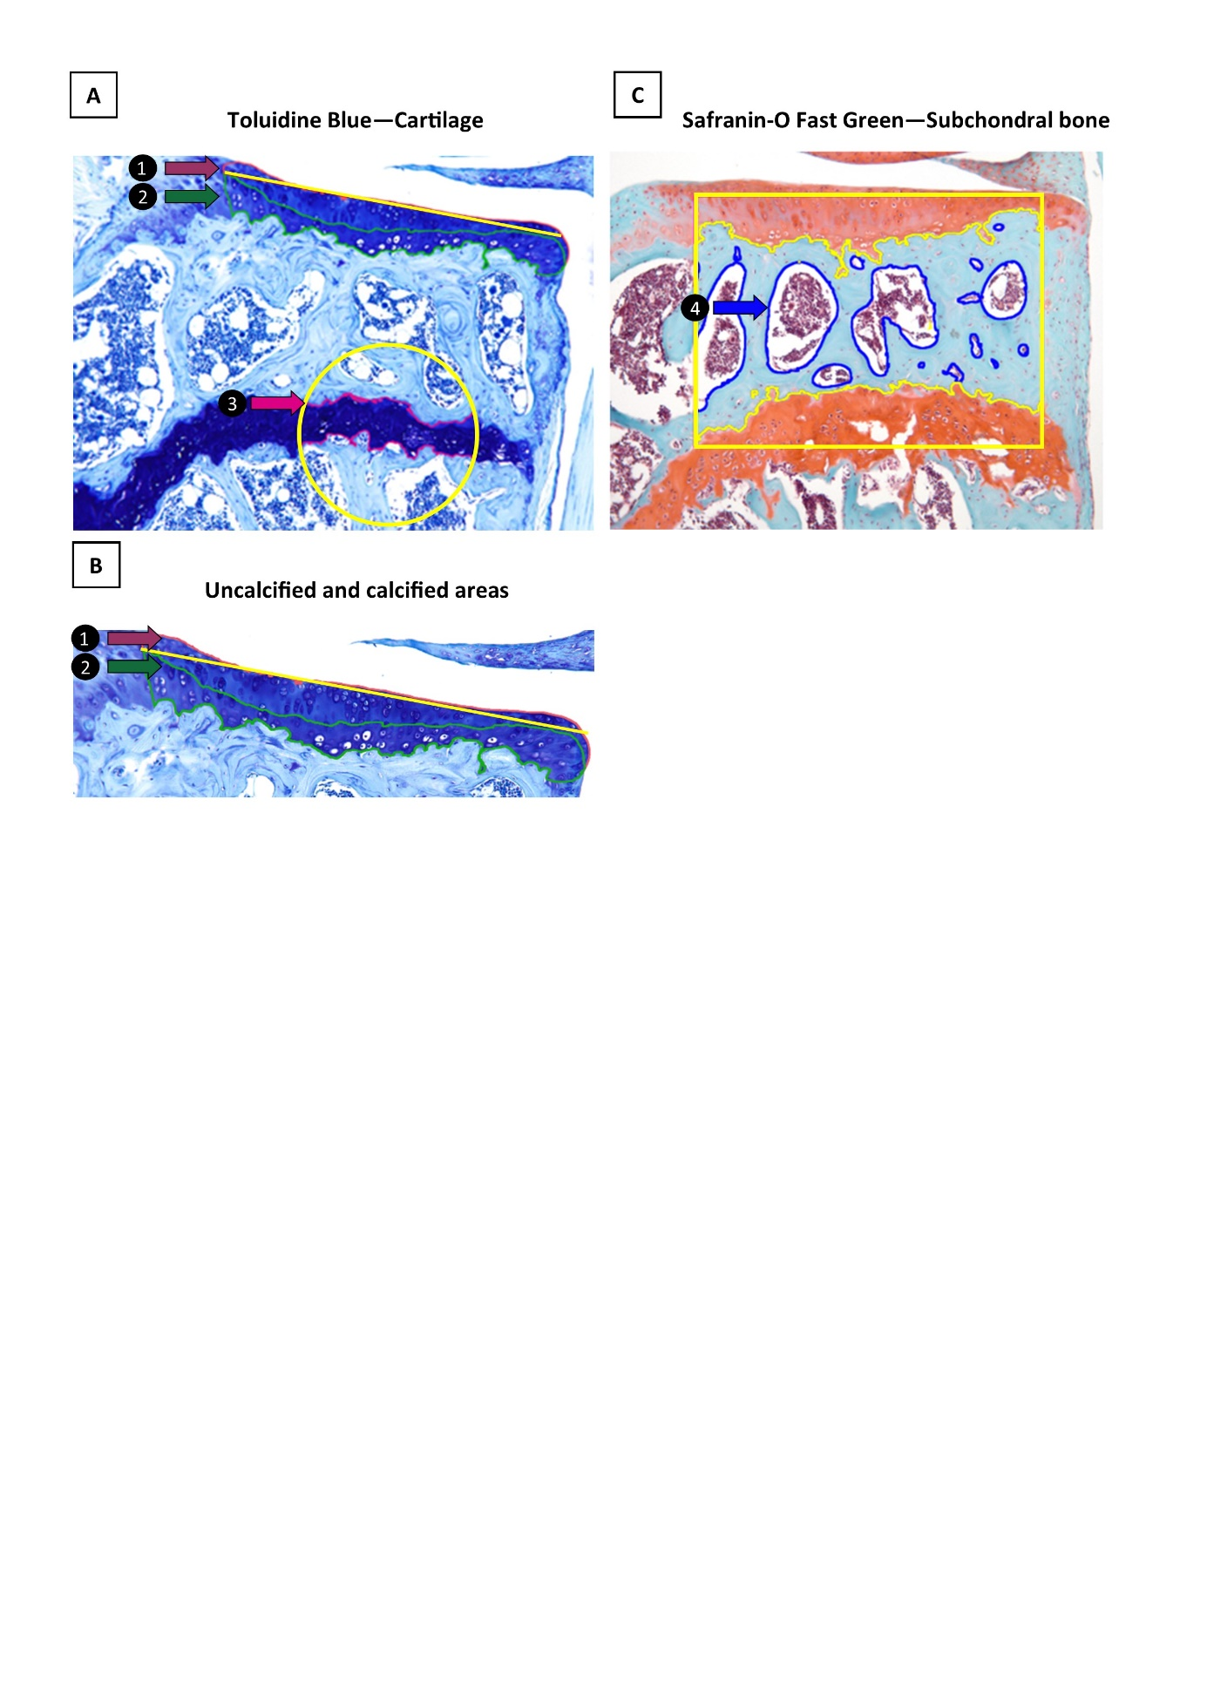
Supplemental Table 1
4 months : Front Paws
Parameter | Genotype | Value | KO vs WT | KO vs UP | UP vs WT

Stand Index | KO | -3,135 | 0,6056 | 0,9594 | 0,7708
Stand Index | WT | -2,702 | 0,6056 | 0,9594 | 0,7708
Stand Index | UP | -3,012 | 0,6056 | 0,9594 | 0,7708
Stand  (s) | KO | 0,1982 | 0,9999 | 0,9999 | 0,9999
Stand  (s) | WT | 0,1968 | 0,9999 | 0,9999 | 0,9999
Stand  (s) | UP | 0,1825 | 0,9999 | 0,9999 | 0,9999
Max Contact Area  (cm²) | KO | 1,172 | 0,4027 | 0,0033 (**) | 0,0610
Max Contact Area  (cm²) | WT | 1,073 | 0,4027 | 0,0033 (**) | 0,0610
Max Contact Area  (cm²) | UP | 0,8901 | 0,4027 | 0,0033 (**) | 0,0610
Print Area  (cm²) | KO | 1,364 | 0,3367 | 0,0032 (**) | 0,0762
Print Area  (cm²) | WT | 1,233 | 0,3367 | 0,0032 (**) | 0,0762
Print Area  (cm²) | UP | 1,024 | 0,3367 | 0,0032 (**) | 0,0762
Swing  (s) | KO | 0,1191 | 0,0400 (*) | 0,0362 (*) | 0,9999
Swing  (s) | WT | 0,1475 | 0,0400 (*) | 0,0362 (*) | 0,9999
Swing  (s) | UP | 0,1427 | 0,0400 (*) | 0,0362 (*) | 0,9999
Swing Speed  (cm) | KO | 75,67 | 0,5725 | 0,5373 | 0,9999
Swing Speed  (cm) | WT | 66,77 | 0,5725 | 0,5373 | 0,9999
Swing Speed  (cm) | UP | 67,95 | 0,5725 | 0,5373 | 0,9999
Stride Length  (cm) | KO | 8,430 | 0,2212 | 0,1306 | 0,9499
Stride Length  (cm) | WT | 9,074 | 0,2212 | 0,1306 | 0,9499
Stride Length  (cm) | UP | 9,188 | 0,2212 | 0,1306 | 0,9499
Step Cycle  (s) | KO | 0,3153 | 0,7737 | 0,9999 | 0,9999
Step Cycle  (s) | WT | 0,3429 | 0,7737 | 0,9999 | 0,9999
Step Cycle  (s) | UP | 0,3206 | 0,7737 | 0,9999 | 0,9999
Single Stance  (s) | KO | 0,1191 | 0,0296 (*) | 0,0362 (*) | 0,9999
Single Stance  (s) | WT | 0,1443 | 0,0296 (*) | 0,0362 (*) | 0,9999
Single Stance  (s) | UP | 0,1412 | 0,0296 (*) | 0,0362 (*) | 0,9999
Initial dual stance  (s) | KO | 0,03823 | 0,0935 | 0,0021 (**) | 0,2172
Initial dual stance  (s) | WT | 0,02829 | 0,0935 | 0,0021 (**) | 0,2172
Initial dual stance  (s) | UP | 0,02049 | 0,0935 | 0,0021 (**) | 0,2172
Terminal dual stance  (s) | KO | 0,03836 | 0,0470 (*) | 0,0047 (**) | 0,5603
Terminal dual stance  (s) | WT | 0,02713 | 0,0470 (*) | 0,0047 (**) | 0,5603
Terminal dual stance  (s) | UP | 0,02255 | 0,0470 (*) | 0,0047 (**) | 0,5603
Base of support  (cm) | KO | 2,106 | 0,0140 (*) | 0,4637 | 0,1610
Base of support  (cm) | WT | 1,688 | 0,0140 (*) | 0,4637 | 0,1610
Base of support  (cm) | UP | 1,944 | 0,0140 (*) | 0,4637 | 0,1610
Intensity | KO | 0,1489 | 0,0732 | 0,0007 (***) | 0,1216
Intensity | WT | 0,2147 | 0,0732 | 0,0007 (***) | 0,1216
Intensity | UP | 0,2730 | 0,0732 | 0,0007 (***) | 0,1216

4 months : Hind Paws
Parameter | Genotype | Value | KO vs WT | KO vs UP | UP vs WT

Stand Index | KO | -10,62 | 0,0061 (**) | 0,0153 (*) | 0,9136
Stand Index | WT | -7,544 | 0,0061 (**) | 0,0153 (*) | 0,9136
Stand Index | UP | 7,903 | 0,0061 (**) | 0,0153 (*) | 0,9136
Stand  (s) | KO | 0,1850 | 0,0931 | 0,5373 | 0,9999
Stand  (s) | WT | 0,2091 | 0,0931 | 0,5373 | 0,9999
Stand  (s) | UP | 0,1975 | 0,0931 | 0,5373 | 0,9999
Max Contact Area  (cm²) | KO | 0,7649 | 0,0134 (*) | 0,1267 | 0,5320
Max Contact Area  (cm²) | WT | 1,074 | 0,0134 (*) | 0,1267 | 0,5320
Max Contact Area  (cm²) | UP | 0,9663 | 0,0134 (*) | 0,1267 | 0,5320
Print Area  (cm²) | KO | 0,9344 | 0,0142 (*) | 0,2787 | 0,2975
Print Area  (cm²) | WT | 1,292 | 0,0142 (*) | 0,2787 | 0,2975
Print Area  (cm²) | UP | 1,116 | 0,0142 (*) | 0,2787 | 0,2975
Swing  (s) | KO | 0,1319 | 0,6208 | 0,7914 | 0,9560
Swing  (s) | WT | 0,1226 | 0,6208 | 0,7914 | 0,9560
Swing  (s) | UP | 0,1254 | 0,6208 | 0,7914 | 0,9560
Swing Speed  (cm/s) | KO | 67,92 | 0,4127 | 0,5038 | 0,9999
Swing Speed  (cm/s) | WT | 77,41 | 0,4127 | 0,5038 | 0,9999
Swing Speed  (cm/s) | UP | 74,37 | 0,4127 | 0,5038 | 0,9999
Stride Length  (cm) | KO | 8,330 | 0,4284 | 0,0898 | 0,6104
Stride Length  (cm) | WT | 8,783 | 0,4284 | 0,0898 | 0,6104
Stride Length  (cm) | UP | 9,126 | 0,4284 | 0,0898 | 0,6104
Step Cycle  (s) | KO | 0,3108 | 0,7731 | 0,8602 | 0,9855
Step Cycle  (s) | WT | 0,3285 | 0,7731 | 0,8602 | 0,9855
Step Cycle  (s) | UP | 0,3243 | 0,7731 | 0,8602 | 0,9855
Single Stance  (s) | KO | 0,1191 | 0,9914 | 0,7499 | 0,8200
Single Stance  (s) | WT | 0,1200 | 0,9914 | 0,7499 | 0,8200
Single Stance  (s) | UP | 0,1242 | 0,9914 | 0,7499 | 0,8200
Initial dual stance  (s) | KO | 0,03142 | 0,0535 | 0,3594 | 0,9999
Initial dual stance  (s) | WT | 0,04169 | 0,0535 | 0,3594 | 0,9999
Initial dual stance  (s) | UP | 0,03783 | 0,0535 | 0,3594 | 0,9999
Terminal dual stance  (s) | KO | 0,03356 | 0,0778 | 0,5038 | 0,9999
Terminal dual stance  (s) | WT | 0,04485 | 0,0778 | 0,5038 | 0,9999
Terminal dual stance  (s) | UP | 0,03976 | 0,0778 | 0,5038 | 0,9999
Base of support  (cm) | KO | 3,516 | 0,8857 | 0,8160 | 0,9893
Base of support  (cm) | WT | 3,609 | 0,8857 | 0,8160 | 0,9893
Base of support  (cm) | UP | 3,637 | 0,8857 | 0,8160 | 0,9893
Intensity | KO | 0,1530 | 0,1829 | 0,9999 | 0,8192
Intensity | WT | 0,09976 | 0,1829 | 0,9999 | 0,8192
Intensity | UP | 0,1218 | 0,1829 | 0,9999 | 0,8192

8 months : Front Paws
Parameter | Genotype | Value | KO vs WT | KO vs UP | UP vs WT

Stand Index | KO | -2,976 | 0,4716 | 0,9999 | 0,9999
Stand Index | WT | -2,397 | 0,4716 | 0,9999 | 0,9999
Stand Index | UP | -2,732 | 0,4716 | 0,9999 | 0,9999
Stand  (s) | KO | 0,2172 | 0,5961 | 0,9099 | 0,3607
Stand  (s) | WT | 0,2356 | 0,5961 | 0,9099 | 0,3607
Stand  (s) | UP | 0,2095 | 0,5961 | 0,9099 | 0,3607
Max Contact Area  (cm²) | KO | 1,030 | 0,0120 (*) | 0,7729 | 0,0529
Max Contact Area  (cm²) | WT | 1,256 | 0,0120 (*) | 0,7729 | 0,0529
Max Contact Area  (cm²) | UP | 1,079 | 0,0120 (*) | 0,7729 | 0,0529
Print Area  (cm²) | KO | 1,178 | 0,0140 (*) | 0,6791 | 0,0832
Print Area  (cm²) | WT | 1,451 | 0,0140 (*) | 0,6791 | 0,0832
Print Area  (cm²) | UP | 1,252 | 0,0140 (*) | 0,6791 | 0,0832
Swing  (s) | KO | 0,1229 | 0,1553 | 0,0486 (*) | 0,9999
Swing  (s) | WT | 0,1500 | 0,1553 | 0,0486 (*) | 0,9999
Swing  (s) | UP | 0,1533 | 0,1553 | 0,0486 (*) | 0,9999
Swing Speed  (cm/s) | KO | 68,47 | 0,7632 | 0,7452 | 0,9995
Swing Speed  (cm/s) | WT | 64,77 | 0,7632 | 0,7452 | 0,9995
Swing Speed  (cm/s) | UP | 64,60 | 0,7632 | 0,7452 | 0,9995
Stride Length  (cm) | KO | 7,929 | 0,1938 | 0,0336 (*) | 0,6403
Stride Length  (cm) | WT | 8,892 | 0,1938 | 0,0336 (*) | 0,6403
Stride Length  (cm) | UP | 9,379 | 0,1938 | 0,0336 (*) | 0,6403
Step Cycle  (s) | KO | 0,3408 | 0,1686 | 0,6090 | 0,9999
Step Cycle  (s) | WT | 0,3842 | 0,1686 | 0,6090 | 0,9999
Step Cycle  (s) | UP | 0,3604 | 0,1686 | 0,6090 | 0,9999
Single Stance  (s) | KO | 0,1228 | 0,1430 | 0,0535 | 0,9999
Single Stance  (s) | WT | 0,1481 | 0,1430 | 0,0535 | 0,9999
Single Stance  (s) | UP | 0,1516 | 0,1430 | 0,0535 | 0,9999
Initial dual stance  (s) | KO | 0,04792 | 0,8489 | 0,0759 | 0,2054
Initial dual stance  (s) | WT | 0,04300 | 0,8489 | 0,0759 | 0,2054
Initial dual stance  (s) | UP | 0,02712 | 0,8489 | 0,0759 | 0,2054
Terminal dual stance  (s) | KO | 0,04756 | 0,9554 | 0,0559 | 0,0986
Terminal dual stance  (s) | WT | 0,04531 | 0,9554 | 0,0559 | 0,0986
Terminal dual stance  (s) | UP | 0,02831 | 0,9554 | 0,0559 | 0,0986
Base of support  (cm) | KO | 2,002 | 0,5068 | 0,5391 | 0,9984
Base of support  (cm) | WT | 1,864 | 0,5068 | 0,5391 | 0,9984
Base of support  (cm) | UP | 1,870 | 0,5068 | 0,5391 | 0,9984
Intensity | KO | 0,1131 | 0,9999 | 0,6093 | 0,9999
Intensity | WT | 0,09739 | 0,9999 | 0,6093 | 0,9999
Intensity | UP | 0,09320 | 0,9999 | 0,6093 | 0,9999

8 months : Hind Paws
Parameter | Genotype | Value | KO vs WT | KO vs UP | UP vs WT

Stand Index | KO | -8,854 | 0,2133 | 0,1638 | 0,9867
Stand Index | WT | -6,898 | 0,2133 | 0,1638 | 0,9867
Stand Index | UP | -6,723 | 0,2133 | 0,1638 | 0,9867
Stand  (s) | KO | 0,2285 | 0,6897 | 0,8393 | 0,3614
Stand  (s) | WT | 0,2456 | 0,6897 | 0,8393 | 0,3614
Stand  (s) | UP | 0,2168 | 0,6897 | 0,8393 | 0,3614
Max Contact Area  (cm²) | KO | 0,7735 | 0,0002 (***) | 0,0150 (*) | 0,1838
Max Contact Area  (cm²) | WT | 1,281 | 0,0002 (***) | 0,0150 (*) | 0,1838
Max Contact Area  (cm²) | UP | 1,092 | 0,0002 (***) | 0,0150 (*) | 0,1838
Print Area  (cm²) | KO | 0,9831 | 0,0002 (***) | 0,0230 (*) | 0,1125
Print Area  (cm²) | WT | 1,519 | 0,0002 (***) | 0,0230 (*) | 0,1125
Print Area  (cm²) | UP | 1,293 | 0,0002 (***) | 0,0230 (*) | 0,1125
Swing  (s) | KO | 0,1061 | 0,0105 (*) | 0,0345 (*) | 0,8521
Swing  (s) | WT | 0,1339 | 0,0105 (*) | 0,0345 (*) | 0,8521
Swing  (s) | UP | 0,1293 | 0,0105 (*) | 0,0345 (*) | 0,8521
Swing Speed  (cm/s) | KO | 75,28 | 0,6475 | 0,9999 | 0,9999
Swing Speed  (cm/s) | WT | 67,74 | 0,6475 | 0,9999 | 0,9999
Swing Speed  (cm/s) | UP | 73,17 | 0,6475 | 0,9999 | 0,9999
Stride Length  (cm) | KO | 7,764 | 0,2493 | 0,0447 (*) | 0,6284
Stride Length  (cm) | WT | 8,665 | 0,2493 | 0,0447 (*) | 0,6284
Stride Length  (cm) | UP | 9,174 | 0,2493 | 0,0447 (*) | 0,6284
Step Cycle  (s) | KO | 0,2879 | 0,2139 | 0,9999 | 0,8662
Step Cycle  (s) | WT | 0,3027 | 0,2139 | 0,9999 | 0,8662
Step Cycle  (s) | UP | 0,2862 | 0,2139 | 0,9999 | 0,8662
Single Stance  (s) | KO | 0,1050 | 0,0104 (*) | 0,0390 (*) | 0,8197
Single Stance  (s) | WT | 0,1320 | 0,0104 (*) | 0,0390 (*) | 0,8197
Single Stance  (s) | UP | 0,1270 | 0,0104 (*) | 0,0390 (*) | 0,8197
Initial dual stance  (s) | KO | 0,06246 | 0,7260 | 0,2462 | 0,6554
Initial dual stance  (s) | WT | 0,05460 | 0,7260 | 0,2462 | 0,6554
Initial dual stance  (s) | UP | 0,04554 | 0,7260 | 0,2462 | 0,6554
Terminal dual stance  (s) | KO | 0,06126 | 0,8707 | 0,2389 | 0,4838
Terminal dual stance  (s) | WT | 0,05661 | 0,8707 | 0,2389 | 0,4838
Terminal dual stance  (s) | UP | 0,04579 | 0,8707 | 0,2389 | 0,4838
Base of support  (cm) | KO | 3,917 | 0,7297 | 0,9999 | 0,9999
Base of support  (cm) | WT | 4,024 | 0,7297 | 0,9999 | 0,9999
Base of support  (cm) | UP | 4,007 | 0,7297 | 0,9999 | 0,9999
Intensity | KO | 0,1461 | 0,0016 (**) | 0,0027 (**) | 0,9722
Intensity | WT | 0,09121 | 0,0016 (**) | 0,0027 (**) | 0,9722
Intensity | UP | 0,09427 | 0,0016 (**) | 0,0027 (**) | 0,9722

16 months : Front Paws
Parameter | Genotype | Value | KO vs WT | KO vs UP | UP vs WT

Stand Index | KO | -3,510 | 0,6897 | 0,0414 (*) | 0,6034
Stand Index | WT | -2,574 | 0,6897 | 0,0414 (*) | 0,6034
Stand Index | UP | -2,114 | 0,6897 | 0,0414 (*) | 0,6034
Stand  (s) | KO | 0,2083 | 0,6504 | 0,2633 | 0,7525
Stand  (s) | WT | 0,2245 | 0,6504 | 0,2633 | 0,7525
Stand  (s) | UP | 0,2388 | 0,6504 | 0,2633 | 0,7525
Max Contact Area  (cm²) | KO | 0,9117 | 0,1656 | 0,0987 | 0,9345
Max Contact Area  (cm²) | WT | 1,022 | 0,1656 | 0,0987 | 0,9345
Max Contact Area  (cm²) | UP | 1,045 | 0,1656 | 0,0987 | 0,9345
Print Area  (cm²) | KO | 1,037 | 0,1390 | 0,1265 | 0,9889
Print Area  (cm²) | WT | 1,166 | 0,1390 | 0,1265 | 0,9889
Print Area  (cm²) | UP | 1,177 | 0,1390 | 0,1265 | 0,9889
Swing  (s) | KO | 0,1127 | 0,0110 (*) | 0,0005 (***) | 0,4263
Swing  (s) | WT | 0,1430 | 0,0110 (*) | 0,0005 (***) | 0,4263
Swing  (s) | UP | 0,1565 | 0,0110 (*) | 0,0005 (***) | 0,4263
Swing Speed  (cm/s) | KO | 80,19 | 0,1677 | 0,0057 (**) | 0,2918
Swing Speed  (cm/s) | WT | 69,05 | 0,1677 | 0,0057 (**) | 0,2918
Swing Speed  (cm/s) | UP | 59,08 | 0,1677 | 0,0057 (**) | 0,2918
Stride Length  (cm) | KO | 8,130 | 0,0114 (*) | 0,4293 | 0,2553
Stride Length  (cm) | WT | 9,176 | 0,0114 (*) | 0,4293 | 0,2553
Stride Length  (cm) | UP | 8,580 | 0,0114 (*) | 0,4293 | 0,2553
Step Cycle  (s) | KO | 0,3204 | 0,1834 | 0,0251 (*) | 0,5799
Step Cycle  (s) | WT | 0,3673 | 0,1834 | 0,0251 (*) | 0,5799
Step Cycle  (s) | UP | 0,3957 | 0,1834 | 0,0251 (*) | 0,5799
Single Stance  (s) | KO | 0,1102 | 0,0255 (*) | 0,0008 (***) | 0,7841
Single Stance  (s) | WT | 0,1422 | 0,0255 (*) | 0,0008 (***) | 0,7841
Single Stance  (s) | UP | 0,1545 | 0,0255 (*) | 0,0008 (***) | 0,7841
Initial dual stance  (s) | KO | 0,04890 | 0,2393 | 0,6400 | 0,9999
Initial dual stance  (s) | WT | 0,03957 | 0,2393 | 0,6400 | 0,9999
Initial dual stance  (s) | UP | 0,04172 | 0,2393 | 0,6400 | 0,9999
Terminal dual stance  (s) | KO | 0,04986 | 0,1950 | 0,4125 | 0,9226
Terminal dual stance  (s) | WT | 0,03952 | 0,1950 | 0,4125 | 0,9226
Terminal dual stance  (s) | UP | 0,04196 | 0,1950 | 0,4125 | 0,9226
Base of support  (cm) | KO | 2,189 | 0,4017 | 0,0357 (*) | 0,3963
Base of support  (cm) | WT | 2,040 | 0,4017 | 0,0357 (*) | 0,3963
Base of support  (cm) | UP | 1,875 | 0,4017 | 0,0357 (*) | 0,3963
Intensity | KO | 0,1370 | 0,2138 | 0,5193 | 0,9999
Intensity | WT | 0,1060 | 0,2138 | 0,5193 | 0,9999
Intensity | UP | 0,1091 | 0,2138 | 0,5193 | 0,9999

16 months : Hind Paws
Parameter | Genotype | Value | KO vs WT | KO vs UP | UP vs WT

Stand Index | KO | -7,240 | 0,9999 | 0,9999 | 0,9999
Stand Index | WT | -6,534 | 0,9999 | 0,9999 | 0,9999
Stand Index | UP | -6,784 | 0,9999 | 0,9999 | 0,9999
Stand  (s) | KO | 0,2204 | 0,5801 | 0,0985 | 0,4962
Stand  (s) | WT | 0,2418 | 0,5801 | 0,0985 | 0,4962
Stand  (s) | UP | 0,2683 | 0,5801 | 0,0985 | 0,4962
Max Contact Area  (cm²) | KO | 0,7817 | 0,0566 | 0,1145 | 0,9754
Max Contact Area  (cm²) | WT | 1,007 | 0,0566 | 0,1145 | 0,9754
Max Contact Area  (cm²) | UP | 0,9853 | 0,0566 | 0,1145 | 0,9754
Print Area  (cm²) | KO | 0,9933 | 0,1083 | 0,2277 | 0,9543
Print Area  (cm²) | WT | 1,221 | 0,1083 | 0,2277 | 0,9543
Print Area  (cm²) | UP | 1,186 | 0,1083 | 0,2277 | 0,9543
Swing  (s) | KO | 0,09631 | 0,0040 (**) | 0,0029 (**) | 0,9565
Swing  (s) | WT | 0,1255 | 0,0040 (**) | 0,0029 (**) | 0,9565
Swing  (s) | UP | 0,1281 | 0,0040 (**) | 0,0029 (**) | 0,9565
Swing Speed  (cm/s) | KO | 87,05 | 0,1386 | 0,0180 (*) | 0,5844
Swing Speed  (cm/s) | WT | 76,67 | 0,1386 | 0,0180 (*) | 0,5844
Swing Speed  (cm/s) | UP | 70,93 | 0,1386 | 0,0180 (*) | 0,5844
Stride Length  (cm) | KO | 7,936 | 0,0091 (**) | 0,0951 | 0,6900
Stride Length  (cm) | WT | 9,013 | 0,0091 (**) | 0,0951 | 0,6900
Stride Length  (cm) | UP | 8,707 | 0,0091 (**) | 0,0951 | 0,6900
Step Cycle  (s) | KO | 0,3133 | 0,1067 | 0,0051 (**) | 0,3767
Step Cycle  (s) | WT | 0,3637 | 0,1067 | 0,0051 (**) | 0,3767
Step Cycle  (s) | UP | 0,3991 | 0,1067 | 0,0051 (**) | 0,3767
Single Stance  (s) | KO | 0,09559 | 0,0055 (**) | 0,0028 (**) | 0,9146
Single Stance  (s) | WT | 0,1236 | 0,0055 (**) | 0,0028 (**) | 0,9146
Single Stance  (s) | UP | 0,1273 | 0,0055 (**) | 0,0028 (**) | 0,9146
Initial dual stance  (s) | KO | 0,06292 | 0,8214 | 0,9999 | 0,3389
Initial dual stance  (s) | WT | 0,05523 | 0,8214 | 0,9999 | 0,3389
Initial dual stance  (s) | UP | 0,06931 | 0,8214 | 0,9999 | 0,3389
Terminal dual stance  (s) | KO | 0,06289 | 0,8660 | 0,7988 | 0,5267
Terminal dual stance  (s) | WT | 0,05807 | 0,8660 | 0,7988 | 0,5267
Terminal dual stance  (s) | UP | 0,06924 | 0,8660 | 0,7988 | 0,5267
Base of support  (cm) | KO | 3,916 | 0,9984 | 0,7295 | 0,7733
Base of support  (cm) | WT | 3,908 | 0,9984 | 0,7295 | 0,7733
Base of support  (cm) | UP | 3,796 | 0,9984 | 0,7295 | 0,7733
Intensity | KO | 0,1646 | 0,0418 (*) | 0,1269 | 0,9999
Intensity | WT | 0,09608 | 0,0418 (*) | 0,1269 | 0,9999
Intensity | UP | 0,09931 | 0,0418 (*) | 0,1269 | 0,9999

Supplemental Table 2
