Table 1. Characteristics of included trials on comparison between intervention group and control group. A+T, intervention group; A, control group; RCT, Randomized Controlled Trial; END, early neurological deterioration; mRS, modified Rankin Scale; NIHSS, National Institutes of Health Stroke Scale; sICH, symptomatic intracranial hemorrhage; ICH, intracranial.
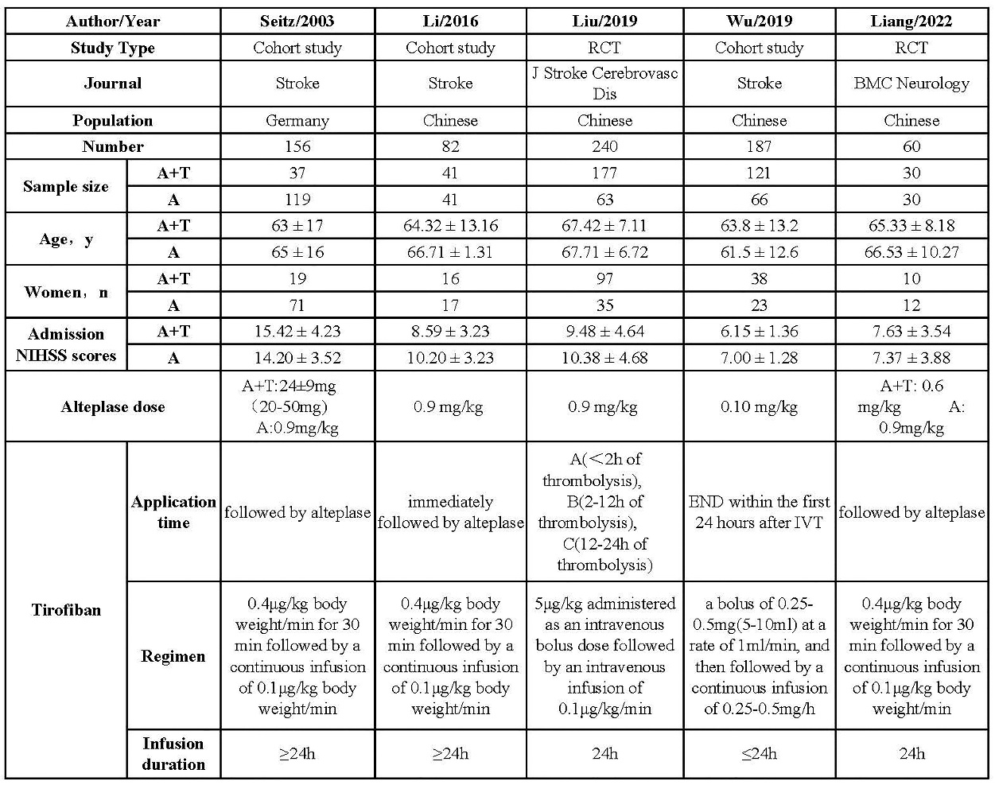

Table 2. Quality assessment of included randomized controlled trials on comparison between intervention group and control group.

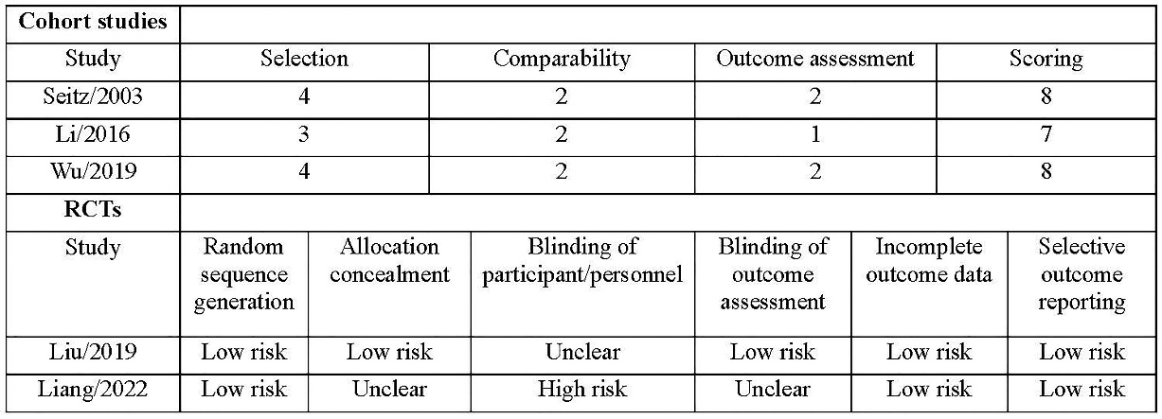

Table 3. Summary of safety and efficacy outcomes. Values are frequency (%).
