Table S1. HRCT Scoring quantitative for Idiopathic Pulmonary Fibrosis
Score | Characteristic
0 | Without fibrosis
1 | Thickening of alveolar septal and interstitium in lung lobules; no dispersed honeycombing
2 | Peripheral honeycomb (with or without septal and interstitial thickening) covering <25% in lung lobules
3 | Peripheral honeycomb (with or without septal and interstitial thickening) covering 25%-49% in lung lobules
4 | Peripheral honeycomb (with or without septal and interstitial thickening) covering 50%-75% in lung lobules
5 | Peripheral honeycomb (with or without septal and interstitial thickening) covering >75% in lung lobules

(A)
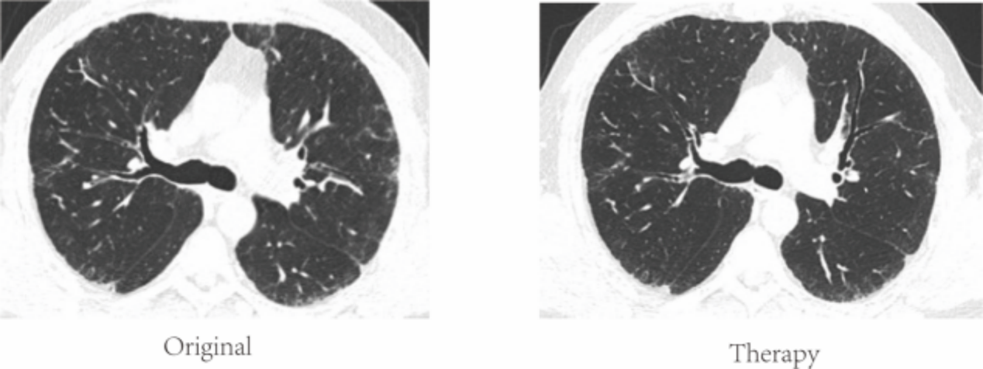
(B)
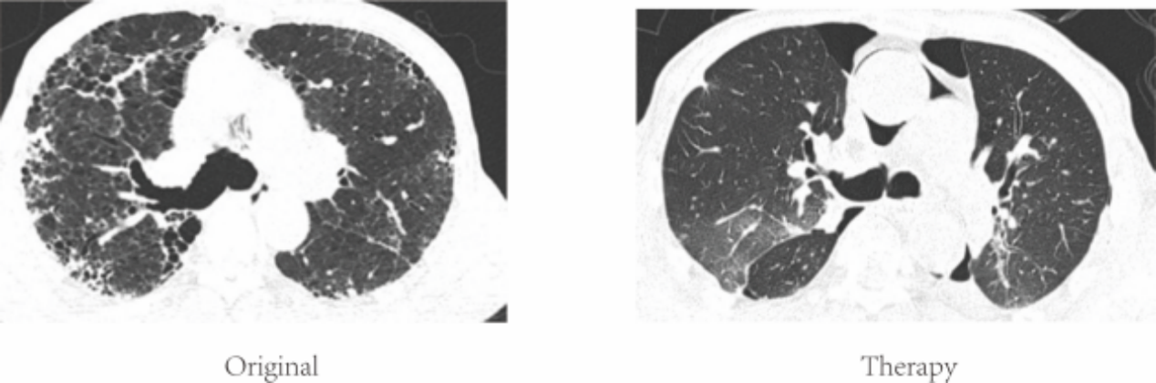
(C)
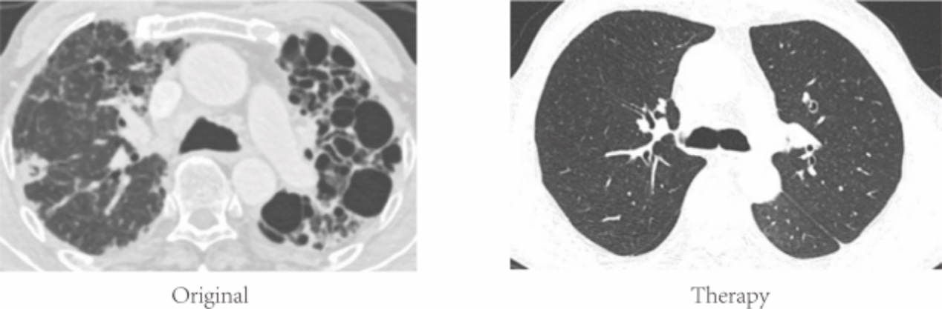
(D)
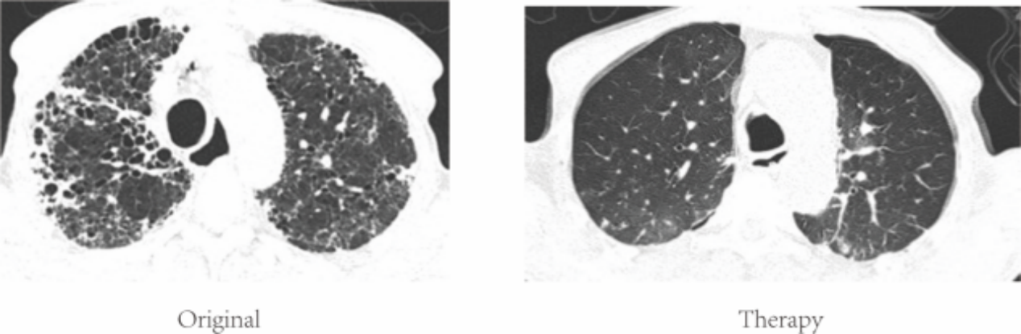
Figure S1. Radiographic changes at the level of bronchi in improved UIP-IPF patients. (A) a 57 years old man with IPF illustrates HRCT fibrosis score of 2 (peripheral honeycomb (with or without septal and interstitial thickening) covering <25% in lung lobules) in left upper, internal, and lower lobules of lung and then treated with pirfenidone. (B) a 69 years old man with IPF illustrates HRCT fibrosis score of 3 (peripheral honeycomb (with or without septal and interstitial thickening) covering 25%-49% in lung lobules) in right peripheral and left upper, internal, and lower lobules of lung and then treated with nintedanib. (C) a 59 years old man with IPF illustrates HRCT fibrosis score of 4 (peripheral honeycomb (with or without septal and interstitial thickening) covering 50%-75% in lung lobules) in most of the left and right upper lobules of lung and initially treated with nintedanib while treated with a lung transplant at last. (D) a 70 years old man with IPF illustrates HRCT fibrosis score of 5 (peripheral honeycomb (with or without septal and interstitial thickening) covering >75% in lung lobules) in most of the left and right lobules of lung and then treated with pirfenidone. Original means initial diagnosis; Therapy means anti-fibrotic therapy.

(A)
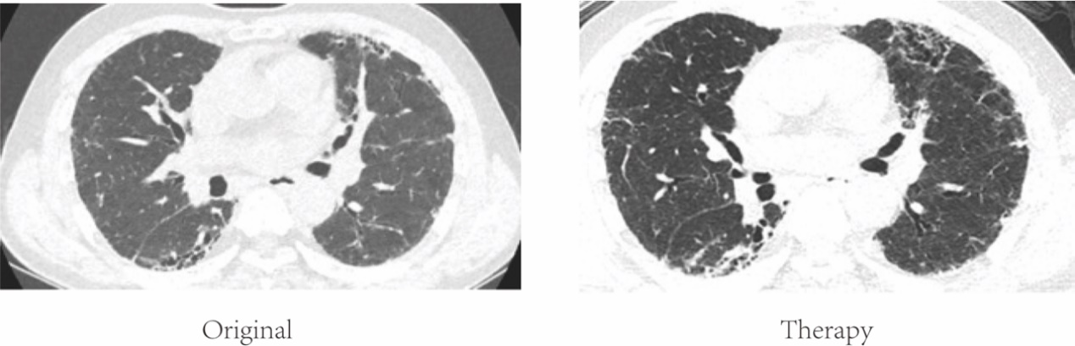
(B)
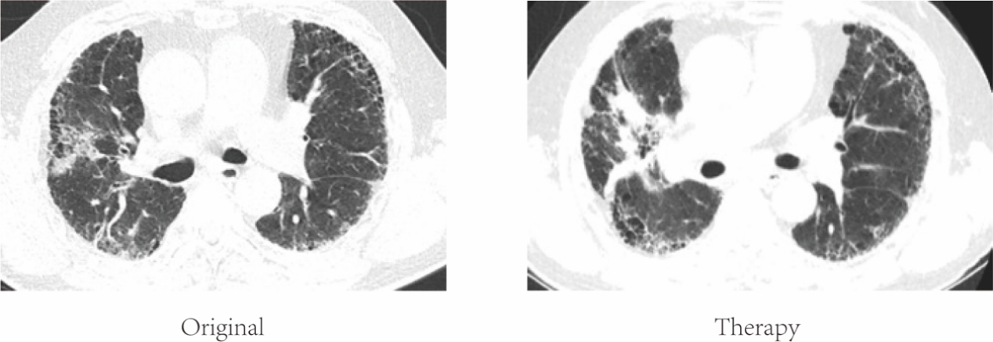
(C)
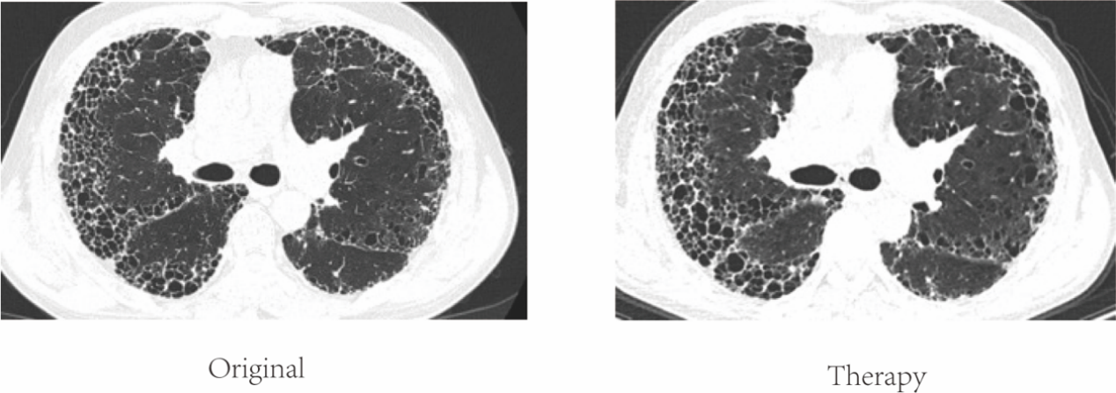
(D)
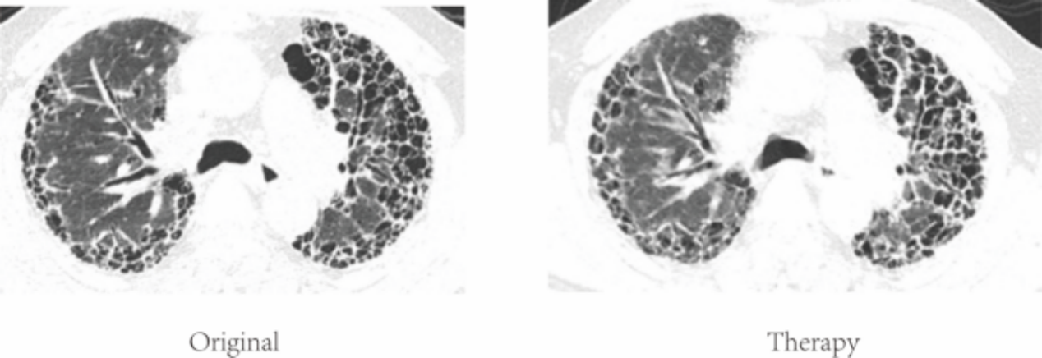
Figure S2. Radiographic changes at the level of bronchi in worsened UIP-IPF patients. (A) a 69 years old man with IPF illustrates HRCT fibrosis score of 2 (peripheral honeycomb (with or without septal and interstitial thickening) covering <25% in lung lobules) in left upper, right lower lobules of lung progressive thickening which was treated with pirfenidone. (B) a 62 years old man with IPF illustrates HRCT fibrosis score of 3 (peripheral honeycomb (with or without septal and interstitial thickening) covering 25%-49% in lung lobules) in left, right lobules of lung peripheral progressive thickening which was treated with pirfenidone. (C) a 59 years old man with IPF illustrates HRCT fibrosis score of 4 (peripheral honeycomb (with or without septal and interstitial thickening) covering 50%-75% in lung lobules) in most of the left and right lobules of lung peripheral progressive thickening which was treated with pirfenidone. (D) a 72 years old man with IPF illustrates HRCT fibrosis score of 5 (peripheral honeycomb (with or without septal and interstitial thickening) covering >75% in lung lobules) in almost all of the left, and right internal, lower peripheral lobules of lung peripheral progressive thickening which was treated with pirfenidone. Original means initial diagnosis; Therapy means anti-fibrotic therapy.

