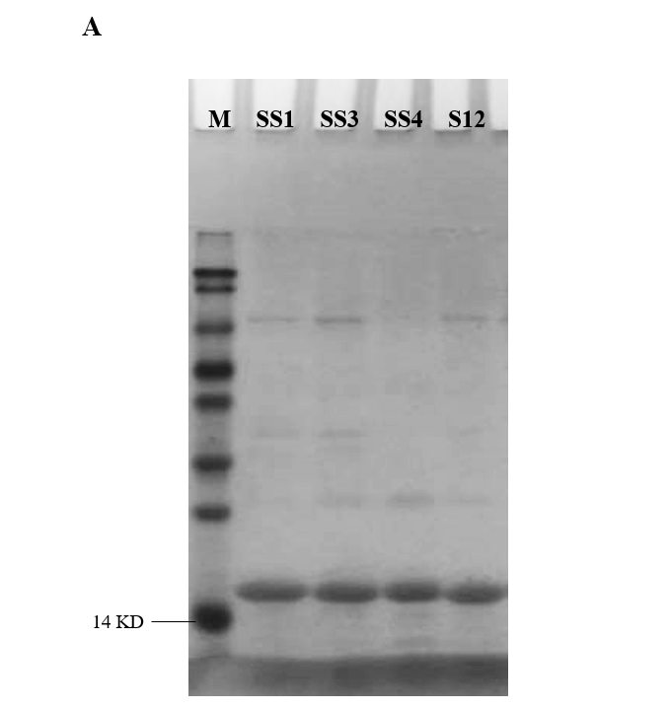
Figure. 2. (A) SDS-PAGE profile of recombinant anti-RBD VHH after Ni-column purification (reducing condition). The gels/bots come from the same gel.

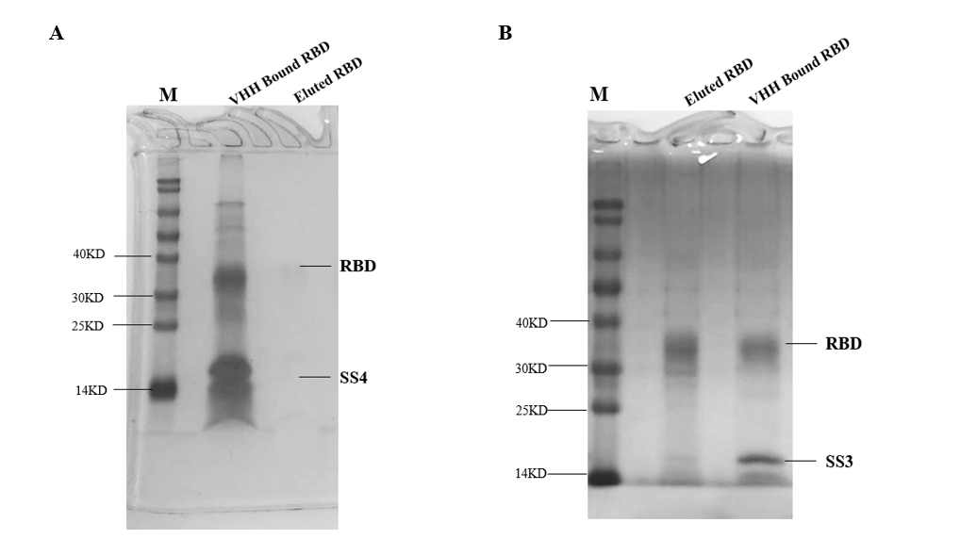
Figure. 4. Effect of affinity ligand on the elution efficiency for purifying RBD. (A) SDS-PAGE analysis of elution on affinity columns conjugated with SS4 (reducing condition). Binding RBD was eluted with 0.1 M glycine-HCl, pH2.5, and 0.1 M glycine-NaOH, pH10. (B) SDS-PAGE analysis of elution on affinity columns conjugated with SS3 (reducing condition).
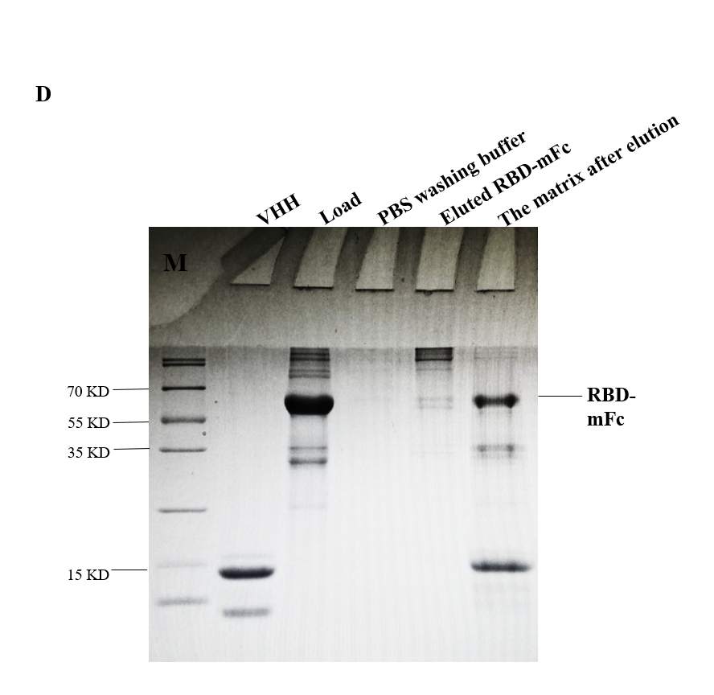

Figure. 5. (D) Effect of S99&N96-Sepharose 4FF on the elution efficiency for RBD purification (reducing condition). The bound RBD was eluted with a variety of elution buffers listed in table 1, but only one representative elution fraction was shown above as the Lane of eluted RBD-mFc. The gels/bots come from the same gel.

