Supplemental Figure 1. Distribution of 301 Taiwanese patients with primary immunodeficiency disease

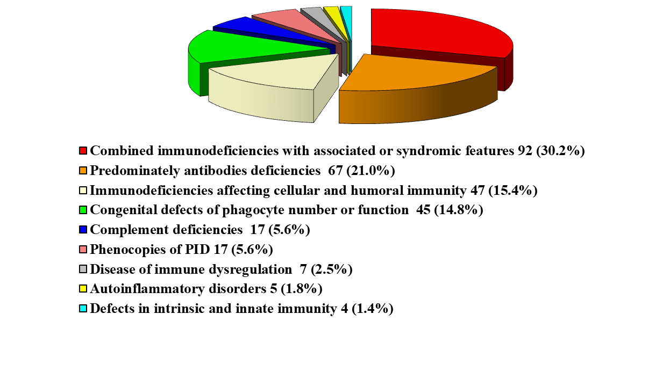

Supplemental Table 1-1. The hematologic data and immunoglobulin levels in PID patients with the mono-IBD phenotype at first admission

M:male  F: female | Age | WBC  mm3 | S/L/E  % | Hb  mg/dL | PLT  mm3 | IgM mg/dL | IgG  mg/dL | IgA  mg/dL | IgE  IU/L
ZAP70/M | 2Y2M | 17300 | 52/34/6 | 8.3 | 614 | 57 | 75 | 38 | 1560
IKBKG1/M | 1M | 8740 | 33/65/1 | 8.2 | 232 | <4.5 | 286 | 2.7
IKBKG2/M | 4M | 21400 | 46/35/13 | 7.8 | 274 | <17 | 42 | <23
TTC7A-1-1/F | 2M | 10900 | 72/8/4 | 10.7 | 125 | <17 | 41 | <7 | <18
TTC7A-1-2/F | 3M | 13400 | 91/2/2 | 10.5 | 133 | <17 | 179 | <7 | <18
TTC37-1/M | 1Y5M | 26800 | 78/18/0 | 9.4 | 365 | 151 | <134 | 26.1 | <18
TTC37-2/F | 7M | 6300 | 50/33/3 | 12 | 131 | 203 | 120 | 28.6 | <18
TTC37-3/M | 4M | 13300 | 52/34/7 | 10.1 | 392 | 22 | 148 | <26.1 | <4.3
PIK3CD/F | 2Y6M | 12700 | 39/50/1 | 12.0 | 122 | 213 | 391 |  | <19
PIK3R1/M | 20Y6M | 11300 | 88/6/0 | 12.8 | 371 | 38 | <146 | <26
FOXP3-1/M | 4M | 15460 | 48/32/7 | 10.2 | 643 | 82 | 1242 | 46.2 | 18000
FOXP3-2/M | 6M | 24800 | 47/37/5 | 9.6 | 563 | 62.7 | 876 | 39.1 | 2920
LRBA/M | 3M | 900 | 33/45/0 | 11.4 | 425 | 7.7 | <150 | <6.3 | <17.5
IL10RA/F | 9M | 16800 | 69/26/0 | 10.5 | 686 | 96 | 981 | 92.8 | 49.1
XIAP-1/M | 2M | 2600 | 33/53/3 | 7.5 | 47 | 203 | 941 |  | 84.7
XIAP-2/M | 2M | 2800 | 56/36/0 | 7.3 | 5 | 358 | 1720 | 40.3 | 254
STAT1/M | 7M | 10500 | 61/34/1 | 12.6 | 144 | 120 | 821 | 38.6 | <17.5

Supplemental Table 1-2. The percentages of lymphocyte subsets in PID patients with the mono-IBD phenotype at first admission

 | Age | CD4 | CD4+CD45RA+ | CD4+CD45RO+ | CD8 | CD19 | CD19+CD27- | CD19+CD27+ | NK
 |  |  | Under CD4 |  |  |  | Under CD19
ZAP70/M | 2Y2M | 53 | 24 | 28 | 3.2 | 34.2 | 32.8 | 0.6 | 19.2
IKBKG1/M | 1M | 6.5 | 5.8 | 0.8 | 22.4 | 50.2 |  |  | 5.1
IKBKG2/M | 4M | 63 |  |  | 12.2 | 21.9
TTC7A-1-1/F | 2M | 33 | 27.7 | 5.4 | 23.9 | 20.7 | 20.2 | 0.5 | 18.2
TTC7A-1-2/F | 3M | 16 | 10.3 | 5.6 | 60.4 | 3.0 | 2.9 | 0.04 | 2.2
TTC37-1/M | 1Y5M | 62.1 | 56.6 | 5.1 | 14.6 | 13.6 | 13.5 | 0.2 | 8.1
TTC37-2/F | 7M | 43.8 | 32.1 | 10.6 | 22.8 | 26.5 | 25.6 | 1.1 | 3.6
TTC37-3/M | 4M | 42.4 | 31.5 | 10.9 | 7.4 | 11.1 | 10.2 | 0.4
PIK3CD/F | 2Y6M | 10.1 | 3.9 | 4.6 | 63.7 | 10.1 | 9.9 | 0.1 | 17.8
PIK3R1/M | 20Y6M | 28.0 | 1.7 | 19.0 | 60.3 | 0.4 | 0.1 | 0.4 | 6.9
FOXP3-1/M | 4M | 43.5 | 38.2 | 5.4 | 28.4 | 11.8 | 10.3 | 1.5
FOXP3-2/M | 6M | 44.5 | 31.4 | 12.2 | 35.4 | 15.2 | 12.7 | 2.5 | 3.1
LRBA/M | 3M | 81.8 | 20.4 | 60.5 | 2.8 | 1.9 | 1.8 | 0.2 | 11.4
IL10RA/F | 9M | 27.7 | 19.3 | 11.9 | 10.1 | 18.5 | 17.4 | 1.2 | 22.1
XIAP-1/M | 2M | 57.9 | 45.7 | 11.4 | 14.9 | 22.5 | 22.4 | 0.1 | 4.4
XIAP-2/M | 2M | 34.6 | 15.2 | 20.9 | 37.2 |  |  |  | 6.0
STAT1/M | 7M | 30.3 | 7.7 | 21.5 | 25.6 | 33.7 | 33.0 | 0.7 | 5.3

