A bibliometric and visualization analysis of the aerosol research on glaciers in the Indian Himalayan Region (IHR)
Prity S. Pippal¹, Ramesh Kumar¹, Atar Singh¹, Rajesh Kumar^{1*}
¹Department of Environmental Science, School of Earth Sciences, Central University of Rajasthan, India
*Corresponding Author: rajesh.kumar@curaj.ac.in.

Figure S1: Clustering of the author with other authors based on published document over the year.
Figure S2: Production by the top 15 authors during the study period, but the most productive period for authors was 2016-2021.
Figure S3: Coupling of authors, and authors, the country with their used keywords in the form of three field plots during the study period.
Figure S4: Annual scientific production during the study period.
Figure S5: Lotka’s Law shows an author's production frequency of published articles.
Figure S6: Word growth and source growth for the current study evolution based on occurrences of annual keywords.
Figure S7: Trend of topics from the authors' keywords during the study period.
Figure S8: Bradford's Law presents two zones for core and non-core sources for the top 15 articles based on their frequency rank.
Figure S9: Represents the collaboration network map between the country during the study period.
Table S1: Impact Factors of author for locally cited documents for the study period.
Table S2: Contribution of authors in the form of proportion over written articles according to Lotka’s Law.
Table S3: Publishers' production contribution in proportion over written articles.

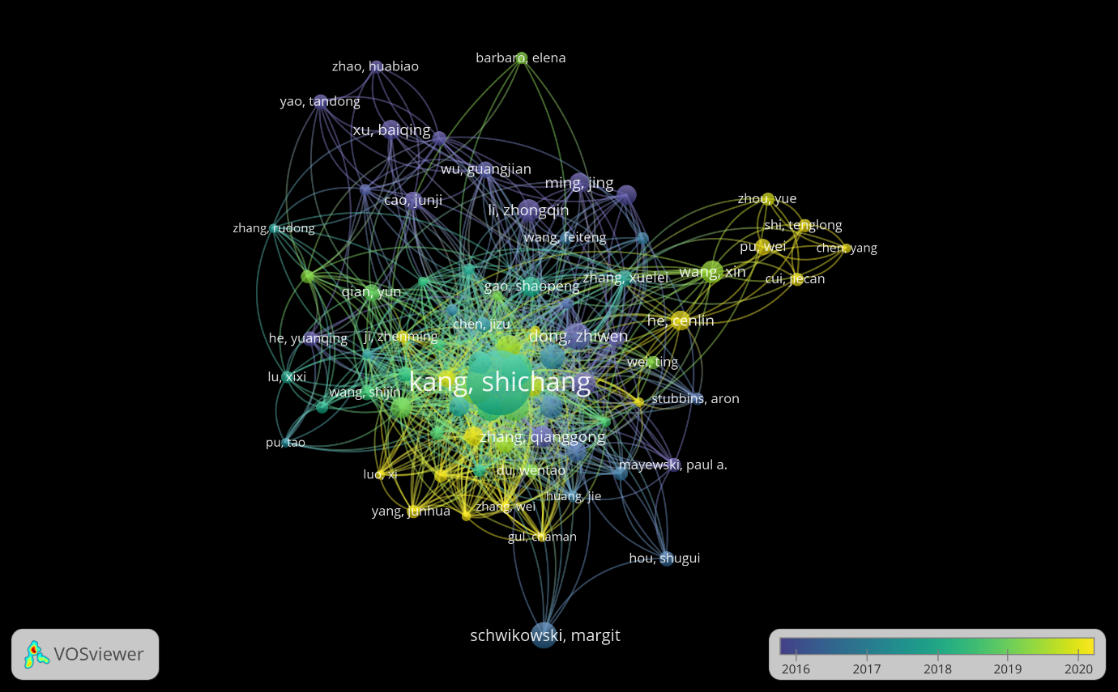
Figure S1: Clustering of the author with other authors based on published document over the year.
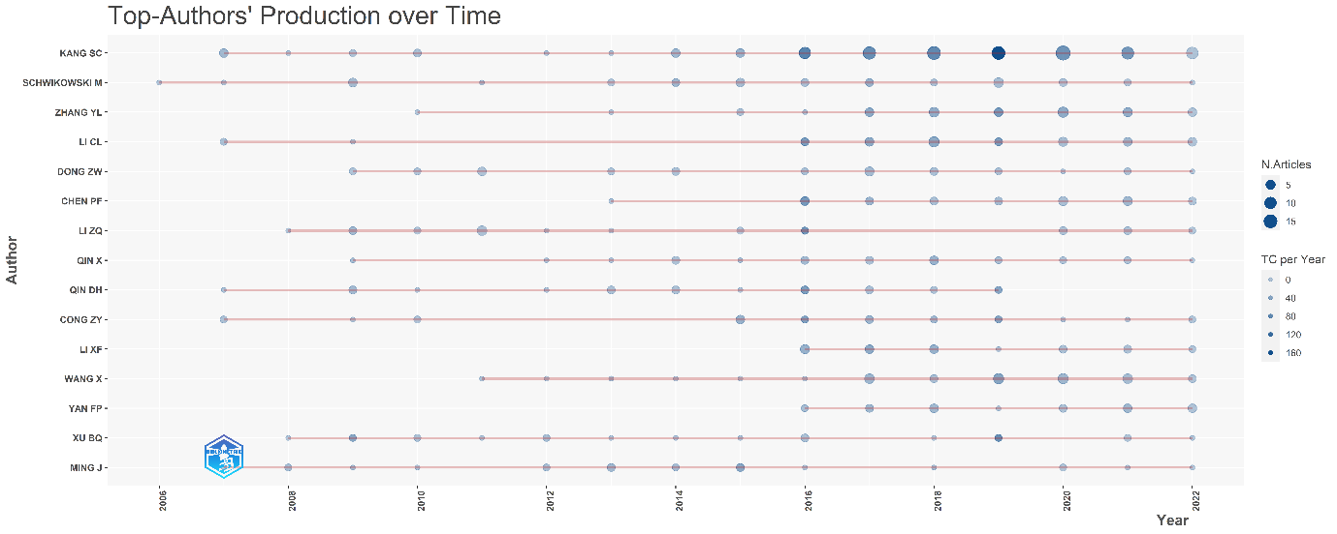
Figure S2: Production by the top 15 authors during the study period, but the most productive period for authors was 2016-2021.

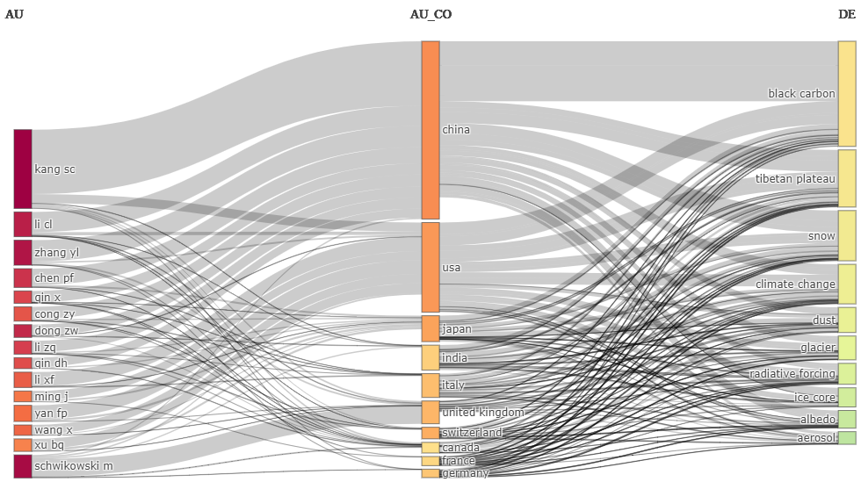
Figure S3: Coupling of authors, and authors, the country with their used keywords in the form of three field plots during the study period.
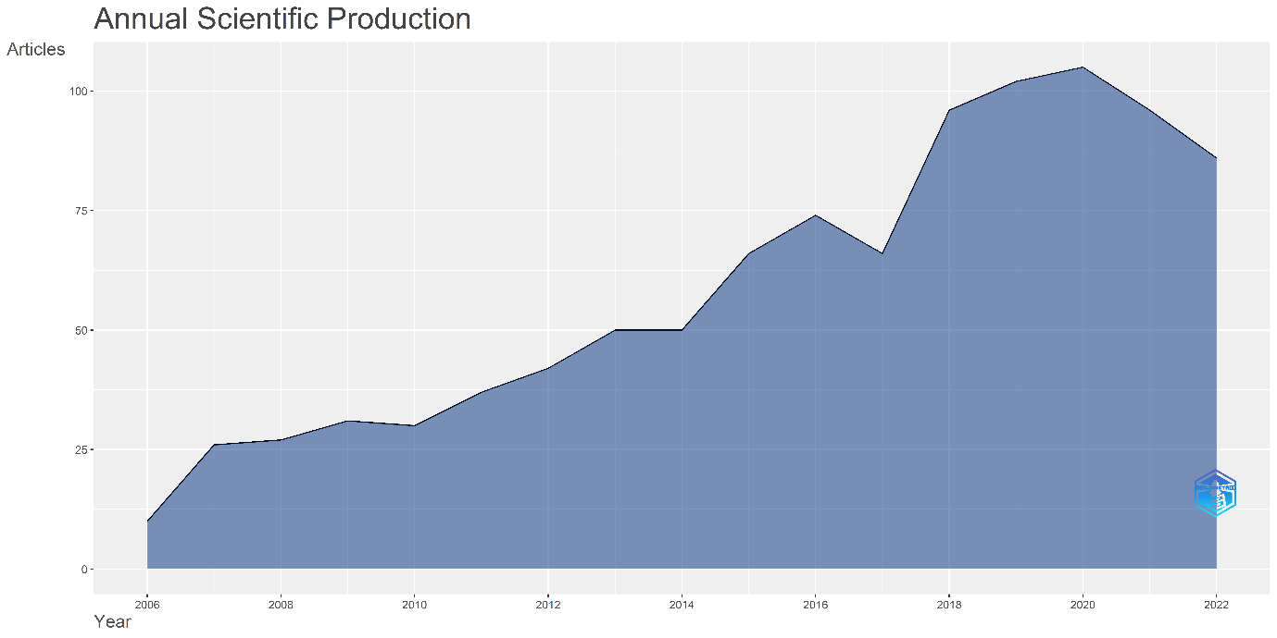

Figure S4: Annual scientific production during the study period.
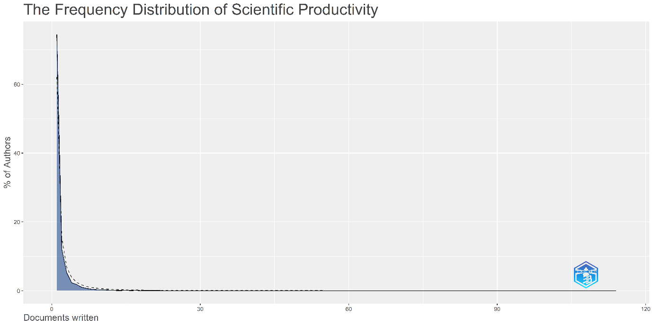
Figure S5: Lotka’s Law shows an author's production frequency of published articles.
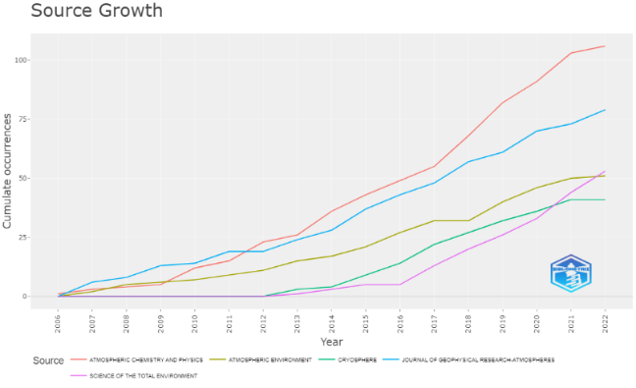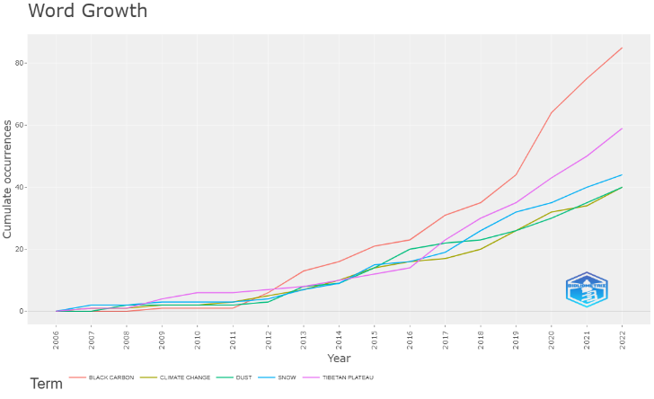
Figure S6: Word growth and source growth for the current study evolution based on occurrences of annual keywords.
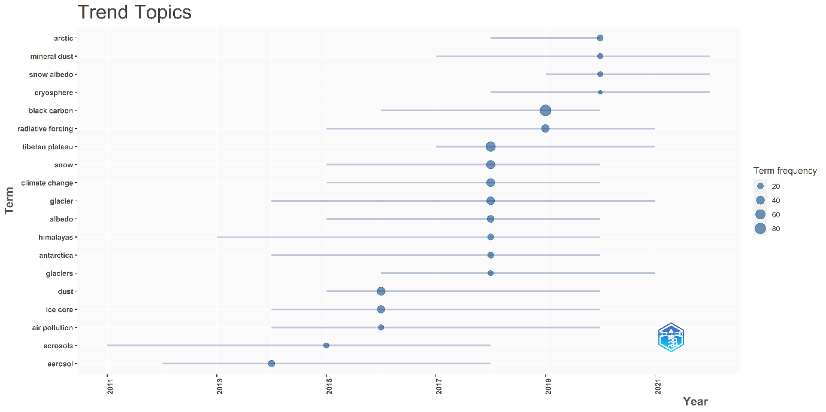

Figure S7: Trend of topics from the authors' keywords during the study period.
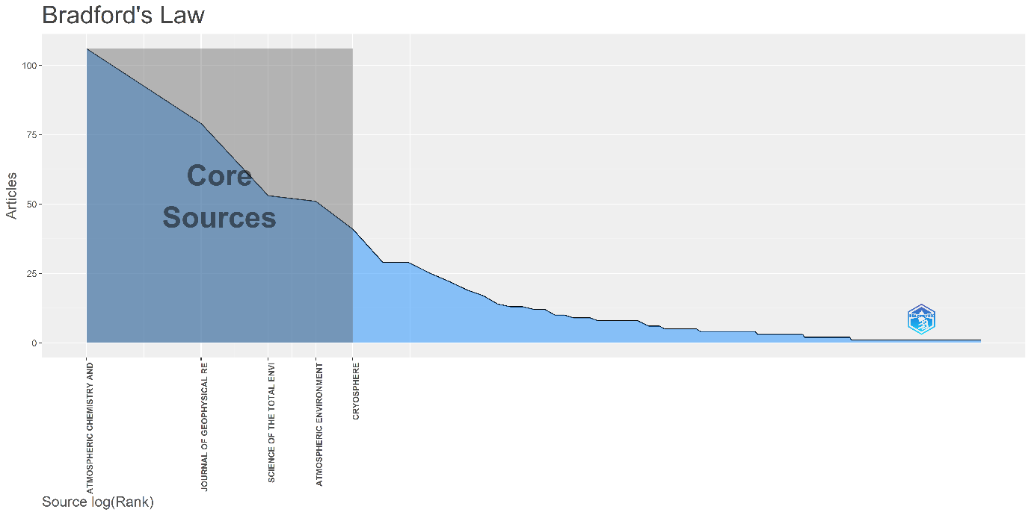
Figure S8: Bradford's Law presents two zones for core and non-core sources for the top 15 articles based on their frequency rank.
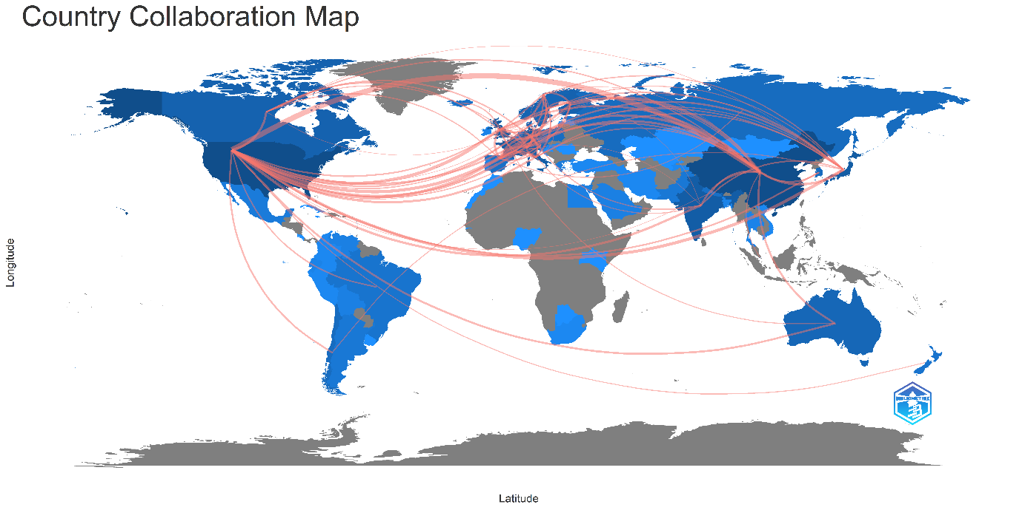
Figure S9: Represents the collaboration network map between the country during the study period.
Table S1: Impact Factors of author for locally cited documents for the study period.
Rank | Author | H  index | G  index | M  index | Total Citation | No. of Articles
19 | Flanner MG | 12 | 16 | 0.75 | 5560 | 16
1 | Kang SC | 30 | 53 | 1.875 | 3342 | 116
7 | Qian Y | 15 | 19 | 1.25 | 1779 | 19
8 | Painter TH | 15 | 15 | 1 | 1467 | 15
12 | Xu BQ | 14 | 20 | 0.933 | 1315 | 20
3 | Li CL | 17 | 31 | 1.063 | 1270 | 31
6 | Ming J | 15 | 19 | 0.938 | 1199 | 19
11 | Cong ZY | 14 | 21 | 0.875 | 1157 | 21
2 | Qin DH | 18 | 23 | 1.125 | 1148 | 23
17 | Cao JJ | 13 | 16 | 0.929 | 1148 | 16
21 | Yao TD | 12 | 14 | 0.8 | 1099 | 14
4 | Schwikowski M | 16 | 32 | 0.941 | 1057 | 35
16 | Zhang QG | 13 | 18 | 0.813 | 970 | 18
5 | Zhang YL | 16 | 30 | 1.231 | 913 | 33
22 | Li ZQ | 11 | 22 | 0.733 | 855 | 22

Table S2: Contribution of authors in the form of proportion over written articles according to Lotka’s Law
Documents written | No. of Authors | Proportion of Authors
1 | 3158 | 0.745
2 | 513 | 0.121
3 | 223 | 0.053
4 | 98 | 0.023
5 | 77 | 0.018
6 | 44 | 0.01
7 | 29 | 0.007
8 | 19 | 0.004
9 | 13 | 0.003

Table S3: Publishers' production contribution in proportion to written articles.
Sr.  No. | Publisher | No. of Articles | Contribution (%)
1 | Elsevier | 294 | 27.87%
2 | Copernicus | 177 | 16.78%
3 | AGU | 143 | 13.56%
4 | Springer Nature | 97 | 9.19%
5 | American Chemical Society | 35 | 3.32%

