Figure S1. Ten days old Culture of Macrophomina phaseolina in PDA medium (A) and presence of abundant black microslerotia (B)
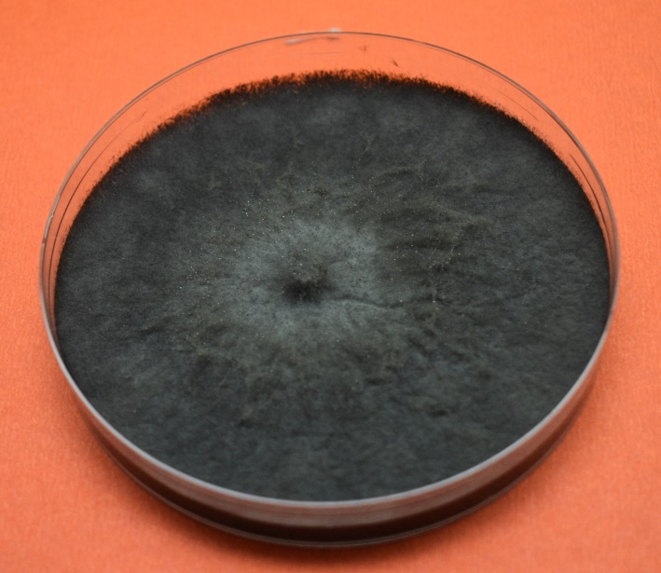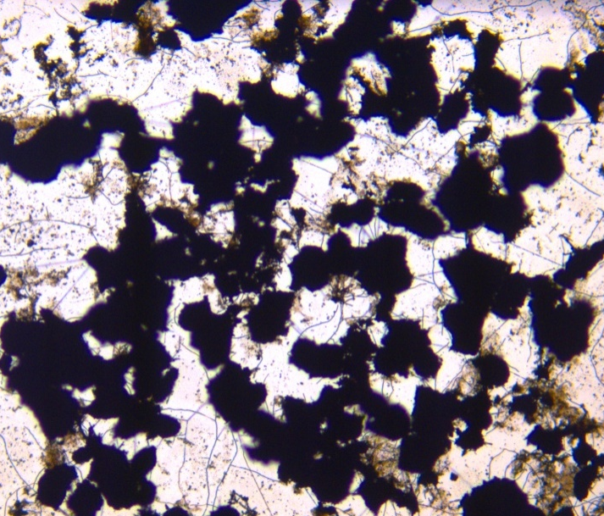
A
B

Figure S2: Frequency distribution of disease reaction during 2018 and 2019
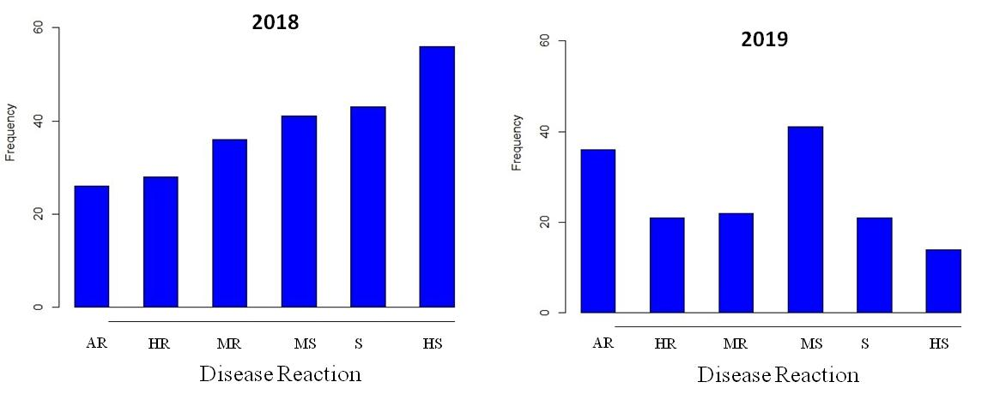

Figure S3. Charcoal rot affected plants (A) and infected lower stem portion (B)
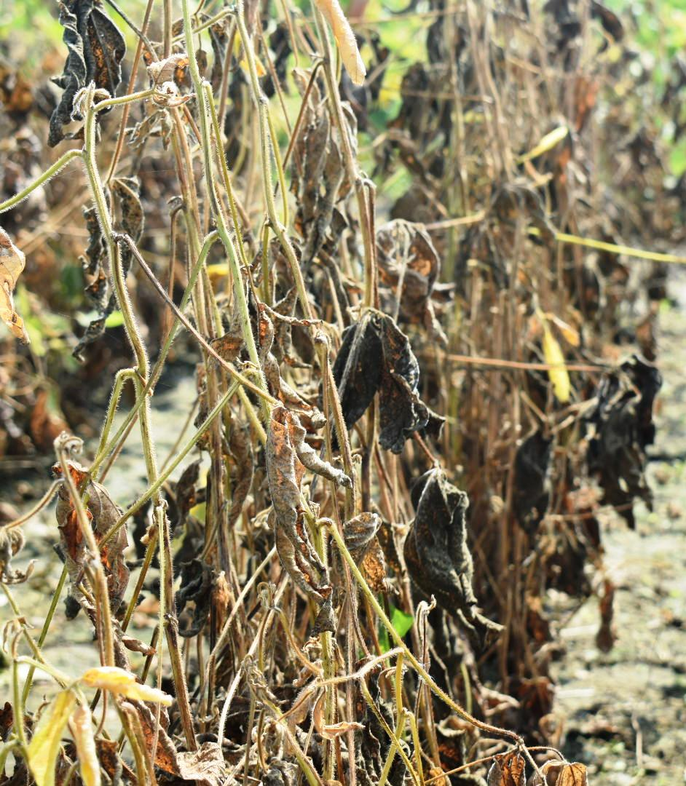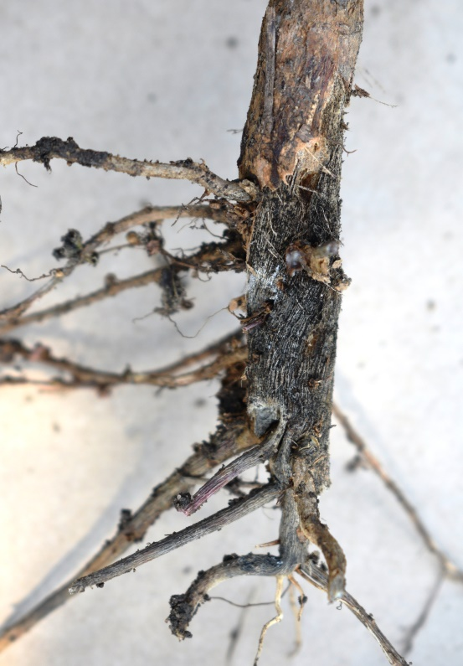
B
A

Figure S4. Close up view of resistant and susceptible genotypes during evaluation
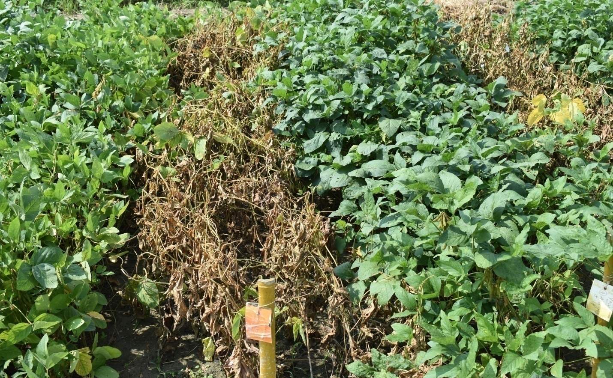

Figure S5. Sick plot showing genotypic variation for charcoal rot incidence in soybean
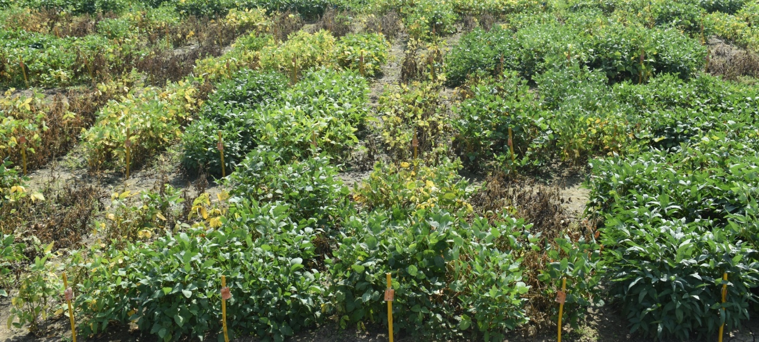

Figure S6: Representative gel picture of the Satt447 alleles among 48 soybean genotypes
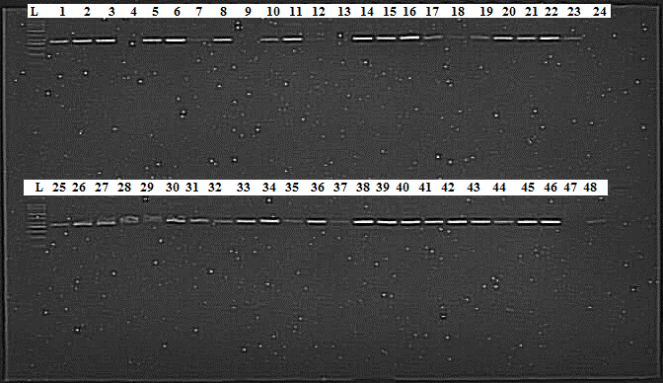

Table S1: Percent Disease Incidence of soybean genotypes during preliminary evaluation in the year 2018. PDI-Percent Disease Incidence, DR-Disease Reaction, HR- Highly Resistant, R- Resistant, MR-Moderately Resistant, MS-Moderately Susceptible, S-Susceptible and HS-Highly Susceptible. Pair-wise comparison using LSD (p < 0.05)
S.No | Genotype | PDI | DR | S.No | Genotype | PDI | DR | S.No | Genotype | PDI | DR
1 | EC 34117 | 0.001¹ | R | 79 | AMS 269 | 6.12^{1-A} | MR | 157 | JS 21-03 | 39.20 ^{a-u} | S
2 | AMS 100-39 | 0.001¹ | R | 80 | AGS-59 | 8.19^{1-E} | MR | 158 | EC 172613 | 39.57 ^{a-t} | S
3 | AMS 264 | 0.001¹ | R | 81 | AMS 38-24 | 8.19^{1-E} | MR | 159 | AQL 37 | 39.88 ^{b-v} | S
4 | AMS 475 | 0.001¹ | R | 82 | Cat 1957 | 8.19^{1-E} | MR | 160 | JS 20-76 | 40.83 ^{a-u} | S
5 | AMS MB 5-18 | 0.001¹ | R | 83 | JSM 229 | 8.69^{1-I} | MR | 161 | SL 958 | 41.78 ^{d-w} | S
6 | B 1664 | 0.001¹ | R | 84 | EC 241709 | 8.70^{1- G} | MR | 162 | JS 97-57 | 42.12 ^{c-w} | S
7 | B 1667 | 0.001¹ | R | 85 | EC 389748 | 8.87^{1-H} | MR | 163 | JS 20-37 | 42.27 ^{b-w} | S
8 | Cat 1847 | 0.001¹ | R | 86 | EC 396055 | 8.87^{1-H} | MR | 164 | EC 287754 | 44.61 ^{f-y} | S
9 | Cat 2126B | 0.001¹ | R | 87 | JS 21-74 | 9.80^{1-J} | MR | 165 | SQL 36 | 44.68 ^{g-x} | S
10 | Cat 2130 B | 0.001¹ | R | 88 | G 305 | 9.95^{1-J} | MR | 166 | MACS 1407 | 45.12 ^{h-y} | S
11 | Cat 2310 | 0.001¹ | R | 89 | AGS 31 | 9.95^{1-J} | MR | 167 | PS 1589 | 46.83 ^{j-1} | S
12 | Cat 2503 | 0.001¹ | R | 90 | Cat 1368 | 9.95^{1-J} | MR | 168 | EC 291398 | 47.02 ^{k-2} | S
13 | CAT 2511 | 0.001¹ | R | 91 | DSB 25 | 10.77^{1-K} | MS | 169 | EC 393231 | 47.02 ^{k-2} | S
14 | CAT 87 | 0.00¹⁻⁴ | HR | 92 | NRC SL 2 | 11.37^{1-L} | MS | 170 | JS 20-50 | 47.29 ^{k-3} | S
15 | DS 1318 | 0.00¹⁻⁴ | HR | 93 | JS 21-06 | 11.87^{1-M} | MS | 171 | EC 109540 | 47.47 ^{l-5} | S
16 | DS 3104 | 0.00¹⁻⁴ | HR | 94 | JS 22-09 | 11.87^{1-M} | MS | 172 | Cat 492 | 48.20 ^{l-7} | S
17 | DS 3106 | 0.00¹⁻⁴ | HR | 95 | JS 99-78 | 11.87^{1-M} | MS | 173 | EC 39107 | 48.47 ^{l-8} | S
18 | EC 250608 | 0.00¹⁻⁴ | HR | 96 | JS 20-36 | 13.06^{1-N} | MS | 174 | PS 1569 | 48.98 ^{m-9} | S
19 | EC 350664 | 0.001¹² | R | 97 | JSM 230 | 13.43^{1-M} | MS | 175 | EC 538830 | 50.68 ^{n-0} | HS
20 | EC 391181 | 0.001¹² | R | 98 | JS 20-103 | 13.60^{1-N} | MS | 176 | JS 97-52 | 50.75 ^{o-A} | HS
21 | EC 393222 | 0.001¹² | R | 99 | JS 20-15 | 13.60^{1-N} | MS | 177 | JSM 115 | 50.75 ^{o-A} | HS
22 | EC 393228 | 0.001¹² | R | 100 | RVS 2007-06 | 13.71^{1-N} | MS | 178 | SL 710 | 53.32 ^{p-B} | HS
23 | EC 547464 | 0.001¹² | R | 101 | Cat 489 A | 14.08^{1-O} | MS | 179 | JSM 242 | 53.77 ^{q-B} | HS
24 | G -10525 | 0.001¹² | R | 102 | JS 20-84 | 14.62^{1-O} | MS | 180 | JS 21-77 | 55.19 ^{s-E} | HS
25 | Harder | 0.001¹² | R | 103 | JS 20-92 | 14.62^{1-O} | MS | 181 | Cat 408 | 55.62 ^{s-D} | HS
26 | JS 20-18 | 0.001¹² | R | 104 | RVS 2009-9 | 15.47^{2-N} | MS | 182 | EC 468597 | 56.08 ^{t-F} | HS
27 | JS 20-19 | 0.14¹⁻⁶ | R | 105 | JS 20-27 | 16.03^{3-Q} | MS | 183 | ERS 0757 | 56.88 ^{t- H} | HS
28 | JS 20-20 | 0.14¹⁻⁶ | R | 106 | JS 20-56 | 16.03^{3-Q} | MS | 184 | EC 289099 | 57.18 ^{u-J} | HS
29 | JS 20-23 | 0.14¹⁻⁶ | R | 107 | JS 20-71 | 16.03^{3-Q} | MS | 185 | JS 20-48 | 57.72 ^{v-K} | HS
30 | JS 20-39 | 0.14¹⁻⁶ | R | 108 | NRC 138 | 16.75^{3-S} | MS | 186 | JS 20 -41 | 59.39 ^{w-N} | HS
31 | JS 20-53 | 0.14¹⁻⁶ | R | 109 | EC 109543 | 16.81^{5-S} | MS | 187 | EC 241695 | 60.44 ^{x-zO} | HS
32 | JS 20-57 | 0.14¹⁻⁶ | R | 110 | RSC 11-03 | 17.02^{3-S} | MS | 188 | PS 1592 | 60.92 ^{y-zP} | HS
33 | JS 20-73 | 0.14¹⁻⁶ | R | 111 | SKF SPC 11 | 17.02^{3-S} | MS | 189 | JS 20-29 | 61.56 ^{z8-zL} | HS
34 | JS 20-78 | 0.14¹⁻⁶ | R | 112 | JS 20-90 | 17.35^{4-S} | MS | 190 | JS 93-05 | 62.03 ^{z9-zL} | HS
35 | JS 20-96 | 0.14¹⁻⁶ | R | 113 | JS 21-13 | 17.91^{6-R} | MS | 191 | SL 900 | 63.38 ^{z2-zQ} | HS
36 | JS 20-98 | 0.14¹⁻⁶ | R | 114 | JS 21-75 | 17.91^{6-R} | MS | 192 | NRC 117 | 64.82 ^{z1-zQ} | HS
37 | JS 21 -70 | 0.14¹⁻⁶ | R | 115 | JS 99-89 | 17.91^{6-R} | MS | 193 | G 288 | 64.92 ^{z3-zQ} | HS
38 | JS 21-05 | 0.71¹⁻⁷ | R | 116 | JSM 250 | 18.16^{5-S} | MS | 194 | JS 20-79 | 65.41 ^{z4-zR} | HS
39 | JS 21-17 | 0.71¹⁻⁷ | R | 117 | NRC 100 | 18.16^{5-S} | MS | 195 | JSM 245 | 65.70 ^{z6-zS} | HS
40 | JS 21-18 | 0.71¹⁻⁷ | R | 118 | NRC 133 | 18.16^{5-S} | MS | 196 | KDS 256 | 65.70 ^{z6-zS} | HS
41 | JS 21-71 | 0.71¹⁻⁷ | R | 119 | SQL 89 | 18.44^{7-T} | MS | 197 | PANDRINATH | 65.70^{z6-zS} | HS
42 | JS 21-72 | 0.71¹⁻⁷ | R | 120 | VLS 69 | 18.44^{7-T} | MS | 198 | EC 396059 | 65.94 ^{z7-zS} | HS
43 | JS 21-73 | 0.71¹⁻⁷ | R | 121 | NRC 121 | 19.47^{0-V} | MS | 199 | JS 20-74 | 67.35 ^{z0-zS} | HS
44 | JS 21-76 | 0.71¹⁻⁷ | R | 122 | JS 20-40 | 19.74^{8-X} | MS | 200 | JS 20 -51 | 68.11 ^{zA-zS} | HS
45 | JS 22-01 | 0.71¹⁻⁷ | R | 123 | PI 210178 | 19.75^{9-Y} | MS | 201 | JS 20-31 | 68.37 ^{z0-zS} | HS
46 | JS 22-02 | 0.71¹⁻⁷ | R | 124 | AGS-205 | 19.81^{8-Z} | MS | 202 | MACS 1442 | 68.50 ^{z0-zS} | HS
47 | JS 22-03 | 0.71¹⁻⁷ | R | 125 | AGS 48 | 20.80^{A-Z} | MS | 203 | EC 39044 | 69.27 ^{zB-zS} | HS
48 | JS 22-04 | 0.71¹⁻⁷ | R | 126 | AMS 358 | 23.59^{B-a} | MS | 204 | JS 20-49 | 69.44 ^{zB-zS} | HS
49 | JS 22-05 | 0.71¹⁻⁷ | R | 127 | EC 590225 | 24.27^{B-e} | MS | 205 | BRG 1 | 69.82 ^{zB-zT} | HS
50 | JS 22-06 | 0.71¹⁻⁷ | R | 128 | SL 1074 | 24.31^{B-c} | MS | 206 | EC 245988 | 72.40 ^{zC-zT} | HS
51 | JS 22-07 | 0.71¹⁻⁷ | R | 129 | DS 3105 | 24.33^{B-e} | MS | 207 | EC528640 | 73.23 ^{zD-zU} | HS
52 | JS 22-08 | 0.71¹⁻⁷ | R | 130 | AGS174 | 24.48^{F-e} | MS | 208 | EC 280148 | 73.71 ^{zF-zU} | HS
53 | JSM 146 | 0.71¹⁻⁷ | R | 131 | JSM 122 | 24.48^{B-d} | MS | 209 | JS 20- | 74.2555^{zG-zU} | HS
54 | JSM 149 | 0.71¹⁻⁷ | R | 132 | RSC 10-52 | 25.33^{B-c} | S | 210 | EC 33940 | 74.78 ^{zI-zU} | HS
55 | JSM 228 | 2.27¹⁻⁹ | MR | 133 | VLS 94 | 25.33^{B-c} | S | 211 | G 2263 | 74.78 ^{zI-zU} | HS
56 | JSM 265 | 2.27¹⁻⁹ | MR | 134 | EC393224 | 26.02^{C -e} | S | 212 | JS 20-52 | 75.66 ^{zM-zU} | HS
57 | JSM 298 | 2.27¹⁻⁹ | MR | 135 | EC 16213 | 26.17^{D -e} | S | 213 | AMS 148 | 75.86 ^{zM-zU} | HS
58 | JSM 301 | 2.27¹⁻⁹ | MR | 136 | MACS 1543 | 27.00^{J-g} | S | 214 | HARA SOYA | 76.54 ^{zO-zU} | HS
59 | KDS 1009 | 2.27¹⁻⁹ | MR | 137 | NRC 128 | 27.00^{J-g} | S | 215 | SL 599 | 76.65 ^{zM-zU} | HS
60 | KDS 1073 | 2.27¹⁻⁹ | MR | 138 | SL 955 | 28.21^{K- h} | S | 216 | CAT 905 | 76.68 ^{zN-zU} | HS
61 | KDS 1097 | 2.27¹⁻⁹ | MR | 139 | EC 241690 | 28.77^{L-i} | S | 217 | DSb 21 | 76.68 ^{zN-zU} | HS
62 | MACS 1520 | 2.27¹⁻⁹ | MR | 140 | TYPE 49 | 28.83^{M-j} | S | 218 | EC 173325 | 76.68 ^{zN-zU} | HS
63 | MACS 1566 | 2.27¹⁻⁹ | MR | 141 | EC 172663 | 29.61^{M-k} | S | 219 | JS 20-82 | 77.22 ^{zM-zU} | HS
64 | NRC 86 | 2.27¹⁻⁹ | MR | 142 | JSM 283 | 30.59^{N-l} | S | 220 | EAGLE 51 | 78.44 ^{zP-zU} | HS
65 | NRC 99 | 2.27¹⁻⁹ | MR | 143 | RVS 2002-4 | 31.71^{O-l} | S | 221 | JS 95-60 | 78.98 ^{zS-zU} | HS
66 | PI 204336 | 2.55¹⁻⁹ | MR | 144 | WT 88 | 31.71^{O-1} | S | 222 | CAT 539 | 80.51 ^{zQ-zU} | HS
67 | PK 768 | 2.55¹⁻⁹ | MR | 145 | JS 20-30 | 32.56^{P-m} | S | 223 | EC 103336 | 80.51 ^{zQ-zU} | HS
68 | PS 1469 | 2.55¹⁻⁹ | MR | 146 | JS 335 | 32.84^{W-i} | S | 224 | CAT 3284 | 83.19 ^{zR-zU} | HS
69 | PS 1611 | 2.55¹⁻⁹ | MR | 147 | JS 21-78 | 33.92^{Q-n} | S | 225 | SL 744 | 83.45 ^{zR-zU} | HS
70 | PS 1613 | 2.55¹⁻⁹ | MR | 148 | Shivalik | 34.05^{Q-o} | S | 226 | EC 308287 | 87.70 ^{zTzU} | HS
71 | PS 1641 | 2.55¹⁻⁹ | MR | 149 | JSM 188 | 34.69^{S-o} | S | 227 | EC 396065 | 87.70 ^{zTzU} | HS
72 | RKS 47 | 2.55¹⁻⁹ | MR | 150 | AMS 56 | 34.79^{R-o} | S | 228 | CAT 418 | 89.61 ^{zU} | HS
73 | RKS 63 | 2.55¹⁻⁹ | MR | 151 | JS 20-61 | 36.41^{T-r} | S | 229 | EAGLE 81 | 89.61 ^{zU} | HS
74 | RVS 2011-1 | 2.55¹⁻⁹ | MR | 152 | SL96 | 36.53^{U-q} | S | 230 | EC 232019 | 89.61 ^{zU} | HS
75 | RVS 2012-15 | 2.55¹⁻⁹ | MR | 153 | NRC 2755 | 37.02^{W-p} | S | - | - | - | -
76 | SQL 32 | 2.55¹⁻⁹ | MR | 154 | MACS 1370 | 37.79 ^{W-s} | S | - | - | - | -
77 | AGS 76 | 6.12^{1-A} | MR | 155 | EC 572160 | 39.11 ^{a-s} | S | - | - | - | -
78 | AMS 2014-1 | 6.12^{1-A} | MR | 156 | AGS 112 | 39.16 ^{a-u} | S | - | - | - | -
Least Significant Difference (LSD); Adjusted means followed by a similar uppercase letter are not significantly different (at p < 0.05)
Table S2: Percent Disease Incidence of soybean genotypes during preliminary evaluation in the year 2019. PDI-Percent Disease Incidence, DR-Disease Reaction, HR-Highly Resistant, R- Resistant, MR-Moderately Resistant, MS-Moderately Susceptible, S-Susceptible and HS-Highly Susceptible.
S.No | Genotype | PDI | DR | S.No | Genotype | PDI | DR | S.No | Genotype | PDI | DR
1 | Harder | 0.000¹ | HR | 53 | AMS 358 | 0.884¹² | R | 105 | SQL 32 | 21.678^{5-L} | MS
2 | JS 20-103 | 0.000¹ | HR | 54 | AMS MB 5-18 | 0.884¹² | R | 106 | G -10525 | 21.798^{6-L} | MS
3 | JS 20-15 | 0.000¹ | HR | 55 | CAT 1957 | 0.884¹² | R | 107 | RVS 2007-06 | 22.635^{6-L} | MS
4 | JS 20-18 | 0.000¹ | HR | 56 | CAT 2126B | 0.884¹² | R | 108 | AMS 100-39 | 22.650^{6-K} | MS
5 | JS 20-19 | 0.000¹ | HR | 57 | CAT 2130 B | 0.884¹² | R | 109 | CAT 1368 | 22.650^{6-K} | MS
6 | JS 20-20 | 0.000¹ | HR | 58 | JS 21-06 | 1.194¹²³ | MR | 110 | CAT 2503 | 22.819^{6-L} | MS
7 | JS 20-27 | 0.000¹ | HR | 59 | JS 21-17 | 1.194¹²³ | MR | 111 | EC 396055 | 22.819^{6-L} | MS
8 | JS 20-30 | 0.000¹ | HR | 60 | JS 21-71 | 1.194¹²³ | MR | 112 | JSM 298 | 22.891^{6-L} | MS
9 | JS 20-39 | 0.000¹ | HR | 61 | JS 21-72 | 1.194¹²³ | MR | 113 | JS 21-13 | 22.960^{6-L} | MS
10 | JS 20-40 | 0.000¹ | HR | 62 | JS 21-73 | 1.194¹²³ | MR | 114 | EC 389748 | 23.805^{7-L} | MS
11 | JS 20-53 | 0.000¹ | HR | 63 | JS 21-74 | 1.194¹²³ | MR | 115 | PK 768 | 24.471^{7-M} | MS
12 | JS 20-56 | 0.000¹ | HR | 64 | JS 21-75 | 1.194¹²³ | MR | 116 | SL 1074 | 24.471^{7-M} | MS
13 | JS 20-57 | 0.000¹ | HR | 65 | JS 22-01 | 1.194¹²³ | MR | 117 | B 1667 | 24.657^{8-N} | MS
14 | JS 20-71 | 0.000¹ | HR | 66 | JS 22-02 | 1.194¹²³ | MR | 118 | JSM 250 | 24.973^{8-O} | MS
15 | JS 20-73 | 0.000¹ | HR | 67 | JS 22-04 | 1.194¹²³ | MR | 119 | KDS 1073 | 24.973^{8-O} | MS
16 | JS 20-84 | 0.000¹ | HR | 68 | JS 22-08 | 1.194¹²³ | MR | 120 | NRC SL 2 | 24.973^{8-O} | MS
17 | JS 20-90 | 0.000¹ | HR | 69 | JS 22-09 | 1.194¹²³ | MR | 121 | RVS 2011-1 | 25.356^{0-P} | S
18 | JS 20-92 | 0.000¹ | HR | 70 | JS 99-89 | 1.194¹²³ | MR | 122 | MACS 1566 | 25.959^{9-Q} | S
19 | JS 20-96 | 0.000¹ | HR | 71 | JSM 122 | 1.194¹²³ | MR | 123 | B 1664 | 26.543 ^{A-R} | S
20 | JS 20-98 | 0.000¹ | HR | 72 | JSM 228 | 2.186¹⁻⁴ | MR | 124 | EC 391181 | 26.597 ^{B-Q} | S
21 | JS 21-05 | 0.000¹ | HR | 73 | JSM 230 | 2.186¹⁻⁴ | MR | 125 | CAT 1847 | 27.449 ^{C-R} | S
22 | JS 21-77 | 0.000¹ | HR | 74 | JSM 283 | 2.186¹⁻⁴ | MR | 126 | EC 393228 | 27.482 ^{C-Q} | S
23 | MACS 1370 | 0.000¹ | HR | 75 | JSM 301 | 2.186¹⁻⁴ | MR | 127 | NRC 121 | 27.845 ^{D-R} | S
24 | PI 210178 | 0.000¹ | HR | 76 | KDS 1097 | 2.186¹⁻⁴ | MR | 128 | JSM 265 | 29.637 ^{E-S} | S
25 | PS 1469 | 0.000¹ | HR | 77 | PI 204336 | 2.186¹⁻⁴ | MR | 129 | VLS 69 | 30.330 ^{F-T} | S
26 | PS 1611 | 0.000¹ | HR | 78 | TYPE 49 | 2.186¹⁻⁴ | MR | 130 | JS 335 | 30.374 ^{K-R} | S
27 | PS 1613 | 0.000¹ | HR | 79 | EC 241690 | 9.130¹⁻⁵ | MR | 131 | NRC 138 | 31.352^{G-T} | S
28 | PS 1641 | 0.000¹ | HR | 80 | JS 21 -70 | 10.719²⁻⁶ | MS | 132 | RKS 63 | 31.893 ^{H-T} | S
29 | RSC 10-52 | 0.000¹ | HR | 81 | EC 34117 | 12.050²⁻⁷ | MS | 133 | CAT 2310 | 34.095 ^{L-U} | S
30 | SKF SPC 11 | 0.000¹ | HR | 82 | JS 21-76 | 12.360²⁻⁸ | MS | 134 | RKS 47 | 37.137 ^{N-U} | S
31 | SL 955 | 0.000¹ | HR | 83 | JS 20-36 | 13.692³⁻⁰ | MS | 135 | AMS 38-24 | 37.156 ^{M-U} | S
32 | SL 958 | 0.000¹ | HR | 84 | RVS 2002-4 | 13.800^{3-A} | MS | 136 | AMS 475 | 37.903 ^{P-U} | S
33 | SL96 | 0.000¹ | HR | 85 | JS 22-05 | 14.115^{4-B} | MS | 137 | EC 393222 | 39.264 ^{R-W} | S
34 | SQL 89 | 0.000¹ | HR | 86 | MACS 1520 | 15.107^{5-C} | MS | 138 | AGS-59 | 41.571 ^{S-Y} | S
35 | VLS 94 | 0.000¹ | HR | 87 | CAT 492 | 15.111^{5-D} | MS | 139 | NRC 99 | 42.147 ^{T-Y} | S
36 | WT 88 | 0.000¹ | HR | 88 | RSC 11-03 | 15.111^{5-D} | MS | 140 | JS 20-29 | 42.598^{U-X} | S
37 | CAT 2511 | 0.032¹² | R | 89 | RVS 2009-9 | 15.111^{5-D} | MS | 141 | JS 93-05 | 47.540^{W-Z} | S
38 | CAT 489 A | 0.032¹² | R | 90 | JS 22-03 | 15.671^{5-D} | MS | 142 | EC 590225 | 50.801 ^{X-a} | HS
39 | CAT 87 | 0.032¹² | R | 91 | NRC 2755 | 16.341^{5-D} | MS | 143 | JSM 229 | 51.500 ^{V-b} | HS
40 | DS 1318 | 0.032¹² | R | 92 | NRC 86 | 16.664^{5-D} | MS | 144 | EC 547464 | 56.821 ^{Z-c} | HS
41 | DS 3104 | 0.032¹² | R | 93 | EC393224 | 17.238^{5-E} | MS | 145 | AGS174 | 56.896 ^{Z-d} | HS
42 | DS 3105 | 0.032¹² | R | 94 | JS 21-18 | 18.400^{5-F} | MS | 146 | EC 241709 | 62.582 ^{b-e} | HS
43 | DS 3106 | 0.032¹² | R | 95 | JS 22-06 | 18.400^{5-E} | MS | 147 | NRC 100 | 63.020 ^{a-e} | HS
44 | DSB 25 | 0.032¹² | R | 96 | JS 97-52 | 18.610^{5-G} | MS | 148 | EC 109543 | 66.259 ^{c-e} | HS
45 | EC 350664 | 0.032¹² | R | 97 | MACS 1543 | 19.392^{5-H} | MS | 149 | JS 99-78 | 67.421 ^{c-f} | HS
46 | G 305 | 0.884¹² | R | 98 | NRC 128 | 19.392^{5-H} | MS | 150 | JSM 146 | 67.421 ^{c-f} | HS
47 | AGS-205 | 0.884¹² | R | 99 | JS 20-23 | 19.563^{5-J} | MS | 151 | JS 95-60 | 69.252 e | HS
48 | AGS 31 | 0.884¹² | R | 100 | JS 22-07 | 19.629^{5-J} | MS | 152 | EC 250608 | 69.327 ^{d-f} | HS
49 | AGS 48 | 0.884¹² | R | 101 | RVS 2012-15 | 19.671^{5-I} | MS | 153 | JS 20-78 | 70.592 ^{e-g} | HS
50 | AGS 76 | 0.884¹² | R | 102 | AMS 2014-1 | 20.482^{5-J} | MS | 154 | EC 16213 | 78.866 ^{f-g} | HS
51 | AMS 264 | 0.884¹² | R | 103 | KDS 1009 | 20.621^{5-J} | MS | 155 | JSM 149 | 82.097 ^{g} | HS
52 | AMS 269 | 0.884¹² | R | 104 | NRC 133 | 20.621^{5-J} | MS | - | - | - | -
Least Significant Difference (LSD); Adjusted means followed by a similar uppercase letter are not significantly different (at p < 0.05)

Table S3: Year-wise ANOVA of PDI in preliminary evaluation of soybean genotypes
2018
Sources of Variation | DF | MSS | F value | P value
Block | 6 | 4447.32*** | 150.60 | 2.19e⁻¹⁴
Treatment | 229 | 793.28*** | 26.86 | 1.43e⁻¹⁰
Treatment: Check | 3 | 2565.45*** | 86.87 | 6.70e⁻¹¹
Treatment: Test and Test vs. Check | 226 | 769.76*** | 26.02 | 1.87e⁻¹⁰
Residuals | 18 | 29.52
2019
Sources of Variation | DF | MSS | F value | P value
Block | 5 | 897.63*** | 62.56 | 1.64e⁻⁹
Treatment | 154 | 519.79*** | 36.22 | 5.88e⁻¹⁰
Treatment: Check | 3 | 1580.96*** | 110.18 | 1.92e⁻¹⁰
Treatment: Test and Test vs. Check | 151 | 498.71*** | 34.75 | 8.00e⁻¹⁰
Residuals | 15 | 14.34
Significance at p<0.001

Table S4: Year-wise ANOVA of PDI, AUDPC and Grain yield in selected soybean genotypes evaluated. NS- Non- Significant
2020
Sources of Variation | DF | PDI |  | AUDPC |  |  | Grain Yield
Sources of Variation | DF | MSS | F  Value | MSS |  | F  Value | MSS |  | F  Value
Genotype | 47 | 1033.00*** | 98.40 | 860071.00*** |  | 450.00 | 53435.00*** |  | 174.00
Replication | 2 | 19.30^{NS} | 1.84 | 23253.00^{NS} |  | 1.70 | 184.00^{NS} |  | 0.59
Error | 94 | 10.50 | - | 1911.00 |  | - | 307.00 |  | -
2021
Sources of Variation | DF | PDI |  | AUDPC |  |  | Grain Yield
Sources of Variation | DF | MSS | F  Value | MSS | F  Value |  | MSS | F  Value
Genotype | 47 | 793.00*** | 98.40 | 583853.00*** | 490.00 |  | 61099.00*** | 260.00
Replication | 2 | 22.80^{NS} | 2.61 | 21130.00^{NS} | 0.948 |  | 352.00^{NS} | 1.39
Error | 94 | 8.73 | - | 1192.00 | - |  | 235.00 | -
***Significant at p<0.001
Table S5: Variance components and genetic parameters of the traits: PDI, AUDPC and Grain yield in the selected genotypes evaluated in the years 2020 and 2021. PDI – Percent Disease Incidence, AUDPC – Area Under Disease Progress Curve, σ²_{g} – Genotypic variance, σ²_{e} – Residual variance, σ²_{p} – Phenotypic variance, H² – Broad – sense heritability, CV_{g} – Genotypic coefficient of variation, CV_{r} – Residual coefficient of variation and CV_{g} / CV_{r} – Ratio between genotypic and residual coefficient of variation.
Parameters | PDI |  | AUDPC |  | Grain Yield
Parameters | 2020 | 2021 | 2020 | 2021 | 2020 | 2021
σ²_{g} | 341 | 261 | 286054 | 194220 | 17709 | 20288
σ²_{e} | 10.5 | 8.73 | 1911 | 1192 | 307 | 235
σ²_{p} | 351 | 270 | 287964 | 195412 | 18016 | 20523
H² (%) | 97.00  (High)* | 96.80  (High) * | 99.00  (High) * | 99.00  (High) * | 98.00  (High) * | 99.00  (High) *
CV_{g} | 61.10  (High)# | 62.60  (High) # | 123  (High) # | 135  (High) # | 45.20  (High) # | 38.20  (High) #
CV_{r} | 10.70  (Medium) # | 11.4  (Medium) # | 10  (Medium) # | 10.60  (Medium) # | 5.95  (Low) # | 4.11  (Low) #
CV_{g} / CV_{r} | 5.70 | 5.47 | 12.20 | 12.80 | 7.60 | 9.30
*Categorization has been done as per Robinson (1966); # Categorization has been done as per Lush (1940)

Table S6: Genotypic BLUP values for the traits under study during 2020 and 2021
S.No | Genotype | Year 2020 |  |  | Year 2021
S.No | Genotype | AUDPC | PDI | Yield | AUDPC | PDI | Yield
1 | Dsb 21 | 2096.3 | 78.9 | 16.6 | 1806.3 | 65.9 | 28.0
2 | NRC 86 | 300.3 | 33.7 | 338.1 | 219.0 | 25.3 | 438.1
3 | JS 97-52 | 556.0 | 40.1 | 346.4 | 350.0 | 31.5 | 408.2
4 | AMS 264 | 97.6 | 16.3 | 394.4 | 38.1 | 13.0 | 511.1
5 | NRC 128 | 952.0 | 49.9 | 157.5 | 443.5 | 38.1 | 321.9
6 | JS 20-96 | 38.4 | 11.8 | 460.7 | 22.5 | 7.0 | 443.1
7 | PS 1225 | 110.1 | 22.5 | 382.8 | 78.6 | 15.5 | 446.4
8 | NRC 2755 | 1011.2 | 50.6 | 101.1 | 711.7 | 43.8 | 209.0
9 | SL 955 | 107.0 | 22.1 | 386.1 | 106.7 | 18.5 | 486.2
10 | JS 335 | 231.7 | 33.7 | 270.1 | 403.0 | 31.8 | 414.8
11 | JS 95-60 | 2355.1 | 81.1 | 19.9 | 2133.8 | 75.0 | 18.0
12 | JS 20-19 | 44.6 | 9.1 | 319.9 | 50.6 | 11.9 | 365.0
13 | PS 1641 | 44.6 | 14.0 | 422.6 | 103.6 | 18.1 | 366.7
14 | CAT 87 | 568.5 | 35.2 | 227.1 | 212.7 | 27.1 | 371.7
15 | AMS MB-5-18 | 350.2 | 33.2 | 351.3 | 658.7 | 40.8 | 285.3
16 | JS 20-73 | 41.5 | 13.5 | 391.1 | 38.1 | 12.6 | 371.7
17 | JS 21-71 | 54.0 | 13.3 | 389.5 | 47.4 | 12.3 | 476.3
18 | CAT 492 | 846.0 | 46.5 | 126.0 | 431.0 | 37.1 | 232.2
19 | JS 21-05 | 19.7 | 6.3 | 513.7 | 10.0 | 2.4 | 597.5
20 | JS 20-53 | 54.0 | 11.3 | 331.5 | 44.3 | 8.8 | 458.0
21 | JS 20-20 | 10.3 | 2.4 | 387.8 | 0.7 | 0.3 | 431.4
22 | CAT 1957 | 1008.1 | 48.4 | 150.8 | 365.5 | 32.9 | 228.9
23 | JS 20-30 | 730.6 | 39.6 | 160.8 | 215.9 | 28.5 | 260.4
24 | JS 21-77 | 428.1 | 33.9 | 379.5 | 381.1 | 30.4 | 353.4
25 | MACS 1370 | 412.6 | 38.6 | 175.7 | 449.7 | 40.0 | 287.0
26 | HARDER | 378.3 | 41.8 | 179.0 | 166.0 | 28.0 | 371.7
27 | JS 21-73 | 82.0 | 16.8 | 450.8 | 125.4 | 20.0 | 532.7
28 | JS 20-98 | 22.8 | 8.3 | 510.4 | 16.3 | 7.0 | 630.7
29 | JS 20-29 | 1503.9 | 68.4 | 43.1 | 880.1 | 52.0 | 130.9
30 | MACS 1520 | 275.4 | 29.4 | 308.3 | 409.2 | 36.9 | 355.1
31 | EC 393228 | 450.0 | 37.2 | 192.3 | 717.9 | 49.1 | 162.5
32 | KDS 1097 | 406.3 | 32.1 | 313.2 | 141.0 | 19.6 | 519.4
33 | JS 20-39 | 54.0 | 12.5 | 382.8 | 84.9 | 14.2 | 453.0
34 | JS 93-05 | 1566.2 | 59.7 | 29.9 | 1360.4 | 52.5 | 81.1
35 | PS 1613 | 658.9 | 38.9 | 286.7 | 256.4 | 28.8 | 466.3
36 | EC 350664 | 462.4 | 33.7 | 177.3 | 240.8 | 25.6 | 265.4
37 | DS 1318 | 44.6 | 13.0 | 351.3 | 41.2 | 13.5 | 497.9
38 | EC 34117 | 150.6 | 22.1 | 291.7 | 247.0 | 28.0 | 270.4
39 | PK 768 | 57.1 | 15.0 | 402.7 | 66.2 | 14.6 | 461.3
40 | AMS 100-39 | 440.6 | 35.4 | 296.7 | 222.1 | 25.0 | 418.2
41 | JSM 283 | 347.1 | 31.3 | 232.0 | 509.0 | 36.4 | 265.4
42 | JSM 228 | 44.6 | 14.0 | 361.3 | 59.9 | 11.2 | 408.2
43 | JS 22-01 | 19.7 | 6.3 | 500.5 | 6.9 | 3.3 | 579.2
44 | NRC 138 | 814.8 | 49.4 | 132.6 | 487.2 | 33.6 | 321.9
45 | DS 3106 | 163.1 | 24.1 | 411.0 | 41.2 | 13.3 | 534.4
46 | DS 3104 | 184.9 | 25.1 | 321.5 | 119.2 | 21.3 | 453.0
47 | CAT 1847 | 178.7 | 26.2 | 339.7 | 131.6 | 24.7 | 365.0
48 | PS 1611 | 119.5 | 23.4 | 402.7 | 35.0 | 12.2 | 547.7

