Supplementary information
Growing season temperature and precipitation affect nutrient resorption in herbaceous species through foliar stoichiometric control strategies
Xiaowei Liuª, Youqi Wang^{b}, Wenhui Fuª, Zhiyou Yuan^{c,d}, Qiang Yu^{c,e}, Changhui Peng^{f,g}, Sally E. Koerner^{h}, Liang Guo^{c,d,}*

a. College of Grassland Agriculture, Northwest A&F University, Yangling, 712100, China
b. School of Ecology and Environment, Ningxia University, Yinchuan, 750021, China
c. State Key Laboratory of Soil Erosion and Dryland Farming on the Loess Plateau, Northwest A&F University, Yangling, 712100, China
d. Institute of Soil and Water Conservation, Chinese Academy of Science and Ministry of Water Resource, Yangling, 712100, China
e. School of Life Sciences, University of Technology Sydney, NSW, 2007, Australia
f. School of Geographic Sciences, Hunan Normal University, Changsha, 410081, China
g. Institute of Environmental Sciences, University of Quebec at Montreal, Montreal, H3C3P8, Canada
h. Department of Biology, University of North Carolina Greensboro, Greensboro, 27402, USA
* Corresponding author: guoliang2014@nwsuaf.edu.

Table S1 Two-way ANOVA of the effects of functional group types and sampling year on nutrient resorption efficiency and leaf functional traits.
Variables | Functional group (FG) | Year |  |  |  | FG |  |  | Year |  |  | FG×Year
Variables | Functional group (FG) | 2013 | 2016 | 2020 |  | F | P |  | F | P |  | F | P
LT | graminoid | 0.33±0.01a** | 0.30±0.01ab*** | 0.28±0.02b*** |  | 63.186 | <0.001 |  | 12.389 | <0.001 |  | 0.257 | 0.613
LT | forb | 0.25±0.02A | 0.17±0.01B | 0.18±0.01B
SLA | graminoid | 0.94±0.10a*** | 0.55±0.01b*** | 0.57±0.01b*** |  | 136.262 | <0.001 |  | 12.801 | <0.001 |  | 1.136 | 0.290
SLA | forb | 1.52±0.06A | 1.29±0.08A | 1.32±0.06A
LDMC | graminoid | 0.55±0.02a*** | 0.58±0.02a*** | 0.57±0.02a*** |  | 175.371 | <0.001 |  | 3.178 | 0.078 |  | 0.272 | 0.603
LDMC | forb | 0.35±0.01A | 0.39±0.02A | 0.39±0.01A
Ng | graminoid | 14.24±0.81a** | 16.40±0.96a* | 15.59±0.73a*** |  | 44.606 | <0.001 |  | 4.261 | 0.042 |  | 0.557 | 0.457
Ng | forb | 20.79±1.45AB | 19.56±0.87B | 23.36±0.77A
Pg | graminoid | 1.17±0.07a** | 0.90±0.03b*** | 0.98±0.05b*** |  | 141.037 | <0.001 |  | 0.253 | 0.616 |  | 7.896 | 0.006
Pg | forb | 1.49±0.07A | 1.66±0.05A | 1.66±0.05A
[N:P]g | graminoid | 12.47±0.83b^{ns} | 18.29±0.96a*** | 15.87±0.37a** |  | 5.230 | 0.025 |  | 0.831 | 0.365 |  | 2.680 | 0.105
[N:P]g | forb | 14.80±1.61A | 11.84±0.49B | 14.11±0.31AB
Ns | graminoid | 10.15±1.04a*** | 9.10±0.74a*** | 11.83±0.84a*** |  | 50.004 | <0.001 |  | 9.658 | 0.002 |  | 0.435 | 0.511
Ns | forb | 14.81±0.75B | 13.09±0.62B | 17.48±0.63A
Ps | graminoid | 0.75±0.06a*** | 0.47±0.05b** | 0.74±0.03a*** |  | 69.744 | <0.001 |  | 3.133 | 0.080 |  | 1.575 | 0.213
Ps | forb | 1.11±0.03AB | 0.97±0.09B | 1.28±0.05A
[N:P]s | graminoid | 13.84±0.91b^{ns} | 20.83±1.49a* | 15.92±0.87b* |  | 8.293 | 0.005 |  | 0.401 | 0.528 |  | 0.354 | 0.553
[N:P]s | forb | 13.40±0.69A | 15.51±1.33A | 13.74±0.35A
NRE | graminoid | 49.57±3.32ab^{ns} | 59.93±2.74a^{ns} | 44.83±4.26b^{ns} |  | 0.602 | 0.440 |  | 0.934 | 0.337 |  | 0.763 | 0.385
NRE | forb | 51.95±2.81A | 56.39±2.03A | 51.64±1.76A
PRE | graminoid | 53.91±3.96ab^{ns} | 62.82±4.10a^{ns} | 45.25±3.23b^{ns} |  | 0.000 | 0.997 |  | 1.986 | 0.162 |  | 1.223 | 0.272
PRE | forb | 50.54±2.33A | 61.66±3.91A | 49.82±2.35A
Note: Values were mean ± standard error. Different lowercase and uppercase letters indicate that the significant difference among the three surveyed years in graminoids and forbs (P < 0.05), respectively. The asterisks (*, **, ***, or “^{ns}”) indicate the significant (P < 0.05, 0.01, 0.001, respectively) or insignificant (P > 0.05) difference of relevant variables between graminoids and forbs. LT, leaf thickness; SLA, specific leaf area; LDMC, leaf dry matter content; Ng, N concentration in green leaf; Pg, P concentration in green leaf; leaf [N:P]g, N:P ratio in green leaf; Ns, N concentration in senesced leaf; Ps, P concentration in senesced leaf; leaf [N:P]s, N:P ratio in senesced leaf; NRE, nitrogen resorption efficiency; PRE, phosphorus resorption efficiency.
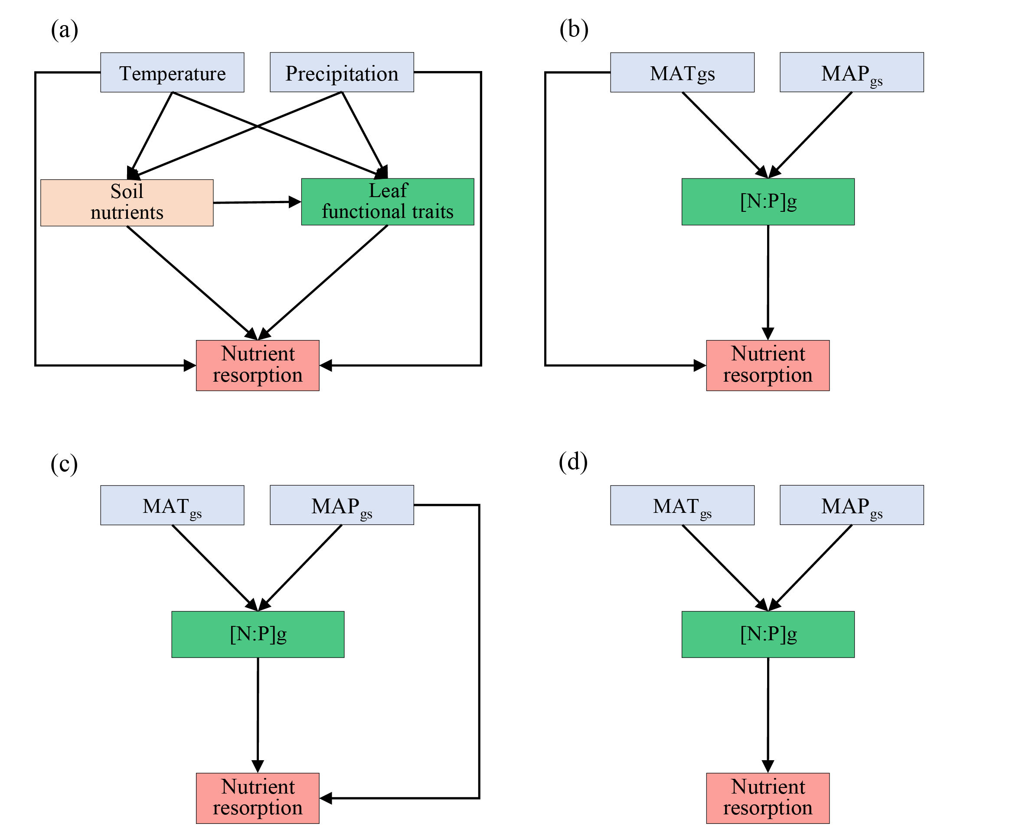
Fig. S1 Structural equation model development. (a) A theoretical and empirical structural equation model framework was built based on the results reported by previous studies. Specifically, changes of soil temperature and moisture caused by air temperature and precipitation could affect soil nutrient status (Tian et al., 2019; Ghiloufi and Chaieb, 2021), which subsequently influences leaf functional traits such as foliar morphological trait and nutrient concentration (Ordoñez et al., 2009; Wang et al., 2018). Meanwhile, variations of air temperature and precipitation also could control directly leaf functional trait and nutrient resorption (Reed et al., 2012; Gong et al., 2020). Further, there is close relationships between soil nutrients and nutrient resorption and between leaf functional trait and nutrient resorption (Tully et al., 2013; Zhao et al., 2017; Wang et al., 2018). However, in current study, few significant correlations were observed between soil nutrients and leaf functional trait and nutrient resorption, as well as between leaf functional trait and nutrient resorption, except between N:P ratio of green leaf ([N:P]g) (Fig. 3-4; Fig. S5). Similarly, only growing season temperature (GST) correlated to nutrient resorption, while growing season precipitation (GSP) showed the significant relationships with [N:P]g (Fig. 3). Therefore, three key factors (GST, GSP and [N:P]g) were screened out to establish the three alternatively priori structural equation models (b-d). Then, for graminoids, two alternative structural models were selected. The two models differed primarily in terms of which direct effects of GST (b) or GSP (c) on nutrient resorption were included. In detail, the model (b) was fitted well for both nitrogen resorption efficiency (NRE, Fisher’s C=0.207, P=0.902) and phosphorus resorption efficiency (PRE, Fisher’s C=3.331, P=0.189), and the significantly direct effects of GST on nutrient resorption were also confirmed. Moreover, the model (c) fitted badly for NRE (Fisher’s C=5.856, P=0.054) and PRE (Fisher’s C=10.294, P=0.006), and with insignificantly direct effects of GSP on nutrient resorptions. Additionally, for forbs, the three models were all performed and filtered. The model (b) was not fitted well for both NRE (Fisher’s C=12.582, P=0.002) and PRE (Fisher’s C=6.504, P=0.039), as well as model (c) for both NRE (Fisher’s C=12.095, P=0.002) and PRE (Fisher’s C=8.221, P=0.016). However, model (d) was fitted well for NRE (Fisher’s C=7.172, P=0.127) and PRE (Fisher’s C=4.999, P=0.287). Therefore, the model (b) and (d) were finally adopted to explore the direct and indirect effects of climate and leaf functional traits on nutrient resorption efficiencies for graminoids and forbs, respectively.
References
Chen Z F, Xiong P F, Zhou J J, Yang Q, Wang Z, Xu B C. 2020. Grassland productivity and diversity changes in responses to N and P addition depend primarily on tall clonal and annual species in semiarid Loess Plateau. Ecol Eng 145:105727. https://doi.org/10.1016/j.ecoleng.2020.105727
Du E Z, Terrer C, Pellegrini A F A, Ahlström A, van Lissa C J, Zhao X, Xia N, Wu X H, Jackson R B. 2020. Global patterns of terrestrial nitrogen and phosphorus limitation. Nat Geosci 13:221–226. https://doi.org/10.1038/s41561-019-0530-4
Ghiloufi W, Chaieb M. 2021. Environmental factors controlling vegetation attributes, soil nutrients and hydrolases in South Mediterranean arid grasslands. Ecol Eng 161:106155. https://doi.org/10.1016/j.ecoleng.2021.106155
Gong H D, Cui Q J, Gao J. 2020. Latitudinal, soil and climate effects on key leaf traits in northeastern China. Glob Ecol Conserv 22:e00904. https://doi.org/10.1016/j.gecco.2020.e00904
Ordoñez J C, van Bodegom P M, Witte J P M, Wright I J, Reich PB, Aerts R. 2009. A global study of relationships between leaf traits, climate and soil measures of nutrient fertility. Glob Ecol Biogeogr 18: 137–149. https://doi.org/10.1111/j.1466-8238.2008.00441.x
Reed S C, Townsend A R, Davidson E A, Cleveland C C. 2012. Stoichiometric patterns in foliar nutrient resorption across multiple scales. New Phytol 196:173–180. https://doi.org/10.1111/j.1469-8137.2012.04249.x
Tian L M, Zhao L, Wu X D, Hu G J, Fang H B, Zhao Y H, Sheng Y, Chen J, Wu J C, Li W P, Ping C L, Pang Q Q, Liu Y, Shi W, Wu T H, Zhang X M. 2019. Variations in soil nutrient availability across Tibetan grassland from the 1980s to 2010s. Geoderma 338:197–205. https://doi.org/10.1016/j.geoderma.2018.12.009
Tully K L, Wood T E, Schwantes A M, Lawrence D. 2013. Soil nutrient availability and reproductive effort drive patterns in nutrient resorption in Pentaclethra macroloba. Ecology 94:930–940. https://doi.org/10.1890/12-0781.1
Wang Z Q, Fan Z X, Zhao Q, Wan, M C, Ran J Z, Huang H, Niklas K J. 2018. Global data analysis shows that soil nutrient levels dominate foliar nutrient resorption efficiency in herbaceous species. Front Plant Sci 9:1431. https://doi.org/10.3389/fpls.2018.01431
Zhao G S, Shi P L, Wu J S, Xiong D P, Zong N, Zhang X Z. 2017. Foliar nutrient resorption patterns of four functional plants along a precipitation gradient on the Tibetan Changtang Plateau. Ecol Evol 7: 1–12. https://doi.org/10.1002/ece3.3283

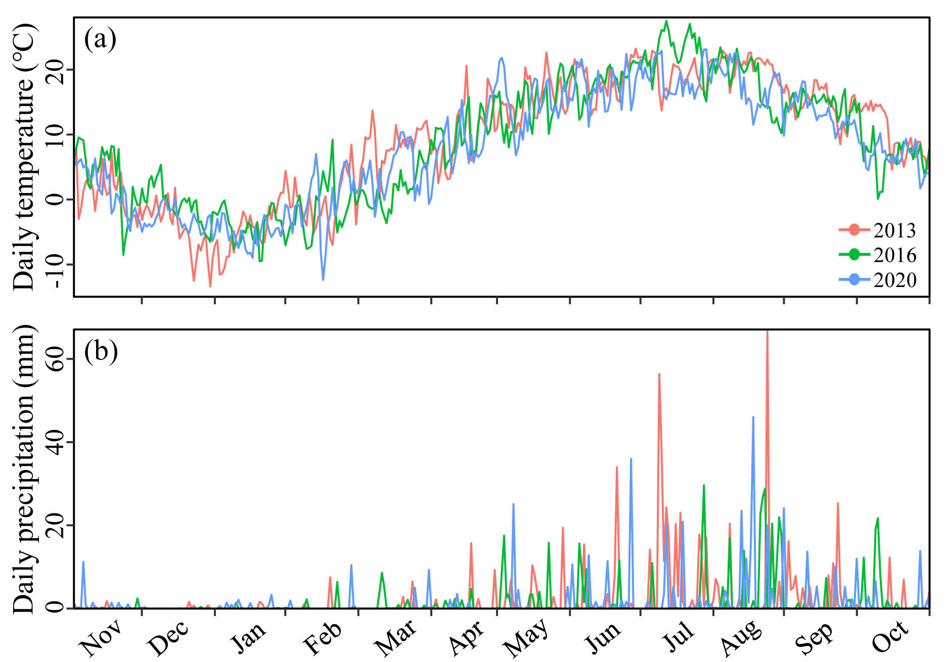
Fig. S2 Variations of daily temperature and precipitation among selected years.

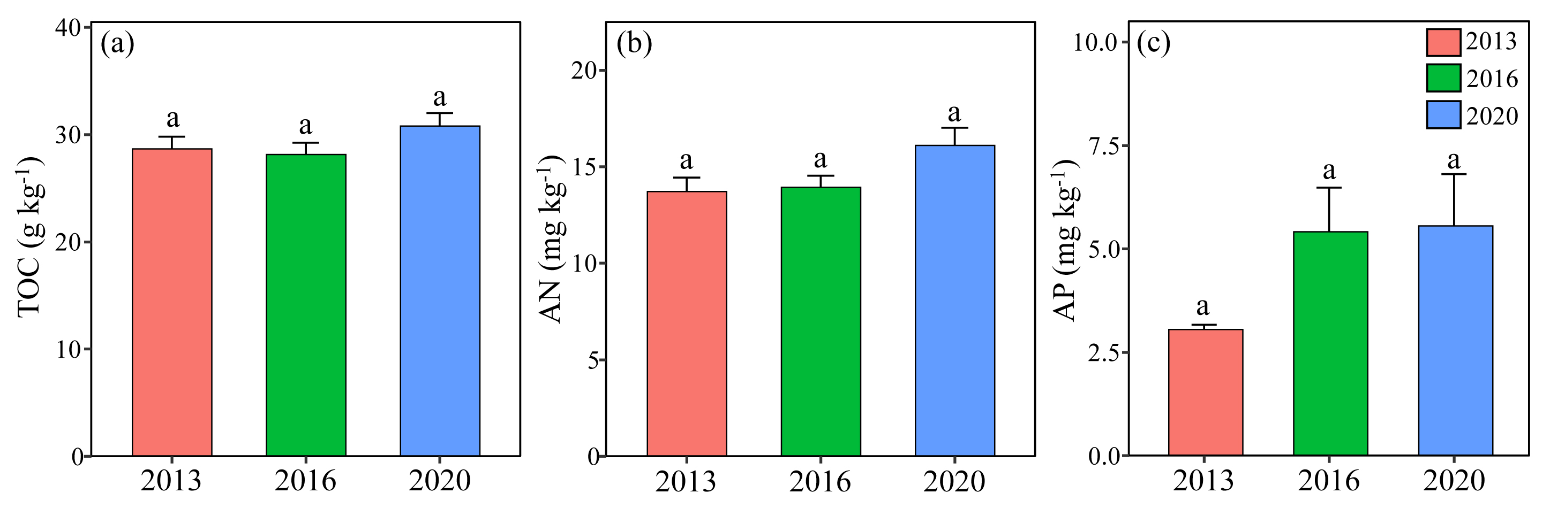
Fig. S3 Variation of soil nutrients among different years. Values are means ± standard error (n = 3). Different lowercase letters indicate that means are significantly different (P < 0.05) among the three years. TOC, total organic carbon; AN, available nitrogen; AP, available phosphorus.
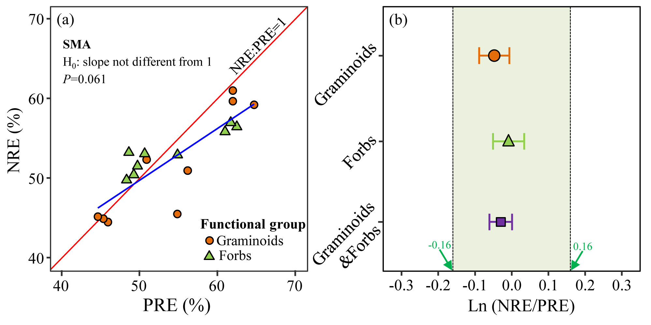
Fig. S4 Standard major axis (SMA) analysis determined whether nitrogen resorption efficiency (NRE) and phosphorus resorption efficiency (PRE) was equal (a), and ln-NRE/PRE was used to deduced the nutrient limitation (b). The regression slope of NRE and PRE was not different from 1 (P>0.05) indicated NRE was nearly equal with PRE in both graminoids and forbs (i.e., NRE: PRE=1). The error bar was the variation (95% CI) of ln-transformed NRE/PRE. According to the results of Du et al. (2020), the value of ln (NRE/PRE) that ranged from −0.16 to 0.16 indicated co-limited by N and P or weakly limited by either nutrient alone. Meanwhile, previous studies showed that the Loess Plateau was a nutrient-poor region (Chen et al., 2020). Hence, based on above, we believe that plants in this study region were co-limited by N and P.
References:
Du E Z, Terrer C, Pellegrini A F A, Ahlström A, van Lissa C J, Zhao X, Xia N, Wu X H, Jackson R B. 2020. Global patterns of terrestrial nitrogen and phosphorus limitation. Nat Geosci 13:221–226. https://doi.org/10.1038/s41561-019-0530-4
Chen Z F, Xiong P F, Zhou J J, Yang Q, Wang Z, Xu B C. 2020. Grassland productivity and diversity changes in responses to N and P addition depend primarily on tall clonal and annual species in semiarid Loess Plateau. Ecol Eng 145:105727. https://doi.org/10.1016/j.ecoleng.2020.105727
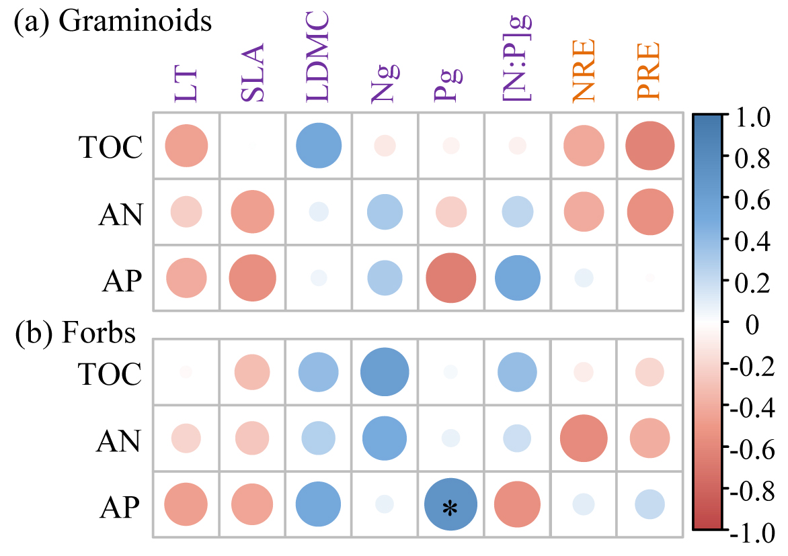
Fig. S5 Relationship between soil nutrients, leaf functional traits and resorption efficiency in graminoids (a) and forbs (b). TOC, total organic carbon; AN, available nitrogen; AP, available phosphorus; LT, leaf thickness; SLA, specific leaf area; LDMC, leaf dry matter content; Ng, N concentration in green leaf; Pg, P concentration in green leaf; [N:P]g, N and P ratio in green leaf; NRE, nitrogen resorption efficiency; PRE, phosphorus resorption efficiency. *, P<0.05.
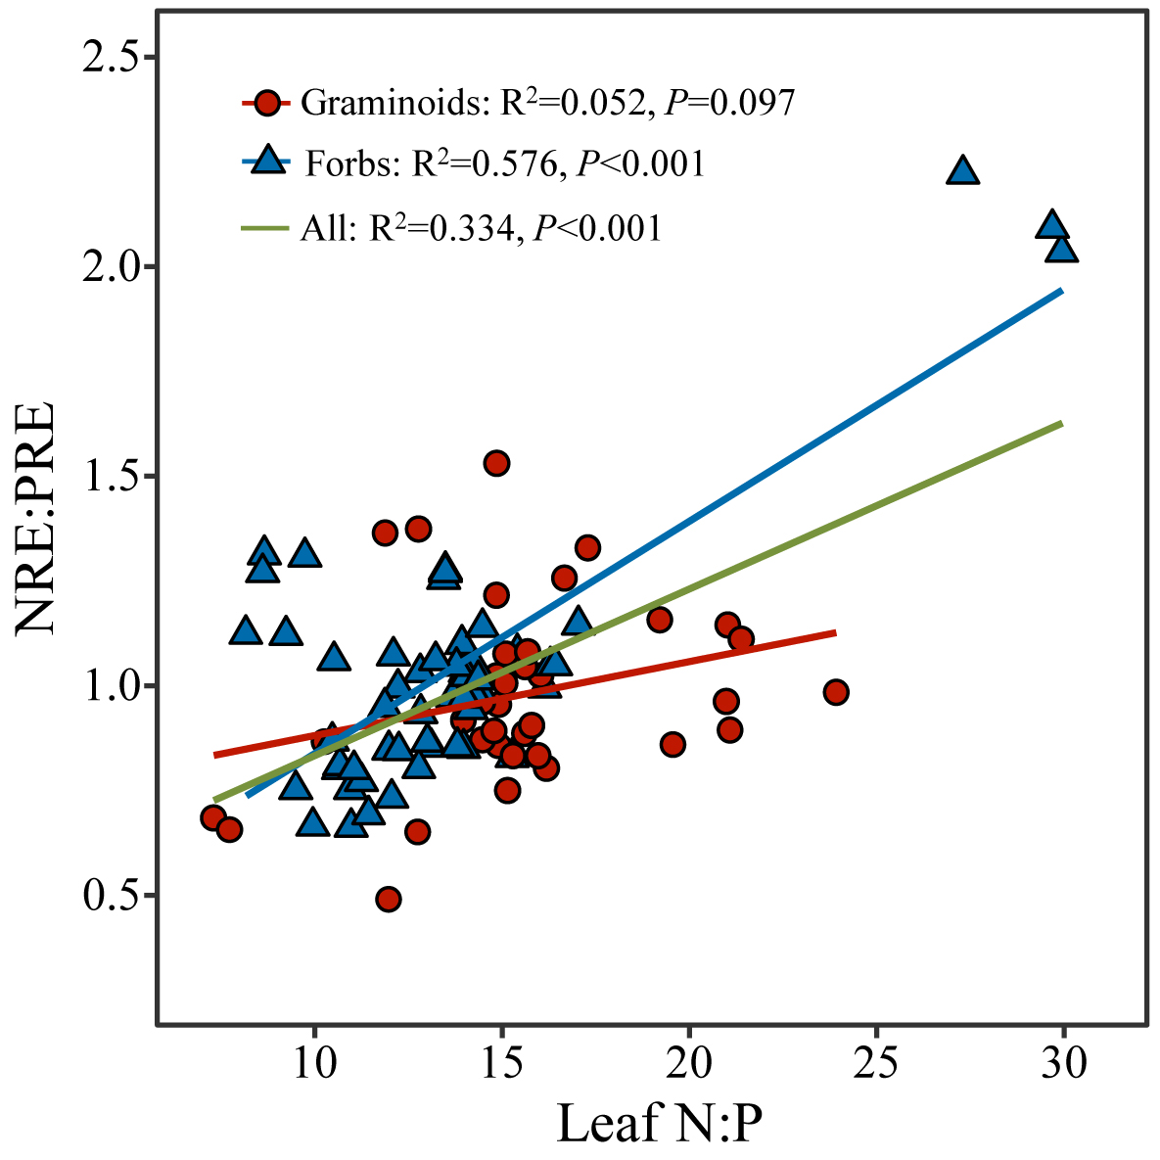
Fig. S6 Relationship between Leaf N:P ratio and NRE:PRE ratio. Leaf N:P ratio, N:P ratio in green leaf. NRE, nitrogen resorption efficiency; PRE, phosphorus resorption efficiency.

