Supplementary Information

Supplementary Table S1. Primers used in this study.

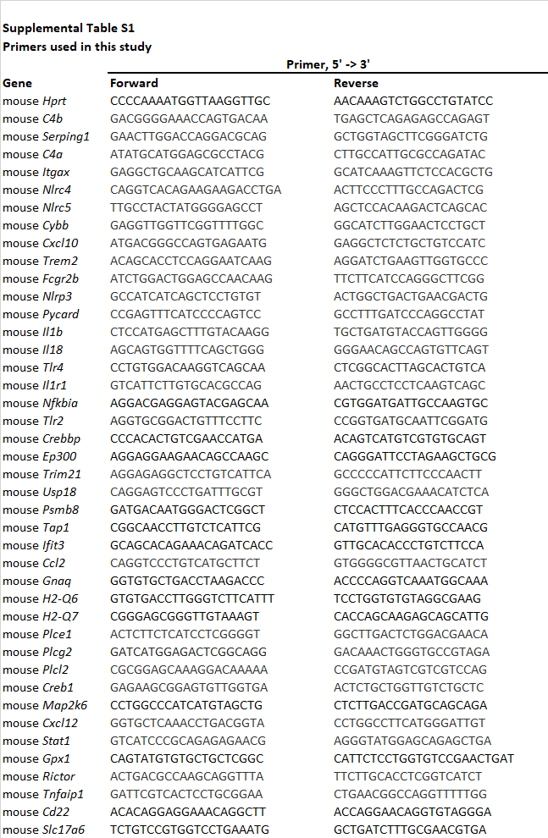

Supplementary Figure 1. Physiological monitoring data of GFP and GFP-(GR)₁₀₀ (a) and Nlrp3^{-/-}-GFP and Nlrp3^{-/-}-GFP(GR)₁₀₀ mice (b).
