Electronic Supplemental Material 1_Figures

Integrating laboratory experiments and biogeographic modelling approaches to understand sensitivity to ocean warming in rare and common marine annelids
Massamba-N’Siala G., Reygondeau G., Simonini R., Cheung W.W.L., Prevedelli D., Calosi P.

Journal: Oecologia
Fig. S1. Maps of the known global distribution of the common (a-b; green filled symbols), uncommon (c-d; orange filled symbols), and rare (e-g; dark-red filled symbols) species of the genus Ophryotrocha considered in our study

Fig. S2 Relationship between mean maximum local abundance and mean range size (measured at a global scale as extent of occurrence, EOO) of the studied species. Species were identified as common (green solid dots), uncommon (orange solid dots), and rare (dark-red solid dots). The cut-off points for rarity and commonness are placed, respectively, at the first quartile of the geographic range size (1,186,476 Km²) and local abundance (60 indiv.), and the third quartile of the geographic range size (44,262,226 Km²) and local abundance (79 indiv.). Species lying between these cut-off points are defined as uncommon. Areas defining the species’ status are delimited by grey, dashed lines

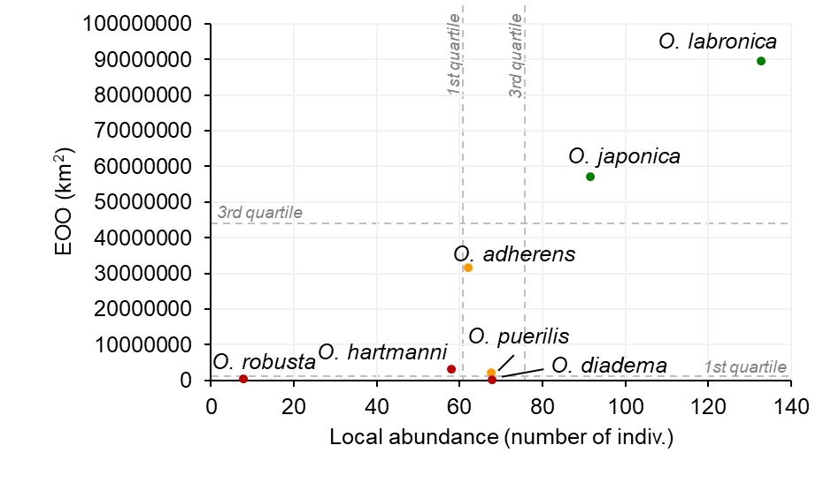

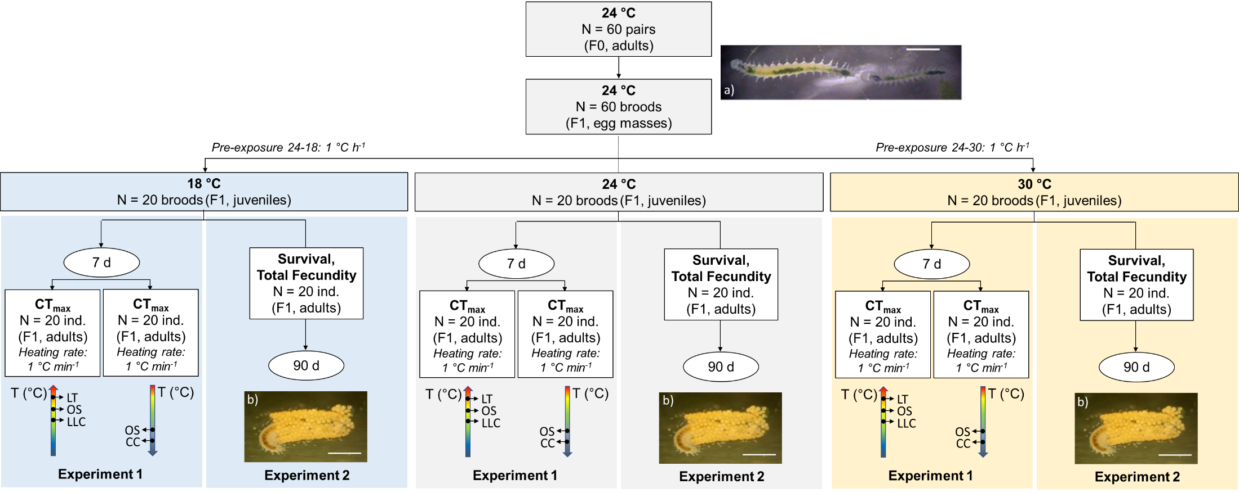
Fig. S3. Schematic representation of the experimental design. Each step shown in the figure was performed for each studied species. Broods of F1 individuals were assigned to three acclimation temperatures (18, 24, or 30 °C) after a pre-exposure of 1 °C h⁻¹ that started at the culture temperature (24 °C). Maximum and minimum critical temperature limits (CT_{max} and CT_{min}, respectively) were assessed after 7 d of exposure to the assigned acclimation temperature (Experiment 1). The endpoints used as proxy for CT_{max} were loss of locomotor control (LLC), onset of spasms (OS), and upper lethal temperature (LT). The endpoints used as proxy for CT_{min} were onset of spasms (OS) and chill coma (CC). CT_{max} and CT_{min} were measured sequentially during a continuous observation of the individuals exposed to an acute heating or cooling rate of 1 °C min⁻¹, respectively. Individual survival and total fecundity were measured during 90 d of exposure to the assigned acclimation temperature (Experiment 2). Images show individuals of the common species O. labronica: a pair of mating adults (a) and an individual providing parental care to the egg mass (b) (unit bar = 1 mm).

Fig. S4. Maps of the thermal habitat suitability index (HSI) of the common (c), uncommon (u), and rare (r) species of the studied species based on real temperature data for the North Atlantic and Mediterranean regions using the World Ocean Atlas 2018 database (Locarnini et al. 2019). The scale of HSI at the bottom of each map ranges from 0 (when the environment is unsuitable for the species) to 1 (when the environment is optimal for the species)
Fig. S5. Maps of the thermal habitat suitability index (HIS) of common (c), uncommon (u), and rare (r) species of studied species based on real temperature data for the Mediterranean Sea using the MEDAR/MEDATLAS database (Fichaut et al. 2003). The scale of HSI at the bottom of each map ranges from 0 (when the environment is unsuitable for the species) to 1 (when the environment is optimal for the species)
Fig. S6. Maximum likelihood phylogeny of cytochrome oxidase I for the studied Ophryotrocha species and additional eight marine annelid species, using the gastropod mollusc Lottia gigantea as outgroups. Numbers at the nodes of the tree are ultrafast bootstrap supports (%). The names of the seven Ophryotrocha species considered in our study are indicated with different colours according to their common (green), uncommon (orange), and rare (dark red) status
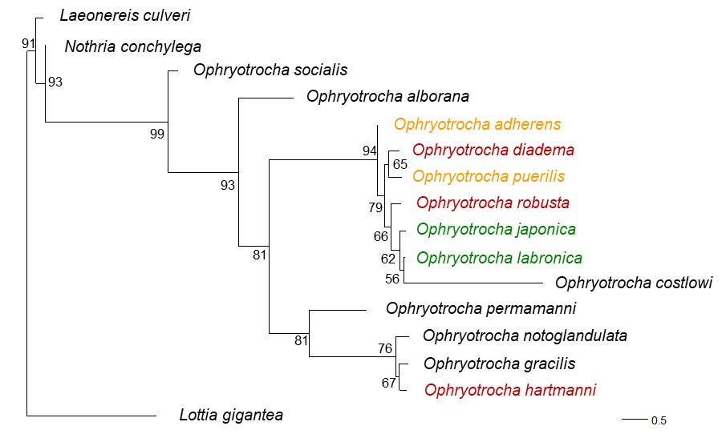

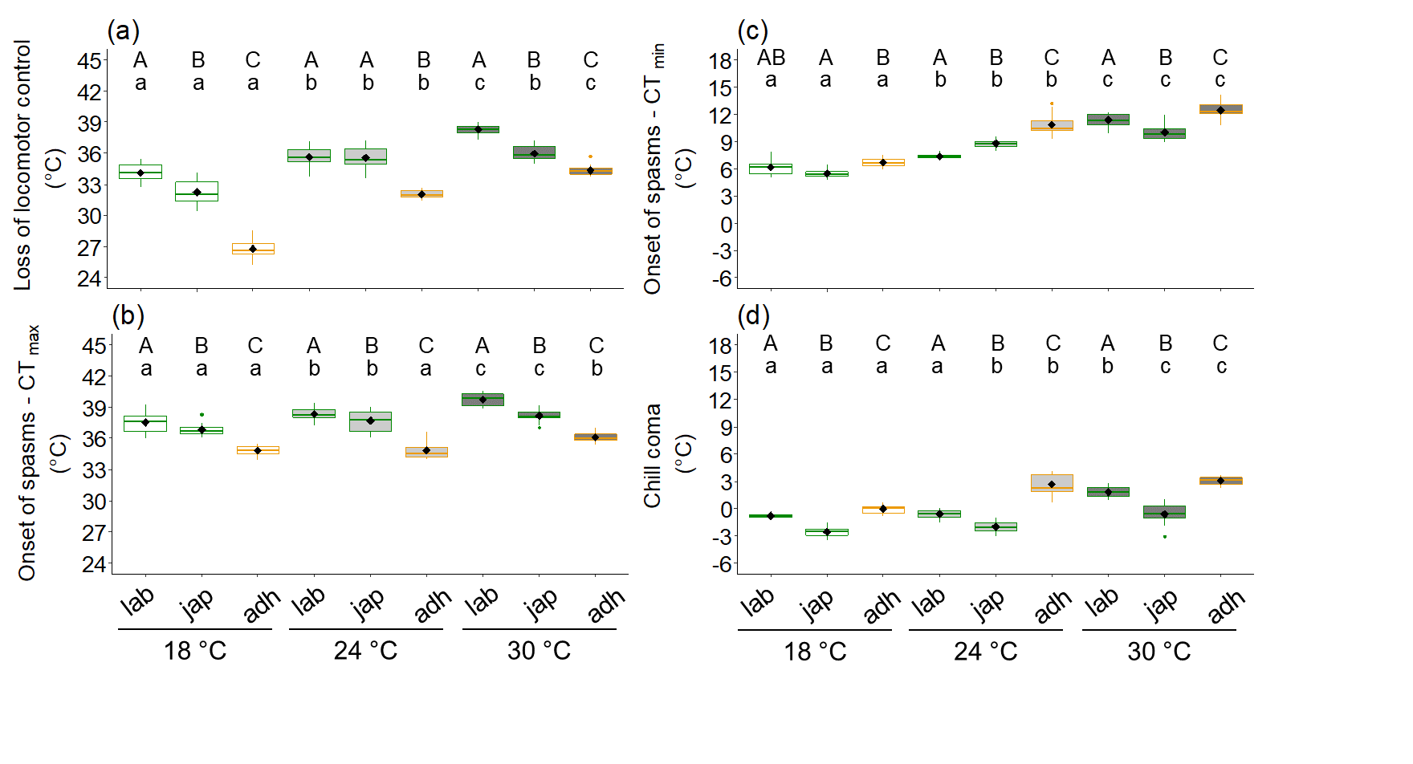
Fig. S7. Difference in upper (a-b) and lower (c-d) physiological thermal tolerance limits (CT_{max} and CT_{min}, respectively) between O. labronica (lab), O. japonica (jap), the two common species (green border), and O. adherens (adh), an uncommon species (orange border). CT_{max} and CT_{min} were measured after 7 d of exposure to all acclimation temperatures: 18, 24, and 30 °C (white, grey, and dark grey fill, respectively). The boundary of the box closest to zero indicates the 25th percentile, a horizontal black line and a diamond symbol inside the box mark the median and mean, respectively, and the boundary of the box farthest from zero indicates the 75th percentile. Whiskers above and below the box indicate the 10th and 90th percentiles. Points above and below the whiskers indicate outliers. Capital letters indicate differences among species within acclimation temperature. Lowercase letters indicate differences among acclimation temperatures within the same species.

Fig. S8. Difference in upper physiological thermal tolerance limits (CT_{max}) measured as lethal temperature between O. labronica (lab) and O. japonica (jap), the two common species (green border), and O. adherens (adh), an uncommon species (orange border) after 7 d of exposure to all acclimation temperatures: 18, 24, and 30 °C. See Fig. S7 for the description of the box plots. Capital letters indicate differences among species.
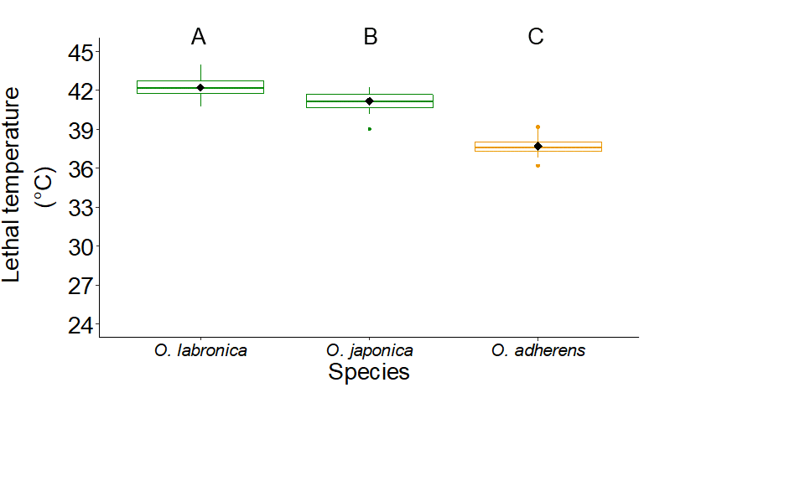

Fig. S9. Maps of the thermal habitat suitability index (HSI) derived from the curves of the fundamental thermal niche of the common (c), uncommon (u), and rare (r) studied species of the genus Ophryotrocha and obtained for the North Atlantic and Mediterranean regions for the present day (1970-2000), mid- (2050-2059) and late- (2090-2099) 21st Century scenarios for the RCP2.6 scenario of the IPCC
Fig. S10. Maps of the thermal habitat suitability index (HSI) derived from the curves of the fundamental thermal niche of the common (c), uncommon (u), and rare (r) studied species of the genus Ophryotrocha and obtained for the North Atlantic and Mediterranean regions for the present day (1970-2000), mid- (2050-2059) and late- (2090-2099) 21st Century scenarios for the RCP8.5 scenario of the IPCC
Fig. S11. Maps of the difference in the thermal habitat suitability (HSI) between the mid- (2050-2059) or late- (2090-2099) 21st Century scenario, and the present day (1970-2000) scenario under the RCP2.6 scenario in the North Atlantic and Mediterranean regions, obtained for the common (c), uncommon (u), and rare (r) studied species of the genus Ophryotrocha

