Supporting Information
Design and Introducing Quaternary Ammonium Hydroxide‐Functionalized Graphene Oxide Quantum Dots as an Efficient Pseudo-Homogeneous Catalyst for Epoxidation of α,β-Unsaturated Ketones
Mohammed Salim Mohammed,ª Homa Targhan,^{b} Kiumars Bahrami*^{a,b}
ª Nanoscience and Nanotechnology Research Center (NNRC), Razi University, Kermanshah, 67149-67346, Iran.
^{b}Department of Organic Chemistry, Faculty of Chemistry, Razi University, Kermanshah 67149-67346, Iran.
E-mail: k.bahrami@razi.ac.ir; Fax: +98(833)4274559; Tel: +98(833)4274559.

¹H-NMR and FT-IR data of the selected products
Figure S1. ¹H-NMR of (4-methoxyphenyl)(3-(4-methoxyphenyl)oxiran-2-yl)methanone (Table 2, Entry 4)
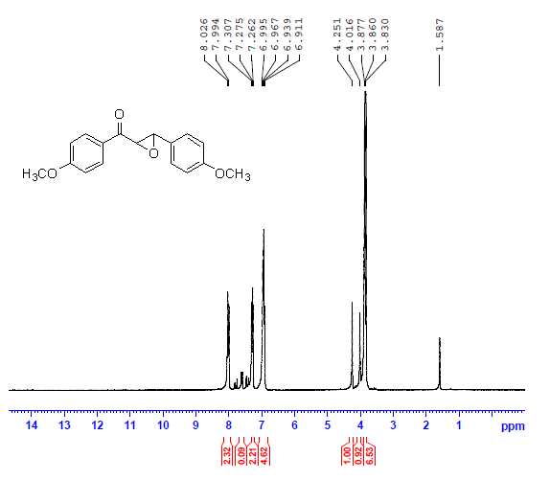

Figure S2. ¹H-NMR of (4-chlorophenyl)(3-(4-chlorophenyl)oxiran-2-yl)methanone (Table 2, Entry 2)

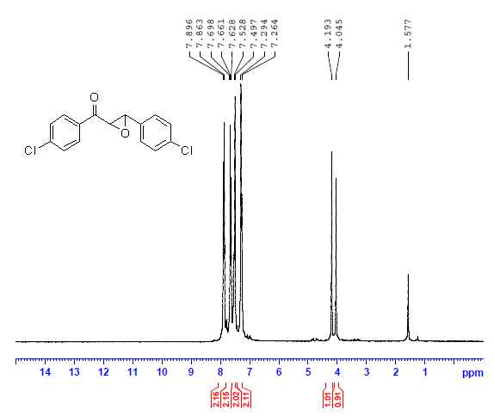

Figure S3. FT-IR of (4-methoxyphenyl)(3-(4-methoxyphenyl)oxiran-2-yl)methanone (Table 2, Entry 4)
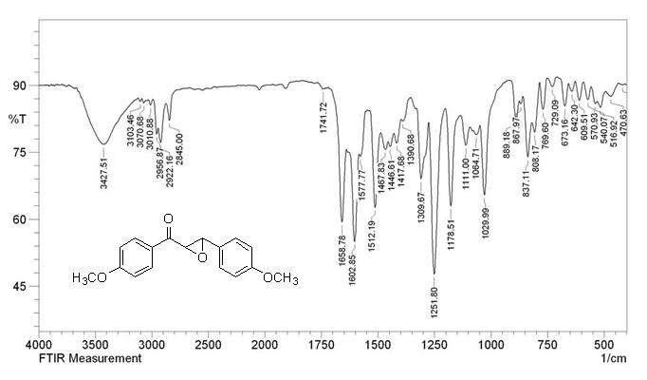

Figure S4. FT-IR of (4-chlorophenyl)(3-(4-chlorophenyl)oxiran-2-yl)methanone (Table 2, Entry 2)

