Tables:
Table S1. Information on the meteorological and water level stations used in this study
Table S2. Information of the GCMs used in this study
Table S3. Evaluation metrics information
Table S4. Performances of GCMs’ precipitation Data
Table S5. Performances of GCMs’ temperature Data
Table S6. SWAT parameters and their ranges selected for calibration
Table S7. Optimized values of SWAT parameters for eleven different periods
Table S8. Projected future precipitation data and changes over the historical period
Table S9. Projected temperature data and changes over the historical period

Figures:
Figure S1: Study area
Figure S2: Schematic diagram of uncertainty analysis in future runoff projection
Figure S3: Taylor diagrams showing the performance of eleven GCMs after bias correction
Figure S4: Yeongsan river Runoff hydrographs during model: (a)Calibration period; and (b)Validation period
Figure S5: Hydrographs for the historical period using eleven calibrated sets of SWAT parameters
Figure S6: Monthly runoff for historical period according to eleven calibrated sets of HM parameters
Figure S7: Boxplots of JS-D values according to SSP scenarios and two future periods
Figure S8: Evaluation of uncertainty in future extreme runoff for eleven GCMs and eleven HM parameters using JS-D

Table S1. Information on the meteorological and water level stations used in this study
Meteorological stations
Station | Period | Climate variables
Jeongeup | 1985 -present | Daily precipitation, minimum temperature, and maximum temperature
Namwon | 1985 -present
Gwangju | 1985 -present
Jangheung | 1985 -present
Haenam | 1985 -present
Mokpo | 1985 -present
Water level station
Station | Period | Avg. annual runoff  ($m^{3}/year$) | Runoff coefficient
Geukrak | 1998 -present | 19.2 | 0.65

Table S2. Information of the GCMs used in this study
Modeling Center | Models | Resolution  (Longitude x Latitude)
Center for Australian Weather and Climate Research (Ausralia)) | ACCESS ESM 1-5 | 1.25° x 1.875°
Canadian Earth System Model version 5, Canadian Centre for Climate Modelling and Analysis (Canada) | CanESM5 | 2.81°×2.81°
Institute for Numerical Mathematics, Russian Academy of Science, (Russia) | INM-CM4-8 | 2°×1.5°
 | INM-CM5-0 | 2°×1.5°
Institut Pierre Simon Laplace (France) | IPSL-CM6A-LR | 1.26°×2.5°
Atmosphere and Ocean Research Institute, The University of Tokyo (Japan) | MIROC6 | 1.4° × 1.4°
Max Planck Institute for Meteorology (MPI-M) (Germany) | MPI-ESM1-2-HR | 0.94° × 0.94°
Max Planck Institute for Meteorology (MPI-M) (Germany) | MPI-ESM1-2-LR | 1.9° × 1.9°
Meteorological Research Institute (Japan) | MRI-ESM2-0 | 1.1° × 1.1°
Norwegian Climate Centre (Norway) | NorESM2-LM | 2.50° ×1.89°
Norwegian Climate Centre (Norway) | NorESM2-MM | 0.94° × 1.25°

Table S3. Evaluation metrics information
Metrics | Formular | Factors | Range
NRMSE | $$=\frac{\sqrt{\frac{1}{n}\sum_{i=1}^{n}{{(X_{s}-X_{o})}^{2}}}}{\overline{X_{o}}}$$ | $X_{s}$: Simulation data  $X_{o}$: Reference data | $$Value=0 (Best)$$
RSR | $$\frac{RMSE}{{STDEV}_{X_{0}}}$$ | $X_{s}$: Simulation data  $X_{o}$: Reference data | $$Value=0 (Best)$$
NSE | $$1-\frac{\sum_{i=1}^{n}{{(X_{s}-X_{o})}^{2}}}{\sum_{i=1}^{n}{{(X_{o}-\overline{X_{o}})}^{2}}}$$ | $X_{s}$: Simulation data  $X_{o}$: Reference data | $$Value<1 (Best)$$
$$R^{2}$$ | $$=1-\frac{\sum{{(X_{O}-X_{S})}^{2}}}{\sum{{(X_{O}-{\overline{X}}_{O})}^{2}}}$$ | $X_{s}$: Simulation data  $X_{o}$: Reference data | $$0\left(Worst\right)<Value<1(Best)$$
KGE | $$=1-\sqrt{{\left(r-1\right)}^{2}+{\left(α-1\right)}^{2}+{\left(β-1\right)}^{2}}$$ | $r$: Pearson product-moment correlation coefficient  $α$: variability error  $β$: bias term | $$0\left(Worst\right)<Value<1(Best)$$

Table S4. Performances of GCMs’ precipitation Data
GOF | ACCESS ESM 1-5 | CanESM5 | INM-CM4-8 | INM-CM5-0 | IPSL-CM6A-LR | MIROC6 | MPI-ESM1-2-HR | MPI-ESM1-2-LR | MRI-ESM2-0 | NorESM2-LM | NorESM2-MM
RMSE | 1.24 | 1.58 | 5.16 | 1.29 | 2.88 | 1.50 | 0.63 | 0.93 | 0.50 | 3.53 | 3.15
PBIAS | 1.00 | 1.50 | 3.70 | 0.80 | 2.70 | 1.60 | 0.30 | 0.60 | 0.10 | 3.40 | 3.60
RSR | 0.09 | 0.12 | 0.38 | 0.09 | 0.21 | 0.11 | 0.05 | 0.07 | 0.04 | 0.26 | 0.23
NSE | 0.99 | 0.99 | 0.86 | 0.99 | 0.96 | 0.99 | 1.00 | 1.00 | 1.00 | 1.00 | 1.00

Table S5. Performances of GCMs’ temperature Data
GOF | ACCESS ESM 1-5 | CanESM5 | INM-CM4-8 | INM-CM5-0 | IPSL-CM6A-LR | MIROC6 | MPI-ESM1-2-HR | MPI-ESM1-2-LR | MRI-ESM2-0 | NorESM2-LM | NorESM2-MM
RMSE | 0.042 | 0.047 | 0.052 | 0.046 | 0.051 | 0.046 | 0.044 | 0.054 | 0.043 | 0.051 | 0.065
PBIAS | 0.000 | 0.000 | 0.000 | 0.000 | 0.000 | 0.000 | 0.000 | 0.000 | 0.000 | 0.000 | 0.000
RSR | 0.005 | 0.005 | 0.005 | 0.005 | 0.005 | 0.005 | 0.005 | 0.006 | 0.005 | 0.005 | 0.007
NSE | 1.000 | 1.000 | 1.000 | 1.000 | 1.000 | 1.000 | 1.000 | 1.000 | 1.000 | 1.000 | 1.000

Table S6. SWAT parameters and their ranges selected for calibration
 | Parameter | Description | Sensitivity indices |  | Range |  | Fitted
 | Parameter | Description | t-Stat | P-value | Min | Max | Fitted
Ground  water | ALPHA_BF | Baseflow alpha factor | 0.00 | 17.38 | 0 | 1 | 0.43
Ground  water | GW_DELAY | Groundwater delay time | 0.00 | 3.24 | 30 | 450 | -156.11
Ground  water | GW_REVAP | Groundwater re-evaporation coefficient | 0.00 | -5.83 | 0.02 | 0.3 | 0.16
Ground  water | GWQMN | Threshold water level in shallow aquifer for baseflow | 0.00 | -12.20 | 0 | 5000 | 821.43
Ground  water | RCHRG_DP | Deep aquifer percolation fraction | 0.00 | 18.18 | 0 | 1 | 0.57
Ground  water | REVAPMN | Threshold depth of water in the shallow aquifer for re-evaporation | 0.62 | 0.49 | 0 | 600 | -104.76
Hydrologic  response  unit | EPCO | Plant uptake compensation factor | 0.85 | 0.19 | 0 | 1 | 0.44
Hydrologic  response  unit | ESCO | Soil evaporation compensation factor | 0.70 | 0.38 | 0.7 | 0.95 | 0.97
Hydrologic  response  unit | SLSUBBSN | Average slope length | 0.00 | -2.91 | -0.2 | 0.2 | -0.22
Hydrologic  response  unit | CANMX | Maximum canopy storage | 0.00 | -10.63 | 0 | 100 | 18.65
Soil | SOL_AWC | Available water capacity of the soil layer | 0.05 | -1.99 | -0.2 | 0.1 | -0.18
Soil | SOL_K | Saturated hydraulic conductivity | 0.00 | 15.83 | -0.8 | 0.8 | 0.07
Soil | SOL_Z | Depth from soil surface to bottom of layer | 0.00 | -5.04 | -0.8 | 0.8 | -0.88
Channel  routing | CH_K2 | Effective hydraulic conductivity in main channel alluvium | 0.00 | -11.11 | -300 | 500 | -555.59
Channel  routing | CH_N2 | Manning's "n" value for the main channel | 0.06 | -1.85 | 0.01 | 0.2 | 0.19
Management | CN2 | Initial SCS runoff curve number for moisture condition Ⅱ | 0.00 | 19.64 | 35 | 98 | 0.05
Basin | SFTMP | Snowfall temperature | 0.83 | -0.22 | -20 | 20 | -17.60
Basin | SMFMN | Melt factor for snow on December 21 | 0.50 | -0.68 | 0 | 20 | 13.84
Basin | SMFMX | Melt factor for snow on June 21 | 0.43 | -0.78 | 0 | 20 | -0.02
Basin | SMTMP | Snow melt base temperature | 0.82 | -0.22 | -20 | 20 | -18.15
Basin | SURLAG | Surface runoff lag coefficient | 0.06 | 1.88 | 0 | 24 | 13.18
Basin | TIMP | Snow pack temperature lag factor | 0.20 | 1.28 | 0 | 1 | 0.71
Sub-basin | CH_N1 | Manning’s “n” value for the tributary channels | 0.02 | -2.30 | -1 | 1 | -0.02

Table S7. Optimized values of SWAT parameters for eleven different periods
Parameter | 1 | 2 | 3 | 4 | 5 | 6 | 7 | 8 | 9 | 10 | 11
v__ALPHA_BF | 1.41 | 1.77 | 0.61 | 0.12 | 0.36 | 0.77 | 1.35 | 1.21 | 0.75 | 1.46 | 0.59
v__CANMX | 71.74 | -6.43 | 12.81 | -16.62 | -10.23 | 31.97 | 44.46 | -26.21 | -26.48 | -0.50 | 4.11
v__CH_K2 | 946.84 | 593.18 | -53.20 | 18.31 | -29.32 | -99.17 | 153.87 | -339.53 | -366.22 | -290.05 | 7.11
v__CH_N2 | 0.18 | 0.16 | 0.08 | 0.13 | 0.14 | 0.16 | 0.11 | 0.05 | 0.12 | 0.09 | 0.12
v__CH_N1 | -0.32 | 0.08 | 0.13 | 1.75 | 0.09 | -0.51 | -0.66 | 0.03 | 0.39 | 0.29 | 0.18
r__CN2 | 0.35 | 0.45 | 0.23 | 0.31 | 0.15 | 0.00 | 0.30 | -0.13 | -0.44 | 0.23 | -0.05
v__EPCO | 0.76 | -0.55 | 0.41 | 0.31 | 0.47 | 0.50 | 0.27 | 0.15 | -0.18 | 0.64 | 0.72
v__ESCO | 0.95 | 0.86 | 0.77 | 0.74 | 0.84 | 0.84 | 0.80 | 0.89 | 1.04 | 1.07 | 0.79
v__GW_DELAY | 344.11 | 220.13 | 265.61 | 637.14 | 474.47 | -30.21 | 274.90 | 437.72 | 403.40 | 70.57 | 453.23
v__GW_REVAP | 0.22 | 0.10 | 0.03 | -0.06 | 0.06 | 0.14 | 0.11 | 0.13 | 0.18 | 0.16 | 0.15
v__GWQMN | 3660.49 | 63.26 | 1769.21 | 1956.91 | 1471.16 | 1036.05 | 3122.76 | 2322.08 | 3323.78 | 2300.67 | 1556.10
v__RCHRG_DP | 1.10 | 0.99 | 0.51 | -0.03 | 0.09 | 0.35 | 0.94 | 0.80 | 0.66 | 1.47 | 0.65
v__REVAPMN | 614.27 | 496.01 | 688.73 | 487.86 | 414.19 | 465.66 | 770.30 | 39.03 | -8.61 | 605.39 | 63.65
v__SFTMP | 8.90 | -15.94 | -10.96 | 24.99 | 32.68 | -13.63 | 10.11 | 0.76 | 2.01 | -6.19 | -1.11
r__SLSUBBSN | -0.19 | -0.28 | 0.01 | -0.07 | -0.17 | 0.09 | -0.02 | 0.03 | 0.12 | -0.11 | 0.05
v__SMFMN | 15.95 | 8.97 | 12.41 | 12.94 | 22.13 | -1.88 | 26.34 | 13.97 | 14.92 | 20.13 | 7.48
v__SMFMX | 18.41 | 10.23 | 14.68 | 13.16 | 12.60 | 25.41 | 16.83 | 1.33 | 15.02 | 16.74 | 10.02
v__SMTMP | -22.80 | 5.58 | 20.53 | -13.20 | -4.76 | 26.36 | 0.59 | 0.37 | 4.28 | 7.06 | -22.20
r__SOL_AWC | 0.03 | -0.14 | -0.07 | -0.19 | -0.17 | 0.00 | -0.08 | -0.10 | 0.03 | -0.06 | -0.03
r__SOL_K | 0.76 | 0.96 | 0.04 | 1.10 | 0.13 | 1.18 | -0.33 | -0.14 | 1.27 | -0.97 | 0.84
r__SOL_Z | -0.30 | 0.20 | 0.74 | -0.35 | -0.19 | -0.59 | -0.16 | -0.12 | -0.82 | 0.28 | -0.61
v__SURLAG | 10.84 | 20.82 | 26.08 | 11.85 | 10.03 | 24.98 | 10.47 | 13.48 | -3.15 | 31.90 | 9.80
v__TIMP | -0.25 | 0.45 | 0.54 | 0.95 | 1.25 | 0.78 | 0.41 | 0.12 | 0.51 | 0.86 | 0.28

Table S8. Projected future precipitation data and changes over the historical period
(Unit : mm)
SSPs | Time period | Season | ACCESSESM1-5 | CanESM5 | INM-CM4-8 | INM-CM5-0 | IPSL-CM6A-LR | MIROC6 | MPI-ESM1-2-HR | MPI-ESM1-2-LR | MRI-ESM2-0 | NorESM2-LM | NorESM2-MM | Average | Change ratio  (%)
SSP2-4.5 | NF | Spring | 393.3 | 492.3 | 465.1 | 478.8 | 522.9 | 425.5 | 575.6 | 694.9 | 415.3 | 460.6 | 494.6 | 492.6 | 94.3
SSP2-4.5 | NF | Summer | 551.6 | 568.1 | 560.9 | 761.6 | 684.4 | 683.6 | 615.1 | 601.1 | 706.7 | 682.3 | 705.0 | 647.3 | -10.9
SSP2-4.5 | NF | Autumn | 300.3 | 134.0 | 231.0 | 276.0 | 222.3 | 283.1 | 112.1 | 120.5 | 166.1 | 228.5 | 261.2 | 212.3 | -18.5
SSP2-4.5 | NF | Winter | 176.5 | 175.1 | 246.0 | 210.1 | 182.4 | 105.1 | 207.3 | 189.8 | 181.9 | 151.1 | 154.6 | 180.0 | 61.5
SSP2-4.5 | FF | Spring | 437.5 | 548.3 | 513.3 | 483.0 | 474.1 | 461.3 | 559.8 | 713.6 | 461.8 | 546.8 | 493.9 | 517.6 | 104.1
SSP2-4.5 | FF | Summer | 600.6 | 521.2 | 588.7 | 737.5 | 743.6 | 684.3 | 635.6 | 617.9 | 698.7 | 899.4 | 668.1 | 672.3 | -7.4
SSP2-4.5 | FF | Autumn | 306.2 | 168.7 | 259.7 | 241.2 | 189.5 | 306.9 | 126.2 | 148.5 | 211.8 | 187.3 | 233.1 | 216.3 | -17.0
SSP2-4.5 | FF | Winter | 201.5 | 228.4 | 263.1 | 226.7 | 145.9 | 110.4 | 200.9 | 166.5 | 188.5 | 196.1 | 177.8 | 191.5 | 71.8
SSP5-8.5 | NF | Spring | 418.5 | 499.1 | 486.2 | 490.5 | 522.9 | 412.9 | 488.9 | 634.5 | 428.2 | 501.5 | 515.3 | 490.8 | 93.6
SSP5-8.5 | NF | Summer | 612.0 | 458.5 | 629.0 | 708.6 | 684.4 | 616.1 | 616.8 | 593.5 | 701.9 | 700.7 | 647.0 | 633.5 | -12.8
SSP5-8.5 | NF | Autumn | 208.7 | 154.7 | 231.9 | 217.7 | 222.3 | 252.4 | 112.1 | 127.7 | 169.3 | 211.8 | 286.9 | 199.6 | -23.4
SSP5-8.5 | NF | Winter | 156.6 | 183.1 | 232.1 | 140.9 | 182.4 | 102.7 | 183.3 | 177.6 | 181.7 | 141.3 | 135.0 | 165.1 | 48.2
SSP5-8.5 | FF | Spring | 427.5 | 613.5 | 538.1 | 561.8 | 474.1 | 524.9 | 619.3 | 726.0 | 471.1 | 598.8 | 589.3 | 558.6 | 120.3
SSP5-8.5 | FF | Summer | 537.0 | 647.1 | 600.7 | 793.6 | 743.6 | 754.4 | 647.8 | 677.3 | 702.6 | 723.0 | 657.4 | 680.4 | -6.3
SSP5-8.5 | FF | Autumn | 262.5 | 139.6 | 196.3 | 253.4 | 189.5 | 299.7 | 122.7 | 155.0 | 194.6 | 194.9 | 237.0 | 204.1 | -21.6
SSP5-8.5 | FF | Winter | 185.3 | 190.0 | 280.9 | 133.9 | 145.9 | 131.9 | 240.1 | 206.3 | 204.9 | 191.9 | 181.9 | 190.3 | 70.7

Table S9. Projected temperature data and changes over the historical period
(Unit: °C)
SSPs | Time period | Season | ACCESSESM1-5 | CanESM5 | INM-CM4-8 | INM-CM5-0 | IPSL-CM6A-LR | MIROC6 | MPI-ESM1-2-HR | MPI-ESM1-2-LR | MRI-ESM2-0 | NorESM2-LM | NorESM2-MM | Average | Change
SSP2-4.5 | NF | Spring | 11.4 | 13.3 | 15.0 | 14.4 | 8.7 | 14.6 | 12.0 | 13.7 | 12.8 | 14.6 | 15.1 | 13.2 | 0.7
SSP2-4.5 | NF | Summer | 21.5 | 25.8 | 25.0 | 25.3 | 25.1 | 25.6 | 24.4 | 25.2 | 26.1 | 23.7 | 26.5 | 24.9 | 0.1
SSP2-4.5 | NF | Autumn | 17.7 | 19.4 | 17.0 | 15.9 | 16.5 | 17.9 | 16.7 | 17.9 | 17.0 | 15.8 | 15.7 | 17.1 | 1.4
SSP2-4.5 | NF | Winter | 6.3 | 6.6 | 5.6 | 5.0 | -1.0 | 3.6 | 2.8 | 4.5 | 3.2 | 6.2 | 4.0 | 4.2 | 2.0
SSP2-4.5 | FF | Spring | 12.4 | 16.3 | 16.1 | 16.7 | 12.8 | 15.2 | 13.0 | 14.5 | 13.6 | 19.2 | 17.9 | 15.2 | 2.7
SSP2-4.5 | FF | Summer | 23.5 | 27.4 | 25.6 | 26.4 | 27.3 | 26.6 | 25.5 | 26.3 | 26.9 | 28.0 | 27.5 | 26.5 | 1.6
SSP2-4.5 | FF | Autumn | 19.2 | 18.9 | 16.2 | 14.5 | 15.9 | 19.0 | 18.0 | 18.7 | 17.8 | 16.9 | 14.7 | 17.2 | 1.6
SSP2-4.5 | FF | Winter | 7.2 | 7.7 | 6.4 | 5.9 | 0.5 | 4.3 | 4.2 | 5.3 | 3.9 | 8.4 | 5.2 | 5.4 | 3.1
SSP5-8.5 | NF | Spring | 13.6 | 14.0 | 15.5 | 14.9 | 10.1 | 14.9 | 12.4 | 13.5 | 13.1 | 17.1 | 15.6 | 14.1 | 1.6
SSP5-8.5 | NF | Summer | 22.6 | 26.3 | 25.0 | 25.2 | 25.9 | 25.9 | 24.4 | 25.0 | 26.3 | 27.4 | 26.7 | 25.5 | 0.7
SSP5-8.5 | NF | Autumn | 19.2 | 20.0 | 16.1 | 16.1 | 17.7 | 18.3 | 17.2 | 17.7 | 17.6 | 18.2 | 16.2 | 17.7 | 2.0
SSP5-8.5 | NF | Winter | 8.1 | 7.0 | 5.9 | 5.3 | 0.2 | 3.7 | 3.6 | 4.1 | 3.8 | 7.4 | 4.2 | 4.8 | 2.6
SSP5-8.5 | FF | Spring | 15.6 | 19.0 | 18.4 | 17.8 | 14.1 | 16.8 | 14.2 | 15.5 | 14.8 | 21.0 | 19.5 | 17.0 | 4.5
SSP5-8.5 | FF | Summer | 25.0 | 28.6 | 26.5 | 27.3 | 27.9 | 27.3 | 26.3 | 27.0 | 27.7 | 29.0 | 28.5 | 27.4 | 2.5
SSP5-8.5 | FF | Autumn | 22.1 | 21.4 | 15.8 | 15.6 | 17.1 | 20.4 | 19.7 | 20.5 | 19.5 | 18.8 | 16.4 | 18.9 | 3.2
SSP5-8.5 | FF | Winter | 10.2 | 10.4 | 7.7 | 7.2 | 1.9 | 6.2 | 5.9 | 7.0 | 5.7 | 9.9 | 7.1 | 7.2 | 5.0

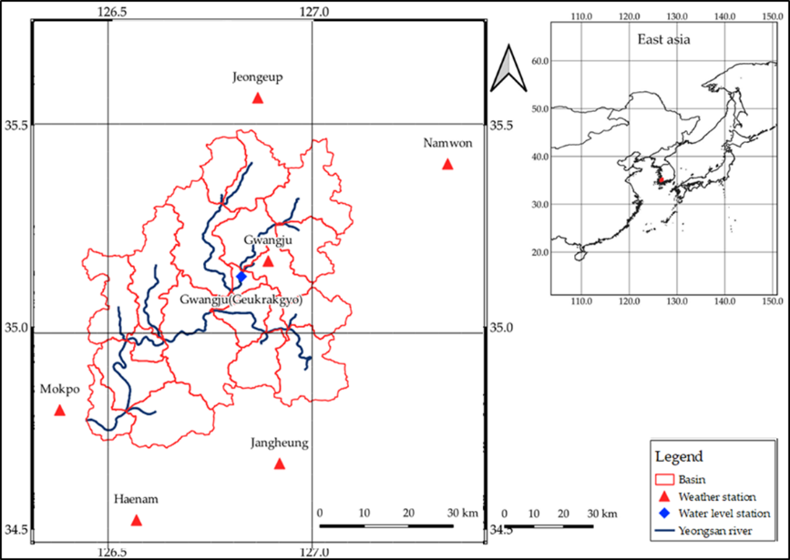
Figure S1: Study area

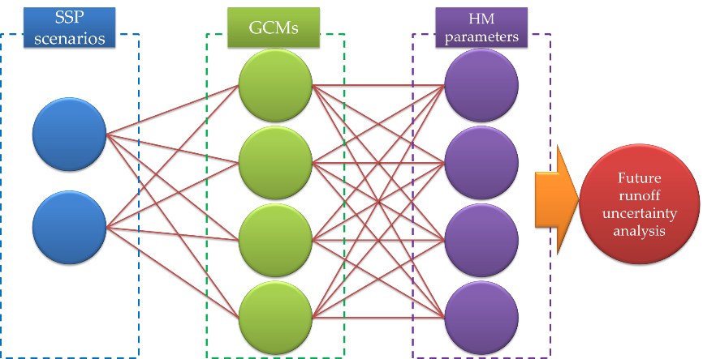
Figure S2: Schematic diagram of uncertainty analysis in future runoff projection

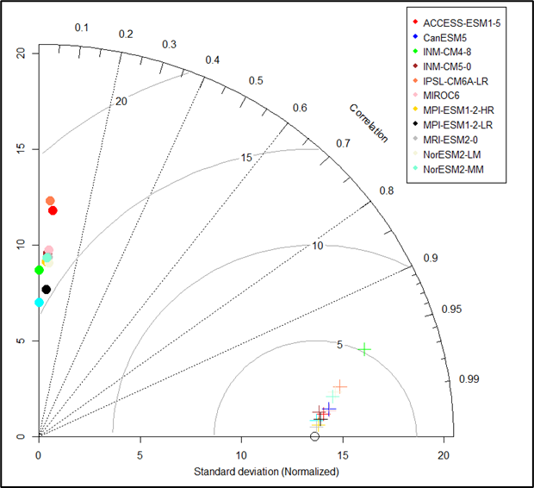 | 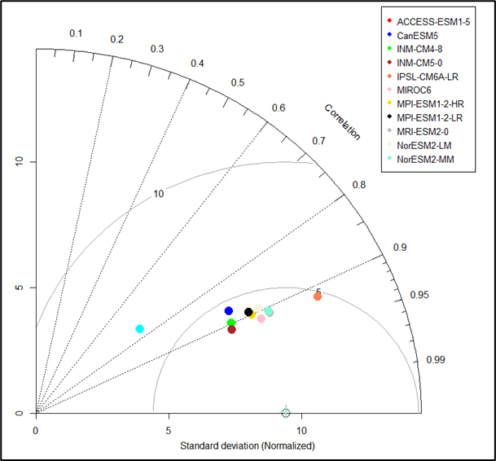
(a) Precipitation | (b) Temperature
Figure S3: Taylor diagrams showing the performance of eleven GCMs after bias correction

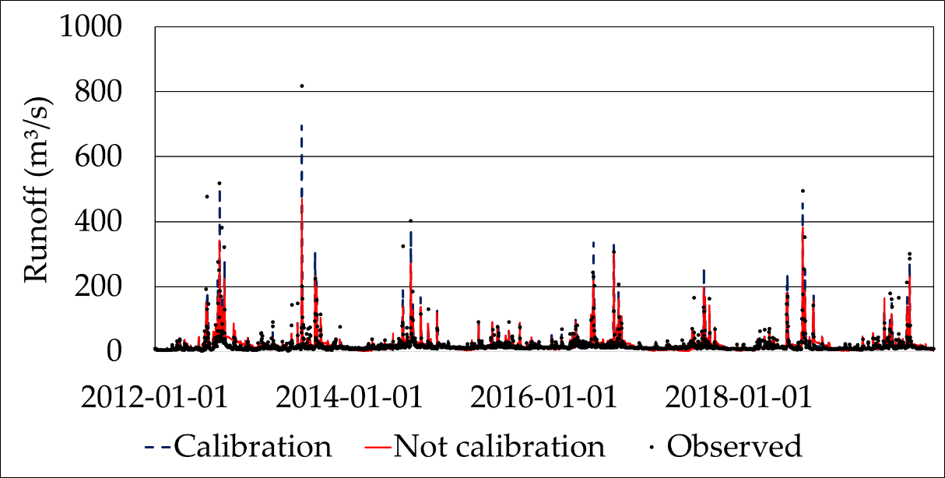
(a) Calibration period (2012-2019)
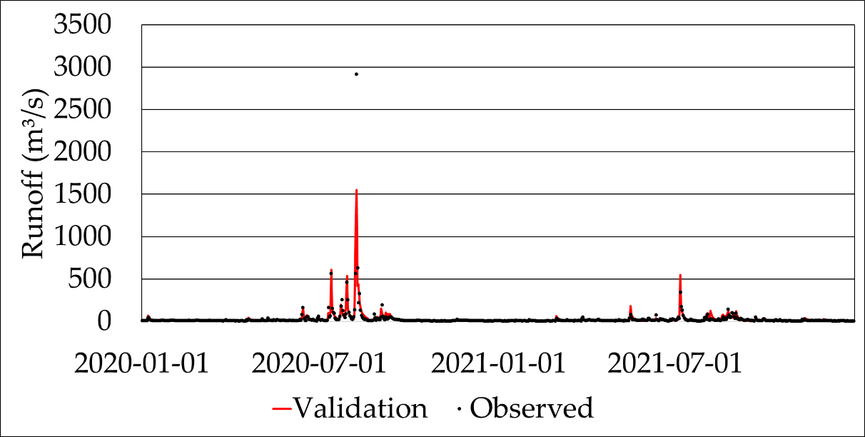
(b) Validation period (2020-2021)
Figure S4: Yeongsan river Runoff hydrographs during model: (a)Calibration period; and (b)Validation period

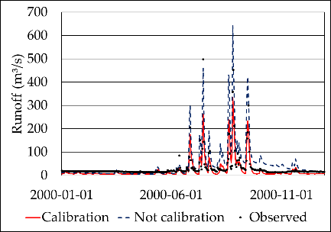 | 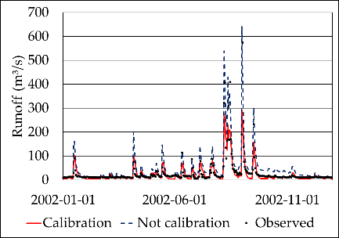 | 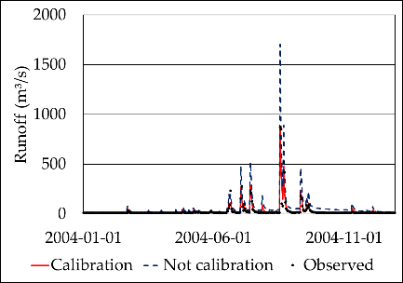
(a) Case 1 | (b) Case 2 | (c) Case 3
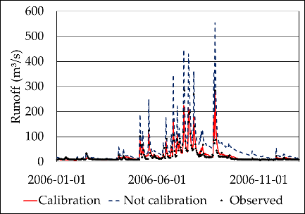 | 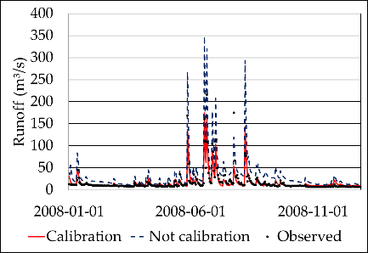 | 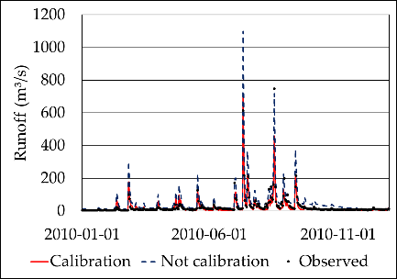
(d) Case 4 | (e) Case 5 | (f) Case 6
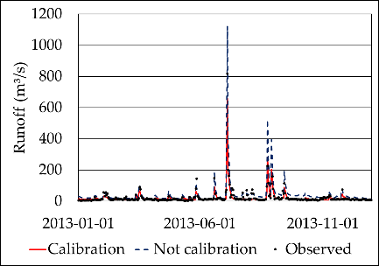 | 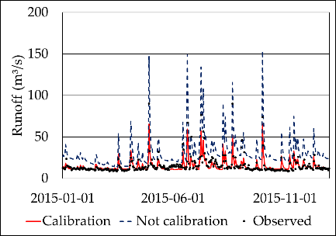 | 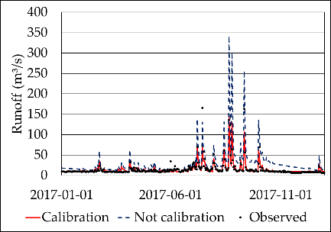
(g) Case 7 | (h) Case 8 | (i) Case 9
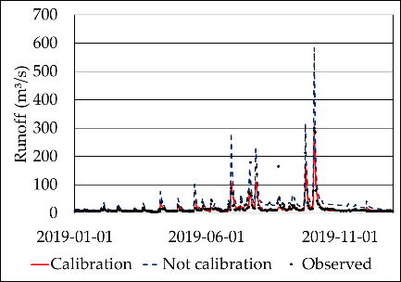 | 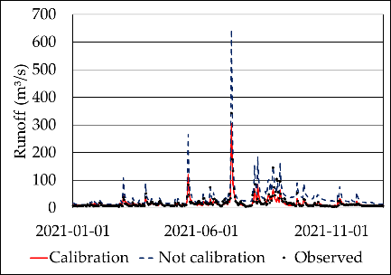
(j) Case 10 | (k) Case 11
Figure S5: Hydrographs for the historical period using eleven calibrated sets of SWAT parameters

Figure S6: Monthly runoff for historical period according to eleven calibrated sets of HM parameters

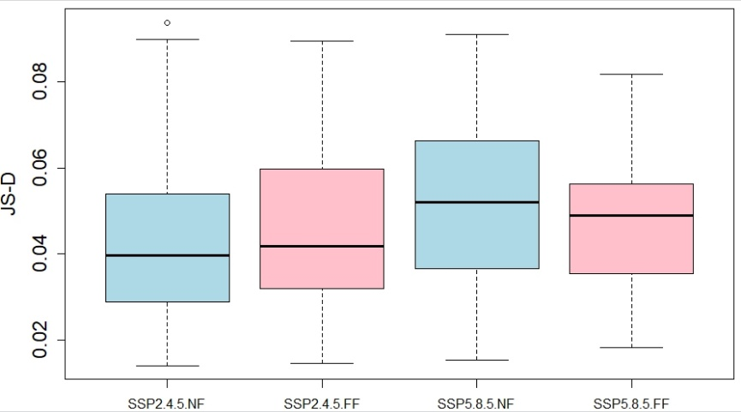
Figure S7: Boxplots of JS-D values according to SSP scenarios and two future periods

(a) Near future of SSP2-4.5
(b) Far future of SSP2-4.5
(c) Near future of SSP5-8.5
(d) Far future of SSP5-8.5
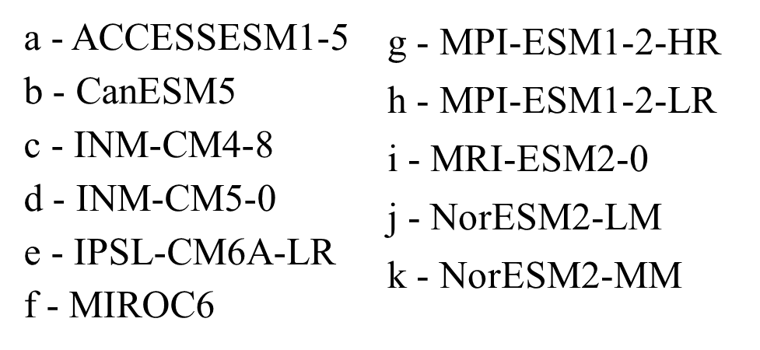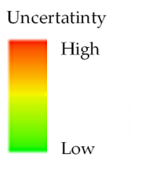
Figure S8: Evaluation of uncertainty in future extreme runoff for eleven GCMs and eleven HM parameters using JS-D

