Supporting Information
Self-supplying Cu²⁺ and oxidative stress synergistically enhanced disulfiram-mediated melanoma chemotherapy

Yingqian Gao^{1,2}, Xiaojun Cai³, Weijuan Zou³, Xiuzhen Tang³, Lixian Jiang³, Junnian Hao³, Yuanyi Zheng³, Xinhua Ye^{1*}, Tao Ying^{3*}, Ao Li^{1*}

*Correspondence: cqh2liao@163.com; yexh-0125@163.com; yingtaomail@yeah.net
1. Department of Ultrasound in Medicine, The First Affiliated Hospital of Nanjing Medical University, Nanjing 210029, P .R. China.
2. Department of Ultrasound in Medicine, The Affiliated Drum Tower Hospital of Nanjing University Medical School, Nanjing 210029, P .R. China.
3. Department of Ultrasound in Medicine, Shanghai Sixth People's Hospital Affiliated to Shanghai Jiao Tong University School of Medicine, Shanghai 200233, P .R. China.

Figure S1. (a) UV−vis absorption spectrum of CPNDs. (b) Survey XPS spectra of CPNDs.

Figure S2. Mechanism of DSF/Cu²⁺ reactions.

Figure S3. UV−vis absorption spectrum of CuET.

Figure S4. Digital photograph of the reaction between DDTC and CPNDs at different pH values.

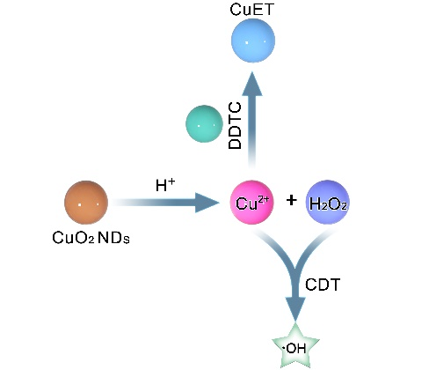
Figure S5. Scheme of the reaction between DDTC and CPNDs.

Figure S6. Digital photograph of the decomposition of CuET under oxidation condition.

Figure S7. (a) CCK-8 assay of DDTC and DDTC combined CPNDs. (b) CCK-8 assay of CPNDs.

Figure S8. live-dead cell staining iamges, scale bar is 100 μm.

Figure S9. Flow cytometry analysis of A375 cells after different treatments.

Figure S10. H&E staining of major organs (heart, liver, spleen, lung, and kidney) after different treatments, scale bar is 100μm.

