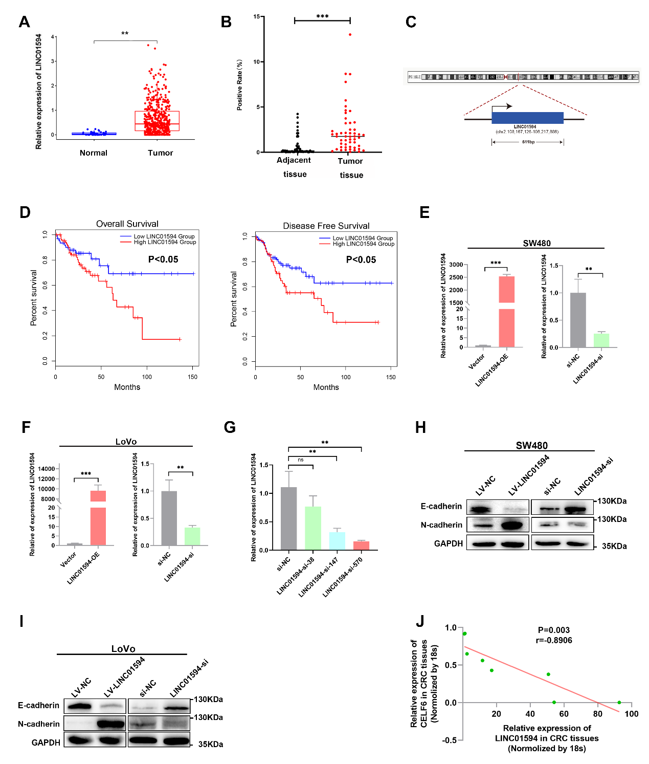
Figure S1. A, LINC01594 expression in TCGA CRC RNA-seq dataset (P<0.05). B, FISH was used to determine the expression of LINC01594 in CRC TMAs and statistical data are shown,* p<0.05, **p<0.01. C, Data from NCBI showed the characteristic of LINC01594 genomic locus and full length. D, Kaplan-Meier overall survival and disease-free survival curves of LINC01594 in TCGA database (p<0.05). E-F, Overexpression and knockdown efficiency of LINC01594 were detected by qPCR in SW480 cells and LoVo cells. G, QRT-PCR was used to detect three siRNAs, si-LINC01594-38, si-LINC01594-147, si-LINC01594-570, and the knockdown efficiency of si-LINC01594-570 was much higher than si-LINC01594-38 and si-LINC01594-147. Data are presented as the mean ± SD. *P < 0.05, **P < 0.01, ***P < 0.001. H-I, Western blot showed that LINC01594 promote epithelial–mesenchymal transition (EMT). J, qRT-PCR was used to detect CELF6 and LINC01594 co-expression in CRC tissues, and correlation analysis confirmed that LINC01594 negatively associated with CELF6.
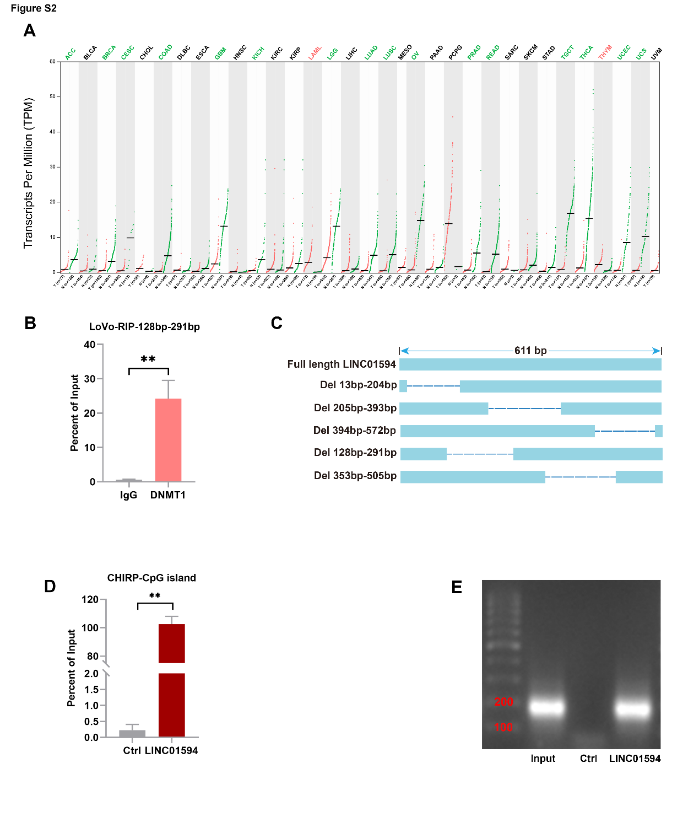
Figure S2. A, CELF6 was significantly downregulated in multiple tumors. B, RIP-qPCR verified that LINC01594 binds with DNMT1 in the 128-291 bp region in both LoVo cells. C, LINC01594 truncations were designed that deleted 13-204 bp; 205-393 bp; 394-572 bp; 128-291 bp; 253-505 bp. D-E, DNA enrichment in ChIRP experiments with control and LINC01594 probes determined by qPCR and calculated as percentage of Input with the indicated primer sets. Student’s t-test p-values are summarized as follows: *p < 0.05; ** p< 0.01; *** p< 0.001.

Figure S3. A, Biotinylated LINC01594 with deletions were used in RNA-pulldown assay.
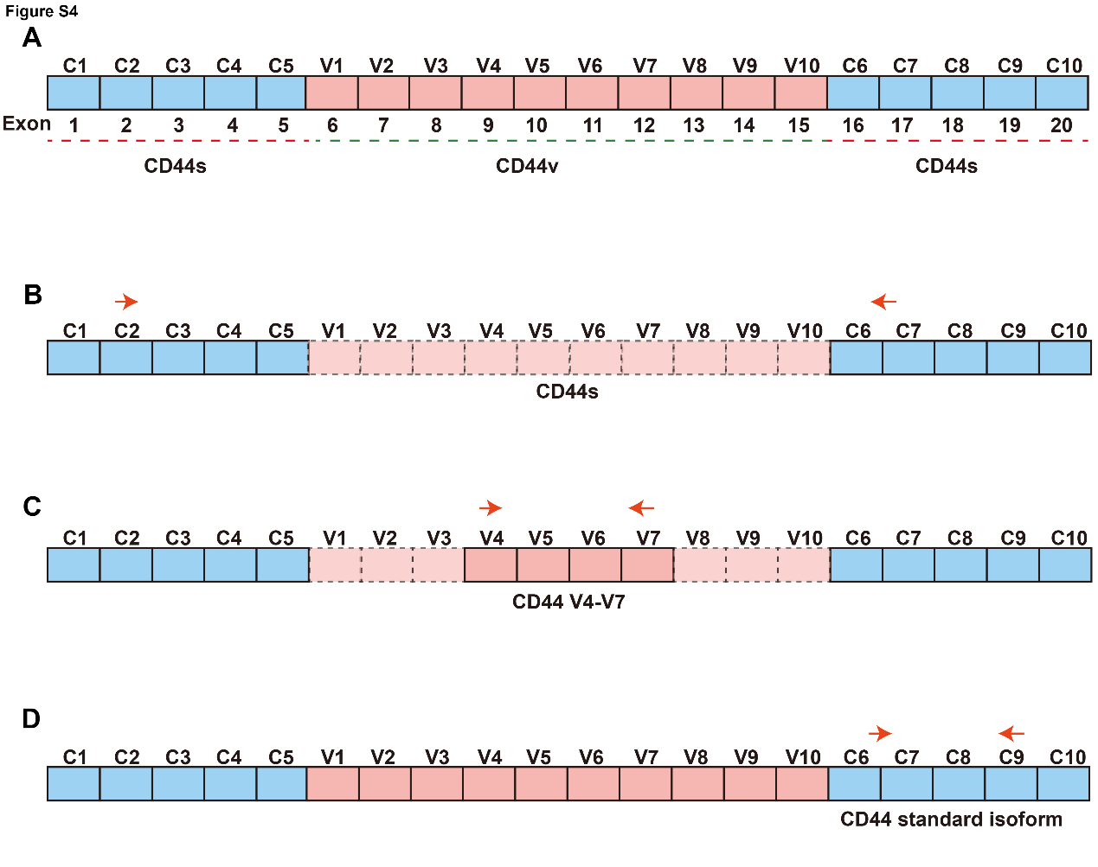
Figure S4. A, CD44 full length isoform was showed. B, To determine the CD44s the forward primer was designed on exon 2 and reverse on exon 15 and exon 16 of CD44 mRNA, the CD44s was 690 bp. C, The forward primers of CD44 V4-V7 was designed on variant exon 4 and reverse primers was designed on variant exon 7. C, The CD44 standard isoform primers was designed to detect exon 15 to exon 18.

