Supplementary information

FGF10 Protects aganist Myocardial Ischemia/Reperfusion Injury
through AMPK/mTOR/TFEB Pathway
Yu Zhu^{1*}, Zhicheng Hu^{2*}, Gen Chen³, Zhenyu Hu², Junjie Zhu², Hongfang Ma¹, Shengqu He²,
Xiejun Xu², Zhiyuan Huang², Yonggan Dong², Xueqiang Guan^{4#},Xu Wang^{2#} and Yang Wang^{1#}
Author names and institutional affiliations
¹Department of Histology and Embryology, Institute of Neuroscience, Wenzhou Medical University, Wenzhou, P.R. China.
²School of Pharmaceutical Science, Wenzhou Medical University, Wenzhou, P.R. China.
³Department of Physiology and Pharmacology, School of Medicine, Ningbo University, Ningbo, 315211, P.R. China.
⁴Department of Cardiology, The Second Affiliated Hospital and Yuying Children's Hospital of Wenzhou Medical University, Wenzhou, P.R. China.
*These authors contributed equally.
#Address correspondence to:
Xueqiang Guan, Department of Cardiology, The Second Affiliated Hospital and Yuying Children's Hospital of Wenzhou Medical University, Wenzhou 325027, P.R. China. Email: wzsgxq@163.com
Xu Wang, School of Pharmaceutical Science, Wenzhou Medical University, Wenzhou, 325000, P.R. China. Detailed address: Wenzhou Medical University, Center North Road, Wenzhou, Zhejiang 325035, P.R. China. Tel./fax: +86 577 86699790; e-mail: wang_xu2003@163.com
Yang Wang, Department of Histology and Embryology, Institute of Neuroscience, Wenzhou Medical University, Wenzhou 325000, P.R. China. Email: yw1867@126.com
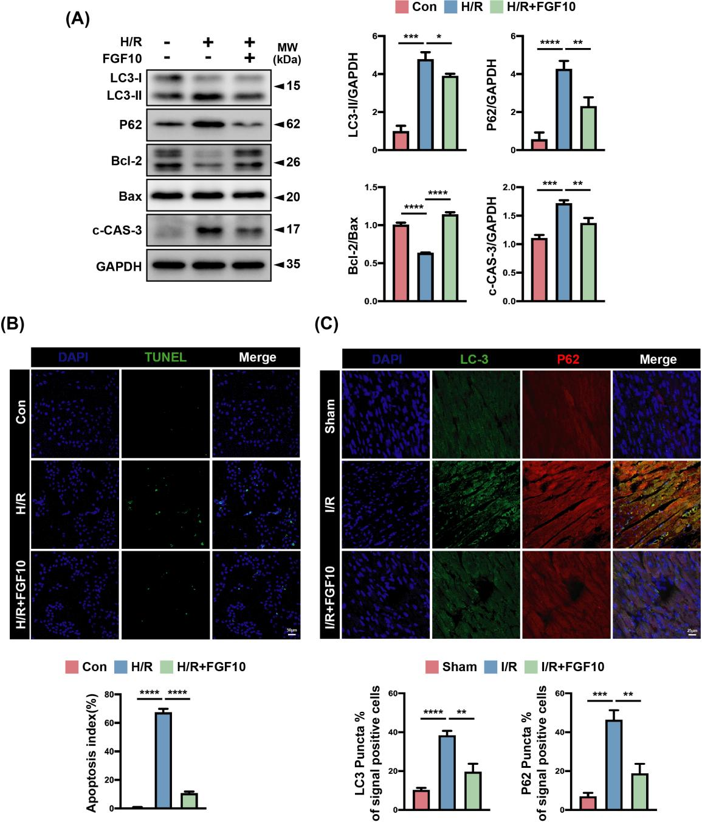
Supplementary Figure 1. FGF10 ameliorates apoptosis of cardiomyocytes and autophagosome accumulation in vitro.
- Western blot and quantitative analysis were performed to determine the protein levels of LC3-I/II, P62, Bcl-2, Bax and c-CAS-3 in the NRCMs of different group mice. n =3-4 per group. (B) Representative immunofluorescence (green for TUNEL, blue for DAPI) and quantitative analysis the number of TUNEL positive cardiomyocytes in different group. Scale bar =50 μm. n =3 per group. (C) Representative immunofluorescence (green for LC-3, red for P62, blue for DAPI) and quantitative analysis the number of LC-3 and P62 positive cardiomyocytes in different group mice heart sections. Scale bar =25 μm. n =3 per group. Data represent means ± SEM, Two-tailed student’s t test. * P<0.05, ** P<0.01, *** P<0.001, **** P<0.0001.
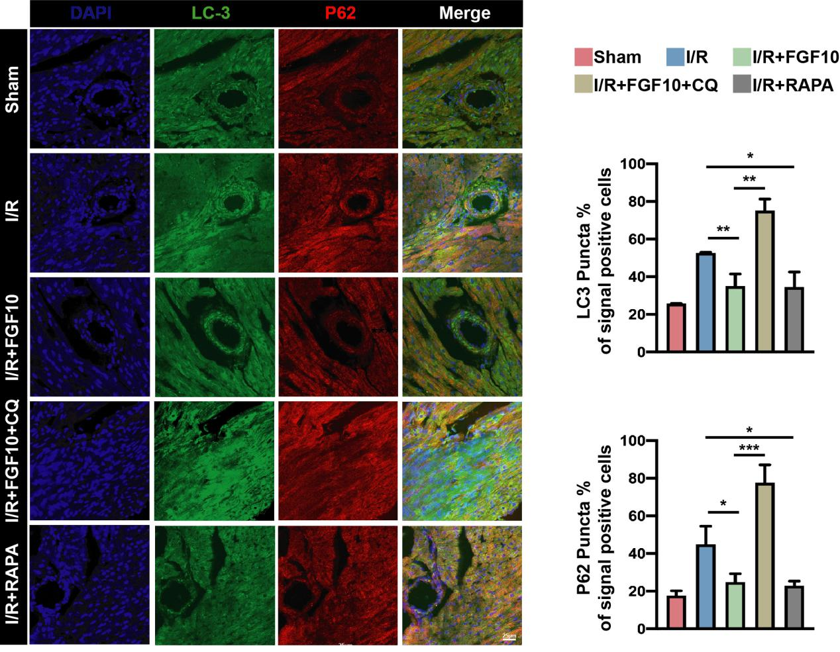
Supplementary Figure 2. The protective effect of FGF10 is related to the regulation of autophagic flux.
Representative immunofluorescence (green for LC-3, red for P62, blue for DAPI) and quantitative analysis the number of LC-3 and P62 positive cardiomyocytes in different group mice heart sections. Scale bar =25 μm. n =3 per group. Data represent means ± SEM, Two-tailed student’s t test. * P<0.05, ** P<0.01, *** P<0.001.
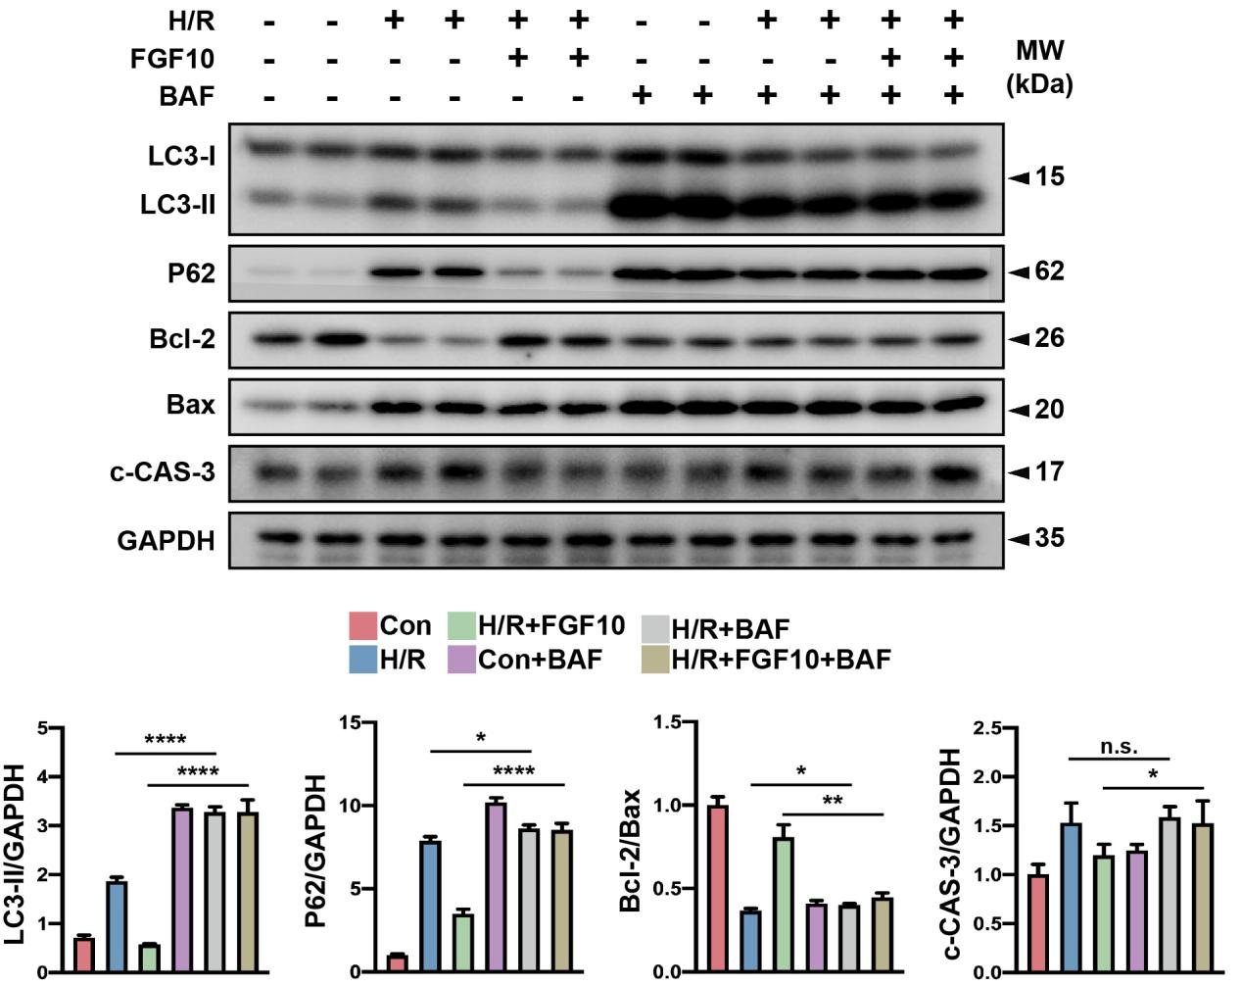
Supplementary Figure 3. FGF10 prevents H/R-induced apoptosis by facilitating autophagosome clearance in vitro.
Western blot and quantitative analysis were performed to determine the protein levels of LC3-I/II, P62, Bcl-2, Bax and c-CAS-3 in the NRCMs from control, H/R and H/R+FGF10 with or without bafilomycin A1 treatment. n =3-4 per group. Data represent means ± SEM, Two-tailed student’s t test. * P<0.05, ** P<0.01, *** P<0.001, **** P<0.0001. N.S.: non-significant.
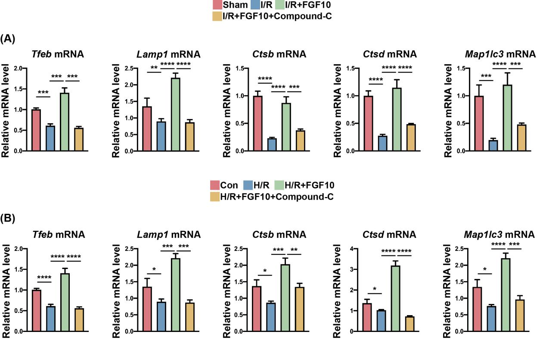
Supplementary Figure 4. FGF10 promotes the autophagy fusion related genes expression.
(A) q-PCR analysis of mRNA levels for TFEB-regulated autophagy- and lysosome-related genes in the heart from I/R+FGF10 groups with or without Compound-C treatment. n =4 per group. (B) q-PCR analysis of mRNA levels for TFEB-regulated autophagy- and lysosome-related genes in the NRCMs from H/R+FGF10 groups with or without Compound-C treatment. n =3-5 per group. Data represent means ± SEM, Two-tailed student’s t test. * P<0.05, ** P<0.01, *** P<0.001, **** P<0.0001.
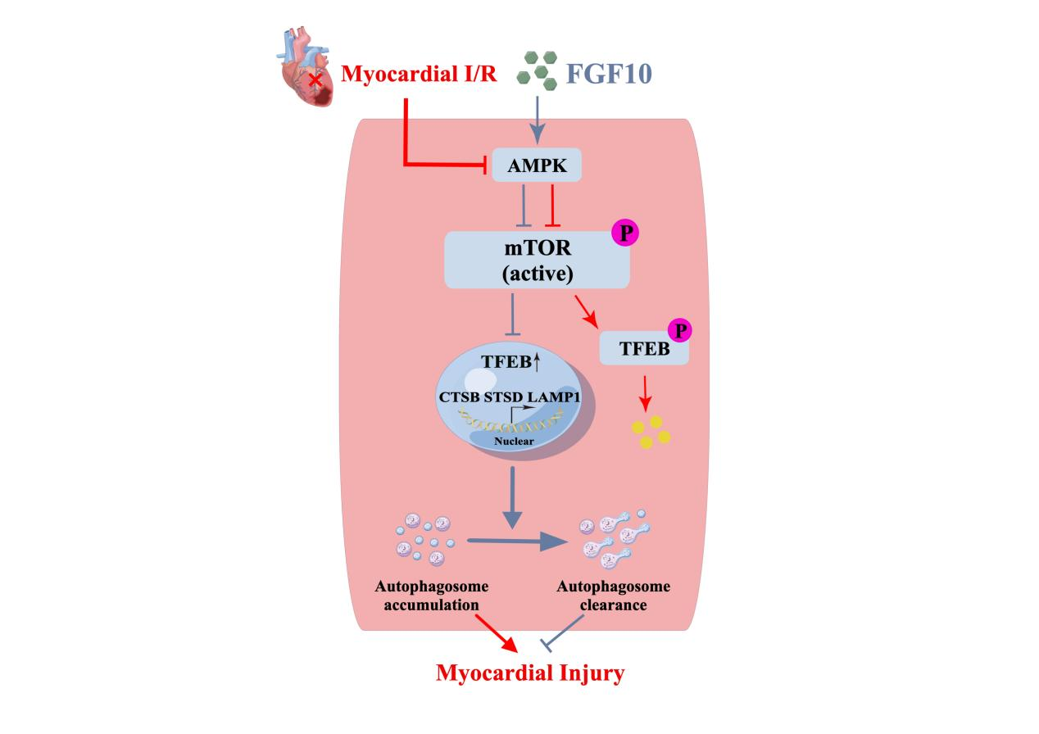
Supplementary Figure 5. Schematic illustration of the protective effects of FGF10 on cardiomyocytes under ischemic and reperfusion conditions. Myocardial I/R would cause autophagosome accumulation and the loss of a huge number of cardiomyocytes. In this study, we revealed that FGF10 promotes autophagosome clearance via AMPK/mTOR/TFEB pathway then decreases myocardial injury.

Supplementary Table 1. Detailed primers used in the RT-PCR.
Primer | Forward | Reverse
Fgf10 (Rat) | 5'- GATACTGACACATTGTGCCTCAG -3' | 5'- CGGCAACAACTCCGATTTCC -3'
Ctsb (Rat) | 5'- GTGGTATCCAGTGTGGGGATG -3' | 5'- GGGATGGTGTAGGGTAAGCAG -3'
Ctsd (Rat) | 5'- GTGTAAACCGAGCCCTGATGACTT -3' | 5'- CAGCAGCAGGGAGGGGGCAGCACT -3'
Tfeb (Rat) | 5'- GGTGCAGTCCTACCTGGAGA -3' | 5'- GTGGGCAGCAAACTTGTTCC -3'
Lamp1 (Rat) | 5'- GGACAACACGACGGTGACAAG -3' | 5'- GAACTTGCATTCATCCCGAACTGGA -3'
Map1lc3 (Rat) | 5'- CGTCCTGGACAAGACCAAGT -3' | 5'- CTCGTCTTTCTCCTGCTCGT -3'
Gapdh (Rat) | 5'- ATCACTGCCACTCAGAAG -3' | 5'- AAGTCACAGGAGACAACC -3'
Fgf10 (Mouse) | 5'- TCAGCGGGACCAAGAATGAAG -3' | 5'- CGGCAACAACTCCGATTTCC -3'
Ctsb (Mouse) | 5'- ACCAATTCTCCCTCTGCTTGA -3' | 5'- CTGAGGGTGACAGGAAACCAG -3'
Ctsd (Mouse) | 5'- CTACCTGAACGTCACTCGAAAG -3' | 5'- CAGTGGAGAAGGAGCAAGTTAG -3'
Tfeb (Mouse) | 5'- GCGGCAGAAGAAAGACAATC -3' | 5'- CTGCATCCTCCGGATGTAAT -3'
Lamp1 (Mouse) | 5'- GATACAGTGGGGTTTGTGGG -3' | 5'- CTGTCGAGTGGCAACTTCAG -3'
Map1lc3 (Mouse) | 5'- GCTCATCAAGATAATCAGACG -3' | 5'- GCATAAACCATGTACAGGAAG -3'
Gapdh (Mouse) | 5'- AGGTCGGTGTGAACGGATTTG -3' | 5'- TGTAGACCATGTAGTTGAGGTCA -3'

