Supplementary information for

The pathogenesis of common Gjb2 mutations associated with human hereditary deafness in mice

Qing Li^{1,8,*} · Chong Cui^{2,3,4,8} · Rongyu Liao¹ · Xidi Yin¹ · Bowei Huang^{2,3,4} · Yanbo Cheng⁵ · Daqi Wang^{2,3,4} · Liqin Wang^{2,4} · Meng Yan⁶ · Jinan Zhou^{2,3,4} · Jingjing Zhao^{2,4} · Wei Tang¹ · Yingyi Wang⁵ · Xiaohan Wang⁷ · Jun Lv^{2,3,4} · Jinsong Li^{1,5,6} · Huawei Li^{2,3,4,*} and Yilai Shu^{2,3,4,*}

¹State Key Laboratory of Cell Biology, Shanghai Key Laboratory of Molecular Andrology, Shanghai Institute of Biochemistry and Cell Biology, Center for Excellence in Molecular Cell Science, Chinese Academy of Sciences, University of Chinese Academy of Sciences, Shanghai, China.
²ENT institute and Department of Otorhinolaryngology, Eye & ENT Hospital, State Key Laboratory of Medical Neurobiology and MOE Frontiers Center for Brain Science, Fudan University, Shanghai, China.
³Institutes of Biomedical Sciences, Fudan University, Shanghai, China.
⁴NHC Key Laboratory of Hearing Medicine, Fudan University, Shanghai, China.
⁵School of Life Science and Technology, Shanghai Tech University, Shanghai, China.
⁶School of Life Science, Hangzhou Institute for Advanced Study, University of Chinese Academy of Sciences, Hangzhou, China.
⁷Renerval Biotherapeutics, Jiangsu, China.
⁸Q. Li, and C. Cui, contributed equally to this work.
*Corresponding authors: Yilai Shu: yilai_shu@fudan.edu.cn.; Huawei Li: hwli@shmu.edu.cn; Qing Li: liqing2015@sibcb.ac.cn.
This PDF file includes:
Figures. S1 to S8
Tables. S1 to S2
Legends for Supplemental Material
Supplementary Figures

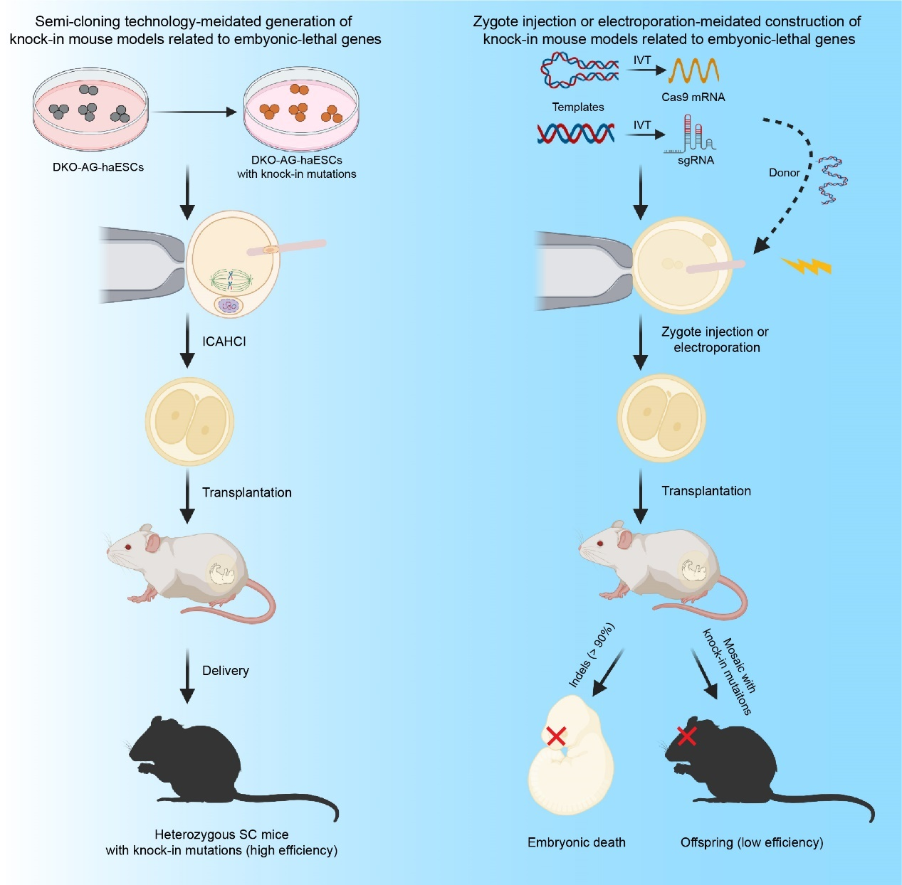
Figure S1. Comparison of semi-cloning technology and zygote injection/electroporation-mediated construction of knock-in mouse models of embryonic-lethal genes (created in BioRender.com).

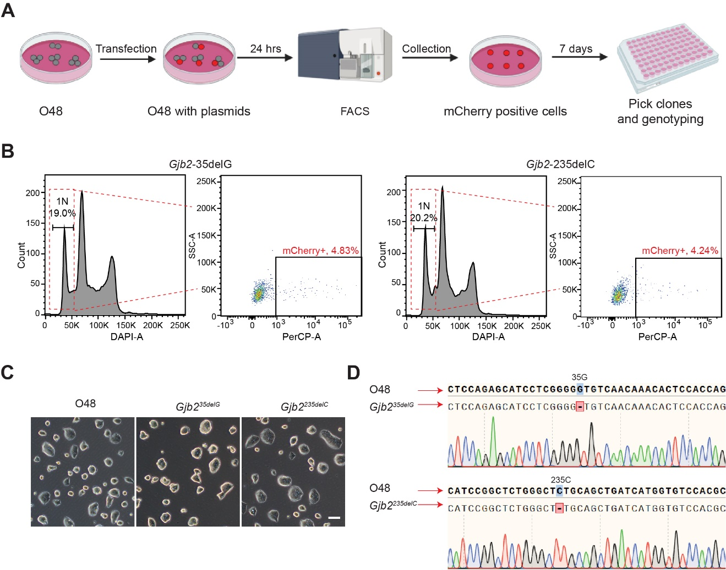
Figure S2. Generation of DKO-AG-haESCs carrying 35delG and 235delC in Gjb2. (A) Experimental procedures for generating DKO-AG-haESCs carrying 35delG and 235delC in Gjb2 via CRISPR-Cas9 technology. (B) O48 cells with haploid genome and highly expressed mCherry were enriched through FACS after transfection, followed by single-cell expansion to obtain Gjb2^{35deG} and Gjb2^{235delC} cell clones. (C) Images of cultured O48, Gjb2^{35deG}, and Gjb2^{235delC} haploid ESCs. Scale bar, 100 μm. (D) Representative Sanger sequencing results of Gjb2^{35deG} and Gjb2^{235delC} haploid ESCs.

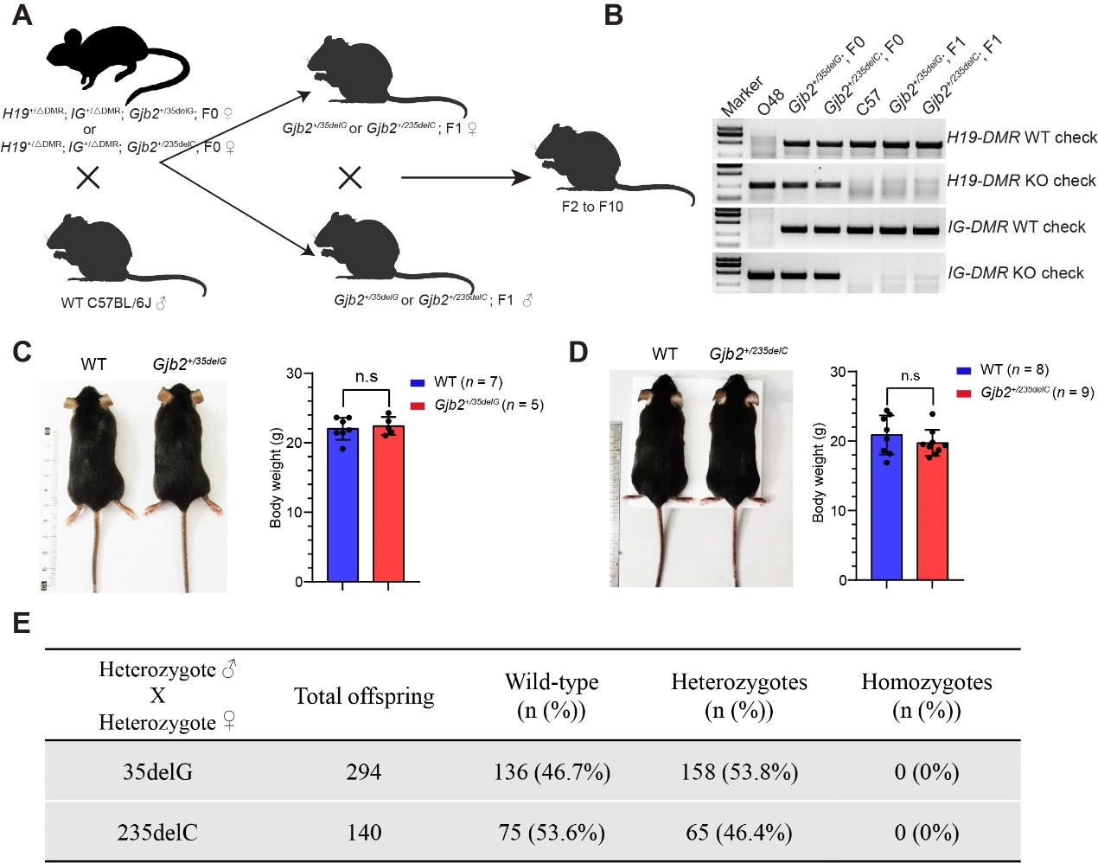
Figure S3. 35delG and 235delC heterozygous mice showed normal growth but homozygous lethality. (A) Schematic diagram of backcrossing of Gjb2^{+/35deG} and Gjb2^{+/235delC} F0 mice with C57BL/6J mice to generate the F2 to F10 mice. (B) Genotyping of H19-DMR and IG-DMR in the offspring of Gjb2^{+/35deG} and Gjb2^{+/235delC} mice. Mice with H19-DMR or IG-DMR deletion were abandoned in the F2 generation. (C) Representative images (left) and body weight (right) of wild-type and Gjb2^{+/35delG} males at 8 weeks of age. (D) Representative images (left) and body weight (right) of wild-type and Gjb2^{+/235delC} males at 8 weeks of age. Data are the mean ± s.e.m of the indicated biological replicates in (C) and (D). n.s, no significance. (E) Summary of the genotypes of offspring of 35delG and 235delC heterozygotes. The absence of homozygotes indicated the homozygous lethality of Gjb2^{35delG/35delG} and Gjb2^{235delC/235delC}.
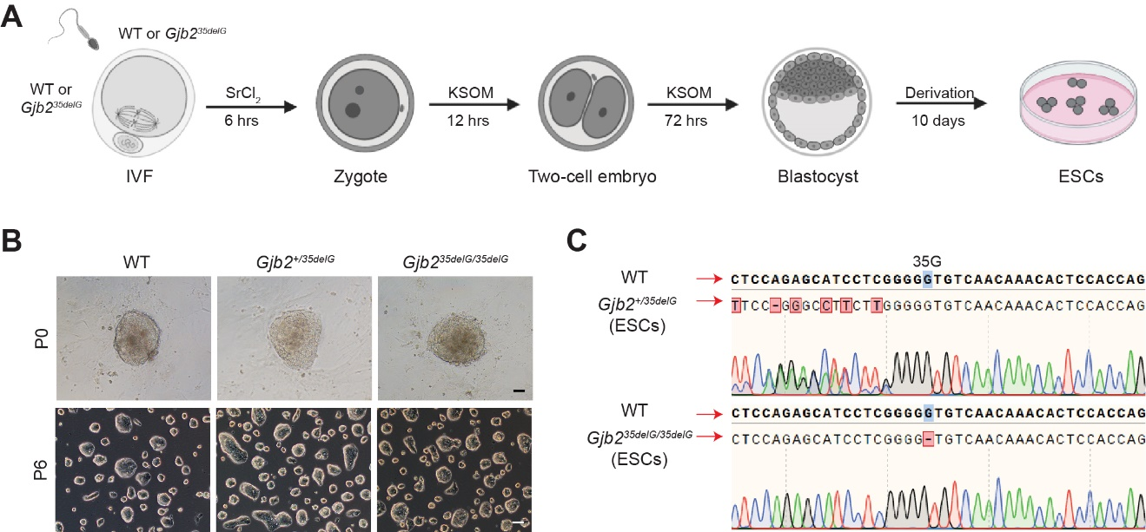
Figure S4. The derivation of the ESC line carrying homozygous 35delG in Gjb2. (A) Schematic diagram of the generation of Gjb2 35delG homozygous ESCs from blastocysts (created in BioRender.com). (B) Cell morphology of cultured wild-type, Gjb2^{+/35delG}, and Gjb2^{35delG /35delG} ESCs at passage 0 (P0) and P6. Scale bar, 100 μm. (C) Representative Sanger sequencing results of Gjb2^{+/35deG} and Gjb2^{35delG /35delG} ESCs.

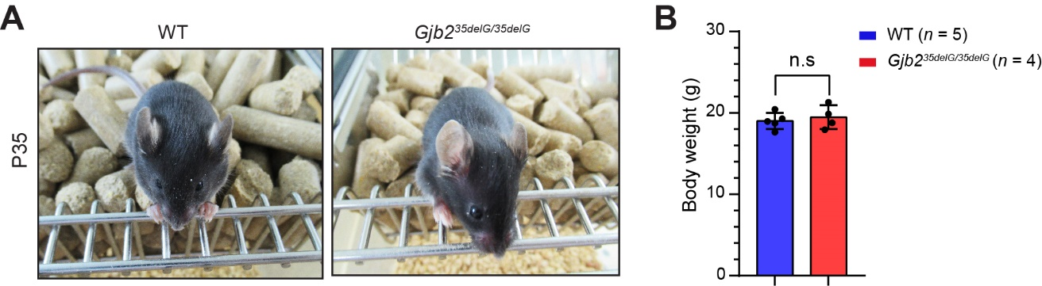
Figure S5. 35delG homozygous mice showed normal growth at P35. (A) Representative images of wild-type and Gjb2^{35delG/35delG} males at P35. (B) The body weight of wild-type and Gjb2^{35delG/35delG} males at P35, indicating that the inactivation of Gjb2 did not influence individual growth. Data are the mean ± s.e.m of the indicated biological replicates. n.s, no significance.

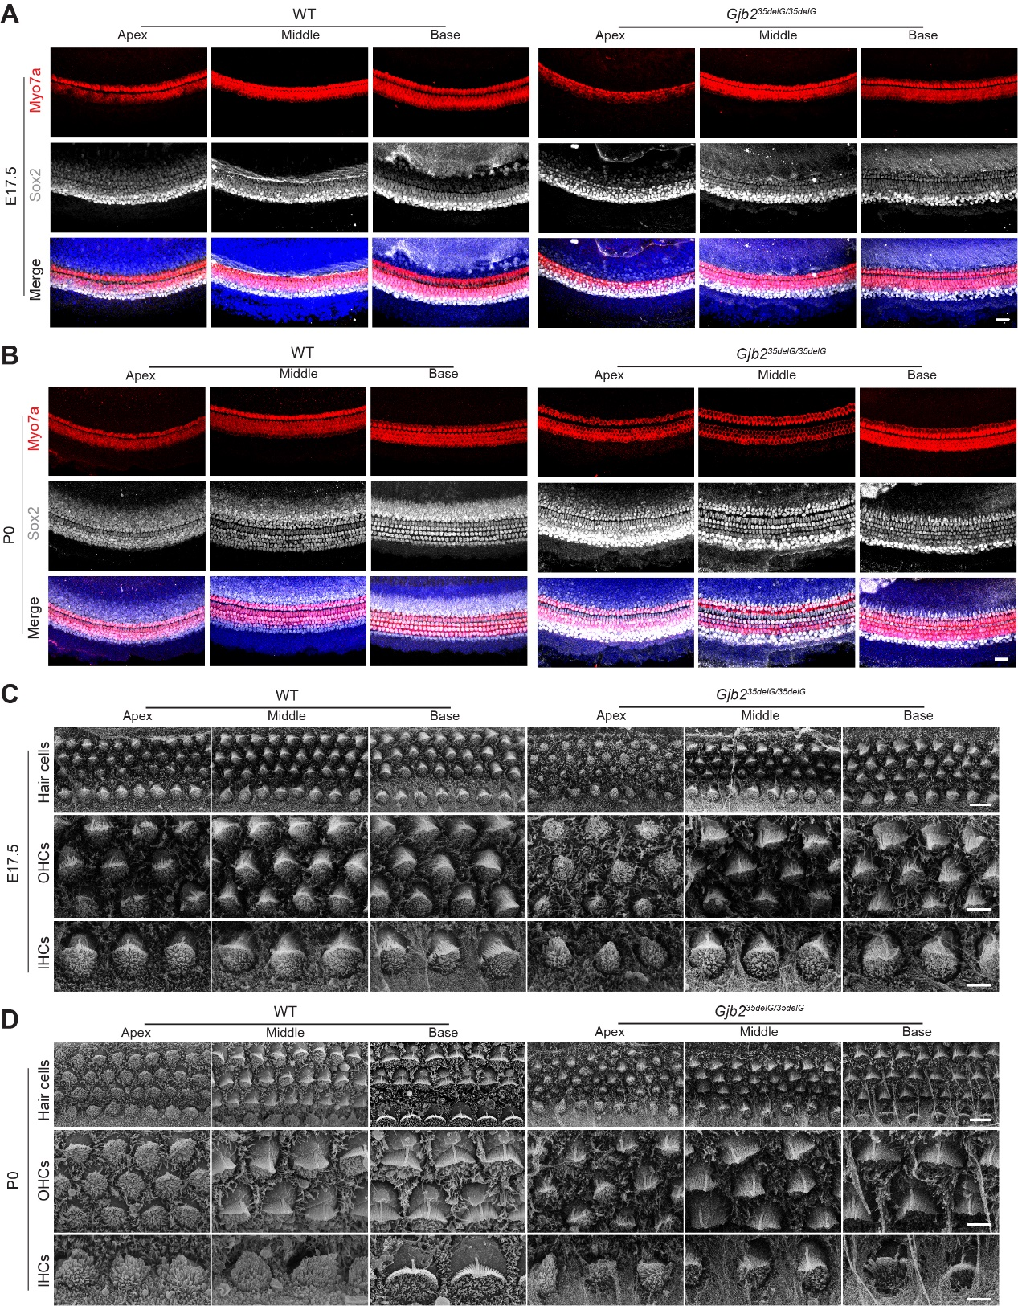
Figure S6. Gjb2 is dispensable for the development of hair cells and supporting cells in the cochlea at prenatal stages. (A and B) Representative confocal microscopy images of Myo7a and Sox2 immunofluorescence in the apical, middle, and basal turns of the cochleae from wild-type and Gjb2^{35delG/35delG} mice at E17.5 (A) and P0 (B). Three independent mice were analyzed in each group. Scale bar, 20 μm. (C and D) Representative SEM images of hair cell stereocilia morphology in the apical, middle, and basal turns of the cochleae from wild-type and Gjb2^{35delG/35delG} mice at E17.5 (C) and P0 (D). Low magnification: hair cells in the upper panel. Scale bar, 50 μm. High magnification: IHCs in the middle panel and OHCs in the bottom panel. Scale bar, 25 μm. Three independent mice were analyzed in each group.

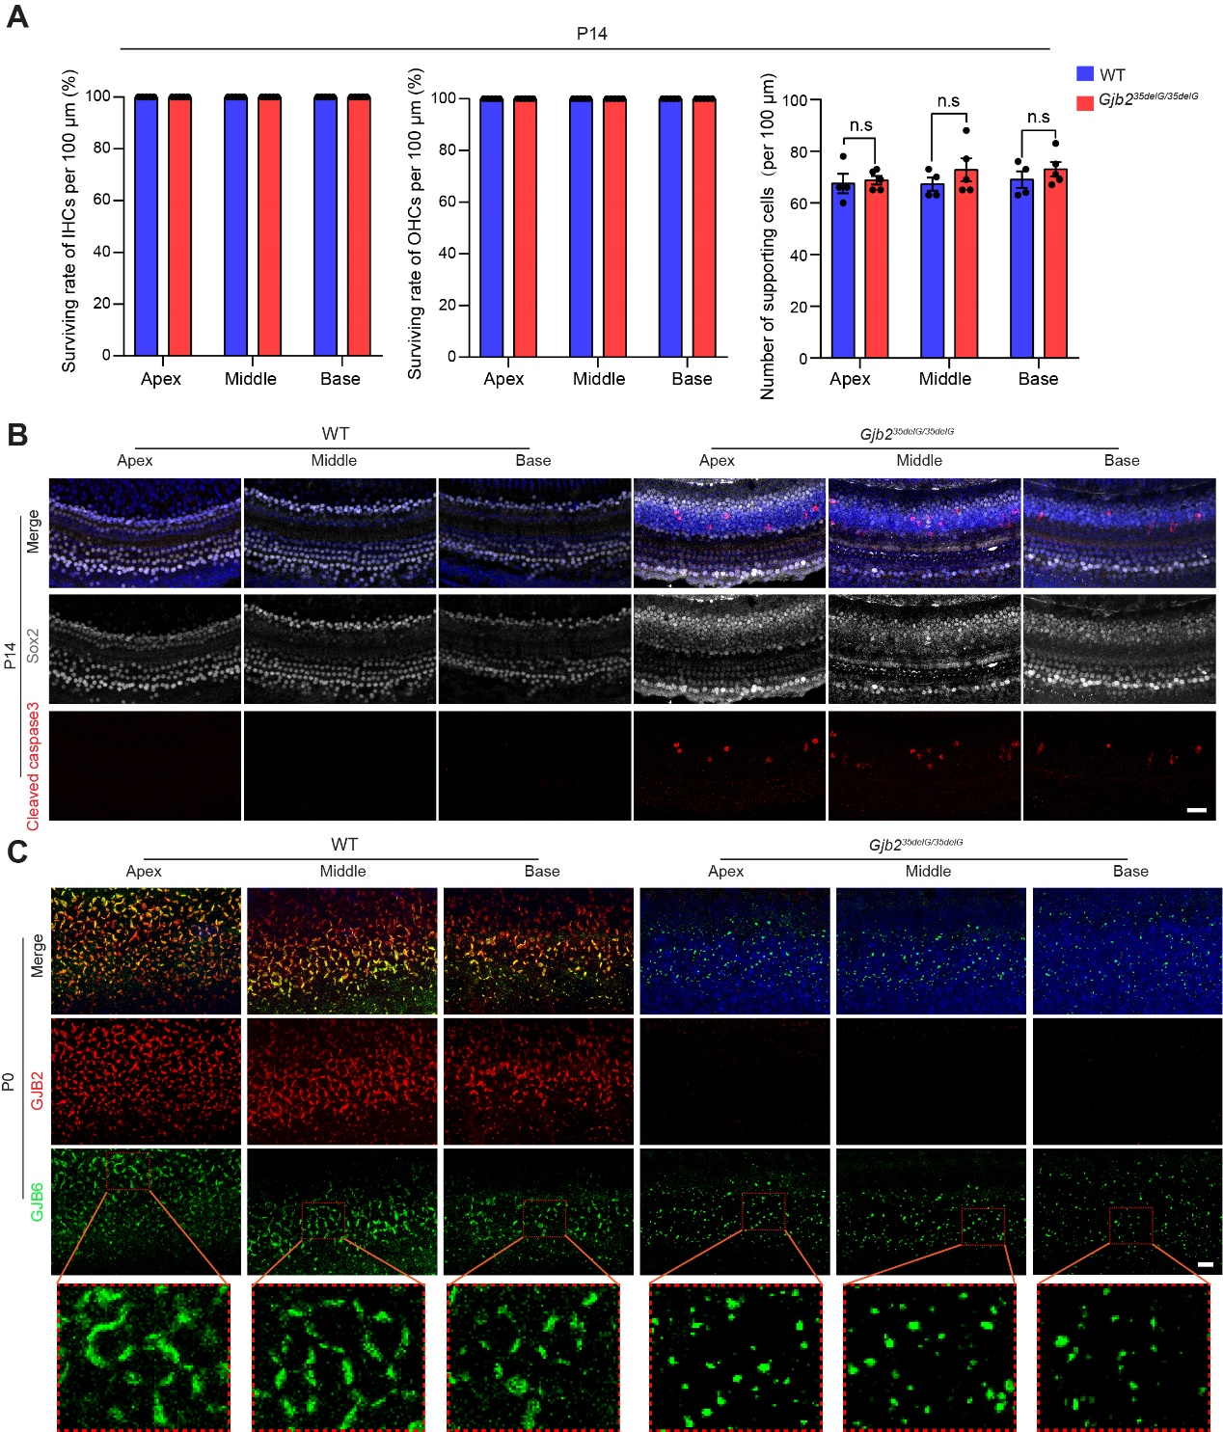
Figure S7. The influence of GJB2 on hair cells and supporting cells. (A) Quantification of surviving inner hair cells (IHCs), outer hair cells (OHCs), and supporting cells (SCs) in the wild-type and Gjb2^{35delG/35delG} mice at P14, respectively. Data are shown as the mean ± s.e.m of the indicated biological replicates. n.s., no significance by Student’s unpaired two-sided t-test. (B) The representative confocal microscopy images of Caspase-3 immunofluorescence in the apical, middle, and basal turns of the cochleae from wild-type and Gjb2^{35delG/35delG} mice at P14. Three independent mice were analyzed for each group. Scale bar, 20 μm. (C) Representative confocal microscopy images of GJB2 (connexin26, Cx26) and GJB6 (connexin30, Cx30) immunofluorescence in the apical, middle, and basal turns of the cochleae from wild-type and Gjb2^{35delG/35delG} mice at P0. Three independent mice were analyzed for each group. Scale bar, 20 μm.

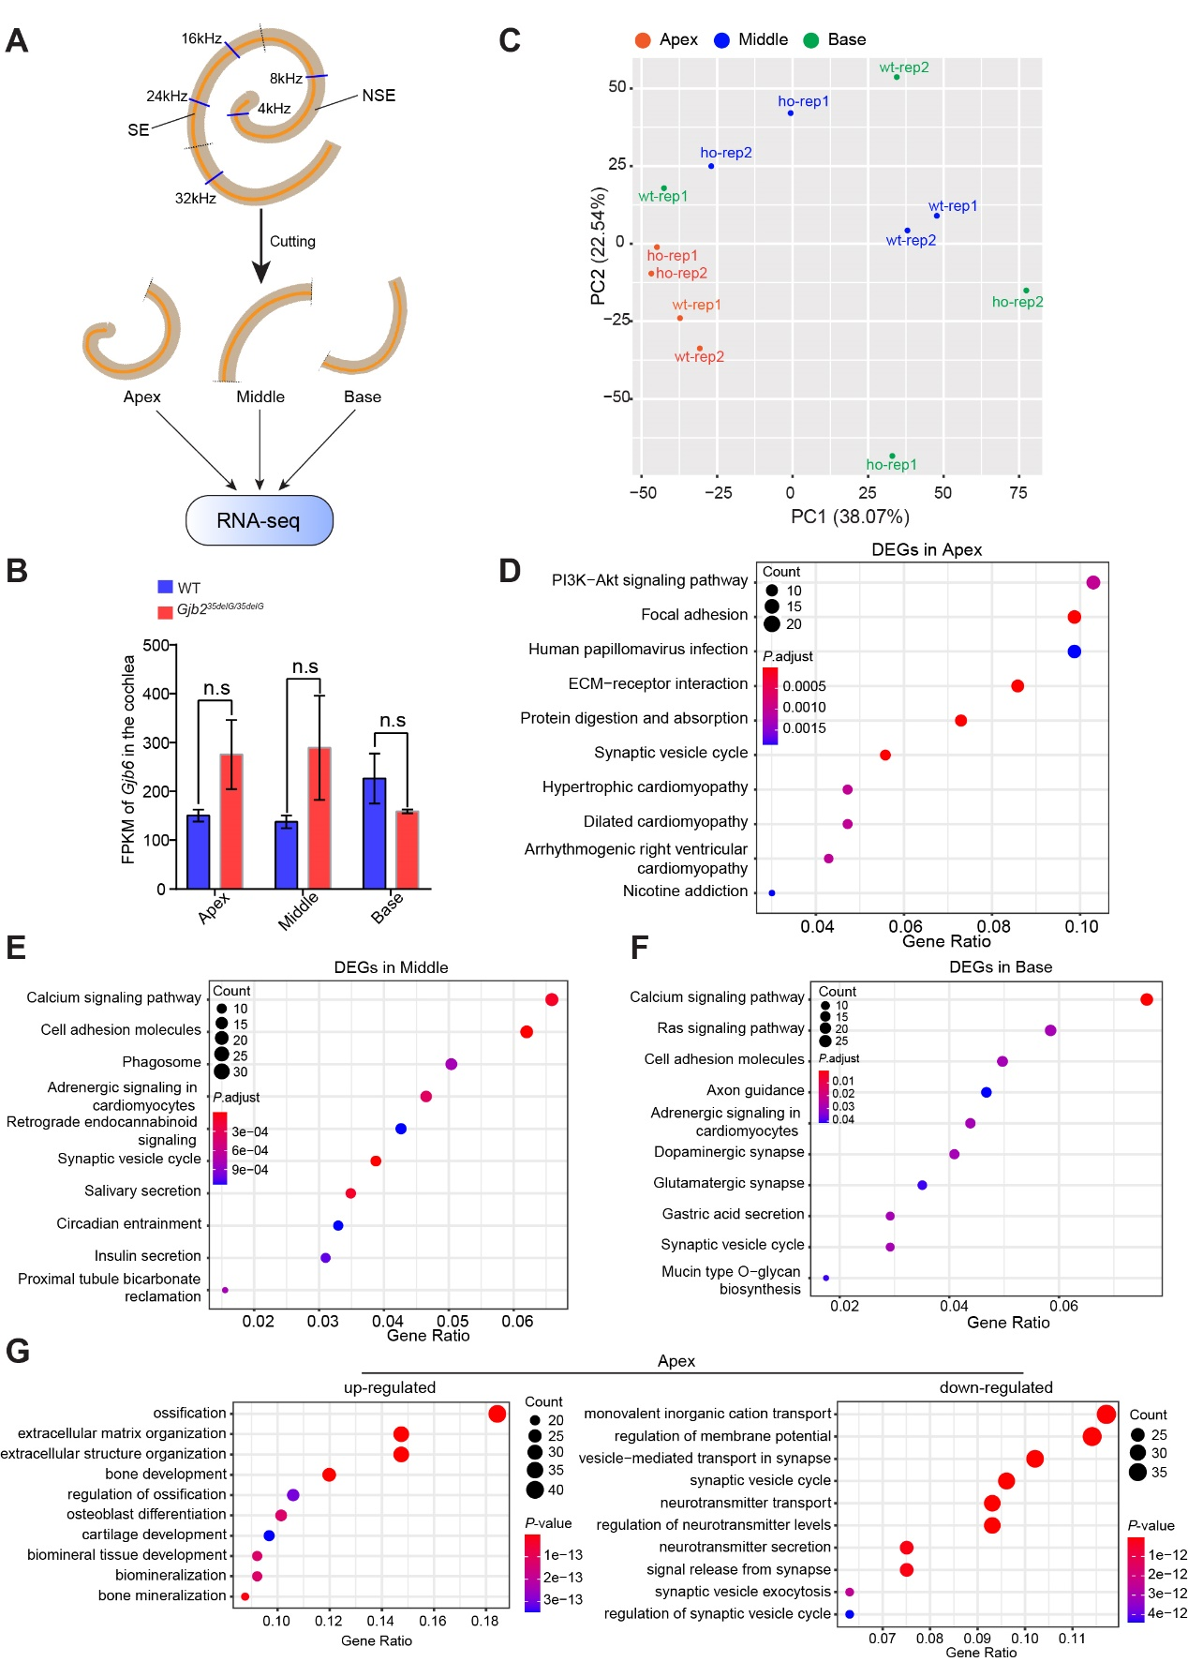
Figure S8. RNA sequencing and analysis of cochleae at P14. (A) Schematic diagram of the isolation and RNA-seq of cochleae from wild-type and Gjb2^{35deG /35deG} mice at P14. Cochleae were divided into three equal sections referred to as the apical, middle, and basal turns according to the sensitivity of different sound frequencies. SE, sensory epithelium; NSE, non-sensory epithelium. (B) FPKM of Gjb6 in the different turns of the cochlea as revealed by RNA-seq, n = 2. (C) The principal component analysis of RNA-seq data from wild-type and Gjb2^{35delG/35delG} cochleae, including the apical, middle, and basal turns. Two biological repeats for each group. (D-F) The Kyoto Encyclopedia of Genes and Genomes (KEGG) pathway analysis of DEGs between wild-type and Gjb2^{35delG/35delG} cochleae in the apical turn (D), middle turn (E), and basal turn (F). (G) GO analysis of up-regulated and down-regulated genes between wild-type and Gjb2^{35delG/35delG} in the apical turn.

ES cell lines | No. of injected embryos transferred (mixed wild-type 2N embryos) | No. of recipient mice | No. total born (%) | No. pups alive at term (% transferred embryos) | No. pups surviving more than 2-weeks (35delG homozygotes)
Gjb2^{35delG/35delG}-2 P6 | 90 | 3 | 7 (7.8) | 4 (4.4) | 0 (0)
Gjb2^{35delG/35delG}-3 P5 | 96 | 4 | 9 (9.4) | 8 (8.3) | 2 (2)
Gjb2^{35delG/35delG}-3 P6 | 60 | 2 | 9 (15) | 8 (13.3) | 0 (0)
Gjb2^{35delG/35delG}-3 P6 | 88 | 4 | 11 (12.5) | 9 (10.2) | 1 (1)
Gjb2^{35delG/35delG}-3 P6 | 22 | 1 | 4 (18.2) | 4 (18.2) | 2 (2)
Gjb2^{35delG/35delG}-3 P6 | 92 | 4 | 9 (9.8) | 5 (5.4) | 0 (0)
Gjb2^{35delG/35delG}-3 P7 | 88 | 4 | 12 (13.6) | 9 (10.2) | 0 (0)
Gjb2^{35delG/35delG}-3 P7 | 88 | 4 | 6 (6.9) | 2 (2.3) | 0 (0)
Gjb2^{35delG/35delG}-3 P8 | 80 | 4 | 8 (10) | 6 (7.5) | 0 (0)
Gjb2^{35delG/35delG}-3 P8 | 105 | 5 | 8 (7.6) | 4 (3.8) | 1 (1)
Gjb2^{35delG/35delG}-3 P6 | 66 | 3 | 5 (4.5) | 1 (1.5) | 1 (1)
Gjb2^{35delG/35delG}-3 P7 | 132 | 6 | 19 (14.4) | 15 (11.4) | 8 (8)
Gjb2^{35delG/35delG}-3 P8 | 120 | 5 | 10 (8.3) | 7 (5.8) | 1 (1)
Gjb2^{35delG/35delG}-3 P8 | 120 | 5 | 16 (13.3) | 12 (10) | 5 (5)
Gjb2^{35delG/35delG}-3 P9 | 156 | 6 | 26 (16.7) | 22 (14.1) | 4 (4)
Gjb2^{35delG/35delG}-6 P5 | 156 (48)ª | 6 | 27 (17.3) | 26 (16.7) | 20 (1)
Gjb2^{35delG/35delG}-6 P6 | 132 (36)ª | 6 | 24 (18.2) | 24 (18.2) | 22 (0)
Gjb2^{35delG/35delG}-6 P6 | 154 (42)ª | 7 | 23 (14.9) | 23 (14.9) | 18 (0)
ª Transferred tetraploid embryos mixed with some wild-type diploid embryos in each uterus of recipients.
Table S1. Summary of homozygous 35delG mice generation via tetraploid embryo complementation.

Table S2. List of oligo and primer sequence information related to experimental procedures.
Name | Sequence (5’-3’) | Application
Gjb2-35delG-oligoF | CACCAGTGTTTGTTGACACCCCCG | Oligos for construction of pX330-mCherry-35delG and pX330-mCherry-235delC
Gjb2-35delG-oligoR | AAACCGGGGGTGTCAACAAACACT
Gjb2-235delC-oligoF | CACCCTGGGCTCTGCAGCTGATCA
Gjb2-235delC-oligoR | AAACTGATCAGCTGCAGAGCCCAG
Gjb2-35/235-leftF | GCCCTGTTCCTCTCACACAG | Primers for construction o19T-Gjb2-35G and 19T-Gjb2-235C
Gjb2-35-leftR | CTGGTGGAGTGTTTGTTGACACCCCGAGG | Primers for construction o19T-Gjb2-35G and 19T-Gjb2-235C
Gjb2-35-rightF | CCAGAGCATCCTCGGGGTGTCAACAAACACT | Primers for construction o19T-Gjb2-35G and 19T-Gjb2-235C
Gjb2-35/235-rightR | CTCAGTGGCACCTTCCTCAG | Primers for construction o19T-Gjb2-35G and 19T-Gjb2-235C
Gjb2-235-leftR | TGGCGTGGACACCATGATCAGCTGCAAGCCCA | Primers for construction o19T-Gjb2-35G and 19T-Gjb2-235C
Gjb2-235-rightF | TCCGGCTCTGGGCTTGCAGCTGATCATGGTGTC | Primers for construction o19T-Gjb2-35G and 19T-Gjb2-235C
Gjb2-checkF | TGCCCGGGAAGACAGTTAAG | Genotyping
Gjb2-checkR | TTCATGTCTCCGGTAGGCCA | Genotyping
H19-DMR-wt-F | AGATGGGGTCATTCTTTTCC | Genotyping
H19-DMR-wt-R | ATTGCTCTTAGCTTCTGTTG | Genotyping
H19-DMR-del-F | GTGGTTAGTTCTATATGGGG | Genotyping
H19-DMR-del-R | TCTTACAGTCTGGTCTTGGT | Genotyping
IG-DMR-wt-F | TGTATGGTACAAACCGGGTGA | Genotyping
IG-DMR-wt-R | ACTTTTGCTGTGAGGCACTTG | Genotyping
IG-DMR-del-F | TGTGCAGCAGCAAAGCTAAG | Genotyping
IG-DMR-del-R | ATACGATACGGCAACCAACG | Genotyping

Supplemental Material. List of DEGs between wild-type and 35delG homozygous cochleae.

