Supplementary material for

Magnetite nanoparticles modulate microbial nitrate reduction pathways: Implications for nitrogen cycle in ferruginous oceans

Pengcong Wang^{1, 2}, Genming Luo^{1, 2}, Dominic Papineau^{2, 3}, Deng Liu^{2, 4, *}, Hongmei Wang^{2, 4}, Yiliang Li⁵, & Zongmin Zhu^{1, 2, *}

¹ Hubei Key Laboratory of Critical Zone Evolution, School of Earth Sciences, China University of Geosciences, Wuhan 430074, China
² State Key Laboratory of Biogeology and Environmental Geology, China University of Geosciences, Wuhan 430074, China
³ Department of Earth Sciences, London Centre for Nanotechnology, and Centre for Planetary Sciences, University College London, London, UK
⁴ School of Environmental Studies, China University of Geosciences, Wuhan 430078, China
⁵ Department of Earth Sciences, the University of Hong Kong, Hong Kong, China

* Corresponding authors: Zongmin Zhu (zhumin@cug.edu.cn) or Deng Liu (liudeng@cug.edu.cn)

Number of Figures: 3

Figure S1. Fe 2p XPS spectra of CM (a) and HM (b) before and after microbial nitrate reduction.

Figure S2. Linear fitting of Fe(II)/Fe_{Total} ratio (chemical) and the absolute value of Δχ (|Δχ| value) of CM (a) and HM (b).

Figure S3. O 1s XPS spectra of CM (a and b) and HM (c and d) before and after the treatment of strain 2002.

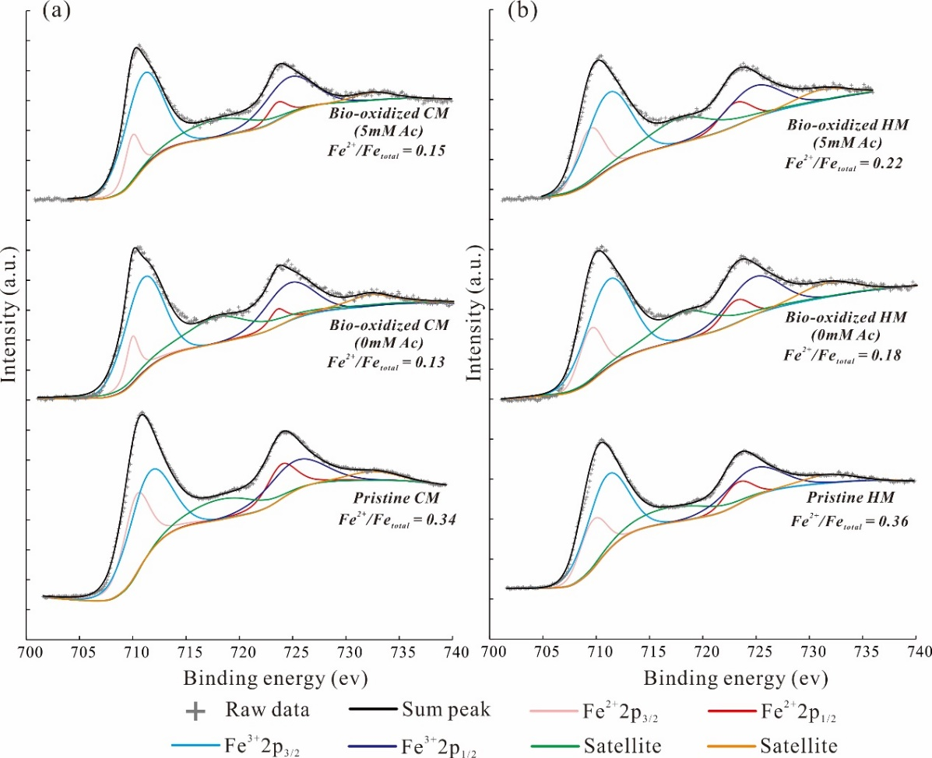
Figure S1

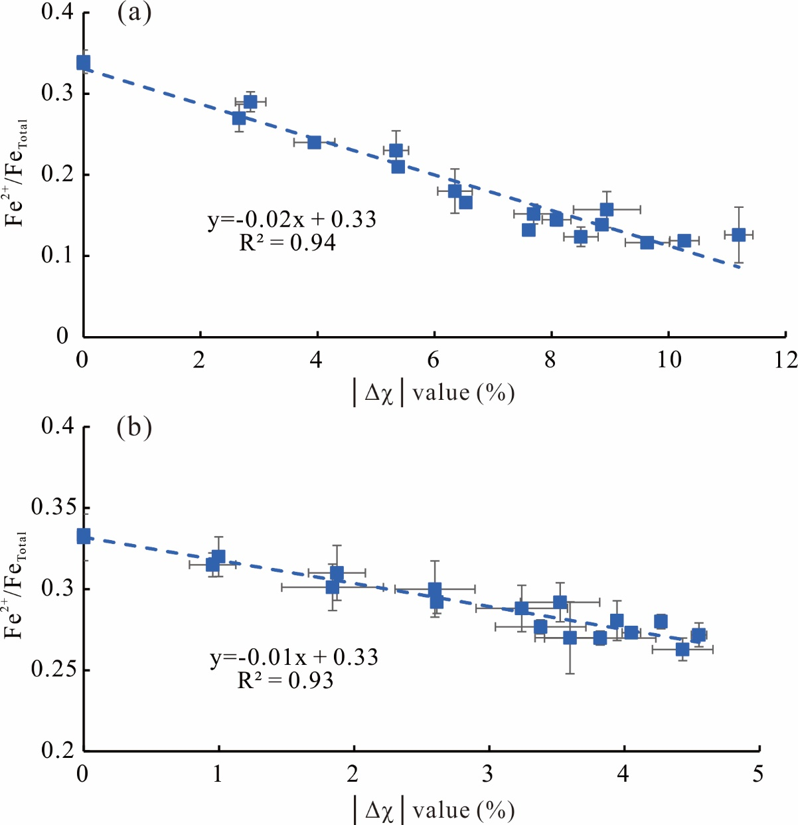
Figure S2

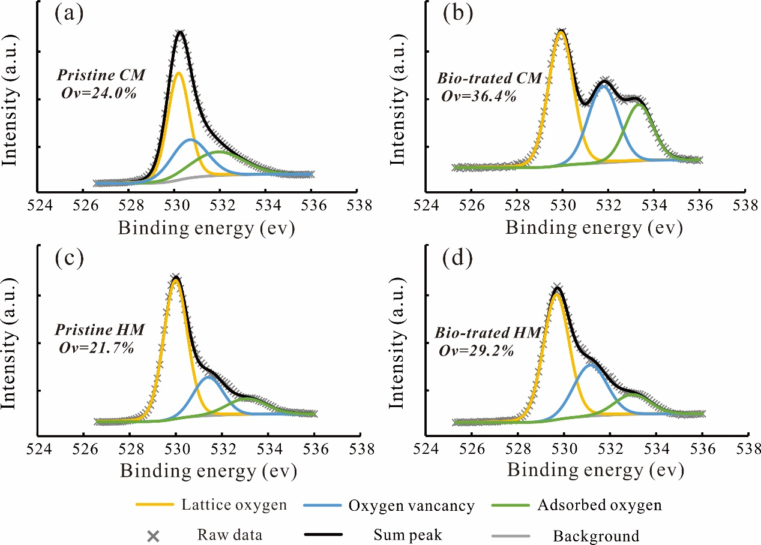
Figure S3

