SUPPLEMENTARY MATERIALS

Study of the effect nitro and hydroxyl substituents of two Imidazopyridines derivatives on inhibitory efficacy: Combining Theoretical and Experimental Study
Abdellah Elyoussfi ª, Walid Daoudi ^{b*}, Amin Salhi ^{c} , Issam Azghay ^{c}, Mhamed Ahari ^{c} , Hassan Amhamdi ^{c} , Noureddine Benchat ª, Ali Dafali ª , Abdelmalik El Aatiaoui ^{b}
- Laboratory of Applied Chemistry and Environment (LCAE), Department of Chemistry, Faculty of Sciences, University Mohamed I, Po. Box 717, 60000 Oujda, Morocco.
- Laboratory of Molecular Chemistry, Materials and Environment (LCM2E),Departement of chemistry, Multidisciplinary Faculty of Nador, University Mohamed I, 60700 Nador, Morocco.
- Applied Chemistry Unit, Sciences and Technologies Faculty, Abdelmalek Essaadi University, 32 003 Al Hoceima, Morocco.

*correspondence author Email: walid.daoudi@ump.ac.ma

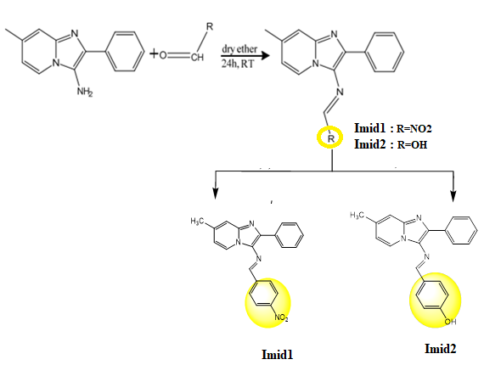

Scheme SI.1. Structures of the two compounds Imid₁₋₂.

Table SI.1.Conformation of structure of synthesized inhibitors.

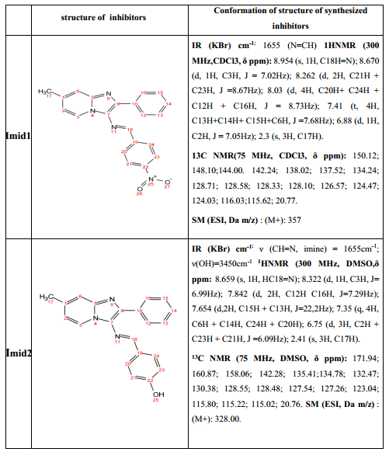

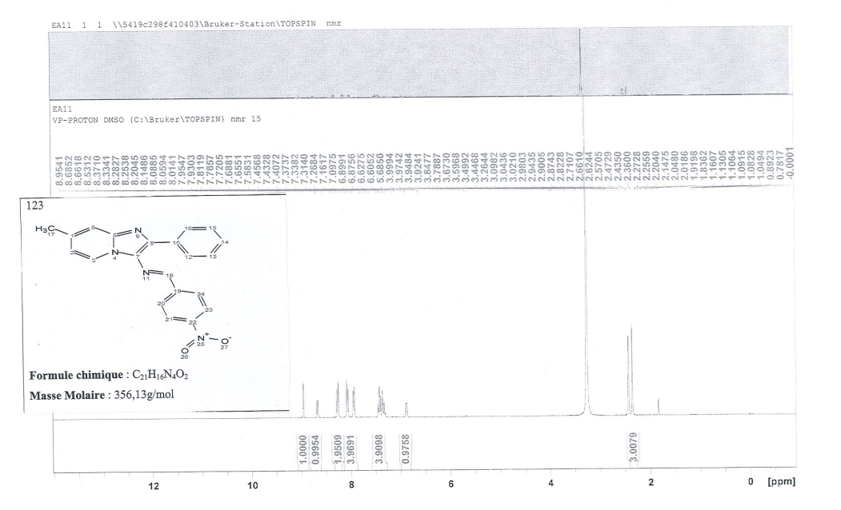

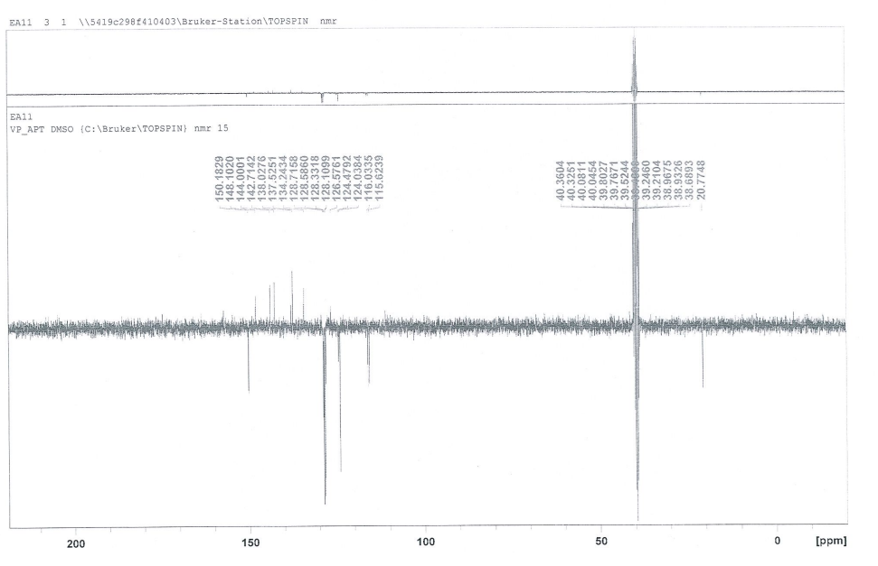
Fig. SI.1. ¹H, ¹³C NMR spectra of Imid1 ligand.

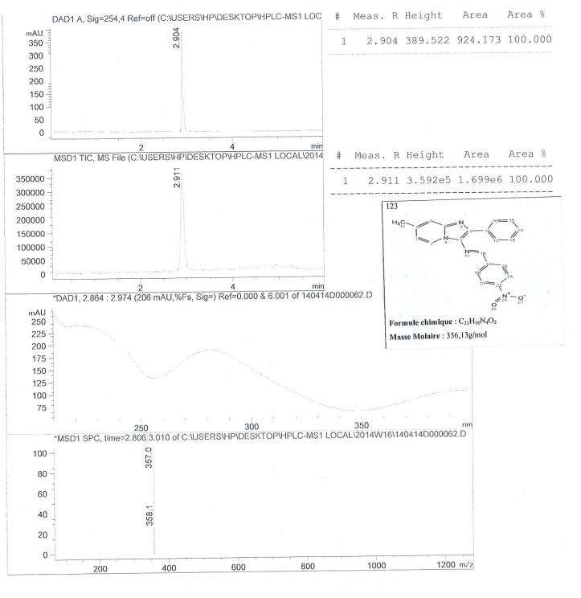
Fig. SI.2. HPLC-coupled MS mass spectrum of Imid1 ligand.

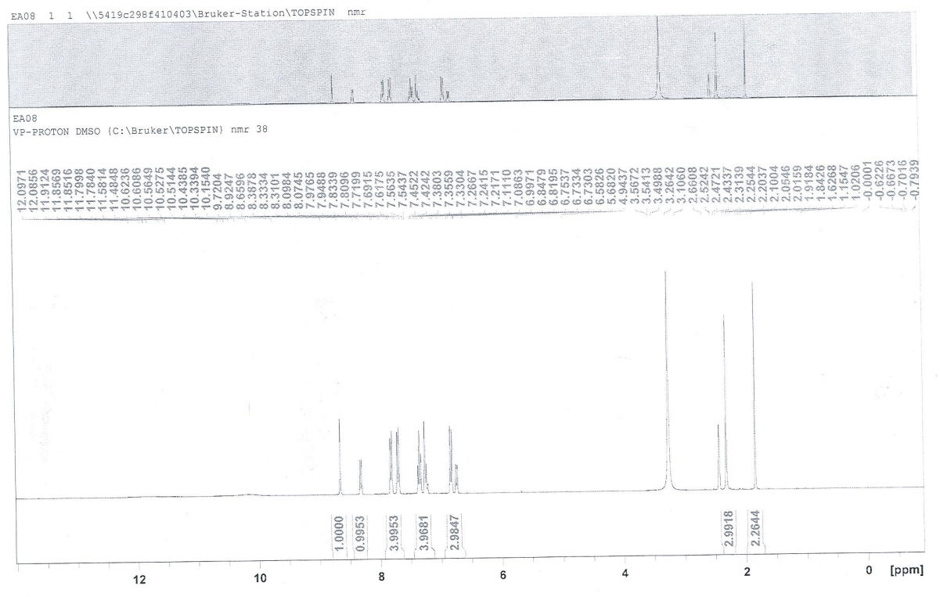

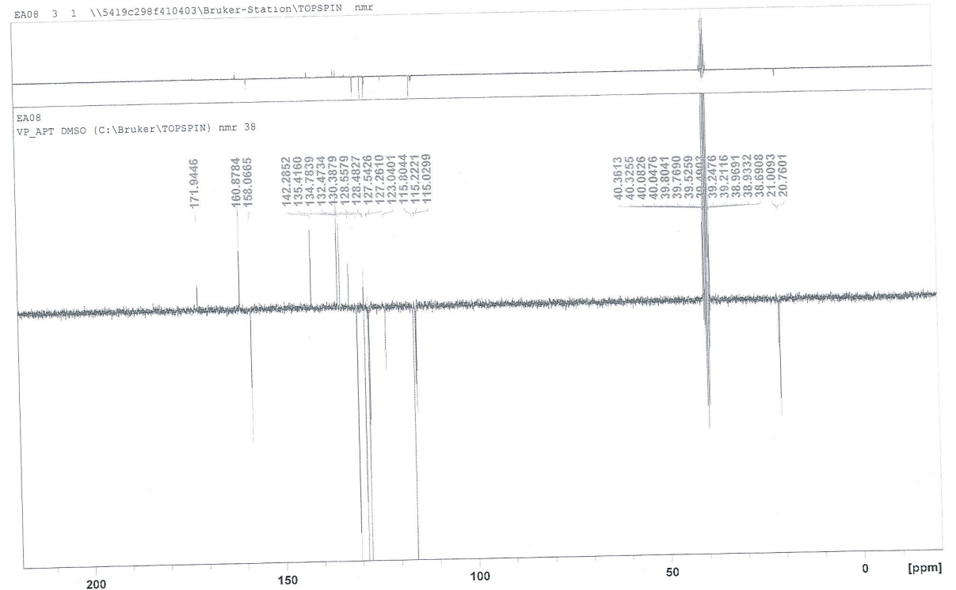
Fig. SI.3. ¹H, ¹³C NMR spectra of Imid2 ligand.

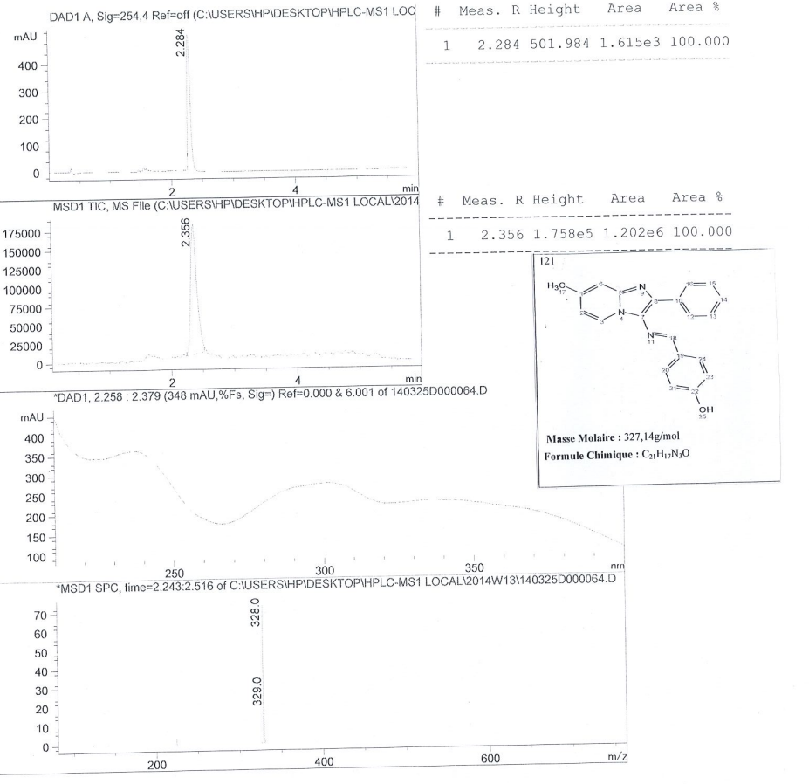

Fig. SI.4. HPLC-coupled MS mass spectrum of Imid1 ligand.

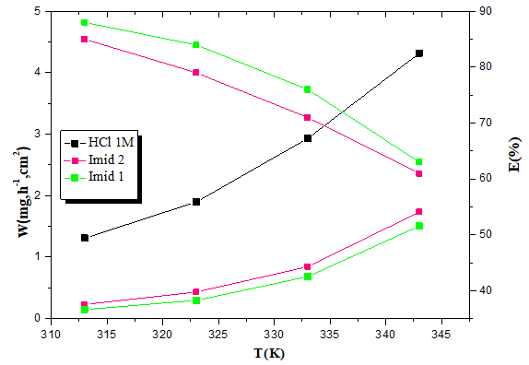

Fig. SI.5. Variation of corrosion rate and inhibitory efficiency of Imid1 and Imid2 inhibitors as a function of temperature.

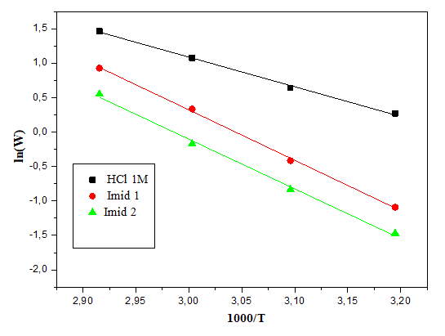

Fig. SI.6. Arrhenius lines (ln(W) vs 1/T) of steel in HCl medium (1M) without and with addition of Imidazopyridines tested at 10⁻³ M.

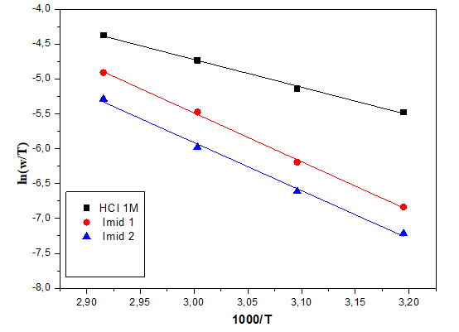

Fig. SI.7. Arrhenius lines (ln(W/T) vs 1/T) of steel in HCl medium (1M) without and with addition of Imidazopyridines tested at 10⁻³ M.

