One-pot Synthesis of Nitrile from Aldehyde using Magnetically Recoverable Nanocatalyst
Shripad M Patil, ^{ab}* Ashwini Bedre ^{b}
^{ab} School of chemical engineering and physical science, Lovely professional university phagwara-144411, Punjab, India. Email- patilshripad55@gmail.com
^{b} Savitribai Phule Pune University, Dada Patil Mahavidyalaya, Karjat-414401, Maharashtra. (INDIA)

Spectral data:
¹H-NMR Spectral data
¹³C-NMR Spectral data

Benzonitrile: Colorless oil; Yield 98%; b. p. 190-191°C; ¹H NMR (CDCl₃, 400 MHz, ppm) δ 7.55-7.65 (m, 3H), 7.45-7.42 (m, 2H); ¹³C NMR (CDCl₃, 100 MHz, ppm) δ 133.8, 133.0, 129.7, 119.9, 113.5; MS (GC) m/z calcd for C₇H₅N: 103.02, Found 103.09.
4-Fluorobenzonitrile: Colorless oil; Yield 95%; b. p. 31-33 °C; ¹H NMR (CDCl₃, 400 MHz, ppm) δ 7.65-7.73 (m, 2H), 7.17-7.23 (m, 2H); ¹³C NMR (CDCl₃, 100 MHz, ppm) δ 166.4 (d, J_{C-F}= 251 Hz), 135.7 (d, JC-F= 9.2 Hz), 118.3, 117.5 (d, J_{C-F}= 22.5 Hz), 109.5 (d, JC-F= 3.7 Hz), ¹⁹F NMR (CDCl₃, 376 MHz, ppm) δ 103.7; MS (GC) m/z calcd for C₇H₄FN: 121.05, Found 121.06.
4-Chlorobenzonitrile: White solid; Yield 96%; m. p. 89-90 °C ¹H NMR (400 MHz, CDCl₃) δ 7.47 (d, J = 8.3 Hz, 2H), 7.59 (d, J = 8.5 Hz, 2H); ¹³C NMR (100 MHz, CDCl₃) δ 110.5, 117.8, 129.3, 133.5, 139.7; MS (70 eV, EI): m/z = 137.3.
4-Bromobenzonitrile: White solid, Yield 95%; m. p. 113-114 °C; ¹H NMR (CDCl₃, 400 MHz, ppm) δ 7.52 (d, J= 8.5 Hz, 2H), 7.63 (d, J= 8.5 Hz, 2H); ¹³C NMR (CDCl₃, 100 MHz, ppm) δ 112.6, 118.7, 128.4, 133.7, 134.6; MS (GC) m/z calcd for C₇H₄BrN: 180.94, Found 181.05.
2-Chlorobenzonitrile: White solid, Yield 94% m. p. 42-44 °C; ¹H NMR (400 MHz, CDCl₃): δ = 7.72-7.69 (m, 1H), 7.55-7.48 (m, 2H), 7.40-7.35, (m, 1H); ¹³C NMR (100 MHz, CDCl₃): δ = 113.5, 116.2, 127.2, 130.3, 133.7, 134.2, 136.7. MS (70 eV, EI): m/z = 137.3.
4-Nitrobenzonitrile: Yellow solid, Yield 93%; m. p. 143-145 °C ¹H NMR (CDCl₃, 400 MHz, ppm) δ 7.92-7.95 (d, J= 8.0 Hz, 2H), 8.35-8.37 (d, J= 8.0 Hz, 2H); ¹³C NMR (CDCl₃, 100 MHz, ppm) δ 116.9, 118.8, 124.7, 133.7, 150.5; MS (GC) m/z calcd for C₇H₄FN: 148.07, Found 147.95.
4-Methoxybenzonitrile: White solid, Yield 97%; m. p. 57-68 °C; ¹H NMR (400 MHz,CDCl₃): δ 3.84 (s, 3H), 6.92-6.88 (m, 2H), 7.65-7.57 (m, 2H); ¹³C NMR (100 MHz, CDCl₃): δ = 162.7, 134.3, 119.4, 114.7, 104.3, 55.9; MS (70 eV, EI): m/z = 133.5.
4-Hydroxybenzonitrile: White solid, Yield 96%; m. p. 110-111 °C; ¹H NMR (CDCl₃, 400 MHz, ppm) δ 6.20 (br, 1H), 6.91 (d, J = 8.6 Hz, 2H), 7.53 (d, J = 8.6 Hz, 2H); ¹³C NMR (CDCl₃, 100 MHz, ppm)δ103.6, 116.8, 119.6, 134.7, 160.4; MS (GC) m/z calcd for C₇H₅NO₂: 119.06, Found 119.03.
4-Methylbenzonitrile Colorless liquid Yield 95%; m. p. 217-218 °C; ¹H NMR (400 MHz, CDCl₃): δ 2.45 (s, 3H), 7.30 (d, J = 8.2 Hz, 2H), 7.57 (d, J = 8.6 Hz, 2H); ¹³C NMR (100 MHz, CDCl₃): δ = 21.7, 109.5, 119.5, 129.7, 132.1. 143.9; MS (70 eV, EI): m/z = 117.3.
2, 4-dimethoxybenzonitrile: White solid, Yield 95%; m. p = 81-82 °C; ¹H NMR (400 MHz, CDCl₃): δ 7.05 (dd, J = 12.1 Hz, 3.1 Hz, 1H), 7.07 (d, J = 2.9 Hz, 1H), 6.87 (d, J = 8.7 Hz, 1H), 3.90 (s, 3H), 3.80 (s, 3H); ¹³C NMR (100 MHz, CDCl₃): δ = 155.9, 153.3, 120.9, 117.7, 116.7, 112.9, 101.3, 56.6, 55.7; MS (70 eV, EI): m/z = 163.3.
2-Methylbenzonitrile: Colorless liquid, Yield 95%; b. p. 205-206 °C; ¹H NMR (400 MHz,CDCl₃): δ 7.57 (dd, J = 7.7 Hz, 1.2 Hz ,1H), 7.49 (td, J = 8.2 Hz, 1.6 Hz, 1H), 7.33 (d, J = 8.3 Hz，1H), 7.29-7.27 (m, 1H), 2.57 (s, 3H); ¹³C NMR (100 MHz, CDCl₃): δ = 142.2, 132.8, 132.7, 130.4, 126.4, 118.4, 112.7, 20.7; MS (70 eV, EI): m/z = 117.5.
3-Methylbenzonitrile: Colorless liquid, Yield 96%; b. p. 213-214 °C; ¹H NMR (400 MHz,CDCl₃): δ 7.45-7.43 (m, 2H), 7.40-7.38 (m, 1H), 7.35-7.31 (m, 1H), 2.37 (s, 3H); ¹³C NMR (100 MHz, CDCl₃): δ 139.4, 133.4, 132.7, 129.5, 129.3, 119.3, 112.5, 21.1; MS (70 eV, EI): m/z = 117.3.
1-Naphthonitrile: Colorless oil, Yield 95%; b. p. 36-39 °C; ¹H NMR (CDCl₃, 400 MHz, ppm) δ 7.52 (t, J= 8.1 Hz, 1H) , 7.63 (t, J= 7.4 Hz, 1H), 7.66 (t, J= 7.1 Hz, 1H), 7.93-7.88 (m, 2H), 8.08 ( d, J= 8.6 Hz, 1H), 8.24 (d, J= 8.6 Hz, 1H); ¹³C NMR (CDCl₃, 100 MHz, ppm)δ110.7, 118.8, 125.5, 125.7, 128.5, 129.6, 129.4, 133.3, 133.5, 133.9, 133.2; MS (GC) m/z calcd for C₁₁H₇N: 153.04, Found 153.02.
Furan-2-Carbonitrile: Yellow liquid, Yield 91%; b. p. 146-147 °C ¹H NMR (400 MHz, CDCl₃): δ 7.63 (dd, J = 1.5 Hz, 0.5 Hz, 1H), 7.15 (dd, J = 3.8 Hz, 0.9 Hz, 1H), 6.58 (dd, J = 3.8 Hz, 2.1 Hz, 1H); ¹³C NMR (100 MHz, CDCl₃): δ = 147.7, 126.4, 122.3, 111.7; MS (70 eV, EI): m/z = 93.3.
2-Thiophenecarbonitrile: Brown oil, Yield 90%; ¹H NMR (CDCl₃, 400 MHz, ppm) δ 7.12-7.10 (m, 1H), 7.63 (dd, J= 3.7Hz, 1.3 Hz, 1H), 7.62 (dd, J= 3.6 Hz, 1.3 Hz, 1H); ¹³C NMR (CDCl₃, 100 MHz, ppm) δ 110.5, 115.3, 128.2, 133.6, 138.4; MS (GC) m/z calcd for C₅H₃NS: 109.02, Found 108.99.

Spectral data:
(Table 2, Compound 1)
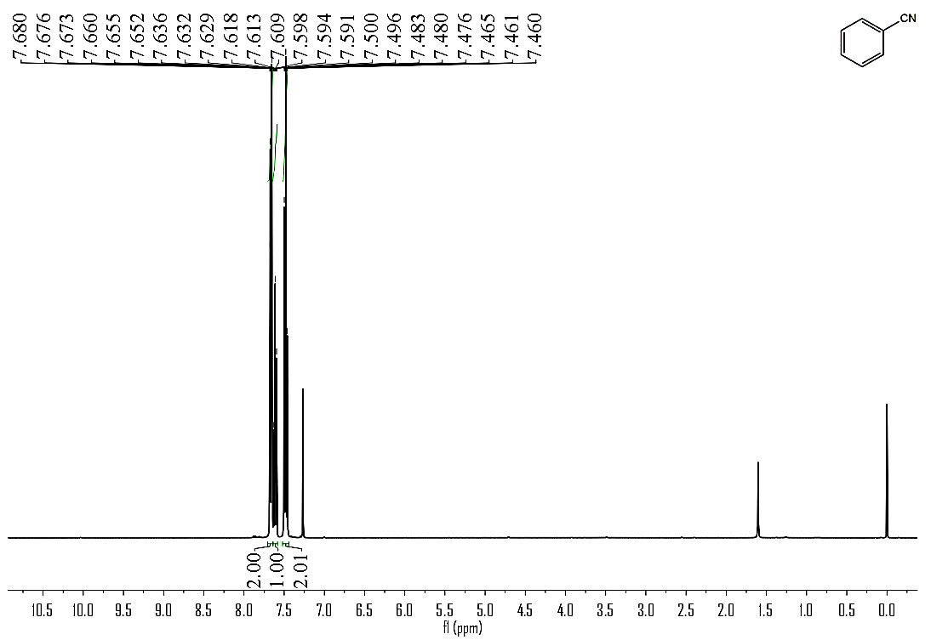
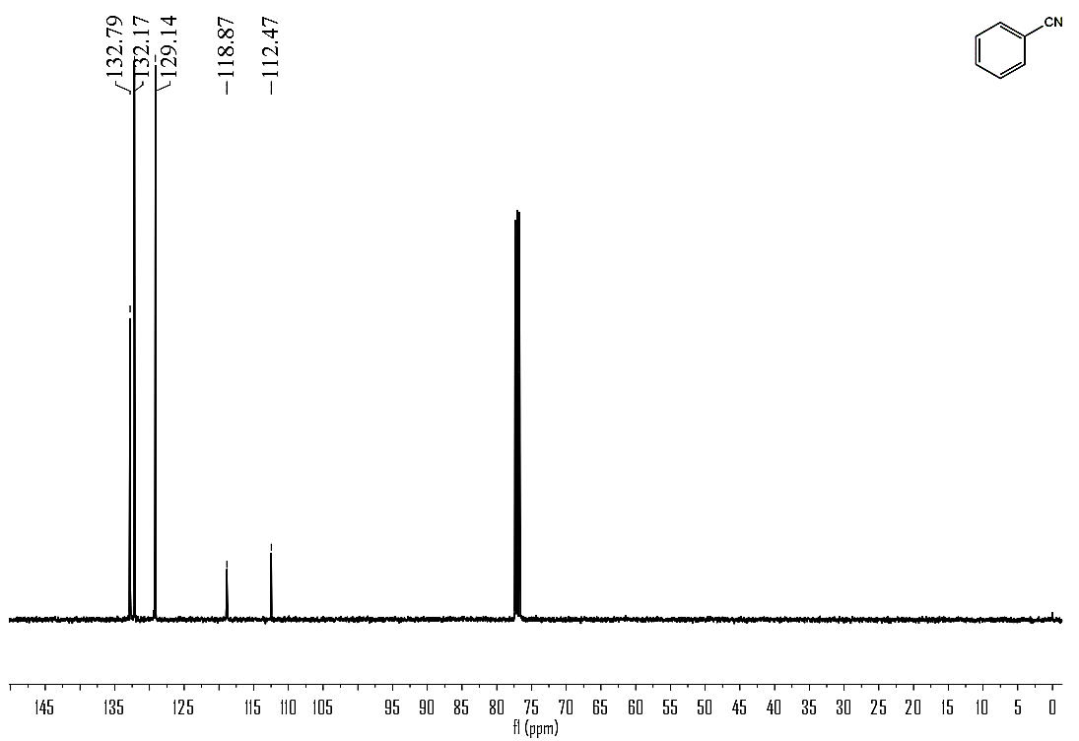

(Table 2, Compound 2)
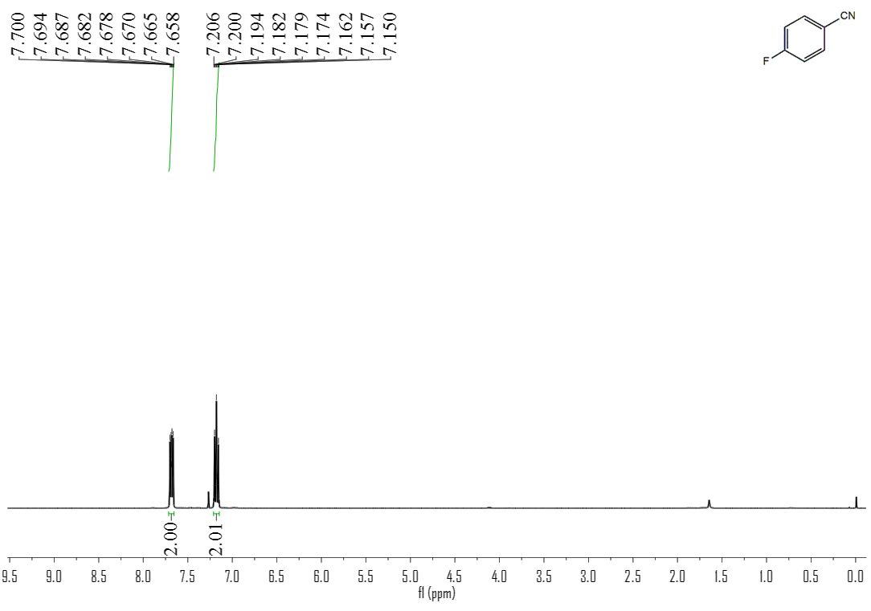
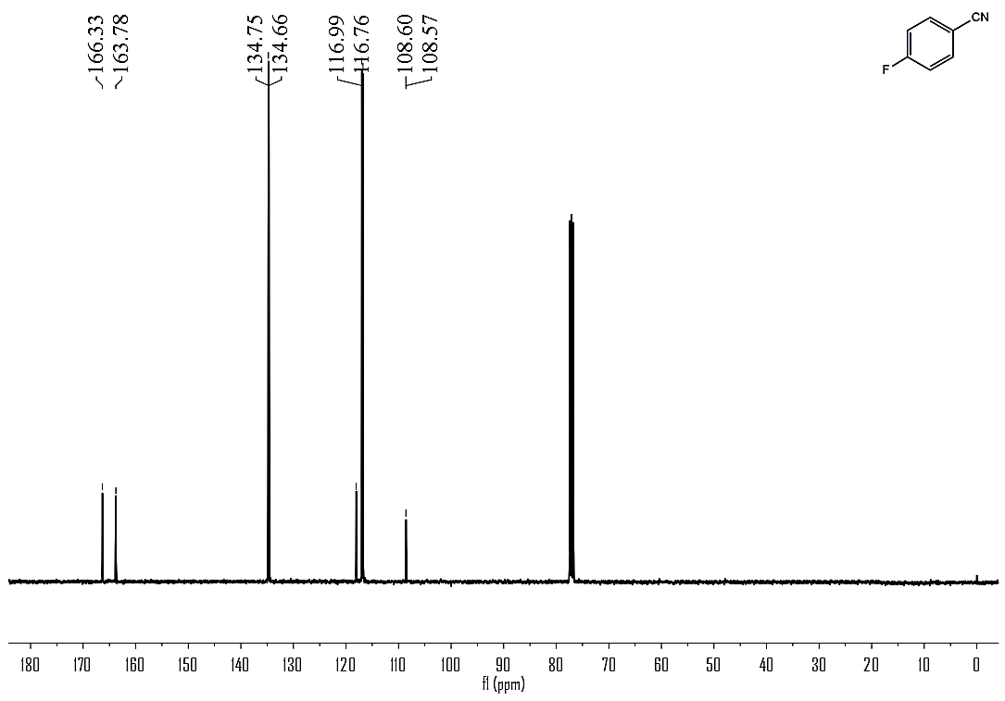

(Table 2, Compound 3)
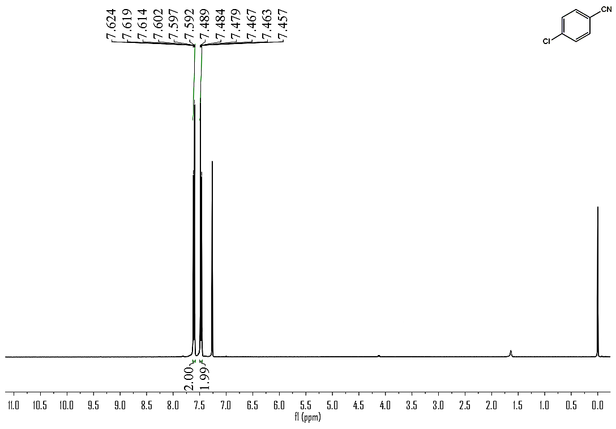
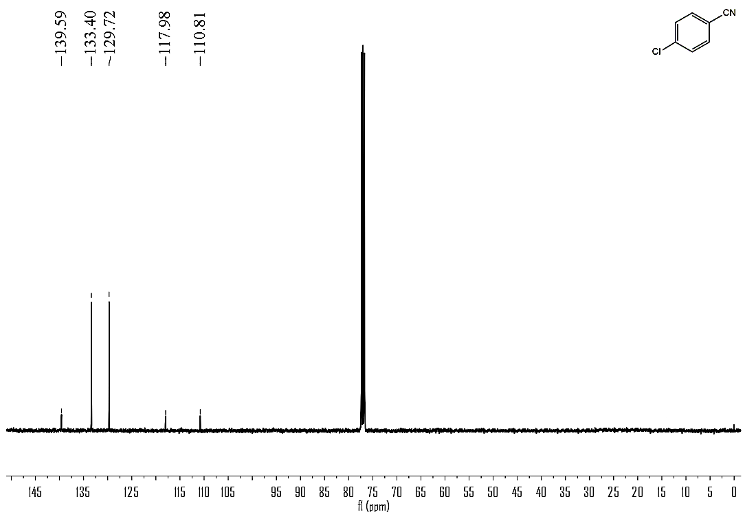

(Table 2, Compound 4)
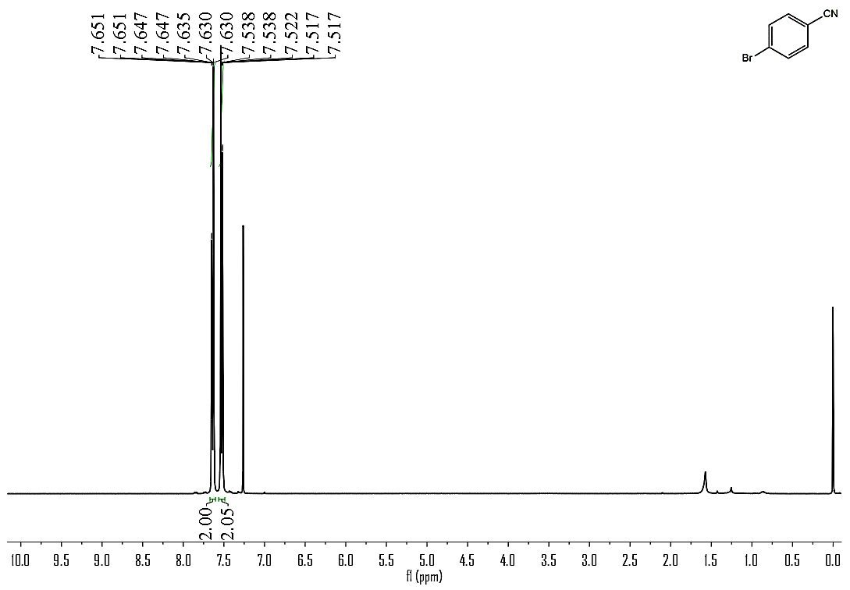
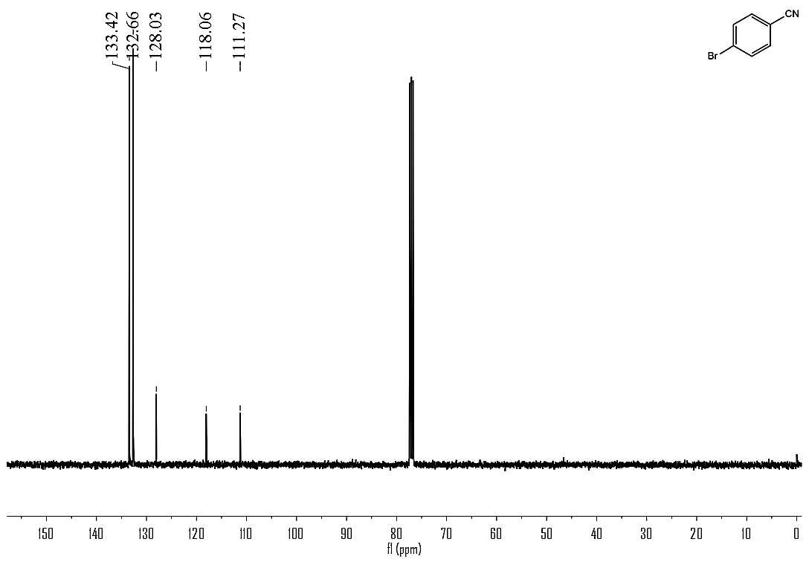

(Table 2, Compound 5)
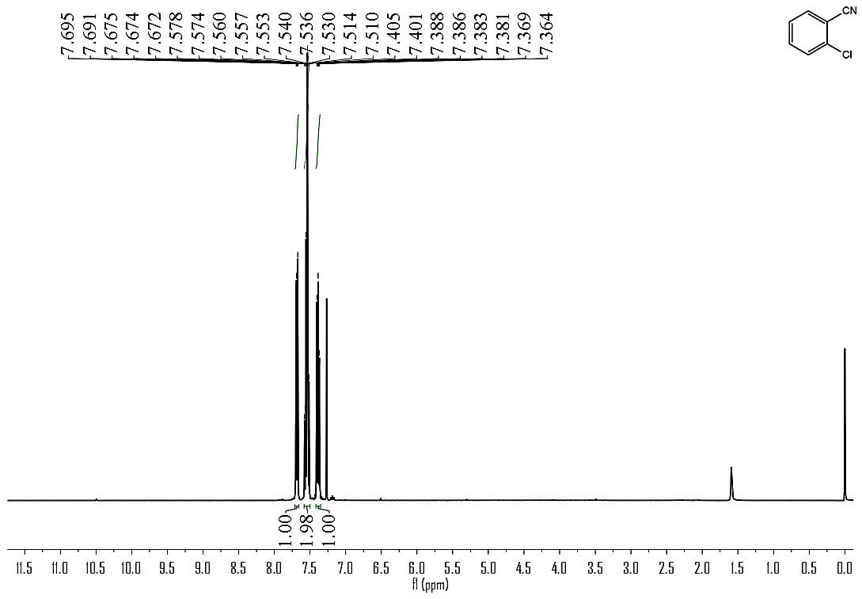
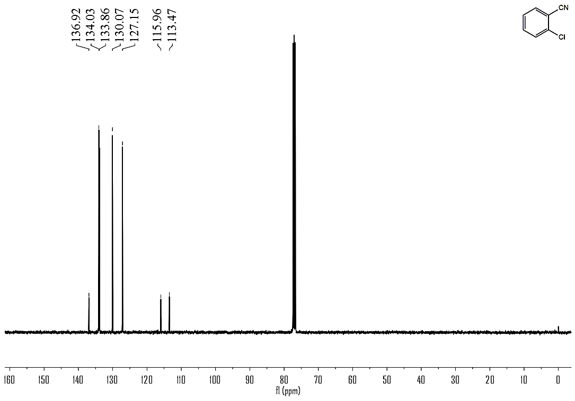

(Table 2, Compound 6)
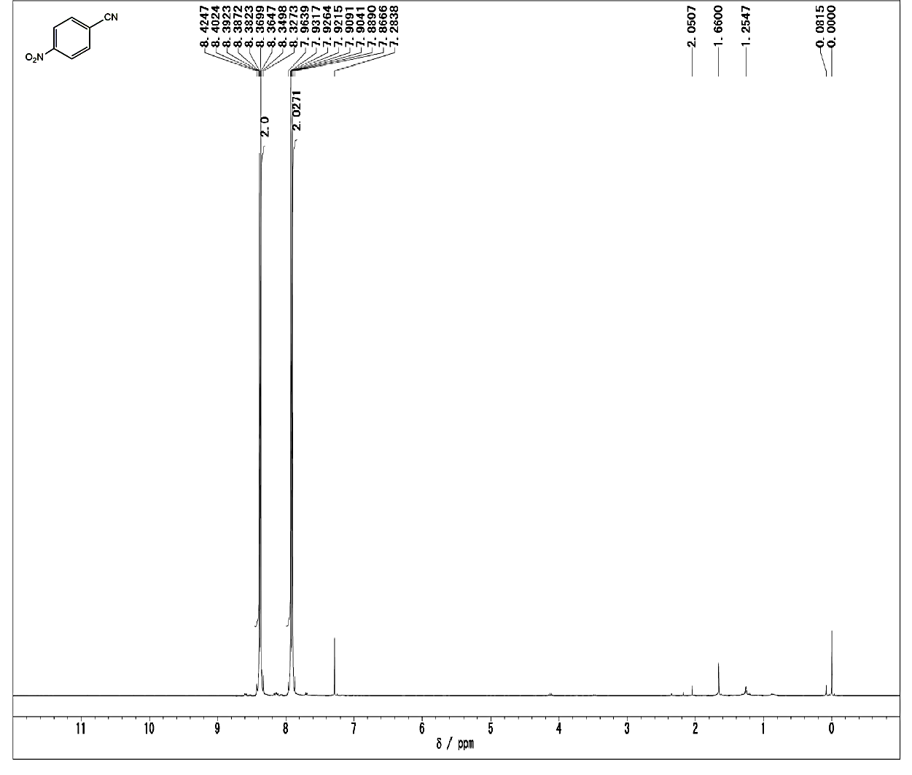
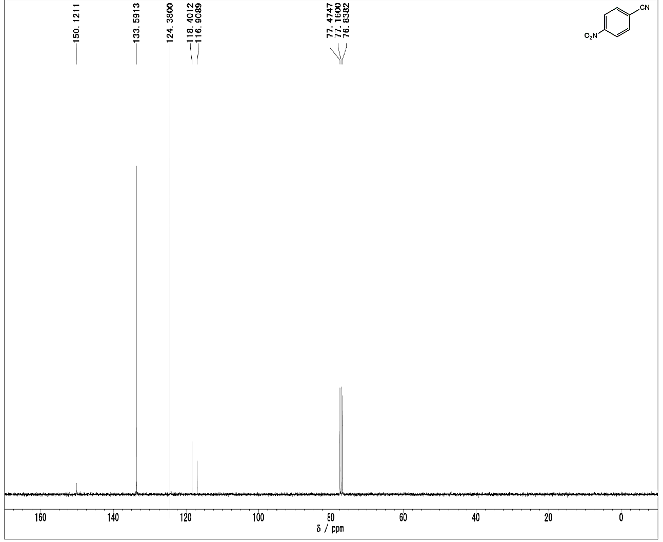

(Table 2, Compound 7)
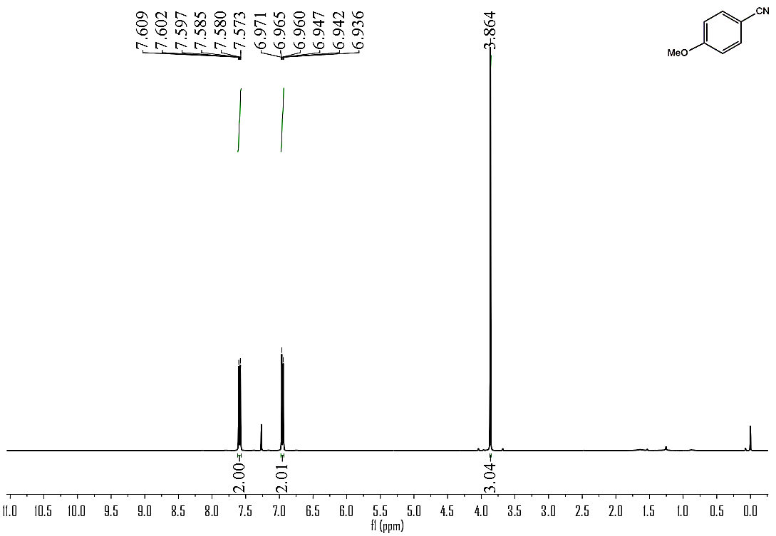
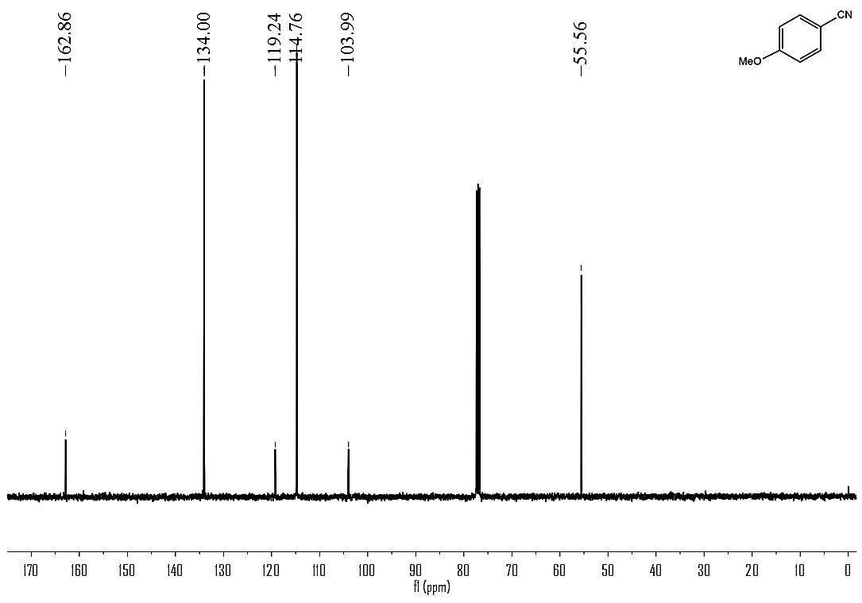

(Table 2, Compound 8)
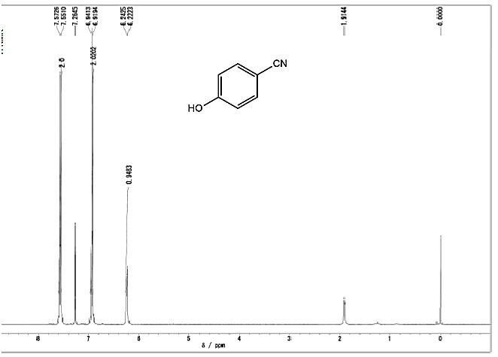
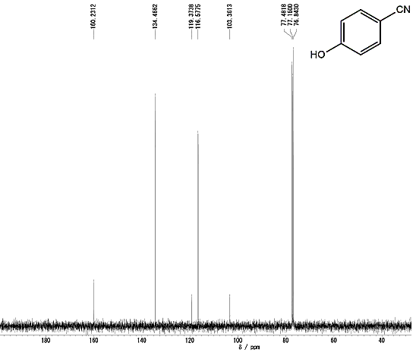

(Table 2, Compound 9)
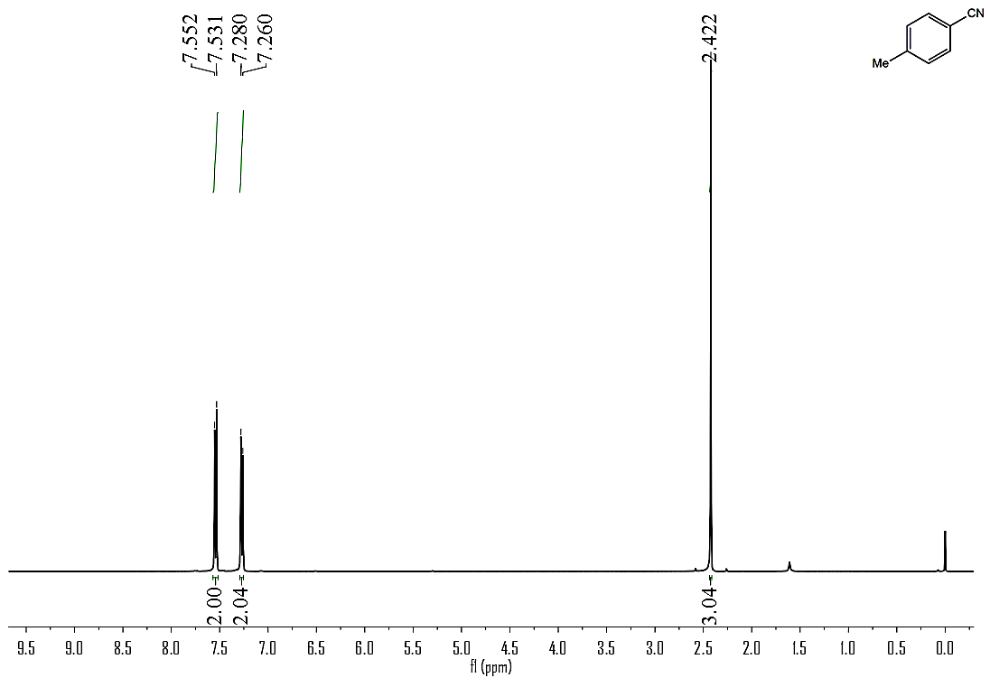
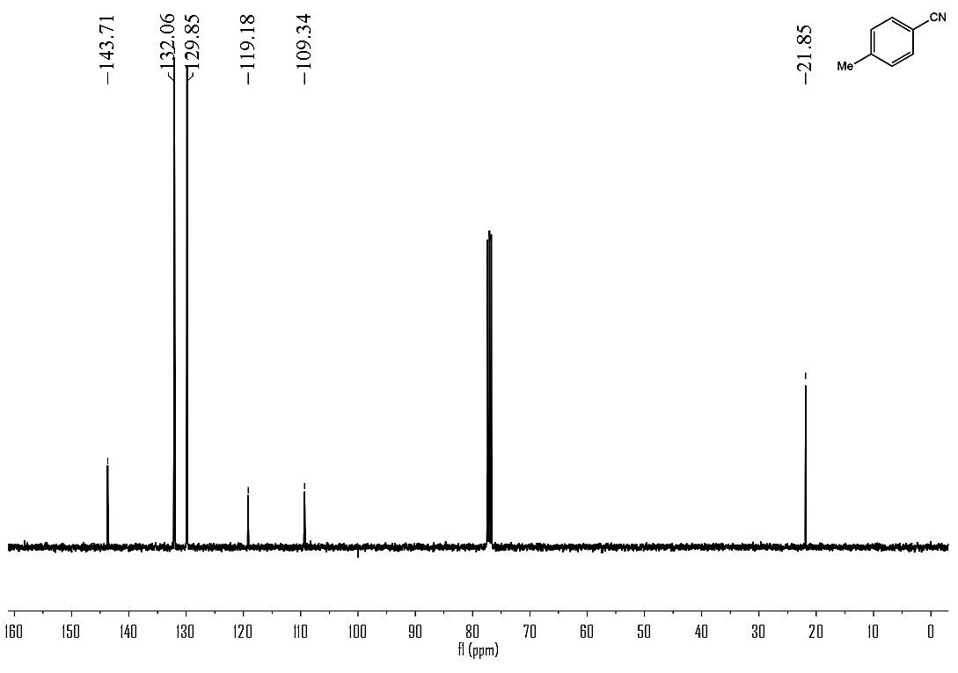

(Table 2, Compound 10)
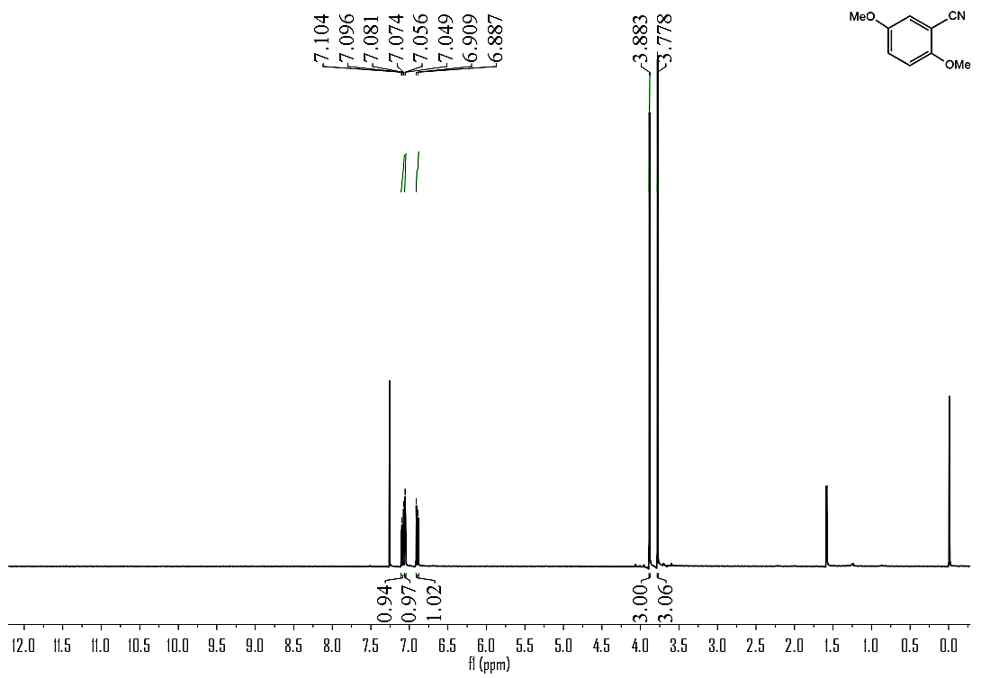
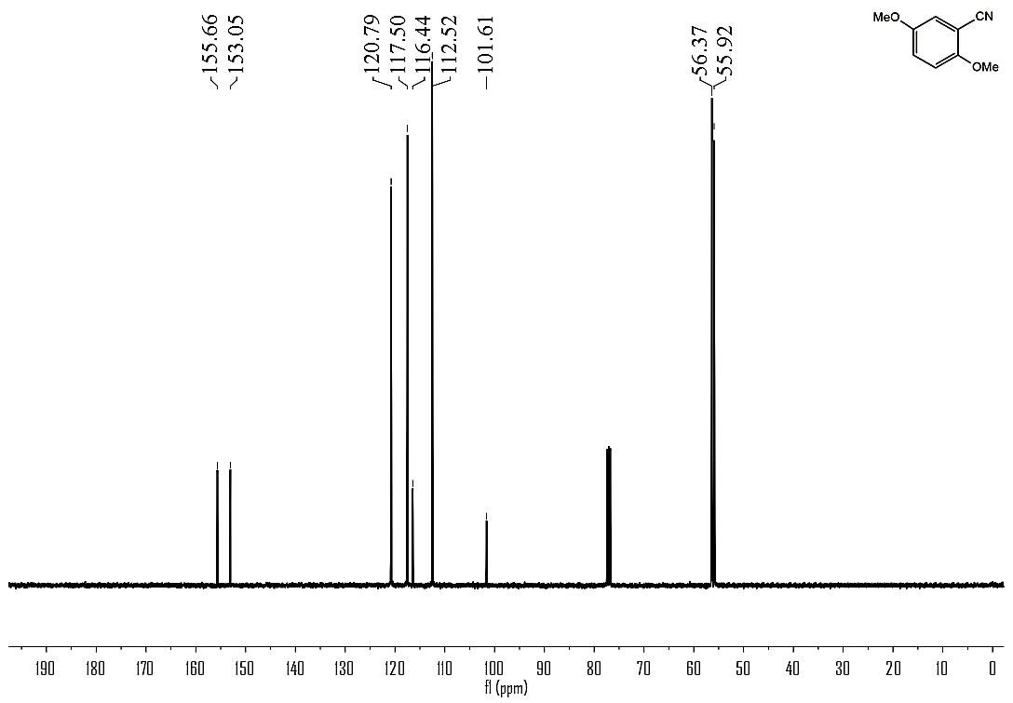

(Table 2, Compound 11)
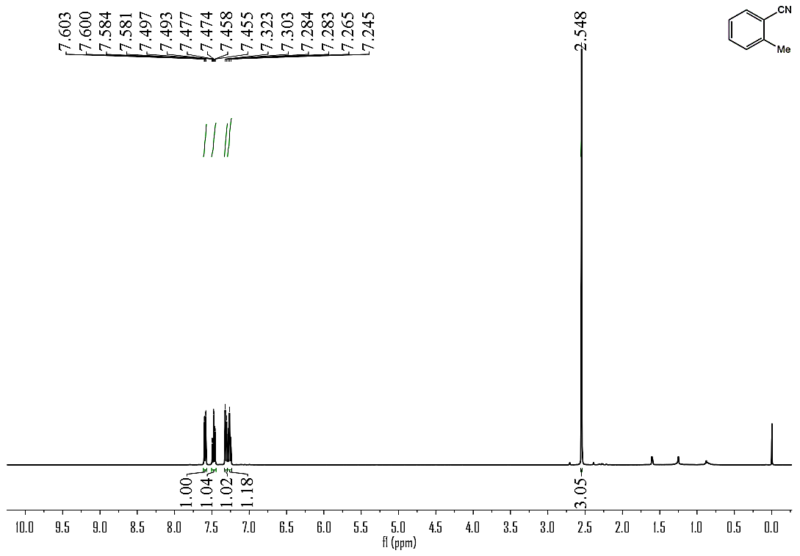
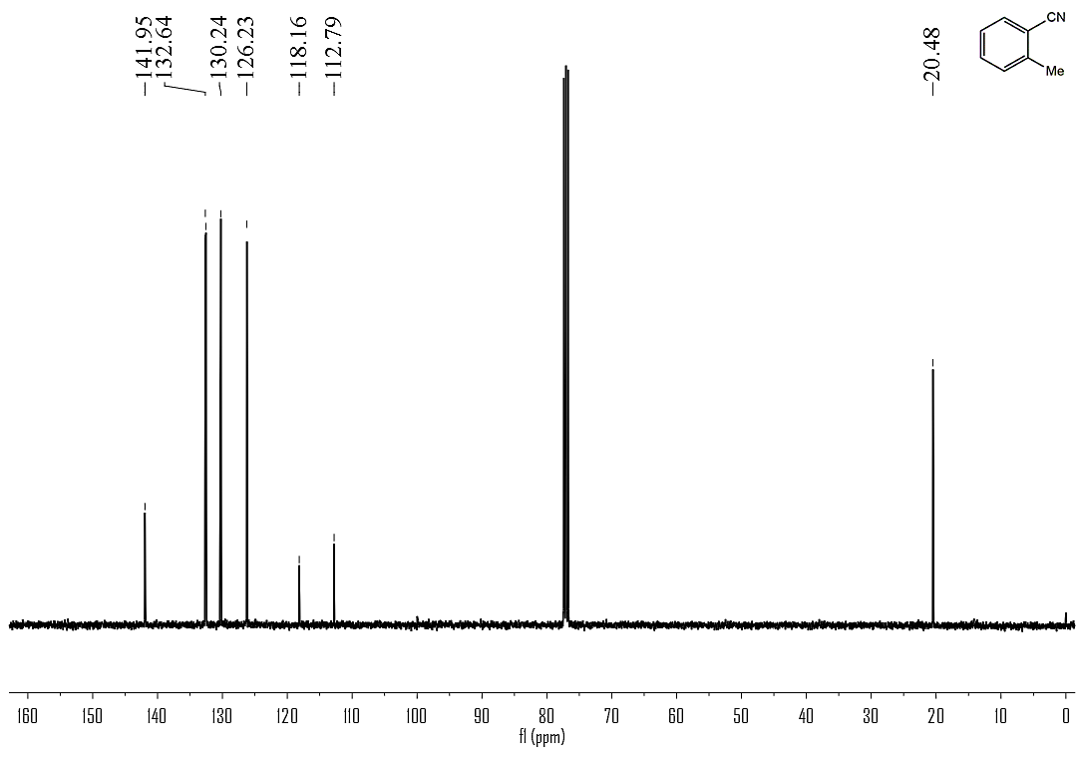

(Table 2, Compound 12)
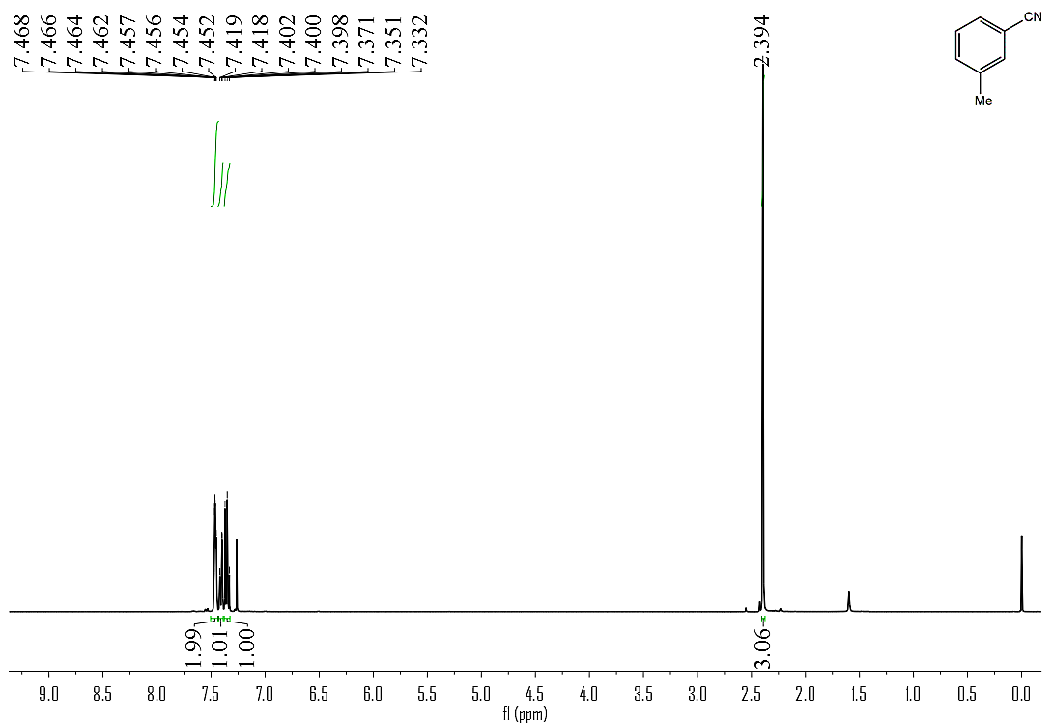
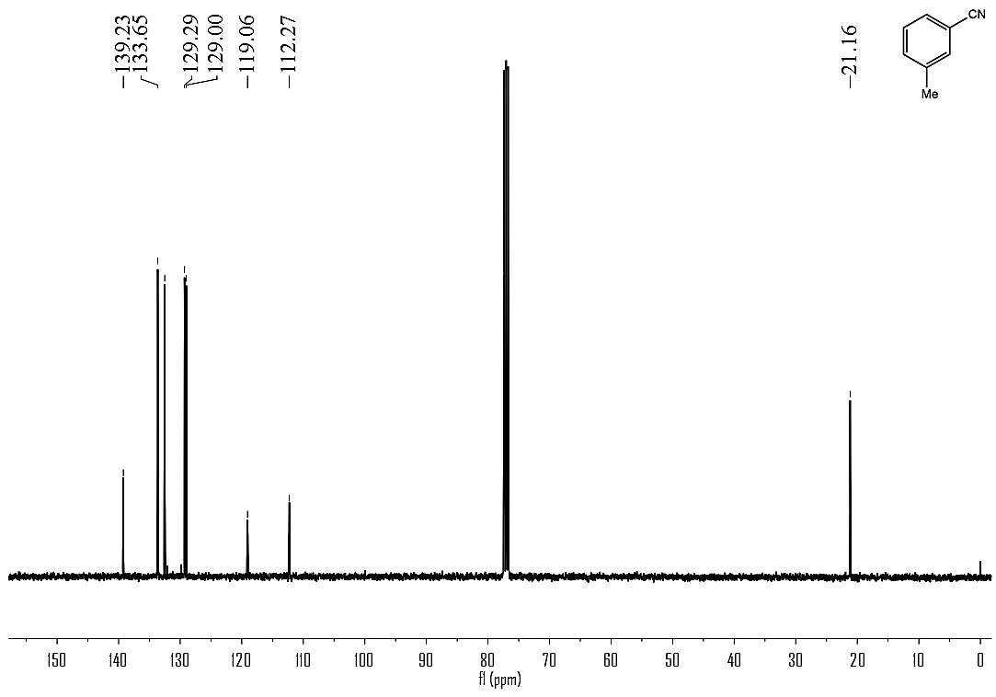

(Table 2, Compound 13)
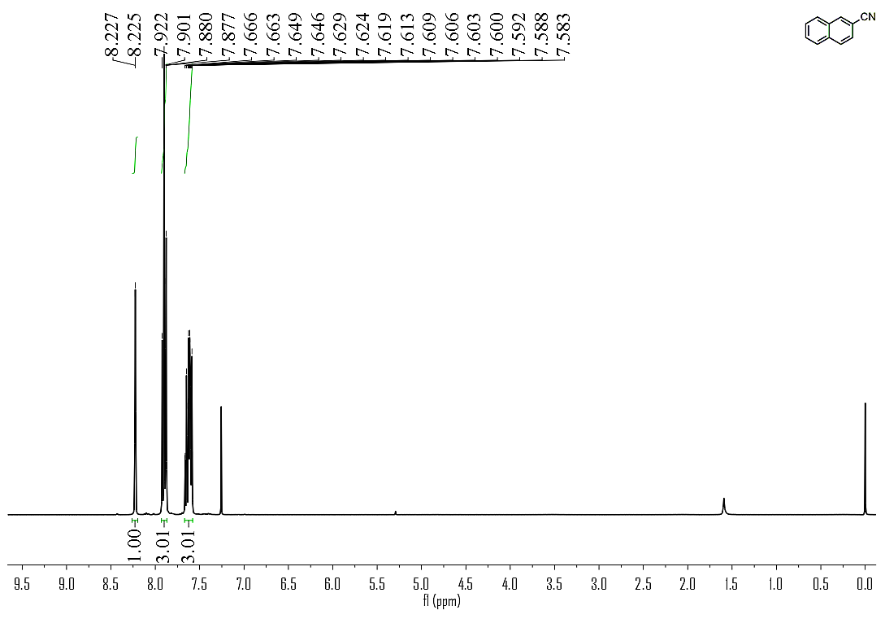
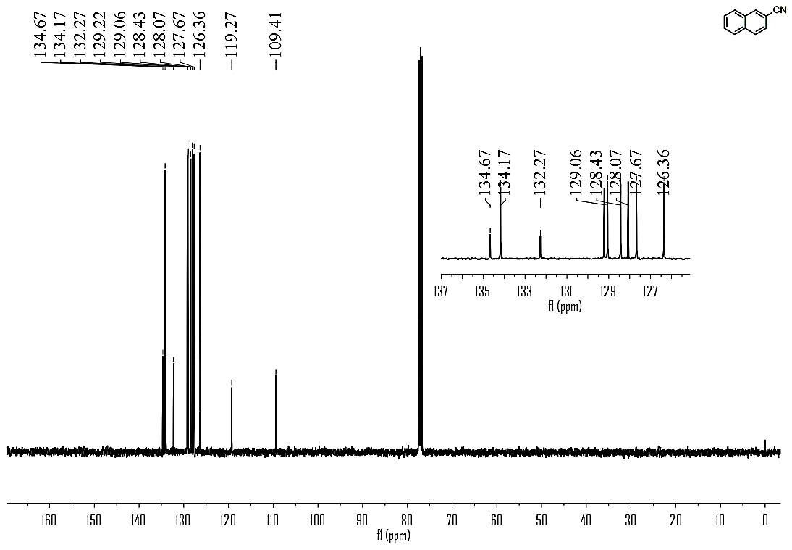

(Table 2, Compound 14)
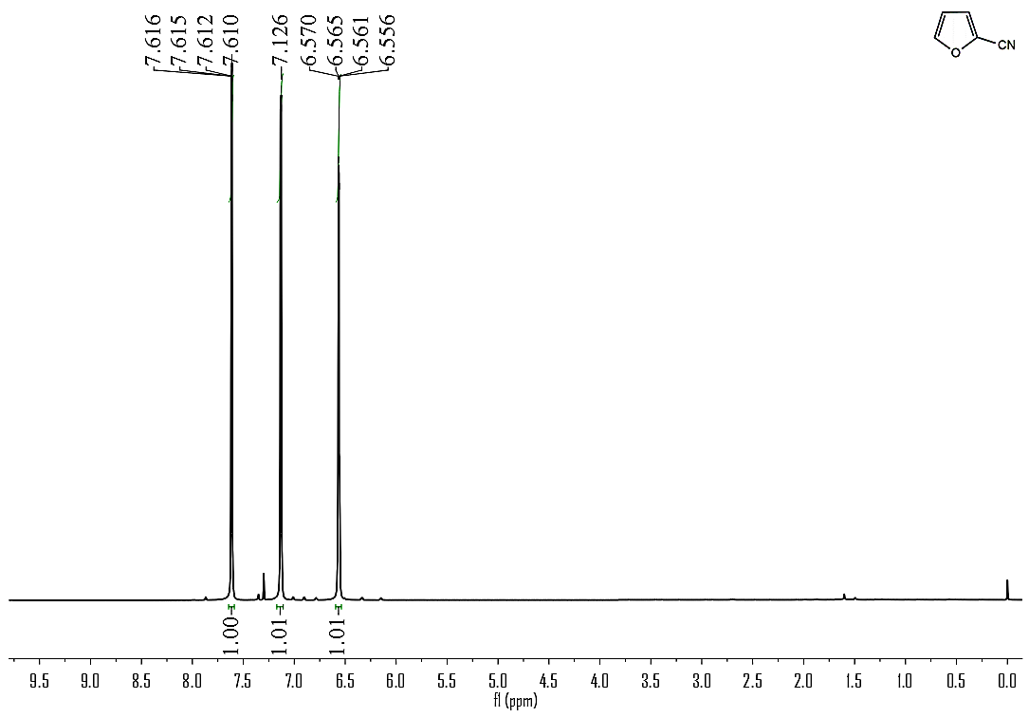
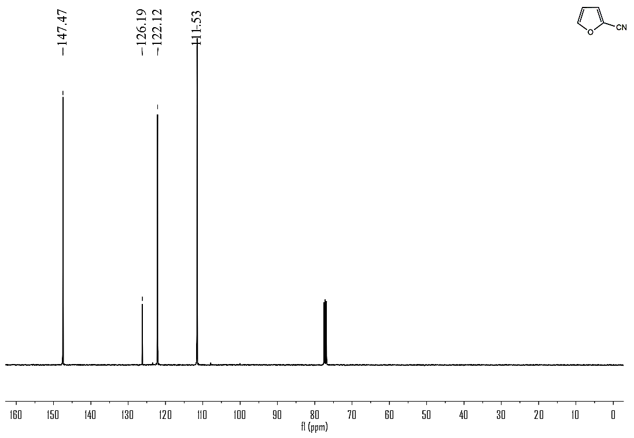

(Table 2, Compound 15)
