SUPPLEMENTARY MATERIAL

Supplementary Material 1: Illustrations of common parcellation errors and motion artifacts

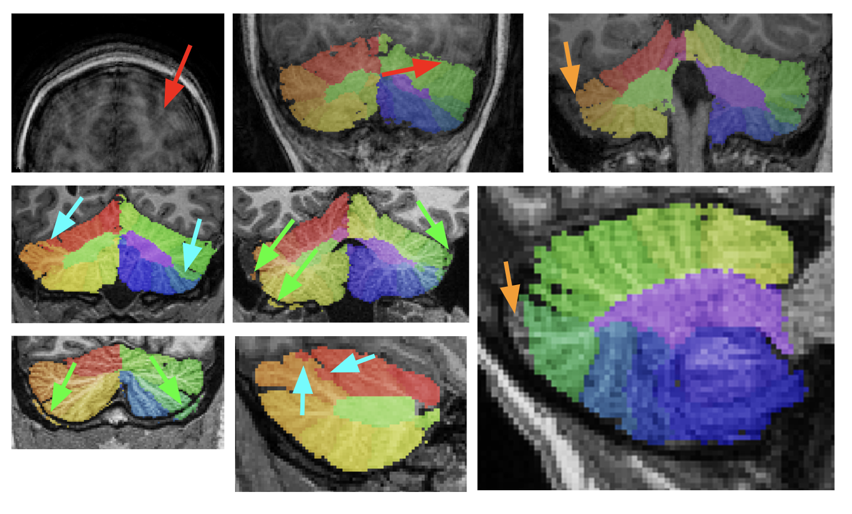
Legend:
Red arrows: motion related artifacts (ghosting); Orange: Non segmented cerebellar tissue; Cyan: Parcellation errors ; Green : non cerebellar tissue labeled as cerebellar tissue

Supplementary Material 2: Comparison of subjects included and excluded from the analyses after quality control

Demographics | Included (N = 850) | Excluded (N = 559) | Statistics | P-val
Mean Age (SD)*** | 10.8 (3.0) | 10.0 (3.1) | Student Z = -4.7 | < 0.0001***
Sex (%of M)*** | 354/496 (58%) | 164/395 (71%) | Chi2 T = 21.5 | < 0.0001***
SRS Total (SD)* | 51.5 (29.8) | 55.1 (31.3) | Student Z = 2.1 | 0.037*
SCI (SD) | 43.0 (23.6) | 45.6 (24.7) | Student Z = 1.9 | 0.061
RRB (SD)* | 8.5 (7.1) | 9.5 (7.5) | Student Z = 2.5 | 0.011*
FSIQ (SD) | 99.7 (15.7) | 99.2 (15.0) | Student Z = -1.0 | 0.328

Legend
SD, standard deviation; M, male; SRS Total, Social Responsiveness Scale total score; SCI, social and communication SRS’s subscale; RRB, RRB, repetitive behavior SRS’s subscale; IQ Total, Intelligence Quotient; significant differences are marked by P-val threshold: < 0.05 (*) or < 0.001 (***).

Supplementary Material 3. Association between social and communication impairment scale (SCI) and cerebellar anatomy.

Lobule | Pval | Pval Corr | Tval | IC95% | DOF
Cerebellum | 0.0034 | 0.0239* | 2.93 | [0.181 ; 0.914] | 11
Ant. Lobe | 0.1059 | 0.1483 | 1.62 | [-0.011 ; 0.113] | 11
VI | 0.0117 | 0.0280* | 2.52 | [0.023 ; 0.185] | 11
Crus I | 0.1737 | 0.1736 | 1.36 | [-0.041 ; 0.225] | 11
Crus II | 0.0120 | 0.0280* | 2.51 | [0.026 ; 0.214] | 11
VIIB | 0.0736 | 0.1289 | 1.79 | [-0.004 ; 0.093] | 11
Post. Lobe | 0.1451 | 0.1693 | 1.46 | [-0.031 ; 0.207] | 11

Legend
Pval, P-value; Pval Corr, Benjamini-Hochberg FDR correction; CI95%, Confidence Interval; DOF, degrees of freedom ; SCI, social and communication SRS’s subscale.
* Significant results.

Supplementary Material 4: Association between volumes of the cerebellum and social communication impairment scale (SCI), age, sex, IQ, intracranial volume (ICV) and interactions between SCI and covariates.

LOBULE | SCI | AGE | SEX | IQ | ICV | SCI*AGE | SCI*SEX | SCI*IQ | SCI*ICV | Out.
Cerebellum | 0.0034 | 0.0064 | 0.0269 | 0.0804 | <0.0001 | 0.0767 | 0.4276 | 0.0766 | 0.1177 | 4
Lobe Ant | 0.1059 | 0.0339 | 0.0575 | 0.2445 | <0.0001 | 0.1576 | 0.5236 | 0.2706 | 0.4082 | 3
Lobule VI | 0.0117 | 0.4769 | 0.8570 | 0.6843 | <0.0001 | 0.6060 | 0.9638 | 0.9979 | 0.0194 | 2
Crus I | 0.1737 | 0.6614 | 0.0965 | 0.3029 | <0.0001 | 0.7069 | 0.3953 | 0.3970 | 0.6269 | 2
Crus II | 0.0120 | 0.1955 | 0.5929 | 0.0204 | <0.0001 | 0.1692 | 0.5249 | 0.0777 | 0.2762 | 5
Lobule VIIB | 0.0736 | 0.3418 | 0.0718 | 0.0038 | <0.0001 | 0.5662 | 0.1883 | 0.0370 | 0.4869 | 5
Lobe Post-Inf | 0.1451 | 0.0039 | 0.0017 | 0.1538 | <0.0001 | 0.0218 | 0.2926 | 0.1128 | 0.7459 | 1

Legend
P-value for each variate and interaction terms.
SCI, social and communication SRS’s subscale. IQ, Intelligence Quotient.

Supplementary Material 5: Association between volumes of the cerebellum and SRS Total and RRB.

LOBULE | SRS Total |  | RRB
LOBULE | P-value | Corrected P-value | P-value | Corrected P-value
Cerebellum | 0.0105 | 0.0732 | 0.3236 | 0.6789
Lobe Ant | 0.3593 | 0.3593 | 0.5819 | 0.6789
Lobule VI | 0.0247 | 0.0863 | 0.5775 | 0.6789
Crus I | 0.2553 | 0.2979 | 0.8342 | 0.8342
Crus II | 0.0422 | 0.0986 | 0.1325 | 0.6789
Lobule VIIB | 0.1014 | 0.1775 | 0.4276 | 0.6789
Lobe Post-Inf | 0.1904 | 0.2665 | 0.5731 | 0.6789

Legend
SRS Total, Social Responsiveness Scale total score; RRB, RRB, repetitive behavior SRS’s subscale; Benjamini-Hochberg FDR correction.

