Supporting Information
Overcoming lattice mismatch for heterostructures
Wen Kiat Chan,^{a#} Zhongzheng Yu, ^{a,b#*} Donglei Zhou,^{c} Junzhi Ye,^{b} Alasdair Tew,^{b} Lars van Turnhout,^{b} Akshay Rao,^{b} and Timothy Thatt Yang Tan^{a*}
ª School of Chemistry, Chemical Engineering and Biotechnology, Nanyang Technological University, 637459, Singapore
^{b} Cavendish Laboratory, University of Cambridge, Cambridge, CB3 0HE, United Kingdom

^{c} State Key Laboratory of Integrated Optoelectronics, College of Electronic Science and Engineering, Jilin University, Changchun, 130012, China

*Corresponding author at: School of Chemistry, Chemical Engineering and Biotechnology, Nanyang Technological University, 637459, Singapore.
E-mail address: yuzh0010@e.ntu.edu.sg (Z. Yu), tytan@ntu.edu.sg (T.T.Y. Tan).

#These authors contributed equally: Wen Kiat Chan, Zhongzheng Yu.

Materials
Yttrium (III) acetate hydrate (Y(CH₃COO)₃∙xH₂O), gadolinium acetate hydrate (Gd(CH₃COO)₃∙xH₂O), ytterbium acetate hydrate (Yb(CH₃COO)₃∙xH₂O), thulium acetate hydrate (Tm(CH₃COO)₃∙xH₂O), cesium carbonate (Cs₂CO₃, 99.9%), lead chloride (PbCl₂, 99.999%), lead bromide (PbBr₂, 99.99%), lead iodide (PbI₂, 99.999%), 1-octadecene (ODE, 90%), oleic acid (OA, 90%), oleylamine (OAm, 70%) and n-hexane (HPLC grade) were purchased from Sigma-Aldrich and used directly without any further purification.

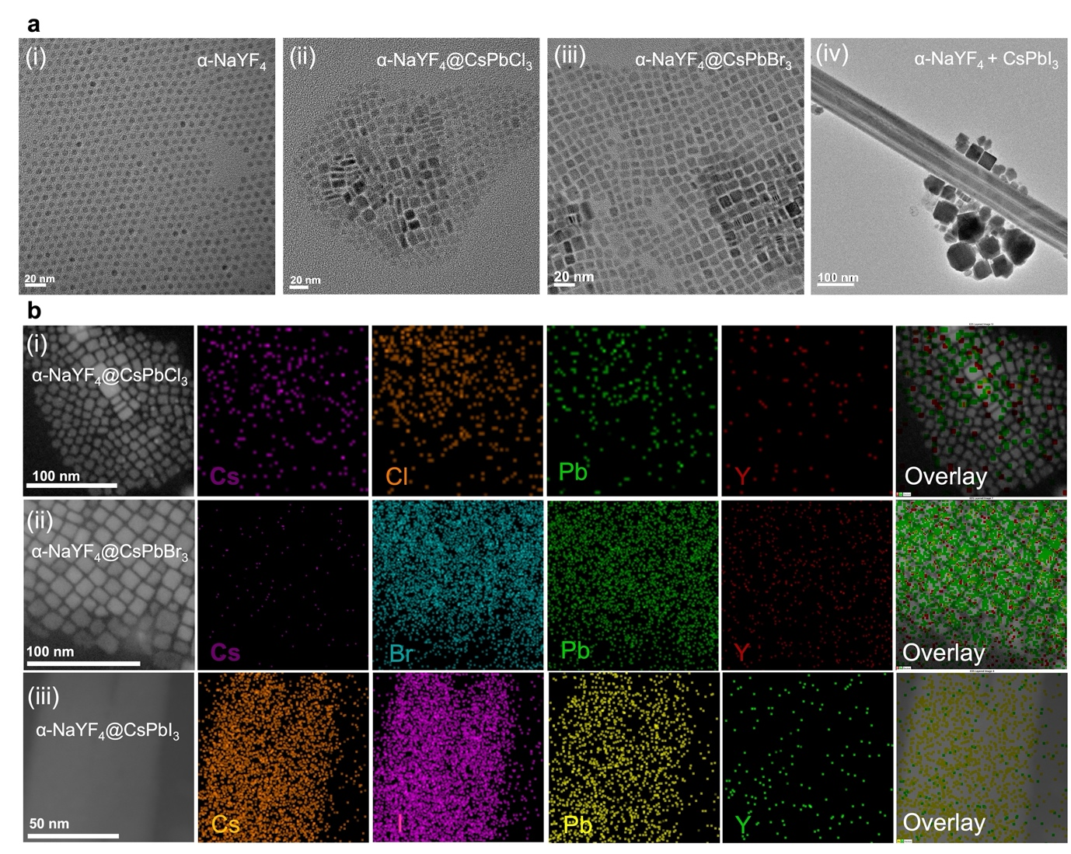

Supplementary Fig. 1 (a)(i) TEM image of ultrasmall α-NaYF₄ LnNPs. TEM images of (ii) α-NaYF₄@CsPbCl₃ NCs and nanoplatelets, (iii) α-NaYF₄@CsPbBr₃ NCs and (iv) α-NaYF₄@CsPbI₃ NWs and NCs. (b) EDS elemental mapping of (i) α-NaYF₄@CsPbCl₃ NCs, (ii) α-NaYF₄@CsPbBr₃ NCs, and (iii) α-NaYF₄@CsPbI₃ NWSCs.
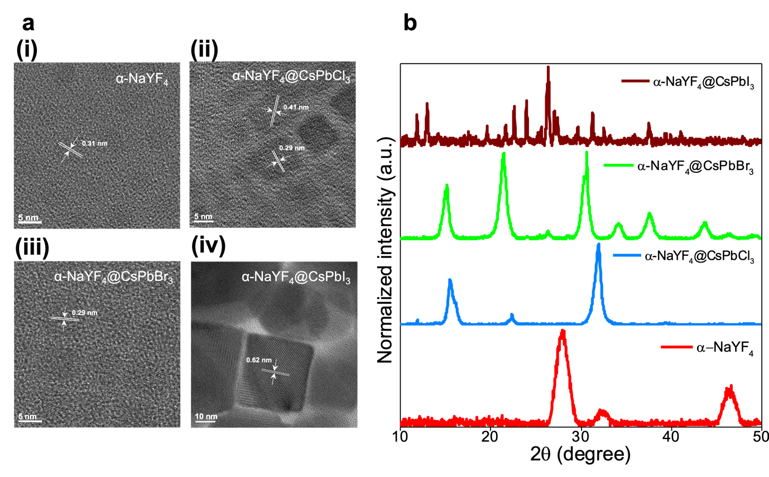
Supplementary Fig. 2 (a) HRTEM images of (i) ultrasmall α-NaYF₄ LnNPs, (ii) α-NaYF₄@CsPbCl₃, (iii) α-NaYF₄@CsPbBr₃ and (iv) α-NaYF₄@CsPbI₃. (b) XRD patterns of α-NaYF₄@CsPbX₃ samples and α-NaYF₄.

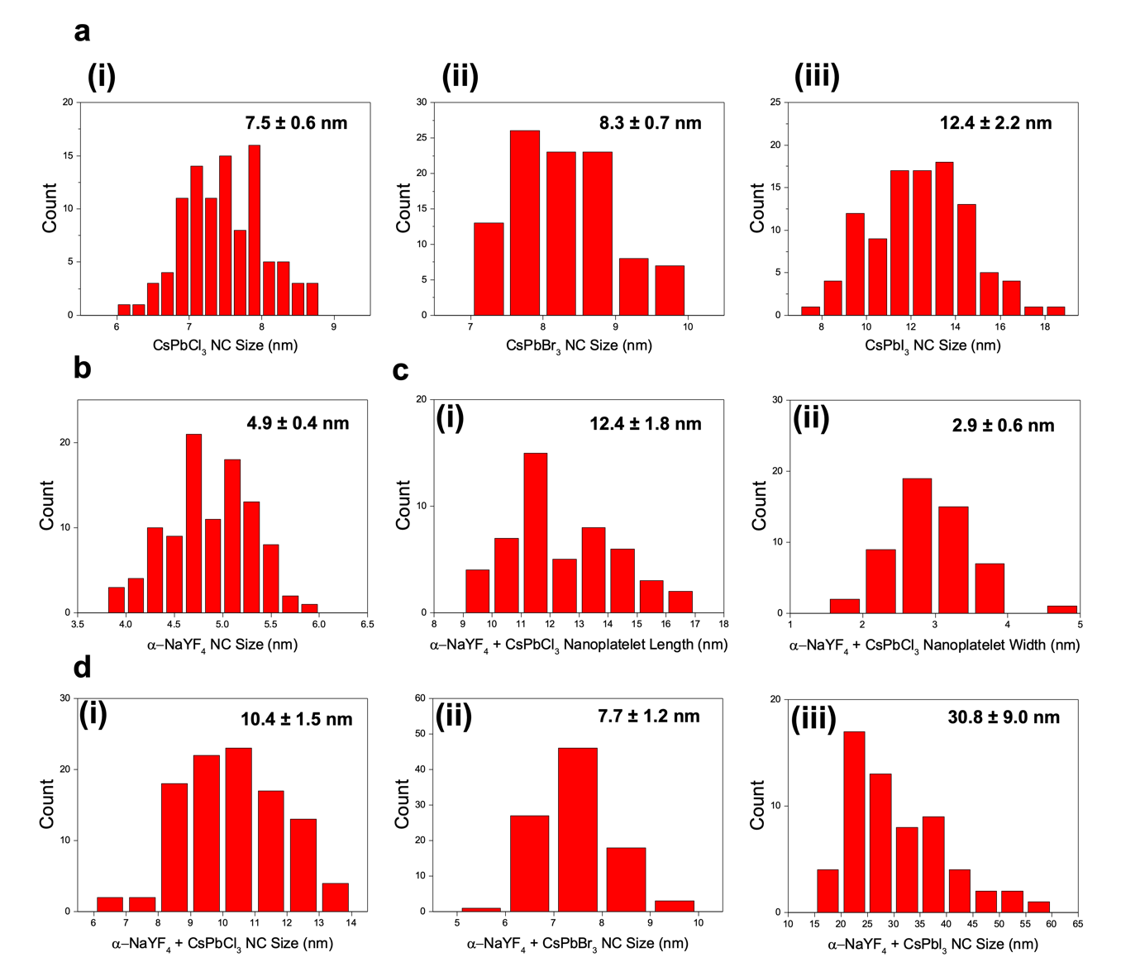

Supplementary Fig. 3 Particle size distributions of (a) pure (i) CsPbCl₃ NCs, (ii) CsPbBr₃ NCs, and (iii) CsPbI₃ NCs, (b) α-NaYF₄ LnNPs, (c) CsPbCl₃+α-NaYF₄ (i) nanoplatelet length, and (ii) nanoplatelet width, and (d) (i) α-NaYF₄@CsPbCl₃, (ii) α-NaYF₄@CsPbBr₃ and (iii) α-NaYF₄@CsPbI₃.

Supplementary Fig. 4 TEM (i) and HRTEM (ii) images of pure (a) CsPbCl₃, (b) CsPbBr₃, and (c) CsPbI₃ samples synthesized using hot injection. (d) XRD patterns of pure CsPbX₃ samples.

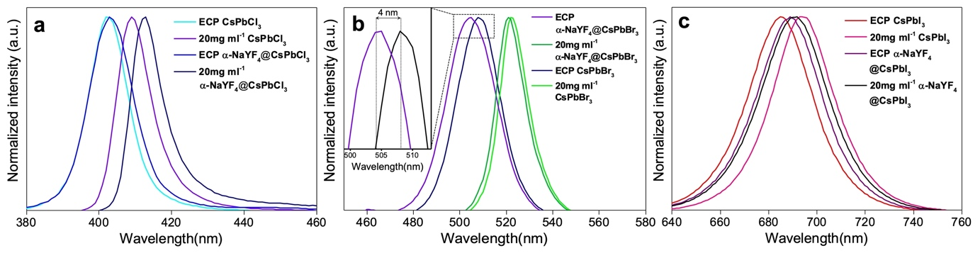

Supplementary Fig. 5 Emission spectra of (a) pure CsPbCl₃ and α-NaYF₄@CsPbCl₃, (b) pure CsPbBr₃ and α-NaYF₄@CsPbBr₃ (inset: Enlarged portion of emission spectra showing blue shifted emission for CsPbBr₃+α-NaYF₄ compared to pure CsPbBr₃), and (c) pure CsPbBr₃ and α-NaYF₄@CsPbI₃. Samples excited under 365 nm light and dispersed in hexane.

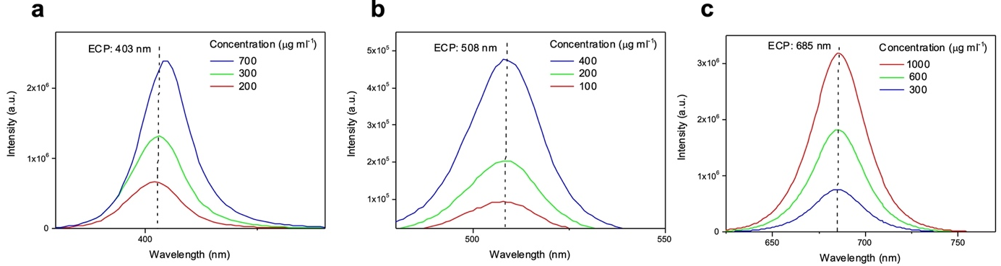

Supplementary Fig. 6 ECPs of pure (a) CsPbCl₃, (b) CsPbBr₃, and (c) CsPbI₃. Samples excited under 365 nm light and dispersed in hexane.

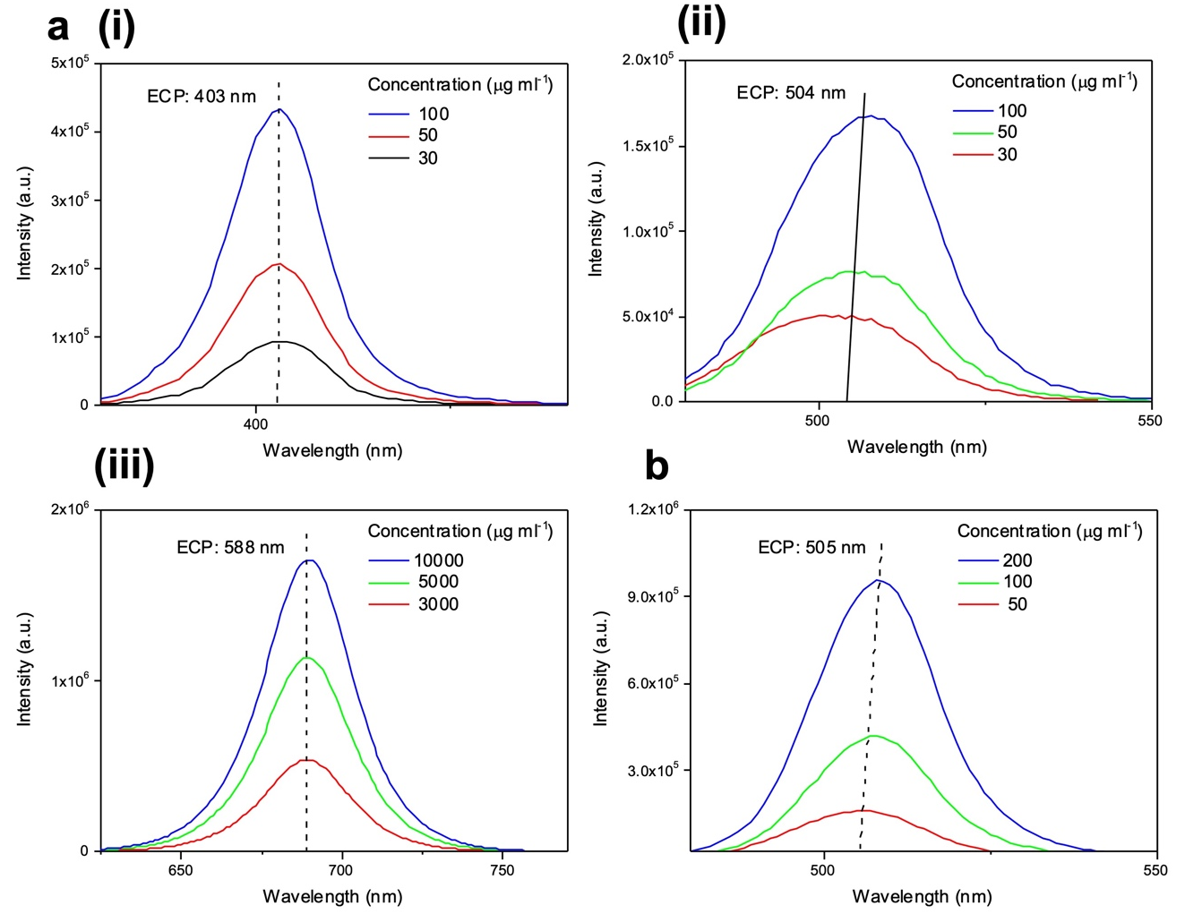

Supplementary Fig. 7 ECPs of (a)(i) α-NaYF₄@CsPbCl₃, (ii) α-NaYF₄@CsPbBr₃, and (iii) α-NaYF₄@CsPbI₃. (b) ECP of β-NaGdF₄ @CsPbBr₃. Samples excited under 365 nm light and dispersed in hexane.

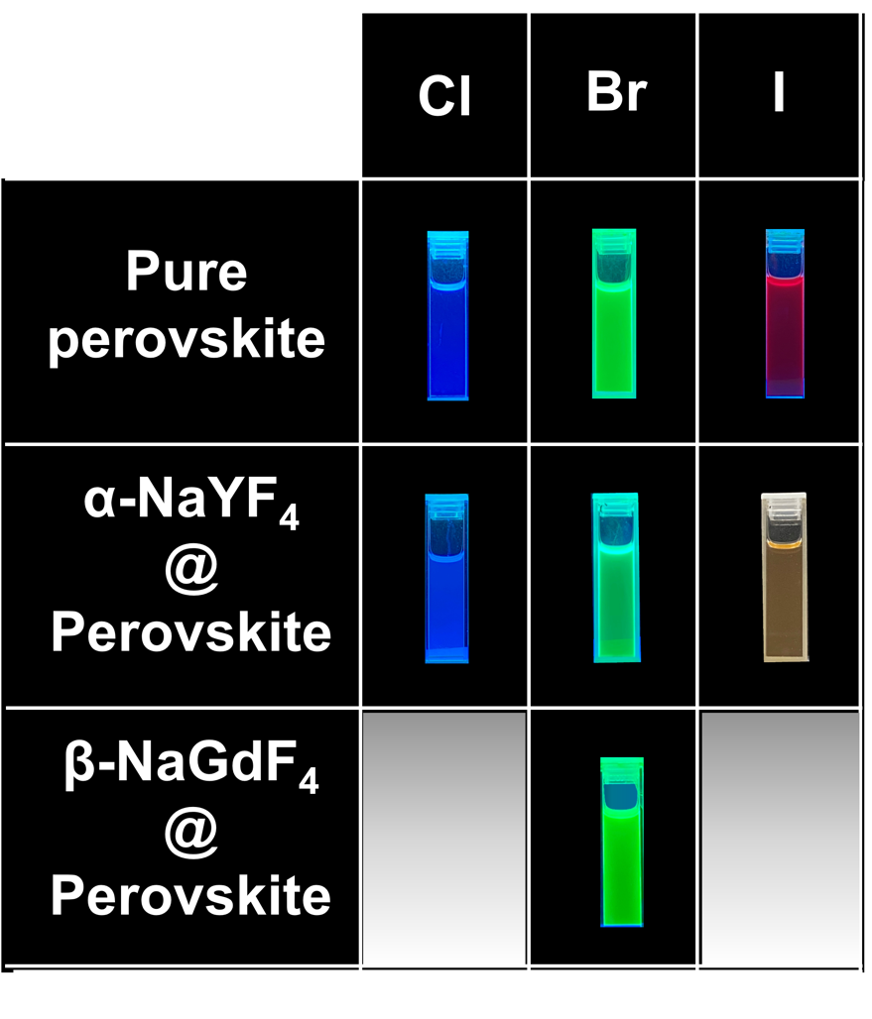
Supplementary Fig. 8 Photographs of samples taken under UV light.

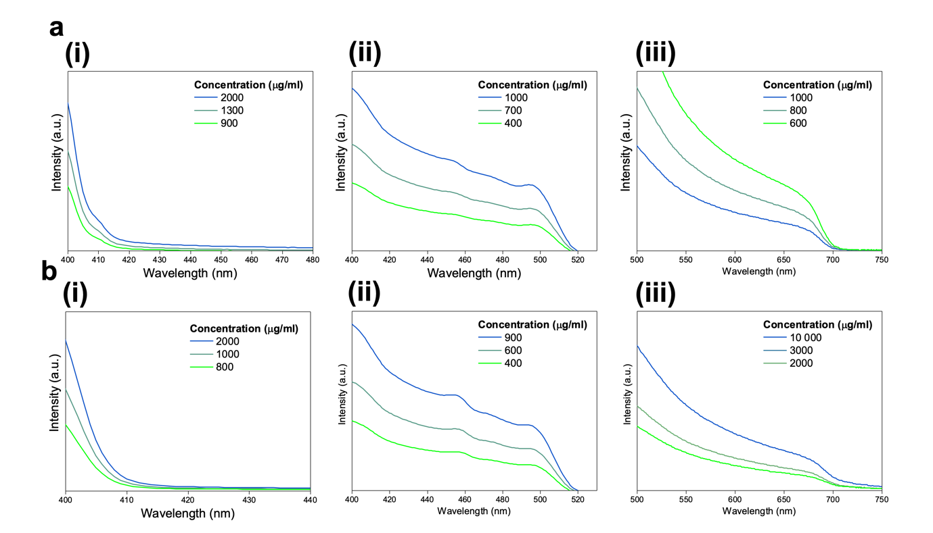

Supplementary Fig. 9 UV-Vis absorption spectra for (a) pure (i) CsPbCl₃, (ii) CsPbBr₃, and (iii) CsPbI₃, and (b)(i) α-NaYF₄@CsPbCl₃+, (ii) α-NaYF₄@CsPbBr₃, and (iii) α-NaYF₄@CsPbI₃.

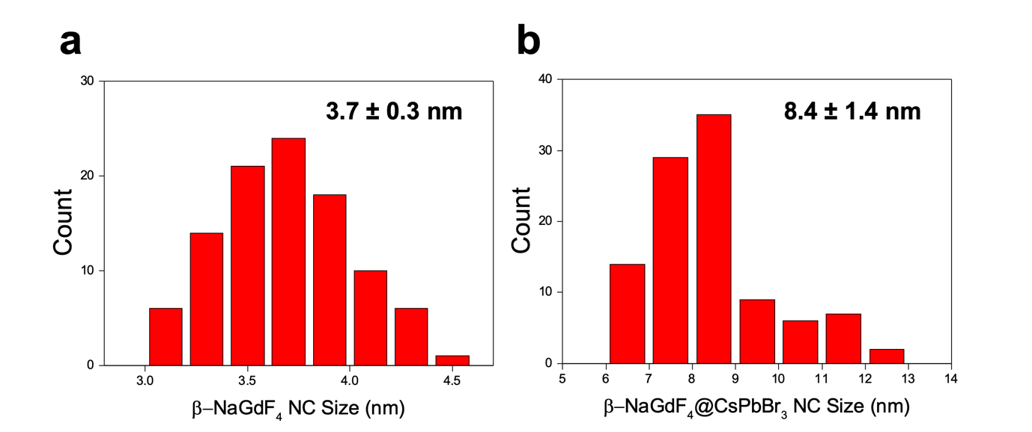

Supplementary Fig. 10 Particle size distribution for (a) β-NaGdF₄, and (b) β-NaGdF₄ @CsPbBr₃.

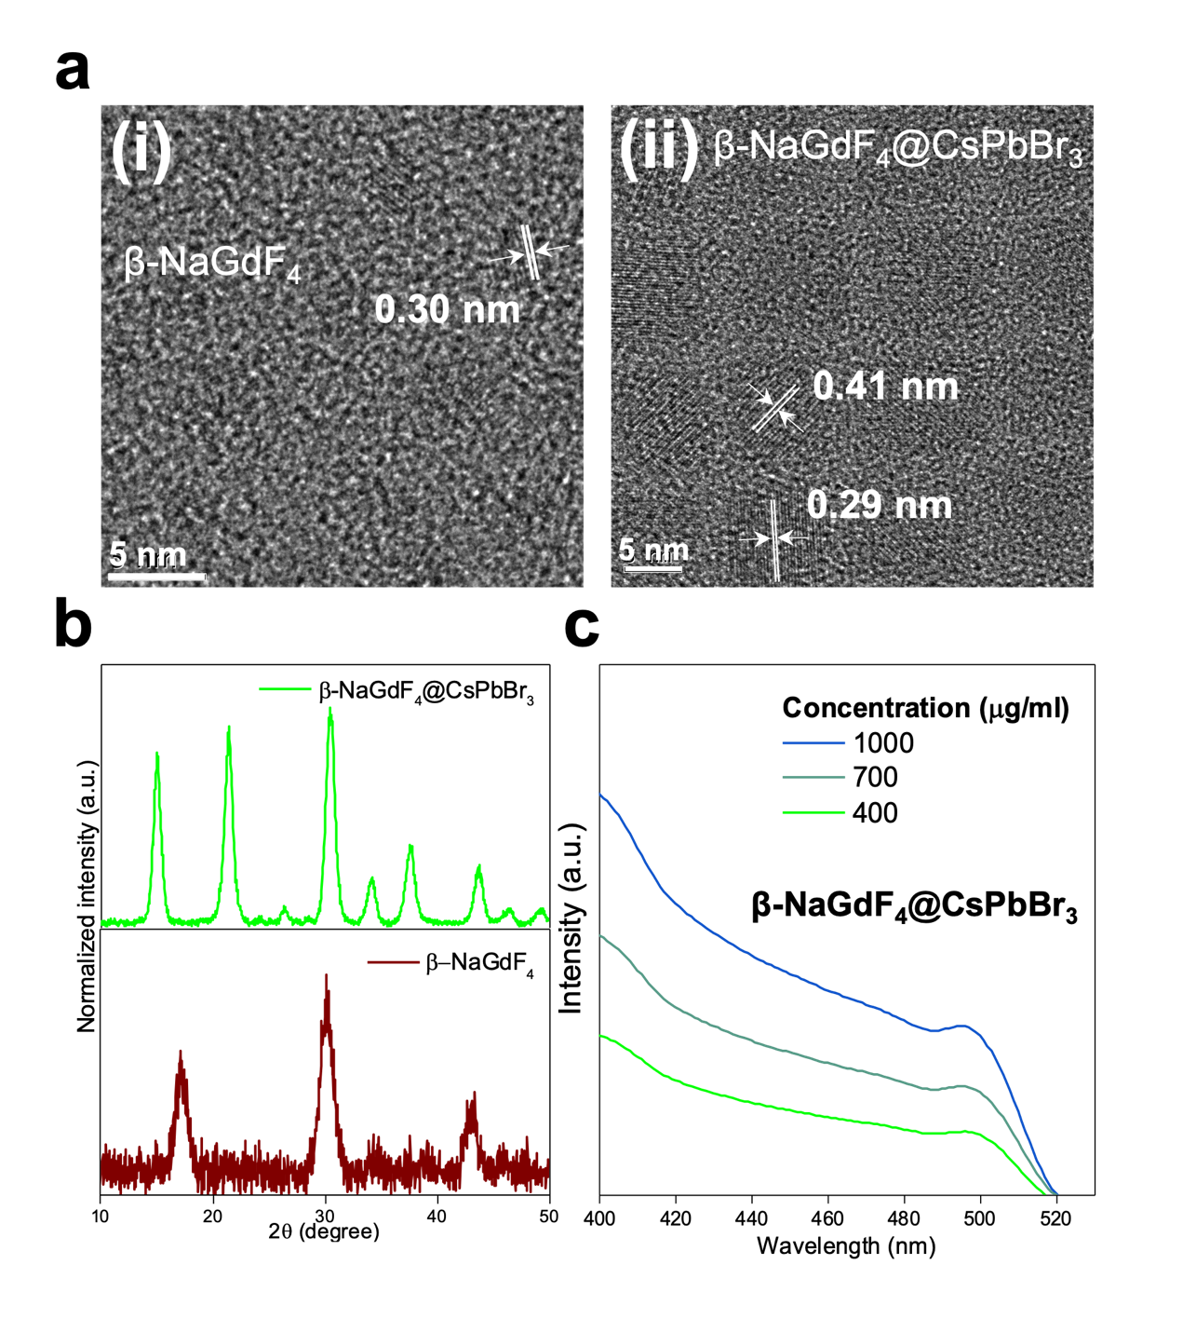
Supplementary Fig. 11 (a) HRTEM images of (i) β-NaGdF₄, and (ii) β-NaGdF₄@CsPbBr₃. (b) XRD patterns of β-NaGdF₄ and β-NaGdF₄@CsPbBr₃. (c) UV-Vis absorption spectra of β-NaGdF₄@CsPbBr₃.

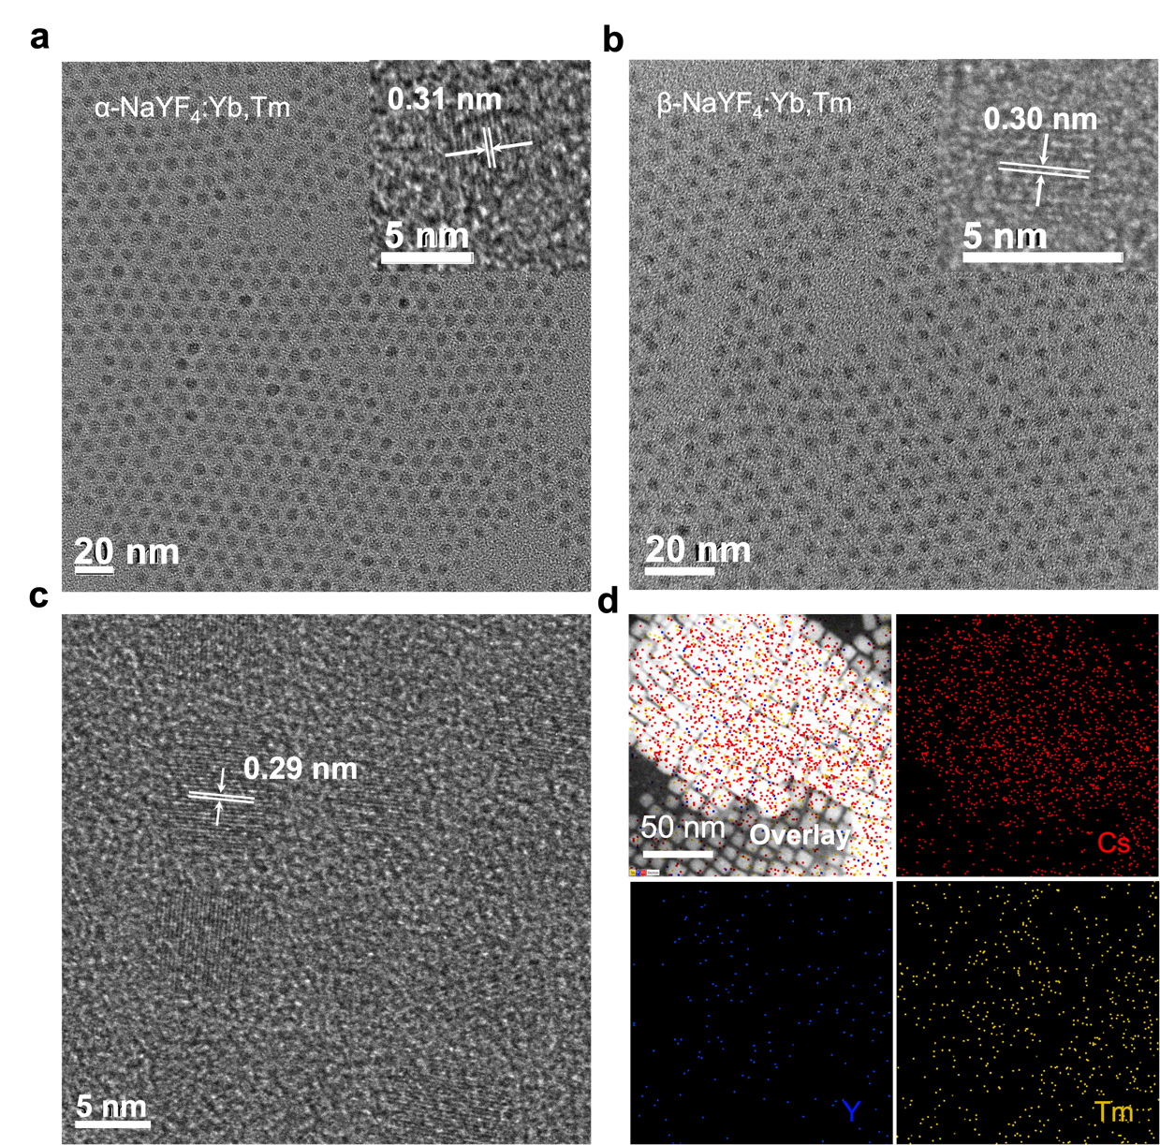

Supplementary Fig. 12 TEM image of (a) α-NaYF₄:Yb,Tm LnNPs and (b) β- NaGdF₄:Yb,Tm@CsPbBr₃. (c) HRTEM of α-NaYF₄:Yb,Tm@CsPbBr₃. (d) EDS elemental mapping of α-NaYF₄:Yb,Tm@CsPbBr₃.
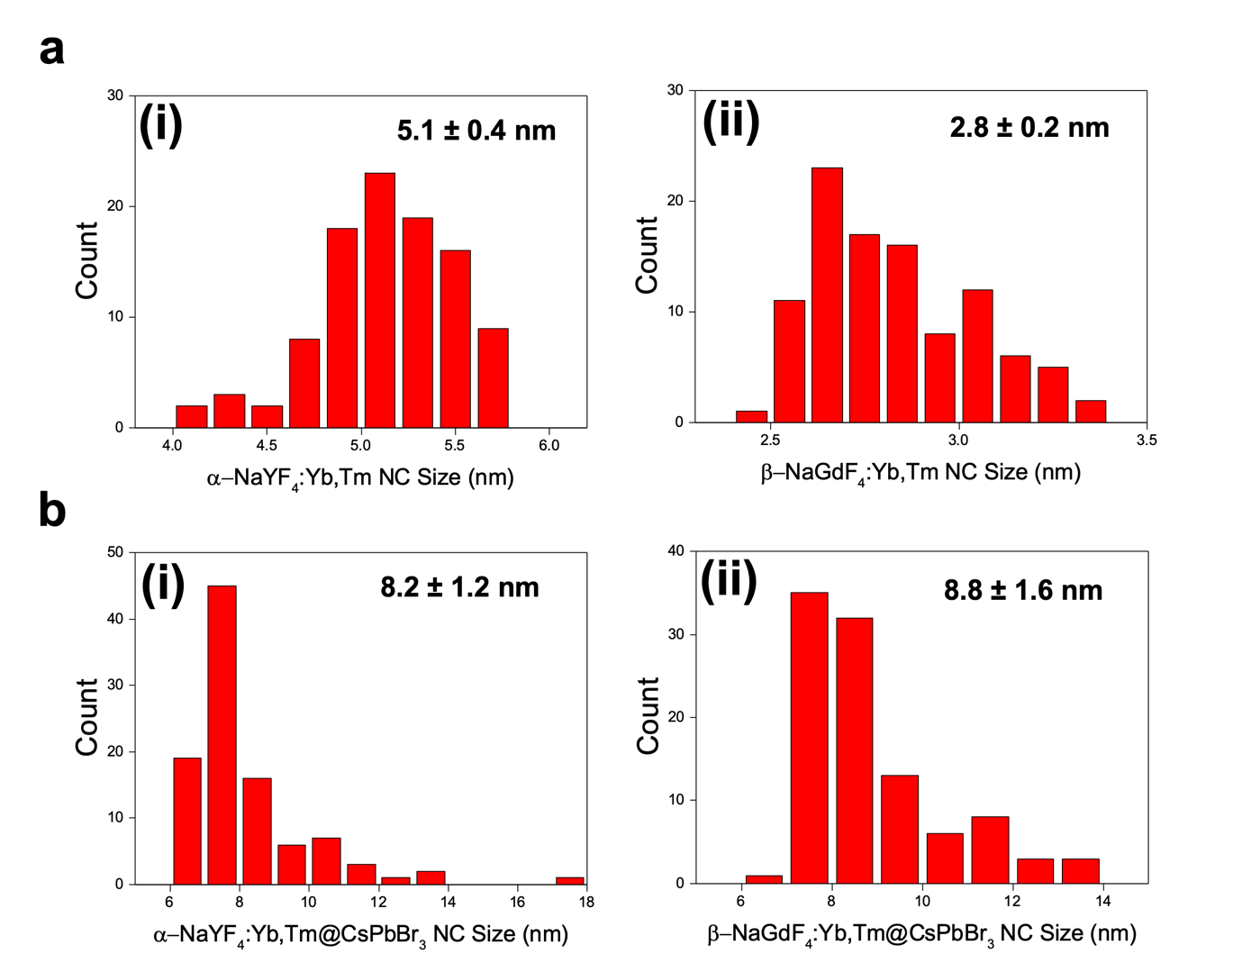

Supplementary Fig. 13 (a) Particle size distributions of (i) α-NaYF₄:Yb,Tm and (ii) β-NaGdF₄:Yb,Tm LnNPs. (b) Particle size distributions of (i) α-NaYF₄:Yb,Tm@CsPbBr₃ and (ii) β-NaGdF₄:Yb,Tm@CsPbBr₃.

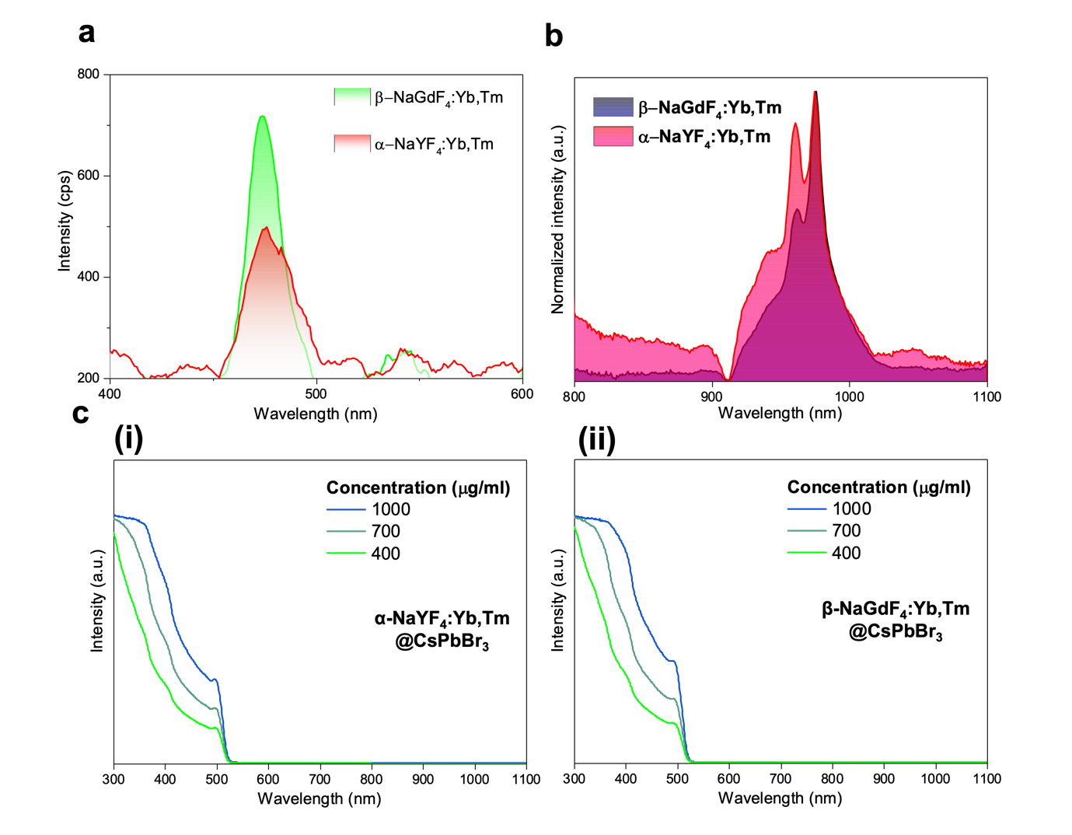

Supplementary Fig. 14 (a) Emission spectra of α-NaYF₄:Yb,Tm and β-NaGdF₄:Yb,Tm LnNPs under 980 nm laser excitation. (b) Absorption spectra of α-NaYF₄:Yb,Tm and β-NaGdF₄:Yb,Tm LnNPs in NIR range. Samples prepared with concentration of 20 mg ml⁻¹. (c) Absorption spectra of (i) α-NaYF₄:Yb,Tm@CsPbBr₃ and (ii) β-NaGdF₄:Yb,Tm@CsPbBr₃ in visible range at different concentrations.
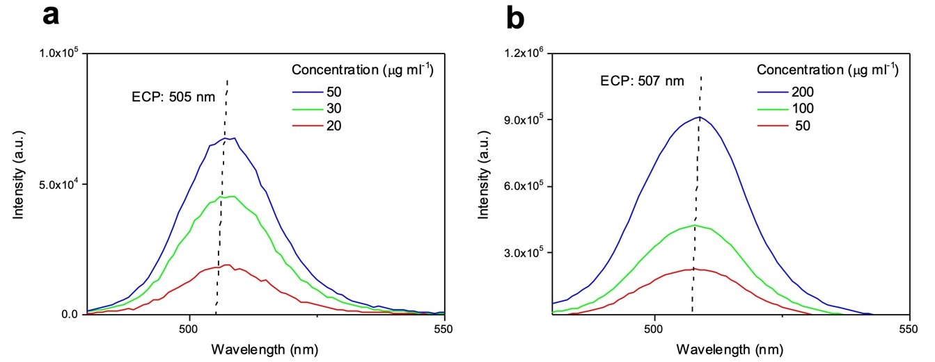

Supplementary Fig. 15 ECPs of (a) α-NaYF₄:Yb,Tm@CsPbBr₃ and (b) β-NaGdF₄:Yb,Tm@CsPbBr₃. Samples excited under 365 nm light and dispersed in hexane.

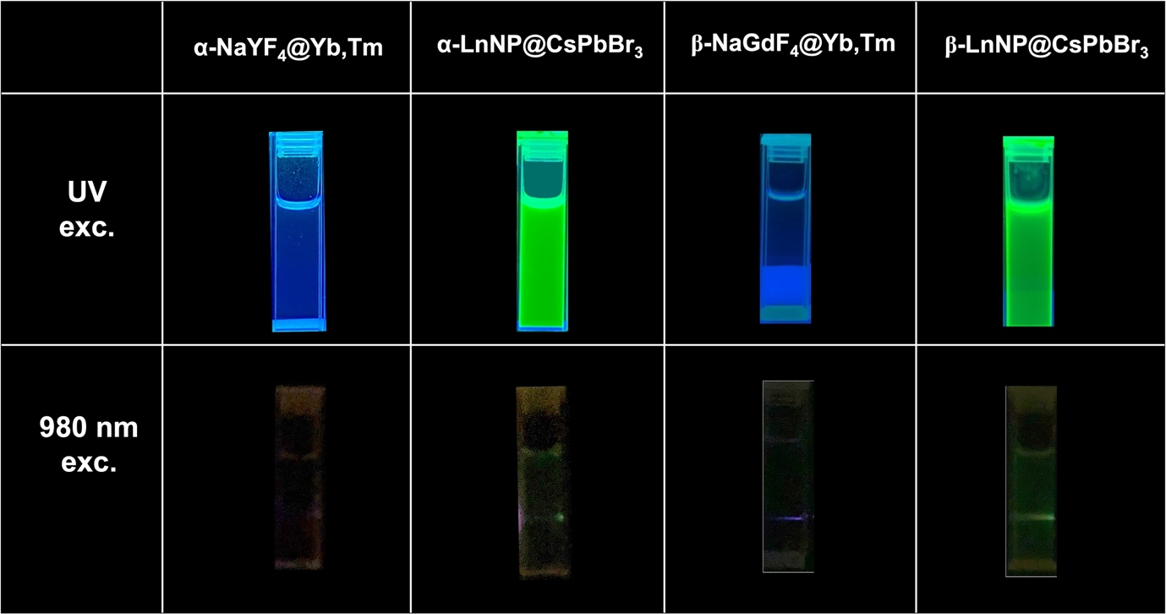

Supplementary Fig. 16 Photographs of samples taken with UV light and 980nm laser excitation.

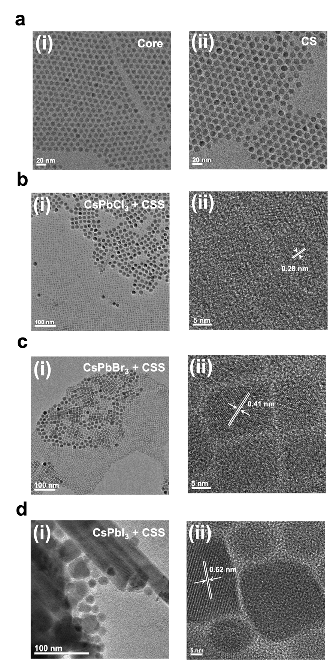

Supplementary Fig. 17 TEM images of (a)(i) core LnNPs, (ii) core-shell LnNPs, (b)(i) CsPbCl₃+CSS, (c)(i) CsPbBr₃+CSS, and (d)(i) CsPbI₃+CSS samples. HRTEM images of (b)(ii) CsPbCl₃+CSS, (c)(ii) CsPbBr₃+CSS, and (d)(ii) CsPbI₃+CSS samples.

Supplementary Fig. 18 Particle size distributions of (a) (i) core LnNPs, (ii) core-shell LnNPs, (iii) CSS LnNPs, (b) CsPbCl₃ NCs, and (c) CsPbBr₃ NCs.
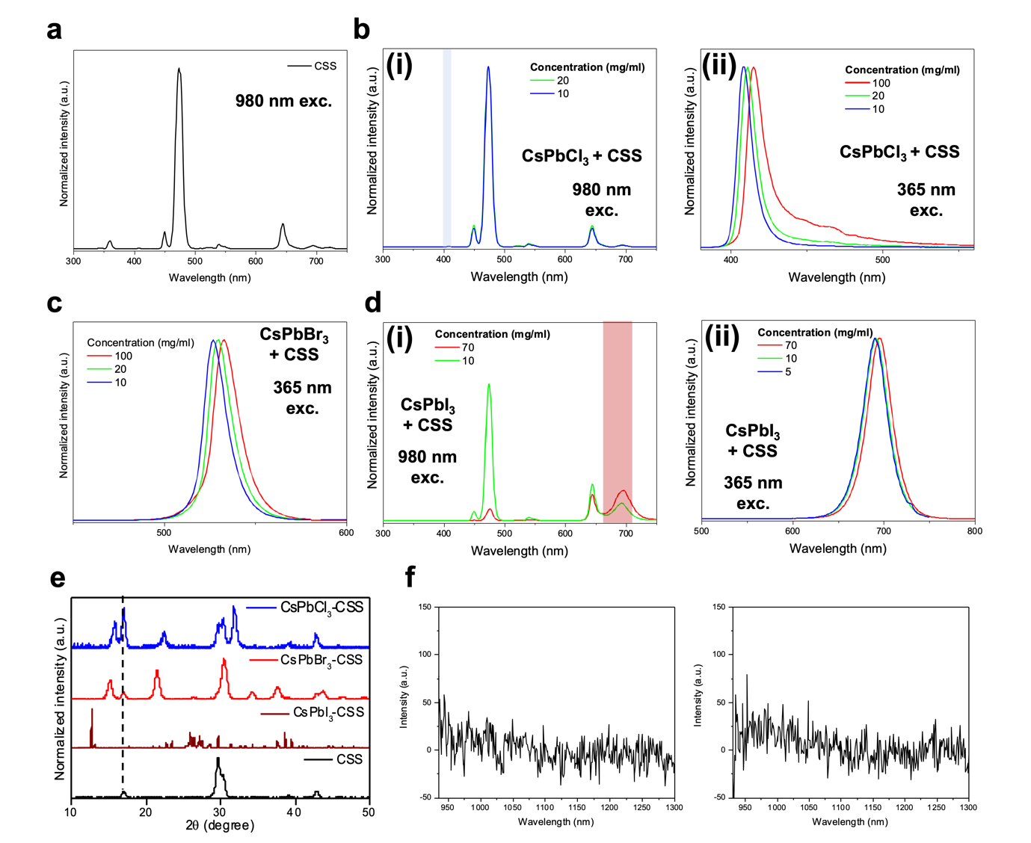

Supplementary Fig. 19 (a) Emission spectra of CSS LnNPs under 980nm laser excitation. Emission spectra of (b) CsPbCl₃+CSS under (i) 980nm, (ii) 365nm excitation, (c) CsPbBr₃+CSS under 365nm excitation, (d) CsPbI₃+CSS under (i) 980nm, and (ii) 365nm excitation. Samples are dispersed in hexane. (e) XRD patterns of CSS LnNPs and CsPbX₃+CSS samples. (f) NIR emission of CsPbCl₃+CSS and CsPbBr₃+CSS.

Supplementary Fig. 20 EDS scans of the (a) CsPbCl₃+CSS, and (b) CsPbI₃+CSS samples.

Supplementary Fig. 21 UV-Vis absorption spectra of (a) CsPbCl₃+CSS, (b) CsPbBr₃+CSS, and (c) CsPbI₃+CSS samples.

