Supplementary Material
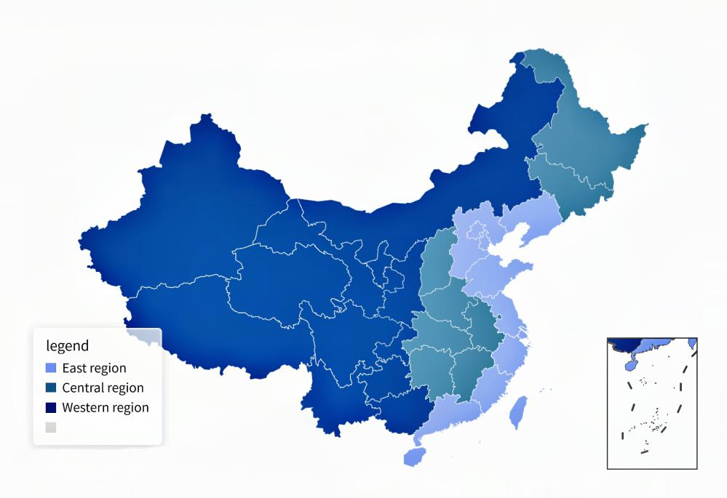
S1 Distribution of eastern, central and western China

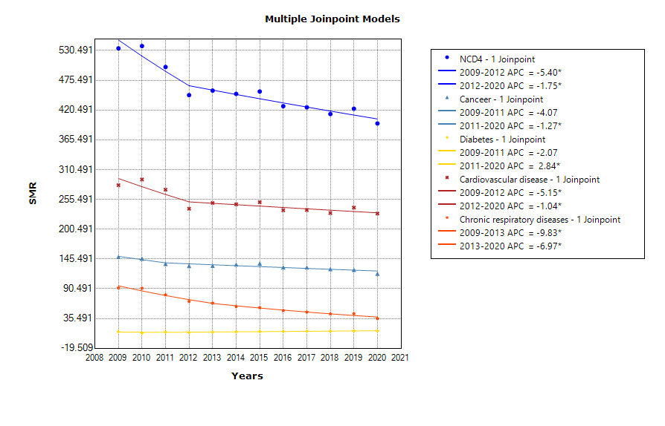
S2A Trends in standardized mortality rates are illustrated using Joinpoint analyses from the four major NCDs. APC indicates annual percentage change. P ≤0.05
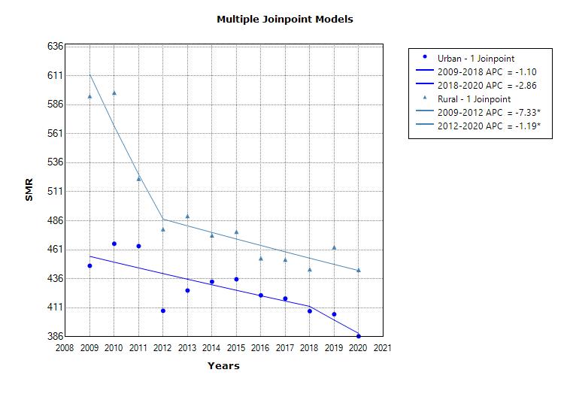
S2B Trends in standardized mortality rates are illustrated using Joinpoint analyses from the four major NCDs by geographic. APC indicates annual percentage change. P ≤0.05
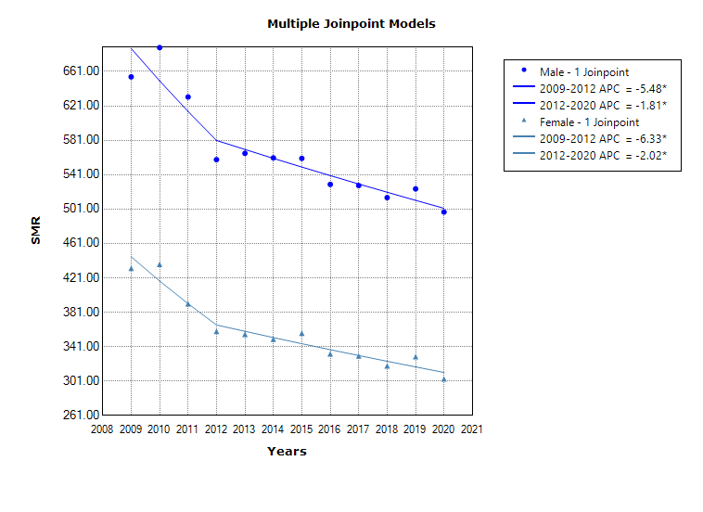
S2C Trends in standardized mortality rates are illustrated using Joinpoint analyses from the four major NCDs by gender. APC indicates annual percentage change. P ≤0.05
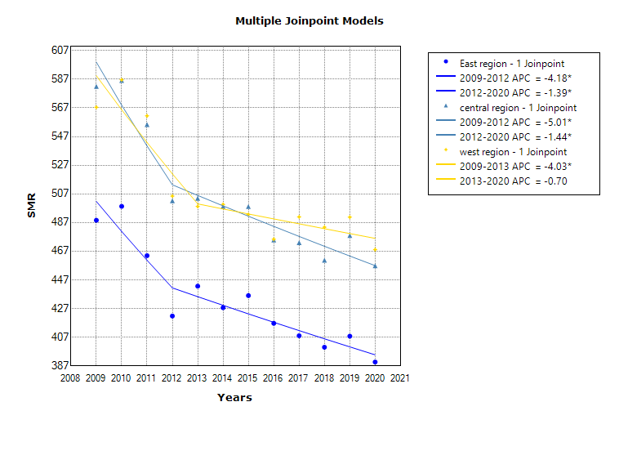
S2D Trends in standardized mortality rates are illustrated using Joinpoint analyses by region. APC indicates annual percentage change. P ≤0.05

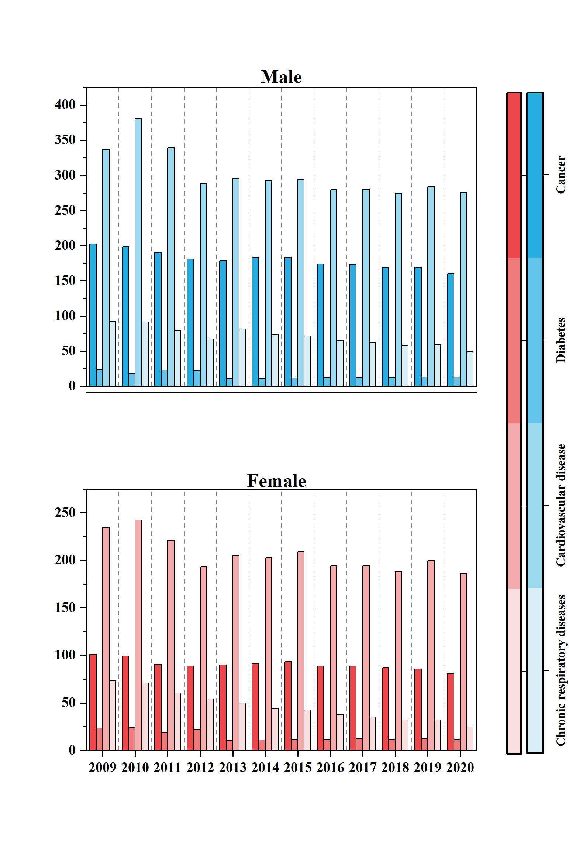
S3A Standardized mortality rates for Cancer, Diabetes, Cardiovascular disease and Chronic respiratory disease by gender
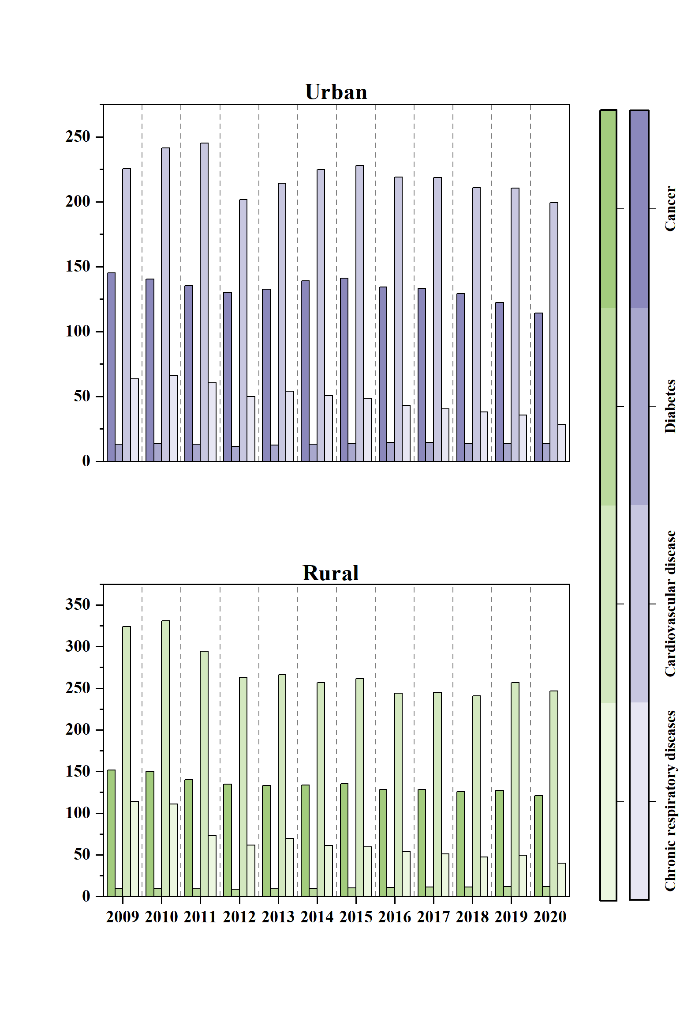
S3B Standardized mortality rates for Cancer, Diabetes, Cardiovascular disease and Chronic respiratory disease by urban and rural groups

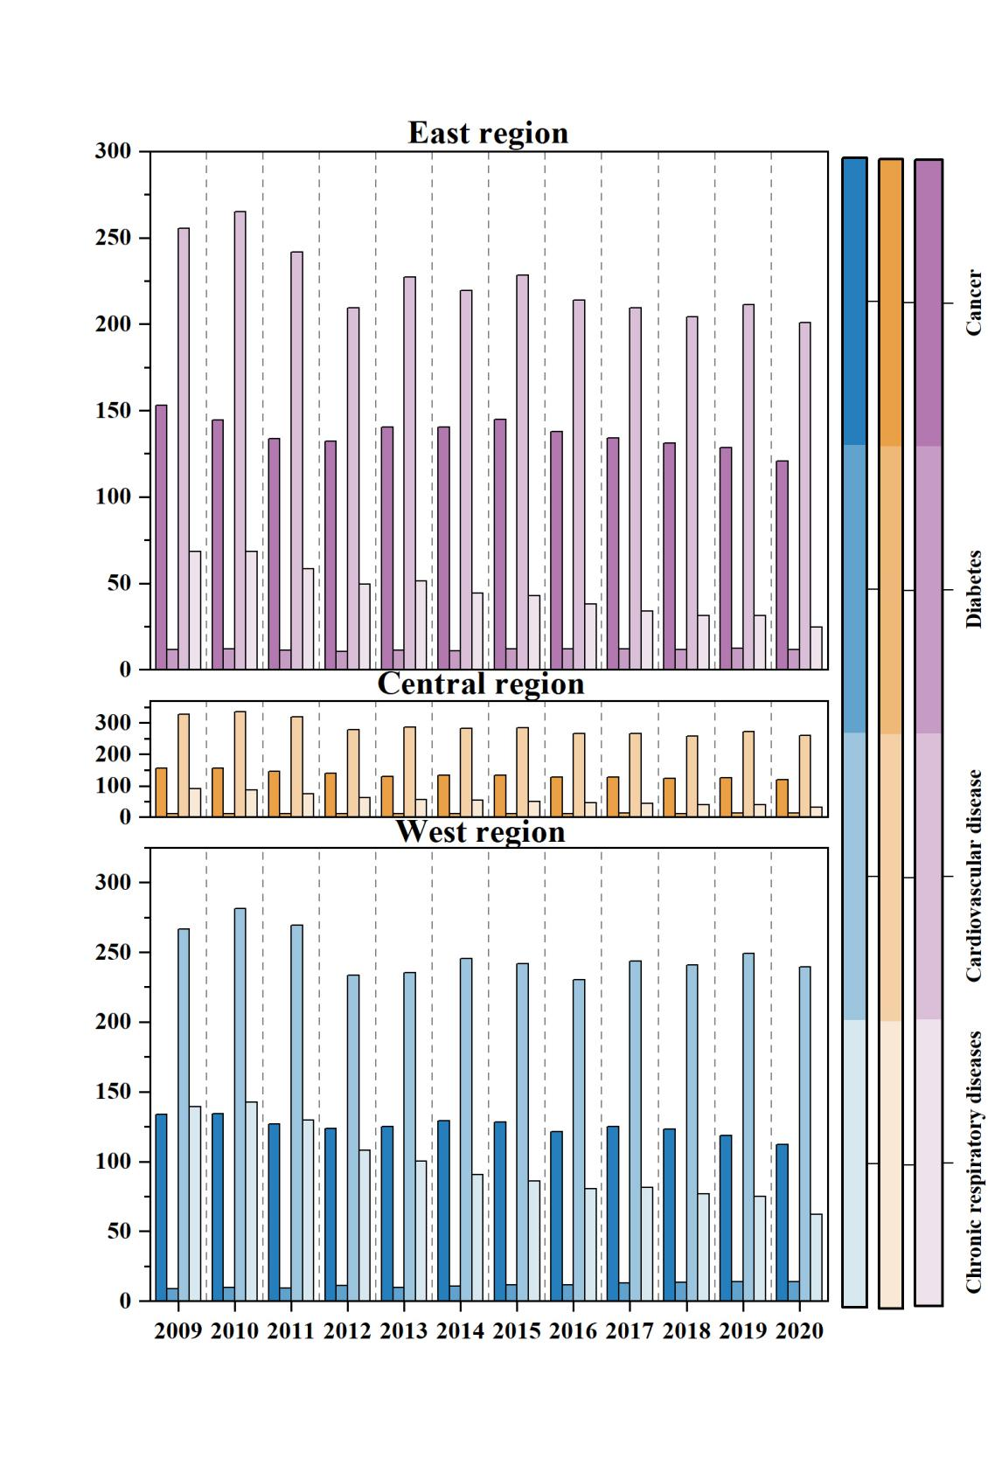

S3C Standardized mortality rates for Cancer, Diabetes, Cardiovascular disease and Chronic respiratory disease by regions

