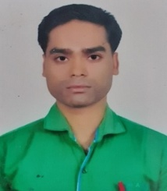
Ashish Kumar Soni is qualified UGC NET in 2019. Presently he is working as an Assistant Professor in Computer Science and Information Technology (CS & IT) department at Govt. College, Jaitwara, M.P., India. He is having over 7 years experience in academic and non-academic areas. His expertise areas are information hiding techniques, AI, Ad-hoc Networks, Cloud Computing and Data mining.

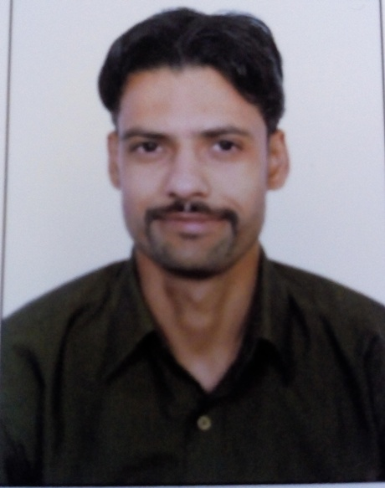
Dr. Ankur Khare completed his Bachelor of Engineering (B.E.) degree in Computer Science and Engineering (CSE), MPCT, Gwalior, M.P., India in 2011, Master of Engineering (M.E.)in Computer Science & Engineering (CSE) in 2014 from UIT, RGPV, Bhopal, M.P., India, Ph.D. (Computer Science & Engineering (CSE)) in 2021 from Rabindranath Tagore University, Bhopal, M.P., India. He is also qualified UGC NET in 2013 and GATE in 2020. He served as an Assistant Professor in Computer Science (CS) and Computer Science Engineering (CSE) department in various colleges in India. Presently he is working as an Assistant Professor in Computer Science and Information Technology (CS & IT) department at Rabindranath Tagore University, Bhopal, M.P., India. He is having over 8 years of academic and research experience. His expertise areas are Cyber Security, Blockchain, Cryptography, Data Mining, Machine Learning, Ad-hoc Networks and Wireless Security. He is published research papers in SCI/SCIE/SCOPUS indexed journals.His research areas are Computer Networks, Network Security, Crypto-Virology and Chaotic System.

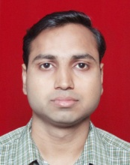
Dr. Rajendra Gupta is an Associate Professor in Rabindranath Tagore University, Raisen. He is doctorate in Computer Science and having 20 years of working experiences in Government and Non-Government Academic Fields. His teaching and research areas belong to Image Processing, Network Security, Data Mining and Statistical Analysis. He has published 52 research papers in International and National Journals and presented 12 papers in international conferences. He is reviewer of International Journals and member of various Academic Bodies.

