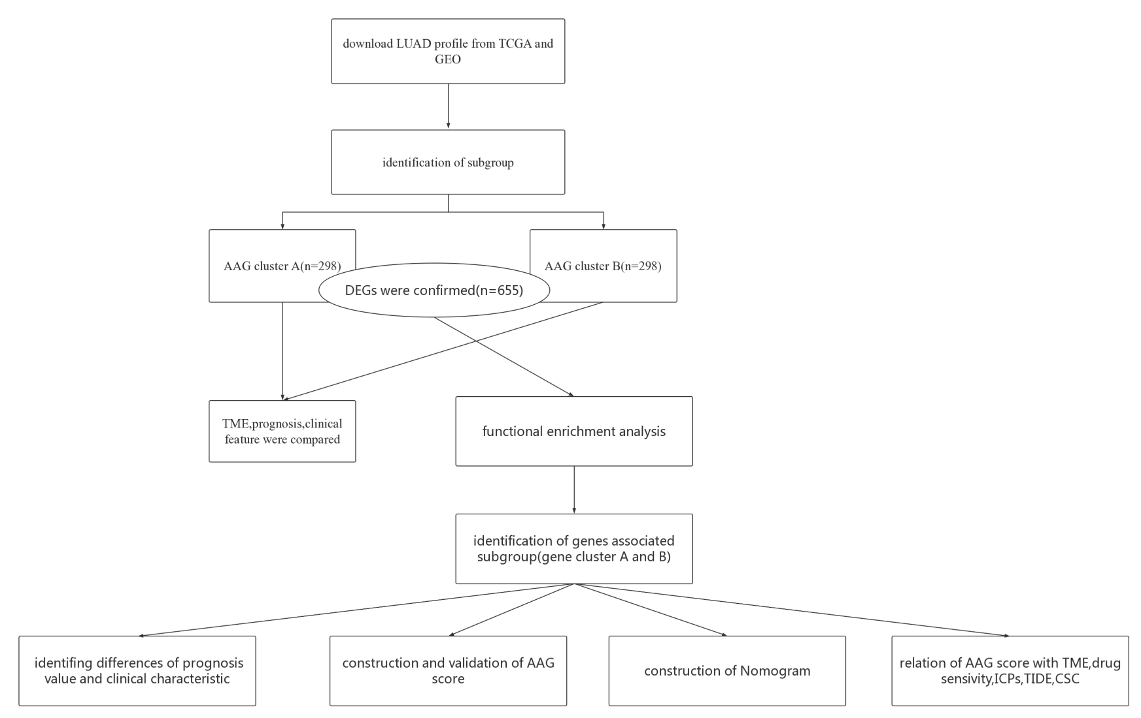

Figure S1.Flow chart of the study
(A)
Id | coef
FLNC | 0.119045864849518
MARVELD1 | 0.23730958229692
IL7R | -0.26768672369
ANLN | 0.135481378556386
FSTL3 | 0.155314846508861
AKAP12 | 0.134865024033759
(B)(C)
Figure S2 Identifying representative candidate prognostic genes.(A) The results of multivariate cox regression analysis for prognostic genes.(B-C) The LASSO regression analysis and partial likelihood deviance on the prognostic genes.

(A)(B)(c)(D)(E)
Figure S3 Validation of AAG_score in test cohort. (A) Expression patterns of selected prognostic genes in high- and low-risk groups.(B)KM analysis of the OS between the two groups. (C-D).The ranked dot plot indicates the AAG_score distribution and scatter plot presenting the patients’ survival status.(E)ROC curves to predict the sensitivity and specificity of 1-, 3-, and 5-year survival according to the AAG_score.

(A)(B)(c)
(d)(E)
Figure S4 Validation of AAG_score in entire cohort.( A)Expression patterns of selected prognostic genes in high- and low-risk groups.(B.C)The ranked dot plot indicates the AAG_score distribution and scatter plot presenting the patients’ survival status. (D)KM analysis of the OS between the two groups.(E)ROC curves to predict the sensitivity and specificity of 1-, 3-, and 5-year survival according to the AAG_score.

