Supplementary Information

Observation of spatiotemporal temperature-dependent catalytic activation within individual catalyst particle at work
Yu Tian^{1,2}, Mingbin Gao^{1,*}, Hua Xie¹, Xuelian Zhou^{2,3}, Qinglong Qiao³, Shuliang Xu¹, Zhaochao Xu³, Mao Ye^{1,*}, Zhongmin Liu^{1,2}
¹National Engineering Research Center of Lower-Carbon Catalysis Technology, Dalian National Laboratory for Clean Energy, Dalian Institute of Chemical Physics, Chinese Academy of Sciences, Dalian 116023, People’s Republic of China
²University of Chinese Academy of Sciences, Beijing 10049, People’s Republic of China
³Key Laboratory of Separation Science for Analytical Chemistry, Dalian Institute of Chemical Physics, Chinese Academy of Sciences, Dalian 116023, People’s Republic of China
*Corresponding authors, e-mail address: mbgao@dicp.ac.cn (M. Gao) and maoye@dicp.ac.cn (M. Ye).

Table of Contents

Supplementary Notes 1. Summary of typical spatiotemporal-resolved temperature measurement methods
Supplementary Notes 2. Materials
Supplementary Notes 3. Characterization methods of materials
Supplementary Notes 4. Preparation and characterizations of nanothermometry
Supplementary Notes 5. Preparation and characterizations of catalyst particle
Supplementary Notes 6. Multimodal imaging techniques
Supplementary Notes 7. Methanol-to-hydrocarbons catalyzed by H-ZSM-5 zeolites at different temperature
Supplementary Notes 8. Methanol-to-hydrocarbons catalyzed by catalyst particle
Supplementary Notes 9. Simulations

Supplementary Notes 1. Summary of typical spatiotemporal-resolved temperature measurement methods
Technology | Resolution |  | Temperature range | Example
Technology | Spatial- | Temporal- | Temperature range | Example
Infrared thermography | 10 µm | 10 μs | 230-2200 K | Simeone et al.¹ measured the temperature profiles of the fixed-bed reactor by fast IR thermography at a spatial resolution of 1 mm.
Upconversion luminescence thermometry | 0.1 µm | 10 µs | 300-900 K | Hartman et al.² determined the local temperature of catalyst particle surface with an accuracy of 0.3 K and demonstrated that the set temperature is deviated from the local temperature at the catalyst surface.
Magnetic resonance imaging | 1 mm | - | - | Koptyug et al.³ implemented MRI-based approach for the thermometry of fixed-bed reactor during propylene hydrogenation catalyzed by Pd/γ-Al₂O₃ catalyst.
Thermocouple | 100 µm | 10 µs | -270-2300 K | Yarulina et al.⁴ proved that the strong effect of heat generation inside the catalyst bed on lifetime of MTH reaction over ZSM-5 by using multiple thermocouples placed at different position in the fixed-bed reactor.
Fluorescence thermometry | 0.1µm | 10µs | RT-800K | Terlingen et al.⁵ used EuOCl as both catalyst and thermometer to operando measure reaction temperature, and studied the dynamic changes of the reaction conditions and catalyst temperature.
Raman thermometry | 1 µm | 1 s | 300-2500 K | Smith et al.⁶ showed the temperature-dependent Raman signals and used Raman thermometry to measure heat effect during free evaporation.

Supplementary Notes 2. Materials
The following chemicals were purchased from Tianjin Kemiou Chemical Reagent Co., Ltd.: cyclohexane (99.5%, CH), ethanol (>99.8%, EtOH), methanol (>99.85%, MeOH), sodium hydroxide (> 97%, NaOH), ammonium hydroxide (28 wt% in H₂O, ammonia), tetraethyl orthosilicate (99.999%, TEOS) and furfuryl alcohol (98.5%, FA). IGEPAL CO-520 ((C₂H₄O)_{n}·C₁₅H₂₄O with n ≈ 5, average Mn = 441g mol⁻¹, NP-5) was provided by Shanghai Aladdin Biochemical Technology Co., Ltd.. Demineralized water was purified by a Milli-Q system (18.2 MΩ) before use. The main chemicals used in the synthesis of catalyst particle by micro-fluidic chip are polydimethylsiloxane (PDMS) (Dow Coming Corporation, USA), soya-bean oil (Yihai Kerry Co., Ltd. China), Polyglyceryl polyricinoleate (Palsgaard Co., China), PEG-10000 (Sinopharm Chemical Reagent Co., Ltd. China), nitric acid (65-68%) (Xilong Scientific Limited Co., China), silica gel solution (30%) (Qingdao Ocean Chemical Co., Ltd. China) and acetic acid (Sinopharm Chemical Reagent Co., Ltd. China). All chemicals were used without further purification. Na-ZSM-5 zeolites was purchased from Saint Chemical Materials.

Supplementary Notes 3. Characterization methods of materials
X-ray diffraction (XRD). The crystalline and phase purity of the materials were characterized by powder X-ray diffraction on a PANalytical X’Pert PRO X-ray diffractometer. Cu Kα radiation (λ = 0.154 nm) was used as the X-ray source, operated at 40 mA and 40 kV. XRD patterns were recorded in the range of 2θ = 5 ~ 60°.
X-ray fluorescence (XRF) spectrometer. The chemical composition of H-ZSM-5 zeolites was determined with a Philips Magix-601 spectrometer. The composition of H-ZSM-5 zeolites are expressed as Si/Al.
Nitrogen isothermal adsorption-desorption. After the sample was degassed at 623 K under vacuum for 6 h, the nitrogen isothermal adsorption-desorption was conducted with Micromeritics ASAP 2020 at 77 K. The surface area, total pore volume, and micropore volume were calculated by Brunauer-Emmett-Teller (BET) and t-plot methods.
Ammonia-temperature-programmed desorption (TPD). The NH₃-TPD profiles of samples were recorded on a chemical adsorption instrument, namely Micrometric 2920. During the experiments, the sample (40-60 mesh, ~ 0.1 g) was placed in a quartz U-shaped reactor and heated at 873 K in flowing He for 1 h. After cooling to 373 K, the sample was saturated with NH₃ gas. Then the gas is switched to He and purged for 30 minutes to desorb the physically adsorbed ammonia. Next, NH₃-TPD was carried out at a constant heating rate of 10 K/min from 373 to 973 K and the ammonia desorption signal was detected by TCD detector.
Scanning electron microscopy (SEM). The morphology, particle size and size distribution of catalysts were observed by field-emission-SEM Hitachi SU8020 and Hitachi TM3000.
High-resolution transmission electron microscopy (HRTEM). HRTEM images of nanothermometry particle were obtained by JEOL JEM-2100. Integrated differential phase contrast scanning transmission electron microscopy (iDPC-STEM) images of H-ZSM-5 zeolite were recorded on FEI Titan Cubed Themis ETEM G3.
Luminescence thermometry. Upconversion luminescence spectra were obtained via fluorescence spectrometer (Edinburgh FS5), in which a heating platform (Linkam HFS600E-PB2) was attached⁷.
Structured Illumination Microscopy (SIM). Super resolution fluorescence imaging was performed using an N-SIM structured illumination imaging microscope from Nikon, Japan. The objective system was an inverted mechanical moving ECLIPSE TI-E, a 100×/NA 1.49 oil-immersed TIRF objective (for the measurements of spatial distribution of coke species) or a 10×/0.30 objective (for the measurements of diffusion of FA in catalyst particles) and an ORCA-Flash 4.0 sCMOS camera.
Diffuse reflectance infrared transform spectroscopy (DRIFTS). DRIFT was used to detect the changes of hydroxyl (Brønsted acid site, BAS) signal and carbonaceous-chemical bond formation within zeolite catalysts during methanol-to-hydrocarbons (MTH) reaction. DRIFT spectra were recorded on a Bruker Vextex 70 spectroscope equipped with an MCT detector. The catalyst sample was placed in the PIKE in-situ reaction cell with a ZnSe window and heated at 623 K to remove the adsorbed water. The spectra were detected by collecting 32 scans at resolution of 4 cm⁻¹ under flowing nitrogen and the spectrum range is 4000-500 cm⁻¹.
Analysis of coke species within catalysts by solution–extraction experiments. Weighting about 15 mg of catalyst sample into a polytetrafluororthylene tube, adding 1 mL of 20 vol% hydrofluoric acid aqueous solution, standing for ~ 8 h to fully dissolve the zeolite framework. Subsequently, adding 1 mL of dichloromethane with internal standard substance of hexachloroethane (100 ppm), standing for about 1 h. Then, adding 5wt% sodium hydroxide aqueous solution to neutralize the solution to pH ~7. The solution in the tube was transferred to a separatory funnel and then left to separated layers. The lower organic phase in the funnel was collected by a chromatographic bottle and filtered with an organic filter membrane⁸.
The coke species with molecular weights less than 200 Da in organic phase was analyzed by Agilent 7890A/5975C gas chromatography/mass spectrometry (GC/MS) equipped with HP-5 column. The mass spectrometry signal was used to assign coke species through the NIST spectral library, and the relative proportion of coke species was analyzed through the chromatographic FID signal.
Matrix-assisted laser desorption ionization Fourier-transform ion cyclotron resonance (MALDI-FT-ICR). Coke species in the organic phase with molecular weights greater than 200 Da were analyzed by MALDI-FT-ICR MS. The organic phase liquid was mixed with the matrix dithranol (5 mg/mL) using a 15-T SolariX XR FT-ICR MS instrument from Bruker, Germany, with a Nd:YAG laser (λ = 335 nm) and a flight in reflection mode time mass spectrometry for analysis. Mass spectrometers are able to detect organic molecular signals with molecular weights between 200-3000 Da⁹.

Supplementary Notes 4. Preparation and characterizations of nanothermometry
Synthesis of NaYF₄:Yb³⁺, Er³⁺ (NaYF₄)@SiO₂ nanothermometry. The preparation of NaYF₄ nanoparticle was referred to the work by Wang et al.¹⁰ A micro-emulsion method was used to grow an inert SiO₂ layer around the NaYF₄ nanoparticles^{11, 12, 13}. Firstly, 50 mg NaYF₄ nanoparticles was mixed with 60 mL cyclohexane, the mixture solution was sonicated for 5 minutes to disperse the NaYF₄. 2 g CO-520 was added to the mixture, then the mixture was stirred in a water bath (~ 298 K). Subsequently, 300 µL deionized water and 500 µL ammonium hydroxide were added to the mixture. When the solution was stirred to transparent state, adding 120 µL TEOS into mixture. At last, the mixture was stirred in the dark for 48 h to allow the growth of silica layer at NaYF₄.
After the above steps, 20 mL acetone was added to the mixture to break up the micelles, and then the mixture was centrifuged at 10000 rpm. The supernatant was removed and the sediment was washed two times by EtOH and deionized water. The samples were dried in an oven at 393 K to obtain NaYF₄@SiO₂ nanothermometry.
Characterizations of nanothermometry. The NaYF₄@SiO₂ nanothermometry was calcined in a muffle furnace for 3 h at 773 K (named NaYF₄@SiO₂_773 K) and then examined the thermostability¹¹. The results of XRD, HRTEM and photoluminescence (PL) spectroscopy of NaYF₄@SiO₂ and NaYF₄@SiO₂_773 K are shown in Supplementary Figure 1. In Supplementary Figure 1a and c, the morphology of NaYF₄@SiO₂_773 K is remained well as that of pristine NaYF₄@SiO₂. In Supplementary Figure 1b and d, it can be found that XRD patterns of the NaYF₄@SiO₂_773 K is consistent with that of pristine NaYF₄@SiO₂. In Supplementary Figure 1e, it can be seen that the emission intensity of the sample decreases significantly as the increase of temperature. In Supplementary Figure 1f, it can be seen that the relative emission intensity (range from 495-540 nm) declines in exponentially as the temperature increases.

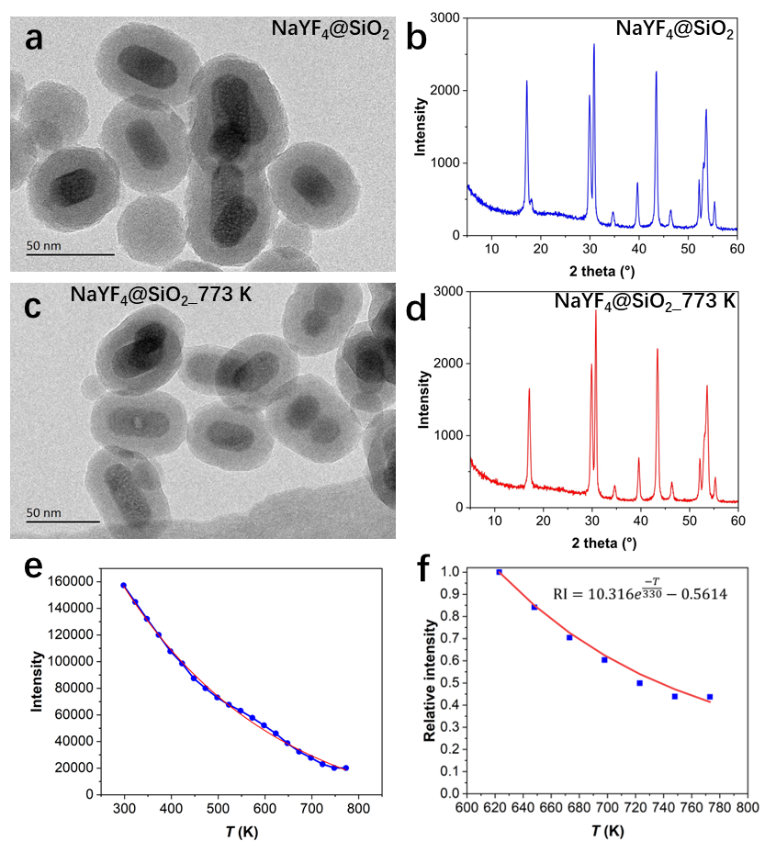
Supplementary Figure 1. HRTEM images of (a) NaYF₄@SiO₂ and (c) NaYF₄@SiO₂_773 K. XRD patterns of (b) NaYF₄@SiO₂ and (d) NaYF₄@SiO₂_773 K. (e) Relation between integral emission intensity (range from 495-540 nm) of NaYF₄@SiO₂ and temperature. (f) Correlation between relative change in emission intensity (RI) of NaYF₄@SiO₂ and temperature using the emission intensity at 623 K as normalization reference.

Supplementary Notes 5. Preparation and characterizations of catalyst particle
Synthesis of catalyst particle by microfluidic technology. First, the Na-ZSM-5 zeolite, silica gel solution and NaYF₄@SiO₂ were dispersed in deionized water. As shown in Supplementary Figure 2, soybean oil was passed through the microchannel 1 as the continuous phase, and the mixture solution was passed through the microchannel 2. At the junction of the T-shaped microchannel, soybean oil and the mixture meet and form spherical precursors under the action of surface tension. Then, the precursor solution (alkaline) was injected into the cross-shaped microchannel^{14, 15}. Meanwhile, the acetic acid solution was injected at the other two ports of the cross-shaped microchannel to neutralize the whole solution and solidify the precursors to catalyst particles. Catalyst particles contained with Na-ZSM-5 zeolites and NaYF₄@SiO₂ nanothermometry were obtained after aging and washing. Catalyst particles contained with H-ZSM-5 zeolites were obtained by successive ion-exchange with 1 M NH₄NO₃ solution at 353 K for three times. The solid to liquid ratio is 15, that means of 1 g catalyst corresponding to 15 ml NH₄NO₃ solution. Finally, the catalyst particles were calcined at 773 K for 3 h in tube furnace. Catalyst particles contained with different amounts of H-ZSM-5 zeolites (15wt%, 25wt% and 35wt% of zeolites, which are named as CAT-15% zeo., CAT-25% zeo. and CAT-35% zeo., respectively) and NaYF₄@SiO₂ (8wt%) nanothermometry were obtained by controlling the content of Na-ZSM-5 in the feed solution. The average particle size of these catalyst particles is 330 μm. By controlling the flow rate of solution in the microchannel, catalyst particles with different particle sizes can be made. The catalyst particles (contained with 25% H-ZSM-5 zeolites) with particle size of 270 μm and 300 μm were obtained by controlling flow rate (6 and 8 mL/h respectively), which are named as CAT-25% zeo.(S) and CAT-25% zeo.(M).
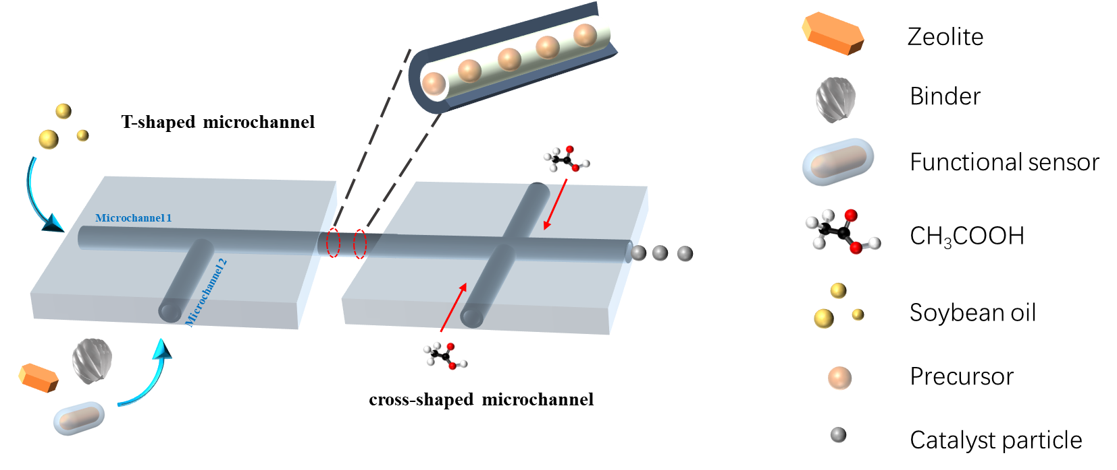
Supplementary Figure 2. Schematic diagram of fabrication of catalyst particles by microfluidic chip.

Characterizations of catalyst particles. Supplementary Figure 3 shows the XRD pattern, FESEM and iDPC-STEM images of H-ZSM-5 zeolites. The Si/Al ratio of H-ZSM-5 measured by XRF is 36.2. The typical morphology of CAT-35% zeo. sample is shown in Supplementary Figure 4a, and the statistical average particle size is 330 ± 5 μm. The particle size of CAT-15% zeo., CAT-25% zeo. and CAT-35% zeo. samples are similar. As shown in Supplementary Figure 4b, the nitrogen adsorption-desorption isotherms at 77 K of all samples have step uptakes near P/P₀ = 0 which is resulted from the microporous structure of MFI framework. For the catalyst particles, a distinct hysteresis loop exists in the region 0.45 < P/P₀ < 1, which is the characteristic of mesopores in the binder. The results of textural properties of H-ZSM-5 zeolites and catalyst particles are summarized in Supplementary Table 1. The NH₃-TPD profiles are plotted as the desorption ‘rate’ versus temperature and shown in Supplementary Figure 4c-f. The density of Brønsted acid sites (BAS) in catalysts is summarized in Supplementary Table 2. According to the amount of medium and strong acid determined by TPD, the content of the zeolites in catalyst particle is in line with the expected content.
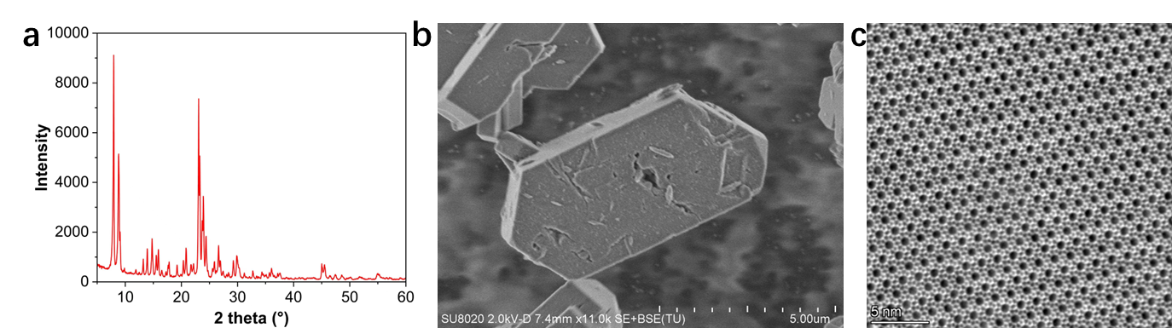
Supplementary Figure 3. (a) Powder XRD pattern, (b) FE-SEM image and (c) iDPC-STEM image of H-ZSM-5 zeolites.

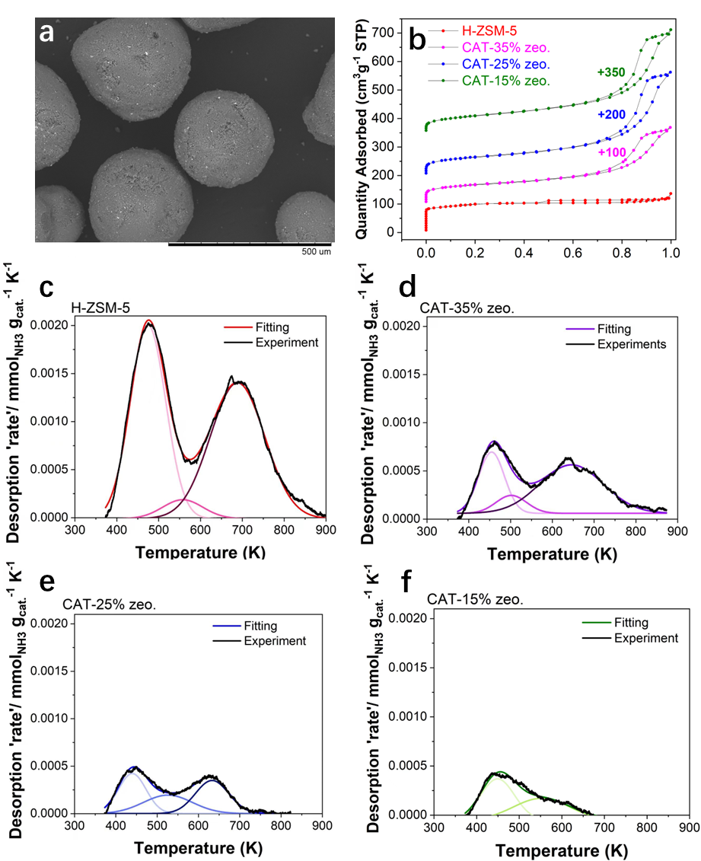
Supplementary Figure 4. (a) FE-SEM images of CAT-35% zeo. sample. (b) Nitrogen adsorption and desorption isotherms of catalyst particles at 77 K. NH₃-TPD profiles of (c) H-ZSM-5 zeolites, (d) CAT-35% zeo., (e) CAT-25% zeo. and (f) CAT-15% zeo. samples.

Supplementary Table 1. Textural properties of catalysts obtained from nitrogen adsorption and desorption isotherms at 77 K.
Sample | Surface area(m² g⁻¹) |  | Pore volume(cm³ g⁻¹)
Sample | S_{total} | S_{micro} | V_{total} | V_{micro}
H-ZSM-5 | 340 | 191 | 0.18 | 0.09
CAT-35% zeo. | 241 | 65 | 0.40 | 0.03
CAT-25% zeo. | 233 | 38 | 0.54 | 0.015
CAT-15% zeo. | 218 | 6.6 | 0.53 | 0.0001

Supplementary Table 2. Acid amount of H-ZSM-5 and catalyst particle determined from the area calculated under the NH₃-TPD profiles.
Sample | Medium and strong acid amount  (mmol g_{cat.}⁻¹ ) | Weak acid amount  (mmol g_{cat.}⁻¹ ) | Total acid amount  (mmol g_{cat.}⁻¹ )
H-ZSM-5 | 0.283 | 0.239 | 0.522
CAT-35% zeo. | 0.106 | 0.073 | 0.179
CAT-25% zeo. | 0.071 | 0.052 | 0.123
CAT-15% zeo. | 0.045 | 0.047 | 0.092

Imaging of spatial distribution of zeolites within catalyst particle. Using furfuryl alcohol (FA) as fluorescent-dyed probe to visualize the location of H-ZSM-5 zeolites within catalyst particles^{16, 17}. The experimental process is as follows. First, catalyst particles were dispersed in deionized water (2 mL) in the in-situ cell at 298 K. Then 5 μL of FA (50 vol%) was added into in-situ cell. The products from FA oligomerization at BAS can be excited by 561 nm laser and detected the fluorescence signal at 570-640 nm. The SIM was implemented to image the reaction-diffusion process of FA oligomerization in catalyst particle¹⁸. As shown in Supplementary Figure 5, the permeation process of FA from outer edge to center of catalyst particle can be visualized. In Supplementary Figure 6, for the long reaction time, it can be observed that the uniform distribution of products of FA oligomerization in all catalyst samples, which illustrates that the uniform distribution of H-ZSM-5 zeolites within each catalyst particle samples.

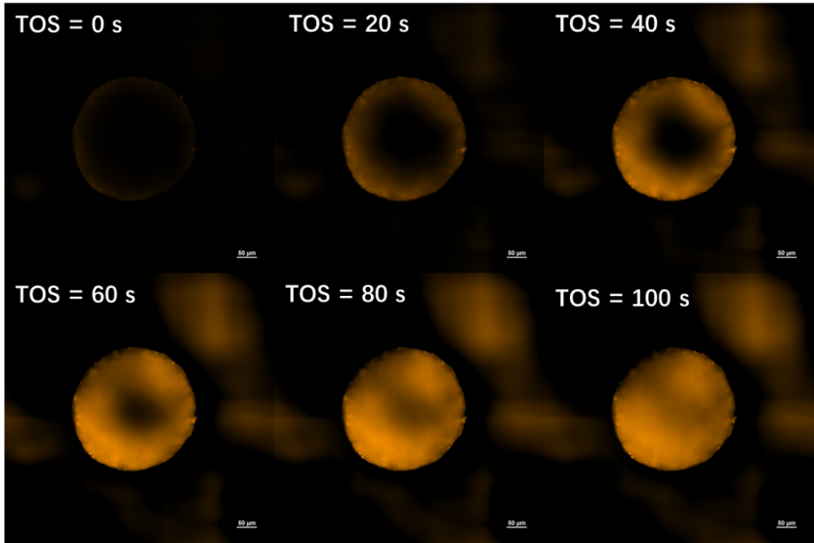
Supplementary Figure 5. The permeation of FA and formation process of oligomer within CAT-35% zeo. sample at 298 K.

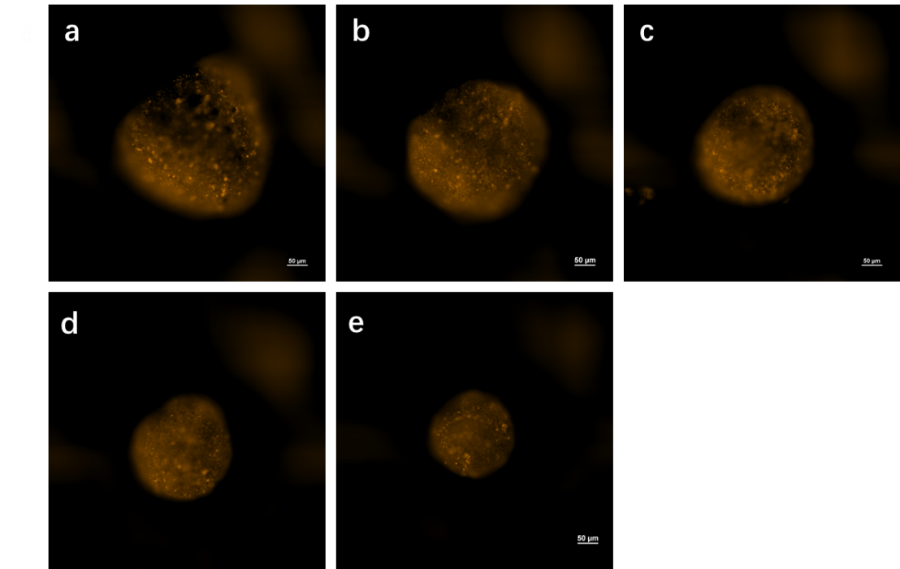
Supplementary Figure 6. SIM images of spatial distribution of H-ZSM-5 zeolites within (a) CAT-15% zeo., (b) CAT-25% zeo., (c) CAT-35% zeo., (d) CAT-25% zeo. (M) and (e) CAT-25% zeo. (S) samples.

Supplementary Notes 6. Multimodal imaging techniques
Upconversion luminescence imaging by two-photon microscopy. The spatiotemporal-resolved changes in temperature within individual catalyst particle were measured by upconversion luminescence imaging^{11, 13}. The Olympus FV1000 MPE confocal laser scanning microscope offers conventional confocal laser scanning of samples on three-dimensional (3D) slide. Long working distance objective allow imaging of large catalyst particles at work under high temperature. Two-photon confocal microscope system was built on the Olympus research-grade upright microscope BX61WI. Multi photon laser can adjusted at the range of 690-1040 nm by Mai Tai (Spectra-Physics). The two-photon beam has a deeper penetration through solid sample. In this work, the upconversion luminescence of NaYF₄@SiO₂ was excited by 980 nm laser and detected signal at 495-540 nm. The objective magnification is 40×. Through adjusting the focal plane, the fluorescence images can be shown in 3D form or locked in the center plane of the catalyst particles. As shown in Supplementary Figure 7, the catalyst samples were placed in in-situ cell and pretreated by nitrogen at 623 K. Then the reactant (saturated vapor of methanol carried by nitrogen at 293 K) was switched, and the spatiotemporal changes in luminescence within catalyst particle was captured by microscopy during MTH reactions.
Correlation between luminescent intensity and temperature.
In this work, the changes in upconversion luminescent intensity of NaYF₄@SiO₂ embedded in catalyst are used to indicated temperature variations. As shown in Supplementary Figure 1e, the integral emission intensity (range from 495-540 nm) of NaYF₄@SiO₂ excited by 980 nm laser decreases exponentially as temperature increasing. In Supplementary Figure 1f, the quantitative relation between relative change in emission intensity (RI) of NaYF₄@SiO₂ and temperature is shown. In the in-situ cell equipped with micro-thermocouple, the temperature was set to the range of 623-723 K. Using emission intensity at 623 K as normalization reference, the overall RI of NaYF₄@SiO₂ embedded in catalyst particle was detected by two-photon confocal microscope under different temperature at non-reactive conditions can be measured. Due to the dilution of NaYF₄@SiO₂ in catalyst (8wt%), the RI of NaYF₄@SiO₂ embedded in catalyst and temperature needs to be re-correlated. The RI was substituted into equation in Supplementary Figure 1f to obtain corresponding temperature. The correlation between RI of NaYF₄@SiO₂ embedded in catalyst particle and temperature of in-situ cell can be written as $RI=10.80×{10}^{9}e^{-T/27.5}-0.56$. Such correlation is used to obtain spatiotemporal evolutions of temperature within individual catalyst particle.

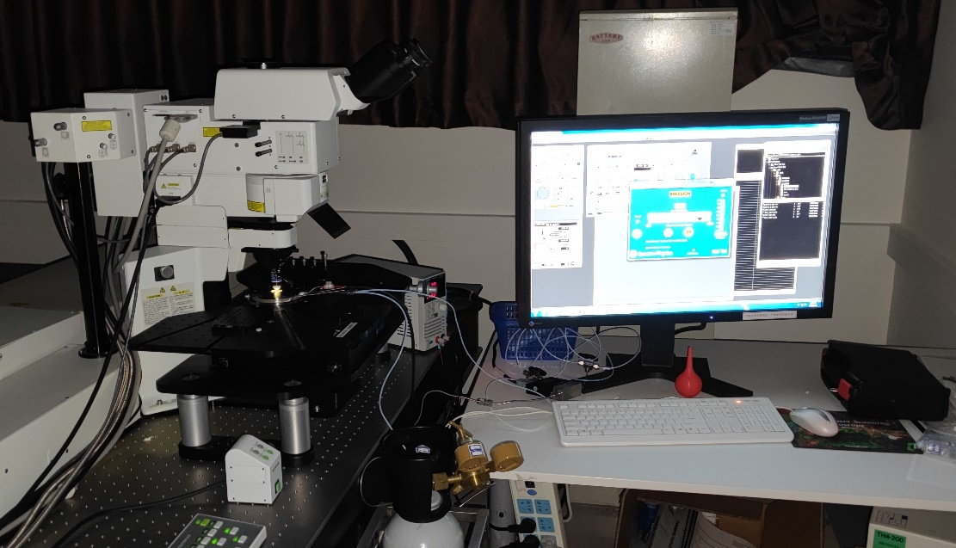
Supplementary Figure 7. Photograph of upconversion luminescence-confocal microscopy device equipped with in-situ reaction cell.

As shown in the Supplementary Figure 8a, the catalysts particles are divided into three regions, i.e. core, inner shell and outer shell region, for spatiotemporal temperature change analysis within individual catalyst particle. The temperature spatiotemporal evolutions during MTH reactions at different catalyst particle region with similar particle size (~ 330 μm) but contained with different amounts of zeolites, i.e. CAT-15% zeo., CAT-25% zeo. and CAT-35% zeo., are shown in Supplementary Figure 8b-d, respectively. The temperature spatiotemporal evolutions during MTH reactions at different region for catalyst particle contained with similar amounts of zeolites but with different particle size (~ 270 μm and ~ 300 μm), i.e. CAT-25% zeo. (S) and CAT-25% zeo. (M), are shown in Supplementary Figure 8e and f, respectively. During MTH reactions, for all individual catalyst particle, the temperature rise at core region is obviously higher than that at outer shell region. In Supplementary Figure 8b-d, increasing the density of H-ZSM-5 zeolite within catalyst particle, the overall temperature rises for whole particle increases. Particularly, the temperature gradient from core to outer shell region in catalyst particle with high density of H-ZSM-5 zeolites is apparently higher than that in catalyst particle with low density of H-ZSM-5 zeolites. This is resulted from the enhanced heat generation capacity by increasing the density of active sites within catalyst particle, which provides higher heat flux from outer shell to core region. In Supplementary Figure 8 (c), (e) and (f), under similar density of H-ZSM-5 zeolites within individual particle, decreasing the particle size leads to increased temperature rise in the whole particle. At the similar capacity of heat generation, minishing the particle size can be beneficial to the increasement of heat transfer rate and temperature gradient within particle, which can accelerate the reaction rate at active sites.

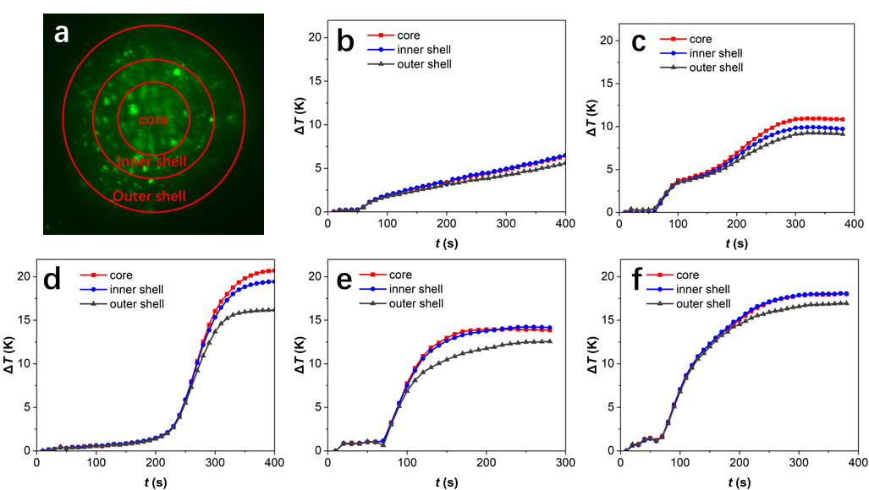
Supplementary Figure 8. (a) Division of spatial region for the analysis in spatiotemporal evolutions of temperature during MTH reactions within individual catalyst particle. Temporal evolutions of temperature during MTH reactions at different region within individual catalyst particle with (b) 15% (CAT-15% zeo.), (c) 25% (CAT-25% zeo.) and (d) 35% (CAT-35% zeo.) zeolite content. Temporal evolutions of temperature during MTH reactions at different region within individual catalyst particle with particle size of (e) 300 μm (CAT-25% zeo. (M)) and (f) 270 μm (CAT-35% zeo. (S)).

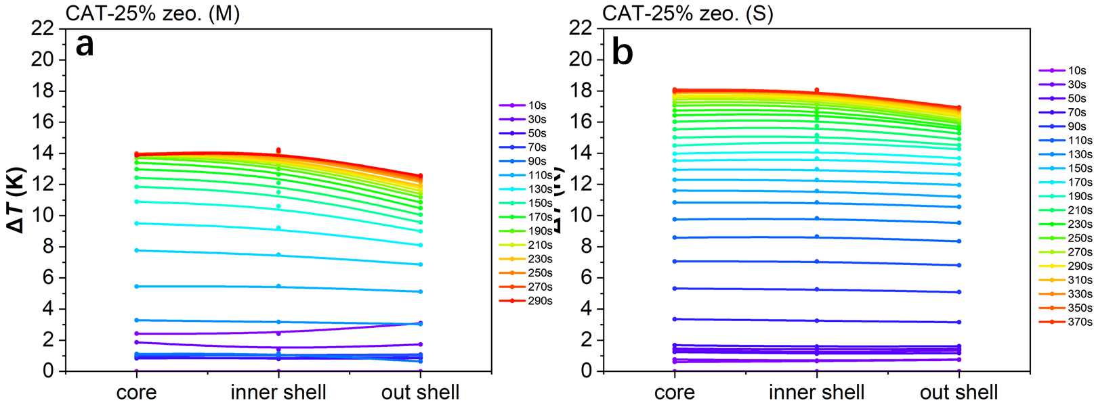
Supplementary Figure 9. Spatiotemporal evolutions of temperature during MTH reactions within (a) CAT-25% zeo. (M) and (b) CAT-25% zeo. (S) catalyst particle.

Structured illumination microscopy (SIM). SIM was applied to gain super-resolution images on the spatiotemporal distribution of the coke species located in catalyst particles^{18, 19}. Imaging with 405, 488, 561, and 640 nm multilaser light sources, the emissions by excitation were collected with four photomultiplier tubes in the range 435-485, 500-545, 570-640, 663-738 nm for the four lasers, respectively. Imaging was performed under ex-situ condition at room temperature. Samples were loaded on glass-bottomed culture dishes (35 mm dish with 20 mm well) and images were taken at a Z-plane of middle of zeolitic crystal. The software NIS-Elements Ar and N-SIM Analysis were used to analyze the collected images and computationally reconstruct the super-resolution image.

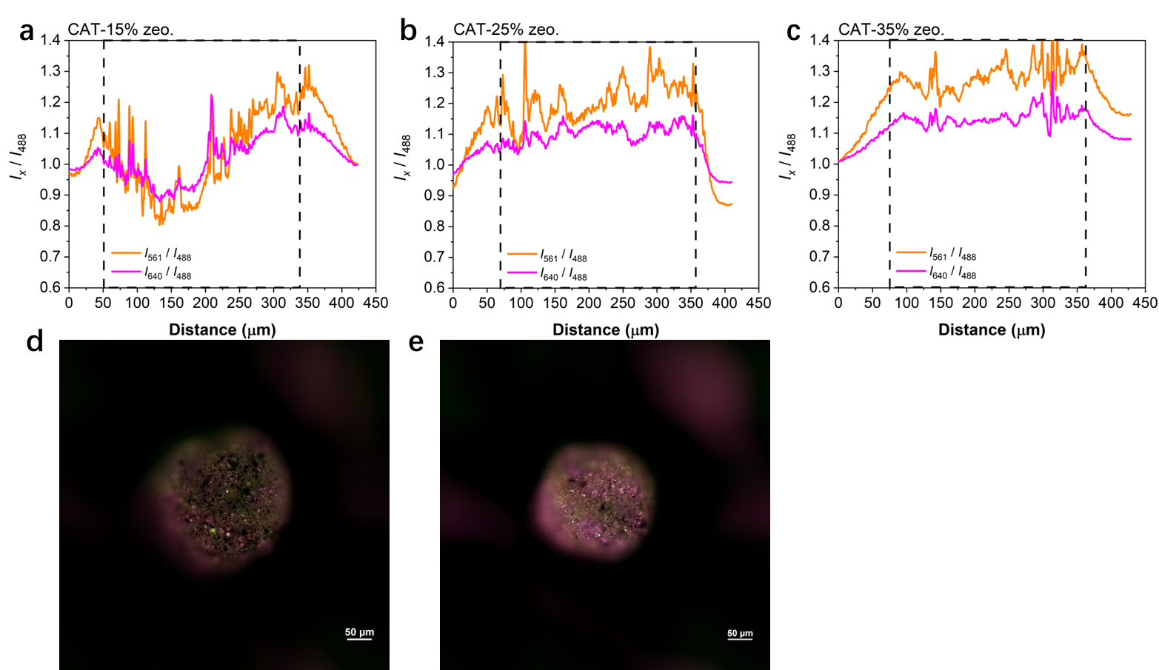
Supplementary Figure 10. The spatial distribution of ratio of fluorescence-emission intensity between 561/640 nm and 488 nm excitation wavelength in (a) CAT-15% zeo., (b) CAT-25% zeo. and (c) CAT-35% zeo. samples. The spatial distribution of carbonaceous species in deactivated (d) CAT-25% zeo. (M) and (e) CAT-25% zeo. (S) samples obtained by SIM. The SIM images shown is the fluorescence that originated from the overlap of four profiles with a laser excitation of 488 nm (detection at 500-545 nm, false color: green), 561 nm (detection at 570-640 nm, false color: orange), 640 nm (detection at 663-738 nm, false color: pink). The images were taken in the middle plane of the zeolite crystal. The scale bar represents 50 μm.

In-situ infrared microimaging (IRM). The experiments were performed by use of a Fourier transform IR microscope (Bruker Hyperion 3000) composed of a spectrometer (Bruker vertex 70v) and a 15× optical microscope. The main functions of IR microscopy are detection of spatial-resolved IR spectrum at local region of catalysts^{20, 21}. The methods of obtaining spatial-resolved IR spectrum at different position of individual catalyst particle are shown in Supplementary Figure 11. The in-situ optical reaction cell with BaF₂ window in this device is connected to a reactant system and mounted on a movable platform under the microscope. Such an arrangement facilitates the selection of a reasonably catalyst particle for subsequent reaction studies. Sample activation was accomplished by heating under nitrogen purging at 623 K and kept for 2 h. MTH reactions were carried out at 623 K. The spatial-resolved IR spectrum were collected at the sweep of nitrogen at 623 K.

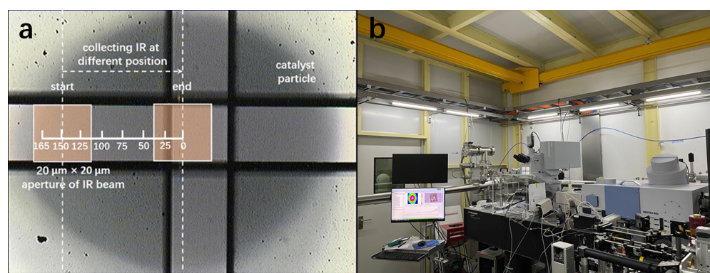
Supplementary Figure 11. (a) Schematic diagram of collection of spatial-resolved IR spectrum at different position of catalyst particle. The window size of IR spectrum collection is 20 × 20 μm. (b) Photograph of infrared microscopy equipped with in-situ reaction cell.

Supplementary Notes 7. Methanol-to-hydrocarbons reactions catalyzed by H-ZSM-5 zeolites at different temperature
We evaluated the catalytic performance of H-ZSM-5 zeolites at different temperature using fixed-bed reactor. 50 mg H-ZSM-5 and 150 mg quartz sand were mixed and then added to the quartz tube (4 mm inner diameter). MTO reactions were carried out at initial set temperature of 623 K, 673 K and 723 K, respectively. Weight hourly space velocity (WHSV) of methanol was set to 18.94 g_{MeOH} g_{zeo.}⁻¹ h⁻¹ and partial pressure of methanol was 0.25 bar by flowing nitrogen. Changes in temperature of catalyst bed was recorded by thermocouple contacted to catalyst bed. Catalyst particles with different coke content were collected at 623 K (for 60 min, 180 min and deactivation, respectively), 673 K (for 60 min, 180 min, 300 min and deactivation, respectively) and 723 K (for deactivation). The results of catalyst performance and changes in temperature of catalyst bed are shown in Supplementary Figure 12 and Supplementary Figure 13, respectively. As shown in Supplementary Figure 12, when reaching the max temperature (T_{max}) of MTH reaction, the maintenance period at T_{max} increases as the initial reaction temperature increases.
The utilization of BAS in H-ZSM-5 zeolites at different reaction temperature were analyzed by DRIFT. As can be seen from the Supplementary Figure 14, as the reaction progressing, the intensity of absorbance peak around wavenumber 3600 cm⁻¹ is getting lower, this means that BAS is utilized and covered by coke species. Increasing the reaction temperature, the utilization of BAS in H-ZSM-5 zeolites increasing. In Supplementary Figure 15(a), the results of GC-MS show that the type and amoutns of retained carbonaceous species in deactivated catalyst were affected by reaction temperature. At high reaction temperature, the retained amounts of hexamethylbenzene within H-ZSM-5 zeolites decreases, which illustrates more fully activation of hexamethylbenzene during MTH reactions. Consequently, at the high reaction temperature, the amounts of retained polycyclic aromatic hydrocarbons (PAHs) in zeolites increases.

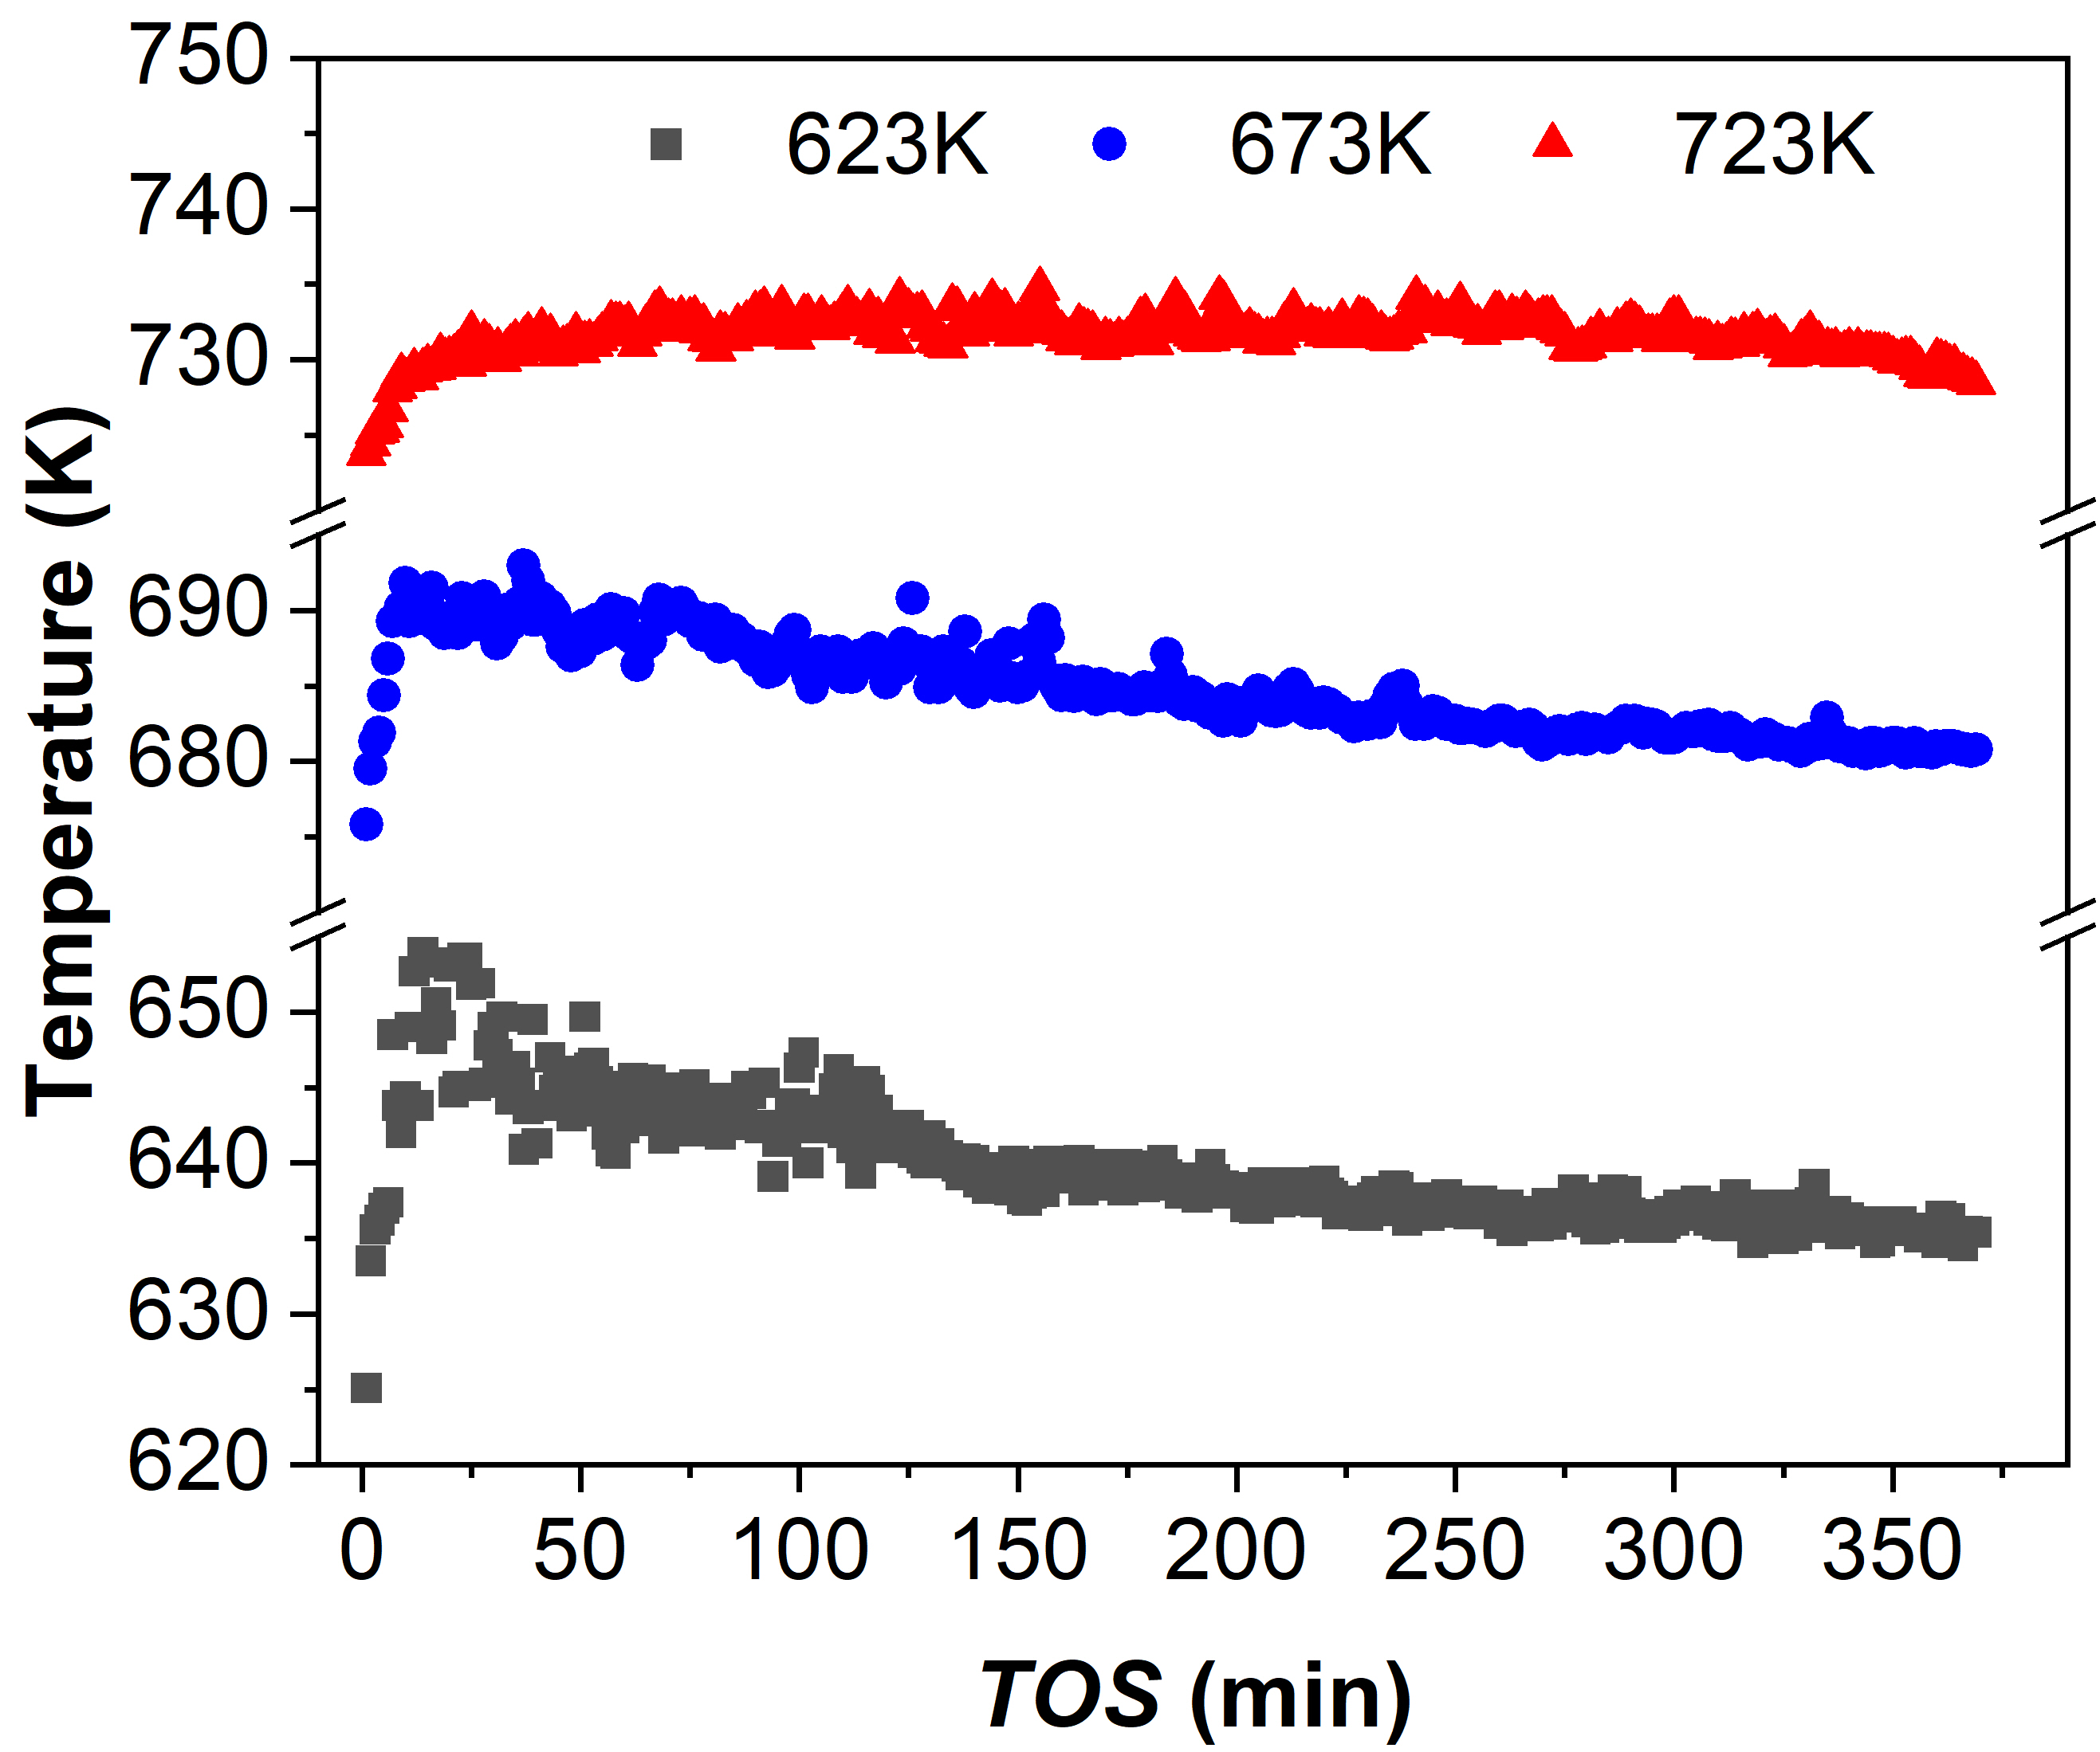
Supplementary Figure 12. Evolutions in temperature of catalyst bed as time on stream during MTH reaction over H-ZSM-5 zeolites at different initial reaction temperature. Experimental conditions: WHSV = 18.94 g_{MeOH} g_{zeo.}⁻¹ h⁻¹ and partial pressure of methanol of 0.25 bar.

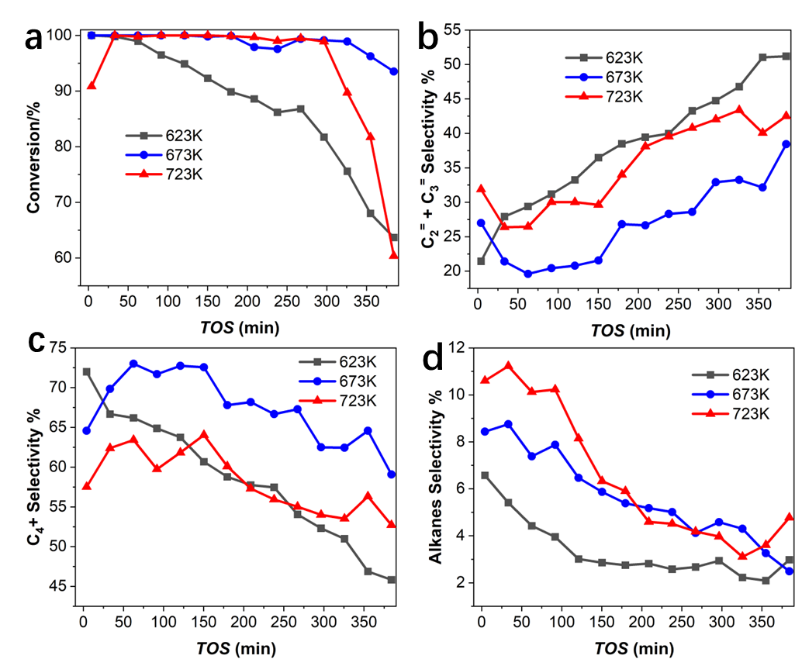
Supplementary Figure 13. (a) Methanol conversion and selectivity of (b) ethylene and propylene, (c) C₄₊ and (d) alkane products (C₂⁼ is ethylene, C₃⁼ is propylene, C₄₊ lumps the products of C₄, C₅ and C₆₊, alkanes lumps the products of methane, ethane and propane).

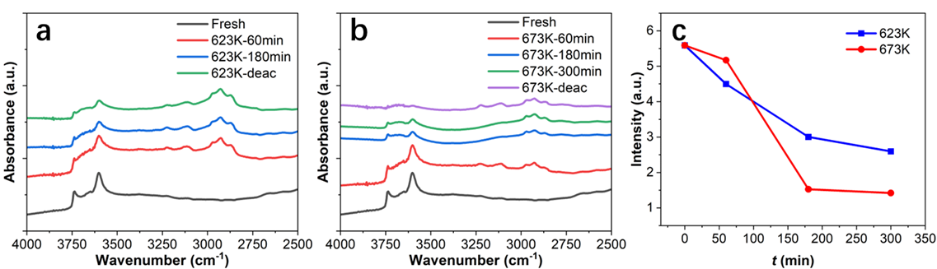
Supplementary Figure 14. DRIFT spectra on H-ZSM-5 zeolite sample during MTH reaction at (a) 623 K and (b) 673 K. (c) The relative change of BAS in H-ZSM-5 zeolite during MTH reaction at 623 K and 673 K.

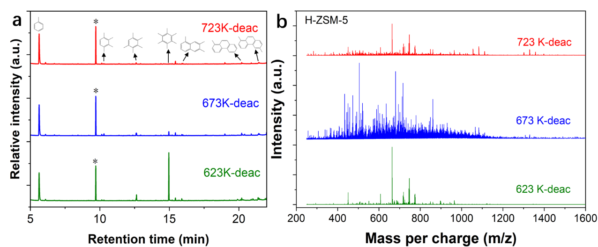
Supplementary Figure 15. (a)The component analysis of retained carbonaceous species in 623K-deac, 673K-deac and 723K-deac samples after catalyst deactivation by GC-MS. * represents the internal standard. (b) The component analysis of coke species with molecular weights greater than 200 Da in 623K-deac, 673K-deac and 723K-deac samples.

Supplementary Notes 8. Methanol-to-hydrocarbons catalyzed by catalyst particle.
Catalysts with different amounts of zeolites
The prepared catalysts with different amounts of zeolites were evaluated in a fixed bed reactor, the initial temperature of catalyst bed was 623 K. In order to keep the same amounts of BAS in catalyst beds, the dosage of catalyst particles is determined by the same amounts of zeolites in the catalyst particles. Weight hourly space velocity (WHSV) of methanol was set to 22.067 g_{MeOH} g_{zeo.}⁻¹ h⁻¹ and partial pressure of methanol was 0.28 bar by flowing nitrogen. As shown in Supplementary Figure 16, as the amounts of zeolites in catalyst particle increases, the T_{max} of catalyst bed increases.
For the deactivated catalyst particles, DRIFT, GC-MS and MALDI-FT-ICR techniques were implemented to detect the utilization of BAS and coke species in zeolites. In Supplementary Figure 18, as the amounts of zeolites within catalyst particle increases, the utilization of BAS increases, i.e. 8.1% for CAT-15% zeo., 16.4% for CAT-25% zeo. and 23.5% for CAT-35% zeo., respectively. In Supplementary Figure 19, as the amounts of zeolites in catalyst particle increases, the molar mass distribution of carbonaceous species tends to heavier molar mass.

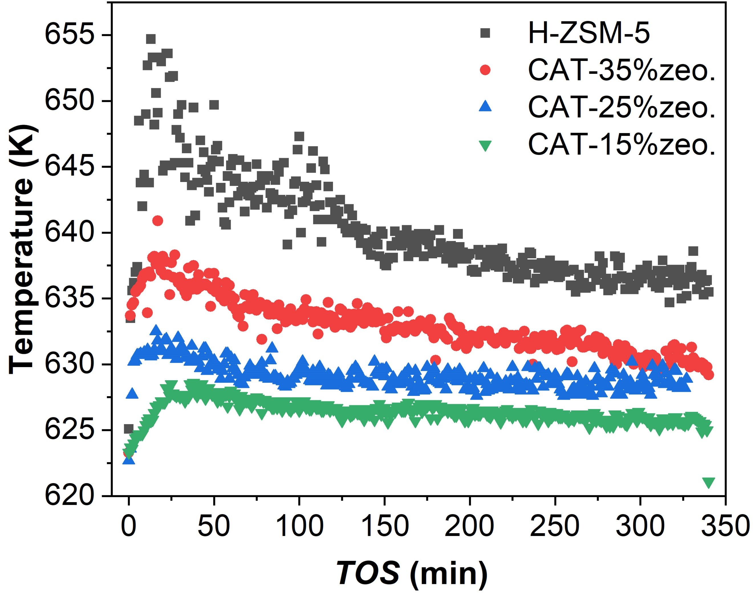
Supplementary Figure 16. Temperature of catalyst bed as a function of time on stream during MTH reaction over H-ZSM-5 zeolites, CAT-15% zeo., CAT-25% zeo. and CAT-35% zeo. at 623 K. Experimental conditions: WHSV = 22.067 g_{MeOH} g_{zeo.}⁻¹ h⁻¹ (keeping the same amounts of zeolites in the catalyst bed) and partial pressure of methanol of 0.28 bar.

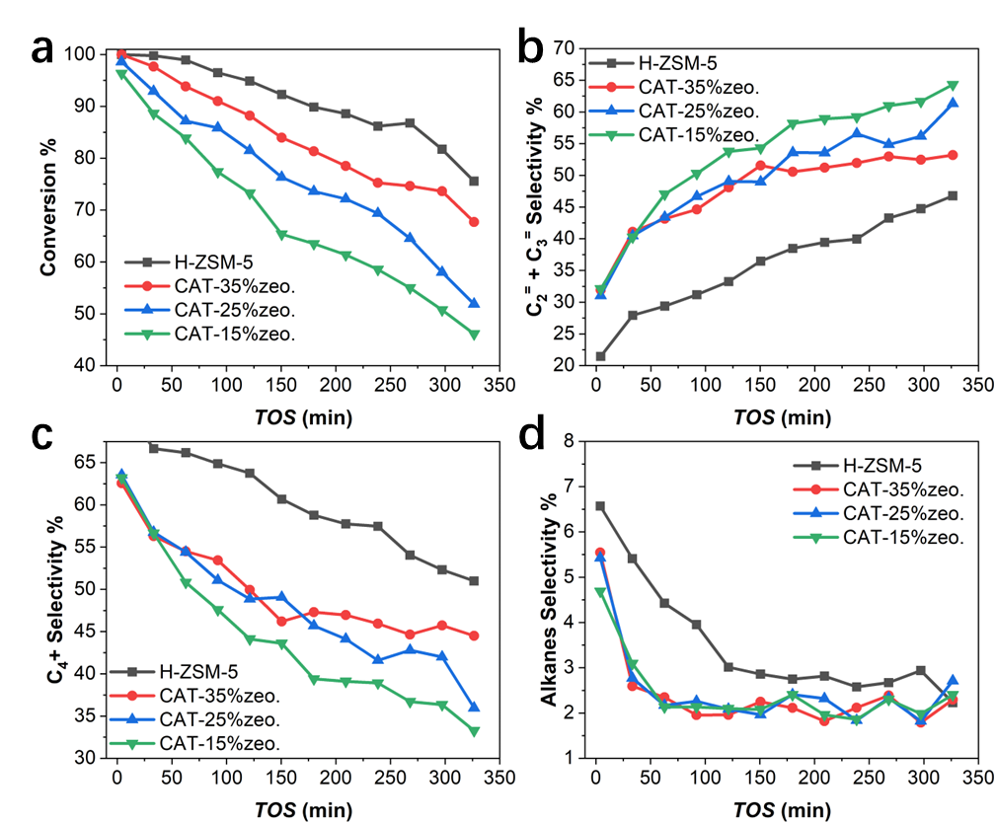
Supplementary Figure 17. (a) Methanol conversion and selectivity of (b) ethylene and propylene, (c) C₄₊ and (d) alkane products (C₂⁼ is ethylene, C₃⁼ is propylene, C₄₊ lumps the products of C₄, C₅ and C₆₊, alkanes lumps the products of methane, ethane and propane).

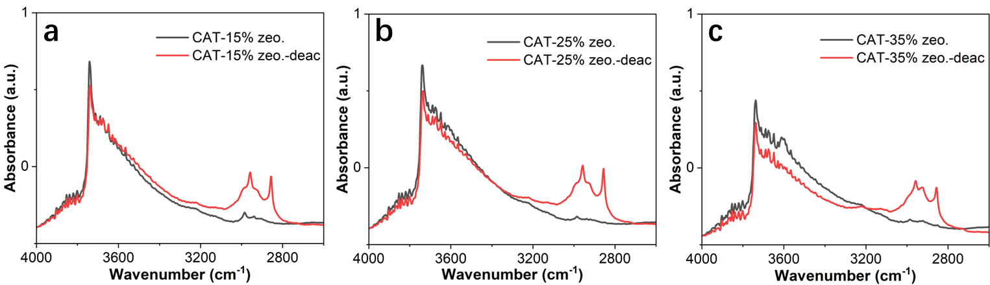
Supplementary Figure 18. DRIFT spectra on fresh and deactivated (a) CAT-15% zeo., (b) CAT-25% zeo. and (c) CAT-35% zeo. samples.

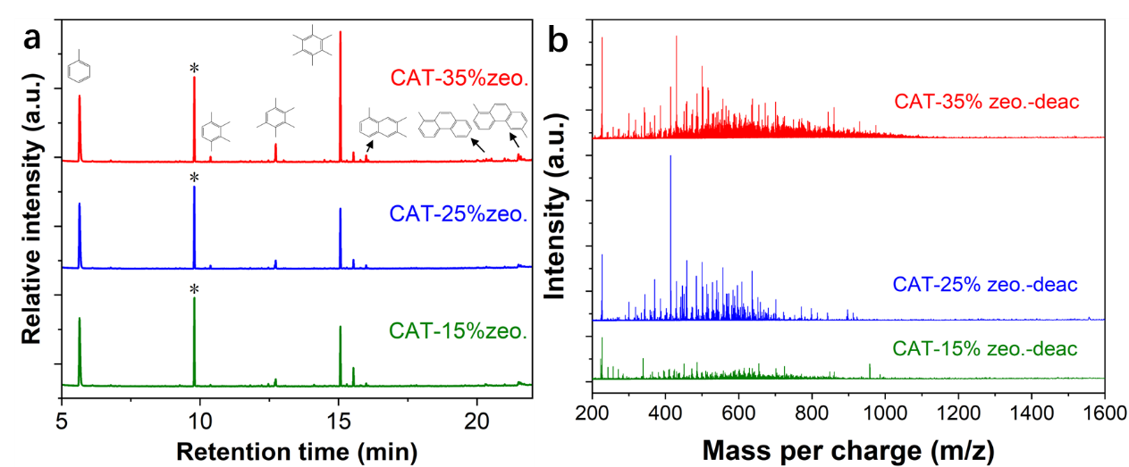
Supplementary Figure 19. (a) The component analysis of retained carbonaceous species in CAT-15% zeo., CAT-25% zeo. and CAT-35% zeo. samples after catalytic deactivation by GC-MS. * represents the internal standard. (b) The component analysis of coke species with molecular weights greater than 200 Da in CAT-15% zeo., CAT-25% zeo. and CAT-35% zeo. samples after catalytic deactivation.

Catalysts with different particle size
The prepared catalysts particle with different particle size were evaluated in a fixed bed reactor, the initial temperature of catalyst bed was 623 K. 120 mg catalyst particles contained with 25wt% amounts of zeolites were added to the quartz tube. Weight hourly space velocity (WHSV) of methanol was set to 22.067 g_{MeOH} g_{zeo.}⁻¹ h⁻¹ and partial pressure of methanol was 0.28 bar by flowing nitrogen. As shown in Supplementary Figure 20, as the particle size catalyst particle increases, the T_{max} of catalyst bed decreases. As shown in Supplementary Figure 22 and Supplementary Figure 23, the DRIFT spectrum results show that the utilization of acid sites is higher in deactivated catalyst particles with small particle size than in particles with large particle size, and the content of aromatic hydrocarbons and macromolecular carbon species is higher.

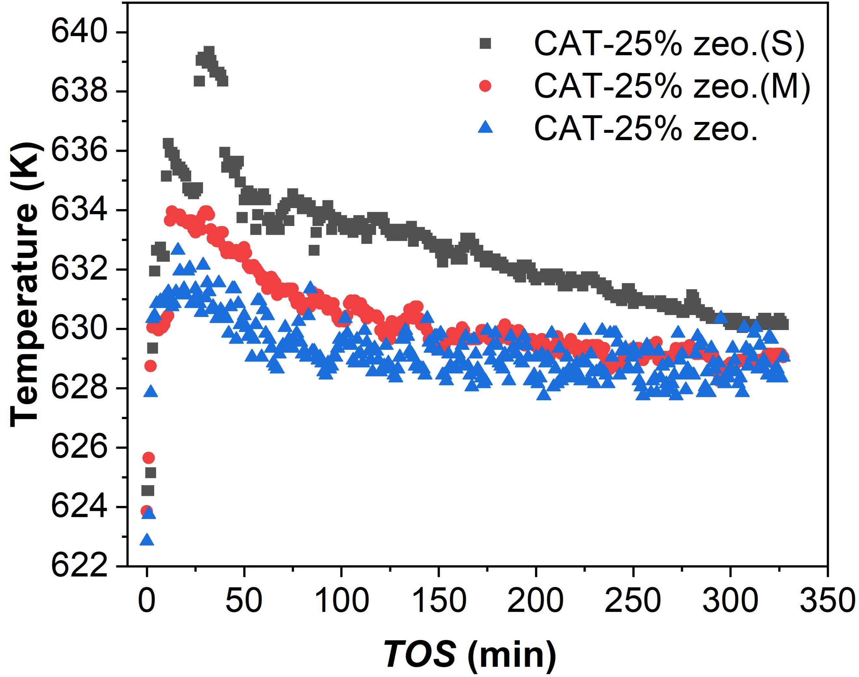
Supplementary Figure 20. Temperature of catalyst bed as a function of time on stream during MTO reaction over CAT-25% zeo. (S), CAT-25% zeo. (M) and CAT-25% zeo. at 623 K. Experimental conditions: WHSV = 22.067 g_{MeOH} g_{zeo.}⁻¹ h⁻¹ and partial pressure of methanol of 0.28 bar.

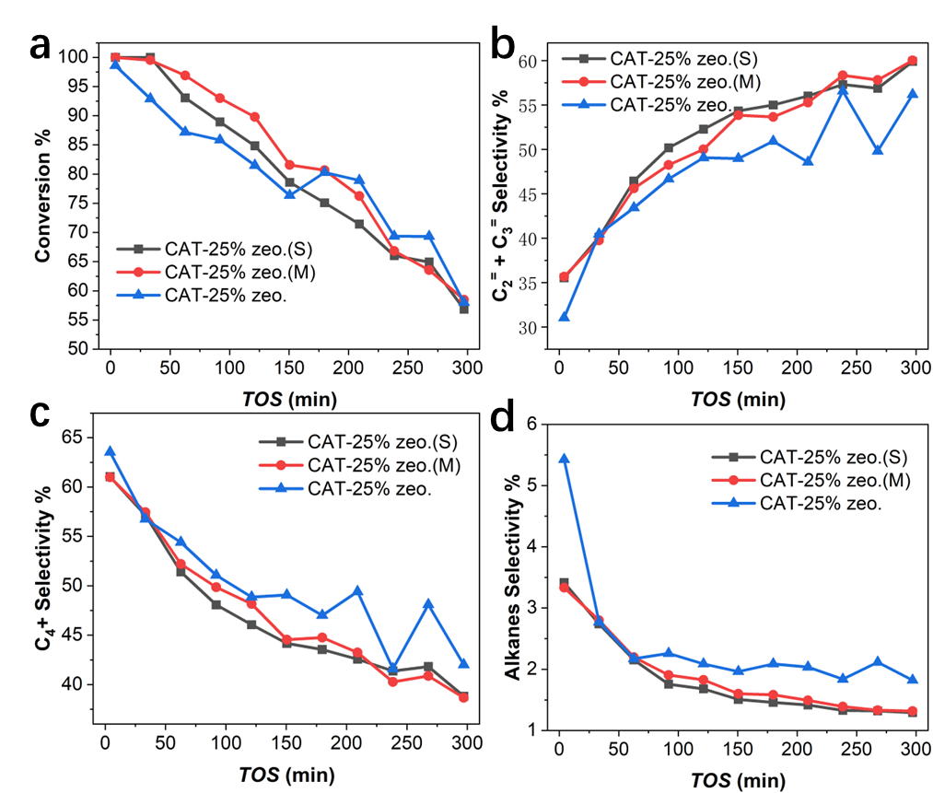
Supplementary Figure 21. (a) Methanol conversion and selectivity of (b) ethylene and propylene, (c) C₄₊ and (d) alkane products (C₂⁼ is ethylene, C₃⁼ is propylene, C₄₊ lumps the products of C₄, C₅ and C₆₊, alkanes lumps the products of methane, ethane and propane).

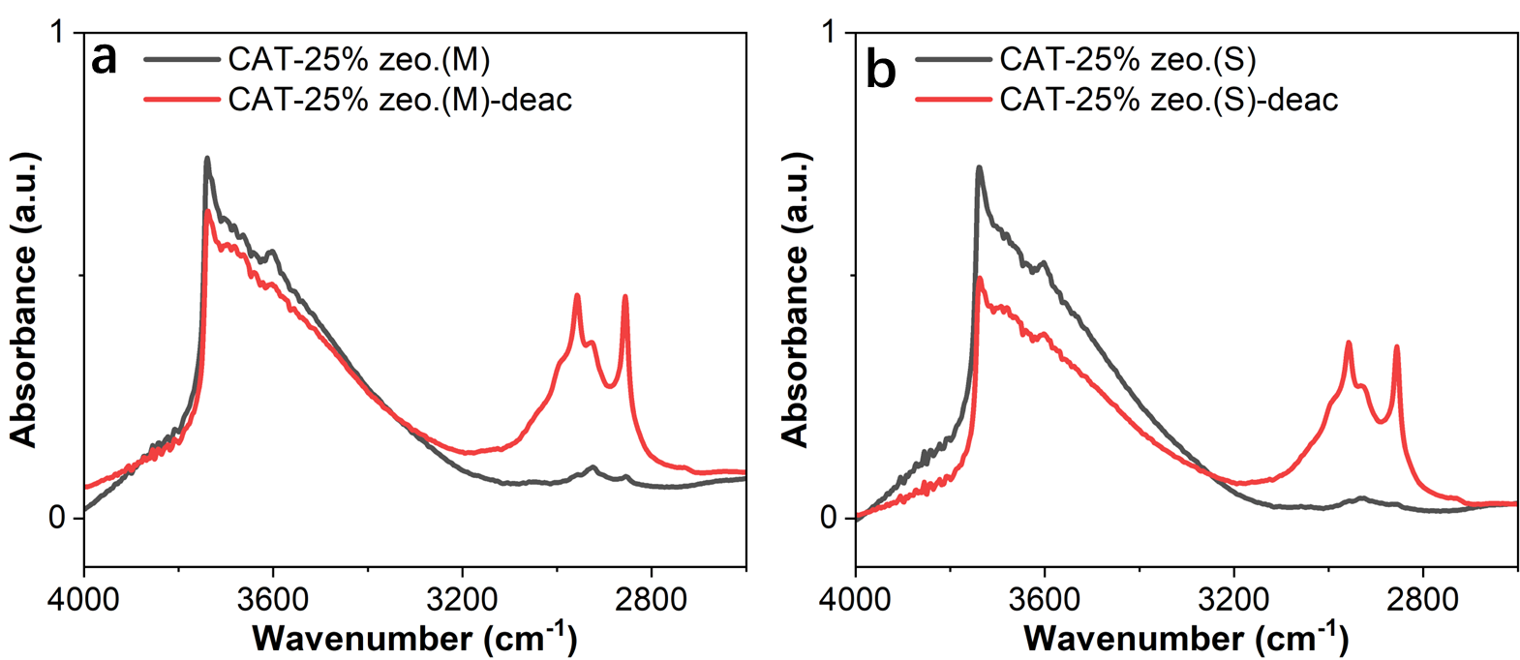
Supplementary Figure 22. DRIFT spectra on fresh and deactivated (a) CAT-25% zeo.(M), (b) CAT-25% zeo.(S) samples.

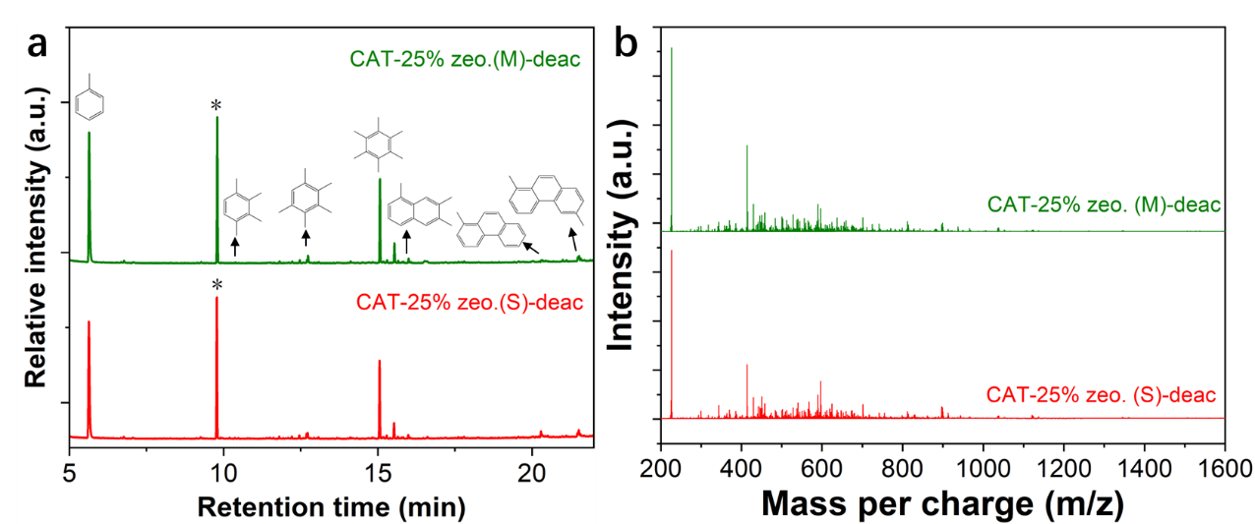
Supplementary Figure 23. (a) The component analysis of retained carbonaceous species in CAT-25% zeo. (M) and CAT-25% zeo. (S) samples after catalytic deactivation by GC-MS. * represents the internal standard. (b) The component analysis of coke species with molecular weights greater than 200 Da in CAT-25% zeo. (M), CAT-25% zeo. (S) samples after catalytic deactivation.

Supplementary Notes 9. Simulations
Density functional theory (DFT) calculations: For the calculation of transition state for methylation reaction, an extended 72 T cluster model extracted from the crystallographic MFI structure represents the structure of neutral H-ZSM-5 model containing one Brønsted acid site^{22, 23}. For the extended model, the terminal Si-H was fixed and oriented along the direction of the corresponding Si-O bond. The location of acid site was chosen at the intersection channel, accessible for adsorbents and surrounded by maximum reaction space. To preserve the integrity of the crystalline structure, the 10-membered ring, active center (SiO)₄-Si-OH-Al-(SiO)₄ and the adsorbate were set to high-level layer while the rest of atoms were set to low-level layer (Supplementary Figure 24). The combined theorical ONIOM method was exploited to the prediction of stability of various adsorption structure and geometries of and transition states (TS)^{22, 24}. For the structure optimization, ωB97XD hybrid density function with 6-31G (d, p) basis sets and semi-empirical AM1 were employed for optimization of structure of high-level and low-level layer, respectively. To obtain high accurate interaction energy, the single-point energies were calculated at the level of ωB97XD/6-31G (d, p) on the basis to of optimized structure. The frequency calculations were performed at the same level as geometry optimizations to check whether the saddle point exhibits the proper number of imaginary frequencies. The attained transition state is a first-order saddle point of potential energy surface, with only a single imaginary frequency. The adsorbed state is verified as being situated in the energy minima points of potential energy surface, with only real frequency. The intrinsic free energy was obtained from the ωB97XD/6-31G (d, p) total electronic energies and the thermal correction from the ωB97XD/6-31G (d, p): AM1 frequency calculations with the correction of zero-point vibration energies. The calculation results of methylation between xylene, trimethylbenzene, tetramethylbenzene, pentamethylbenzene, hexamethylbenzene and naphthalene with methanol were summarized in Supplementary Figure 24.

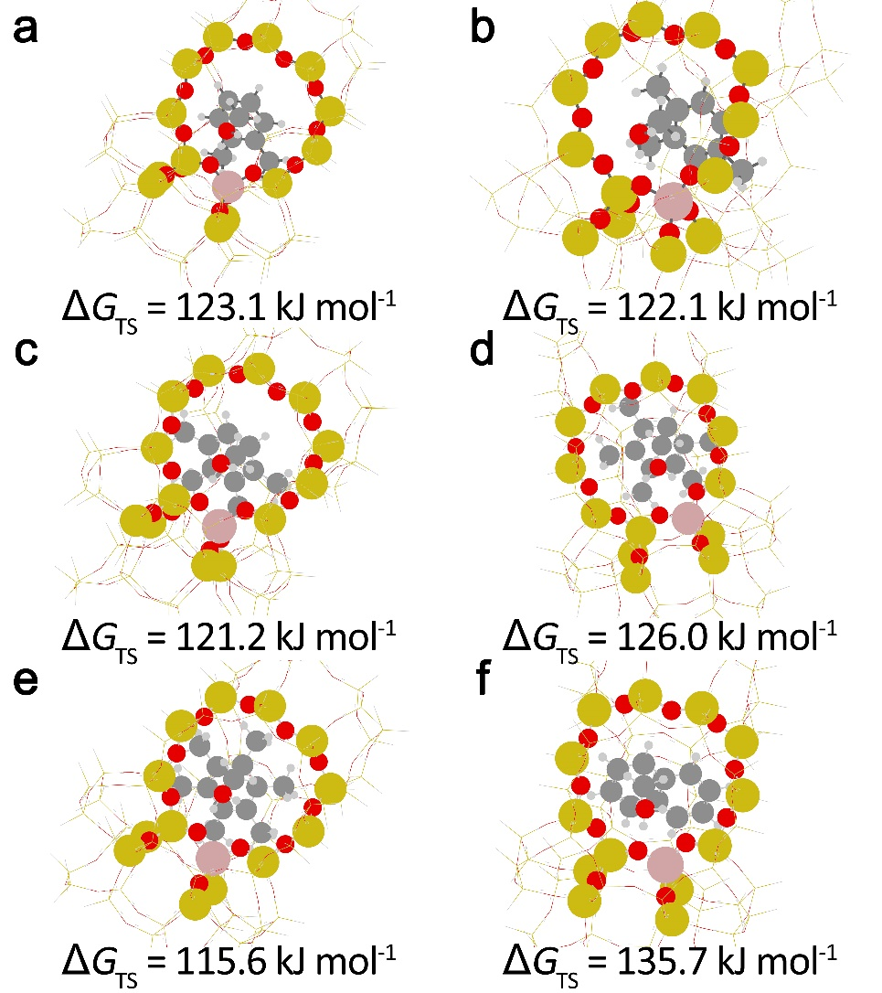
Supplementary Figure 24. Transition state and free energy barriers of methylation between (a) xylene, (b) trimethylbenzene, (c) tetramethylbenzene, (d) pentamethylbenzene, (e) hexamethylbenzene and (f) naphthalene with methanol in H-ZSM-5.

Reaction-diffusion-heat transfer simulations: In the simulations, the reaction network is simplified to the formation of polymethyl benzenes (polyMBs) and polycyclic aromatic hydrocarbons (PAHs). The molar enthalpy of reaction of the formation of polyMBs (e.g. hexylene benzene) from methanol and PAHs (e.g. naphthalene) from polyMBs is estimated as -432.8 and -218.0 kJ mol⁻¹, respectively, which can be considered as the strong exothermic reaction. The reaction free energies of polyMBs and PAHs formation are approximated to 87 and 216 kJ mol⁻¹, respectively²⁵. It can be found that the formation of PAHs is sensitive to temperature due to the higher activation energy of PAHs formation. The intracrystalline diffusivity of methanol within H-ZSM-5 is approximated to 1.0 × 10⁻¹⁰ m²/s at high temperature by molecular dynamics. The H-ZSM-5 zeolites are randomly distributed in catalyst particle, the material of binder is considered to be silica. The effects of H-ZSM-5 zeolites amounts and particle size on BAS utilization, carbonaceous species formation and heat transfer/temperature variations are simulated. The detailed simulation results are shown in Supplementary Figure 25-33.

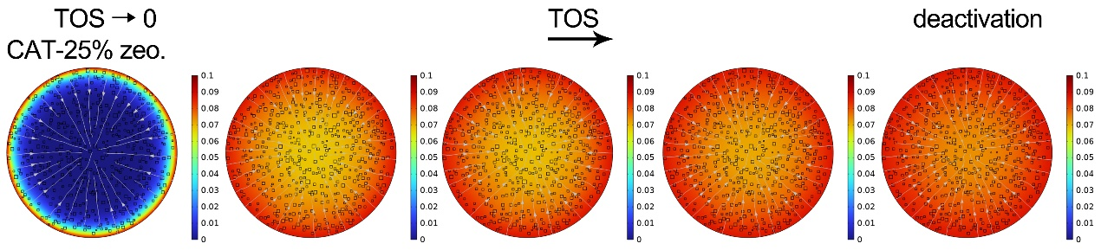
Supplementary Figure 25. Simulated spatiotemporal evolution of concentration of methanol in CAT-25% zeo. catalyst particle during MTH reactions at 623 K.
.
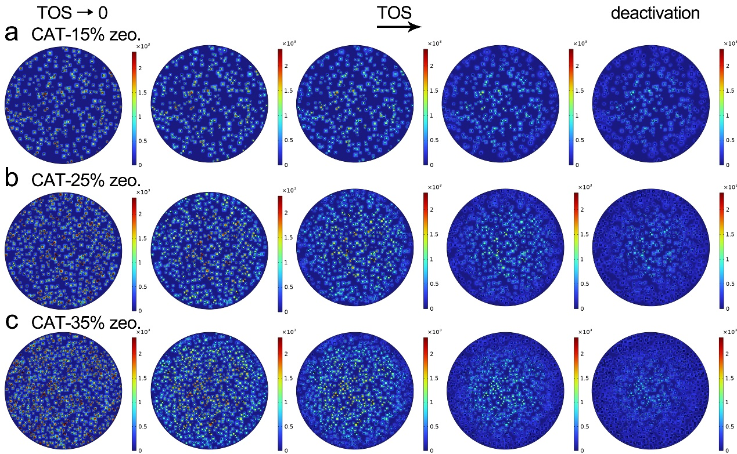
Supplementary Figure 26. Simulated spatiotemporal evolution of concentration of BAS in (a) CAT-15% zeo., (b) CAT-25% zeo. and (c) CAT-35% zeo. catalyst particle during MTH reactions at 623 K.

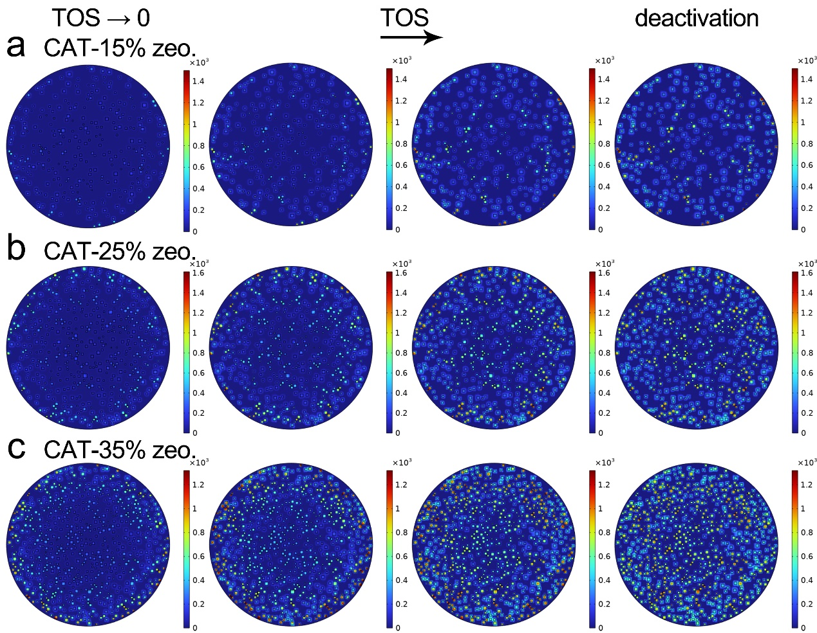
Supplementary Figure 27. Simulated spatiotemporal evolution of concentration of active aromatic species in (a) CAT-15% zeo., (b) CAT-25% zeo. and (c) CAT-35% zeo. catalyst particle during MTH reactions at 623 K.

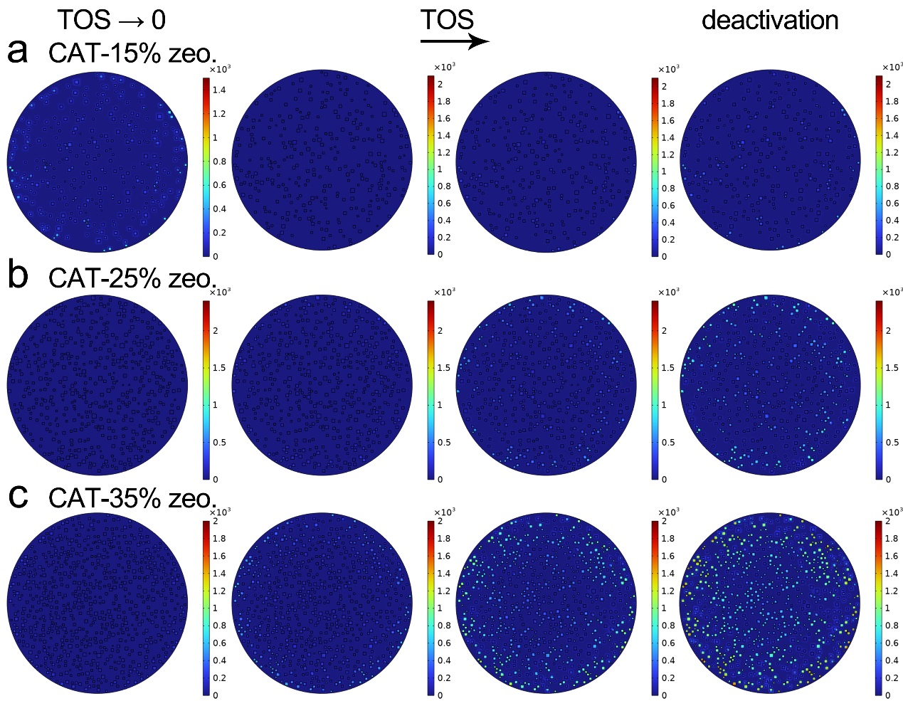
Supplementary Figure 28. Simulated spatiotemporal evolution of concentration of inactive polycyclic aromatic hydrocarbons in (a) CAT-15% zeo., (b) CAT-25% zeo. and (c) CAT-35% zeo. catalyst particle during MTH reactions at 623 K.

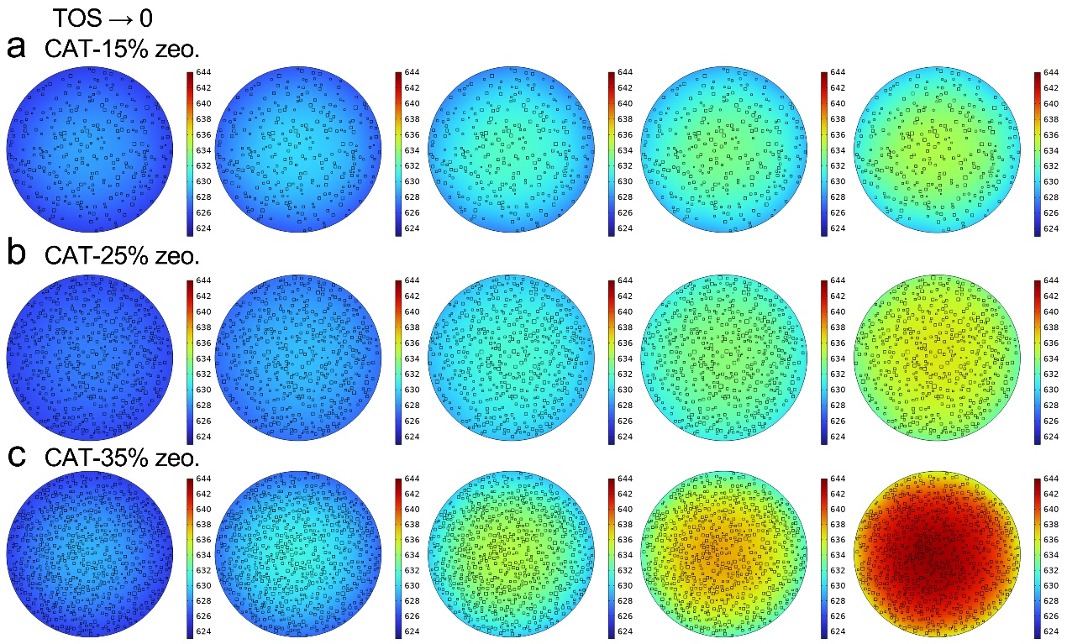
Supplementary Figure 29. Simulated spatiotemporal evolution of temperature in (a) CAT-15% zeo., (b) CAT-25% zeo. and (c) CAT-35% zeo. catalyst particle during MTH reactions at 623 K.

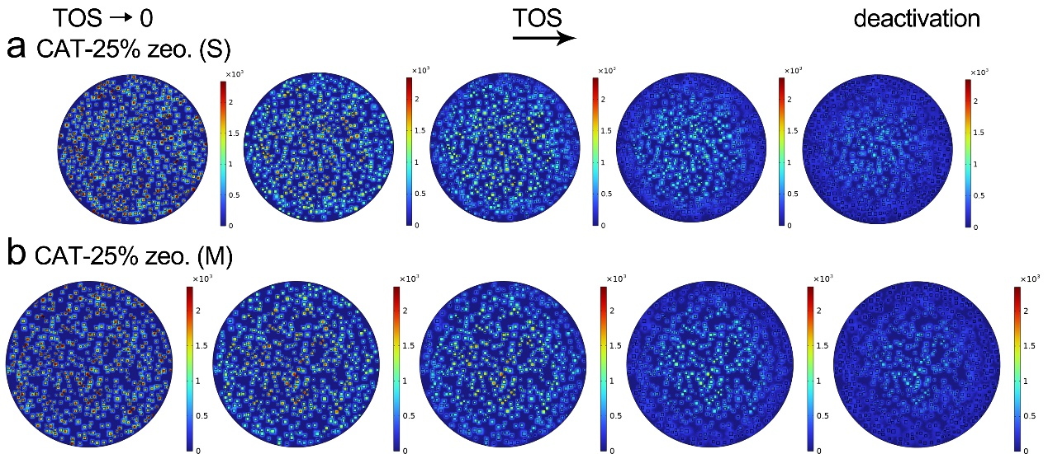
Supplementary Figure 30. Simulated spatiotemporal evolution of concentration of BAS in (a) CAT-25% zeo. (S) and (b) CAT-25% zeo. (M) catalyst particle during MTH reactions at 623 K.

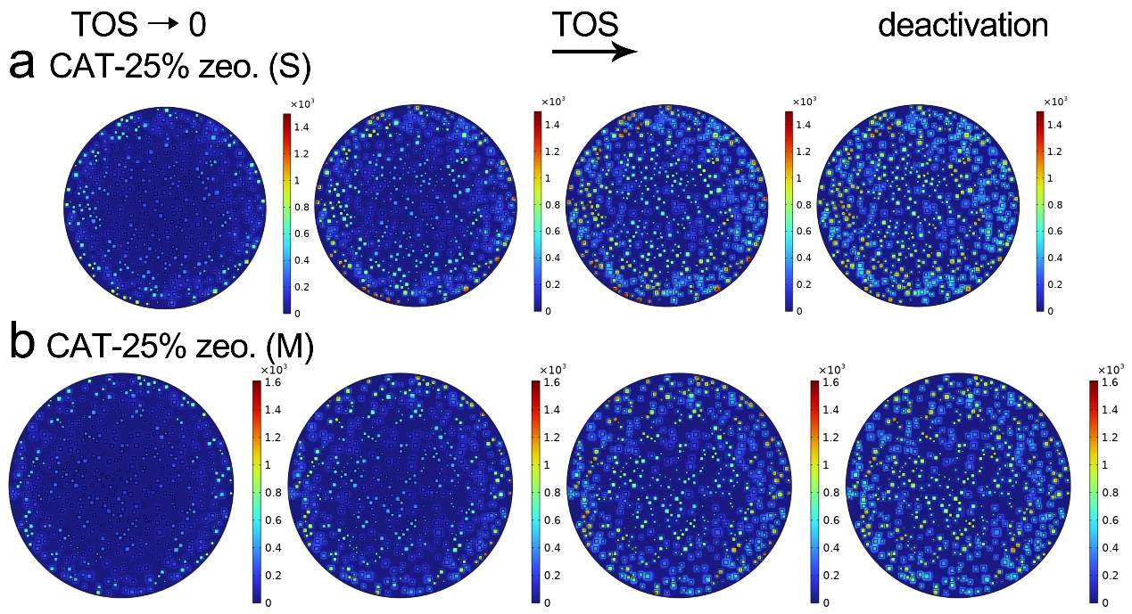
Supplementary Figure 31. Simulated spatiotemporal evolution of concentration of active aromatic species in (a) CAT-25% zeo. (S) and (b) CAT-25% zeo. (M) catalyst particle during MTH reactions at 623 K.

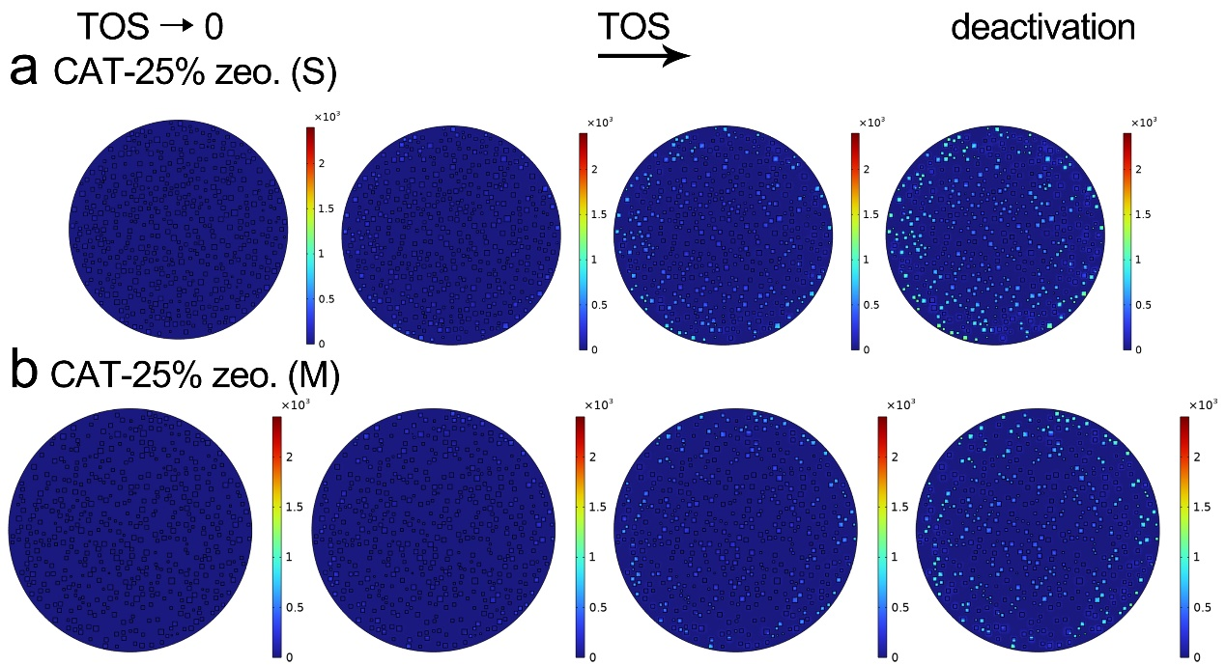
Supplementary Figure 32. Simulated spatiotemporal evolution of concentration of inactive polycyclic aromatic hydrocarbons in (a) CAT-25% zeo. (S) and (b) CAT-25% zeo. (M) catalyst particle during MTH reactions at 623 K.

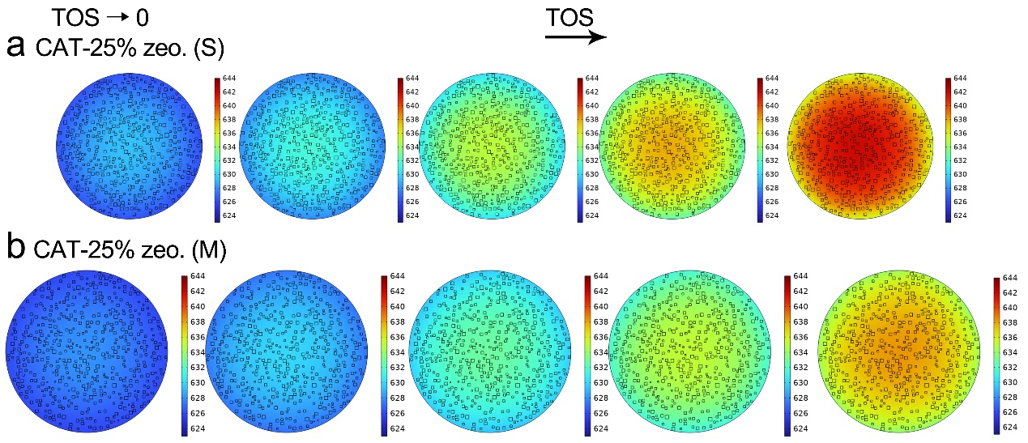
Supplementary Figure 33. Simulated spatiotemporal evolution of temperature in (a) CAT-25% zeo. (S) and (b) CAT-25% zeo. (M) catalyst particle during MTH reactions at 623 K.

Reference in Supplementary Information
1. Simeone, M.; Salemme, L.; Allouis, C., Volpicelli, G. Temperature profile in a reverse flow reactor for catalytic partial oxidation of methane by fast IR imaging. AIChE J. 2008, 54: 2689-2698.
2. Hartman, T.; Geitenbeek, R. G.; Whiting, G. T., Weckhuysen, B. M. Operando monitoring of temperature and active species at the single catalyst particle level. Nat. Catal. 2019, 2: 986-996.
3. Koptyug, I. V.; Khomichev, A. V.; Lysova, A. A., Sagdeev, R. Z. Spatially Resolved NMR Thermometry of an Operating Fixed-Bed Catalytic Reactor. J. Am. Chem. Soc. 2008, 130: 10452-10453.
4. Yarulina, I.; Kapteijn, F., Gascon, J. The importance of heat effects in the methanol to hydrocarbons reaction over ZSM-5: on the role of mesoporosity on catalyst performance. Catal. Sci. Technol. 2016, 6: 5320-5325.
5. Terlingen, B.; Arens, T.; van Swieten, T. P.; Rabouw, F. T.; Prins, T.; de Beer, M. M.; Meijerink, A.; Ahr, M.; Hutter, E. M.; van Lare, C., Weckhuysen, B. M. Bifunctional Europium for Operando Catalyst Thermometry in an Exothermic Chemical Reaction. Angew. Chem. Int. Ed. 2022, 61: e202211991.
6. Smith, J. D.; Cappa, C. D.; Drisdell, W. S.; Cohen, R. C., Saykally, R. J. Raman Thermometry Measurements of Free Evaporation from Liquid Water Droplets. J. Am. Chem. Soc. 2006, 128: 12892-12898.
7. Lv, H.; Du, P.; Li, W., Luo, L. Tailoring of Upconversion Emission in Tm3+/Yb3+-Codoped Y2Mo3O12 Submicron Particles Via Thermal Stimulation Engineering for Non-invasive Thermometry. ACS Sustainable Chem. Eng. 2022, 10: 2450-2460.
8. Guisnet, M., Magnoux, P. Organic chemistry of coke formation. Appl. Catal. A 2001, 212: 83-96.
9. Wang, N.; Zhi, Y.; Wei, Y.; Zhang, W.; Liu, Z.; Huang, J.; Sun, T.; Xu, S.; Lin, S.; He, Y.; Zheng, A., Liu, Z. Molecular elucidating of an unusual growth mechanism for polycyclic aromatic hydrocarbons in confined space. Nat. Commun. 2020, 11: 1079-1090.
10. Wang, F.; Deng, R., Liu, X. Preparation of core-shell NaGdF4 nanoparticles doped with luminescent lanthanide ions to be used as upconversion-based probes. Nat. Protoc. 2014, 9: 1634-1644.
11. Geitenbeek, R. G.; Prins, P. T.; Albrecht, W.; van Blaaderen, A.; Weckhuysen, B. M., Meijerink, A. NaYF4:Er3+,Yb3+/SiO2 Core/Shell Upconverting Nanocrystals for Luminescence Thermometry up to 900 K. J. Phys. Chem. C 2017, 121: 3503-3510.
12. Geitenbeek, R. G.; Nieuwelink, A.-E.; Jacobs, T. S.; Salzmann, B. B. V.; Goetze, J.; Meijerink, A., Weckhuysen, B. M. In Situ Luminescence Thermometry To Locally Measure Temperature Gradients during Catalytic Reactions. ACS Catal. 2018, 8: 2397-2401.
13. Hartman, T.; Geitenbeek, R. G.; Whiting, G. T., Weckhuysen, B. M. Operando monitoring of temperature and active species at the single catalyst particle level. Nat. Catal. 2019: 986-996.
14. Xu, S.; Nie, Z.; Seo, M.; Lewis, P.; Kumacheva, E.; Stone, H. A.; Garstecki, P.; Weibel, D. B.; Gitlin, I., Whitesides, G. M. Generation of Monodisperse Particles by Using Microfluidics: Control over Size, Shape, and Composition. Angew. Chem. Int. Ed. 2005, 44: 724-728.
15. Yu, X.; Cheng, G.; Zhou, M.-D., Zheng, S.-Y. On-Demand One-Step Synthesis of Monodisperse Functional Polymeric Microspheres with Droplet Microfluidics. Langmuir 2015, 31: 3982-3992.
16. Roeffaers Maarten , B. J.; De Cremer, G.; Libeert, J.; Ameloot, R.; Dedecker, P.; Bons, A. J.; Bückins, M.; Martens Johan , A.; Sels Bert , F.; De Vos Dirk , E., Hofkens, J. Super‐Resolution Reactivity Mapping of Nanostructured Catalyst Particles. Angew. Chem. Int. Ed. 2009, 48: 9285-9289.
17. Fu, D.; Maris, J. J. E.; Stanciakova, K.; Nikolopoulos, N.; van der Heijden, O.; Mandemaker, L. D. B.; Siemons, M. E.; Salas Pastene, D.; Kapitein, L. C.; Rabouw, F. T.; Meirer, F., Weckhuysen, B. M. Unravelling Channel Structure–Diffusivity Relationships in Zeolite ZSM-5 at the Single-Molecule Level. Angew. Chem. Int. Ed. 2021, 60: e202114388.
18. Gao, M.; Li, H.; Liu, W.; Xu, Z.; Peng, S.; Yang, M.; Ye, M., Liu, Z. Imaging spatiotemporal evolution of molecules and active sites in zeolite catalyst during methanol-to-olefins reaction. Nat. Commun. 2020, 11: 3641-3652.
19. Zhou, J.; Gao, M.; Zhang, J.; Liu, W.; Zhang, T.; Li, H.; Xu, Z.; Ye, M., Liu, Z. Directed transforming of coke to active intermediates in methanol-to-olefins catalyst to boost light olefins selectivity. Nat. Commun. 2021, 12: 17-27.
20. Kärger, J.; Binder, T.; Chmelik, C.; Hibbe, F.; Krautscheid, H.; Krishna, R., Weitkamp, J. Microimaging of transient guest profiles to monitor mass transfer in nanoporous materials. Nat. Mater. 2014, 13: 333-343.
21. Bonilla, M. R.; Valiullin, R.; Kärger, J., Bhatia, S. K. Understanding Adsorption and Transport of Light Gases in Hierarchical Materials Using Molecular Simulation and Effective Medium Theory. J. Phys. Chem. C 2014, 118: 14355-14370.
22. Van Speybroeck, V.; Van der Mynsbrugge, J.; Vandichel, M.; Hemelsoet, K.; Lesthaeghe, D.; Ghysels, A.; Marin, G. B., Waroquier, M. First Principle Kinetic Studies of Zeolite-Catalyzed Methylation Reactions. J. Am. Chem. Soc. 2011, 133: 888-899.
23. De Wispelaere, K.; Hemelsoet, K.; Waroquier, M., Van Speybroeck, V. Complete low-barrier side-chain route for olefin formation during methanol conversion in H-SAPO-34. J. Catal. 2013, 305: 76-80.
24. Zhang, W.; Chen, J.; Xu, S.; Chu, Y.; Wei, Y.; Zhi, Y.; Huang, J.; Zheng, A.; Wu, X.; Meng, X.; Xiao, F.; Deng, F., Liu, Z. Methanol to Olefins Reaction over Cavity-type Zeolite: Cavity Controls the Critical Intermediates and Product Selectivity. ACS Catal. 2018, 8: 10950-10963.
25. Wang, S.; Chen, Y.; Wei, Z.; Qin, Z.; Liang, T.; Dong, M.; Li, J.; Fan, W., Wang, J. Evolution of aromatic species in supercages and its effect on the conversion of methanol to olefins over H-MCM-22 zeolite: a density functional theory study. J. Phys. Chem. C 2016, 120: 27964-27979.

