Supplementary material
Supplemetary material of the manuscript entitled “Time to death and its predictors among asphyxiated neonates admitted to Jimma University Medical Center, Ethiopia: a retrospective cohort study”.
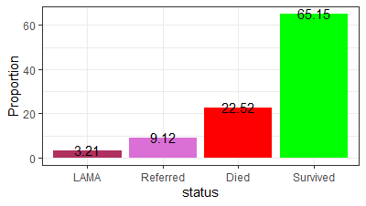
Figure S1: Discharge status of asphyxiated neonates admitted to Jimma University Medical Center
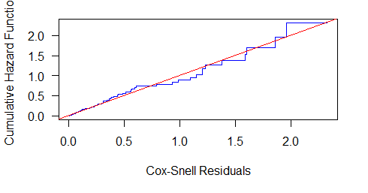
Figure S2: Model fitness test of asphyxiated neonates admitted to Jimma University Medical Center

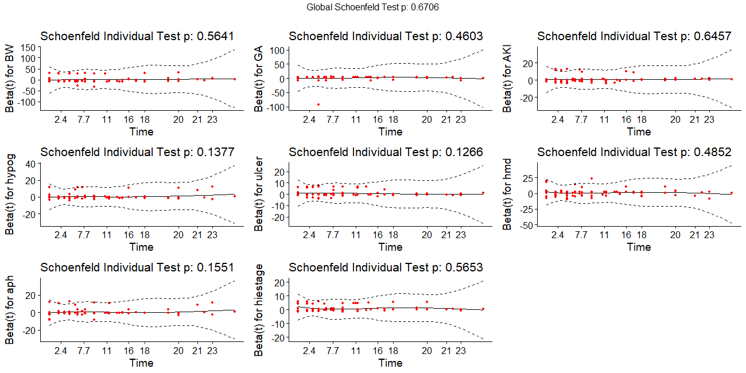
Figure S3: Proportional hazard assumption test of model on asphyxiated neonates admitted to Jimma University Medical Center

