Table 3: Samples of Citrus Fruits Obtained after Performing Different Data Augmentation Process
Data Augmentation Technique | Data Augmentation Sample
Brightness | 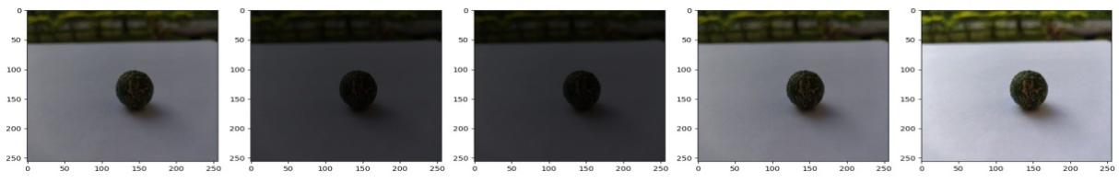
Heightwidthshift | 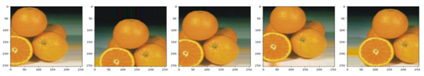
Horizontal flip | 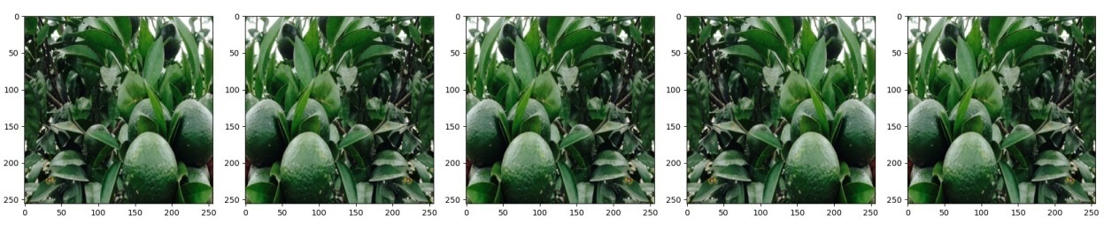
Rotation | 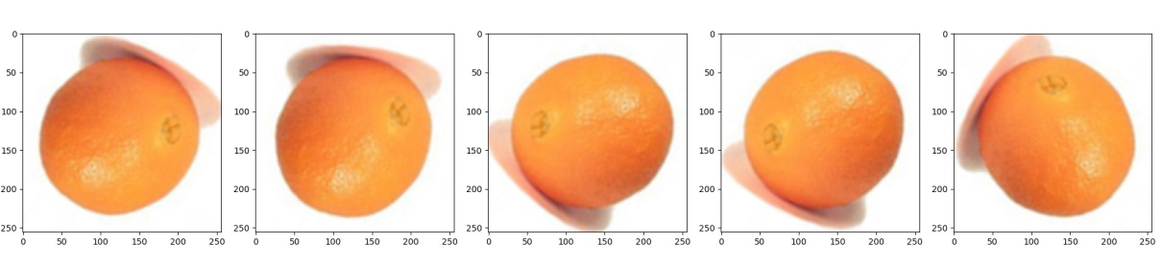
Shear | 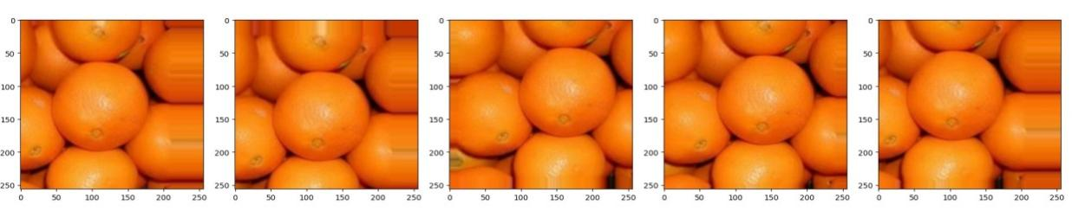
Rescaling | 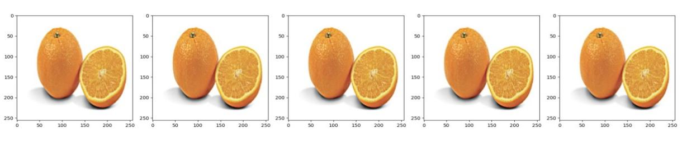
Vertical flip | 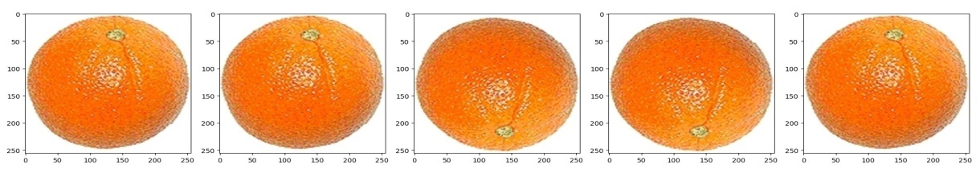
ZCA-Whitening | 