
The ARRIVE Guidelines Checklist
Animal Research: Reporting In Vivo Experiments
Carol Kilkenny¹, William J Browne², Innes C Cuthill³, Michael Emerson⁴ and Douglas G Altman⁵
¹The National Centre for the Replacement, Refinement and Reduction of Animals in Research, London, UK, ²School of Veterinary Science, University of Bristol, Bristol, UK, ³School of Biological Sciences, University of Bristol, Bristol, UK, ⁴National Heart and Lung Institute, Imperial College London, UK, ⁵Centre for Statistics in Medicine, University of Oxford, Oxford, UK.

 |  | ITEM | RECOMMENDATION | Section/  Paragraph
 |  |  |  | Title
 |  |  |  | Abstract
 | INTRODUCTION
 | 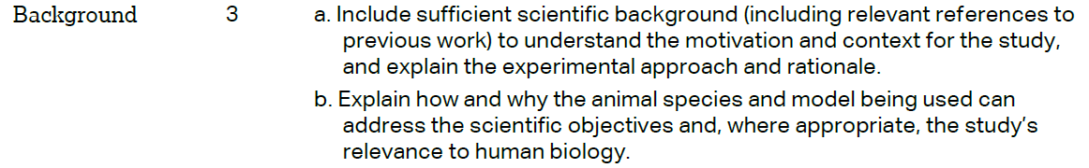 |  |  | Paragraphs 1 – 3.
 |  |  |  | Paragraph 4.
 | METHODS
“Animals and Surgery”
Paragraph 1.
 | 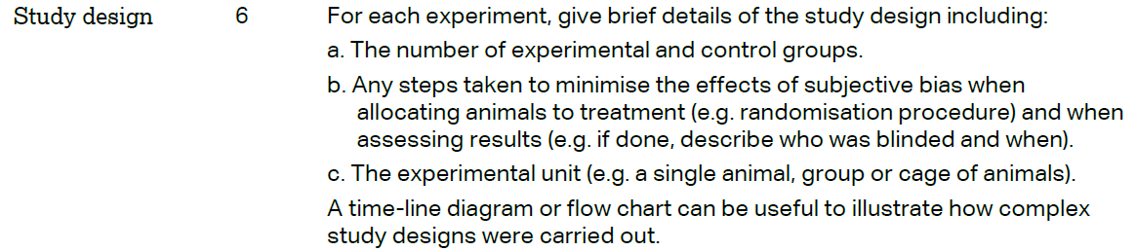 |  |  | “Experimental design”  Paragraphs 1 - 2.
 | 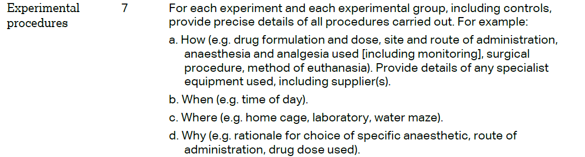 |  |  | “Animals and Surgery” - Paragraphs 1 -2.  “BMMC obtaining and transplantation” - Paragraphs 1 -2.  “Characterisation of the lesion”. Paragraph 1.  “In vivo neural tract tracing procedure”. Paragraph 1.  “Histological Analysis”. Paragraph 1.
 | 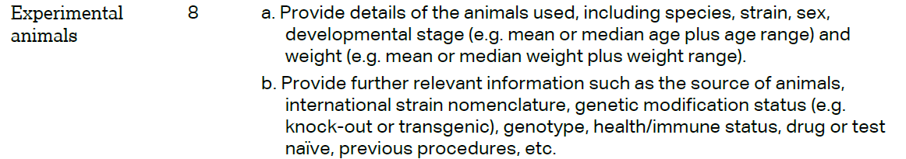 |  |  | “Animals and Surgery” - Paragraph 1.
 | 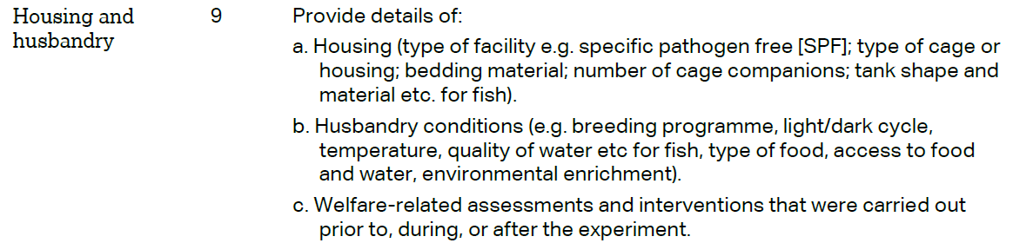 |  |  | “Animals and Surgery” - Paragraph 1.
 | 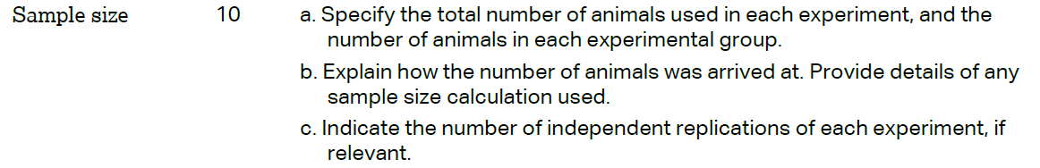 |  |  | “Animals and Surgery” - Paragraph 1.  BMMC obtaining and transplantation” - Paragraph 1.  “Experimental design”  Paragraphs 1.  “Characterisation of the lesion”. Paragraph 1.
 | 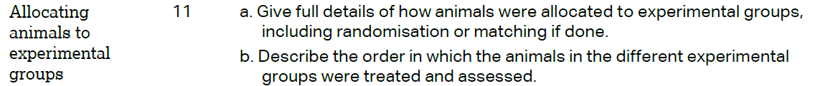 |  |  | “Animals and Surgery” - Paragraph 2.  “BMMC obtaining and transplantation” - Paragraphs 1 -2.  “Experimental design”  Paragraphs 1-2.  “Characterisation of the lesion”. Paragraph 1.  “In vivo neural tract tracing procedure”. Paragraph 1.  “Histological Analysis”. Paragraph 1.
“Characterisation of the lesion”. Paragraph 1.

“In vivo neural tract tracing procedure”. Paragraph 1.

 | 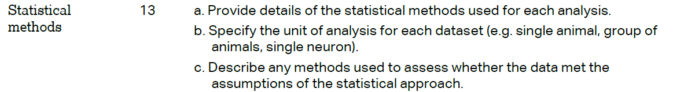 |  |  | “Data analyses”. Paragraphs 1 -2.
 | RESULTS
METHODS
Animals and Surgery” - Paragraph 1.
“Experimental design”
Paragraph 1.
METHODS
Animals and Surgery” - Paragraph 1.
“Experimental design”
Paragraph 1.
“Histological Analysis”. Paragraph 1.
METHODS: “Data analyses”. Paragraphs 1 -2.
RESULTS:
“Quantitative analysis of cortico-cortical…” Paragraphs 1-3 and figure 2.
RESULTS:
“Quantitative analysis of cortico-cortical…” Paragraphs 1-3.
 | DISCUSSION
 | 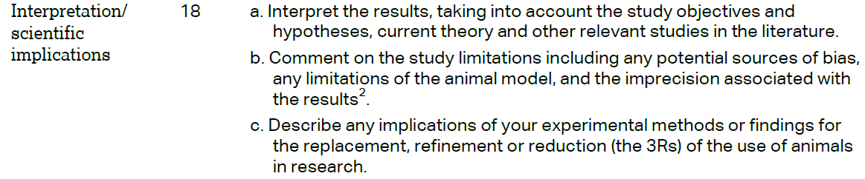 |  |  | DISCUSSION: Paragraphs 1-3.  Paragraph 5.  LIMITATION: Paragraph 1.
 |  |  |  | DISCUSSION: Paragraph 5.
 |  |  |  | FUNDING: Paragraph 1.

