Supplementary files
Title Characterization, nitrogen availability and agronomic efficiency of fermented composts in organic vegetable production

Authors Livia Bischof Pian¹. José Guilherme Marinho Guerra². Ricardo Luis Louro Berbara³. Monalisa Santana Coelho de Jesus4. José Barbosa Junior³. Ednaldo da Silva Araújo².

Authors Affiliations
¹ Smart Farm Collaborative Laboratory. Torres Vedras. Portugal
² Embrapa Agrobiologia – Brazilian Agricultural Research Corporation. Seropédica. Brazil
³ Universidade Federal Rural do Rio de Janeiro. Seropédica. Rio de Janeiro. Brazil
4 Embrapa Agroindústria de Alimentos - Brazilian Agricultural Research Corporation. Rio de Janeiro. Brazil
Corresponding author Livia Bischof Pian. orcid 0000-0001-8605-5464. liviapian@gmail.com

Section: Materials and methods

Table S1. Proportions of plant-based raw materials in the incubation trials
Treatment | Wheat bran | Substitute of wheat bran¹ | Castor bean bran | Leguminous bran
T1(SC)² | 60 | 0 | 40 | 0
T2 | 45 | 15 | 40 | 0
T3 | 30 | 30 | 40 | 0
T4 | 15 | 45 | 40 | 0
T5 | 0 | 60 | 40 | 0
T6 | 60 | 0 | 0 | 40
T7 | 45 | 15 | 0 | 40
T8 | 30 | 30 | 0 | 40
T9 | 15 | 45 | 0 | 40
T10 | 0 | 60 | 0 | 40
¹Coffee husks, brewery residue or elephant grass bran; ²SC = Standard compost.

Table S2. Quantities and inputs of nutrients from fermented composts incorporated into the soil to evaluate agronomic efficiency in the cultivation of vegetables in succession.
Fermented compost ¹ | Incorporated quantity ² |  | Nutrients doses
Fermented compost ¹ |  |  | N | P | K | Ca | Mg
Fermented compost ¹ | kg wet m⁻² | Mg ha⁻¹ | kg ha⁻¹
1 - SC | 0.37 | 2.84 | 100.0 | 24.7 | 33.4 | 12.4 | 16.4
1 - SC | 0.74 | 5.68 | 200.0 | 49.5 | 66.8 | 24.8 | 32.8
1 - SC | 1.48 | 11.37 | 400.0 | 98.9 | 133.5 | 49.5 | 65.6
2 - WB+CH+CB | 0.44 | 3.38 | 100.0 | 24.3 | 46.0 | 22.4 | 17.3
2 - WB+CH+CB | 0.88 | 6.75 | 200.0 | 48.6 | 92.0 | 44.9 | 34.6
2 - WB+CH+CB | 1.76 | 13.51 | 400.0 | 97.3 | 183.9 | 89.8 | 69.3
3 - WB+CH+LB | 0.47 | 3.58 | 100.0 | 15.5 | 55.5 | 22.4 | 14.9
3 - WB+CH+LB | 0.93 | 7.17 | 200.0 | 31.0 | 110.9 | 44.7 | 29.8
3 - WB+CH+LB | 1.86 | 14.33 | 400.0 | 62.0 | 221.8 | 89.5 | 59.6
4 - WB+EG+CB | 0.38 | 2.92 | 100.0 | 17.5 | 33.1 | 19.8 | 16.2
4 - WB+EG+CB | 0.76 | 5.85 | 200.0 | 34.9 | 66.2 | 39.7 | 32.4
4 - WB+EG+CB | 1.52 | 11.69 | 400.0 | 69.9 | 132.4 | 79.3 | 64.7
5 - WB+EG+LB | 0.47 | 3.61 | 100.0 | 13.4 | 33.6 | 28.4 | 15.1
5 - WB+EG+LB | 0.94 | 7.23 | 200.0 | 26.7 | 67.3 | 56.8 | 30.2
5 - WB+EG+LB | 1.88 | 14.45 | 400.0 | 53.4 | 134.6 | 113.6 | 60.5
¹ Standardized proportion based on dry mass; SC (Standard Compost) – 60% wheat bran + 40% castor bran; WB – 30% Wheat Bran; CH – 30% Coffee husk; EG – 30% Elephant grass; CB – 40% Castor bean bran; LB – 40% Leguminous bran. ²Fermented compost incorporated into the soil had approximately 30% moisture.

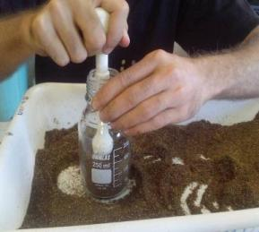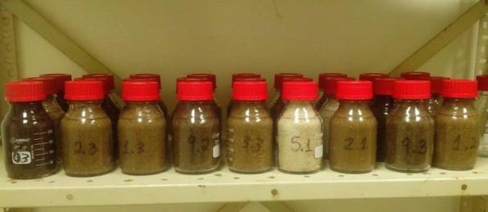
Figure S1. Fermented compost preparation (left) and bottles used in the incubation tests (right).

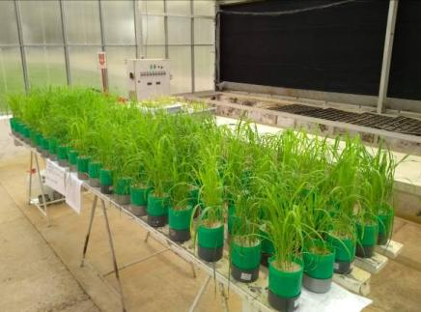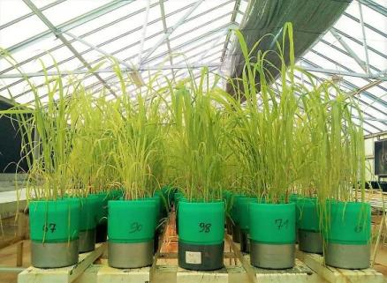
Figure S2. Overview of the bioassay conducted in a greenhouse (left) and pots at maximum plant development (right).

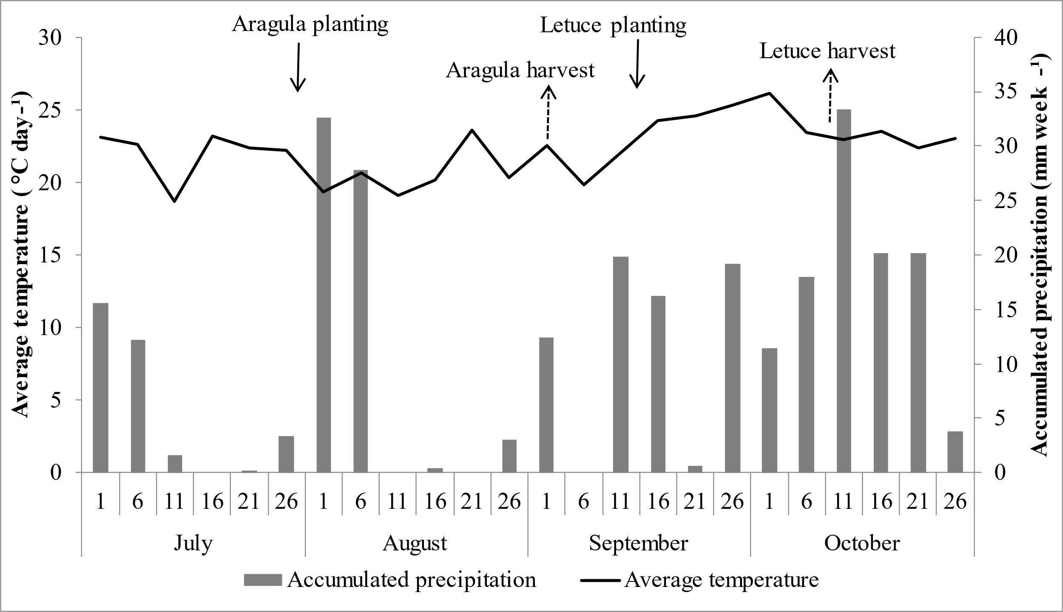
Figure S3. Average temperature and accumulated precipitation from July to October 2018 at Fazendinha Agroecológica Km 47.

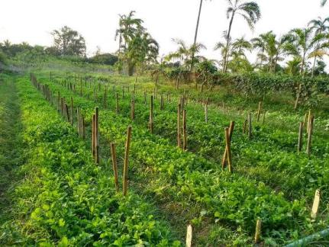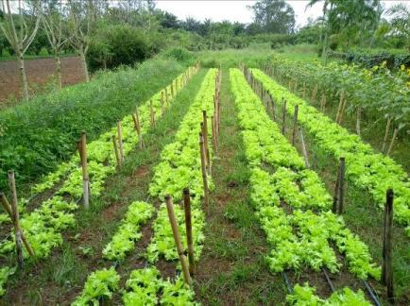
A
B
Figure S4. Overview of the agronomic efficiency experiment of increasing doses of fermented composts in organic cultivation of arugula (left) and crisp lettuce (right).

Section: Results and discussion

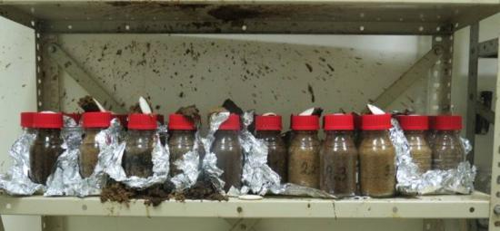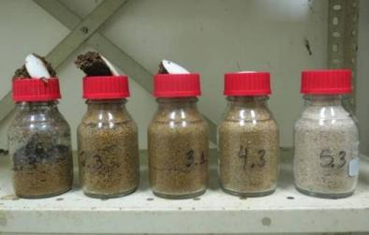
Figure S5. Rupture of the membrane bottles with fermented compost in the first moisture incubation test.

Table S3. Regression equations and R² from the organic acids of fermented compost formulations.
Formulation | Organic Acid | Regression equation | R²
SC¹ (moisture pre-tests) | First pre-test | y = -0.017x² + 1.046x | 0.801
 | Second pre-test | y = -0.206x + 26.31 | 0.977
CH + CB | Lactic acid | y = -0.295x + 20.49 | 0.909
CH + CB | Acetic acid | y = 0.001x2 - 0.101x + 6.081 | 0.669
CH + CB | Ethanol | y = 0.108x + 3.512 | 0.508
CH + LB | Lactic acid | y = -0.003x2 + 0.163x + 15.06 | 0.991
CH + LB | Acetic acid | y = -0.002x2 + 0.132x + 4.853 | 0.554
EG + CB | Lactic acid | y= -0.005x2 + 0.079x + 18.34 | 0.647
EG + CB | Ethanol | y = 0.007x2 - 0.260x + 4.293 | 0.855
EG + LB | Lactic acid | y = -0.001x² + 0.074x + 15.98 | 0.739
EG + LB | Acetic acid | y = -0.002x2 + 0.172x + 4.626 | 0.861
BR + CB | Lactic acid | y = 0.004x2 - 0.333x + 21.60 | 0.567
BR + CB | Acetic acid | y = -0.038x + 5.425 | 0.829
BR + CB | Ethanol | y = 0.078x + 2.448 | 0.853
BR + LB | Lactic acid | y = -0.095x + 16.3 | 0.790
BR + LB | Acetic acid | y = -0.024x + 4.409 | 0.727
BR + LB | Ethanol | y = -0.037x + 4.326 | 0.628
¹SC – Standard Compost; CH – Coffee husk; EG –Elephant grass; CB – Castor bean bran; LB – Leguminous bran.

Table S4. Pearson's correlation matrix of nutrients and organic acids from fermented composts with the gradual replacement of wheat bran by coffee husks complemented with castor bean bran.
 | pH | N | P | K | Ca | Mg | Lactic | Acetic | Ethanol | Butyric | Propanoic
pH | 1.00¹
N | -0.34 | 1.00
P | -0.87 | 0.25 | 1.00
K | 0.72 | -0.30 | -0.64 | 1.00
Ca | 0.53 | -0.22 | -0.65 | 0.59 | 1.00
Mg | -0.82 | 0.15 | 0.81 | -0.54 | -0.32 | 1.00
Lactic | -0.91 | 0.23 | 0.96 | -0.70 | -0.67 | 0.85 | 1.00
Acetic. | -0.22 | 0.07 | 0.60 | -0.24 | -0.65 | 0.29 | 0.52 | 1.00
Ethanol | 0.81 | -0.44 | -0.62 | 0.72 | 0.53 | -0.58 | -0.75 | 0.01 | 1.00
Butyric | 0.95 | -0.25 | -0.73 | 0.58 | 0.43 | -0.71 | -0.80 | -0.05 | 0.76 | 1.00
Propanoic | -0.34 | 0.26 | 0.20 | -0.08 | 0.24 | 0.32 | 0.10 | -0.11 | 0.09 | -0.40 | 1.00
¹ Values in bold were significant (p value<0.01).

Table S5. Pearson's correlation matrix of nutrients and organic acids from fermented composts with the gradual replacement of wheat bran by coffee husks complemented with leguminous bran.
 | pH | N | P | K | Ca | Mg | Lactic | Acetic | Ethanol | Butyric | Propanoic
pH | 1.00¹
N | -0.30 | 1.00
P | -0.76 | 0.29 | 1.00
K | 0.42 | 0.07 | -0.81 | 1.00
Ca | 0.52 | -0.13 | -0.67 | 0.39 | 1.00
Mg | -0.73 | 0.44 | 0.70 | -0.25 | -0.63 | 1.00
Lactic | -0.13 | 0.42 | -0.16 | 0.41 | 0.06 | 0.12 | 1.00
Acetic. | -0.07 | 0.57 | -0.04 | 0.40 | -0.14 | 0.28 | 0.39 | 1.00
Ethanol | 0.23 | -0.48 | -0.29 | 0.14 | 0.20 | -0.37 | 0.24 | -0.46 | 1.00
Butyric | - | - | - | - | - | - | - | - | - | 1.00
Propanoic | - | - | - | - | - | - | - | - | - | - | 1.00
¹ Values in bold were significant (p value<0.01).

Table S6. Pearson's correlation matrix of nutrients and organic acids from fermented composts with the gradual replacement of wheat bran by brewery residue complemented with castor bean bran.
 | pH | N | P | K | Ca | Mg | Lactic | Acetic | Ethanol | Butyric | Propanoic
pH | 1.00¹
N | 0.22 | 1.00
P | -0.08 | -0.29 | 1.00
K | -0.28 | -0.82 | 0.48 | 1.00
Ca | -0.10 | 0.39 | -0.32 | -0.41 | 1.00
Mg | -0.24 | -0.68 | 0.68 | 0.82 | -0.08 | 1.00
Lactic | 0.19 | -0.33 | -0.37 | 0.09 | 0.44 | 0.24 | 1.00
Acetic. | -0.25 | -0.78 | 0.12 | 0.67 | 0.16 | 0.69 | 0.70 | 1.00
Ethanol | 0.61 | 0.47 | -0.24 | -0.59 | 0.26 | -0.48 | 0.15 | -0.36 | 1.00
Butyric | - | - | - | - | - | - | - | - | - | 1.00
Propanoic | 0.26 | 0.74 | -0.61 | -0.93 | 0.29 | -0.84 | -0.03 | -0.63 | 0.57 | - | 1.00
¹ Values in bold were significant (p value<0.01).

Table S7. Pearson's correlation matrix of nutrients and organic acids from fermented composts with the gradual replacement of wheat bran by brewery residue complemented with leguminous bran.
 | pH | N | P | K | Ca | Mg | Lactic | Acetic | Ethanol | Butyric | Propanoic
pH | 1.00¹
N | -0.46 | 1.00
P | 0.45 | -0.73 | 1.00
K | 0.52 | -0.17 | 0.05 | 1.00
Ca | -0.52 | 0.72 | -0.65 | -0.08 | 1.00
Mg | 0.40 | -0.43 | 0.37 | 0.75 | -0.21 | 1.00
Lactic | 0.93 | -0.51 | 0.57 | 0.51 | -0.57 | 0.58 | 1.00
Acetic. | 0.81 | -0.50 | 0.55 | 0.30 | -0.59 | 0.46 | 0.93 | 1.00
Ethanol | 0.60 | -0.58 | 0.39 | 0.24 | -0.75 | 0.14 | 0.60 | 0.68 | 1.00
Butyric | -0.32 | 0.35 | -0.29 | -0.29 | 0.13 | -0.02 | -0.14 | 0.05 | -0.10 | 1.00
Propanoic | - | - | - | - | - | - | - | - | - | - | 1.00
¹ Values in bold were significant (p value<0.01).

Table S8. Pearson's correlation matrix of nutrients and organic acids from fermented composts with the gradual replacement of wheat bran by elephant grass bran complemented with castor bean bran.
 | pH | N | P | K | Ca | Mg | Lactic | Acetic | Ethanol | Butyric | Propanoic
pH | 1.00¹
N | -0.10 | 1.00
P | -0.67 | -0.43 | 1.00
K | -0.80 | -0.11 | 0.75 | 1.00
Ca | 0.84 | -0.03 | -0.75 | -0.64 | 1.00
Mg | -0.05 | 0.13 | 0.17 | 0.08 | 0.09 | 1.00
Lactic | -0.84 | -0.04 | 0.73 | 0.63 | -0.68 | 0.38 | 1.00
Acetic. | 0.26 | 0.18 | -0.47 | -0.51 | 0.02 | -0.36 | -0.48 | 1.00
Ethanol | 0.93 | -0.13 | -0.60 | -0.79 | 0.64 | -0.16 | -0.88 | 0.52 | 1.00
Butyric | 0.94 | -0.11 | -0.56 | -0.73 | 0.64 | -0.23 | -0.90 | 0.39 | 0.97 | 1.00
Propanoic | - | - | - | - | - | - | - | - | - | - | 1.00
¹ Values in bold were significant (p value<0.01).

Table S9. Pearson's correlation matrix of nutrients and organic acids from fermented composts with the gradual replacement of wheat bran by elephant grass bran complemented with leguminous bran.
 | pH | N | P | K | Ca | Mg | Lactic | Acetic | Ethanol | Butyric | Propanoic
pH | 1.00¹
N | -0.56 | 1.00
P | -0.52 | 0.86 | 1.00
K | -0.44 | -0.22 | -0.23 | 1.00
Ca | 0.62 | -0.81 | -0.87 | 0.07 | 1.00
Mg | -0.40 | -0.05 | 0.00 | 0.47 | -0.04 | 1.00
Lactic | -0.57 | 0.09 | -0.12 | 0.62 | -0.21 | 0.48 | 1.00
Acetic. | -0.01 | -0.32 | -0.57 | 0.33 | 0.38 | 0.22 | 0.65 | 1.00
Ethanol | -0.52 | 0.02 | -0.10 | 0.48 | -0.09 | 0.62 | 0.85 | 0.58 | 1.00
Butyric | - | - | - | - | - | - | - | - | - | 1.00
Propanoic | 0.37 | -0.17 | -0.02 | -0.09 | 0.09 | -0.55 | -0.55 | -0.40 | -0.85 | - | 1.00
¹ Values in bold were significant (p value<0.01).

Table S10. Regression equations and R² from the significative variables of the field trial.
Formulation | N-doses | Regression equation | R²
SC¹ | Arugula leaf area | y = 22.97x + 9264 | 0.879
 | Arugula leaf biomass | y = 15.04x + 6420 | 0.918
 | Arugula roots biomass | y = 42.23x + 5558 | 0.98
 | Arugula N | y = 32.72x - 12.01 | 0.989
 | Arugula P | y = 0.03x + 4.028 | 0.984
 | Arugula K | y = 0.209x + 21.93 | 0.987
 | Arugula Ca | y = 0.062x + 16.52 | 0.971
 | Arugula Mg | y = 0.023x + 4.911 | 0.945
 | Soil FDA | y = 0.076x + 69.03 | 0.989
 | Soil microbial N-biomass | y = 4E-05x² - 0.0114x + 9.1269 | 0.867
WB+CH+CB | Arugula leaf area | y = -0.228x2 + 138.7x + 6098 | 0.895
 | Arugula leaf biomass | y = -0.097x2 + 79.12x + 4788 | 0.91
 | Arugula roots biomass | y = 0.010x + 24.58 | 0.661
 | Arugula N | y = 32.73x - 5.415 | 0.902
 | Arugula P | y = 0.033x + 4.587 | 0.916
 | Arugula K | y = -0.001x² + 0.519x + 18.37 | 0.799
 | Arugula Ca | y = 0.066x + 18.70 | 0.918
 | Arugula Mg | y = -6E-05x² + 0.046x + 4.768 | 0.937
 | Soil FDA | y = -0.000x2 + 0.103x + 67.79 | 0.922
 | Soil microbial N-biomass | y = 0.007x + 8.362 | 0.915
WB+CH+LB | Arugula leaf area | y = 42.76x + 10013 | 0.989
WB+CH+LB | Arugula leaf biomass | y = 15.04x + 6420 | 0.918
WB+CH+LB | Arugula N | y = 13.52x + 17.72 | 0.702
WB+CH+LB | Arugula P | y = 0.012x + 4.473 | 0.896
WB+CH+LB | Arugula K | y = 0.107x + 20.52 | 0.867
WB+CH+LB | Arugula Mg | y = 0.014x + 5.305 | 0.893
WB+CH+LB | Soil FDA | y = 0.108x + 54.22 | 0.672
WB+CH+LB | Soil microbial N-biomass | y = 0.024x + 7.710 | 0.963
WB+EG+CB | Arugula leaf biomass | y = 0.001x2 - 0.101x + 6.081 | 0.967
 | Arugula roots biomass | □ y = -0.133x2 + 71.95x + 6353 | 0.98
 | Arugula N | y = -11.64x2 + 69.45x - 20.87 | 0.9
 | Arugula P | y = -0.000x² + 0.057x + 4.907 | 0.915
 | Arugula K | y = -0.000x² + 0.391x + 31.37 | 0.99
 | Arugula Ca | y = -0.000x² + 0.100x + 18.31 | 0.973
 | Arugula Mg | y = -9E-05x² + 0.043x + 6.078 | 0.948
 | Soil FDA | y = 0.054x + 72.79 | 0.802
 | Soil microbial N-biomass | y = 0.008x + 8.100 | 0.959
WB+EG+LB | Arugula N | y = -0.000x² + 0.175x + 30.47 | 0.98
WB+EG+LB | Arugula P | y = 0.008x + 4.996 | 0.836
WB+EG+LB | Arugula K | y = 0.083x + 23.66 | 0.866
WB+EG+LB | Soil microbial N-biomass | y = 0.02x + 7.171 | 0.973
¹SC (Standard Compost) – 60% wheat bran + 40% castor bran; WB – 30% Wheat Bran; CH – 30% Coffee husk; EG – 30% Elephant grass; CB – 40% Castor bean bran; LB – 40% Leguminous bran.

