SUPPORTING INFORMATION

Magnetically-activated 3D printable PLA/PCL/Fe₃O₄ composites for magnetic induction heating generation

Itziar Galarreta-Rodriguez^{1-2*} (0000-0001-9172-4319), Alberto Lopez-Ortega^{1-2*}(0000-0003-3440-4444), Eneko Garayo¹⁻²(0000-0002-3144-7898), Juan Jesús Beato-López¹⁻², Paulo La Roca¹⁻²⁻³(0000-0003-0856-6052), Vicente Sanchez-Alarcos¹⁻²(0000-0002-9282-7683), Vicente Recarte¹⁻²(0000-0002-5342-5403), Cristina Gómez-Polo¹⁻² (0000-0001-8919-4822) and Jose Ignacio Pérez-Landazábal¹⁻²(0000-0003-1172-6141)
1Departamento de Ciencias, Universidad Pública de Navarra, Campus de Arrosadía, 31006, Pamplona, Spain
2Institute for Advanced Materials and Mathematics (INAMAT2), Universidad Pública de Navarra, Campus de Arrosadía, 31006, Pamplona, Spain
3Centro Atómico Bariloche (CNEA), CONICET, Bariloche 8400, Argentina

*Itziar Galarreta-Rodriguez: galarretarodriguez.itziar@gmail.com
*Alberto Lopez-Ortega: lopezortega.alberto@gmail.com

Table S1. Weight loss percentages for prepared PLA/PCL and PLA/PCL/MNP filaments
 | PLA | PCL | Rest
Composite | % weight | % weight | % weight
P0% | 9 | 90 | 1
P5% | 13 | 82 | 5
P10% | 7 | 81 | 12
P20% | 8 | 71 | 21
P40% | 7 | 53 | 40
P60% | 6 | 37 | 57

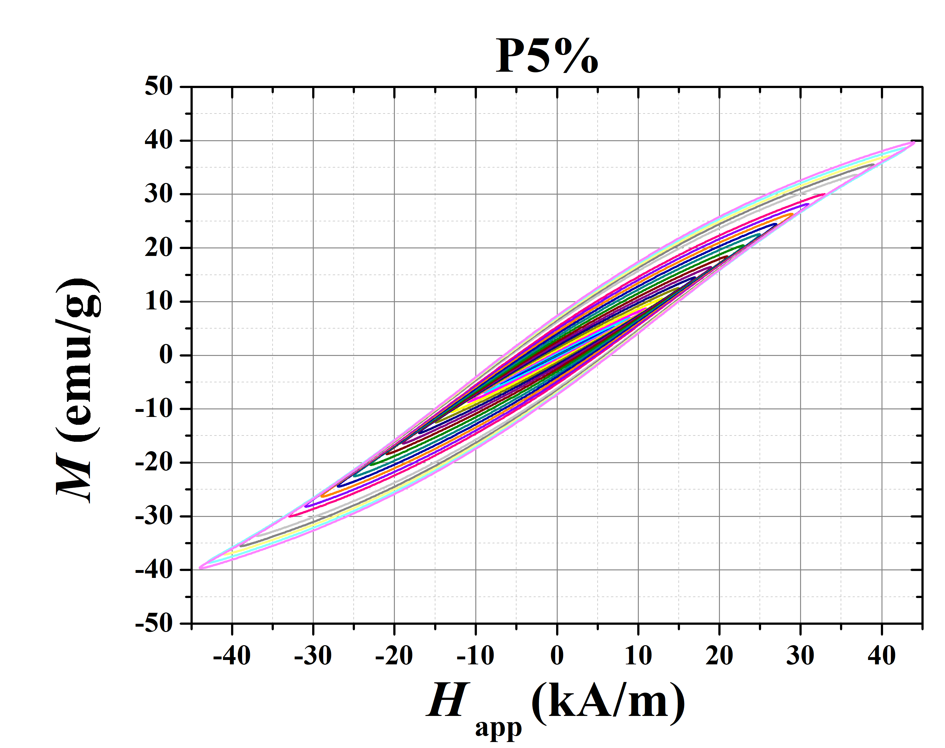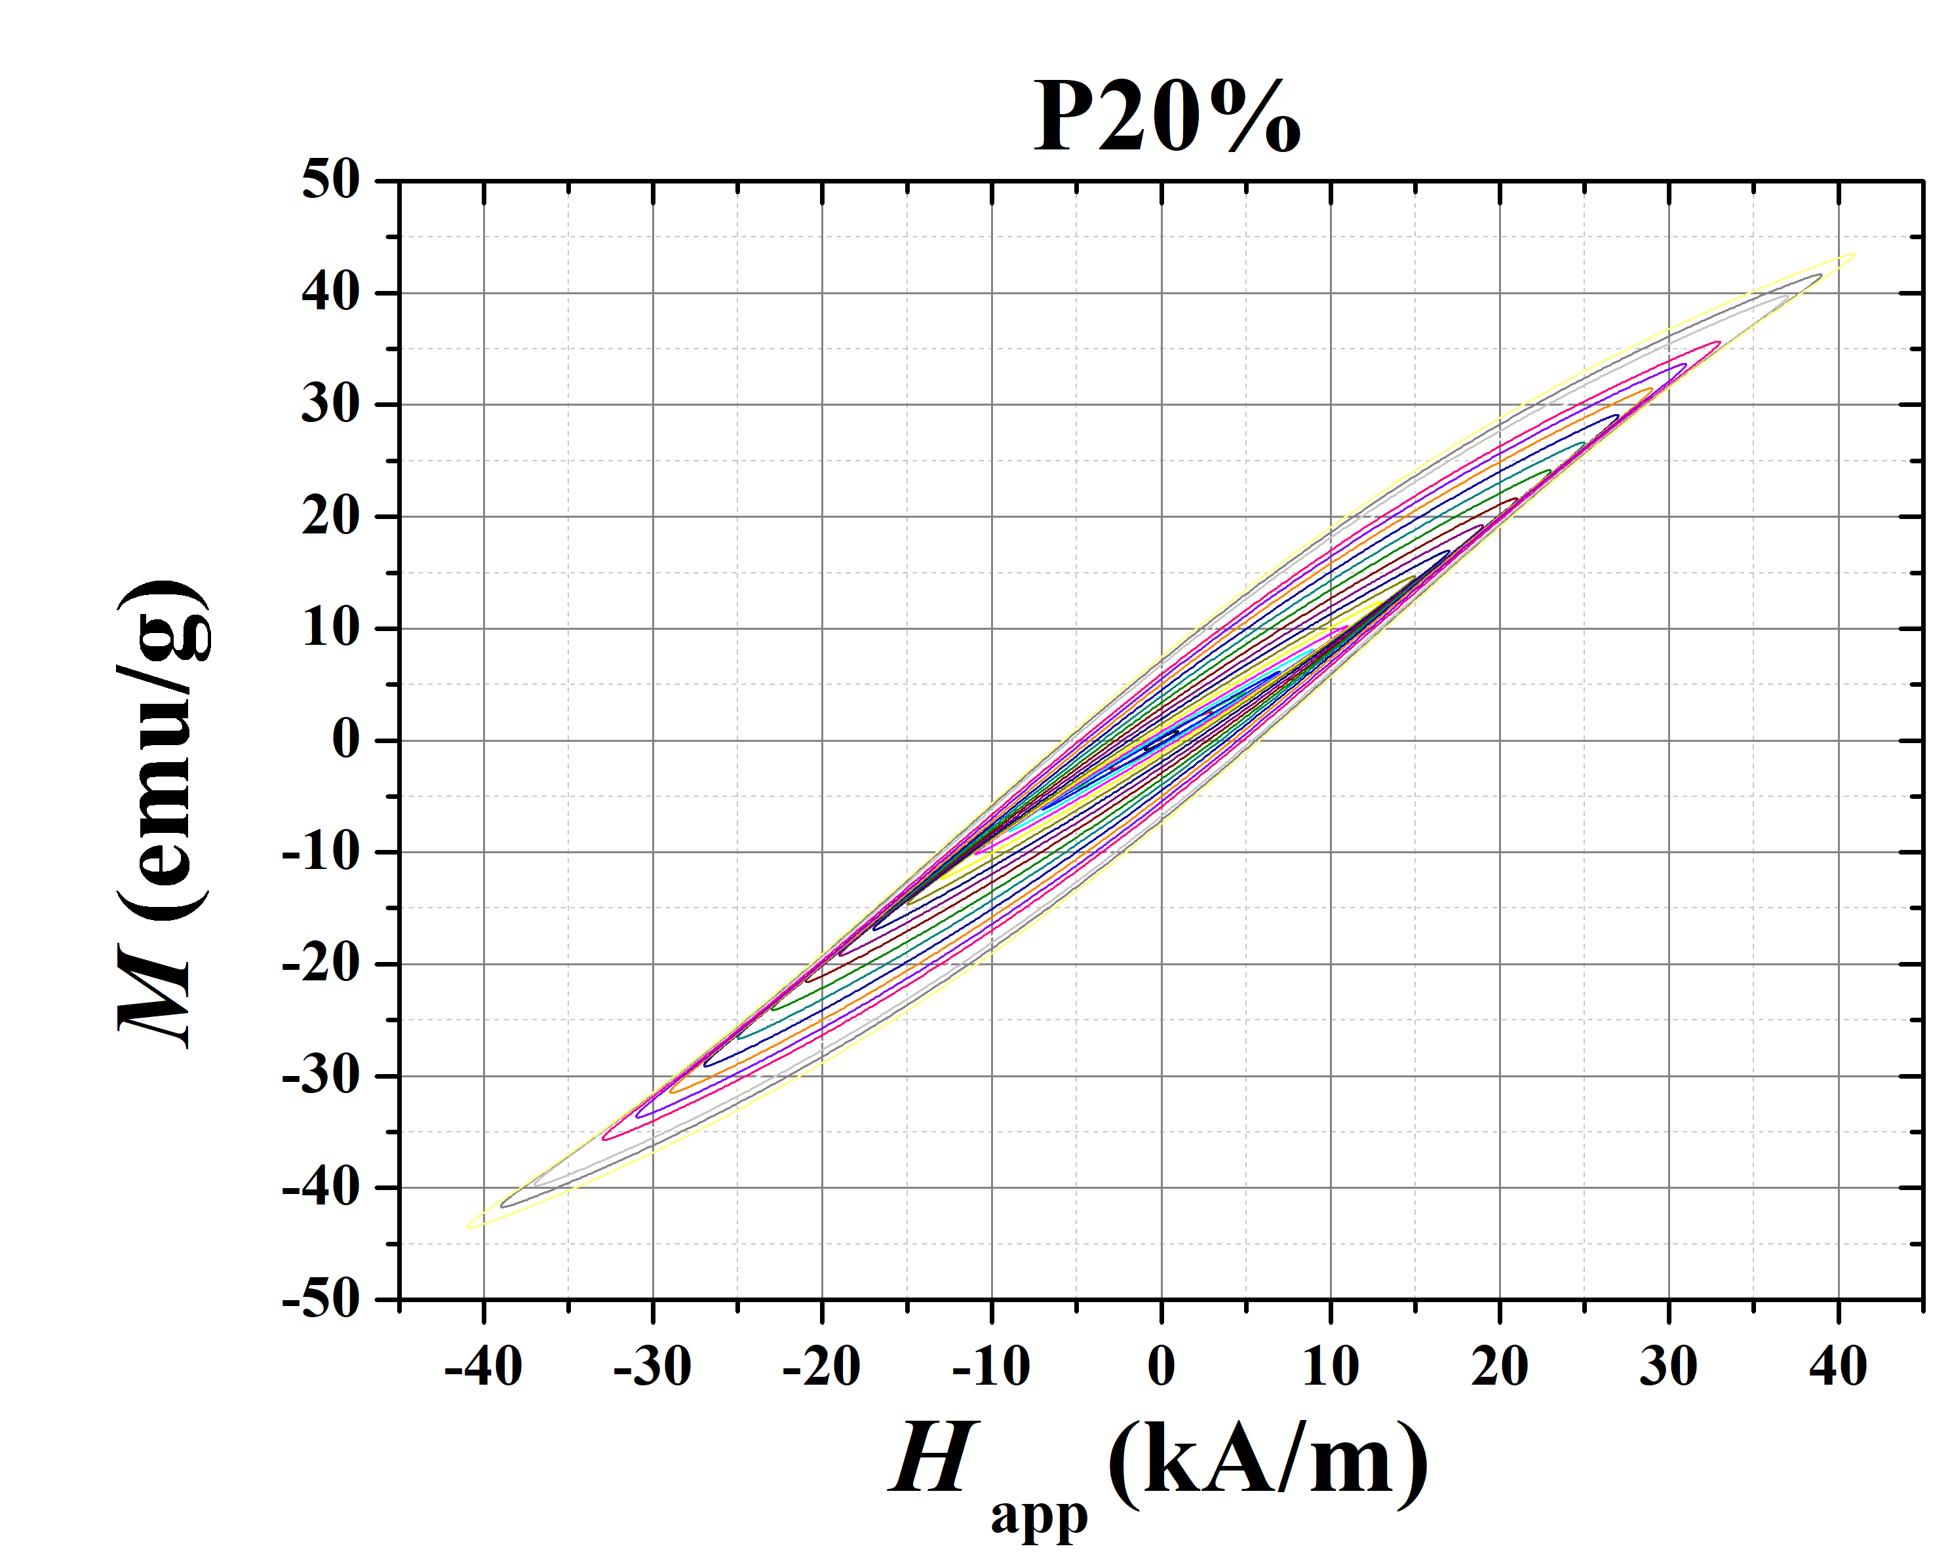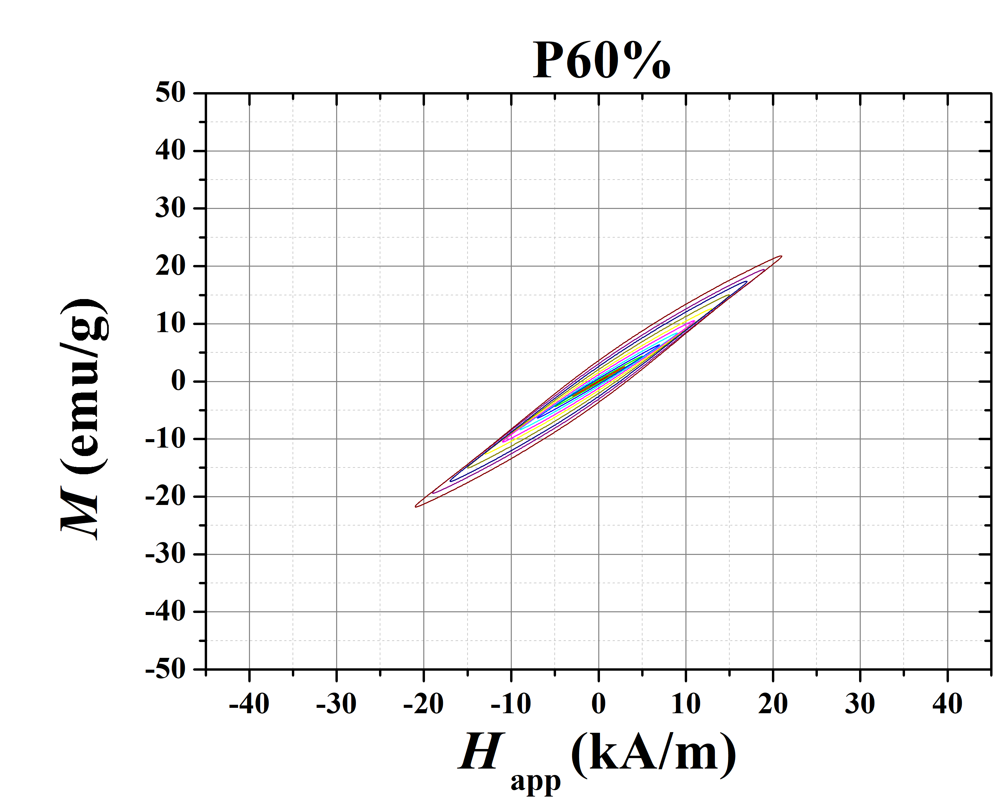
Fig. S1. AC hysteresis loops of the filaments measured at 311 kHz frequency. $SAR$ values are obtained from the area. The magnetization is normalized by the mass of NPs

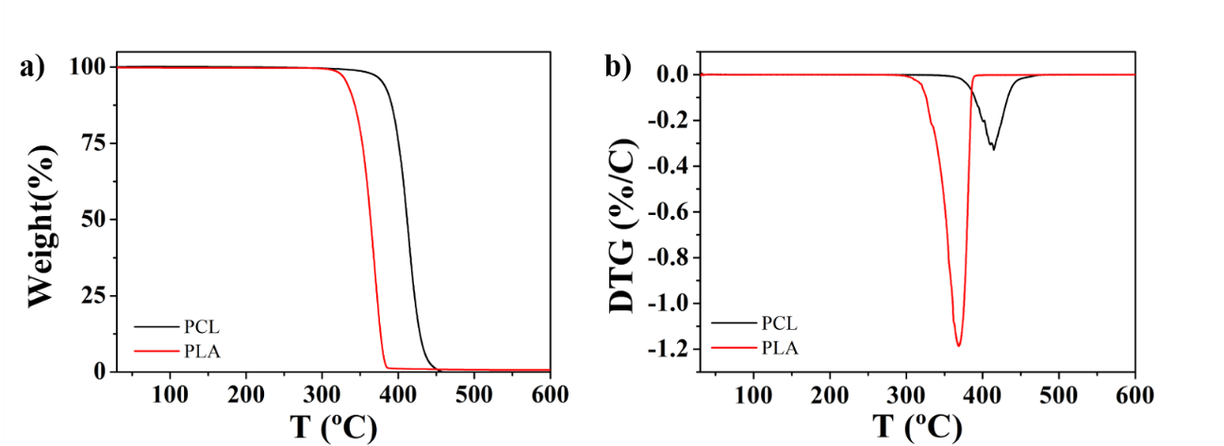
Fig. S2. Thermogravimetry and DTG curves of net PLA and PCL polymers.

