Assessing carbon cycle projections from simple and complex models under SSP scenarios

Supplementary Information

Table S1 Models that gives the maximum and minimum estimate of the global cumulative land carbon flux (including LUC emissions) over 1850–2014 historical and 2015–2100 future SSP scenarios.
NBP | ESMs |  | SCMs
SSP | MAX | MIN | MAX | MIN
Hist | CNRM-ESM2-1 | CESM2-WACCM | OSCARv3.1 | MAGICCv7.5.1
SSP1-1.9 | CNRM-ESM2-1 | UKESM1-0-LL | ACC2 | WASP-v2
SSP1-2.6 | NorESM2-LM | ACCESS-ESM1-5 | OSCARv3.1 | WASP-v2
SSP2-4.5 | CanESM5 | ACCESS-ESM1-5 | OSCARv3.1 | WASP-v2
SSP3-7.0 | CanESM5 | ACCESS-ESM1-5 | OSCARv3.1 | MAGICCv7.5.1
SSP4-3.4 | CNRM-ESM2-1 | UKESM1-0-LL | ACC2 | MAGICCv7.5.1
SSP4-6.0 | CanESM5 | IPSL-CM6A-LR | OSCARv3.1 | WASP-v2
SSP5-3.4-OS | CNRM-ESM2-1 | UKESM1-0-LL | OSCARv3.1 | WASP-v2
SSP5-8.5 | CanESM5 | ACCESS-ESM1-5 | OSCARv3.1 | MAGICCv7.5.1

Table S2 Models that gives the maximum and minimum estimate of the global cumulative ocean carbon flux over 1850–2014 historical and 2015–2100 future SSP scenarios.
Ocean flux | ESMs |  | SCMs
SSP | MAX | MIN | MAX | MIN
Hist | ACCESS-ESM1-5 | CNRM-ESM2-1 | MCE-v1-1 | SCM4OPTv2.1
SSP1-1.9 | MIROC-ES2L | CanESM5 | WASP-v2 | MCE-v1-1
SSP1-2.6 | MIROC-ES2L | CanESM5 | WASP-v2 | MCE-v1-1
SSP2-4.5 | ACCESS-ESM1-5 | CanESM5 | WASP-v2 | MCE-v1-1
SSP3-7.0 | ACCESS-ESM1-5 | CanESM5 | MAGICCv7.5.1 | SCM4OPTv2.1
SSP4-3.4 | IPSL-CM6A-LR | CanESM5 | MAGICCv7.5.1 | MCE-v1-1
SSP4-6.0 | IPSL-CM6A-LR | CanESM5 | WASP-v2 | MCE-v1-1
SSP5-3.4-OS | MIROC-ES2L | CanESM5 | WASP-v2 | MCE-v1-1
SSP5-8.5 | ACCESS-ESM1-5 | CanESM5 | WASP-v2 | SCM4OPTv2.1

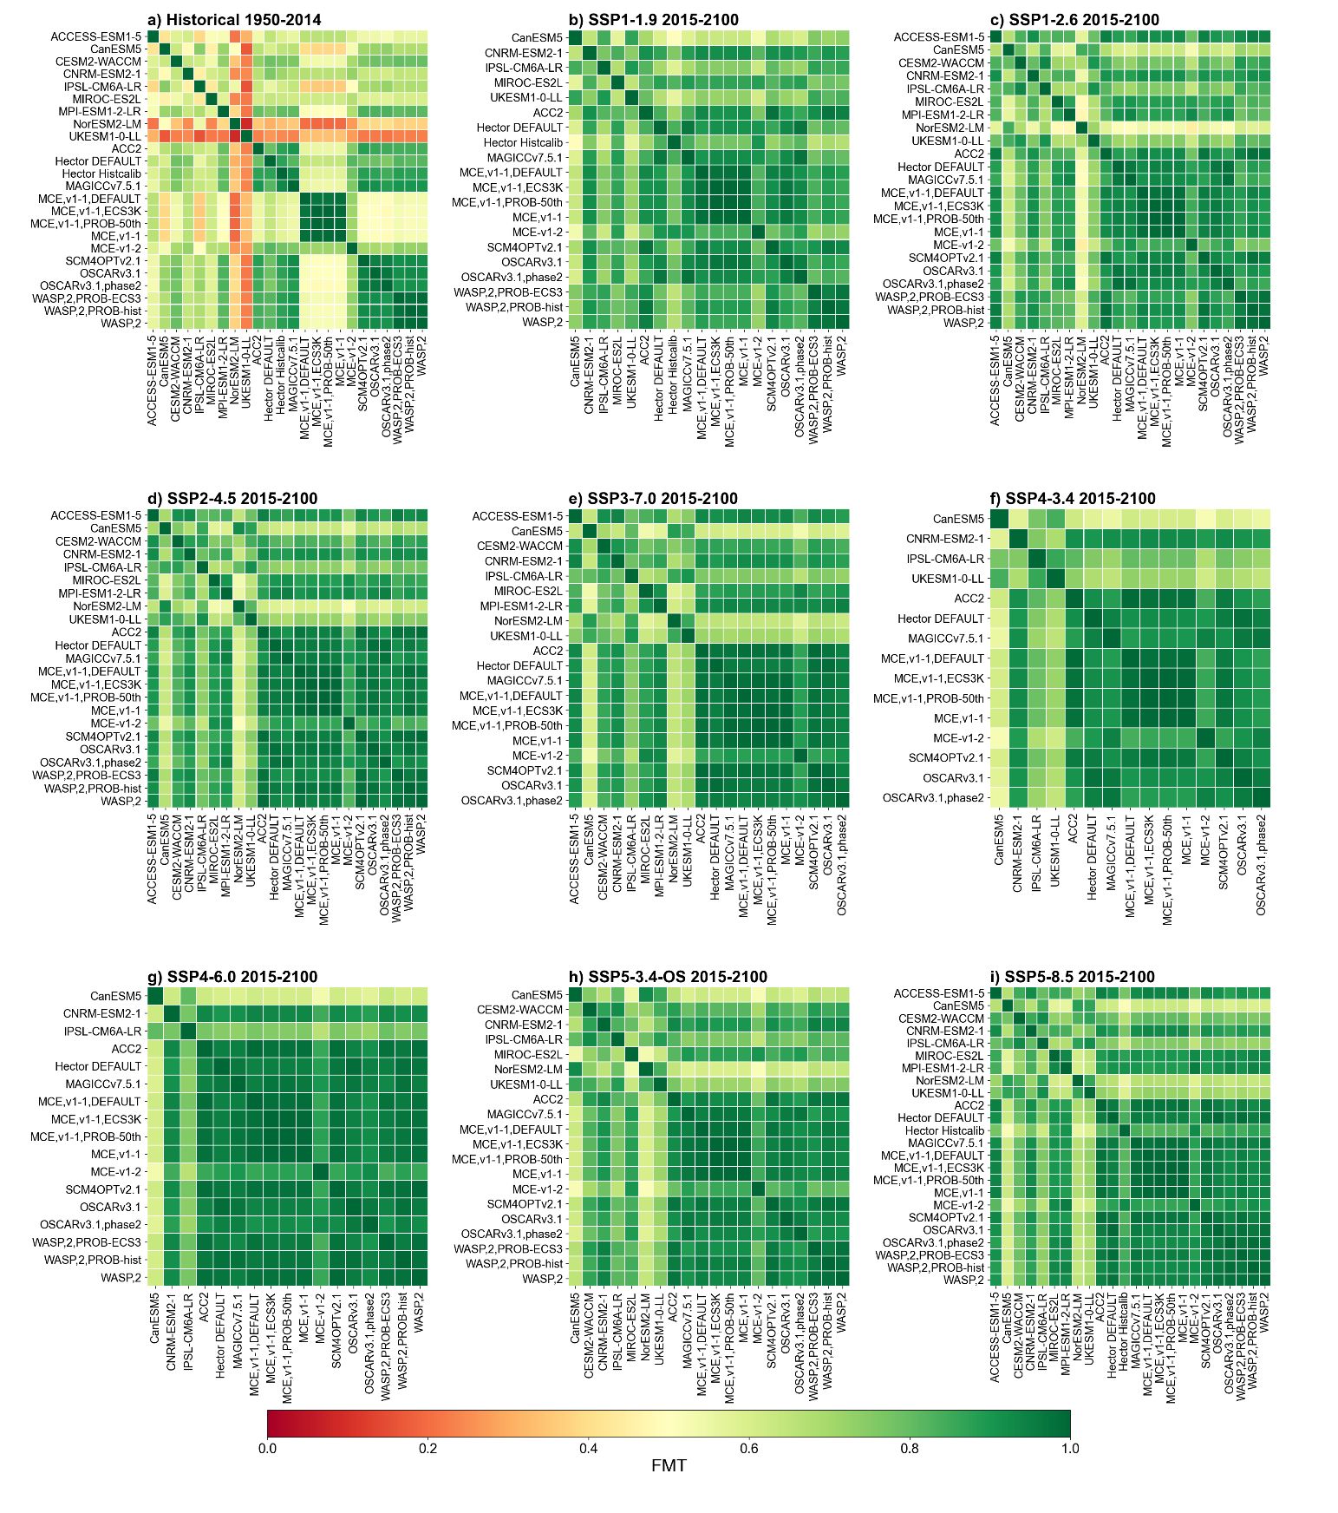

Fig. S1 FMT for GSAT change estimates over historical and future periods by ESMs and SCMs.

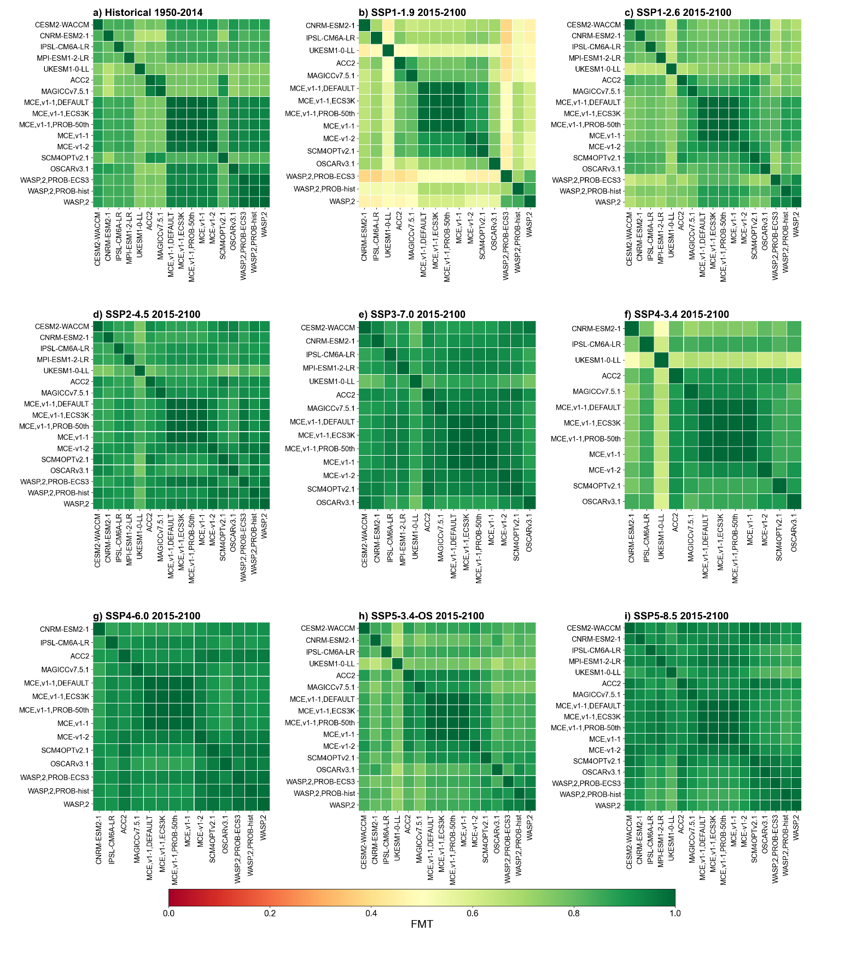

Fig. S2 FMT for compatible CO₂ emissions (FF and LUC) estimates over historical and future periods by ESMs and SCMs.

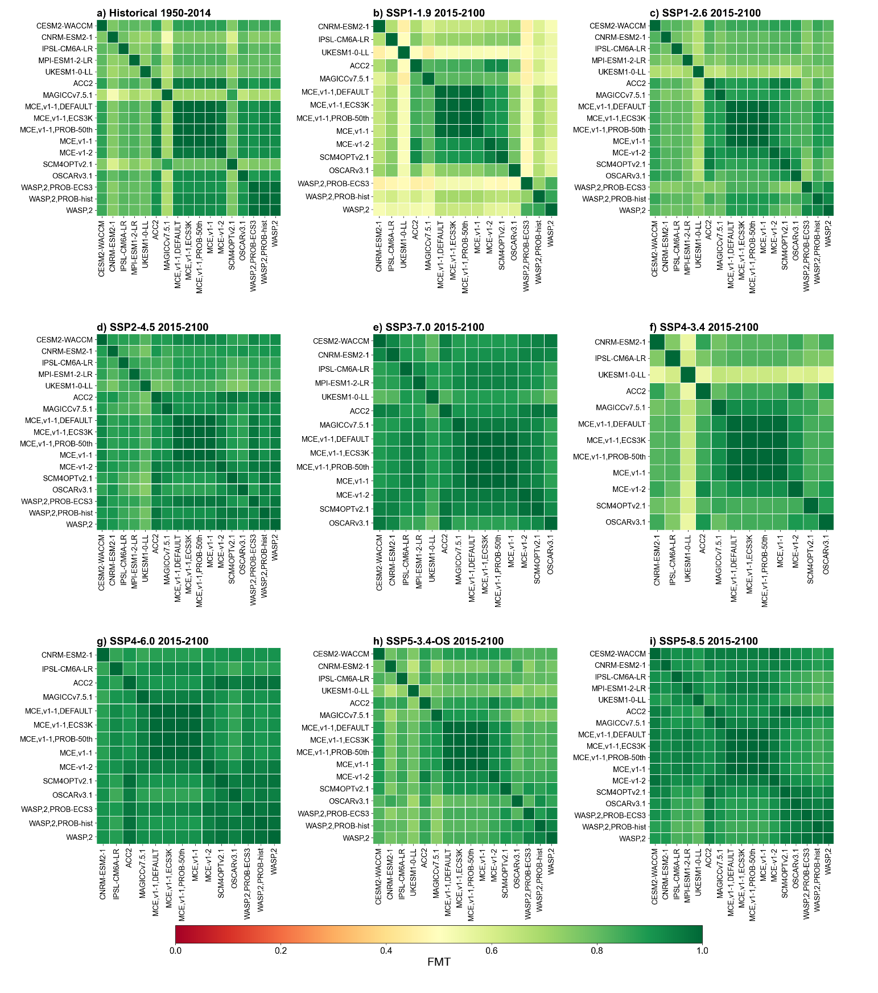

Fig. S3 FMT for compatible FF CO₂ emissions over historical and future periods by ESMs and SCMs.

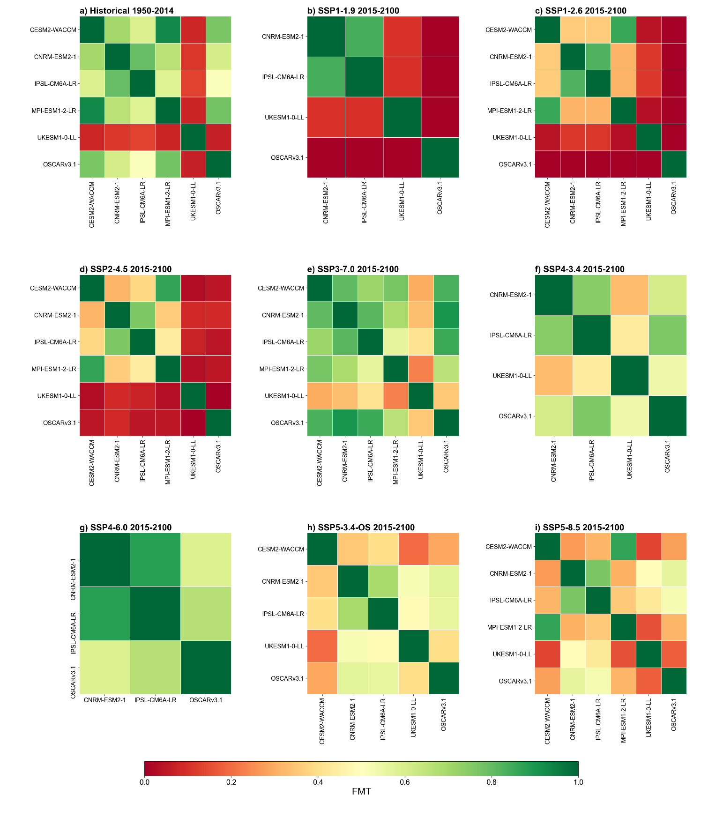

Fig. S4 FMT for LUC carbon emission estimates over historical and future periods by ESMs and SCMs.

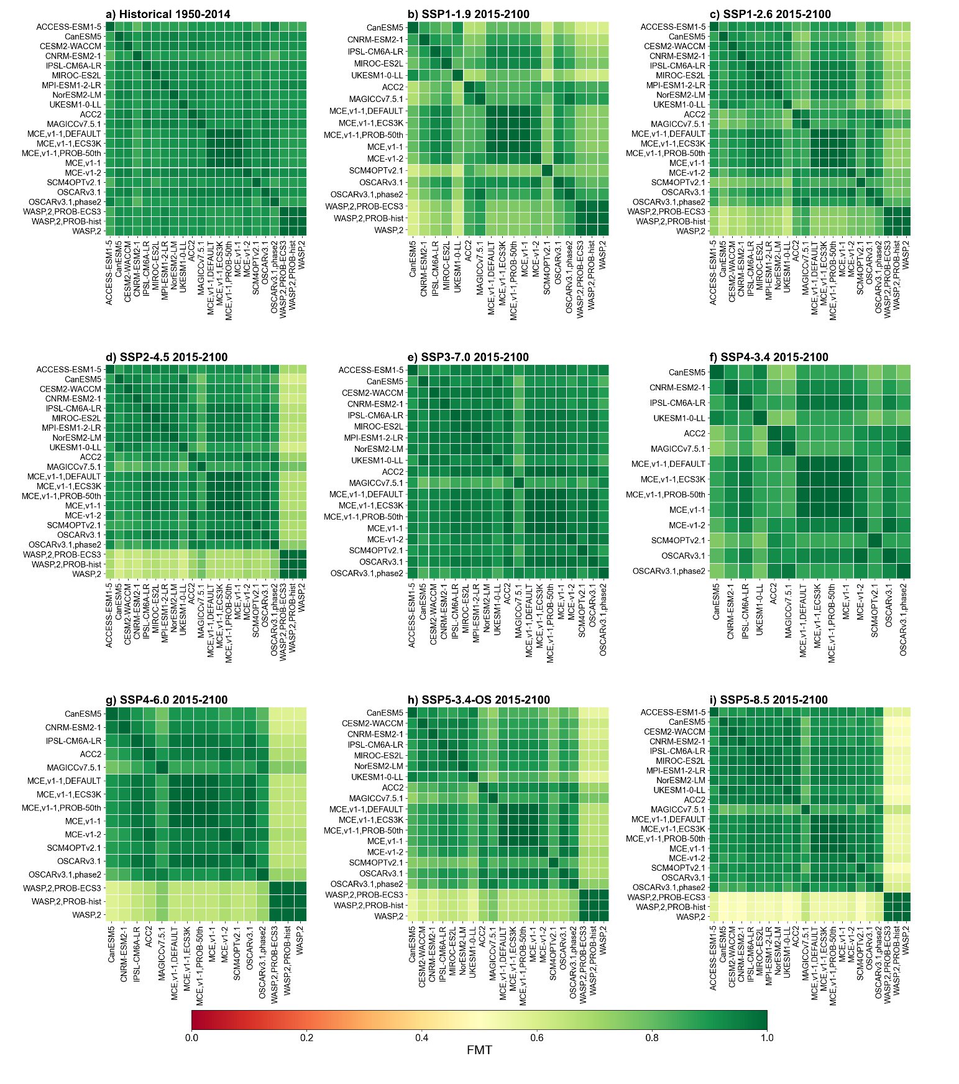

Fig. S5 FMT for ocean carbon flux estimates over historical and future periods by ESMs and SCMs.

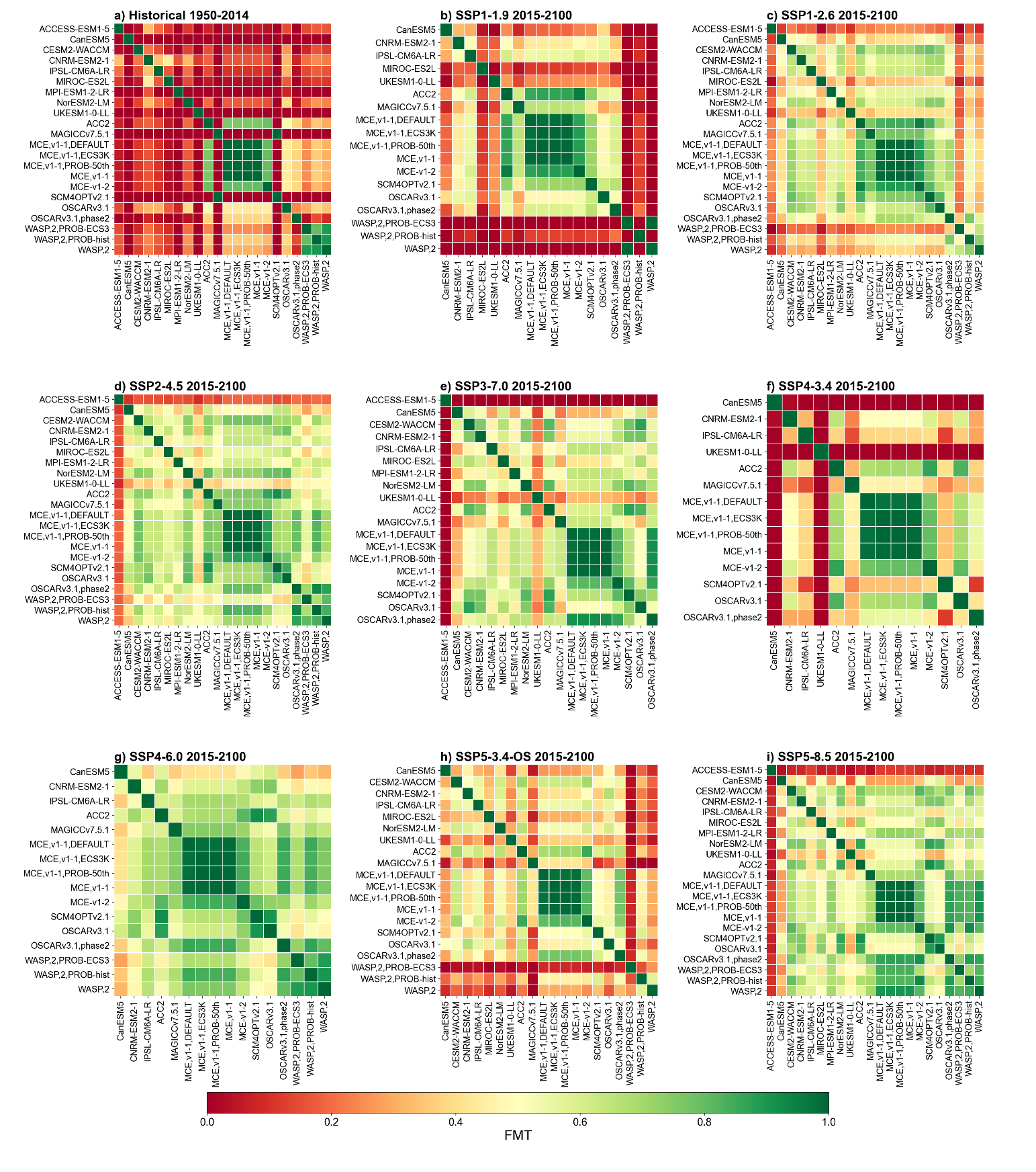

Fig. S6 FMT for land carbon flux NBP (including LUC emissions) estimates over historical and future periods by ESMs and SCMs.

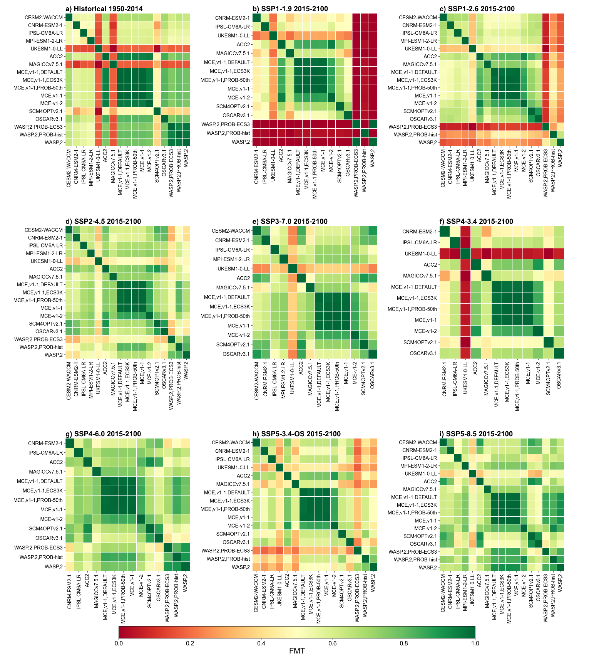

Fig. S7 FMT for natural land carbon sink (excluding LUC emissions) estimates over historical and future periods by ESMs and SCMs.

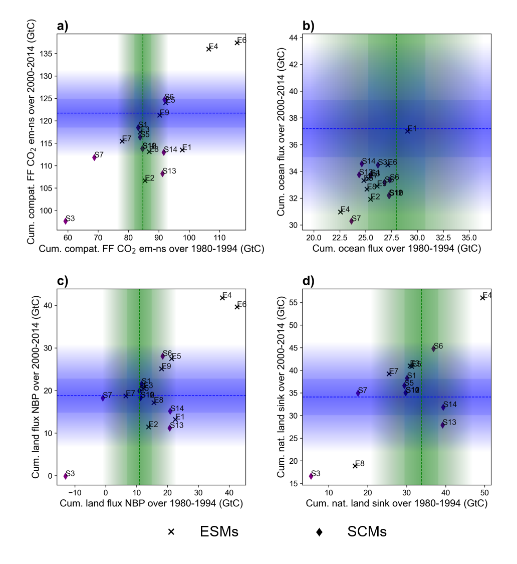

Fig. S8 Historical constraint of cumulative (a) compatible FF CO₂ emissions, (b) ocean carbon flux, (c) NBP, and (d) natural land sink excluding LUC of ESMs and SCMs estimates over 1980–1994 and 2000–2014 periods using Li et al. (2016) mean and uncertainty data. Green and blue dashed lines indicate observation means, dark shading corresponds to one SD, and light shading disseminates to three SDs. The abbreviations of the models are explained in Tables 1 and 2.

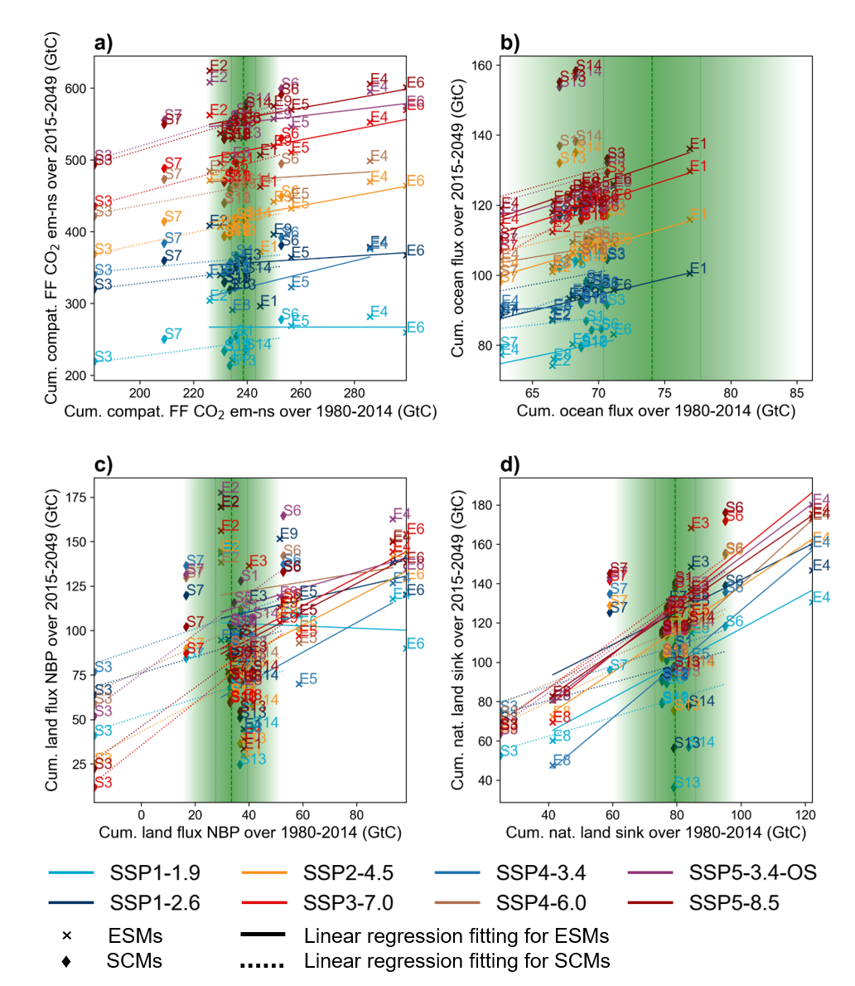

Fig. S9 Emergent constraints of cumulative (a) compatible FF emissions, (b) ocean carbon flux, (c) NBP, and (d) natural land sink excluding LUC from ESMs and SCMs estimated over historical 1980–1994 period using Li et al. (2016) mean and uncertainty data for future 2015–2049 SSP estimates. The lines are linear regressions across the models (solid for ESMs, and dashed for SCMs) for each scenario. Green dashed lines indicate observation means, and dark and light shading corresponds to one and three SD(s),respectively. The abbrevations of the models are given in Tables 1 and 2.

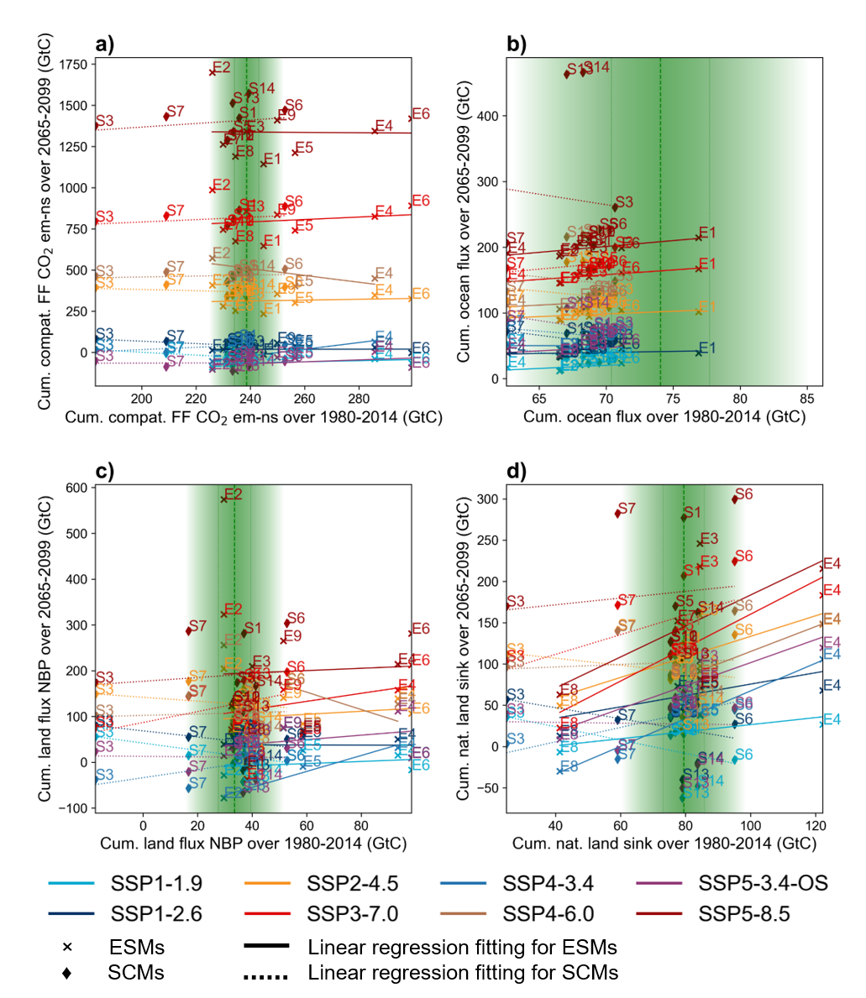

Fig. S10 Emergent constraints of cumulative (a) compatible FF emissions, (b) ocean carbon flux, (c) NBP, and (d) natural land sink excluding LUC of ESMs and SCMs estimated over 1980–1994 period using Li et al. (2016) mean and uncertainty for future 2065–2099 SSP estimates. The lines are linear regressions across the models (solid for ESMs, and dashed for SCMs) for each scenario. Green dashed lines indicate observation means, dark shading corresponds to one SD, and light shading disseminates to three SDs. The abbrevations of the models are explained in Tables 1 and 2.

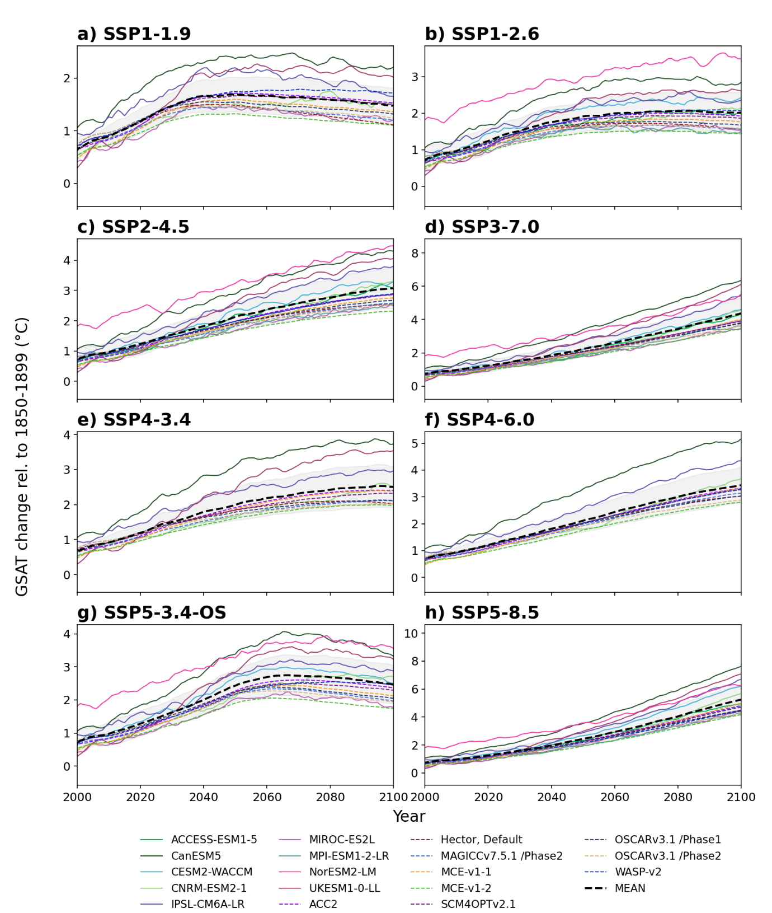

Fig. S11 Interannual variation of GSAT by available ESMs and SCMs for eight SSP scenarios (shown as 5-year moving averages). MEAN refers to the ensemble mean of all models (both ESMs and SCMs), grey shading refers to the model spread defined via one SD.

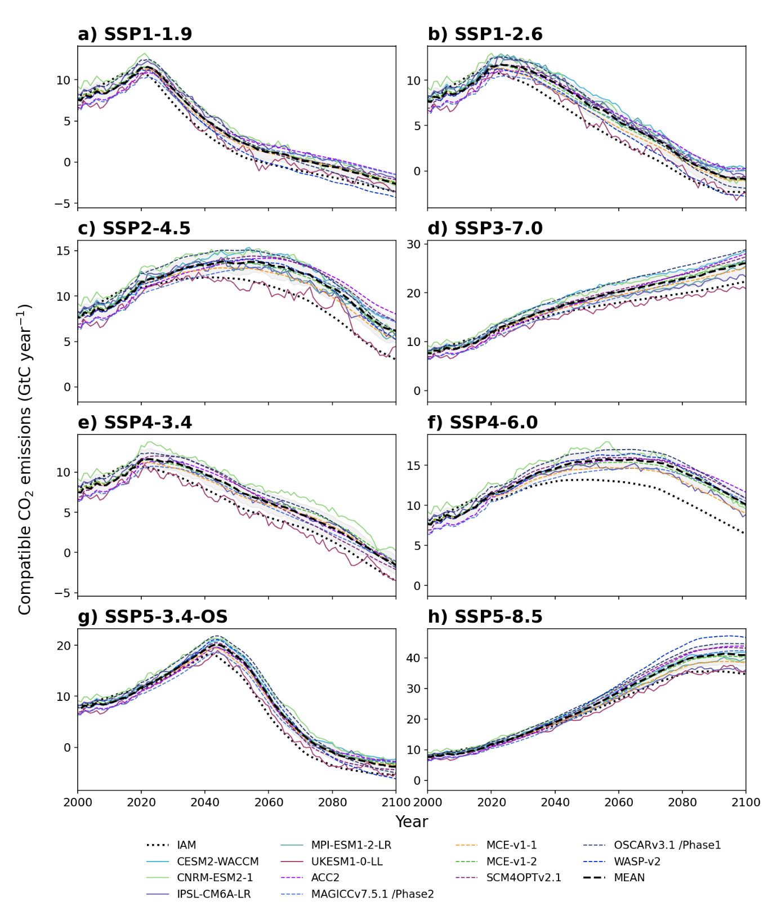

Fig. S12 Interannual variation of compatible CO₂ emissions by available ESMs and SCMs for eight SSP scenarios (shown as 5-year moving averages). Emissions generated by the IAMs corresponding to each SSP scenario are provided for reference. MEAN refers to the ensemble mean of all models (both ESMs and SCMs), grey shading refers to model spread defined via one SD.

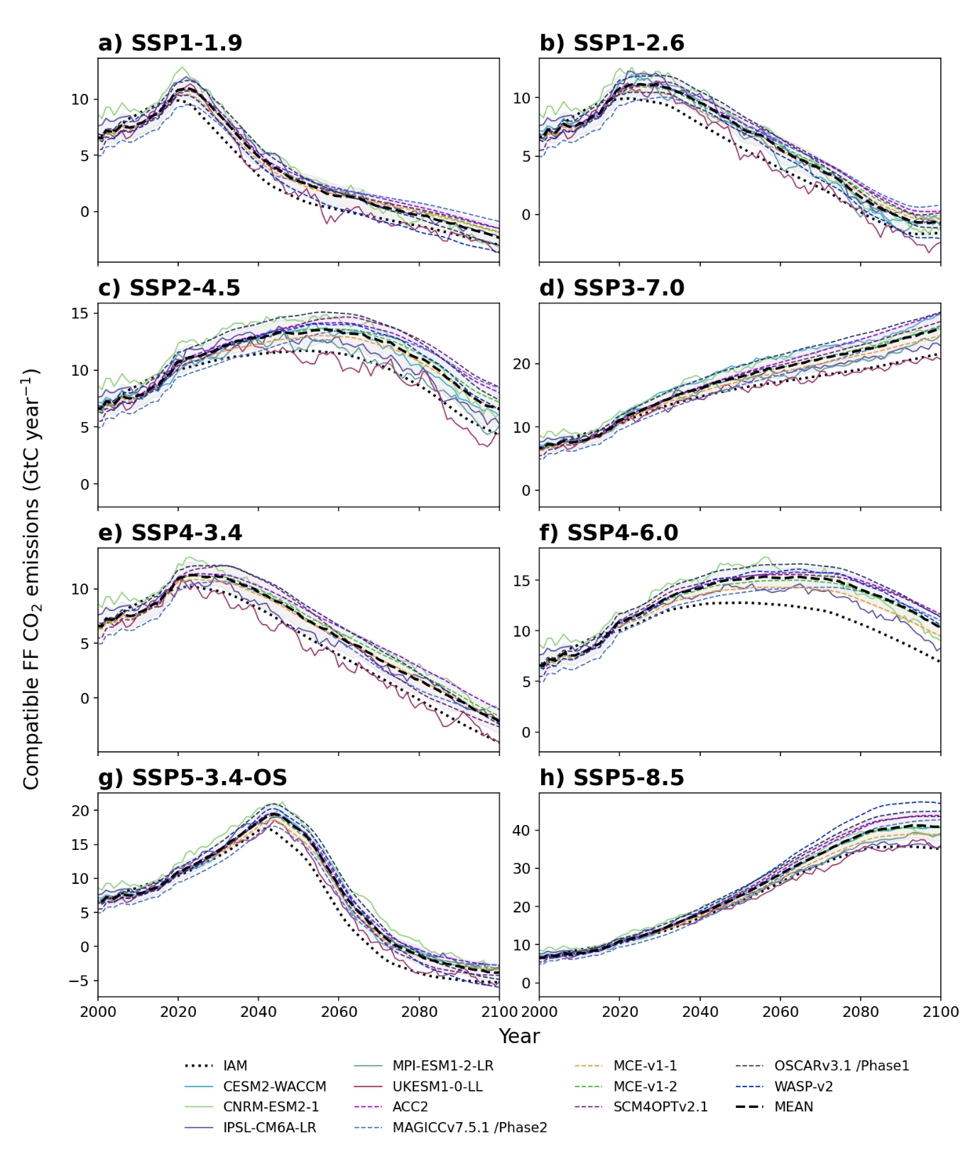

Fig. S13 Interannual variation of compatible FF CO₂ emissions by available ESMs and SCMs for eight SSP scenarios (shown as 5-year moving averages). Emissions generated by the IAMs corresponding to each SSP scenario are provided for reference. MEAN refers to the ensemble mean of all models (both ESMs and SCMs), grey shading refers to model spread defined via one SD.

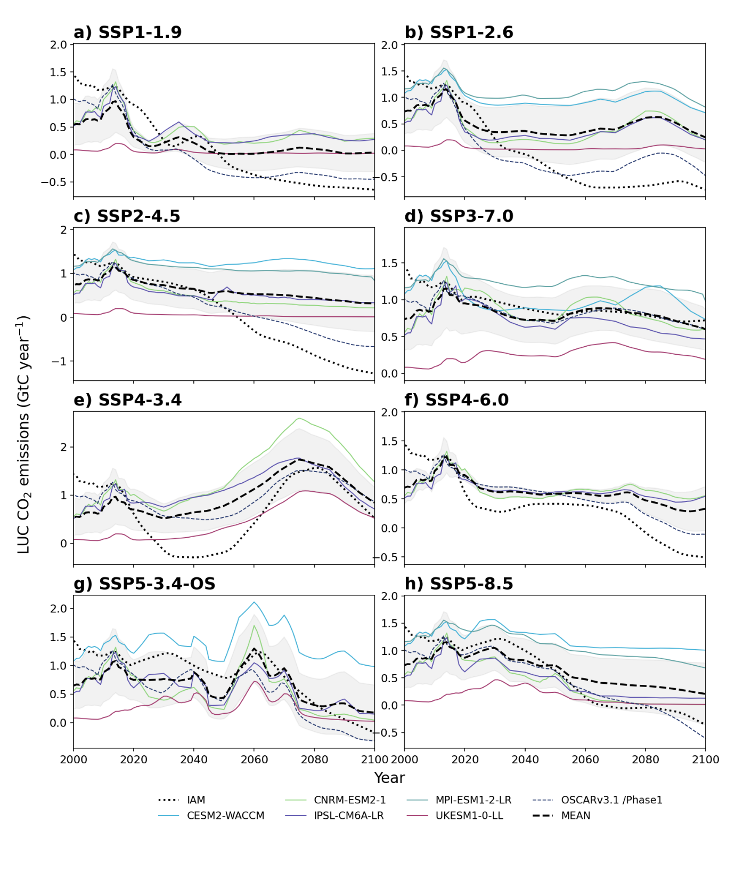

Fig. S14 Interannual variation of LUC CO₂ emissions by available ESMs and SCMs for eight SSP scenarios (shown as 5-year moving averages). Emissions generated by the IAMs corresponding to each SSP scenario are provided for reference. MEAN refers to the ensemble mean of all models (both ESMs and SCMs), grey shading refers to model spread defined via one SD.

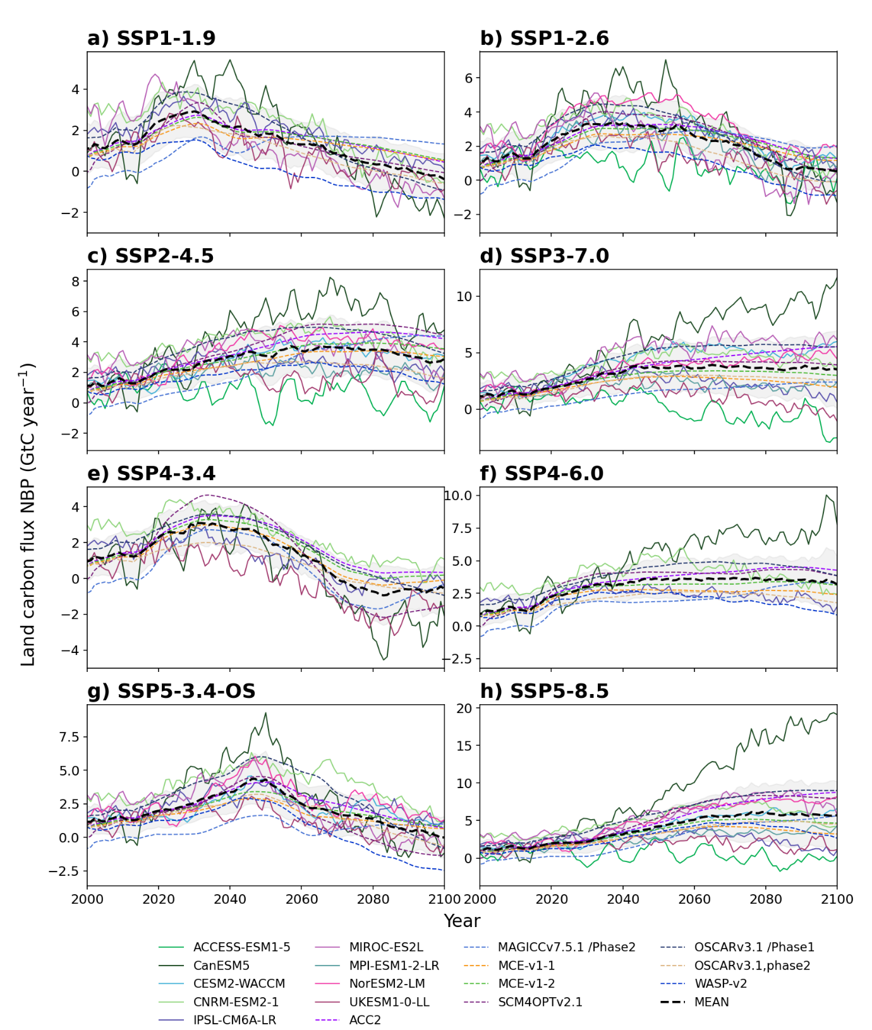

Fig. S15 Interannual variation of global land carbon flux NBP (land sink including LUC emissions) estimates by available ESMs and SCMs for eight SSP scenarios (shown as 5-year moving averages). MEAN refers to the ensemble mean of all models (both ESMs and SCMs), grey shading refers to model spread defined via one SD.

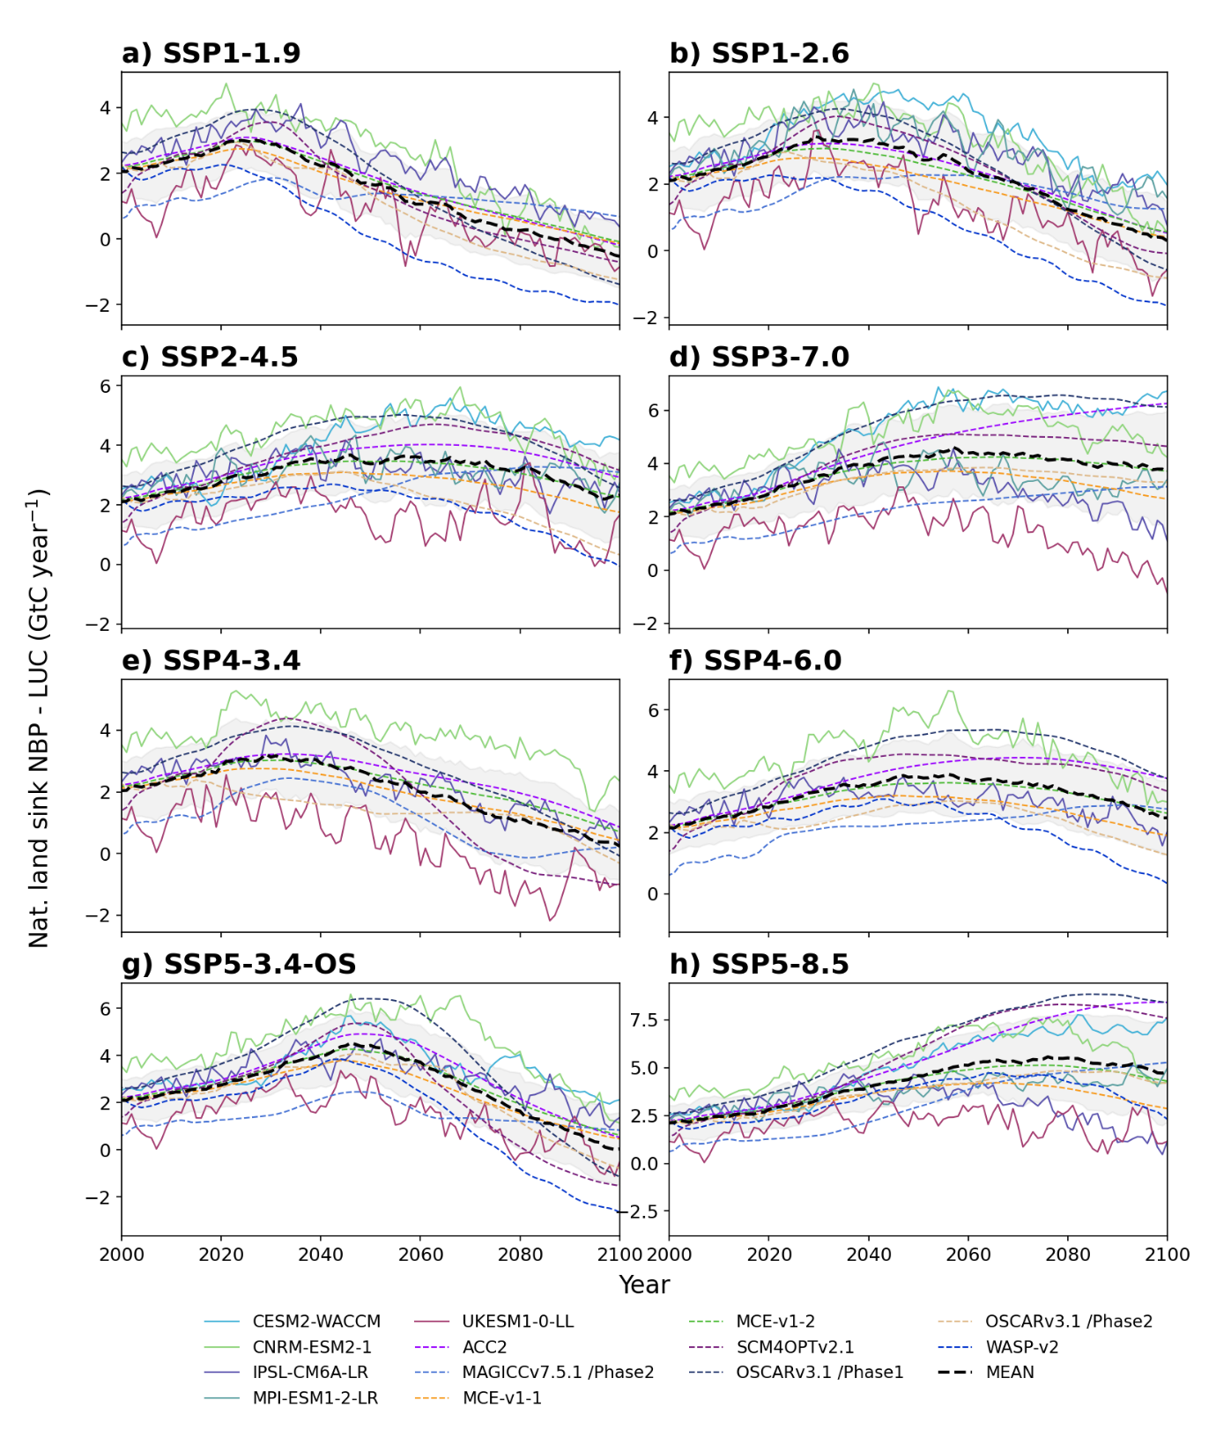

Fig. S16 Interannual variation of global natural land carbon sink (excluding LUC emissions) estimates by available ESMs and SCMs for eight SSP scenarios (shown as 5-year moving averages). MEAN refers to the ensemble mean of all models (both ESMs and SCMs), grey shading refers to model spread defined via one SD.

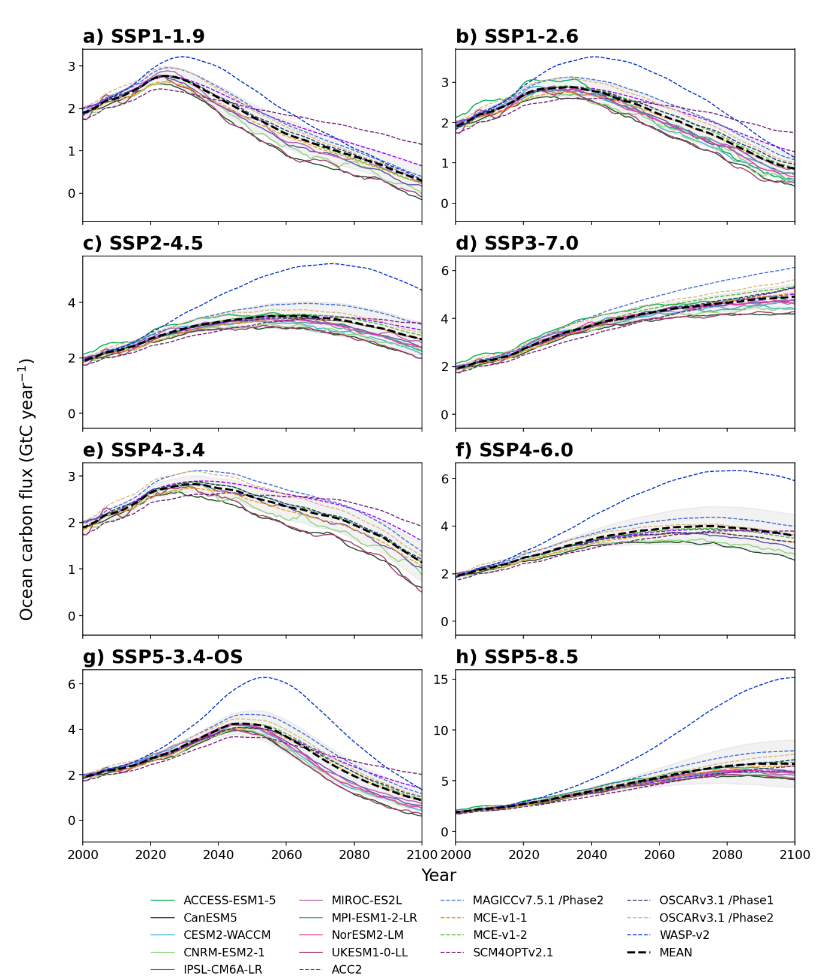

Fig. S17 Interannual variation of global ocean carbon flux estimates by available ESMs and SCMs for eight SSP scenarios (shown as 5-year moving averages). MEAN refers to the ensemble mean of all models (both ESMs and SCMs), grey shading refers to model spread defined via one SD.

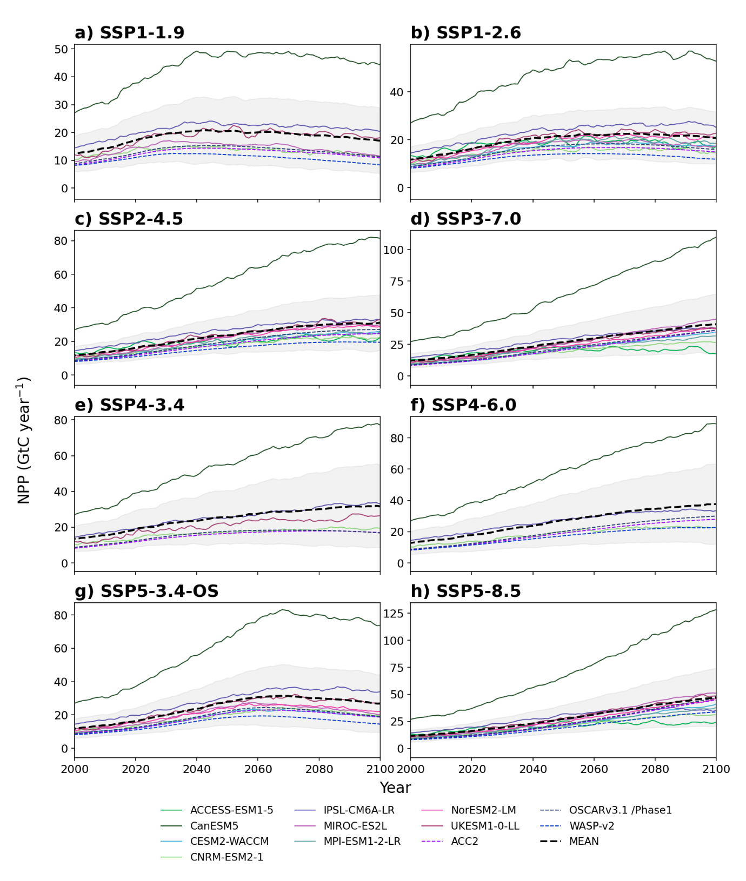

Fig. S18 Interannual variation of NPP (relative to year 1850) estimates by available ESMs and SCMs for eight SSP scenarios (shown as 5-year moving averages). MEAN refers to the ensemble mean of all models (both ESMs and SCMs), grey shading refers to model spread defined via one SD.

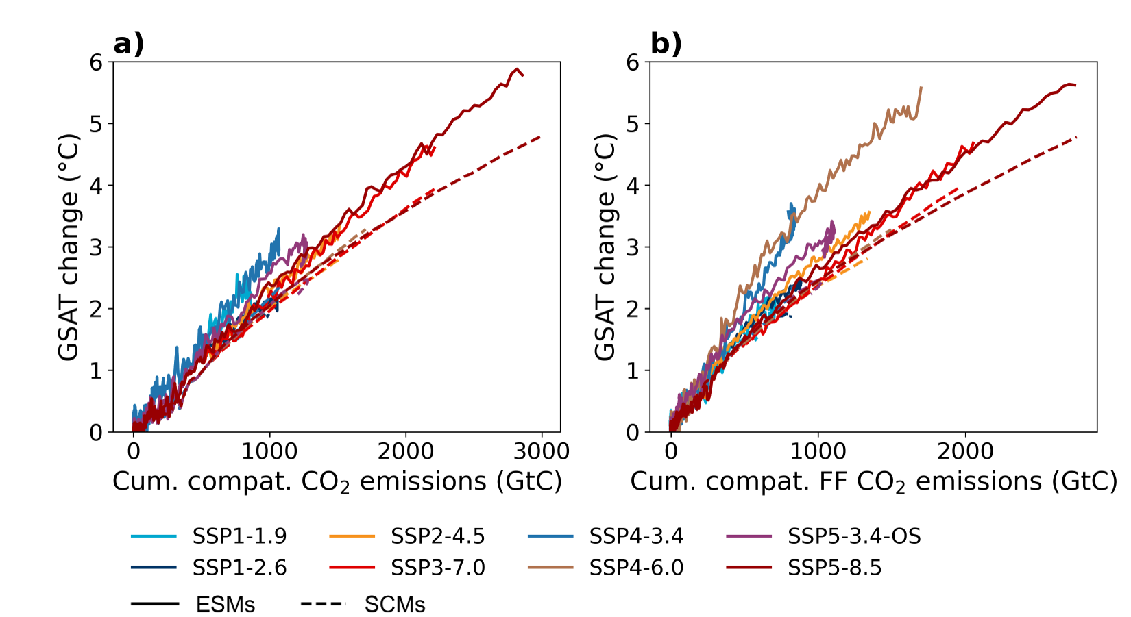

Fig. S19 Changes in GSAT estimated by ESMs (solid lines) and SCMs (dashed) under SSP scenarios over 1850–2100 periods plotted against changes in cumulative compatible (a) total and (b) FF CO₂ emissions. Ensemble means of carbon fluxes are calculated based on a suite of models, excluding outliers. The 5-year moving averages of model-ensemble means are shown.

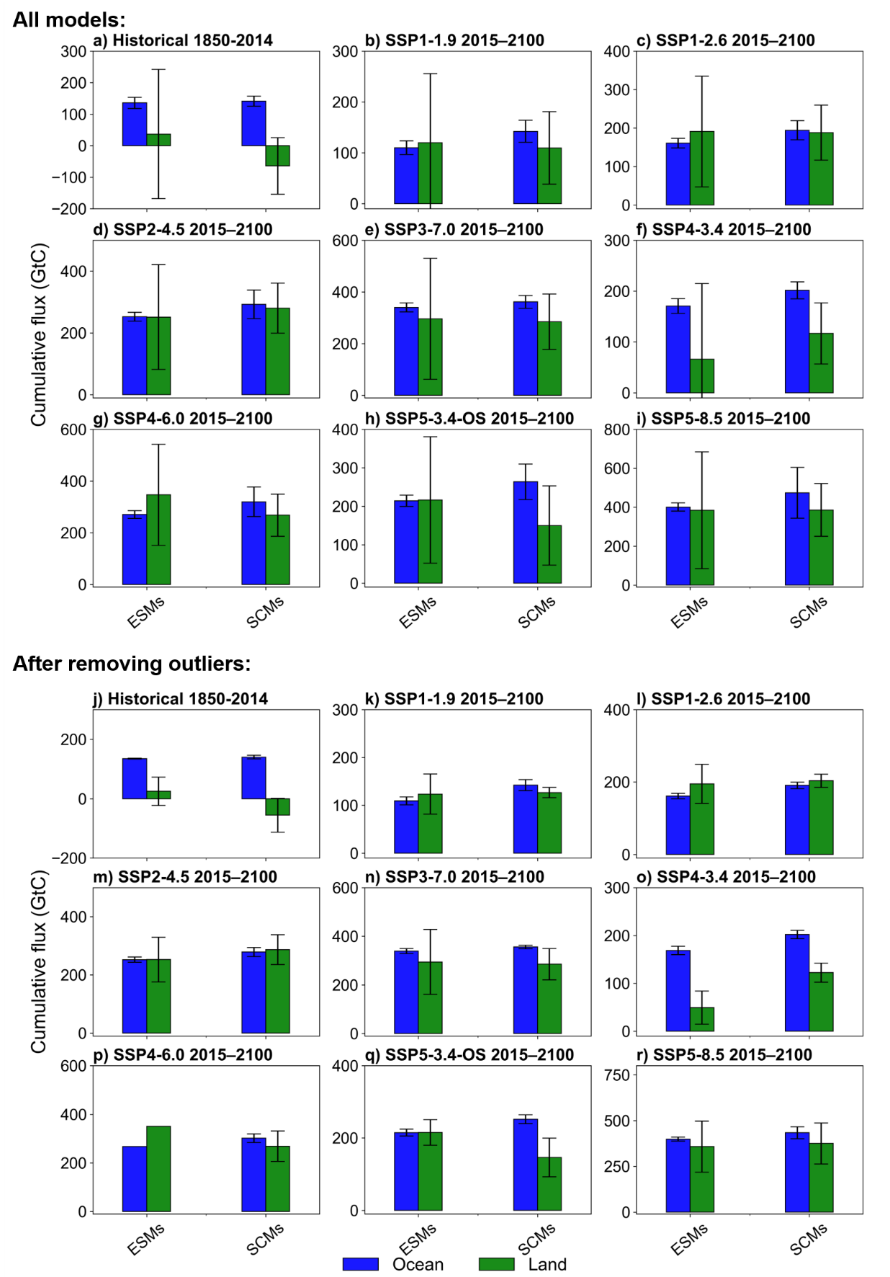

Fig. S20 Global cumulative NBP and ocean carbon fluxes over the past 1850–2014 and future 2015–2100 periods estimated by(a–i) all models available in this study and (j–r) after removing outlier models. Error bars indicate the inter-model spread via one SD (only one ESM was available after removing outliers for SSP4-6.0, thus there are no error bars in panel p).

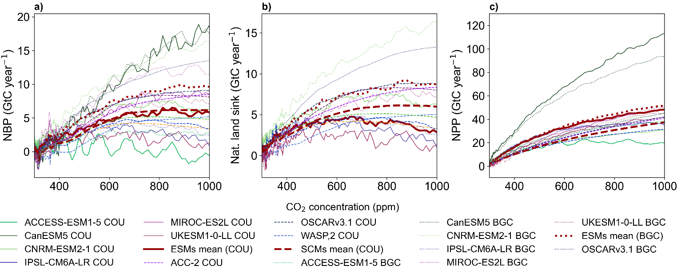Fig. S21 The global mean (a) land carbon flux NBP, including LUC emissions, (b) natural land carbon sink, excluding LUC emissions, and (c) NPP under BGC and COU SSP5-8.5 simulations plotted against CO₂ concentration (shown as 5-year moving averages).

Table S3 Ensemble members and DOIs of ESM simulations used in this study
Scenario  / ESM | ACCESS-ESM1-5 | CanESM5 | CESM2-WACCM | CNRM-ESM2-1 | IPSL-CM6A-LR | MIROC-ES2L | MPI-ESM1-2-LR | NorESM2-LM | UKESM1-0-LL
piControl | r1i1p1f1 | r1i1p1f1,  r1i1p2f1 | r1i1p1f1 | r1i1p1f2 | r1i1p1f1 | r1i1p1f2 | r1i1p1f1 | r1i1p1f1 | r1i1p1f2  (parent to r4..)
piControl | http://doi.org/10.22033/ESGF/CMIP6.4312 | https://doi.org/10.22033/ESGF/CMIP6.3673 | http://doi.org/10.22033/ESGF/CMIP6.10094 | https://doi.org/10.22033/ESGF/CMIP6.4165 | https://doi.org/10.22033/ESGF/CMIP6.5251 | https://doi.org/10.22033/ESGF/CMIP6.5710 | http://doi.org/10.22033/ESGF/CMIP6.6675 | http://doi.org/10.22033/ESGF/CMIP6.8217 | https://doi.org/10.22033/ESGF/CMIP6.6298
historical | r1i1p1f1 | r1i1p1f1 | r1i1p1f1 | r1i1p1f2 | r1i1p1f1 | r1i1p1f2 | r1i1p1f1 | r1i1p1f1 | r4i1p1f2
historical | http://doi.org/10.22033/ESGF/CMIP6.4272 | https://doi.org/10.22033/ESGF/CMIP6.3610 | http://doi.org/10.22033/ESGF/CMIP6.10071 | https://doi.org/10.22033/ESGF/CMIP6.4068 | https://doi.org/10.22033/ESGF/CMIP6.5195 | https://doi.org/10.22033/ESGF/CMIP6.5602 | http://doi.org/10.22033/ESGF/CMIP6.6595 | http://doi.org/10.22033/ESGF/CMIP6.8036 | https://doi.org/10.22033/ESGF/CMIP6.6113
ssp119 |  | r1i1p1f1 |  | r1i1p1f2 | r1i1p1f1 | r1i1p1f2 |  |  | r4i1p1f2
 |  | http://doi.org/10.22033/ESGF/CMIP6.3682 |  | http://doi.org/10.22033/ESGF/CMIP6.4182 | http://doi.org/10.22033/ESGF/CMIP6.5261 | http://doi.org/10.22033/ESGF/CMIP6.5740 |  |  | http://doi.org/10.22033/ESGF/CMIP6.6329
ssp126 | r1i1p1f1 | r1i1p1f1 | r1i1p1f1 | r1i1p1f2 | r1i1p1f1 | r1i1p1f2 | r1i1p1f1 | r1i1p1f1 | r4i1p1f2
 | http://doi.org/10.22033/ESGF/CMIP6.4320 | http://doi.org/10.22033/ESGF/CMIP6.3683 | http://doi.org/10.22033/ESGF/CMIP6.10100 | http://doi.org/10.22033/ESGF/CMIP6.4186 | http://doi.org/10.22033/ESGF/CMIP6.5262 | http://doi.org/10.22033/ESGF/CMIP6.5742 | http://doi.org/10.22033/ESGF/CMIP6.6690 | http://doi.org/10.22033/ESGF/CMIP6.8248 | http://doi.org/10.22033/ESGF/CMIP6.6333
ssp245 | r1i1p1f1 | r1i1p1f1 | r1i1p1f1 | r1i1p1f2 | r1i1p1f1 | r1i1p1f2 | r1i1p1f1 | r1i1p1f1 | r4i1p1f2
 | http://doi.org/10.22033/ESGF/CMIP6.4322 | http://doi.org/10.22033/ESGF/CMIP6.3685 | http://doi.org/10.22033/ESGF/CMIP6.10101 | http://doi.org/10.22033/ESGF/CMIP6.4191 | http://doi.org/10.22033/ESGF/CMIP6.5264 | http://doi.org/10.22033/ESGF/CMIP6.5745 | http://doi.org/10.22033/ESGF/CMIP6.6693 | http://doi.org/10.22033/ESGF/CMIP6.8253 | http://doi.org/10.22033/ESGF/CMIP6.6339
ssp370 | r1i1p1f1 | r1i1p1f1 | r1i1p1f1 | r1i1p1f2 | r1i1p1f1 | r1i1p1f2 | r1i1p1f1 | r1i1p1f1 | r4i1p1f2
 | http://doi.org/10.22033/ESGF/CMIP6.4324 | http://doi.org/10.22033/ESGF/CMIP6.3690 | http://doi.org/10.22033/ESGF/CMIP6.10102 | http://doi.org/10.22033/ESGF/CMIP6.4199 | http://doi.org/10.22033/ESGF/CMIP6.5265 | http://doi.org/10.22033/ESGF/CMIP6.5751 | http://doi.org/10.22033/ESGF/CMIP6.6695 | http://doi.org/10.22033/ESGF/CMIP6.8268 | http://doi.org/10.22033/ESGF/CMIP6.6347
ssp434 |  | r1i1p1f1 |  | r1i1p1f2 | r1i1p1f1 |  |  |  | r4i1p1f2
 |  | http://doi.org/10.22033/ESGF/CMIP6.3692 |  | http://doi.org/10.22033/ESGF/CMIP6.4213 | http://doi.org/10.22033/ESGF/CMIP6.5267 |  |  |  | http://doi.org/10.22033/ESGF/CMIP6.6389
ssp460 |  | r1i1p1f1 |  | r1i1p1f2 | r1i1p1f1 |  |  |  | r4i1p1f2
 |  | http://doi.org/10.22033/ESGF/CMIP6.3693 |  | http://doi.org/10.22033/ESGF/CMIP6.4217 | http://doi.org/10.22033/ESGF/CMIP6.5268
ssp534-over |  | r1i1p1f1 | r1i1p1f1 | r1i1p1f2 | r1i1p1f1 | r1i1p1f2 |  | r1i1p1f1 | r4i1p1f2
 |  | https://doi.org/10.22033/ESGF/CMIP6.3694 | http://doi.org/10.22033/ESGF/CMIP6.10114 | https://doi.org/10.22033/ESGF/CMIP6.4221 | https://doi.org/10.22033/ESGF/CMIP6.5269 | https://doi.org/10.22033/ESGF/CMIP6.5767 |  | http://doi.org/10.22033/ESGF/CMIP6.8315 | https://doi.org/10.22033/ESGF/CMIP6.6397
ssp585 | r1i1p1f1 | r1i1p1f1 | r1i1p1f1 | r1i1p1f2 | r1i1p1f1 | r1i1p1f2 | r1i1p1f1 | r1i1p1f1 | r4i1p1f2
 | http://doi.org/10.22033/ESGF/CMIP6.4333 | https://doi.org/10.22033/ESGF/CMIP6.3696 | http://doi.org/10.22033/ESGF/CMIP6.10115 | http://doi.org/10.22033/ESGF/CMIP6.4226 | https://doi.org/10.22033/ESGF/CMIP6.5271 | http://doi.org/10.22033/ESGF/CMIP6.5770 | http://doi.org/10.22033/ESGF/CMIP6.6705 | http://doi.org/10.22033/ESGF/CMIP6.8319 | https://doi.org/10.22033/ESGF/CMIP6.6405
hist-bgc | r1i1p1f1 | r1i1p2f1 |  | r1i1p1f2 | r1i1p1f1 | r1i1p1f2 |  |  | r4i1p1f2
 | http://doi.org/10.22033/ESGF/CMIP6.4266 | https://doi.org/10.22033/ESGF/CMIP6.3600 |  | https://doi.org/10.22033/ESGF/CMIP6.4047 |  | https://doi.org/10.22033/ESGF/CMIP6.5582 |  |  | https://doi.org/10.22033/ESGF/CMIP6.6055
ssp534-over-bgc |  | r1i1p2f1 |  | r1i1p1f2 | r1i1p1f1 | r1i1p1f2 |  |  | r4i1p1f2
 |  | https://doi.org/10.22033/ESGF/CMIP6.3695 |  | https://doi.org/10.22033/ESGF/CMIP6.4223 |  | https://doi.org/10.22033/ESGF/CMIP6.5769 |  |  | https://doi.org/10.22033/ESGF/CMIP6.6401
ssp585-bgc | r1i1p1f1 | r1i1p2f1 |  | r1i1p1f2 | r1i1p1f1 | r1i1p1f2 |  |  | r4i1p1f2
 | http://doi.org/10.22033/ESGF/CMIP6.4334 | https://doi.org/10.22033/ESGF/CMIP6.3697 |  | http://doi.org/10.22033/ESGF/CMIP6.4228 |  |  |  |  | https://doi.org/10.22033/ESGF/CMIP6.6409

