Overexpression of MiR-32 in Chinese Hamster Ovary Cells Increases Production of Fc-fusion Protein

Masoume Bazaz¹, Ahmad Adeli, Mohammad Azizi¹, Morteza Karimipoor¹, Freidoun Mahboudi¹, Noushin Davoudi¹
¹ Department of Medical Biotechnology, Biotechnology Research Center, Pasteur Institute of Iran, Tehran, Iran

Corresponding Author: Noushin Davoudi
Email address: davoudi@pasteur.ac.ir

Running Title: Evaluation the effect of miR-32 on CHO cell productivity

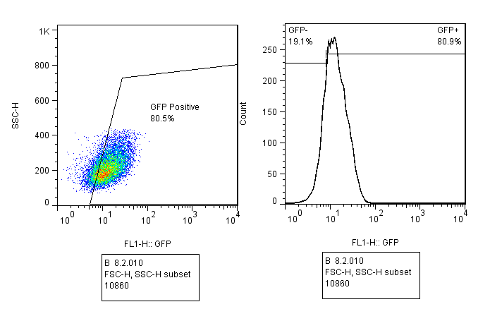
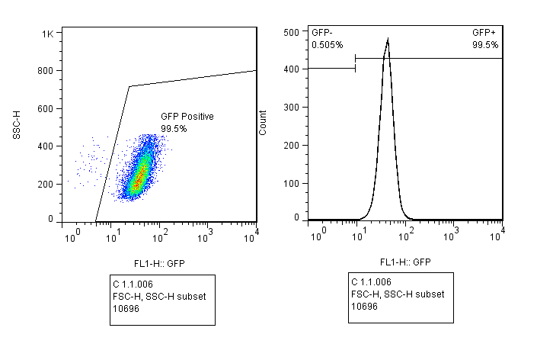
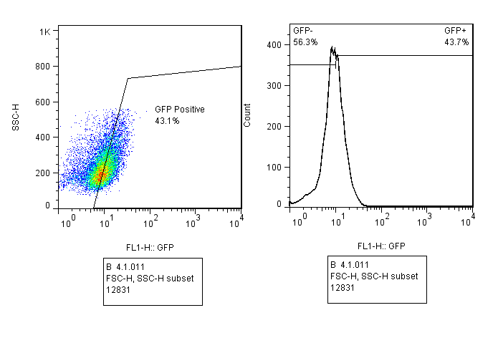
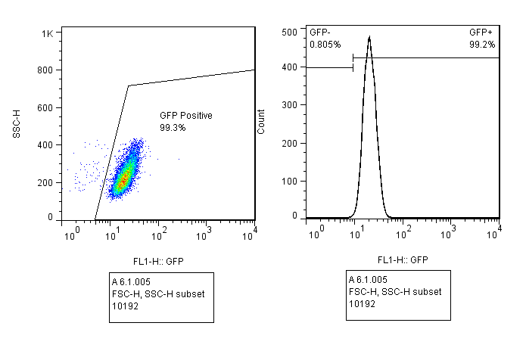
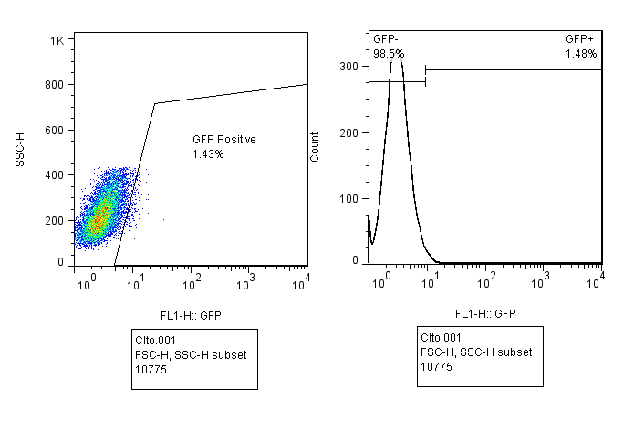
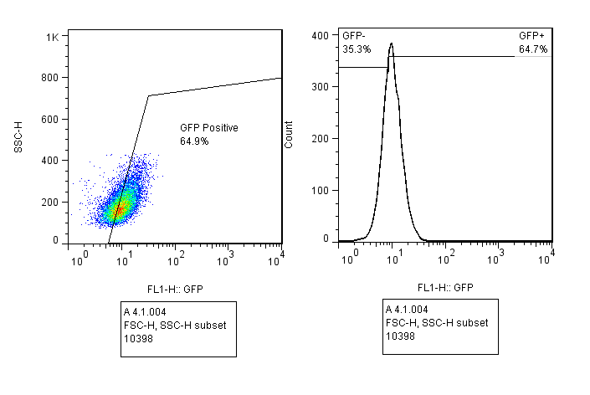
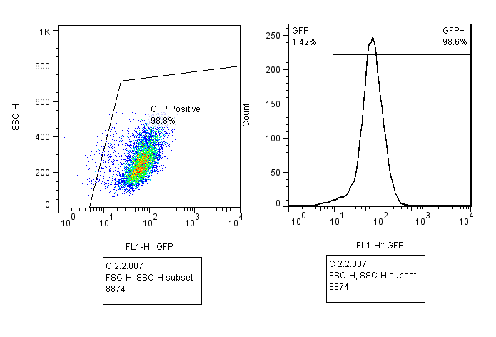
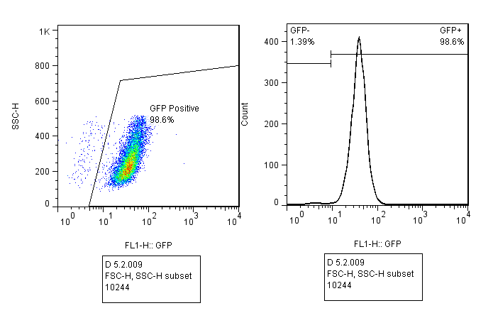
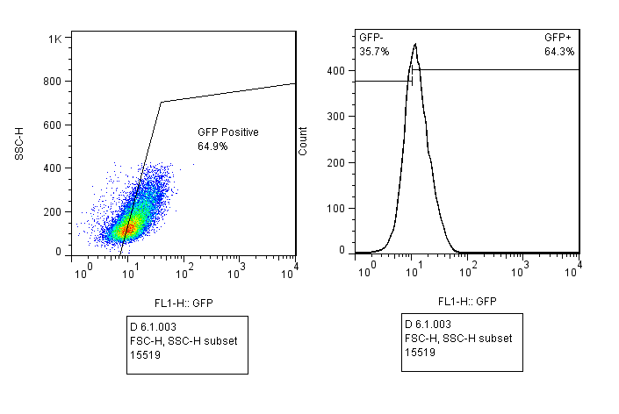
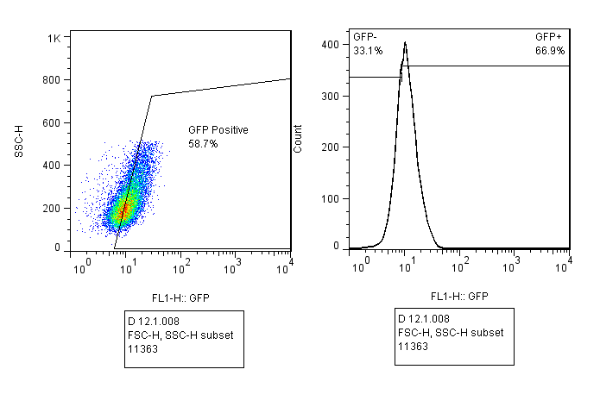
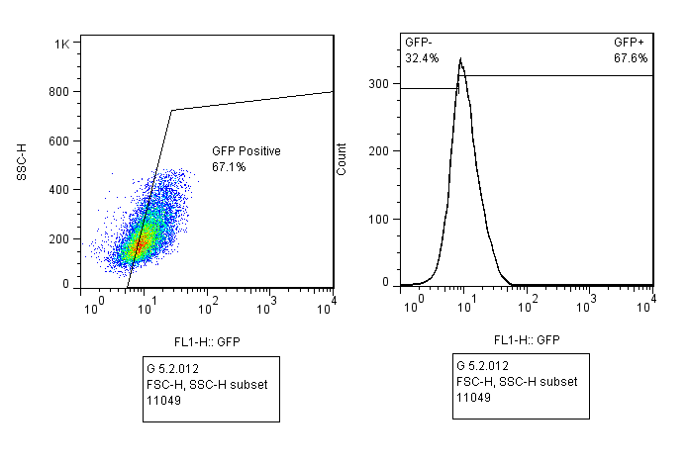
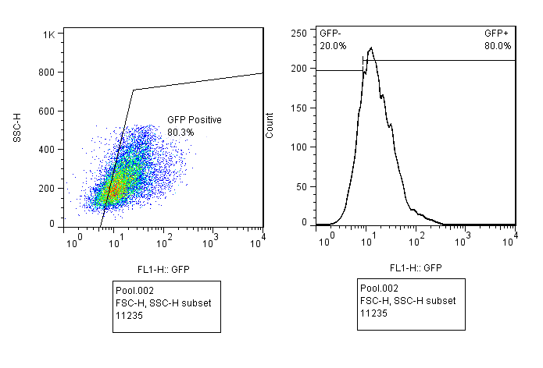
Fig.S1 The flow cytometry results of CHO-Afli single clone screening based on percentage of GFP positive population. Following limiting dilution of cell pool. The single clones detached and analyzed using flow cytometry system.

