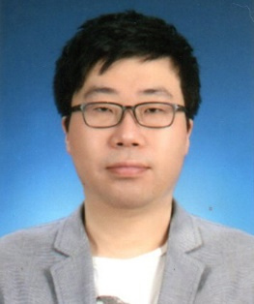
Jin-Woo Kim received his B.S. and Ph.D. degrees in the Electric and Electronics Engineering from Korea University, Seoul, Korea in 1996 and 2011, respectively. He worked for the Research Institute of Information Science and Engineering at the Mokpo National University, Korea, from 2011 until 2016. From 2016 to 2021, he was a research professor in the School of Computer Science and Engineering, Soongsil University. He is currently a research professor in department of statistics at Duksung Women’s University, Seoul, Korea (since 2021). His research interests include AI, embedded-system, IoT, and vehicular network.

Email: jjin300@duksung.ac.kr

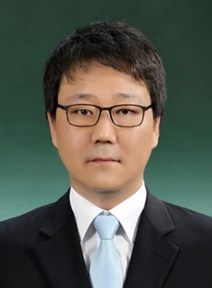
Jaeho Lee (M’10) is currently an assistant professor in department of software at Duksung Women’s University, Seoul, Korea (since 2020). He was an assistant professor at Seowon University from 2015 until 2020, and was a senior researcher at LG Electronics where he worked for international standardization of wireless home networks from 2013 until 2015. He received his B.S. and Ph.D. from the department of Electronics and Electrical Engineering at Korea University, Seoul, Korea, in 2006 and 2013, respectively. From 2002 to 2005, he was the software engineer of wireless networks at JMP System, and he worked at the department of Wibro R&D Lab of Korea Telecommunication Corporation (KT. Corp.) in Korea. His research interests include internet of things based on AI approach, wireless communications and networks including Bluetooth and Wi-Fi technology, and neural networks.

Email: izeho@duksung.ac.kr

