The Supplementary Information for:

Lampreys underwent radical changes in ecology and morphology during the Jurassic era
The supplementary information include:
- Supplementary description and comparison
- Palaeotemperature and fossil occurrences
- Character list and coding
- Methods of phylogenetic analyses
- Additional results and discussion
- CT scanning and computerized tomography
- Illustrations
- Supplementary references

Other supplementary materials include:
- Supplementary Figures 1–3 and legends
- Supplementary Table 1

1. Supplementary Description and Comparison
The feeding structures, including the oral disc, keratinous teeth, laminae surrounding the oral aperture and on the rasping tongue are superbly preserved current materials (Figs. 1, 2a–f, Extended Data Figs. 1b–d, g–i, 2h–l). The closely arranged disc teeth are much smaller than the circumoral teeth and decrease in size outwards. The morphology and arrangement of the disc teeth are very similar to the situation in Geotria (figs. 2–4, and 8 in ref. ⁹). Fifteen and thirteen circumoral teeth are counted in Y. occisor and Y. ingensdentes, respectively, which also lacks the posterior series. They are spatulate in shape and each bear three blades converging into a cusp that points slightly backward and inward. These teeth are therefore stouter and more complicated structured than those analogues in Geotria^{9,10}. The supraoral lamina is very large and roughly corresponds to 11 circumoral teeth in Y. ingensdentes and even encircles most of the circumference of the oral aperture in Y. occisor. Again, it closely resembles that of Geotria^{9,10} in having a pair of central inner cusps flanked by a pair of large and curved wings. The inner bicuspid cusps both bear a posterior blade. The lamina bears an anterior recessed part, analogous to that in Geotria just behind the thick annular muscle (fig. 4e in ref.¹⁰). The infraoral lamina is wide, convexly curved and bears a straight row of about ten stout cusps, of which the central ones are slightly larger than the lateral ones. The transverse lingual lamina is extraordinarily large. In Y. ingensdentes it almost fills up the whole oral aperture. On the anterior semicircle of the periphery of the oral disc, there are some triangular imprints of the oral papillae and ca. 30 comb-like imprints of oral fimbriae and numerous irregular oral papillae preserved in IVPP V16715 (Y. ingensdentes) (Figs. 1g, 2e, Extended Data Fig. 1b, c). In Y. occisor, two anterolateral oral papillae appear to be larger than the others (Figs. 1b, 2f, Extended Data Fig. 2b, k).
The prebranchial region and branchial apparatus left clear imprint on the slabs, with the former is longer than the latter (Fig. 1c–e, f, h). Some faint imprints of the piston can be spotted. The eyes are medium-sized, with the otic capsules positioned immediately behind. The anteriormost part of the gill apparatus is located behind the otic capsule (Fig. 1c, d, f).
In Yanliaomyzon ingensdentes, the dorsal fin is contiguous with the anterior lobe of the caudal fin, which is triangular and higher than the dorsal fin and continuous with the smaller, posterior part of the caudal fin. The dorsal and ventral lobes of the posterior caudal fin are almost equally developed. The fin radials in dorsal and caudal fins are clearly visible (Fig. 1c–f, h, Extended Data Fig. 2a, g). The anal fin fold is present in Y. ingensdentes (Fig. 1f, h, Extended Data Fig. 1a).

2. Palaeotemperature and fossil occurrences
The palaeotemperature curve was projected to our dated petromyzontiform phylogeny (Fig. 4) to reveal the pattern of the tempospatial distribution of the recorded fossil lampreys. The graph shows that the emergence of the fossil lampreys appears to match the cool or cold geological intervals or derive from productive areas associated with continental ice sheets, cooling events or the formation of highland topography. Priscomyzon occurred in the high-latitude South Africa of the Famennian-Tournaisian Ice Age, Hardistiella, Pipiscius and Mayomyzon in the coldest phase of the Permo-Carboniferous Ice Age^{36,37} with an estimated mean surface temperature of the tropical seas of ca. 23℃³⁸, and Yanliaomyzon and Mesomyzon from Yanliao and Jehol basins that were linked to the Yanshanian mountain-building activities in the Mid-Late Jurassic and Early Cretaceous cool intervals³⁸, with the fossil localities of Yanliaomyzon possibly situated on a highland^{13,39}, which is reminiscent of the distribution of Mexican lampreys (Tetrapleurodon) in the tropical zone at 20º N but restricted in high altitude cool watersheds¹¹.
3. Character list, state coding and revision
Characters 1-166 adopted from ref. ²³ and references there, characters 167-196 adopted from ref. ²⁵; and characters 197-208 are newly defined characters. These also were included in the data file (export from software as nexus format and put in Extended Data File 1).
1. Skeletal derivatives of neural crest: (0) absent; (1) present.
2. Ectodermal placodes: (0) absent; (1) present.
3. Distinct prechordal head: (0) absent or weakly developed; (1) prominent.
4. Tripartite vesicles at anterior end of neural tube (prosencephalon, mesencephalon, rhombencephalon): (0) absent; (1) present.
5. Morphologically distinct cerebellum with corpus cerebelli: (0) absent; (1) present.
6. Profundal nerve ganglion: (0) separate from trigeminal ganglion; (1) fused with trigeminal ganglion.
7. Tripartite division of facial nerve into pharyngeal, pretrematic, and postrematic branches: (0) absent; (1) present.
8. Spinal cord in cross section: (0) round; (1) flattened.
9. Ventral and dorsal roots of spinal nerve: (0) united; (1) separate.
10. Ventral and dorsal roots of spinal nerve originates: (0) intersegmentally; (1) intrasegmentally.
11. Mauthner fibers at rhombomere 4: (0) absent; (1) present.
12. Pineal organ (extra-ocular photoreceptor region expressing pineal opsins): (0) absent; (1) present.
13. Pineal opening: (0) covered; (1) uncovered.
14. Adenohypophysis: (0) absent; (1) present.
15. Olfactory peduncles: (0) absent; (1) present.
16. Encapsulated olfactory epithelium with external opening: (0) absent; (1) present.
17. Position of nasohypophyseal opening: (0) terminal; (1) dorsal.
Revision: Fossil lampreys have dorsal positioned nasohypophyseal opening, Mesomyzon was coded as (1) as in Mayomyzon and Priscomyzon according to ref.⁸;
18. Nasohypophyseal canal: (0) nasohypophyseal canal blind; (1) opening into pharynx.
Revision: Mesomyzon was coded as (0) instead of “?” according to ref. ⁸;
19. Nasohypophyseal opening: (0) single; (1) paired.
20. Olfactory organ: (0) unpaired; (1) paired.
21. Nasohypophyseal canal: (0) maintains width and height anteriorly; (1) tapers anteriorly.
22. External opening of nasohypophyseal canal: (0) terminal aperture; (1) tubular extension.
23. Nasohypophyseal barbels extend from: (0) rim of nasohypophyseal aperture; (1) posteriorly to nasohypophyseal aperture.
24. Nasohypophyseal papillae, ventral element: (0) absent; (1) present.
25. Nasohypophyseal papillae, dorsal element(s): (0) midline; (1) paired.
26. Eye with retinal pigmented epithelium: (0) absent; (1) present.
27. Eyes: (0) exposed; (1) covered by dermis; (2) covered by trunk muscles.
28. Extrinsic eye musculature: (0) absent; (1) present.
29. Muscles innervated by oculomotor nerve: (0) three; (1) four.
30. Oblique muscle innervated by trochlear nerve: (0) posterior oblique; (1) superior oblique.
31. Rectus muscles innervated by abducens nerve: (0) two; (1) one.
32. Eyes: (0) laterally placed (interorbital distance equal to width of head at that; (1) close together near midline (interorbital distance substantially less than width of head at that position; (2) on prominent eyestalk.
33. Cartilaginous otic capsules: (0) absent; (1) present.
34. Vertical semicircular canals forming loops: (0) absent; (1) present.
35. Anterior and posterior semicircular canals: (0) share a canal toward utriculus after meeting in a confluence; (1) meet each other at half a loop.
36. Horizontal semicircular canal: (0) absent; (1) present.
37. Statoliths composed of calcium phosphate: (0) absent; (1) present.
38. Endolymphatic duct: (0) is blind; (1) opens externally.
39. Electroreceptive cells: (0) absent; (1) present.
40. Sensory lines: (0) absent; (1) present.
41. Sensory-lines: (0) on head only; (1) on head plus body.
42. Sensory-line: (0) enclosed in grooves; (1) enclosed in canals.
43. Internal taste buds, or functionally equivalent end chemosensory organs innervated by cranial nerves in head: (0) absent; (1) present; (2) lacking internal taste buds but function replaced by Schreiner organs.
44. Preoptic head length: (0) shorter than branchial length; (1) approximately equal to branchial length; (2) longer than branchial length.
Revision: Mesomyzon was coded as equally in length according to ref.⁸;
45. Branchial apparatus: (0) retains arrangement of pharyngula such that first branchial opening assumes infra- or postotic position; (1) displaced anteriorly; (2) displaced posteriorly.
46. Branchial apparatus, displaced anteriorly such that: (0) first branchial opening assumes preotic position; (1) multiple branchial arches occupy preotic position.
47. Branchial apparatus, displaced posteriorly such that prebranchial length is: (0) less than a quarter; (1) approximately a quarter; (2) greater than a third of body length.
48. Pharyngeal skeleton: (0) delineates pharyngeal slits with ciliary band; (1) supports well-developed branchial lamellae.
49. Main skeletal support for branchial apparatus with respect to lamellae: (0) lateral; (1) medial.
50. Pharyngeal skeleton: (0) skeletal arches fused with each other; (1) arches isolated.
51.Hyomandibular pouch: (0) blind; (1) externally open (spiracle).
52. Respiratory current exits through: (0) atrial space; (1) through excurrent duct (=branchial pouch); (2) through parabranchial cavity.
53. Single confluent branchial opening: (0) absent; (1) present.
54. Branchial excurrent duct: (0) opens roughly at position of branchial pouch; (1) extends posteriorly.
55. Branchial openings: (0) spaced accordingly with dimensions of branchial cavities; (1) packed closely together; (2) organized into multiple parallel rows.
56. Number of arches (or pouches) in branchial apparatus: (0) unconstrained to five; (1) held constant at five.
57. Number of arches (or pouches) in branchial apparatus, maximum number: (0) greater than five and fewer than 20; (1) greater than 20.
58. Number of arches (pouches) in branchial apparatus: (0) four or five; (1) six or seven; (2) eight to ten; (3) greater than ten.
59. Branchial series extends: (0) substantially less than half the body length; (1) semiequal to or greater than half the body length.
60. Lateral branchial openings: (0) at similar horizontal level; (1) in a posteroventrally inclined row.
61. Opercular flaps associated with gill openings: (0) absent; (1) present.
62. Branchial epithelium in relative to the body: (0) internal; (1) external.
63. External branchial openings, demarcated by: (0) single element entirely; (1) single element dorsally; (2) multiple plates; (3) a framework of multiple spines; (4) micromeres; (5) naked (mineralized exoskeleton locally absent around the opening.
64. Position of mouth: (0) terminal; (1) subterminal.
Revision: Myxineidus was coded as subterminal (1) according to refs.^{2,51}, similar to the hagfishes (e.g., Tethymyxine).
65. Epidermal oral cirri: (0) absent; (1) present.
66. Postoptically derived ectomesenchyme anterior to mandibular arch gives rise to palatal structures that: (0) meet at midline under nasal/nasohypophyseal organs; (1) meet at dorsal midline anterior to nasohypophyseal organs and form a prominent oral roof.
67. Velum: (0) absent; (1) present.
Revision: Mesomyzon was coded as present (1) according to ref.⁸;
68. Velar cartilages: (0) in hyomandibular position; (1) extend posteriorly.
69. Velar cartilages, functions at terminal ontogenetic stages: (0) pump and valve; (1) valve.
70. Velar wings: (0) absent; (1) present.
71. Velar tentacles, papillae or tubercles: (0) absent; (1) present.
72. Multi-chamber heart: 0, absent; 1, present.
73. Closed pericardium: (0) absent; (1) present.
74. Circulatory system: (0) open; (1) closed.
75. Massive subcutaneous sinus: (0) absent; (1) present.
76. Paired dorsal aortae: (0) absent; (1) present.
Revision: Mesomyzon was coded as absent according to ref.⁸; hagfishes all have paired dorsal aorta, whereas lampreys not.
77. Lateral head vein: (0) drains into anterior cardinal vein or its derivative; (1) continues into (or functions as anterior extension of) anterior cardinal vein or its derivative.
78. Lymphocytes: (0) absent; (1) present.
79. Lymphocytes antigen receptors: (0) VLR; (1) T and B.
80. Subaponeurotic vascular plexus: (0) absent; (1) present.
81. Body forms, relative length: (0) less than five times the next largest dimension (height or width); (1) greater than five but less than ten times; (2) greater than ten times.
82. Body forms, width against height: (0) subcircular or compressed so that branchial openings are lateral; (1) depressed so that branchial openings are ventral.
83. Endoskeletal fin supports: (0) absent; (1) present.
84. Distinct dorsal fin: (0) absent; (1) present.
(Note: Character 85 in ref.²³ was replaced by character 186 below)
85. Fin(s) along dorsal midline originates: (0) above branchial series or anterior to mid-trunk; (1) above anus/anal fin or anterior; (2) posteriorly to anus/anal fin.
Revision: Mesomyzon coded as (0) according to ref.⁸; Priscomyzon recoded as uncertain according to ref.⁴ and personal communications to Dr. Miyashita.
86. Distinct anal fin: (0) absent; (1) present.
Notes: Mesomyzon probably has an anal fin fold according to ref.⁸; however, it is not determined whether it has radials support or not.
87. Paired skin folds (epidermal ridges) in suprapharyngeal position: (0) absent; (1) present.
88. Constricted pectoral fins with endoskeletal elements: (0) absent; (1) present.
89. Long continuous preanal skin fold (epidermal ridge): (0) absent; (1) present.
90. Preanal skin fold (epidermal ridge): (0) midline; (1) paired.
Miyashista et al.²³ coded cephalochordata, Pikaia, Haikouella, Myllokunmingia, Haikouichthys, all hagfish species, Jamoytius, Euphanerops, Cornovichthys, Jamoytius, Euphanerops, Lasanius, Birkenia, Rhyncholepis as having paired preanal skin fold (1); whereas we coded Jamoytius, Euphanerops, Lasanius, Birkenia, Rhyncholepis as having paired preanal skin fold)
Revision: Mesomyzon has a preanal skin fold according to ref.⁸, which is continuous and running along the midline.
91. Preanal skin fold (epidermal ridge): (0) longitudinal; (1) discrete pelvic fins.
Revision: Mesomyzon was coded as (0) according to ref. ⁸.
92. Tail shape: (0) no distinct lobes developed; (1) dorsal lobe much larger than ventral; (2) ventral lobe much larger than dorsal; (3) dorsal and ventral lobes almost equally developed.
Revisions: Miyashita et al.²³ coded character 93 for Euophanerops, Achanarella, Cornovichthys, Lasanius, Birkenia, Rhyncholepis, Turnia, Loganellia as “ventral lobe much larger than dorsal” (state 1 in their character descriptions), which might be a typing error. Here we revised state 1 as “dorsal lobe much larger than ventral”, and 2 as “ventral lobe much larger than dorsal”. Myxineidus, Gilpichthys, Tethymyxine and extant hagfishes coded as (0); Myxinikela code as (1); fossil (including Pipiscius) and extant lampreys all coded as (1); Euconodonta coded as (1). As noted by Janvier², we redefined the caudal fin in lampreys and the traditionally called ‘posterior dorsal fin’ should be the anterior part of the caudal fin, which is usually located behind the level of the opening of the cloaca⁸.
93. Chordal disposition relative to tail development: (0) isochordal; (1) hypochordal; (2) hyperchordal.
94. Skeletal elements consisting of calcium phosphate: (0) absent; (1) present.
95. Bone: (0) absent; (1) present.
96. Cellular bone: (0) absent; (1) present.
97. Lamellar aspidin: (0) absent; (1) present.
98. Perichondral bone: (0) absent; (1) present.
99. Calcified cartilage: (0) absent; (1) present.
100. Cellular cartilages with hypertrophied chondrocytes (30-50 µm in diameter): (0) absent; (1) present.
101. Mature chondrocytes: (0) become separated and generally even spaced by extracellular mat; (1) remain nested in a pair.
102. Dentine: (0) absent; (1) present.
103. Spherical/globular dentine: (0) absent; (1) present.
104. Tubular dentine: (0) absent; (1) present.
105. Tubular dentine, odontobalsts tend to: (0) retreat into pulp cavity; (1) remain in dentinous matrix.
106. Tubular dentine, interconnections of tubules/canaliculi for odontoblasts tend to be: (0) polarized; (1) non-polarized.
107. Tubular dentine, interconnections of canaliculi and spacing between odontoblasts tend to be: (0) regular; (1) irregular.
108. Enamel/oid: (0) absent; (1) present.
109. Enamel: (0) monotypic; (1) bitypic.
110. Calcification/ossification occurs in endoskeleton: (0) absent; (1) present.
111. Calcification/ossification occurs in exoskeleton: (0) absent; (1) present.
112. Mineralized integumentary skeleton, surface coverage: (0) extensive; (1) limited (with evidence for variation and potentials for reduction).
113. Odontodes: (0) monodontodes; (1) polyodontodes.
114. Exoskeleton, organization of superficial layer: (0) spherical; (1) tubular; (2) lamellar.
115. Exoskeleton, vascular/cancellar layer of osteons: (0) absent; (1) present. [an important feature is the three-layered exoskeleton]
116. Exoskeleton, basal tissue: (0) basal lamella; (1) basal attachment.
117. Cancellar layer in exoskeleton, with honeycomb-shaped cavities: (0) absent; (1) present.
118. Scale shape: (0) diamond-shaped; (1) rod-shaped.
119. Oak-leaf-shaped tubercles: (0) absent; (1) present.
120. Triradiate postbranchial spines: (0) absent; (1) present.
121. Median dorsal ridge scales: (0) absent; (1) present.
122. Median dorsal ridge scales: (0) simple; (1) hooked.
123. Vascular canal systems in integumentary skeleton: (0) absent; (1) present.
124. Scales: (0) without visceral ribs; (1) with visceral ribs.
125. Oral plates: (0) absent; (1) present.
126. Odontodes: (0) restricted to exoskeleton; (1) in oral cavity; (2) in pharynx.
127. Dermal head covering in adult state: (0) absent; (1) present.
128. Dermal head covering in adult state: (0) micromeric; (1) large (macromeric) dermal plates or shield.
129. Dermal head covering, macromeric: (0) large unpaired plates covering dorsal and ventral sides; (1) covered by tesserae; (2) multiple plates.
130. Dermal head covering, macromeric/shield: (0) head and anterior trunk continuous; (1) head and anterior trunk decoupled.
131. Endoskeletal contribution to dermal head covering: (0) absent; (1) present.
132. Mineralized exoskeletal circumocular elements: (0) absent; (1) present.
133. Mineralized endoskeletal circumocular elements (sclerotic elements): (0) absent; (1) present.
134. Sclerotic endoskeleton: (0) isolated circumocular elements; (1) eye capsule or stalk.
135. Fusion of visceral arches to the neurocranium: (0) absent; (1) present.
136. Denticulate/cuspidate elements of feeding apparatus, perioral: (0) absent; (1) present.
Revision: Mesomyzon was code present according to ref.⁸;
137. Perioral feeding elements: (0) continuous epidermal covering; (1) discontinuous arrangement.
Revision: Mesomyzon was coded as having discontinuous arrangement according to ref.⁸.
138. Denticulate/cuspidate elements of feeding apparatus, housed within or around buccal cavity: (0) absent; (1) present.
139. Longitudinally aligned tooth rows providing transverse bite: (0) absent; (1) present.
Revision: We herein coded lampreys, both fossil and living, as absent (0).
140. Perioral/buccal feeding structure consisting of keratin: (0) absent; (1) present
141. Feeding apparatus forming a pulley-like system of cartilages and protractor-retractor complex in mandibular arch: (0) absent; (1) present.
Revision: Mesomyzon was coded present as Priscomyzon and Mayomyzon;
142. Jaws (dorsoventral bite): (0) absent; (1) present.
143. Keratinous tooth plate, anterior element, number of fused cusps: (0) two; (1) three.
144. Radial organization of circumoral structures: (0) absent; (1) present.
Revision: Mesomyzon, Mayomyzon were coded as present as in Priscomyzon; Myxineidus was coded as absent according to refs.^{2,51}.
145. Circumoral keratinous teeth, number of tooth rows in lateral field: (0) two to four; (1) five or greater (new character); (2) one row lateral row; (3) plate linking lateral teeth.
146. Cartilaginous trematic rings: (0) absent; (1) present.
Revision: Priscomyzon and Mesomyzon were coded present.
147. Axial skeletal condensations derived from sclerotomes: (0) absent; (1) present.
148. Axial skeletons around dorsal nerve cord (=neural arches): (0) absent; (1) present.
149. Axial skeletons around notochord (=centra): (0) absent; (1) present.
150. Axial skeletons around dorsal aorta (=haemal arches): (0) absent; (1) present.
151. Parachordal cartilages: (0) absent; (1) present.
Revision: Mesomyzon herein was coded as present⁸, sharing the state of Priscomyzon, Mayomyzon^{2,15,23}.
152. Braincase with lateral walls: (0) absent; (1) present.
153. Occiput enclosing vagus and glossopharyngeal nerves: (0) absent; (1) present.
154. Annular cartilage: (0) absent; (1) present.
Revision: Mesomyzon was coded present according to ref.⁸; Myxineidus was coded absent according to the teeth arrangement referred in refs.^{2,51}.
155. Large oral disc: (0) absent; (1) present.
Revision: Myxineidus was coded as absent, whereas it was coded as present in ref.⁵¹.
156. Barbels supported by cartilages: (0) absent; (1) present.
Revision: Myxineidus was coded as absent.
157. Forked subnasal cartilage: (0) absent; (1) present.
158. Tectal cartilages: (0) absent; (1) present.
159. Male gametes shed directly through the coelom: (0) absent; (1) present.
160. Postotic myomeres migrate anteriorly to the position of eye: (0) absent; (1) present absent.
161. Inflected myomeres: (0) Z-shaped; (1) W-shaped.
Revision: Mesomyzon was coded as Z-shaped rather than W-shaped according to ref.⁸; the myomere condition in Mayomyzon is uncertain.
162. Digestive tract in relation to branchial region: (0) follows pharynx; (1) passes (or loops) over branchial apparatus.
Revisions: Mesomyzon was coded passing over the branchial region according to ref.⁸; Mayomyzon was coded passing over branchial region according to refs.^{15,23}; Hardistiella was coded so according to ref.¹⁷; Priscomyzon was coded so according to the degree of the development of its branchial apparatus, suggesting the possible divergence of branchial tube and the esophagus as in living lampreys⁴; Pipiscius coded as in Mayomyzon according to refs.^{4,16}. The digestive tube is arranged in a different pattern in relation to the branchial apparatus and follows the pharynx in hagfishes.
163. Anus, with respect to distribution of mesoderm: (0) terminal or subterminal; (1) non-terminal.
164. Globular slime glands: (0) absent; (1) present.
165. Number of slime glands: (0) approximately 100 or fewer; (1) substantially greater than 100.
166. Slime pores: (0) overlap region of external branchial openings; (1) do not overlap region of external branchial openings.
Character 168 in ref. ²³ (gular pouch in adult male) was represented by character 189 below.
167. Shape of labial teeth: (0) pointed; (1) rounded; (2) spatulate.
168. Alate tooth rows: (0) absent; (1) present.
169. Number of lateral circumoral teeth per side: (0) 3; (1) 4; (2) ≥5.
Notes: Mesomyzon coded as larger than 5 according to ref. 8; Priscomyzon coded as 4 (state 1) according to ref.⁴ and comparison to living lampreys with this number of lateral circumoral teeth.
170. Structure of second lateral circumoral tooth: (0) unicuspid; (1) bicuspid; (2) tricuspid; (3) expanded plates bearing 3-5 cusps; (4) absent.
171. Structure of supraoral laminale: (0) single bridgeless lamina bearing one or more teeth; (1) Two teeth linked by a bridge; (2) two triangular laminae bearing a tooth at each apex; (3) two central teeth flanked by lateral flanges; (4) supraoral lamina not developed.
172. Structure of infraoral lamina: (0) absent; (1) present and bearing 5 teeth; (2) present and bearing > 5 teeth.
173. Shape of transverse lingual lamina: (0) W-shaped; (1) Straight/almost straight; (2) U-shaped.
174. Arrangement of cusps on transverse lingual lamina: (0) uniform in size; (1) median cusp slightly enlarged; (2) median cusp greatly enlarged; (3) three large cusps only, one median and two lateral ones; (4) median and subterminal cusps slightly enlarge.
175. Shape of longitudinal lingual lamina: (0) parenthesis-shaped; (1) hook-shaped; (2) straight.
176. Length of velar tentacles: (0) short; (1) long.
177. Lateralmost velar tentacles folded over onto the dorsal surface of the velar apparatus to form "wings": (0) absent; (1) present.
178. Surface of velar tentacles: (0) smooth;(1) tuberculated or papillose.
179. Number of velar tentacles: (0)＜5; (1)5-9; (2)10-21; (3)23-32.
180. Median velar tentacle(s): (0) absent; (1) one or two free tentacle(s); (2) two tentacles fused at base along part of their lengths.
181. Development of oral fimbriae: (0) present and distributed over the full perimeter of the oral disc; (1) absent.
182. Structure of oral papillae (anterior and lateral section): (0) uniform size; (1) two of the lateral papillae enlarged.
183. Arrangement of oral papillae: (0) absent posteriorly; (1) absent both anteriorly and posteriorly; (2) absent anteriorly.
184. Position of eyes in mature adults: (0) dorsolateral; (1) dorsal.
185. Types of retinal photoreceptor cell: (0) one cone and one rod; (1) two cones and one rod; (2) one rod.
186. Position of dorsal fins relative to each other in mature adults: (0) continuous; (1) contiguous; (2) separate.
187. Connection of second dorsal fin/posterior lobe and caudal fin in immature adults: (0) connected; (1) separate.
188. Number of trunk myomeres in adults: (0) <60; (1) ≥60≤70; (2) >70.
189. Gular pouch in adult males: (0) absent; (1) small; (2) large.
190. Position of cloaca in adults: (0) anterior to or under the origin of the second dorsal fin; (1) under the anterior half of the second dorsal fin or anterior half of the posterior lobe of the single dorsal fin; (2) under the middle or posterior half of the second dorsal fin.
191. Pigmentation of dorsal and upper lateral surfaces of body in adults: (0) uniform; (1) mottled (Petromyzon); (2) pair of blue-green dorsolateral stripes.
192. Pigmentation of neuromasts (lateral line organs) in adults: (0) unpigmented; (1) darkly pigmented.
193. Position of otic capsule relative to first branchial opening in adults: (0) posterior to first branchial opening; (1) anterior to or directly over first branchial opening.
194. Predominant type and diploid number of chromosomes: (0) acrocentric and 164-168; (1) metacentric and submetacentric 76; (2) acrocentric and 180.
195. Number of intestinal diverticula in ammocoetes: (0) no intestinal diverticula; (1) 2; (2) 1.
196. Piston cartilage: (0) absent: (1) present.
197. Posterior circumoral teeth: (0) present; (1) absent.
198. Posterior blade on circumorals and disc teeth: (0) absent; (1) present.
199. Posterior exolateral teeth: (0) present and complete; (1) posterior intermediate absent, marginal present; (2) posterior intermediate and marginal absent.
200. Arrangement of circumoral teeth: (0) sparsely arranged; (1) closely apposed
201. Anterior circumoral size relative to lateral circumorals: (0) nearly equally sized; (1) anterior smaller than lateral.
202. Anterior circumoral size in relative to inner most anterior sic teeth: (0) nearly equally in size or even circumoral smaller; (1) anterior circumorals larger than first anterior row teeth; (2) anterior circumoral lacking or far away from oral aperture; (3) anterior disc teeth lacking.
203. Supraoral in relative to lateral circumorals: (0) nearly equally in size; (1) supraoral much larger.
204. Grooves in rear side of supraoral lamina: (0) absent; (1) present.
205. Cusps on infraoral lamina: (0) uniform; (1) differentiated in size.
206. Cusps on lingual longitudinal lamina: (0) small and straight linearly aligned; (1) large and straight linearly aligned; (2) large and gently curving, comb-like; (3) large and V-shaped; (4) two lines of cusps.
207. Circumoral teeth and oral disc teeth or anterior field teeth including anterior circumorals: (0) of similar shape; (1) distinct in shape.
208. Circumoral teeth and oral disc teeth or anterior field teeth including anterior circumoral: (0) of similar size; (1) circumorals larger than anterior disc teeth.

4. Methods of phylogenetic analyses

4.1 Data
Different from the recent comprehensive vertebrate and cyclostome phylogeny²³, this study focuses on resolving the systematic positions of the Jurassic fossil lampreys within the petromyzontiform as well as their closely related taxa, thus the remote taxa were not included, e.g., the hemichordate (Saccoglossus kowalevskii), tunicate (Ciona intestinalis), cephalochordate (Branchiostoma floridae), Pikaia, controversial Cambrian vertebrates (Haikouella, Haikouichthys, Metaspriggina, and Myllokunmingia), and the lineage leading to the gnathostomes (jawed vertebrates). In this context, the dataset includes 25 extant taxa and 20 fossils from Cyclostomi (total group), and combines both morphological characters and molecular sequences, with morphological characters for all taxa (208 characters), 16S gene for 10 extant species (772 sites) and CO1 gene for 11 extant species (721 sites). The character description and revision are listed above.
The Bayesian total-evidence dating analysis was performed using software MrBayes 3.2.8⁵². This version was not formally released when performing this study and the executable was compiled from the latest source code (https://github.com/NBISweden/MrBayes). We describe the models, priors and Markov chain Monte Carlo (MCMC) settings for the analysis. The data matrix and MrBayes commands are given in Extended Data Files 1 and 2.

4.2 Substitution models
The Mkv model⁵³ was used for the morphological data correcting for the variable coding bias (only variable characters are coded in the matrix). For each gene, the HKY model⁵⁴ was used with independent transition-transversion rate ratio (κ) and exchangeability rates. Rate variation across characters (sites) was modelled using the discrete gamma model⁵⁵, while rate variation across data partitions was drawn from a uniform Dirichlet distribution⁵⁶ under the constraint of average rate across characters (sites) being 1.0.
We used the default priors for the substitution parameters, e.g., exponential (1.0) for the gamma shape parameter (α), beta (1, 1) for the transformed transition-transversion rate ratio (κ/(1+κ)), and a uniform Dirichlet distribution for the exchangeability rates (π).

4.3 Total-evidence dating
Traditional phylogenetic analyses infer branch lengths measured by expected changes per character, which are products of geological times (myr: million years) and evolutionary rates (expected changes per character per myr). Without the fossil ages and clock-model assumptions, the two components are confounded and indistinguishable. In the total-evidence dating analysis, we use fossil ages as tip calibrations to co-estimate divergence times and evolutionary rates. To investigate evolutionary rate heterogeneity among separate morphological regions and between morphological characters and molecular sequences, the morphological characters were divided into three partitions, that is, feeding mechanism (51 characters), branchial apparatus (22 characters) and others (135 characters) (data S2). Eventually, each of the three morphological partitions had an independent clock model and the two gene partitions share another independent clock model.
All partitions share the base clock rate (c) which was assigned a lognormal (–6, 1.0) prior with mean 0.004 and standard deviation 0.005. The evolutionary rate variation was modelled by the relative rate (r) multiplied to the base rate (c). The relative rates in each of the four relaxed clocks follow independent and identically distributed (i.i.d.) lognormal distributions⁵⁷ with mean 1.0, and the variance of each clock (σ) was assigned an exponential (1.0) prior by default.
Apart from the clock model, the other component is the timetree. The timetree was modelled by the fossilized birth-death process^{56,58,59} with speciation rate λ, extinction rate μ, fossil-sampling rate ψ, extant-sampling proportion ρ, and conditioned on the root age (t_{mrca}). The ages of the fossils were fixed to their geological times (see Extended Data File 2). For the priors, t_{mrca} was assigned an offset-exponential distribution with mean 600 and minimum 500 Ma referring to the oldest fossils, d = λ – μ ~ exponential (100) with mean 0.01, v = μ / λ ~ beta (2, 1) and s = ψ / (μ + ψ) ~ beta (1, 1). The extant-sampling proportion was fixed to 0.3, assuming 25 out of about 80 living species were sampled and included in the analyses.
Two independent MCMC runs with 4 chains per run (1 cold, 3 heated) were run 30 million generations and sampled every 400 generations. The first 25% samples were discarded as burn-in and the remaining were combined after examining convergence of both runs. The posterior tree samples were summarized as an all-compatible consensus tree, which displays all compatible clades in the posterior trees as bifurcations, including those with probability smaller than 0.5.
5. Additional results and discussion
The timetree of all taxa estimated from total-evidence dating combining both morphological and molecular data is shown in Fig. 3. Making use of all available data including the fossil ages refines the phylogeny comparing to previous analyses²³. We highlight several taxa positions in the timetree which appear more reasonable. Using the morphological characters alone, fossil Tethymyxine was placed in the crown group of Myxinoidea (sister to Rubicundus, ref. ²³), now it is at the stem when taking its age into account in the total-evidence analysis (Fig. 3), because the age of Tethymyxine is older than the estimated age of crown Myxinoidea. Southern Hemisphere lampreys were paraphyletic when using both morphological and molecular data, while Geotria australis was placed as a sister group of Mordacia species when only morphological characters were used. This difference is mostly due to incorporating both times and rates in the dating analyses, indicated by long time span (~78 Myr) but slow evolutionary rates leading to Geotria australis.
The divergence times of the major clades are generally younger than those estimated in the recent study²³ but more compatible to the estimates of the former molecular study for the myxinoid crown²⁴. In comparison, a few credibility intervals appeared either too wide or too narrow in the previous study (figure S9 in ref.²³). For example, the interval only spanned 7 million years (543.3–536.0 Ma) for Cyclostomi (total group), but spanned 185 million years (350.5–165.0 Ma) for the node of Mesomyzon + crown-group petromyzontiform. This is largely due to the two-step approach applied in their study and each step only incorporated part of the data. They first inferred the phylogeny using purely morphological characters. Then the tree topology was fixed while the fossil ages and molecular data were used to date the tree (discarding the morphological characters). Thus, the divergence time estimates were mainly informed by the fossilized birth-death prior without the morphological characters. Our approach takes full use of the data, including fossil ages, morphological characters and molecular sequences in a coherent analysis. Besides, we also included more fossils in the stem and revised the morphological data (see above).
The morphological data were divided into three partitions with independent relaxed clock models (Extended Data File 2), making it available to investigate the evolutionary rate heterogeneity among them.
The characters of feeding mechanism evolved extremely rapidly with relative rate 10.7 (0.02, 45.1) (median and 95% HPD, same for below) in the transition from the common ancestor shared by petromyzontiform (lampreys) and myxinoidea (hagfishes) (Fig. 3 and fig. S3) and then dramatically slowed down to 1.5 (0.01, 7.6) leading to Pipiscius and 0.4 (0.0, 2.9) leading to the stem and crown petromyzontiforms. This suggests that morphological changes in the feeding mechanism were rapid at the dawn of the history of the group and this functional unit might have played a vital role in this stage just as previously supposed^{1,2}. The rates continued to slow down substantially and differentiated radically during their later history (Fig. 3, Extended Data Fig. 3). Most of the rates are well below 0.5, however, it is worth noting that the rate at the branch from the Palaeozoic to Mesozoic lampreys is roughly six times that along the branch of crown-group lampreys, and that a high rate of 5.4 (0.01, 23.6) is observed along the branch toward Mordaciidae + Petromyzontidae, which is ~77 times of that along the branch toward Geotria (Extended Data Fig. 3). Additionally, within the Mesozoic forms, a modest evolutionary acceleration is also detected at the branch towards Yanliaomyzon species when lampreys diverge from Mesomyzon lineage in the Early Jurassic (Extended Data Fig. 3). These observations concur with the significant increase of the adult body size of the lampreys since the Palaeozoic era in tandem with the establishment of the ‘modern’ three-phased life history. The striking and unexpected anatomical similarity of Jurassic Yanliaomyzon and living Geotria and the evolutionary process of the feeding mechanism suggest that the common ancestor of living lampreys must fairly look like Geotria in the feeding structures and hence maybe a flesh eater rather than a blood feeder as previously proposed^{5,6,10}.

6. CT scanning and computerized tomography
X-ray micro-computerized tomography was adopted for scanning the oral disc and the dentition of IVPP V 15830. The scanning was carried out using the 225 kV micro-computerized tomography (developed by the Institute of High Energy Physics, Chinese Academy of Sciences (CAS)) at the Key Laboratory of Vertebrate Evolution and Human Origins, CAS⁶⁰. The specimen was scanned with beam energy of 140 kV and a flux of 120 uA at a resolution of 36.07 𝜇m per pixel using a 360° rotation with a step size of 0.5°. A total of 720 projections were reconstructed in a 2,048*2,048 matrix of 1,536 slices using a two-dimensional reconstruction software developed by the Institute of High Energy Physics, CAS. The data then was analyzed by using VGstudio 2.2 to produce the 3D images (Extended Data Fig. 2l).
7. Illustrations
All drawings of Figures 1 and 2 were done with pencils by the author. To distinguish the types of the dentition and the associated structures of the feeding mechanism, different colours were filled in corresponding regions using Adobe Photoshop CS6. The phylogenetic trees were visualized in FigTree (v1.4.4) and adjusted in Adobe Illustrator CS6 and Affinity Designer (v1.8.4).

8. Supplementary references
51. Poplin, C., Sotty, D. & Janvier, P. Un Myxinoïde (Craniata, Hyperotreti) dans le Konservat-Lagerstätte Carbonifère supérieur de Montceau-les-Mines (Allier, France). CR Acad. Sci. Paris 332, 345–350 (2001).
52. Ronquist, F. et al. MrBayes 3.2: efficient Bayesian phylogenetic inference and model choice across a large model space. Syst. Biol. 61, 539–542 (2012).
53. Lewis, P. O. A likelihood approach to estimating phylogeny from discrete morphological character data. Syst. Biol. 50, 913–925 (2001).
54. Hasegawa, M., Kishino, H. & Yano, T. Dating of the human-ape splitting by a molecular clock of mitochondrial DNA. J. Mol. Evol. 22, 160–174 (1985).
55. Yang, Z. Maximum likelihood phylogenetic estimation from DNA sequences with variable rates over sites: approximate methods. J. Mol. Evol. 39, 306–314 (1994).
56. Zhang, C., Stadler, T., Klopfstein, S., Heath, T. & Ronquist, F. Total-evidence dating under the fossilized birth–death Process. Syst. Biol. 65, 228–249 (2016).
57. Drummond, A., Ho, S., Phillips, M. & Rambaut, A. Relaxed phylogenetics and dating with Confidence. PloS Biol. 4, e88 (2006).
58. Stadler, T. Sampling-through-time in birth-death trees. J. Theor. Biol. 267, 396–404 (2010).
59. Heath, T. A., Huelsenbeck, J. P. & Stadler, T. The fossilized birth-death process for coherent calibration of divergence-time estimates. Proc. Nat. Acad. Sci. 111, E2957-66 (2014).
60. Wang, Y. F. et al. Development and applications of paleontological computed tomography. Vert. PalAsiat. 57, 84–92 (2019).

9. Supplementary Figures and Legends
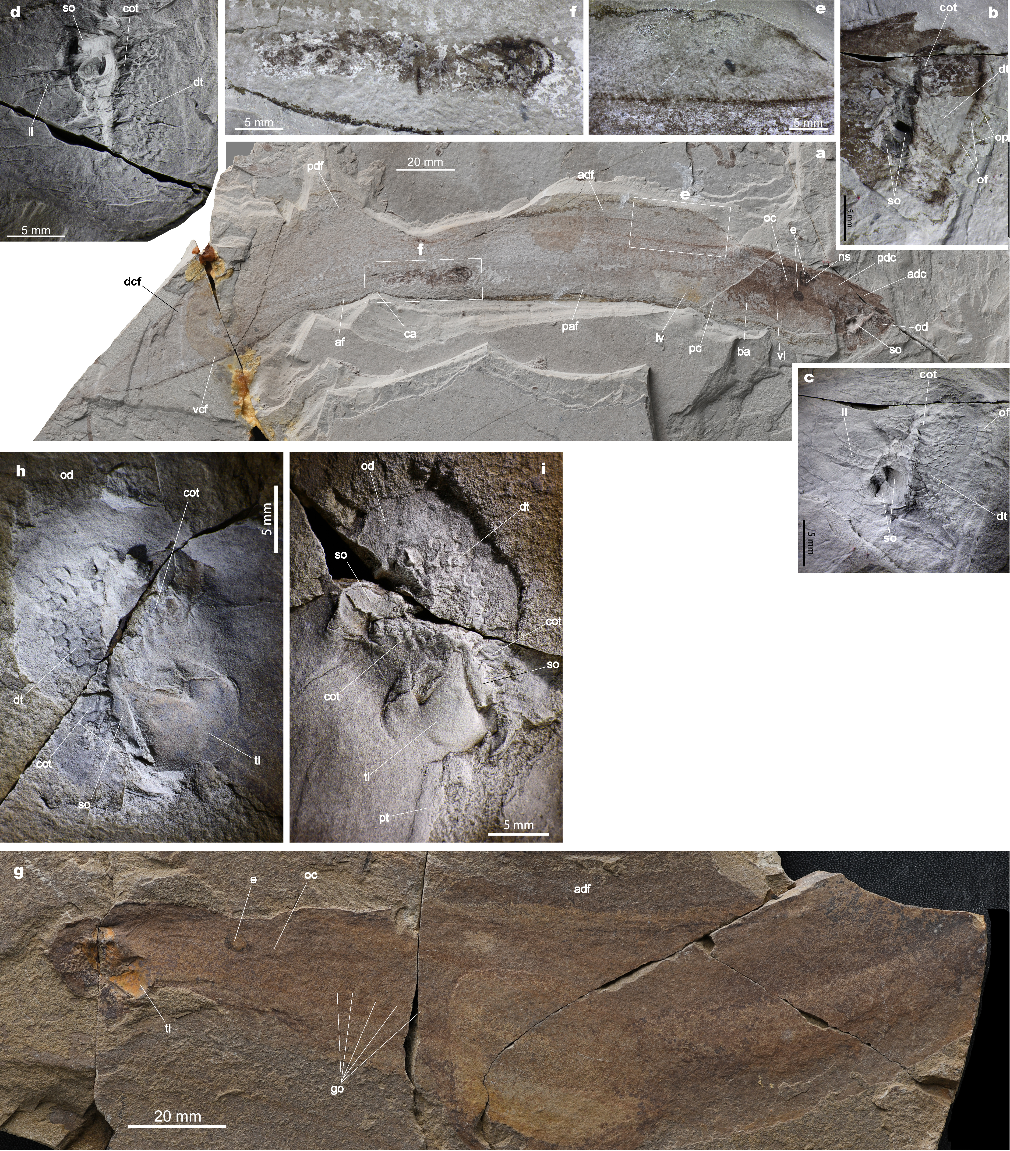
Extended Data Figure 1. Jurassic lampreys, Yanliaomyzon occisor gen. et sp. nov. and Yanliaomyzon ingensdentes gen. et sp. nov. a to f, Yanliaomyzon ingensdentes gen. et sp. nov. (a) Counterpart of holotype (IVPP V 16715A); (b) Photograph and (c) that whitened by ammonia chloride of oral disc and dentition of (a); (d) oral disc and dentition of part of holotype (IVPP V16715B), photograph covered with ammonia chloride and horizontally flipped for comparison; (e) Close-up of front section of anterior dorsal fin; (f) Close-up of intestine contents, showing the skeletal relics of the prey; g–i, Yanliaomyzon occisor gen. et sp. nov. (g) Counterpart of paratype (IVPP V 18956A); (h) oral disc and dentition of (g), whitened by ammonia chloride; (i) oral disc and dentition of part specimen of paratype (IVPP V 18956B), whitened by ammonia chloride.
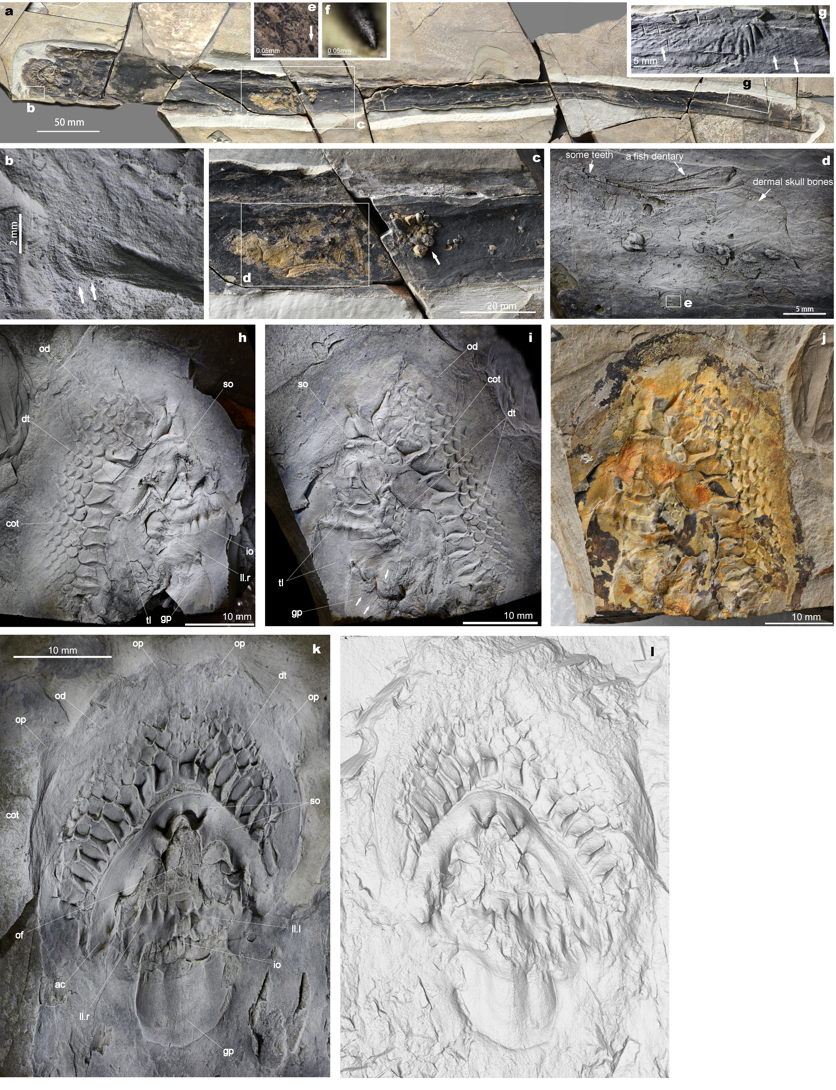
Extended Data Figure 2. Feeding mechanism of Yanliaomyzon and preys of Yanliaomyzon occisor gen. et sp. nov. a–g, Yanliaomyzon occisor gen. et sp. nov. (a) Holotype (IVPP V 15830); (b) Close-up of an oral papilla, whitened by ammonia chloride; (c) Close-up some intestine contents; (d) Some disarticulated bones of an unknown ray-finned fish, image upside-down to facilitate observation; (e) an isolated phosphatic tooth within the intestine contents; (f) Close-up of (e); (g) Close-up of posterior dorsal fin, arrows pointing to the fin radials; h–j, Oral disc and dentition of Yanliaomyzon ingensdentes gen. et sp. nov. (h) Part (IVPP V16716B) and (i) counterpart (IVPP V16716B) of the paratype, images whitened by ammonia chloride; (j) Counterpart (IVPP V16716A) of paratype; k and l, Oral disc and dentition of holotype of Yanliaomyzon occisor gen. et sp. nov. (k) Photograph, (l) Computed tomography (produced using VGstudio 2.2), showing the morphology of the dentition which was actually preserved as a depressed mold.

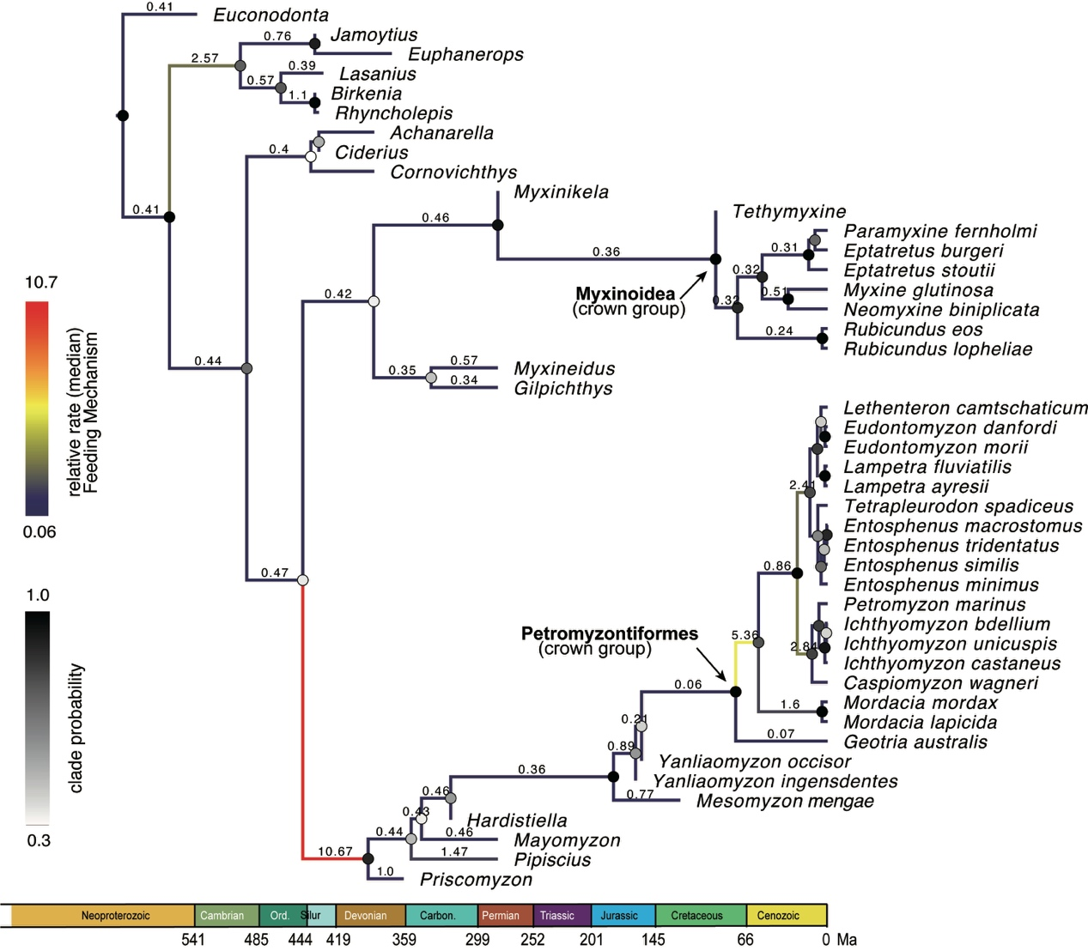
Extended Data Figure 3. Dated phylogeny (timetree) of cyclostomes and the evolutionary rates of their feeding mechanism. The colour of the branch represents the median relative rate of the feeding mechanism characters at that branch. The median values of the relative rates in some focal branches are also shown. For abbreviations see the legend of Fig. 3. For more parameter estimates, such as the branch rates of different partitions, see the log file and tree file (Extended Data Files 2, 3).

Supplementary Table 1. Meristic measurements of Yanliaomyzon occisor gen. et sp. nov and Yanliaomyzon ingensdentes gen. et sp. nov, and comparison with other fossil lampreys
Abbreviations and interpretations: a, cloacal slit length; a-C, tail length; d, oral disc length; d-O, preorbital length (from anteriormost internal edge of oral disc to anterior edge of eye); d-B1, prebranchial length or head length; d-n, snout length (narial opening not well-preserved, measured between anterior edge of naso-hypophysial organ to anteriormost internal edge of oral disc); B₁-B₂, interbranchial opening length; B₁-B₇, branchial length; B₇-a, trunk length; Hh, head height (measured at the level of posterior edge of eye); I, interocular length; mn, number of trunk myomeres; O, eye length; oa, length between oral disc tip to cloaca; O-B₁, postocular length; od, length of maximal axis of the oral disc; TL, total length.

Taxon | TL | BD/TL（%） | oa | B7-a | a-C | d-n | O | O-B₁ | B1-B2 | d | d-O | d-B1 | B1-B7 | a | mn | od/TL  （%）
Yanliaomyzon occisor | 700 | 4.6 | 459.3 | ? | 270.7 | ? | ? | ? | ? | 33 | ? | ? | ? | ? | ? | 4.4
Yanliaomyzon ingensdentes | 310 | 7.2 | 178 | 116 | 127.8 | 29 | 4 | 6.5 | ? | ? | 33 | 42 | 12 | ? | ? | 5.3
Mesomyzon mengae | 150-217 | 11.1-12.5 | 113-166 | 74-107 | 37-51 | 13-20 | 2-2.5 | 6.5-8 | 2-3 | 7.5-13 | 15.5-17.5 | 20-32 | 13-21 | 2-3 | 70-80 | 4.4
Mayomyzon | 33-61 | 10.5 | ？ | ? | ？ | ？ | ? | ? | ? | ? | ? | 7.8 | ？ | ？ | ? | 3.5
Hardistiella | <117 | 9.1 | ca. 76 | ? | 36.9 | ？ | ? | ? | ? | 5 | ? | 13.5 | ？ | ？ | ？ | 6.1
Pipiscius | 40-65 | 11.3 | ? | ? | ? | ？ | ? | ? | ? | ? | ? | ？ | ？ | ？ | ？ | ?
Priscomyzon | 4.2 | 9.3 | ? | 26.5 | ？ | ？ | ? | ? | ? | 8.3 | ? | 9.1 | ？ | ？ | ？ | 21.7

