Supplementary Figures
A
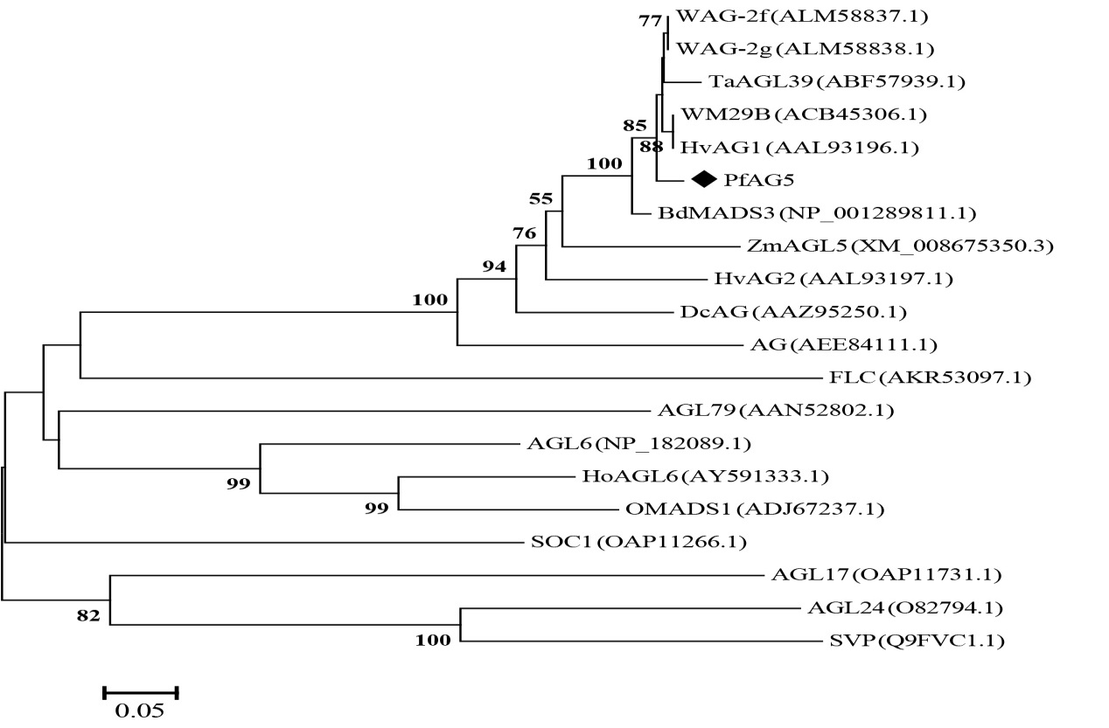
B
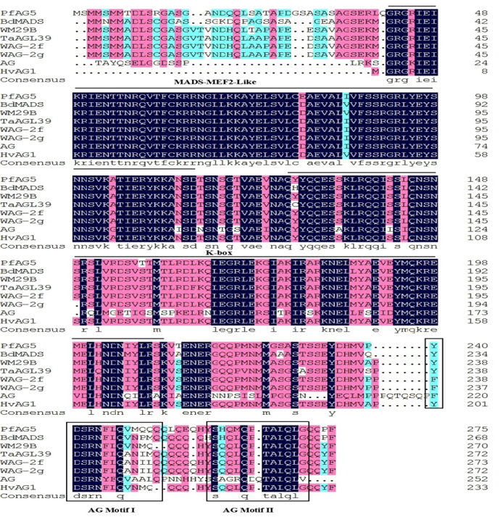
Figure S1. Characterization of the PfAG5 gene sequence. (A) Phylogenetic analysis of PfAG5 amino acid sequence. (B) Deduced amino acid sequence alignment of PfAG5 with BdMADS (NP_001289811.1), HvAG1(AAL93196.1), WM29B (ACB45306.1), TaAGL39 (ABF57939.1), WAG-2f (ALM58837.1), WAG-2g (ALM58838.1), HvAG2 (AAL93197.1) and AG (AEE84112.1). The MADS-MEF2 domain, K-box doain, AG motifⅠand AG motif Ⅱ were indicated.

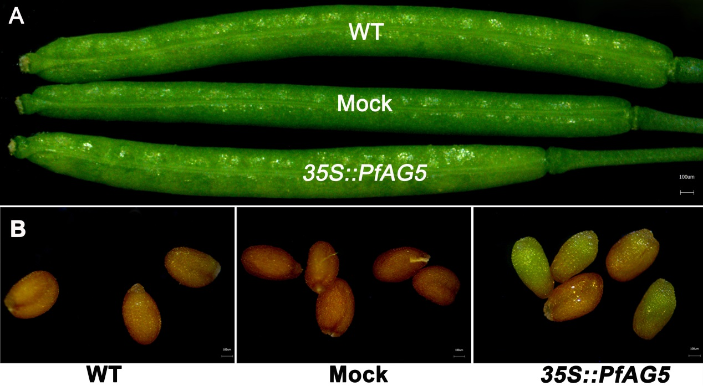

Figure S2. Phenotypic differences of pods (A) and seeds (B) of PfAG5 transgenic Arabidopsis plants and the controls (WT and Mock).

